**Intro to Internet of Things**

**Assignment 2**

**Syed Farhan Jafri  
21L-6074  
BSE-8A**

I chose Route 1 to do the assignment which is from Azadi Chowk to FAST Lahore.

The python connection code is attached in a separate file.

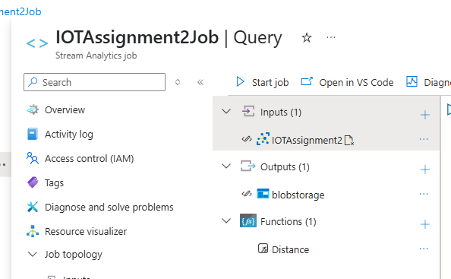**Job Topology**

**ASA Query**

**Distance Function Used**

Distance function used to calculate the distance between two coordinates. I used the Haversine formula as it determines the great-circle distance between two points on a sphere given their longitudes and latitudes. I used the help of GeeksForGeeks and StackOverflow to find a suitable function.

**Screenshot of Output Container**

I have also attached the complete output file to show you complete distances calculated of each coordinate of the route.

