**JZone**

**Internncraft Project 2**

**Online Electronics Store**

JZone is a powerful and modern full stack eCommerce web application built using Next.js, Express.js, MongoDB with Mongoose, Redux Toolkit, Stripe payment method, Bootstrap 5. It includes a feature-rich admin panel for easy management and control of the online store.

1.**Tools Used**: This project is a full stack e-commerce website built with:

**Next.js:** Next.js is The React Framework for Production, providing a fast and scalable foundation for your eCommerce website.

**Express.js:** Express.js is a minimal and flexible Node.js web application framework that offers a robust set of features for web and mobile applications.

**MongoDB:** MongoDB is a developer-friendly data platform that provides the services and tools necessary to build distributed applications at scale.

**Mongoose**: Mongoose provides a straightforward, schema-based solution to model your application data, offering built-in type casting, validation, and query building.

**Stripe:** Stripe offers online payment solutions, allowing you to create a secure and reliable website with e-commerce functionality.

**Nodemailer:** Nodemailer is a module for Node.js applications that facilitates easy email sending, keeping your users informed and engaged.

**Redux Toolkit:** Manage state effortlessly with Redux Toolkit, providing a convenient and efficient way to handle state in your application.

**Typescript + Next.js App Directory:** leverages TypeScript in combination with Next.js, enhancing code reliability and maintainability.

**Bootstrap 5 Framework**: Bootstrap is a popular HTML, CSS, and JS framework for responsive, mobile-first projects.

**Responsive Layout Design:** JZone is fully responsive across all devices, providing a seamless experience for your customers.

2. **Challenges Faced**:

* Build out the project to the designs provided
* Ensuring all components communicated effectively, particularly handling asynchronous operations and managing dependencies.
* Designing efficient schema relationships and ensuring data integrity while supporting complex queries.
* Connecting Stripe APIs to power online payment processing for e-commerce
* Managing complex state logic and ensuring that the state remains consistent and up-to-date across different components.

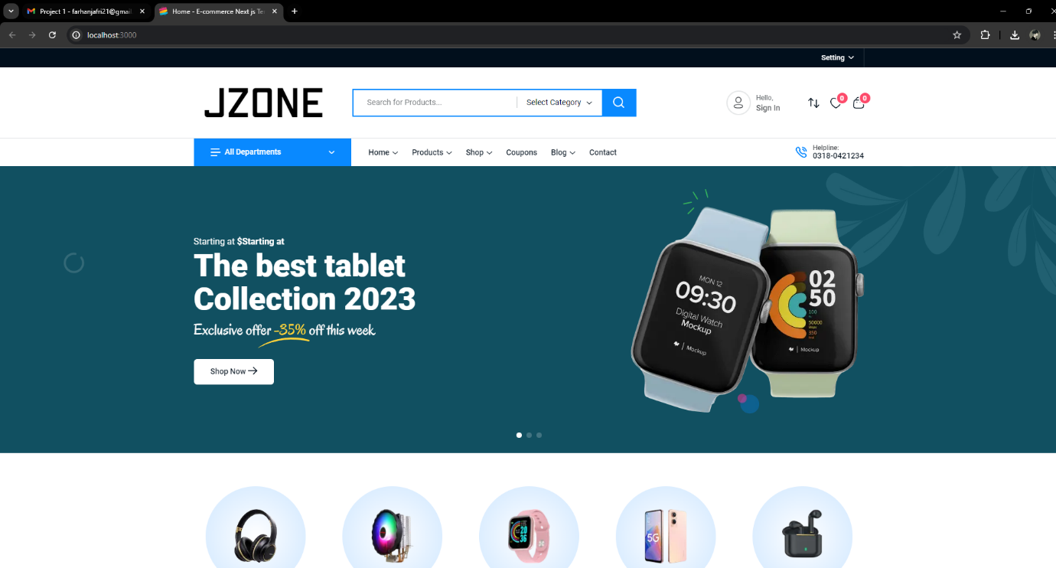**Screenshots:**

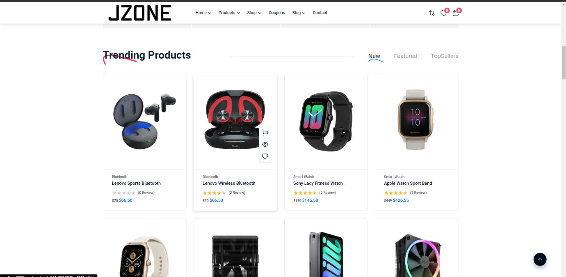

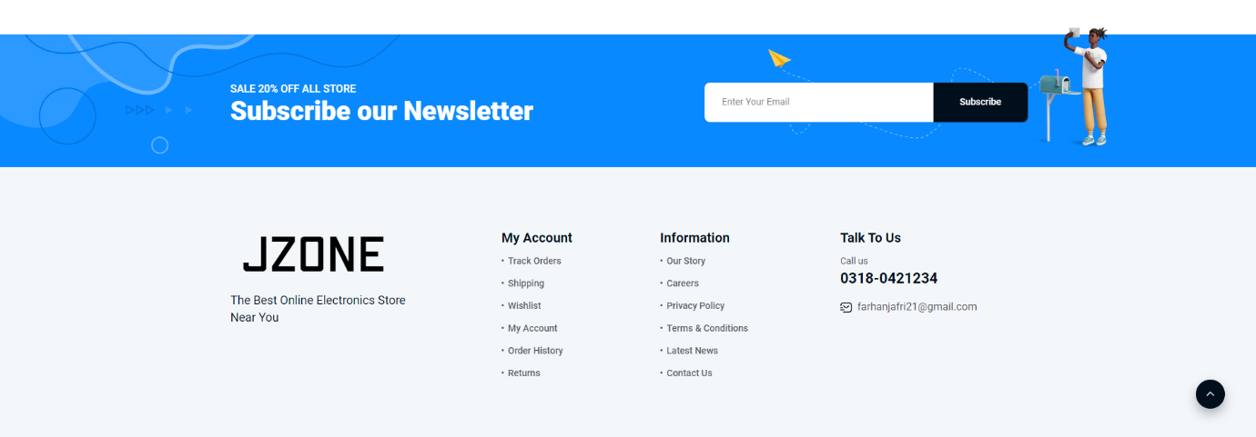

**To run the project:**

1. Open Visual Studio Code and open the project Folder through the application.

2. npm install

3. npm run dev

4. go to the command terminal and right click the url link