**JayStores**

**Internncraft Project 1**

**Online Clothing Store**

1.**Tools Used**: This project is a full stack e-commerce website built with:

* Flexbox
* CSS Grid
* Next JS - React Framework for Production
* Sanity - Sanity is a customizable solution that treats content as data to power digital business.
* Stripe - APIs to power online payment processing for e-commerce
* react-hot-toast - react library that adds beautiful notifications to the react application.
* react icons - JS library to add icons
* swiper js - JS library to add slider component
* canvas-confetti - Lightweight JS plugin to create a confetti celebration explosion effect. It draws confetti graphics on the HTML canvas element.

2. **Challenges Faced**:

* Build out the project to the designs provided
* Implementing cart functionality
* Connecting to Sanity as back end database for e-commerce
* Connecting Stripe APIs to power online payment processing for e-commerce

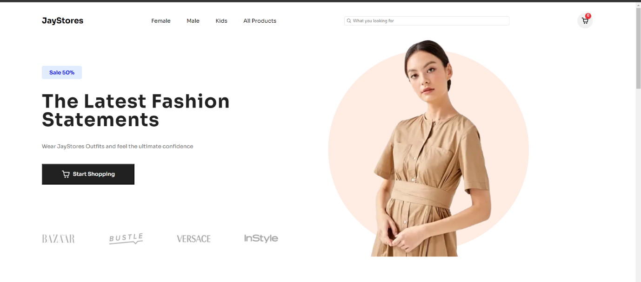**Screenshots:**

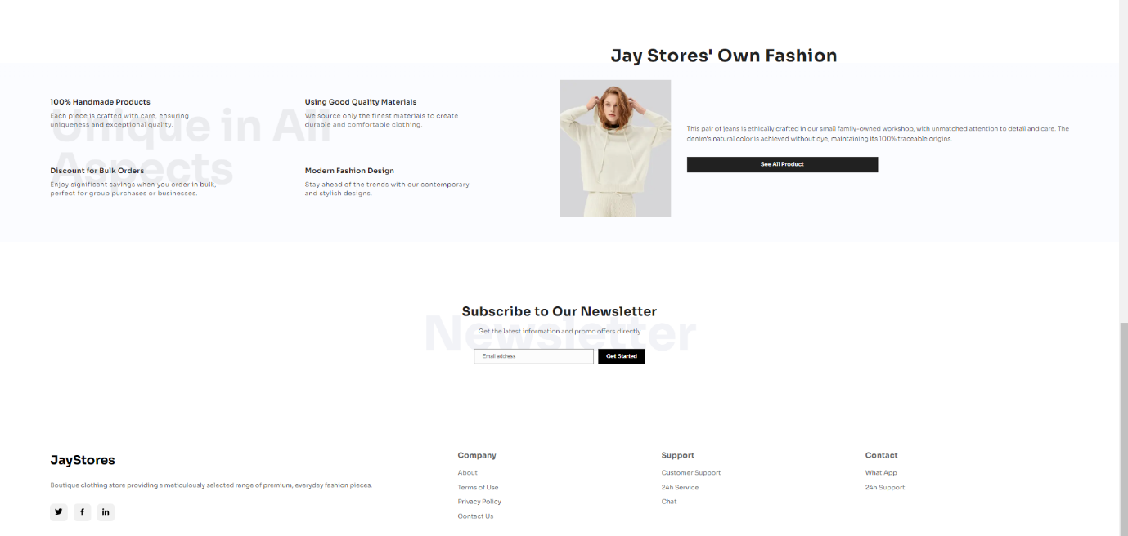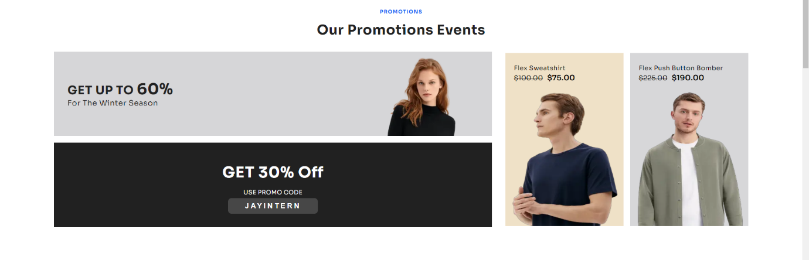

**To run the project:**

1. Open Visual Studio Code and open the project Folder through the application.

2. npm install

3. npm run dev

4. go to the command terminal and right click the url link