**JobJunction**

**Internncraft Month 2 - Project 3**

A comprehensive job application portal developed using the MERN stack, designed to streamline the job application process.

**Features Include:**

* User Authentication and Authorization
* Advanced Job Search and Filtering
* Job Saving and Tracking
* Profile Management
* Admin Dashboard
* Job Posting Capabilities
* Application Tracking System
* Messaging and Notifications
* Responsive Design

1.**Tools Used**: This project is a full stack e-commerce website built with:

* Frontend: React.js, Redux
* Backend: Node.js, Express.js
* Database: MongoDB
* Styling: Tailwind CSS, Material UI, Mantine UI

2. **Challenges Faced**:

* Implementing and managing global state with Redux to ensure data consistency across different components and views.
* Implementing real-time messaging and notifications to keep users updated on job application statuses and other important events.
* Coordinating styles and components from Tailwind CSS, Material UI, and Mantine UI to create a cohesive and visually appealing user interface.
* Setting up secure user authentication and authorization mechanisms, including handling token management and role-based access control.

**Screenshots:**

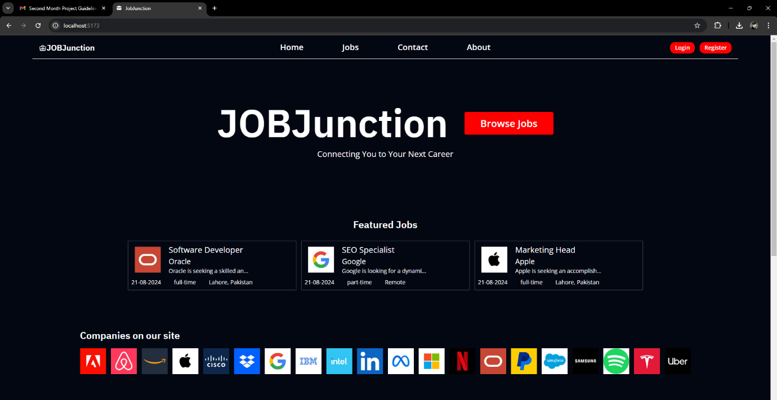**Home Page:**

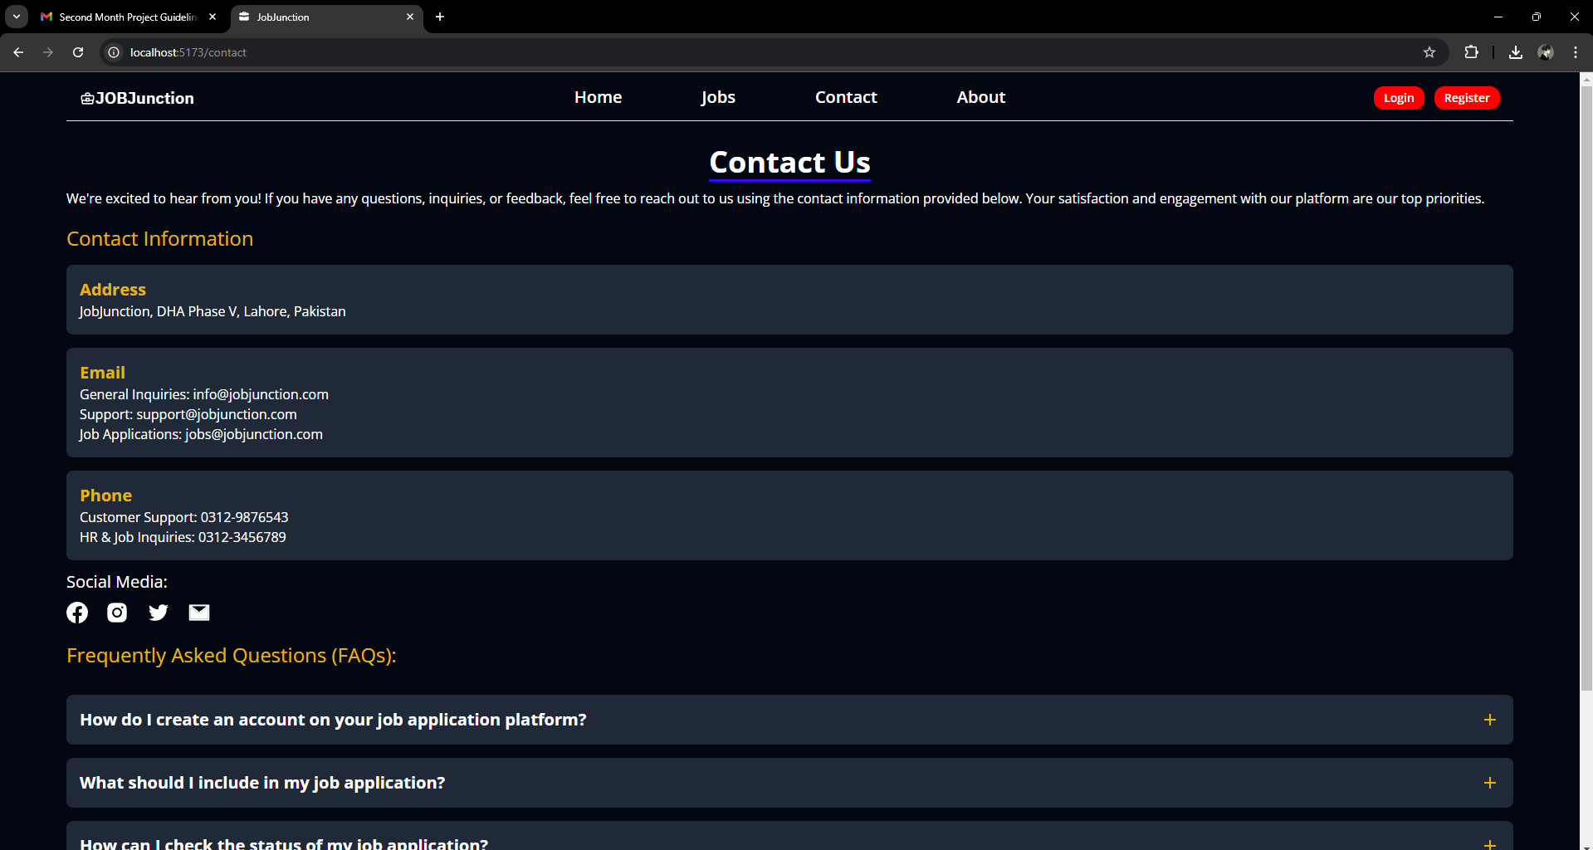**Contact Us Page:**

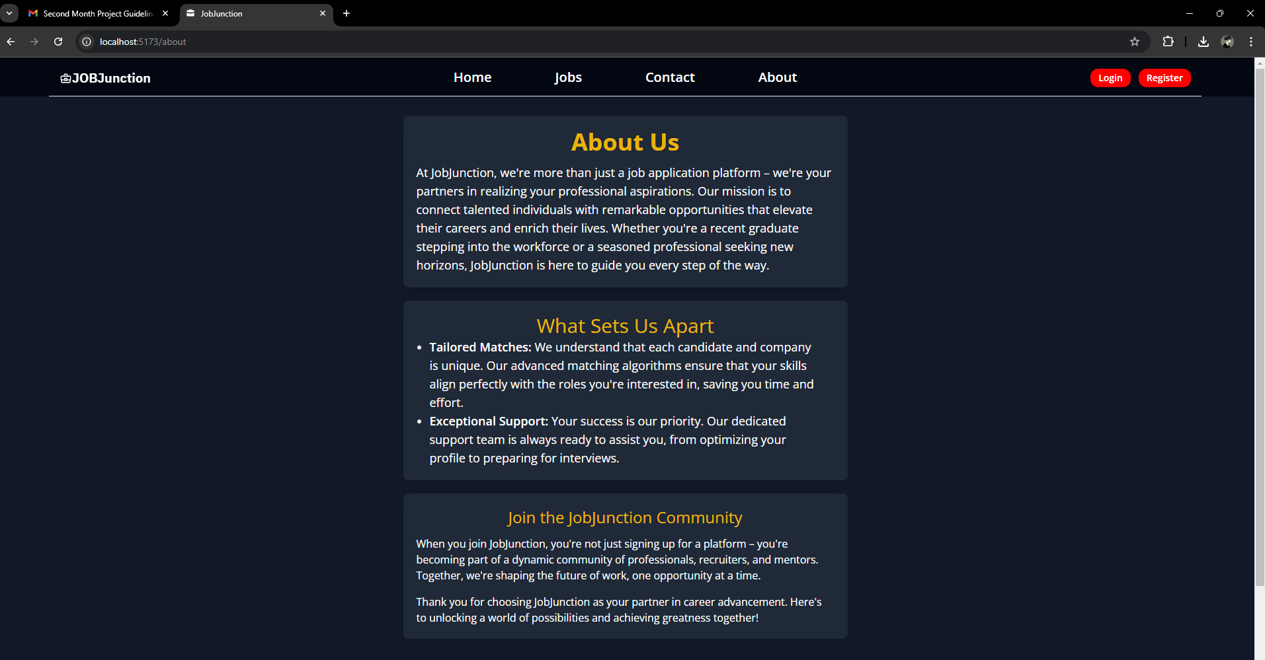**Why Choose Us Page:**

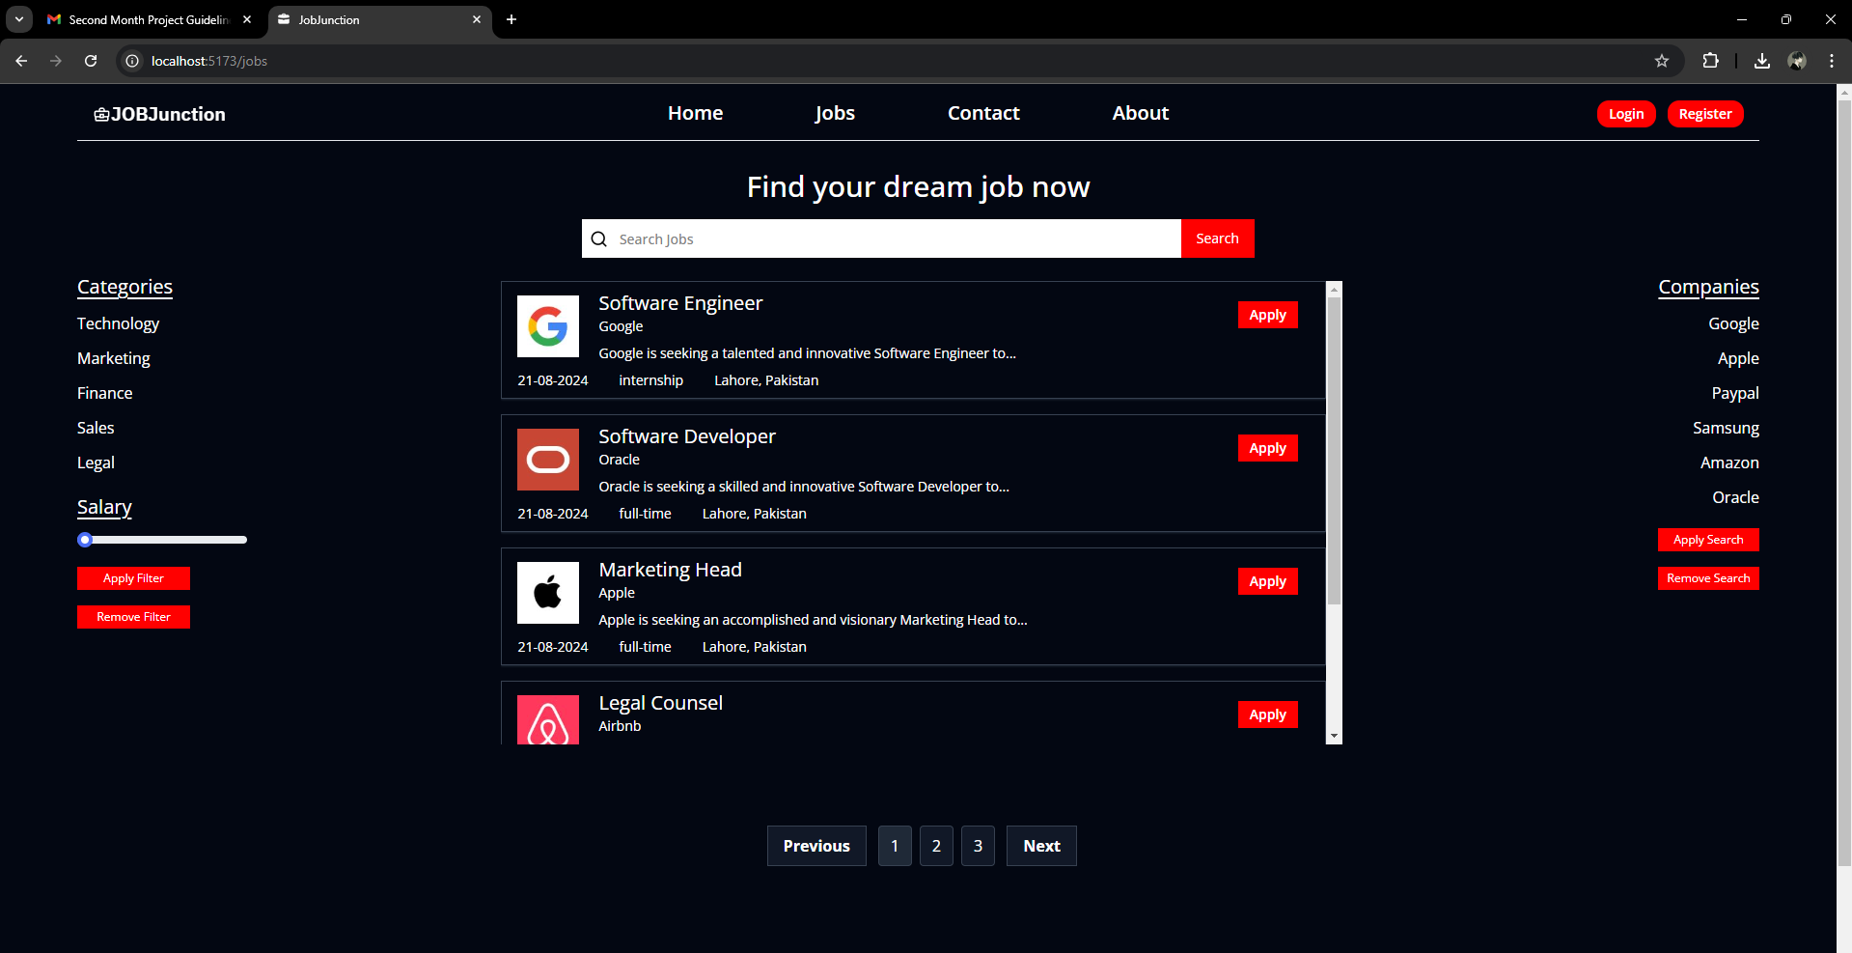**Services/Hiring Vacancy Page:**

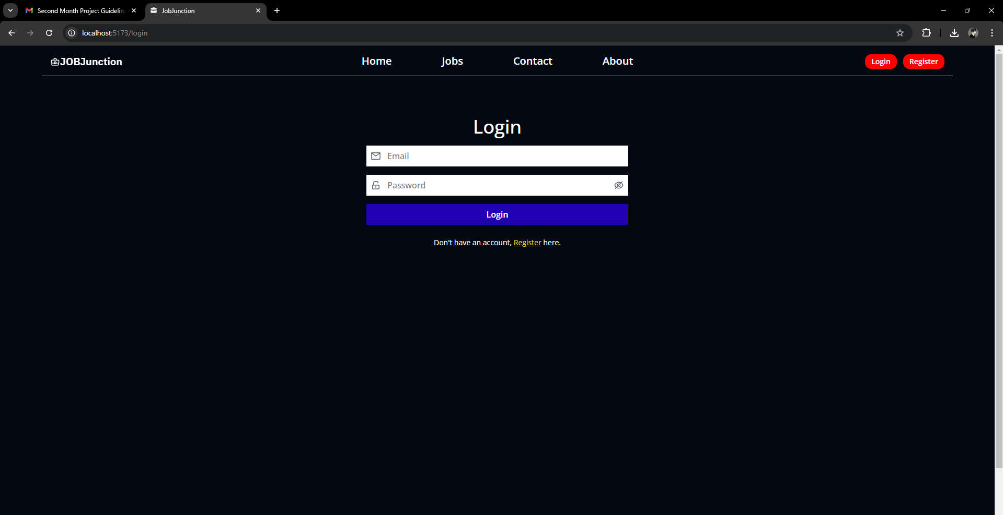**Login/Logout Page:**

**To run the project:**

1. Open Visual Studio Code and open the project Folder through the application.

2. cd server -> npm install

3. cd .. -> cd client -> npm install -> npm run dev

4. go to the command terminal and right click the url link