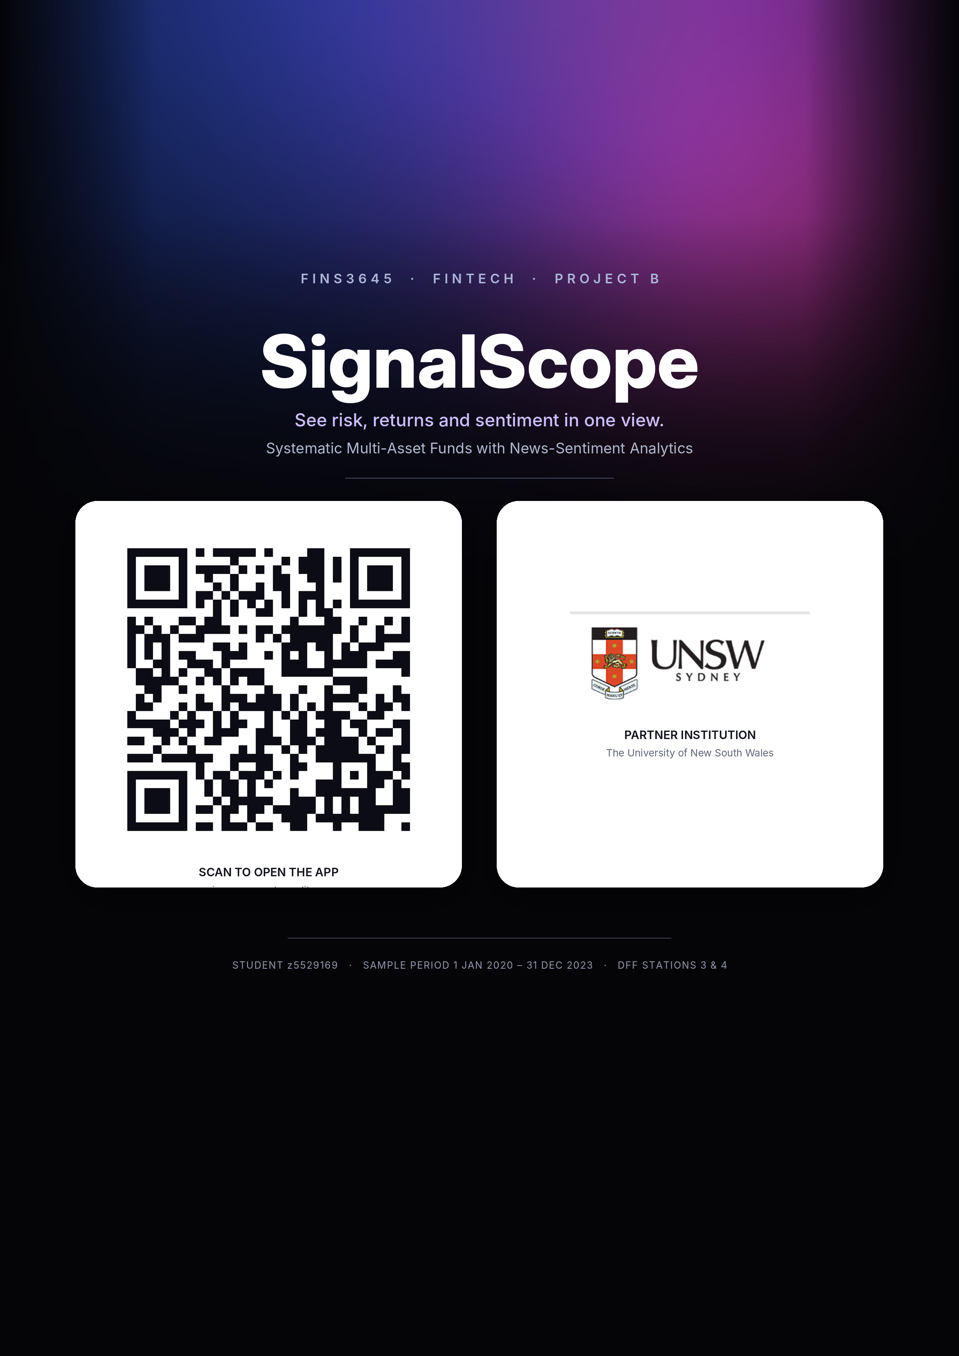

SIGNALSCOPE
See risk, returns and sentiment in one view.
Systematic Multi-Asset Funds with News-Sentiment Analytics
FINS3645 FinTech: Project B, DFF Stations 3 and 4 | Lecturer: Alexander Dickerson | Student ID: z5529169
Sample period: 1 January 2020 – 31 December 2023

Executive summary
SignalScope converts the verified Part A data foundation into a research-grade fund-comparison product. It offers ten systematic funds across equity, cryptocurrency and combined universes, a standalone sector sentiment index built from the supplied headline panel, a reliability-gated fusion of sentiment into one equity fund, and a seven-page Streamlit application. Every fund result is live out of sample from 31 December 2020, with monthly rebalancing, past-only estimation windows, native calendar treatment for equity (252 days) and cryptocurrency (365 days), and a ten-basis-point turnover cost applied throughout.
No single fund dominates every objective. Combined Risk Parity is the preferred balanced result in this sample, carrying the highest Sharpe ratio among the combined funds (0.85) without the full drawdown of the equal-weight alternative. Combined Minimum Variance gives the shallowest drawdown at the cost of return. Crypto Minimum Variance produces the highest Sharpe ratio of any fund (1.01), but a maximum drawdown of –72.99 per cent means a high Sharpe ratio should not be read as low risk. The finance-augmented sentiment tilt lifts the equity minimum-variance fund's annualised return from 5.57 to 6.09 per cent and its Sharpe ratio from 0.49 to 0.53; the effect is real but modest, and the augmented model's improvement over standard VADER on an independent 1,000-headline human-labelled holdout (macro-F1 of 0.576 versus 0.557, reviewer agreement κ = 0.980) is evidence of better sentiment classification, not proof of return predictability. A separately labelled Movie-to-Market Lab compares Spider-Man: No Way Home and Barbie descriptively; it does not enter the ten funds, the sentiment validation, or the portfolio backtest.

1. From data foundation to product
SignalScope answers a specific problem in retail investment dashboards: performance, risk, holdings and news are usually shown on separate screens, letting a user anchor on the most visible return figure without seeing how a fund was built or how reliable the evidence behind it is. Each asset-family and method pair is treated as one investable fund, and every fund carries the same fact sheet (growth of one dollar, annualised return and volatility, Sharpe ratio, maximum drawdown and current holdings), so that comparison happens on consistent terms rather than on one headline number.
The product line runs directly from Project A. Part A (Signal & Story) verified the 50-equity, 10-sector, 10-cryptocurrency and 149,683-headline course dataset, resolved its calendar and duplication issues, and stopped deliberately before scoring sentiment, optimising portfolios or building an app, since those steps belong instead to DFF Stations 3 and 4. Project B reuses that cleaning contract rather than building a second, inconsistent pipeline: adjusted closing prices remain the basis for returns, returns are computed within each ticker before any calendar merge, cryptocurrency keeps its native seven-day calendar until aligned to equity dates for the combined funds, and headline alignment and deduplication rules carry forward unchanged. Part A established what the data could support, and Project B converts that verified foundation into funds, a sentiment index, a fusion extension and a working product.

The Movie-to-Market Lab: an explicit ideation chain
The Movie-to-Market Lab followed the same discipline. The initial interest, formed while exploring the Part A headline panel, was broader: whether film-marketing activity showed up in the financial-news and price data at all. Disney (DIS) was the natural starting point, since it is the only company in the official 50-equity universe with direct studio and franchise exposure. Four verified Disney campaign events were tested in Part A (the Mulan Premier Access announcement, the Black Widow trailer, the Avatar: The Way of Water final trailer, and the Elemental trailer), and the result was informative, though not in the direction expected: raw DIS returns around the events were inconsistent in sign and magnitude across the eleven-trading-day windows, and the financial-news panel captured almost none of the verified campaign dates. The strongest finding was therefore about the limits of the news-coverage data, not about a marketing-return pattern, and DIS's own return in any case mixes streaming, parks, licensing and studio news, so a single diversified company could not isolate a movie effect.
That result narrowed the question rather than closing it. An earlier, broader idea, a wide tree of franchises and correlations, was abandoned because it could not be evidenced from the supplied data and risked implying a causal marketing effect the project cannot support. The narrower comparison of Spider-Man: No Way Home against Barbie was retained instead: the two films offer a sharper contrast in marketing style and audience and richer public campaign-date evidence, but their principal listed exposures, namely Sony Group Corporation (SONY), Mattel, Inc. (MAT) and Warner Bros. Discovery, Inc. (WBD), are not members of the supplied 50-equity universe, so the comparison could not be folded into the official course dataset without breaking the eligibility rule Part A had already set. The decision was accordingly to build the Movie-to-Market Lab as a separately labelled, descriptive research extension covering six predeclared campaign or release events, company-level event windows against SPY, and current IMDb aggregate ratings excluded from any trading claim, sitting outside the ten investable funds, the sentiment validation and the portfolio backtest. A data-governance boundary that bends when it is inconvenient is not a boundary at all.

2. Data foundation and continuity
The fund and sentiment models run on the official FINS3645 bundle verified in Part A: 50 US equities across ten sectors, ten cryptocurrencies and 149,683 supplied headlines, bounded at 31 December 2023 (Dickerson 2026a). After exact deduplication on ticker, date and title, 146,836 unique headlines remain, of which 146,830 map to an equity trading day inside the sample; six end-of-sample headlines fall outside it and are excluded rather than used to extend the analytical boundary.
Every supplied field is retained, but not every field is a model input. Adjusted close drives returns, date and ticker set timing and asset boundaries, and sector groups the equity universe and the sentiment index. Open, high, low and close support internal consistency checks, volume is a liquidity diagnostic, publisher completeness feeds the reliability gate described in Section 5, and URLs are retained only for provenance. Appendix A records this role for every field and lists the underlying artefacts. Forcing metadata fields such as publisher or URL into the covariance optimiser would add complexity without a defensible economic channel, so they remain diagnostic and disclosure fields rather than model inputs, a distinction that matters more than the raw count of fields used.

3. Fund construction methodology

Return and calendar construction
For asset i on its native trading date t, the daily simple return is computed from the adjusted closing price:
r(i,t) = P_{adj}(i,t) / P_{adj}(i,t−1) − 1.
where Padj(i,t) is the dividend- and split-adjusted closing price of asset i on date t, and Padj(i,t−1) is the same asset's adjusted closing price on its immediately preceding native trading day. Returns are computed within each ticker before any calendar merge. Equity returns stay on the roughly 252-day equity trading calendar, cryptocurrency-only funds keep the full 365-day calendar, and for the combined funds already-computed cryptocurrency returns are left-aligned onto the observed equity dates, so the combined product only ever decides on days when every component can be traded.

Estimation timing, net return and the Sharpe ratio
The first live date is 31 December 2020. On every live date t, the applied target weight vector w(t) is estimated using observations strictly before t, and rebalancing occurs on the first observed trading day of each month; equity and combined funds use the prior 252 observations, and cryptocurrency-only funds use the prior 365 observations. The live net return and its associated Sharpe ratio are:
r_{net}(p,t) = w(t)′r(t) − c·Σ_{i} |w(i,t) − w(i,t_{prev})|;
SR(p) = μ_{net,p} / σ_{net,p}.
where w(t)′r(t) is the portfolio's gross return, w(i,tprev) is asset i's weight at the previous rebalance, and c = 0.001 represents ten basis points of cost per unit of one-way turnover; μnet,p and σnet,p are fund p's annualised net return and annualised net volatility. The risk-free rate is assumed to be zero throughout, consistent with the course brief.

Portfolio methods
Three allocation rules are compared inside each universe, plus one sentiment-tilted variant, extending, now out of sample, the in-sample equal-weight, minimum-variance and tangency portfolios built in the Week 4 workshop (Dickerson 2026b). Equal Weight sets w(i,t) = 1/n for the n eligible assets and serves as a transparent diversification baseline rather than an optimiser. Minimum Variance and inverse-volatility Risk Parity are:
Σ_{shrink} = 0.9S + 0.1·diag(S);
w_{MV}(t) = argmin_{w} w′Σ_{shrink} w s.t. Σw = 1, 0 ≤ w ≤ cap;
w_{RP}(i,t) = (1/σ_{i,t}) / Σ_{j}(1/σ_{j,t}).
where S is the sample covariance of daily returns over the estimation window and diag(S) is its diagonal; Σshrink is the 90/10 shrinkage blend used in the minimum-variance optimisation, following the portfolio-variance framework of Markowitz (1952) while reducing the numerical instability a short, high-dimensional window otherwise produces; and σi,t is asset i's realised volatility over the same window. Inverse-volatility weighting produces equal volatility contribution only under a diagonal covariance assumption, so the report describes it accordingly rather than claiming to solve the full-covariance equal-risk-contribution problem of Maillard, Roncalli and Teiletche (2010). All funds are long-only, with position caps of 20 per cent (equity), 30 per cent (cryptocurrency) and 15 per cent (combined) to limit corner solutions; every target vector is checked to sum to one within numerical tolerance.

4. Out-of-sample fund results
Table 1 reports all ten funds after the ten-basis-point turnover deduction, and the growth-of-one-dollar, drawdown, weight and risk-return exhibits required by the brief are collected in Appendix C. No fund dominates on every metric, which is itself the main product-level finding: an app that surfaces only the top return figure would mislead a risk-aware investor, and echoes evidence that no simple rule reliably beats equal weight out of sample (DeMiguel, Garlappi & Uppal 2009; Dickerson 2026c).
Fund | Ann. return | Ann. volatility | Sharpe | Max drawdown
Combined Equal Weight | 15.10% | 21.24% | 0.77 | −28.75%
Combined Minimum Variance | 5.99% | 12.62% | 0.52 | −15.77%
Combined Risk Parity | 13.29% | 16.17% | 0.85 | −20.47%
Crypto Equal Weight | 33.63% | 80.39% | 0.77 | −81.60%
Crypto Minimum Variance | 60.04% | 72.94% | 1.01 | −72.99%
Crypto Risk Parity | 37.94% | 78.63% | 0.81 | −80.22%
Equity Equal Weight | 12.87% | 16.16% | 0.83 | −20.32%
Equity Minimum Variance | 5.57% | 12.64% | 0.49 | −15.59%
Equity Risk Parity | 10.15% | 14.92% | 0.72 | −18.93%
Equity Reliability-Gated Sentiment | 6.09% | 12.64% | 0.53 | −15.62%
Table 1. Out-of-sample performance after 10 bps turnover costs, 31 December 2020 – 31 December/29 December 2023 (crypto/equity calendars respectively). Source: official FINS3645 course data; calculations reported in results/tables/performance_metrics.csv.

Combined Risk Parity: preferred, not universal
Combined Risk Parity is the preferred balanced result among the combined funds. Its 13.29 per cent annualised return sits below Combined Equal Weight's 15.10 per cent, but its volatility is 5.07 percentage points lower and its maximum drawdown is 8.28 percentage points smaller, which lifts its Sharpe ratio to 0.85, the highest of the three combined funds. Combined Minimum Variance gives the shallowest drawdown of the group (−15.77 per cent) at the cost of a lower 5.99 per cent return and a 0.52 Sharpe ratio. This is a trade-off, not a ranking: a risk-averse investor may still prefer minimum variance, and the result is drawn from one three-year live window that spans an unusually compressed monetary, pandemic and crypto cycle. Combined Risk Parity is therefore presented as the preferred flagship inside this sample, not as a universal winner.
All ten supplied cryptocurrencies are used in every crypto and combined fund, but the unconstrained Combined Minimum Variance solution allocates them only 2.65 per cent at the most recent rebalance because their volatility dominates the covariance estimate. A separate sensitivity test, not an offered fund, floors the combined minimum-variance crypto sleeve at 10, 20 and 30 per cent (Figure C7). A 30 per cent floor raises the Sharpe ratio to 0.63 and the return to 12.60 per cent, but the drawdown worsens to −32.88 per cent and the result still falls short of Combined Risk Parity's 0.85 Sharpe. The test supports offering crypto exposure as an explicit, separately chosen sleeve; it does not justify replacing the constrained fund with a forced-crypto variant.

Crypto return is not the same as safety
Crypto Minimum Variance records the highest Sharpe ratio of any fund (1.01) and the highest annualised return (60.04 per cent), but its maximum drawdown is −72.99 per cent, larger than the loss most investors would tolerate from a core holding, and worse still for the equal-weight and risk-parity crypto funds, which lose more than 80 per cent at their worst point. A high Sharpe ratio measures return per unit of volatility, not downside safety: the fund that tops the Sharpe table is also the one an investor could least afford to hold without an explicit loss-tolerance conversation. Minimum-variance concentration also drives turnover: Equity Minimum Variance accumulates 10.19 units of one-way turnover against 1.88 for Equity Risk Parity and one initial unit for Equal Weight, so costs narrow the apparent benefit of a frequently re-optimised covariance estimate.

5. Sector sentiment index and fusion
Unstructured news text has been linked to pessimism and subsequent returns (Tetlock 2007) and to broader investor sentiment (Baker & Wurgler 2007), literature that motivates this station of the course (Dickerson 2026c). Sentiment is scored with VADER, a rule-based method that preserves punctuation, capitalisation, intensity and negation rather than a heavily stripped token set (Hutto & Gilbert 2014). Every headline is scored twice: with standard VADER, and with a transparent finance-augmented lexicon of 18 additional finance-relevant terms. Headlines are mapped to the next observed equity trading day and then lagged a further trading day before use, so a Monday-mapped headline is first usable for Tuesday's decision, which closes the look-ahead channel the course brief specifically warns against.
Ticker-day sentiment is the mean finance-augmented compound score across a ticker's headlines that day, and sector sentiment is the equal-weight mean of its constituent tickers' scores (Figure C4). A ticker-day without headlines is scored neutral zero in the main index. Because this choice is material (a mean absolute difference of 0.036 against an observed-only alternative, against average sector-day coverage of 75.5 per cent of tickers), the observed-only series is reported as a sensitivity check rather than hidden. Standard VADER scores 48.85 per cent of usable headlines as exactly neutral, whilst the finance lexicon lowers this to 46.83 per cent and changes the sign of 2.48 per cent of headlines: a targeted adjustment, not a rewriting of the whole distribution, and a direct response to the coverage gap the Week 8 workshop diagnoses in the packaged VADER dictionary (Dickerson 2026d). General-purpose sentiment dictionaries are well documented to misclassify ordinary accounting language such as liability, cost, debt and tax as negative (Loughran & McDonald 2011), so each of the eighteen retained finance terms (Appendix A) was reasoned about individually rather than accepted from an automated rating pass.
The sentiment classifier was evaluated against an independent 1,000-headline holdout labelled by two human reviewers under a predeclared protocol (positive, neutral or negative financial tone; disagreements adjudicated). Reviewer agreement was very high, at a Cohen's kappa of 0.980. Standard VADER achieved 59.3 per cent accuracy and a macro-F1 of 0.557; the finance-augmented model improved this modestly, to 61.1 per cent accuracy and a macro-F1 of 0.576. Full class-level results and the confusion matrix are reported in Appendix B. This is a genuine, internally validated classification improvement. It is not evidence that headline sentiment predicts subsequent returns, and it is not a claim of production-grade or externally validated commercial accuracy.
The fusion extension applies this signal to one fund only. On each rebalance date, the lagged ticker sentiment is standardised, clipped to [−2, 2] and combined with a bounded reliability score that increases with headline count and publisher completeness. The resulting multiplier is:
m(i,t) = exp[0.35 · z(i,t−1) · q(i,t−1)].
where z(i,t−1) is the clipped, standardised sentiment score, q(i,t−1) ∈ [0,1] is the reliability score, and 0.35 sets the tilt strength; adjusted holdings are renormalised and capped at 20 per cent so the signal can nudge an existing minimum-variance weight but cannot become an unconstrained stock selector. The standardise-tilt-renormalise structure follows the minimum-variance sentiment tilt Dickerson (2026c) presents in Week 10; here the lecture's linear, hand-set tilt is replaced with a bounded exponential multiplier and a reliability gate, so a low-coverage signal is damped automatically rather than tuned by hand.
Fund | Ann. return | Ann. volatility | Sharpe | Max drawdown | Turnover
Equity Minimum Variance | 5.57% | 12.64% | 0.49 | −15.59% | 10.19
Equity Reliability-Gated Sentiment | 6.09% | 12.64% | 0.53 | −15.62% | 11.19
Table 2. Fusion before-and-after comparison, after identical transaction-cost assumptions. Source: results/tables/fusion_comparison.csv.
The tilt lifts annualised return by 0.52 percentage points and the Sharpe ratio by 0.04, leaves volatility almost unchanged, and worsens drawdown only marginally while adding roughly one unit of turnover (Figure C5). The overlay is genuine but small, and its return series is closely correlated with the untilted base fund. The result is consistent with reading sentiment as a modest information overlay on an existing risk model, not as a standalone signal, and it reflects one historical backtest rather than proof that news tone caused later returns.

6. The SignalScope application and the Movie-to-Market Lab
The deployed product mirrors the analytical model rather than decorating it. scripts/run_part_b.py performs all data loading, portfolio estimation, sentiment scoring and figure generation offline and writes the results to results/, and the Streamlit app reads only those precomputed artefacts. It does not import NLTK, recompute a backtest, or contact the data source during a visitor session, which matches the lightweight deployment the course brief requires. The app presents seven pages, namely Overview, Compare Funds, Fund Fact Sheet, Holdings & Allocation, News Sentiment, Movie-to-Market Lab and Methodology & Limitations, each mapped to a specific verified artefact rather than an illustrative placeholder.
At scale, SignalScope sits alongside products with far greater data licensing and infrastructure, namely Morningstar Direct, Koyfin and RavenPack (Morningstar, Inc. 2026; Koyfin 2026; RavenPack 2026), and it does not compete on scale. Its comparative position, assessed in full in Appendix B, is a transparent coursework product that shows its construction logic and limitations inside one interface, rather than a polished dashboard that keeps those choices out of view.
The Movie-to-Market Lab, titled Movie-to-Market Lab: Spider-Man versus Barbie inside the app, is presented on its own page, explicitly separated from the ten funds and the finance-sentiment validation. It compares Spider-Man: No Way Home and Barbie across six predeclared campaign and release events, reporting event-day and eleven-trading-day market-adjusted returns against SPY, alongside IMDb aggregate ratings that are labelled as current aggregates rather than dated reviews and are excluded from any trading claim (IMDb 2026). Event-day results are mixed in direction (for example, Spider-Man's official trailer produced a positive market-adjusted return while Barbie's main trailer produced a negative one, Appendix C) over only six events, far too few to support a return-prediction claim. The Lab is described throughout as a descriptive association around predeclared events, never as evidence of marketing causation or investable alpha.

7. Critical reflection and recommendations
The strongest part of SignalScope is timing discipline: returns are formed before any calendar merge, estimation windows close strictly before their live application date, and the sentiment signal is lagged beyond the trading day it is aligned to. Combined with a genuine, if modest, out-of-sample sentiment-classification improvement on an independent holdout, this gives the product a defensible evidence base rather than an attractive dashboard built on an in-sample fit.
The main limitation is the sample. Three live years, spanning a compressed monetary, pandemic and crypto cycle, are not enough to conclude that any one allocation method or the sentiment tilt will remain preferred outside this window, and the shrunk covariance estimate can still overreact to a short estimation history. Furthermore, the finance lexicon, while transparent and validated on an independent holdout, remains a single research iteration, and ten basis points is a common sensitivity rather than a calibrated execution cost for assets with very different liquidity profiles.
Three recommendations follow, each addressing a specific evidenced gap rather than a generic caution.
Recommendation 1: establish a paper-live governance gate before any live offering. Extend the dataset monthly and run at least twelve months of frozen-parameter paper performance, logging predicted weights, realised returns, turnover, cap usage and drawdown without altering the historical record, and escalating any month in which a weight fails to sum to one or a cap is breached. This converts the current retrospective demonstration into a monitored process, which is the largest gap identified in the Appendix B feasibility assessment.
Recommendation 2: extend the human-labelled validation. The 1,000-headline holdout is a genuine improvement over an unvalidated lexicon, but a macro-F1 gain of 0.02 is moderate rather than decisive. A larger, sector-stratified labelled sample, drawn under the same two-reviewer protocol and retaining only lexicon terms the labelled evidence supports, would materially strengthen the classification claim before any commercial use.
Recommendation 3: replace the uniform cost assumption with an executable cost policy. Separate equity and cryptocurrency cost schedules informed by spread, volatility and order-size evidence, an explicit rule on whether the combined fund can trade cryptocurrency over equity-market weekends, and a gross-versus-net view in the client fact sheet would prevent an attractive theoretical weight vector from becoming operationally misleading. None of these three recommendations asks for a different result. Each asks instead for more evidence before the current, genuinely encouraging results are treated as investment-ready.

8. Conclusion
SignalScope completes DFF Stations 3 and 4 with a reproducible, walk-forward fund engine, an independently validated sentiment index, a measured fusion extension and a working application. Combined Risk Parity is the most balanced result among the combined funds in this three-year sample, Combined Minimum Variance gives the clearest downside control, and the cryptocurrency funds remain high-risk despite their stronger headline returns. The sentiment extension improves the base equity fund modestly and is backed by independent classification validation, but does not establish return predictability. Positioned honestly, SignalScope is a portfolio-learning and research tool, not a production investment product: Appendix B scores it 63/100, feasible as a prototype, with commercial evidence, execution and regulatory readiness remaining as gating criteria before any live offering.

References
Baker, M & Wurgler, J 2007, ‘Investor sentiment in the stock market’, Journal of Economic Perspectives, vol. 21, no. 2, pp. 129–152.
DeMiguel, V, Garlappi, L & Uppal, R 2009, ‘Optimal versus naive diversification: how inefficient is the 1/N portfolio strategy?’, Review of Financial Studies, vol. 22, no. 5, pp. 1915–1953.
Dickerson, A 2026a, FINS3645 FinTech Project 2026: systematic multi-asset funds with news-sentiment analytics, course project brief, UNSW Business School, UNSW Sydney.
Dickerson, A 2026b, FINS3645 Week 4 workshop: the data factory floor and in-sample portfolios, workshop brief, UNSW Business School, UNSW Sydney.
Dickerson, A 2026c, FINS3645 Week 10: agentic coding and revision, lecture slides, UNSW Business School, UNSW Sydney.
Dickerson, A 2026d, FINS3645 Week 8 workshop: VADER, lexicon coverage and the finance-term extension, workshop brief, UNSW Business School, UNSW Sydney.
Hutto, CJ & Gilbert, E 2014, ‘VADER: a parsimonious rule-based model for sentiment analysis of social media text’, Proceedings of the International AAAI Conference on Web and Social Media, vol. 8, no. 1, pp. 216–225, doi:10.1609/icwsm.v8i1.14550.
IMDb 2026, IMDb non-commercial datasets, IMDb.com, viewed 14 August 2026, <https://developer.imdb.com/non-commercial-datasets/>.
Koyfin 2026, Koyfin market data and analytics platform, Koyfin Inc., viewed 14 August 2026, <https://www.koyfin.com/>.
Loughran, T & McDonald, B 2011, ‘When is a liability not a liability? Textual analysis, dictionaries, and 10-Ks’, The Journal of Finance, vol. 66, no. 1, pp. 35–65.
Maillard, S, Roncalli, T & Teiletche, J 2010, ‘The properties of equally weighted risk contribution portfolios’, Journal of Portfolio Management, vol. 36, no. 4, pp. 60–70.
Markowitz, H 1952, ‘Portfolio selection’, The Journal of Finance, vol. 7, no. 1, pp. 77–91, doi:10.1111/j.1540-6261.1952.tb01525.x.
Morningstar, Inc. 2026, Morningstar Direct, viewed 14 August 2026, <https://www.morningstar.com/products/direct>.
RavenPack 2026, RavenPack news analytics platform, viewed 14 August 2026, <https://www.ravenpack.com/>.
Sharpe, WF 1966, ‘Mutual fund performance’, The Journal of Business, vol. 39, no. 1, pp. 119–138.
Tetlock, PC 2007, ‘Giving content to investor sentiment: the role of media in the stock market’, The Journal of Finance, vol. 62, no. 3, pp. 1139–1168.
Yahoo Finance 2026, Historical price data for SONY, MAT, WBD, DIS and SPY, viewed 14 August 2026, <https://finance.yahoo.com/>.

Appendix A. Data governance and artefact index
This appendix records the role of every supplied field and maps each claim in the report to its underlying artefact, so that any number above can be traced back to a reproducible file.

A.1 Role of every supplied field
Dataset | Field(s) | Role | Justification
equity_prices | ticker | Model input / identifier | Defines assets, holdings and per-asset calculations
equity_prices | date | Model timing | Controls ordering, estimation windows and no-look-ahead application
equity_prices | adjClose | Model input | Creates total-return-adjusted daily returns
equity_prices | open, high, low, close | Diagnostic | Checks OHLC consistency and documents intraday price range
equity_prices | volume | Diagnostic / disclosure | Measures trading activity; not treated as a return predictor
equity_prices | sector | Model grouping | Defines equity universe reporting and sector sentiment aggregation
crypto_prices | ticker, date, adjClose | Model input | Creates seven-day crypto returns before calendar alignment
crypto_prices | open, high, low, close, volume | Diagnostic | Checks source integrity and describes market activity
news_headlines | title | Sentiment model input | Scored without stripping punctuation, casing or negation
news_headlines | date | Model timing | Mapped to the next equity trading day, then lagged one further trading day
news_headlines | ticker, sector | Model grouping | Builds ticker-day signals and equal-weight sector indices
news_headlines | publisher | Reliability diagnostic | Measures publisher completeness for the fusion reliability gate
news_headlines | url | Provenance / audit | Retained for traceability; never used as a predictor
Table A1. Field-use register. Source: results/tables/asset_data_use_register.csv.

A.2 Artefact index
Evidence | File
Required fund returns | results/data/fund_returns.csv
Required fund weights | results/data/fund_weights.csv
Required sector sentiment index | results/data/sector_sentiment_index.csv
Required performance metrics | results/tables/performance_metrics.csv
Fusion comparison | results/tables/fusion_comparison.csv
Sentiment validation (holdout) | results/tables/finance_validation_metrics.csv
Sentiment confusion matrix | results/tables/finance_confusion_matrix.csv
Every supplied field's role | results/tables/asset_data_use_register.csv
Model assumptions | results/tables/model_specification.csv
Crypto-sleeve floor sensitivity | results/tables/crypto_sleeve_floor_sensitivity.csv
Movie event summary | results/tables/movie_lab_event_summary.csv
Movie exposure register | results/tables/movie_lab_exposure_register.csv
IMDb aggregate ratings | results/tables/movie_lab_imdb_aggregate_ratings.csv
Product feasibility scorecard | results/tables/product_feasibility_scorecard.csv
Table A2. Artefact index mapping report claims to reproducible files.

Appendix B. Finance-validation detail and competitor positioning

B.1 Human-labelled holdout: overall result
The holdout comprises 1,000 headlines labelled independently by two reviewers under the frozen annotation protocol in docs/annotation_protocol.md (positive, neutral or negative financial tone; disagreements adjudicated to a final label). Reviewer agreement was very high, with a Cohen's kappa of 0.980, which is evidence that the labelling task itself is well specified rather than evidence about the classifier.
Model | Accuracy | Macro-F1 | n
Standard VADER | 59.3% | 0.557 | 1,000
Finance-augmented VADER | 61.1% | 0.576 | 1,000
Table B1. Overall holdout accuracy and macro-F1. Source: results/tables/finance_validation_metrics.csv.

B.2 Per-class precision, recall and F1
Class (n) | Standard: P / R / F1 | Finance-augmented: P / R / F1
Positive (348) | 0.506 / 0.523 / 0.514 | 0.525 / 0.572 / 0.547
Neutral (531) | 0.676 / 0.665 / 0.670 | 0.701 / 0.663 / 0.682
Negative (121) | 0.492 / 0.479 / 0.485 | 0.504 / 0.496 / 0.500
Table B2. Class-level results on the 1,000-headline holdout. Source: results/tables/finance_validation_metrics.csv.

B.3 Confusion matrix: finance-augmented VADER
Actual \ Predicted | Positive | Neutral | Negative
Positive | 199 | 120 | 29
Neutral | 149 | 352 | 30
Negative | 31 | 30 | 60
Table B3. Confusion matrix for the finance-augmented model on the 1,000-headline holdout. Source: results/tables/finance_confusion_matrix.csv.
Reading this matrix: the finance-augmented model correctly recovers 611 of 1,000 labels overall (accuracy 61.1%). The largest single error is Neutral headlines predicted Positive (149 cases) and Positive headlines predicted Neutral (120 cases), which is consistent with financial headlines often carrying muted or ambiguous immediate tone. The model is not commercially validated by this result; it is internally validated as a modest improvement on standard VADER for this specific labelling task.

B.4 Week 10 benchmark comparison
The Week 10 ‘Agentic Coding and Revision’ lecture presents a twelve-fund worked reference implementation, including a maximum-Sharpe tangency portfolio in every universe (Sharpe 1966), under an expanding-window specification with its own constraints and cost treatment (Dickerson 2026c). The comparison below is diagnostic, not a leaderboard: a different specification producing a different Sharpe ratio is not proof of a better fund. Tangency is not offered in SignalScope for the estimation-risk reasons given in Section 3; the lecture's own equal-weight funds are, in its words, hard to improve on, which matches the wider 1/N robustness literature (DeMiguel, Garlappi & Uppal 2009).
Method and universe | Week 10 Sharpe | This project | Difference | Reading
Equity Equal Weight | 0.85 | 0.83 | −0.02 | Approximately reproduces the lecture baseline
Crypto Equal Weight | 0.99 | 0.77 | −0.22 | Does not beat the lecture; specification-sensitive
Combined Equal Weight | 0.76 | 0.77 | +0.01 | Essentially tied
Equity Minimum Variance | 0.62 | 0.49 | −0.13 | Lower risk did not compensate for lower return here
Crypto Minimum Variance | 1.17 | 1.01 | −0.16 | Best Sharpe in this project; −72.99% drawdown prevents a safety claim
Combined Minimum Variance | 0.61 | 0.52 | −0.09 | Lower than lecture, but a shallower −15.77% drawdown
Equity Risk Parity | 0.75 | 0.72 | −0.03 | Close to lecture
Crypto Risk Parity | 1.02 | 0.81 | −0.21 | Does not beat lecture; remains very high drawdown
Combined Risk Parity | 0.78 | 0.85 | +0.07 | The only clear positive Sharpe gap; still sample-dependent
Tangency, all universes | 0.72 / 0.73 / 0.40 | Not offered | n/a | A transparent scope difference, not a hidden failure
Table B4. Sharpe-ratio comparison against the Week 10 reference implementation. Source: Dickerson (2026c); reproduced in student_review/WEEK10_AND_MARKET_FEASIBILITY_PLAN.md.
Combined Risk Parity is the only fund with a clear positive Sharpe gap against its lecture counterpart (0.85 versus 0.78); it also beats the project's own Combined Equal Weight benchmark on Sharpe (0.85 versus 0.77) and drawdown (−20.47% versus −28.75%), while giving up 1.80 percentage points of annualised return. That multi-metric trade-off, reported honestly rather than tuned to dominate every row, is the intended course answer.

B.5 Product feasibility scorecard and competitor positioning
Dimension | Weight | Score /5 | Weighted points | Gate
Technical reliability | 15% | 5 | 15.0 | Ready
Data governance | 10% | 4 | 8.0 | Ready with caveat
Portfolio model | 15% | 4 | 12.0 | Ready with caveat
Sentiment model | 10% | 3 | 6.0 | Validate further
Investor experience | 10% | 5 | 10.0 | Ready with caveat
Differentiation | 10% | 3 | 6.0 | Validate further
Commercial evidence | 10% | 1 | 2.0 | Blocker
Execution and operations | 10% | 1 | 2.0 | Blocker
Regulatory readiness | 10% | 1 | 2.0 | Blocker
Table B5. Weighted product-feasibility scorecard, total 63/100. Source: results/tables/product_feasibility_scorecard.csv.
The scorecard's three blockers, namely commercial evidence, execution/operations and regulatory readiness, all score the minimum of 1 out of 5, and each requires evidence SignalScope does not yet have (a willingness-to-pay test, a broker/custody/incident process, and licensed Australian financial-services advice respectively) rather than a coding fix. This is why the honest positioning throughout this report is a portfolio-learning and research tool, not a live investment product.
Set against comparable products, SignalScope's positioning is narrow but genuine. Morningstar Direct (Morningstar, Inc. 2026) is a professional fund-research platform with institutional data licensing and coverage SignalScope cannot replicate. Koyfin (Koyfin 2026) provides broad market dashboards, screening and charting across listed assets at a scale this project does not attempt. RavenPack (RavenPack 2026) offers enterprise-scale news analytics across a far larger and more heavily curated source base than the supplied 149,683-headline coursework panel. SignalScope's genuine point of difference is transparency at a small scale: a walk-forward ten-fund universe with visible holdings, an explicit transaction-cost treatment, disclosed sentiment-coverage limitations, an independently validated (not merely asserted) sentiment classifier, and a separately labelled research extension, all inside one interface a non-technical user can inspect. It is more transparent about its own construction and limits than a typical polished dashboard; it is not more capable, more data-rich, or commercially proven.

Appendix C. Required figures and supporting material
Figures are reproduced from results/figures/; all use official FINS3645 course data and calculations reported in the corresponding results/tables/ or results/data/ file unless captioned otherwise.
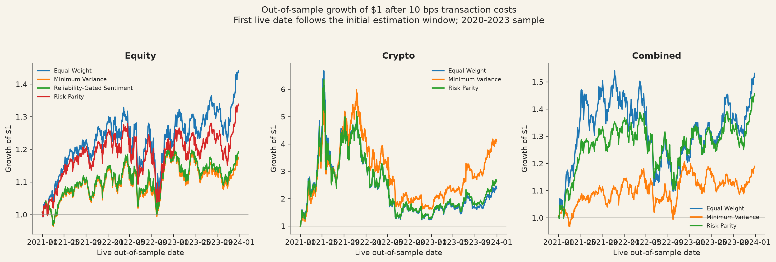
Figure C1. Out-of-sample growth of one dollar after transaction costs, by fund. Crypto-only funds use the seven-day calendar; equity and combined funds use the equity decision calendar.
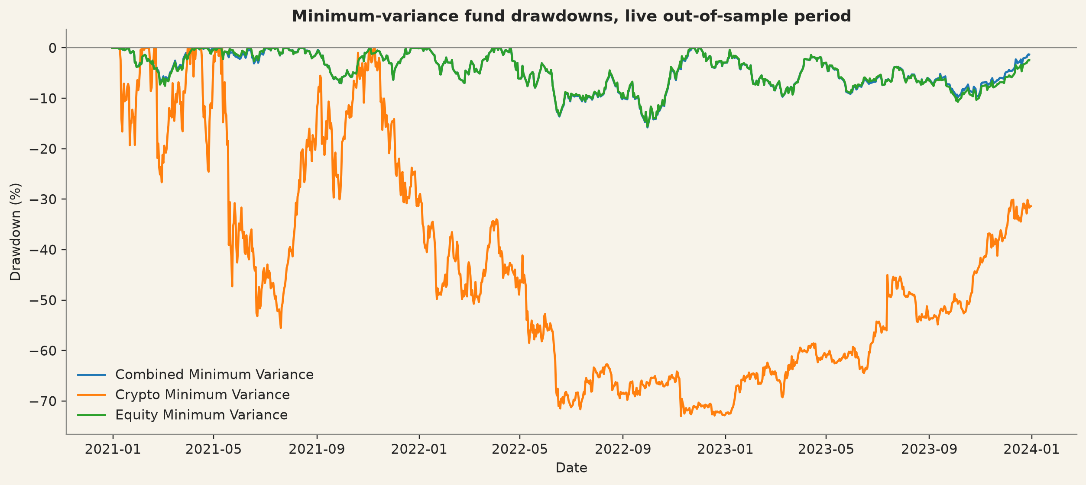
Figure C2. Live out-of-sample drawdowns for the minimum-variance funds.
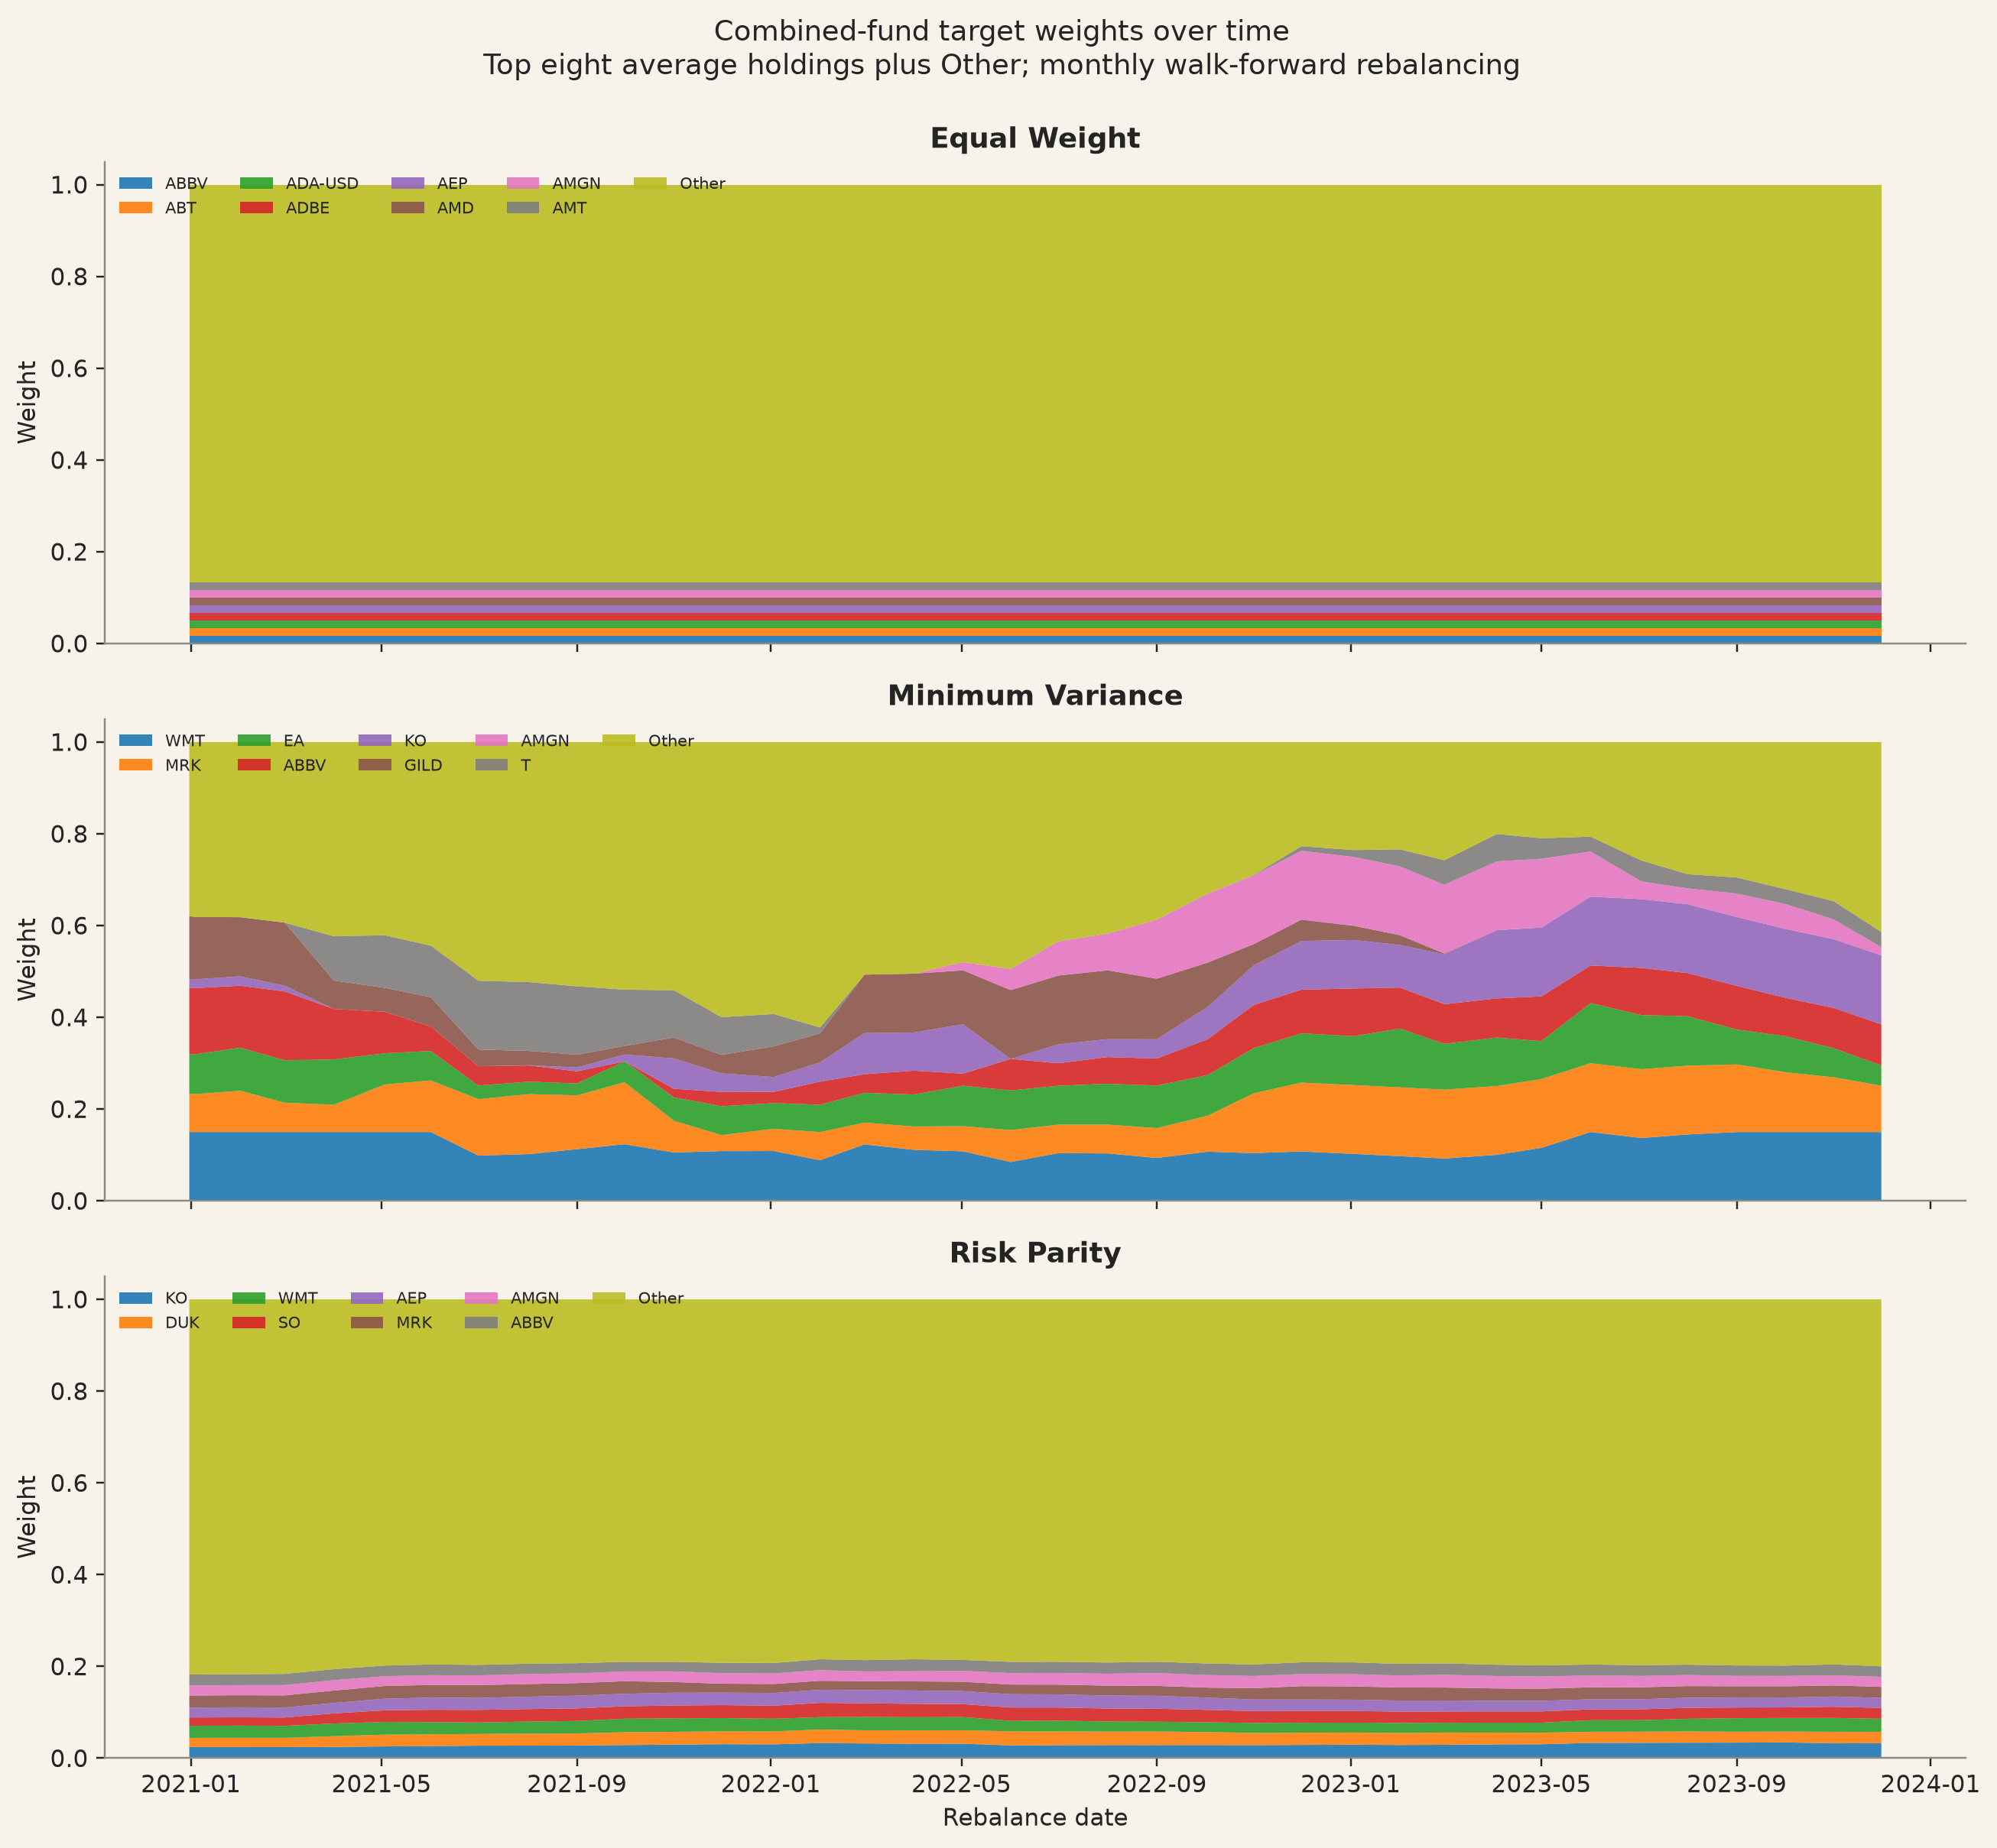
Figure C3. Monthly combined-fund target weights. The eight largest average holdings are shown separately; remaining positions are grouped as Other.
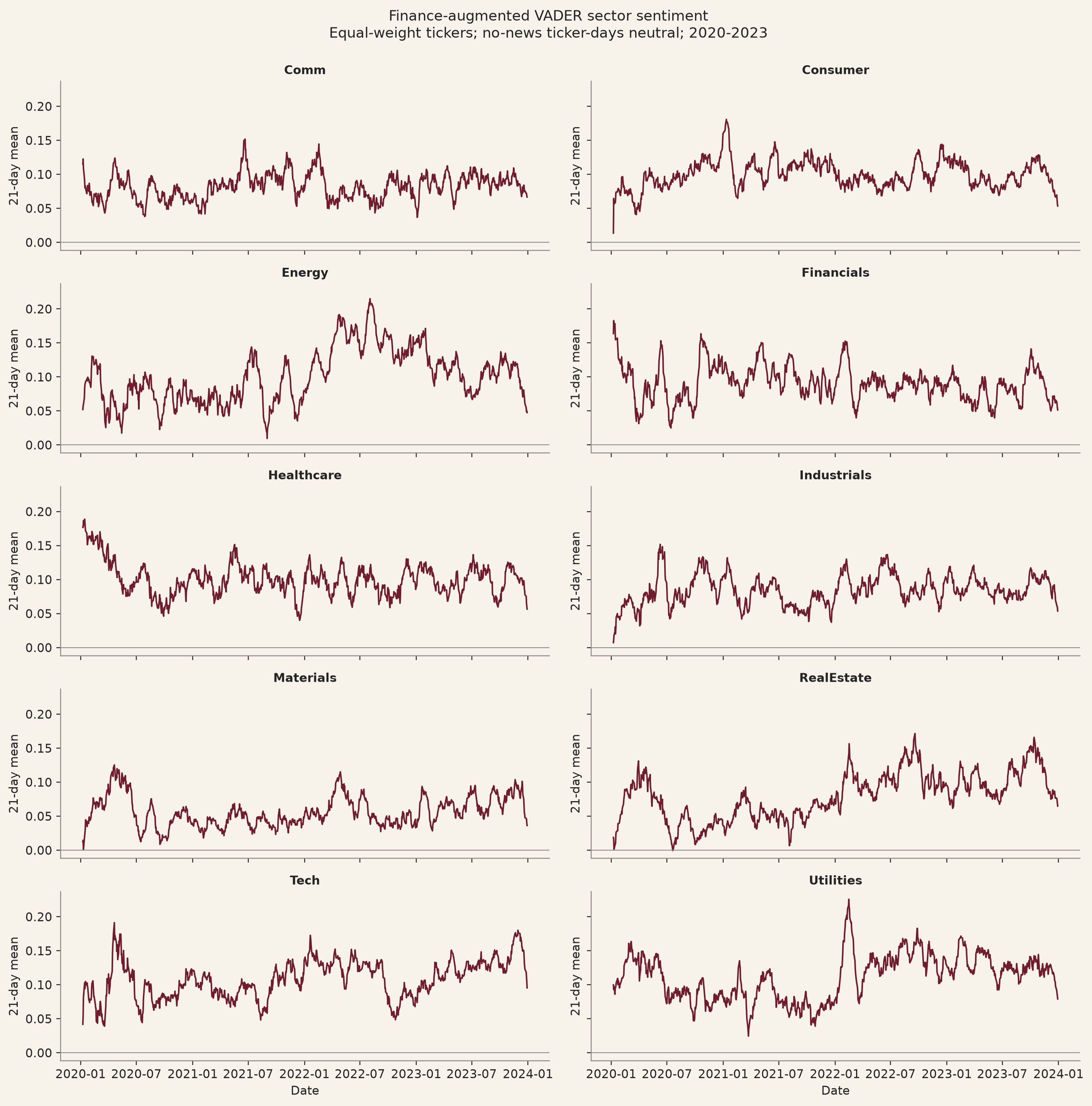
Figure C4. Finance-augmented VADER sector sentiment, equal-weighted across tickers, no-news ticker-days set to neutral; 21-trading-day mean shown for legibility.
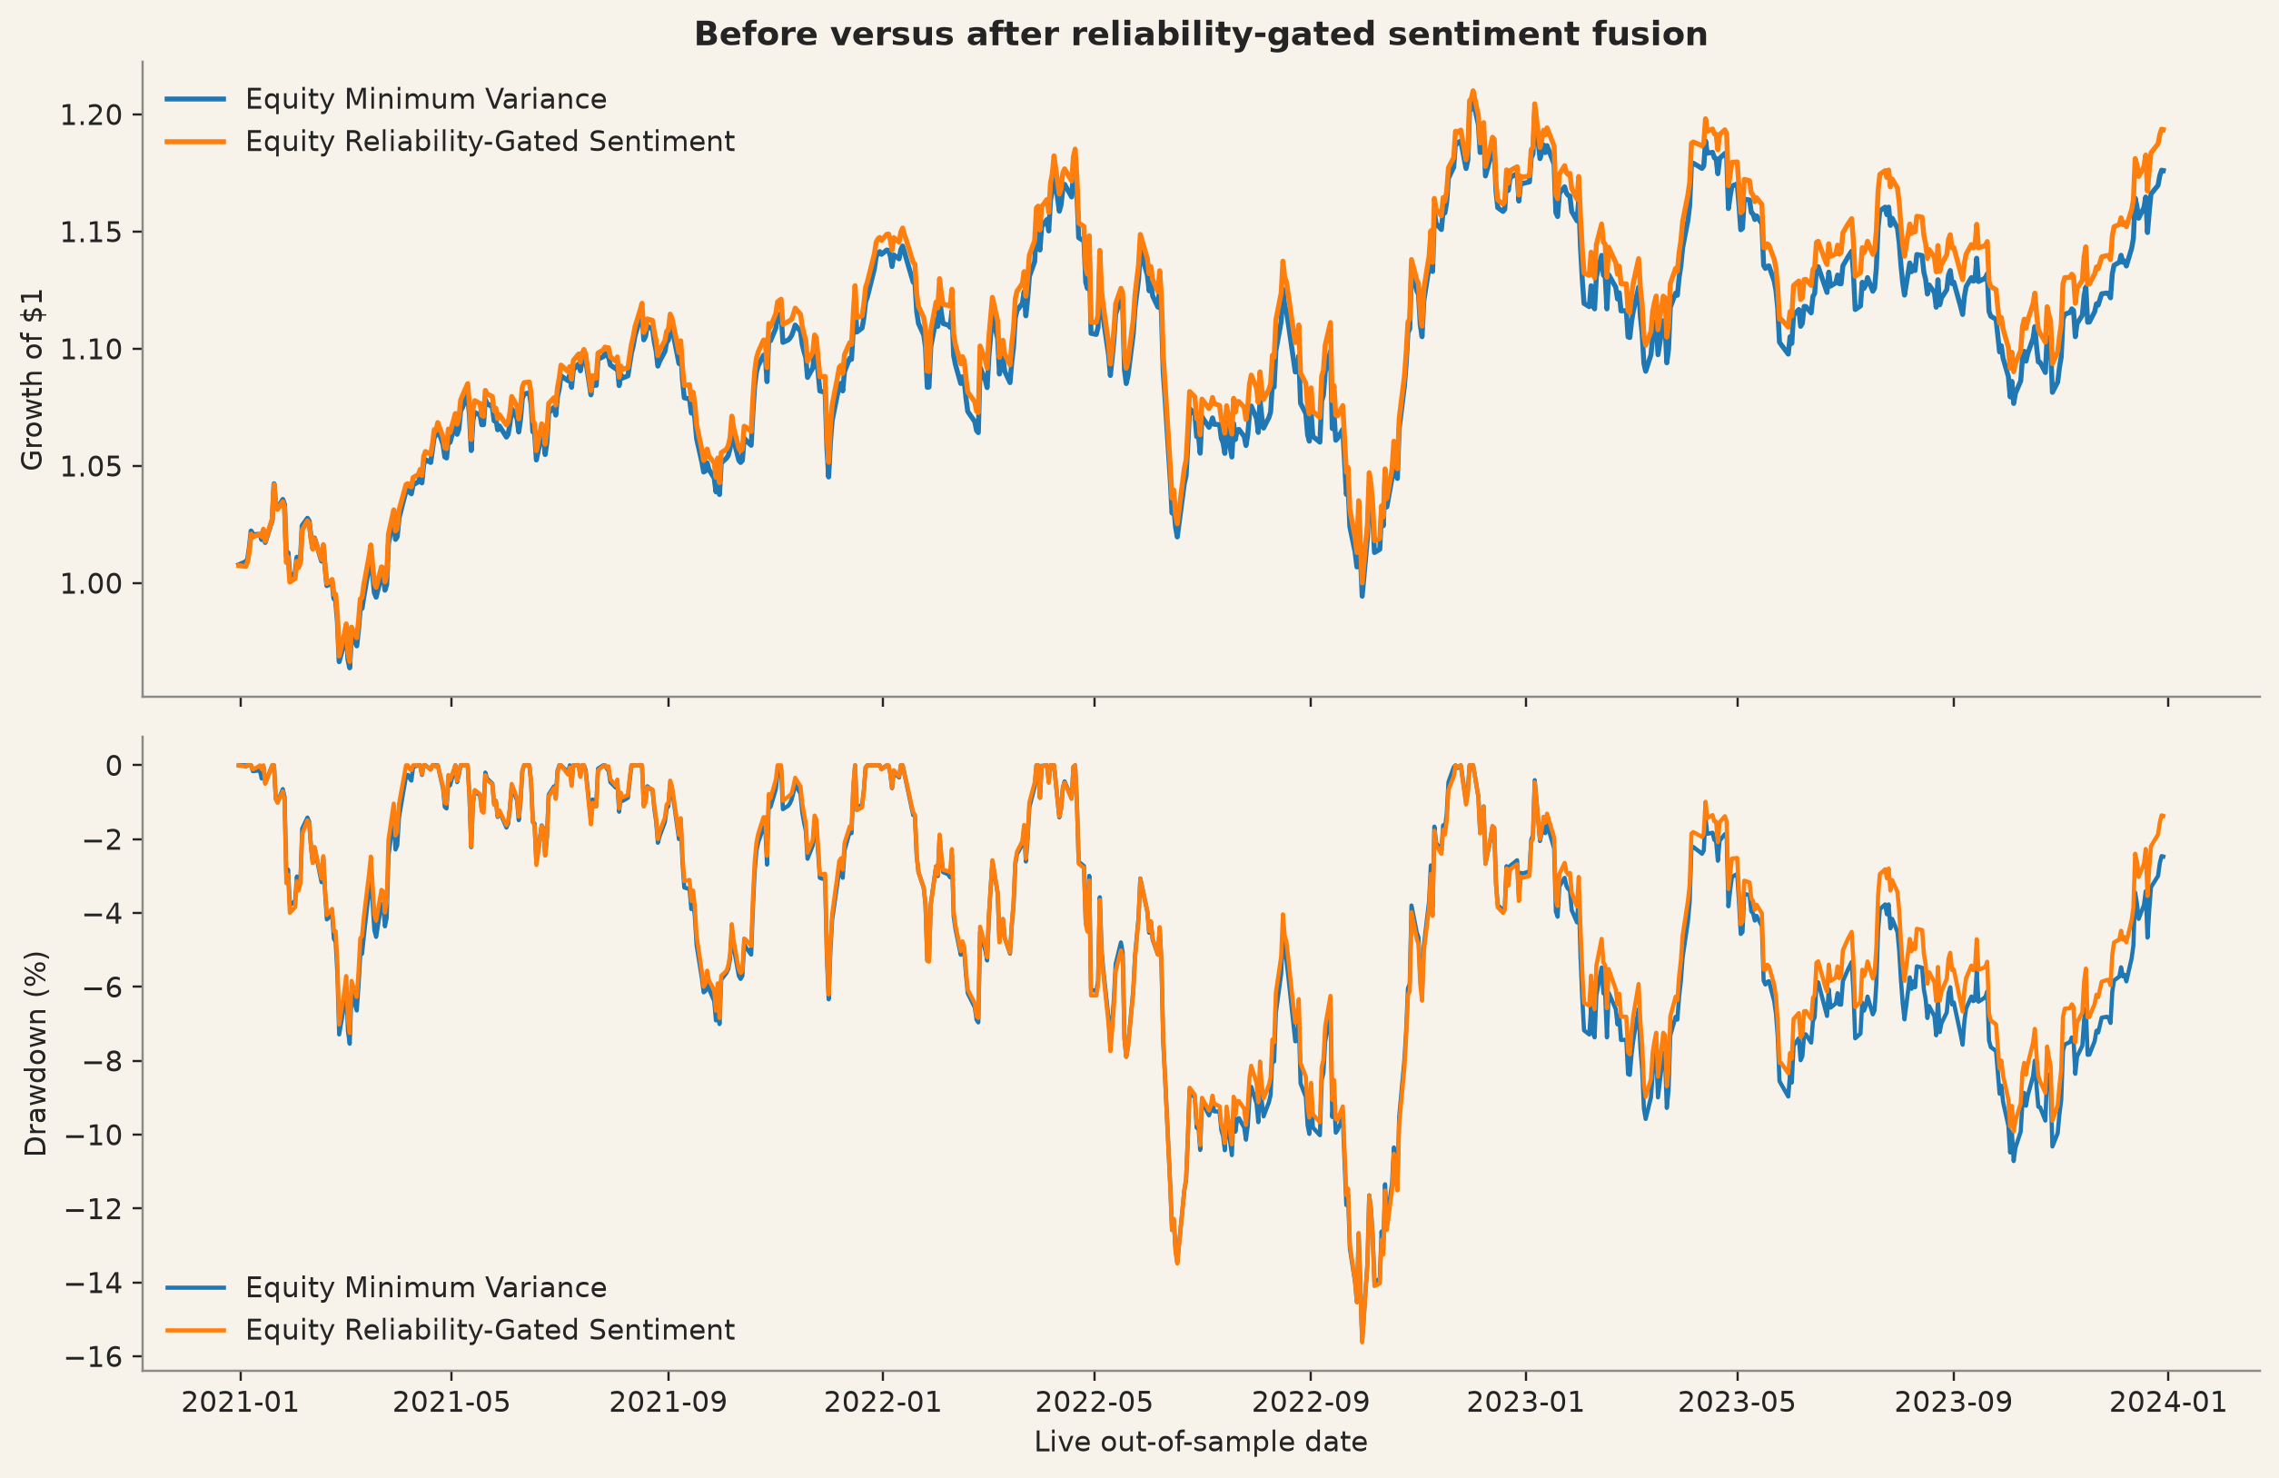
Figure C5. Growth and drawdown before and after the reliability-gated sentiment tilt.
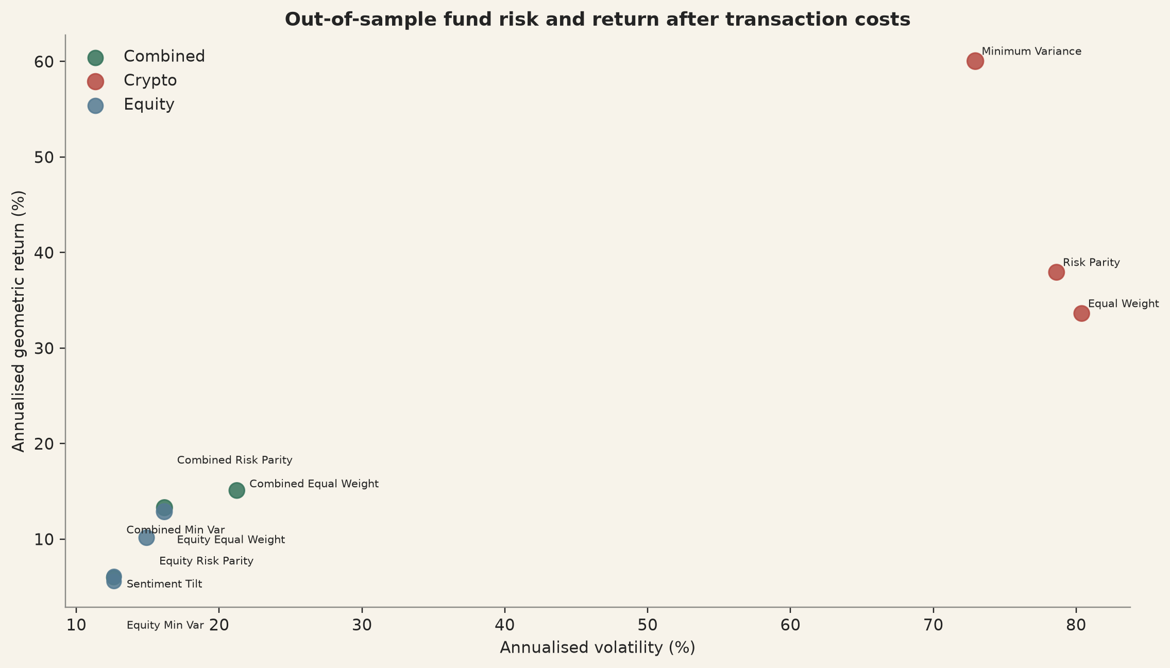
Figure C6. Annualised out-of-sample return versus annualised volatility across funds and methods after transaction costs; point size increases with the Sharpe ratio.
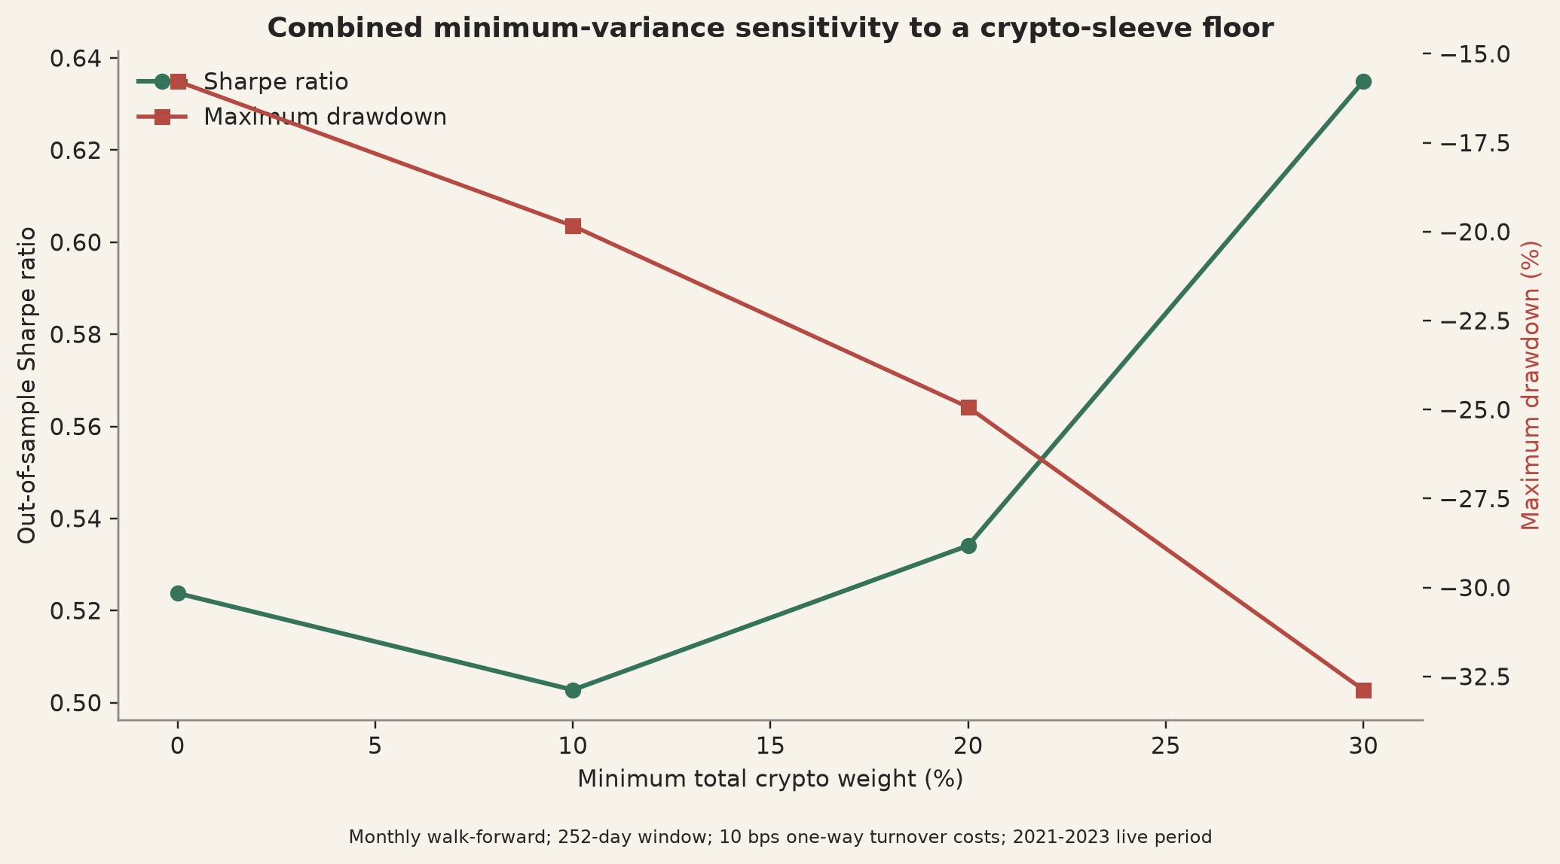
Figure C7. Combined minimum-variance sensitivity to a 0, 10, 20 or 30 per cent minimum total cryptocurrency sleeve. The constrained variants are research tests, not offered funds.

C.1 Movie-to-Market Lab: event-level results
Film / event | Event date | Ticker | Event-day mkt-adj. return | 11-day mkt-adj. return
Spider-Man: No Way Home, official teaser trailer | 23 Aug 2021 | SONY | +2.89% | +1.03%
Spider-Man: No Way Home, official trailer | 16 Nov 2021 | SONY | +1.34% | −0.74%
Spider-Man: No Way Home, US theatrical release | 17 Dec 2021 | SONY | +0.18% | +1.46%
Barbie, teaser trailer 2 | 4 Apr 2023 | MAT | +0.28% | −1.10%
Barbie, main trailer | 25 May 2023 | MAT | −3.00% | −6.97%
Barbie, US theatrical release | 21 Jul 2023 | MAT | −0.42% | −5.01%
Table C1. Event-day and eleven-trading-day market-adjusted returns (company return less SPY return over the matching window) for six predeclared events. Descriptive association only: no causal attribution to marketing. Source: results/tables/movie_lab_event_summary.csv.
Film | IMDb rating | Votes | Status
Spider-Man: No Way Home | 8.1 | 1,057,611 | Current aggregate; excluded from trading claims
Barbie | 6.8 | 701,482 | Current aggregate; excluded from trading claims
Table C2. IMDb aggregate ratings, retrieved 14 August 2026. Ratings are current aggregates, not dated historical reviews, and play no role in the fund or sentiment models. Source: results/tables/movie_lab_imdb_aggregate_ratings.csv; IMDb 2026.

Appendix D. AI use disclosure and prompt-log summary
AI tools were used throughout Project A, Project B and the final SignalScope application as coding, debugging, restructuring, drafting and technical-checking assistants, involved from early system design through to final code and documentation review. Early use explored how asset prices, financial news, portfolio construction and a possible entertainment case study could connect into one consistent analytical pipeline, and this framing helped establish that the movie-related idea was analytically interesting but risky if presented as direct evidence of investable alpha.
For Project B, AI was used to support portfolio-method implementation, sentiment-model coding, validation scripting, application restructuring and the separation of the Movie-to-Market Lab from the core fund universe. It assisted with coding the logic for equal weight, minimum variance, inverse-volatility risk parity, walk-forward rebalancing, annualisation rules, transaction costs, long-only constraints and covariance shrinkage, and with the finance-domain validation scripts, including the human-labelled holdout, reviewer-agreement checks, confusion-matrix generation, precision, recall, F1 and Cohen's kappa calculations. A major area of use was the Streamlit application: AI helped locate the active app, remove unsupported mock-brokerage content, restructure the navigation, align visible metrics with verified result files, refine the dark and light themes, and separate the Movie-to-Market Lab from the official ten-fund universe. Retained outputs were kept only where they matched the verified Project B results and the final fund design, and all retained text was reviewed before submission.

Prompt-log summary
Early framing and ideation: AI was asked to help shape the project into a coherent fintech product and test how prices, news, sentiment and a movie-related extension might fit together. The retained outcome was the decision to keep the project grounded in financial evidence and to treat the entertainment idea cautiously.
Project A to Project B transition: AI was asked to help map how the cleaned Part A dataset became the basis for portfolio modelling, sentiment work and the final app. The retained outcome was a clearer technical continuity between the two projects.
Portfolio modelling: AI was asked to help implement equal weight, minimum variance, inverse-volatility risk parity, transaction costs, walk-forward design and constraints. The retained outcome was cleaner code for the implemented methods.
Sentiment modelling and validation: AI was asked to help implement VADER, the finance-augmented lexicon, lag structure, coverage limits and the finance holdout validation scripts. The retained outcome was clearer technical documentation of what was measured, what improved modestly and what remained limited.
SignalScope app development: AI was asked to locate the active app, remove unsupported mock-brokerage content, align visible metrics with verified CSVs, restructure the navigation and improve the visual and interface design. The retained outcome was the final evidence-based SignalScope application structure and interface.
Movie-to-Market Lab: AI was asked to help frame Spider-Man and Barbie as a bounded descriptive extension rather than a direct trading claim. The retained outcome was the final non-causal, clearly separated movie-analysis module.
Final review: AI was asked to help identify remaining technical gaps, inconsistencies between code and specifications, checklist items and output requirements. The retained outcome was a clearer understanding of which items were technically complete and which still required personal confirmation.
AI tools were used throughout the project for system design, coding support, app development, validation scripting, drafting, documentation revision and technical review, but AI was not the source of truth: it could produce incorrect, overstated or poorly bounded outputs, so retained claims were checked against the datasets, generated tables, app artefacts and final report logic before being kept. The authentic prompt log underlying this summary is retained in ai/prompt_log_project_b.md and ai/prompt_log_project_b_supplement_latest.md.

