Reading

Writing

Music

Photography

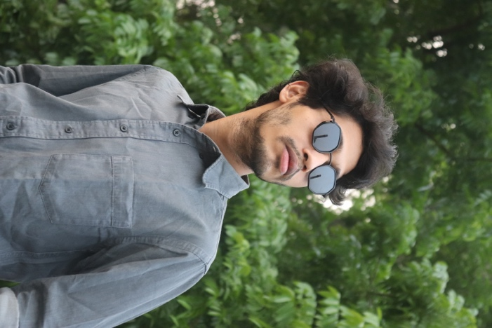

CURICULUM VITAE

**FARHAN KABIR**

**EDUCATION**

**PROFILE**

**Rajshahi University of Engineering & Technology**

**(RUET)**

**Bachelor in Computer Science & Engineering**

**2018-2022**

I am very much passionate about working in IT company.

I am flexible, conscientious, trustworthy and enthusiastic about my work. I can be relied upon to deliver everything that I set out to achieve, ensuring that it is completed to a high personal standard and within given timeframes.

**Cantonment Public School & College, Rangpur**

**(CPSCR)**

**Higher Secondary Certificate (H.S.C)**

**2015-2017**

**CONTACT**

391-mail4.png

farhankabir236@gmail.com

**SKILLS**

* **DATA STRUCTURE & ALGORITHM**
* **ANDROID & IOS APP DEVELOPMENT**
* **SQL EXPERT**
* **OPERATING SYSTEMS**

067-phone.png

+8801783165726

001-home.png

Kazla, Rajshahi

**LANGUAGES**

202-sphere.png

**https://farhankabir133.github.io/fk_site/**

* **HTML, CSS, JAVASCRIPT**
* **PYTHON**
* **SWIFT**
* **SHELL-SCRIPT**

**HOBBIES**

**PROJECTS**

032-book.png016-camera.png

* Works in a **ML project** and build a real time **object detector**
* Build a Web-Chat named **CHAT-ROOM**
* Build an **IOS Calculator** app

006-pencil.png018-music.png

Recreated by: