Reading
Writing
Music
Photography
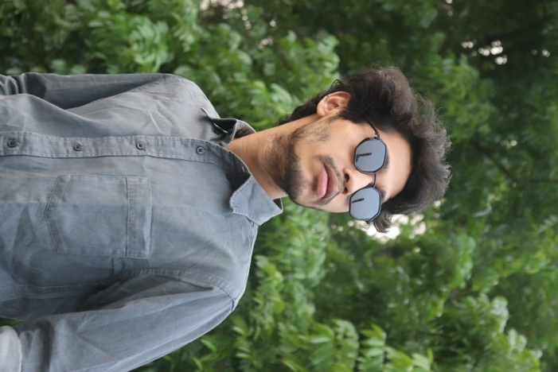

CURICULUM VITAE
FARHAN KABIR

EDUCATION
PROFILE
Rajshahi University of Engineering & Technology
(RUET)
Bachelor in Computer Science & Engineering
2018-2022

I am very much passionate about working in IT company.
I am flexible, conscientious, trustworthy and enthusiastic about my work. I can be relied upon to deliver everything that I set out to achieve, ensuring that it is completed to a high personal standard and within given timeframes.

Cantonment Public School & College, Rangpur
(CPSCR)
Higher Secondary Certificate (H.S.C)
2015-2017
CONTACT


farhankabir236@gmail.com
SKILLS
- DATA STRUCTURE & ALGORITHM
- ANDROID & IOS APP DEVELOPMENT
- SQL EXPERT
- OPERATING SYSTEMS

+8801783165726


Kazla, Rajshahi
LANGUAGES


https://farhankabir133.github.io/fkh_site
- HTML, CSS, JAVASCRIPT
- PYTHON
- SWIFT
- SHELL-SCRIPT

HOBBIES
PROJECTS


- Works in a ML project and build a real time object detector
- Build a Web-Chat named CHAT-ROOM
- Build an IOS Calculator app




Recreated by:

