CHAPTER 4
System Design

4.1 Overview of System Design
System design is the process of defining the architecture, components, interfaces, and data flows of a software system in order to satisfy the specified requirements. It serves as the technical blueprint that guides the implementation phase, ensuring that the resulting system is coherent, maintainable, and capable of fulfilling both functional and non-functional requirements. For Task Flow, the system design encompasses five primary dimensions: overall system architecture, database schema design, RESTful API design, user interface design, and security design.
The design of Task Flow follows a classical client-server architectural pattern, where a browser-based frontend communicates with a Node.js/Express.js backend over HTTP using a RESTful API. All application data is persisted in a PostgreSQL relational database managed exclusively by the backend. This separation of concerns — frontend presentation logic, backend business logic, and database persistence — promotes modularity and makes each layer independently testable and maintainable.

4.2 System Architecture
The Task Flow system is built on a three-tier architecture comprising a presentation tier (frontend), an application tier (backend), and a data tier (database). Each tier has clearly defined responsibilities and communicates with adjacent tiers through well-defined interfaces.
4.2.1 Presentation Tier (Frontend)
The presentation tier consists of six HTML pages served as static files directly by the Express.js server: index.html (login), signup.html (registration), forgot-password.html (password recovery), dashboard.html (main task view), pending.html (pending tasks), complete.html (completed tasks), and stats.html (statistics). All pages share a single CSS stylesheet (css/style.css) and a single JavaScript module (js/app.js), which contains all client-side logic including API communication, DOM manipulation, task rendering, modal management, category handling, and the toast notification system.
The frontend communicates with the backend exclusively through asynchronous HTTP requests using the Fetch API, targeting the RESTful API endpoints exposed at the /api/* path. All requests are made with credentials: include to ensure that session cookies are transmitted, enabling the server to identify the authenticated user across requests. The apiFetch() helper function in app.js abstracts the Fetch API call, handling JSON serialization of request bodies, parsing of JSON responses, and unified error propagation.
4.2.2 Application Tier (Backend)
The application tier is a Node.js application running the Express.js framework. The entry point is server/server.js, which initializes the Express application, configures middleware (CORS, JSON body parsing, URL-encoded body parsing, session management), registers the three route modules, configures the static file serving for the frontend, and starts the HTTP server on the configured port (default: 3000).
The backend is organized into three Express Router modules, each responsible for a distinct domain of the application. The authentication router (server/routes/auth.js) handles user registration, login, logout, session verification, and the two-step forgot-password flow. The tasks router (server/routes/tasks.js) handles all CRUD operations on tasks, status updates, and task retrieval. The categories router (server/routes/categories.js) handles category creation, retrieval, deletion, and default category seeding for new users. All three routers are protected by the requireAuth middleware (server/middleware/auth.js), which verifies the presence of a valid session before allowing access to any protected endpoint.
4.2.3 Data Tier (Database)
The data tier consists of a PostgreSQL database containing three tables: users, categories, and tasks. The database is accessed from the backend exclusively through the node-postgres (pg) library using a connection pool, ensuring efficient reuse of database connections. All database queries use parameterized inputs to prevent SQL injection. The database schema enforces data integrity through primary key constraints (UUID), foreign key constraints with cascading deletes, unique constraints on email addresses, and check constraints on enumerated fields (priority and status).
4.2.4 Architecture Diagram Description
The system architecture can be described as follows. A user interacts with the application through a web browser, which renders the HTML/CSS/JavaScript frontend served by the Express.js server. When a user performs an action — such as creating a task or logging in — the frontend JavaScript code issues an HTTP request to the appropriate /api/* endpoint on the same server. The Express.js server receives the request, validates the session through the auth middleware, routes the request to the appropriate handler in the relevant router module, executes the required database operation through the pg connection pool against the PostgreSQL database, and returns a JSON response to the frontend. The frontend then updates the DOM accordingly and displays a toast notification to the user.

4.3 Database Design
The database design for Task Flow follows the principles of relational database normalization to ensure data integrity, eliminate redundancy, and support efficient query execution. The schema consists of three tables organized around the core domain entities of the application: users, categories, and tasks.
4.3.1 Database Schema
The users table is the root entity of the data model. It stores the account information for each registered user and serves as the parent table for both the categories and tasks tables through foreign key relationships. The table contains the following columns: id (UUID, primary key, default gen_random_uuid()), name (TEXT, not null), email (TEXT, not null, unique), password_hash (TEXT, not null), and created_at (TIMESTAMPTZ, not null, default now()).
The categories table stores user-defined task categories with color assignments. Each category belongs to a single user, enforced by a foreign key constraint on the user_id column. The columns are: id (UUID, primary key), user_id (UUID, foreign key referencing users.id with ON DELETE CASCADE), name (TEXT, not null), color (TEXT, not null, default '#4A90E2'), and created_at (TIMESTAMPTZ, not null, default now()). The ON DELETE CASCADE constraint ensures that when a user account is deleted, all their categories are automatically removed.
The tasks table is the central entity of the application. Each task belongs to a user (via user_id) and optionally to a category (via category_id). The columns are: id (UUID, primary key), user_id (UUID, foreign key referencing users.id with ON DELETE CASCADE), category_id (UUID, nullable foreign key referencing categories.id with ON DELETE SET NULL), title (TEXT, not null), description (TEXT, not null, default empty string), due_date (DATE, nullable), priority (TEXT, not null, default 'medium', check constraint: IN ('high', 'medium', 'low')), status (TEXT, not null, default 'pending', check constraint: IN ('pending', 'complete')), created_at (TIMESTAMPTZ, not null, default now()), and completed_at (TIMESTAMPTZ, nullable). The ON DELETE SET NULL on category_id ensures that deleting a category does not delete the associated tasks but simply removes their category assignment.
Table 4.1: Database Tables and Column Descriptions
Table | Column | Data Type | Description and Constraints
users | id | UUID | Primary key, auto-generated using gen_random_uuid()
users | name | TEXT | Full name of the registered user. Cannot be null.
users | email | TEXT | Email address. Unique constraint prevents duplicate registrations.
users | password_hash | TEXT | bcrypt hash of the user password. Plain-text password never stored.
users | created_at | TIMESTAMPTZ | Account creation timestamp. Defaults to current UTC time.
categories | id | UUID | Primary key, auto-generated.
categories | user_id | UUID | Foreign key to users.id. ON DELETE CASCADE removes user categories on account deletion.
categories | name | TEXT | Category name (max 50 chars enforced at application layer).
categories | color | TEXT | Hex color string (e.g., #4A90E2). Defaults to primary blue.
tasks | id | UUID | Primary key, auto-generated.
tasks | user_id | UUID | Foreign key to users.id. ON DELETE CASCADE removes user tasks on account deletion.
tasks | category_id | UUID | Nullable foreign key to categories.id. ON DELETE SET NULL preserves tasks when category deleted.
tasks | title | TEXT | Task title. Mandatory field, validated at application layer.
tasks | description | TEXT | Optional task description. Defaults to empty string.
tasks | due_date | DATE | Optional due date. Stored as date-only value. Used for overdue detection.
tasks | priority | TEXT | Enumerated: 'high', 'medium', or 'low'. Check constraint enforced at DB level.
tasks | status | TEXT | Enumerated: 'pending' or 'complete'. Check constraint enforced at DB level.
tasks | completed_at | TIMESTAMPTZ | Null for pending tasks. Set to now() when status changes to complete; cleared on restore.

4.3.2 Database Indexes
To optimize the performance of the most frequent query patterns, the following indexes are defined in the schema: idx_categories_user_id on categories(user_id), idx_tasks_user_id on tasks(user_id), and idx_tasks_category_id on tasks(category_id). These indexes accelerate the retrieval of all categories and tasks belonging to a specific user — the most common operation in the application — as well as the lookup of tasks by category for filtering operations.

4.4 RESTful API Design
The Task Flow backend exposes a RESTful API organized under the /api base path. The API follows REST conventions: resources are identified by URI paths, HTTP methods convey the intended operation (GET for retrieval, POST for creation, PUT for full update, PATCH for partial update, DELETE for removal), and all request and response bodies use JSON encoding. Every API endpoint (except the authentication endpoints) requires an authenticated session, enforced by the requireAuth middleware.
Table 4.2: API Endpoints Summary
Method | Endpoint | Description
POST | /api/auth/signup | Register a new user account. Validates name, email uniqueness, and password length. Returns user object and creates session.
POST | /api/auth/login | Authenticate user with email and password. Returns user object and creates session on success.
POST | /api/auth/logout | Destroy the current user session and clear the session cookie.
GET | /api/auth/me | Return the currently authenticated user object from the session. Used by the frontend to verify auth state on page load.
POST | /api/auth/forgot-password/check-email | Step 1 of password reset: check whether the provided email is registered. Returns {exists: true/false}.
POST | /api/auth/forgot-password/set-password | Step 2 of password reset: update the password for the given email after re-verification. Returns success message.
GET | /api/tasks | Retrieve all tasks belonging to the authenticated user, ordered by creation date descending. Auth required.
POST | /api/tasks | Create a new task for the authenticated user. Requires title; optional fields: description, dueDate, priority, category. Auth required.
PUT | /api/tasks/:id | Update all editable fields (title, description, dueDate, priority, categoryId) of a specific task. Auth and ownership required.
PATCH | /api/tasks/:id/status | Update only the status field of a task (pending or complete). Sets or clears completed_at timestamp accordingly. Auth required.
DELETE | /api/tasks/:id | Permanently delete a specific task. Auth and ownership required. Returns 404 if task not found or not owned by user.
GET | /api/categories | Retrieve all categories for the authenticated user. Seeds default categories (Work, Office, Personal, Health) if none exist.
POST | /api/categories | Create a new category with the provided name and color. Name is validated (non-empty, max 50 chars). Auth required.
DELETE | /api/categories/:id | Delete a category. Tasks assigned to the deleted category have category_id set to null (ON DELETE SET NULL). Auth required.
GET | /api/ping | Health check endpoint. Returns {status: "ok"} with a server running confirmation message. No auth required.

All API responses follow a consistent JSON structure. Successful responses include a message field and, where applicable, a data field containing the created or updated resource (e.g., {message: "Task created!", task: {...}}). Error responses include an error field with a descriptive message (e.g., {error: "Email already registered."}). HTTP status codes are used semantically: 200 for successful retrieval and updates, 201 for successful creation, 400 for invalid input, 401 for unauthenticated requests, 404 for resource not found, 409 for conflicts (duplicate email), and 500 for server errors.

4.5 User Interface Design
The user interface of Task Flow was designed with a focus on clarity, visual hierarchy, and ease of use. The design system is built around a cohesive color palette, consistent typography, and a set of reusable UI components defined through CSS custom properties. This section presents the key interface screens of the application with annotations describing the design decisions made for each.
4.5.1 Login Page
The login page adopts a split-panel layout. The left panel features a gradient blue background (transitioning from the deep primary color #1D5FA8 to a lighter #6BAED6) with the Task Flow brand logo, application name, and a motivational tagline. Decorative circular elements create visual depth without distracting from the primary call-to-action. The right panel presents a clean, minimal login form with labeled email and password input fields, a forgot-password link, and a gradient login button. This split layout is a well-established pattern in authentication UI design that effectively separates the marketing message from the functional form.
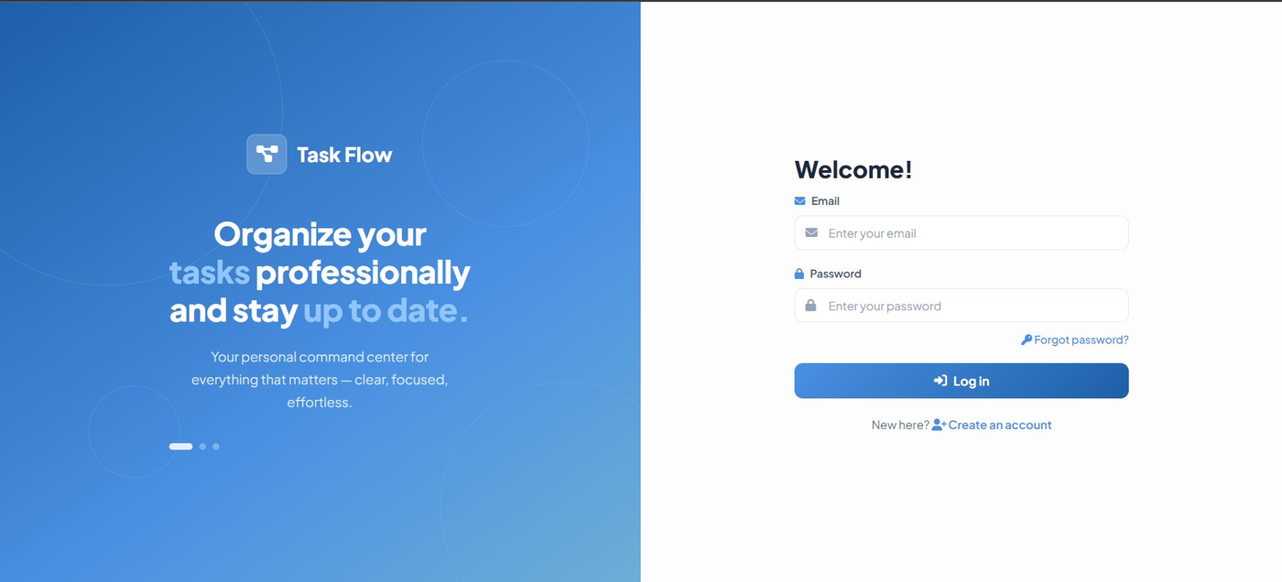
Figure 4.1: Task Flow Login Page
4.5.2 Registration Page
The signup page follows the same split-panel layout as the login page, maintaining visual consistency across the authentication flow. The left panel on the signup page features feature highlights — Smart Task Management, Progress Tracking & Stats, and Custom Categories — presented as frosted-glass cards, giving prospective users an immediate understanding of the system's value proposition. The right panel contains a four-field registration form (full name, email, password, confirm password) with a prominent Sign Up button. Input validation is performed client-side before submission, with toast notifications providing immediate error feedback for issues such as mismatched passwords or insufficient password length.
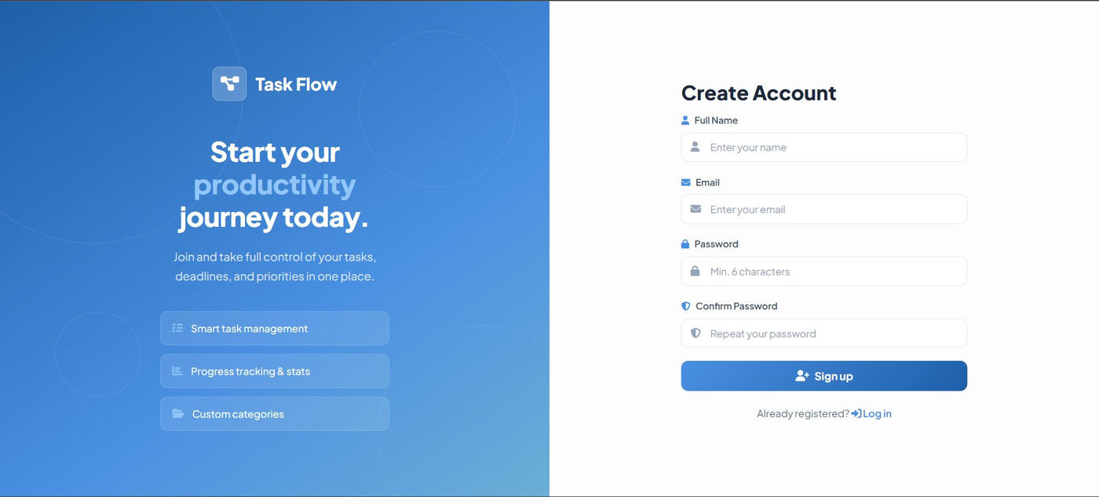
Figure 4.2: Task Flow Sign Up / Registration Page
4.5.3 Dashboard
The dashboard is the primary interface of the application and is designed around a persistent sidebar navigation on the left and a main content area on the right. The sidebar contains the application logo, navigation links (Dashboard, Stats, Tasks with expandable sub-links for Pending and Completed), a categorized task filter section, and a user profile card at the bottom displaying the user's name, email, and a logout button. The main content area features a personalized time-sensitive greeting displaying the user's name and the current date, followed by a search bar and an Add New Task button in the action bar. A filter bar beneath allows users to switch between Pending and All tasks and to filter by priority level using a dropdown. Tasks are rendered as cards in a vertical list below the filter bar.
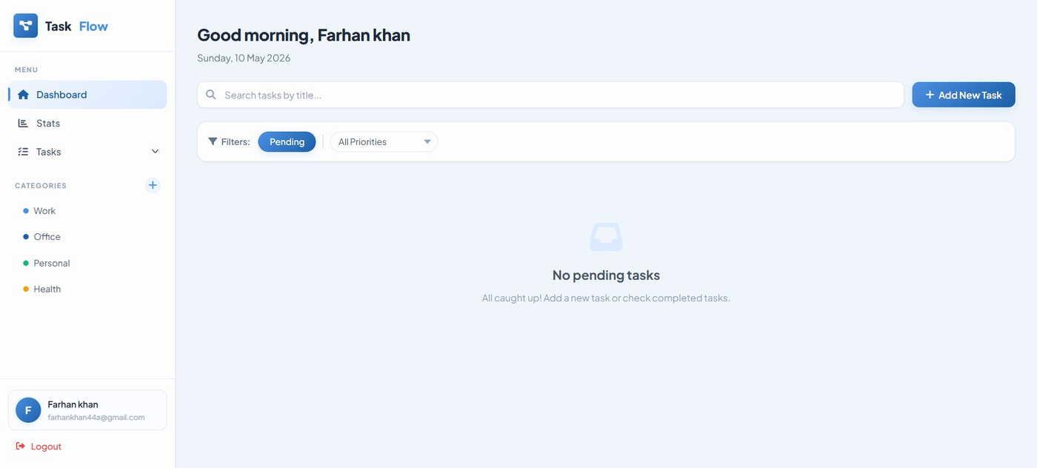
Figure 4.3: Task Flow Dashboard — Main Task View
4.5.4 Add New Task Modal
Task creation is handled through a modal dialog that overlays the current page with a blurred backdrop. The modal contains five input fields: a mandatory title field with placeholder text "What needs to be done?", an optional description textarea, a due date picker, a priority dropdown (Low/Medium/High, defaulting to Medium), and a category dropdown populated from the user's defined categories. The modal is triggered by the Add New Task button and can be dismissed by clicking the close icon, the Cancel button, pressing the Escape key, or clicking the backdrop overlay. The same modal is reused for task editing, with the title changing to "Edit Task" and all fields pre-populated with the existing task data.
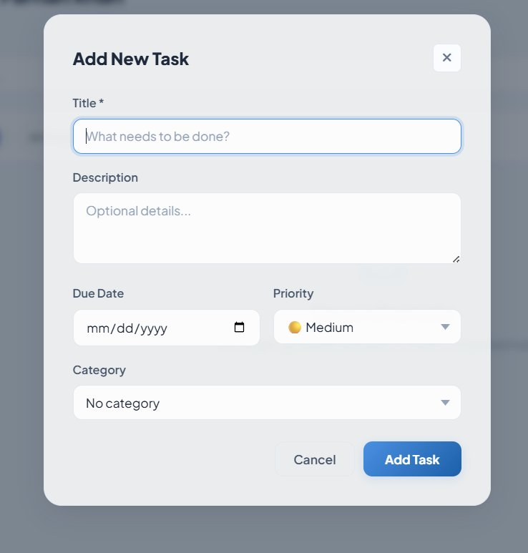
Figure 4.4: Add New Task Modal Dialog
4.5.5 Statistics Page
The statistics page provides a comprehensive view of the user's productivity metrics. At the top, four summary stat cards display total tasks, completed tasks, pending tasks, and the overall completion rate percentage. Each card features a color-coded icon, the numeric value in large bold font, and a contextual sub-label. Below the stat cards, two charts are displayed side-by-side: a bar chart showing the count of high, medium, and low priority tasks (with priority-appropriate colors: red, amber, green), and a doughnut chart showing the ratio of completed to pending tasks. Each chart has a legend below it for accessibility. At the bottom of the page, the Priority Breakdown table provides a detailed tabular view with animated progress bars showing the completion percentage for each priority level.
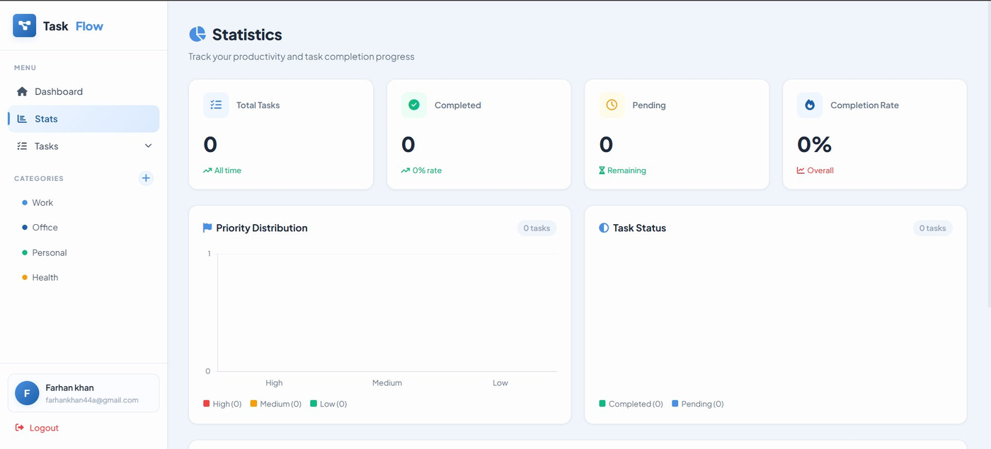
Figure 4.5: Statistics Page — Summary Cards and Charts
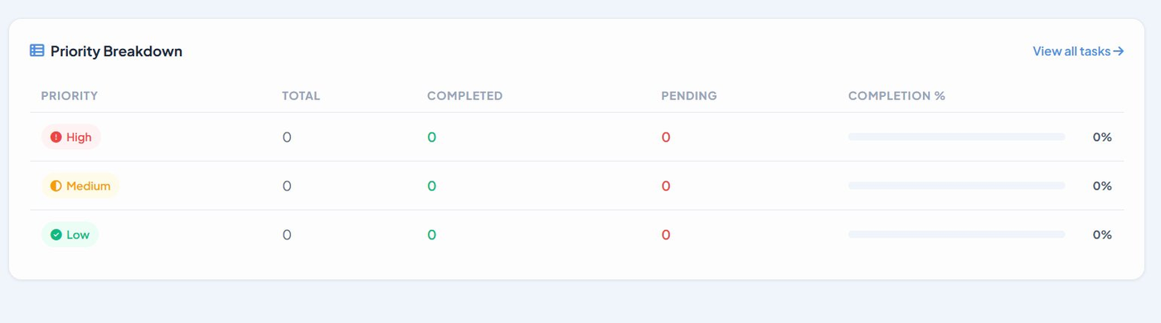
Figure 4.6: Statistics Page — Priority Breakdown Table
4.5.6 Task Card Design
Each task is rendered as a card component with consistent structure across all task list pages. The card displays the task title (struck through for completed tasks), an optional description, a priority badge (color-coded with an appropriate icon), an optional category tag (styled in the category's chosen color), and a due date indicator (shown in red with a warning icon for overdue tasks). The action buttons — Edit, Delete, and Complete (or Restore for completed tasks) — are aligned to the bottom right of the card. Cards have a subtle border, rounded corners, a light shadow, and a hover state that lifts the card slightly and deepens the shadow, providing clear interactive feedback.
4.5.7 Responsive Design
The application is fully responsive across device sizes. On screens narrower than 900px, the sidebar is hidden by default and slides in from the left when the hamburger menu button in the topbar is tapped. A semi-transparent overlay with a blur effect covers the main content area when the sidebar is open, preventing accidental interaction with the background. The topbar displays the Task Flow logo and the hamburger button. Layout grids for the statistics page reflow from two-column to one-column at 900px, and several UI elements — including action bars and modal action buttons — stack vertically on small screens.

4.6 Application Page Flow and Navigation
The navigation flow of the Task Flow application is designed to be intuitive and consistent. The login page (index.html) is the entry point for unauthenticated users. Upon successful login or registration, users are redirected to the dashboard. All protected pages — dashboard, stats, pending, complete — check for an authenticated session on load and redirect unauthenticated visitors back to the login page.
The sidebar navigation, present on all authenticated pages, provides direct access to the Dashboard, Stats, and the Tasks submenu (expanding to reveal Pending and Completed sub-links). Category chips in the sidebar navigate to the dashboard filtered by the selected category. The topbar, visible only on mobile and tablet screens, provides the hamburger menu toggle. All pages include a Logout button in the sidebar footer that terminates the session and redirects to the login page.
The forgot-password flow is a two-step process on a dedicated page (forgot-password.html). In step one, the user enters their registered email. If the email exists in the database, the password entry form is revealed. In step two, the user sets and confirms a new password. On success, they are redirected back to the login page with a success toast notification. This flow does not require any email sending capability, making it self-contained and operable without external email service configuration.

4.7 Security Design
The security design of Task Flow addresses the primary threat categories identified during the requirements engineering phase. The authentication system uses bcrypt password hashing (salt rounds: 10), server-side session management with httpOnly and sameSite: strict cookie attributes, and rate limiting on all authentication endpoints. The data access layer uses parameterized PostgreSQL queries exclusively, eliminating SQL injection vulnerabilities. The frontend rendering layer sanitizes all user-generated content through the escapeHtml() function before DOM insertion, preventing stored XSS attacks.
User data isolation is enforced at the database query level — every task and category query includes a WHERE user_id = $userId condition, ensuring that a user can only ever access or modify their own data, regardless of the task or category ID provided in the request URL. This prevents horizontal privilege escalation attacks where an authenticated user could access another user's data by guessing or enumerating resource IDs.
The Express.js server is configured to trust the proxy headers set by Railway (the deployment platform) in production, enabling correct IP address extraction for rate limiting when the application is running behind a reverse proxy. In development, private LAN IP addresses are accepted by the CORS configuration, facilitating testing from multiple devices on the local network without requiring changes to the application code.

