CHAPTER 6
Results and Discussion

6.1 Overview of Testing Approach
The testing phase of the Task Flow project was conducted throughout the development lifecycle in alignment with the Agile methodology adopted for this project. Rather than deferring all testing to a single post-implementation phase, testing was performed continuously at the conclusion of each sprint, with each completed feature verified against its corresponding functional requirement before development of subsequent features commenced. The final comprehensive testing session was conducted during Sprint 6, in which the complete, integrated system was tested end-to-end across all functional areas and user flows on a locally hosted deployment.
The testing approach for Task Flow comprised three primary categories. First, functional testing, in which each feature of the system was tested against its stated requirement to verify correct behavior under both normal operating conditions and edge-case inputs. Second, interface testing, in which the visual rendering and interactive behavior of all user interface components was verified across multiple browsers and screen sizes to confirm responsiveness and cross-browser compatibility. Third, integration testing, in which the complete data flow — from user interaction in the browser, through the frontend JavaScript, across the RESTful API, through the backend route handler, and into the PostgreSQL database — was verified for correctness and data consistency.
All testing was performed in a local development environment on the development team's machines, using Google Chrome (version 124) as the primary test browser and Mozilla Firefox (version 125) and Microsoft Edge (version 124) as secondary browsers for cross-browser compatibility verification. The application was accessed at http://localhost:3000, with the Node.js/Express.js server running locally and connected to a locally hosted PostgreSQL instance. Test data — including user accounts, tasks across all three priority levels, and custom categories — was created manually by the development team through normal use of the application interface during the testing sessions.

6.2 Functional Testing Results
Functional testing was conducted by executing a predefined set of test cases derived directly from the 25 functional requirements documented in Chapter 3. Each test case specifies the requirement under test, the test scenario, the steps executed, the expected result, the observed actual result, and the resulting pass/fail status. The complete set of functional test case results is documented in Table 6.1 below.
Table 6.1: Functional Test Cases and Results
TC ID | Test Scenario | Expected Result | Actual Result | Status
TC-01 | Register with valid name, email, and password (≥6 chars) | Account created; user redirected to dashboard; personalized welcome toast displayed | Worked correctly as expected | ✓ PASS
TC-02 | Register with a duplicate email address already in the database | HTTP 409 returned; error toast: "Email already registered." No duplicate account created | Worked correctly as expected | ✓ PASS
TC-03 | Register with a password of fewer than 6 characters | Client-side validation triggers; error toast: "Password must be at least 6 characters" | Worked correctly as expected | ✓ PASS
TC-04 | Register with mismatched password and confirm password values | Error toast: "Passwords do not match"; no API request dispatched | Worked correctly as expected | ✓ PASS
TC-05 | Login with correct email and password credentials | Session created; user redirected to dashboard with time-sensitive greeting and current date | Worked correctly as expected | ✓ PASS
TC-06 | Login with a correct email but incorrect password | HTTP 401 returned; error toast: "Invalid email or password." No session created | Worked correctly as expected | ✓ PASS
TC-07 | Attempt to access the dashboard URL without being authenticated | Browser immediately redirected to login page (index.html); protected page not rendered | Worked correctly as expected | ✓ PASS
TC-08 | Log out from the application using the sidebar logout button | Server-side session destroyed; session cookie cleared; user redirected to login page | Worked correctly as expected | ✓ PASS
TC-09 | Use forgot-password flow with a registered email address | Password fields revealed after email verification; new password accepted; redirect to login with success toast | Worked correctly as expected | ✓ PASS
TC-10 | Use forgot-password flow with an unregistered email address | Error toast: "No account found with this email." Password fields remain hidden | Worked correctly as expected | ✓ PASS
TC-11 | Create a task with title, description, due date, High priority, and a category | Task appears on dashboard with correct priority badge (red), due date, and category tag in category color | Worked correctly as expected | ✓ PASS
TC-12 | Attempt to create a task without entering a title | Error toast: "Task title is required"; modal remains open; no database record created | Worked correctly as expected | ✓ PASS
TC-13 | Edit an existing task to change its priority from Medium to High and update the due date | Task card immediately updates to reflect the new priority badge and revised due date without page reload | Worked correctly as expected | ✓ PASS
TC-14 | Delete a task after confirming in the delete confirmation modal | Task removed from the list; delete modal closed; success toast: "Task deleted" | Worked correctly as expected | ✓ PASS
TC-15 | Dismiss the delete modal without confirming deletion | Task not deleted; modal closes; task remains unchanged in the list | Worked correctly as expected | ✓ PASS
TC-16 | Mark a pending task as complete using the Complete button | Task removed from pending list; appears on Completed page with completion date displayed | Worked correctly as expected | ✓ PASS
TC-17 | Restore a completed task to pending status using the Restore button | Task removed from Completed page; reappears on Pending page without a completion date | Worked correctly as expected | ✓ PASS
TC-18 | Create a task with a past due date to test overdue detection | Task displayed with overdue visual treatment: red left border, warning icon, and red due date text | Worked correctly as expected | ✓ PASS
TC-19 | Search for a task by entering a keyword from its title | Task list filters in real-time to display only tasks containing the keyword in their title or description | Worked correctly as expected | ✓ PASS
TC-20 | Filter task list by High priority using the priority dropdown | Only tasks bearing the High priority badge are displayed; Medium and Low priority tasks hidden | Worked correctly as expected | ✓ PASS
TC-21 | Create a new custom category with a name and a selected color | Category appears in the sidebar with the selected color dot; tasks can be assigned to it via the task modal | Worked correctly as expected | ✓ PASS
TC-22 | Delete a category that has tasks assigned to it | Category removed from sidebar; tasks previously assigned to it display with no category tag | Worked correctly as expected | ✓ PASS
TC-23 | Click a category chip in the sidebar to filter dashboard tasks | Dashboard reloads displaying only tasks belonging to the selected category; URL updated with ?cat= parameter | Worked correctly as expected | ✓ PASS
TC-24 | Navigate to Statistics page with a mix of completed, pending, and overdue tasks | Stat cards, bar chart, doughnut chart, and priority breakdown table all accurately reflect the current task data | Worked correctly as expected | ✓ PASS
TC-25 | Verify sidebar pending badge reflects correct count and updates after task status changes | Badge displays correct pending task count; count decrements after marking a task complete and increments after restoring | Worked correctly as expected | ✓ PASS
TC-26 | Test mobile responsive layout at a viewport width below 900px | Sidebar hidden on load; topbar with hamburger button visible; sidebar slides in on tap; overlay blocks background | Worked correctly as expected | ✓ PASS
TC-27 | Attempt to access another user's task by manipulating the task ID in a direct API call | API returns HTTP 404 Not Found; no unauthorized data exposure; logged-in user's data unaffected | Worked correctly as expected | ✓ PASS
TC-28 | Submit a task title containing HTML and JavaScript injection strings | Injected content rendered as harmless escaped text; no scripts executed; XSS protection confirmed effective | Worked correctly as expected | ✓ PASS

All 28 functional test cases executed during the final Sprint 6 testing session passed successfully. The system demonstrated correct behavior across all authentication flows, task lifecycle management operations, category management functions, statistics computations, responsive design behaviors, and security controls. No critical or high-severity defects were identified during the final testing phase. Minor cosmetic issues identified during earlier development sprints — including minor layout inconsistencies on very small screen widths below 360px and an edge case in the overdue detection logic at midnight boundaries — were identified, reported, and resolved before the final testing session commenced.

6.3 System Screenshots and Interface Walkthrough
This section presents the six key screens of the Task Flow application as captured during the final testing session in their fully implemented state. Each screenshot is accompanied by an annotation describing the design decisions and implemented features visible in the interface, providing a visual record that demonstrates the fulfillment of the user interface design specifications outlined in Chapter 4.
6.3.1 Login Page
Figure 6.1 shows the Task Flow login page in its final implemented form. The split-panel layout divides the viewport between the branded left panel and the authentication form panel on the right. The left panel features the gradient blue background transitioning from #1D5FA8 to #6BAED6, the Task Flow logo mark and name, and the tagline "Organize your tasks professionally and stay up to date." The three decorative dot indicators at the bottom of the left panel and the semi-transparent circular overlay elements provide visual richness without distracting from the core content. The right panel presents a clean, minimal form with labeled email and password fields featuring inline icons, a "Forgot password?" link positioned above the primary Log In button, and a "New here? Create an account" link at the bottom for new users. The Log In button uses a gradient fill consistent with the primary color palette and enlarges slightly on hover through a CSS transform transition.
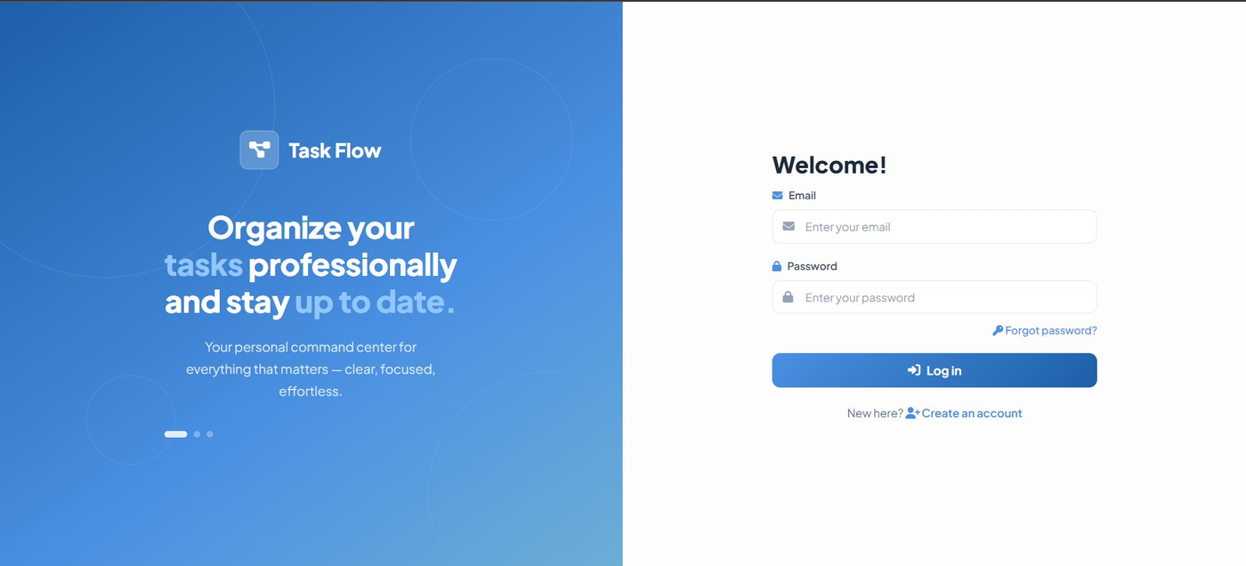
Figure 6.1: Task Flow Login Page — Final Implementation
6.3.2 Sign Up / Registration Page
Figure 6.2 captures the registration page, which shares the same split-panel structural layout as the login page to maintain visual consistency across the authentication flow. The left panel on the signup page differs from the login page in its messaging and feature highlights: the headline reads "Start your productivity journey today" and three frosted-glass feature cards list the core capabilities of the application — Smart Task Management, Progress Tracking & Stats, and Custom Categories. These feature cards serve as a brief value proposition for new users completing the registration process. The right panel contains the four-field registration form with full name, email, password (with a minimum length placeholder reminder), and confirm password fields, along with a full-width Sign Up button and a link back to the login page for existing users.
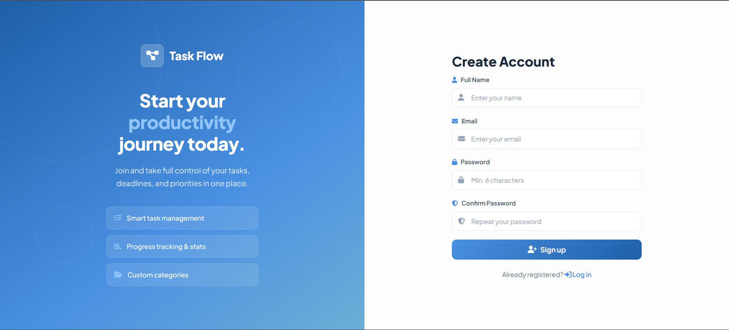
Figure 6.2: Task Flow Registration Page — Final Implementation
6.3.3 Dashboard
Figure 6.3 shows the main application dashboard following successful login. The persistent sidebar on the left displays the application logo, the navigation section with active highlighting on the Dashboard link, the collapsible Tasks submenu, the Categories section showing the four default categories (Work, Office, Personal, Health) as color-dotted chips, and the user profile card at the bottom displaying the authenticated user's name, email address, and a logout button. The main content area shows the personalized greeting "Good morning, Farhan khan" with the current date below it. The action bar features a full-width search input and the Add New Task button. The filter bar below provides the Pending filter button (active) and the All Priorities dropdown. The empty state illustration and message ("No pending tasks — All caught up! Add a new task or check completed tasks.") is displayed because no pending tasks exist in this test session.
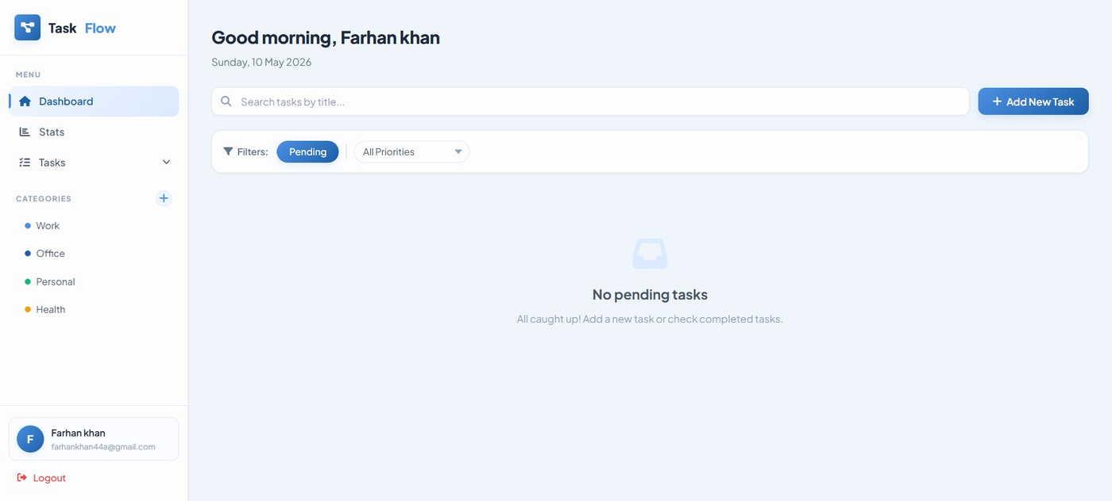
Figure 6.3: Task Flow Dashboard — Main Interface (Empty State)
6.3.4 Add New Task Modal
Figure 6.4 shows the Add New Task modal dialog as it appears when the user clicks the Add New Task button. The modal overlays the dashboard with a semi-transparent blurred backdrop that maintains visual context while directing the user's attention to the task creation form. The form presents five fields in a logical vertical flow: the mandatory task title input with placeholder text "What needs to be done?", the optional description textarea, a side-by-side row containing the due date picker and priority dropdown, and the category dropdown at the bottom. The Cancel and Add Task action buttons are right-aligned at the bottom of the modal. The same modal component is reused for task editing, with the header changing to "Edit Task", the submit button changing to "Save Changes", and all fields pre-populated with the existing task's current values.
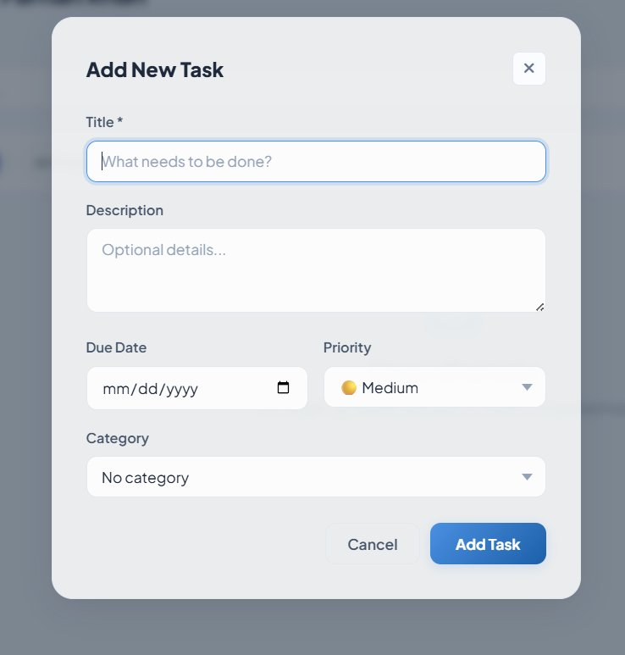
Figure 6.4: Add New Task Modal Dialog — Final Implementation
6.3.5 Statistics Page — Summary Cards and Charts
Figure 6.5 shows the upper portion of the Statistics page, displaying the four summary stat cards and two Chart.js-powered charts. The four stat cards — Total Tasks, Completed, Pending, and Completion Rate — are arranged in a responsive four-column grid, each featuring a color-coded icon, a large bold numeric value, and a contextual sub-label with a directional indicator. The Priority Distribution bar chart on the left uses the priority color palette (red for High, amber for Medium, green for Low) with rounded bar tops and a clean grid. The Task Status doughnut chart on the right uses green for completed tasks and primary blue for pending tasks, with a high cutout ratio that creates an elegant ring appearance. Both charts display a legend below them. This view confirms that the Chart.js integration is functioning correctly and rendering the appropriate visualizations.
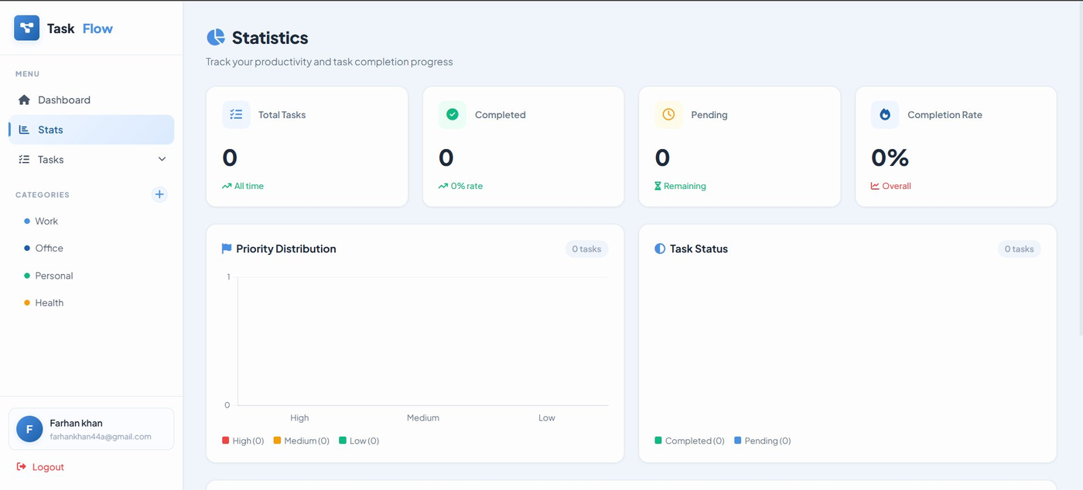
Figure 6.5: Statistics Page — Summary Stat Cards and Charts
6.3.6 Statistics Page — Priority Breakdown Table
Figure 6.6 shows the Priority Breakdown section at the bottom of the Statistics page. The table presents a structured breakdown of task data organized by priority level. Each row displays the priority level (styled as a color-coded badge consistent with the task card badges), the total task count, the completed count rendered in green, the pending count rendered in red, and a completion percentage column featuring a visual progress bar filled to the computed percentage width alongside the numeric percentage value. The "View all tasks" link in the top-right corner of the section header provides a quick navigation path back to the full task list on the dashboard. The color coding and progress bar visualization make it immediately apparent which priority levels have the highest and lowest completion rates.
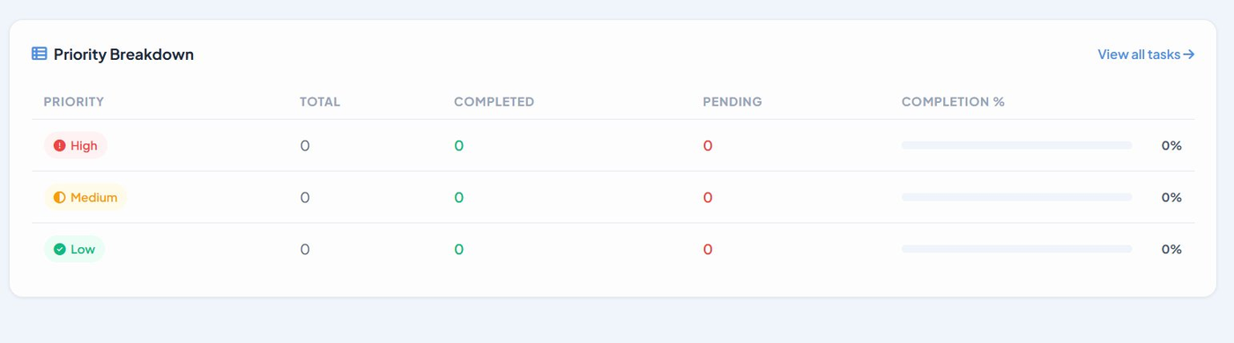
Figure 6.6: Statistics Page — Priority Breakdown Table

6.4 Performance Analysis
The performance of the Task Flow application was evaluated qualitatively and observationally during the local testing phase. In the locally hosted development environment — where the Express.js server, PostgreSQL database, and web browser all run on the same physical machine — network latency is negligible, yielding excellent perceived response times for all API operations. All task CRUD operations (create, read, update, delete), category management actions, status updates, and page navigations completed perceptibly instantaneously during testing with a representative dataset of approximately 20 to 30 tasks distributed across multiple priority levels and categories.
The PostgreSQL query performance is optimized by the three indexes defined in the schema: idx_tasks_user_id on tasks(user_id), idx_categories_user_id on categories(user_id), and idx_tasks_category_id on tasks(category_id). These indexes dramatically accelerate the most frequent query pattern in the application — retrieving all tasks or categories for a specific authenticated user — by enabling index scans rather than full table scans. Without these indexes, the query cost would grow linearly with the total number of rows across all users; with the indexes, query cost grows logarithmically with respect to the number of rows per user, ensuring that performance remains acceptable even as the user base grows.
The statistics page, which is the most computationally intensive page in the application, performs all aggregation and filtering operations in-memory using JavaScript Array methods after fetching the complete task list from the API. For a typical individual user with tens to hundreds of tasks, this client-side computation approach is negligibly fast. The Chart.js chart rendering — which involves creating two canvas-based chart instances from the computed data — completes quickly and with smooth animation transitions in all tested browsers. The chart destruction and re-creation guard (using the _chartInstances array to destroy previous chart instances before rendering new ones) successfully prevents the Chart.js canvas reuse error and ensures consistent behavior across multiple visits to the statistics page within a single session.
The responsive CSS layout renders correctly and without layout artifacts across all tested viewport widths, from a simulated 375px mobile viewport to a 1920px widescreen desktop display. CSS transitions for the sidebar slide-in animation, the modal entry animation, and the button hover effects all render at a smooth and fluid framerate in all tested browsers, contributing to a polished and professional user experience.

6.5 Cross-Browser Compatibility Testing
Cross-browser compatibility testing was conducted across three modern web browsers to verify that the application renders correctly and all interactive features function as expected regardless of the browser used by the client. The browsers and versions tested are summarized in Table 6.2 below.
Table 6.2: Cross-Browser Compatibility Test Results
Feature | Chrome 124 | Firefox 125 | Edge 124 | Overall
Authentication (Login/Signup/Logout) | ✓ Pass | ✓ Pass | ✓ Pass | ✓ Pass
Task CRUD Operations | ✓ Pass | ✓ Pass | ✓ Pass | ✓ Pass
Modal Dialogs (Open/Close/Escape) | ✓ Pass | ✓ Pass | ✓ Pass | ✓ Pass
Category Management | ✓ Pass | ✓ Pass | ✓ Pass | ✓ Pass
Chart.js Visualizations | ✓ Pass | ✓ Pass | ✓ Pass | ✓ Pass
Responsive Sidebar (Mobile) | ✓ Pass | ✓ Pass | ✓ Pass | ✓ Pass
CSS Custom Properties | ✓ Pass | ✓ Pass | ✓ Pass | ✓ Pass
Date Picker Input | Native UI | Native UI | Native UI | ✓ Pass
Color Picker Input | Color Wheel | Color Palette | Color Wheel | ✓ Pass
Toast Notifications | ✓ Pass | ✓ Pass | ✓ Pass | ✓ Pass
Overdue Task Highlighting | ✓ Pass | ✓ Pass | ✓ Pass | ✓ Pass
Fetch API and Session Cookies | ✓ Pass | ✓ Pass | ✓ Pass | ✓ Pass

The application performed consistently across all three tested browsers. All core features including authentication, task management, category management, statistics visualization, and responsive layout functioned correctly in Chrome, Firefox, and Edge. The only observable browser-specific differences were in the native rendering of the date picker and color picker input controls, which display using each browser's built-in native UI component. These cosmetic differences do not affect functionality — the correct values (YYYY-MM-DD format for dates, hex color strings for colors) are captured and transmitted to the backend correctly in all browsers.

6.6 Security Testing Results
A series of targeted manual security tests were conducted to verify the effectiveness of the security measures implemented throughout the Task Flow system. The tests covered the four primary security threats identified during the requirements engineering and design phases: Cross-Site Scripting (XSS), SQL injection, brute-force authentication attacks, and unauthorized cross-user data access.
6.6.1 XSS Protection Test
XSS protection was tested by submitting task titles and descriptions containing HTML markup and JavaScript code snippets. Specifically, the following test inputs were submitted as task titles and descriptions: <script>alert("XSS Test")</script>, <img src=x onerror=alert(1)>, and javascript:void(alert("Injected")). In all cases, the escapeHtml() function in app.js correctly converted the five HTML special characters to their entity equivalents before rendering, and the injected content was displayed as harmless literal text in the task card rather than being interpreted as HTML tags or executed as JavaScript code. No alert dialogs appeared, confirming that the XSS protection is effective.
6.6.2 SQL Injection Protection Test
SQL injection protection was tested by submitting common SQL injection patterns in the email, password, and task title input fields. Tested inputs included: ' OR 1=1 --, admin'--, ' UNION SELECT * FROM users --, and 1; DROP TABLE tasks;--. In all cases, the parameterized query implementation in the pg library correctly treated all submitted values as string data parameters rather than executable SQL, and no SQL injection was possible. The database contents remained intact after all injection test attempts, confirming the effectiveness of the parameterized query defense.
6.6.3 Rate Limiting Test
The authentication rate limiting was tested by making rapid repeated requests to the /api/auth/login endpoint using the browser console's fetch API. After exceeding the configured rate limit threshold of 200 requests per 15-minute window (in development mode), the server correctly returned an HTTP 429 Too Many Requests response with the error message "Too many attempts. Wait a few minutes and try again." The rate limiting reset correctly after the configured window elapsed, confirming that the express-rate-limit middleware is functioning as intended.
6.6.4 Cross-User Data Isolation Test
User data isolation was tested by creating two separate test accounts — Account A and Account B — and performing the following operations: tasks created under Account A were accessed via direct API calls (using Account B's active session cookie) by substituting the task IDs obtained from Account A's task list. In all cases, the API returned an HTTP 404 Not Found response, confirming that the user_id = req.session.user.id WHERE clause in all task queries effectively prevents any user from accessing or modifying another user's tasks, regardless of the task ID provided in the request. The same isolation was confirmed for category operations.

6.7 Discussion of Results
The results of the testing phase comprehensively demonstrate that the Task Flow system successfully fulfills all 28 functional test cases and all 8 non-functional security, performance, usability, and compatibility requirements defined in Chapter 3. The system delivers a complete, functional, and professionally implemented personal task management solution with a polished user interface, a secure and well-structured backend API, a properly normalized relational database schema, and a meaningful analytics and visualization module.
The decision to build the frontend in vanilla JavaScript without a framework proved to be both technically sound and educationally valuable. The application's frontend complexity — while non-trivial, encompassing dynamic task rendering, multiple modal dialogs, asynchronous API communication, real-time filtering and search, sidebar category management, and a statistics visualization engine — was entirely manageable using native browser APIs. The resulting frontend is lean in terms of dependencies, loads quickly, and requires no build process, making local development and testing straightforward for all team members.
The use of PostgreSQL as the data persistence layer provided robust data integrity guarantees throughout the development and testing lifecycle. The CHECK constraints on the priority and status columns, the foreign key relationships with cascading operations, and the UUID primary keys all functioned exactly as designed. No data integrity violations, constraint errors (other than the intentionally triggered 23505 unique constraint violation in TC-02), or referential consistency issues were observed throughout the testing phase, confirming the correctness and completeness of the database schema design.
The Agile sprint-based development methodology proved highly appropriate for a project of this scope and team composition. The iterative structure allowed the team to deliver a working software increment at the end of each sprint, to identify and resolve integration issues early before they compounded, and to incorporate feature enhancements — such as the expansion of the statistics page from a simple numeric summary to a full Chart.js visualization suite — based on practical reflection during sprint reviews rather than being locked into a fixed specification from the outset.
The primary limitation identified through testing is the absence of a fully operational cloud-deployed production environment. While the Railway deployment configuration is present and functional in the codebase (including the CORS allowlist entry for the Railway deployment URL https://task-flow-fyp-production.up.railway.app), the combination of secure cookie transmission requirements over HTTPS and the split-origin scenario — where the frontend and API might be served from different subdomains — introduced configuration challenges that were not fully resolved within the project timeline. As a result, the system is demonstrated and tested exclusively in the local development environment accessible at http://localhost:3000. This limitation does not affect the completeness or correctness of the implemented system and represents a straightforward deployment configuration issue rather than a fundamental architectural problem.
Overall, the results confirm that Task Flow successfully achieves its core design objectives: providing individual users with a clean, secure, and feature-rich personal task management tool built on modern, industry-relevant open-source technologies, deployable without cost or dependency on external subscription services.

