Source Code

#include <stdio.h>

1. int main()

{

1. int a, b, c;
2. printf("masukkan nilai a b c: ");
3. scanf("%d %d %d", &a, &b, &c);
4. if(a>0 && b>0 && c>0){
5. {printf("Ini segitiga sama sisi.\n");}
6. else if(a==b || a==c || b==c)
7. {printf("Ini adalah segitiga sama Kaki.\n");}
8. else if(a*a == b*b+c*c || b*b == a*a+c*c || c*c == b*b+a*a)
9. {printf("Ini segitiga siku-siku");}
10. else
11. {printf("Ini adalah segitiga bebas.\n");}

     }

1. Else
2. {printf("Tidak ada yang dapat dibangun\n");}
3. return 0;

}

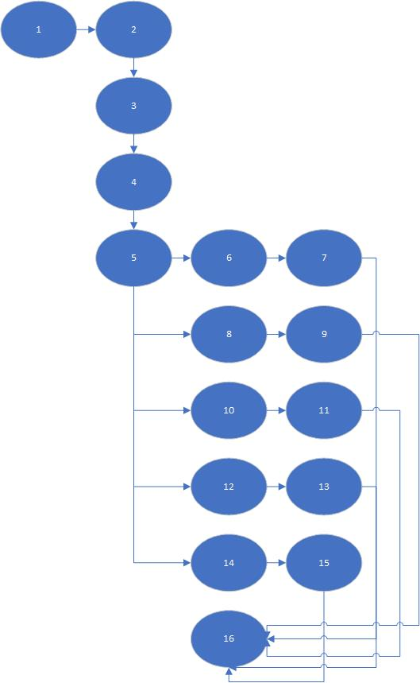Step 1 Flow Chart

Step 2Determine the cyclomatic complexity of the resultant flow graph

Cyclomatic Complexity

V(G) = Edge – Note + 2

= 19 – 16+ 2

= 5

Step 3 Determine a basis set of linearly independent paths

Hasil Independent Path dijabarkan sebagai berikut:

Path 1: 1-2-3-4-5-6-7-16

Path 2: 1-2-3-4-5-8-9-16

Path 3: 1-2-3-4-5-10-11-16

Path 4: 1-2-3-4-5-12-13-16

Path 5: 1-2-3-4-5-14-15-16

Step 4 Prepare test cases that will force execution of each path in the basis set

|  |  |  |  |
| --- | --- | --- | --- |
| Path | NextPath | (X,Y,Z) | Jenis Segitiga |
| 1 | True | 13,13,13 | Segitiga Sama Sisi |
| 2 | True | 4,12,12 | Segitiga Sama Kaki |
| 3 | True | 8,4,4 | Segitiga Siku-Siku |
| 4 | True | 5,6,7 | Segita Bebas |
| 5 | False | -4,1,7 | Tidak Dapat dibangun |