SERVYGO INC.
SOFTWARE REQUIREMENTS SPECIFICATION
servygo-admin-web
Document ID: | SRS-SGW-AWEB-001
Version: | 1.0
Date: | March 15, 2026
Status: | Final for Approval
Classification: | Confidential - Commercial

Prepared For
ServyGo Inc., Saskatoon, SK, Canada
Prepared By
Divergent Technologies Limited, Dhaka, Bangladesh

Binding Clauses — Agreed by Both Parties

Scope Coverage
This SRS covers requirements derived from ServyGo reference documents provided by Arif Rabbani as of the SRS signing date. Any requirement not captured in this SRS but present in reference documents must be raised in writing to be incorporated.

Detail Deferral
This SRS document covers requirements but implementation details will be provided in the Technical Requirements Document (TRD) and Handover Documentation.

No Post-Signing Scope Denial
Once signed, the vendor shall not claim features explicitly described in this SRS as out of scope. Features not described in this SRS, or features requiring interpretation beyond reasonable reading of this document, remain subject to the change request process. Ambiguous requirements shall be resolved collaboratively in the TRD.

Scalable Architecture Obligation
The vendor shall design a modular, loosely coupled architecture that supports the service categories and user scale defined in this SRS. Architecture shall be designed to allow addition of new service types without full platform rewrites. Specific expansion scenarios beyond Phase 1 scope shall be evaluated and quoted separately. Vendor is not liable for architectural changes required due to business model changes made after TRD sign-off.

Minimum Operational Capacity Guarantee
The vendor shall design and implement the platform architecture in accordance with the scalability targets defined in TRD Section 10.6, which specifies design targets of 10,000+ concurrent active users and 5,000+ concurrent API requests. These targets represent architectural design capacity achievable when the AWS infrastructure tier recommended in TRD Section 4.4 is provisioned by the Client. Actual runtime capacity is dependent on the infrastructure configuration selected and funded by the Client. The vendor's obligation is correct architectural design enabling these targets, not guaranteed runtime performance under all conditions.
Note: Actual capacity at any point in time is dependent on the AWS infrastructure tier provisioned and paid for by the Client. The Vendor shall document the minimum recommended infrastructure configuration to achieve these targets. Vendor is not liable for capacity failures resulting from Client choosing a lower infrastructure tier than recommended.

Security & Data Protection
The vendor shall implement the security architecture defined in TRD Sections 4.7 and 9, which covers: authentication and token-based authorization (Section 9.3), RBAC (Section 9.4), API security (Section 9.5), TLS transport encryption (Section 9.6), infrastructure security including WAF (Section 9.7), OWASP Top 10 application protections (Section 9.8), secrets management (Section 9.9), and logging and security monitoring (Section 9.10). Vendor's security obligation is limited to correct implementation of the controls defined in TRD Sections 4.7 and 9 at the time of delivery.
Vendor is not liable for:
- New security vulnerabilities discovered in third-party libraries after delivery (zero-days, upstream CVEs)
- Security incidents caused by Client disabling recommended controls
- Breaches originating from Client-managed infrastructure or accounts
- Attacks exceeding the configured mitigation thresholds of selected security services.

Canadian Compliance
The vendor must ensure the system architecture supports compliance with: PIPEDA, applicable consumer protection laws, and PCI-DSS payment processing standards where applicable.

Post-SRS Documentation Obligations
The vendor must provide complete technical documentation including: system architecture documentation, database schema and data model documentation, API documentation, deployment and installation guides, system administration manuals, and maintenance and troubleshooting documentation.

Warranty Period
The warranty period and scope are governed by the definitions in TRD Section 14. The 12-month warranty applies to defects as defined therein. Items excluded from the warranty definition in the TRD are not covered regardless of when they are raised.

Data Ownership & Backup
All platform data remains the exclusive property of ServyGo. Vendor shall configure automated daily backups using AWS RDS automated backup functionality (up to 7-day retention) and AWS S3 versioning for object storage, in accordance with the storage architecture defined in TRD Section 4.5.2 (Data Storage Strategy), 4.5.5 (Object Storage), and 4.5.10 (Data Security and Access Control), which includes the AWS RDS automated daily backup commitment. Vendor shall document restoration procedures as part of the handover package per TRD Section 8.9. Advanced disaster recovery capabilities (multi-region replication, point-in-time recovery beyond 7 days, RTO/RPO contractual guarantees, business continuity planning) are outside Phase 1 scope and are available as a separately quoted enhancement. Vendor is not liable for data loss caused by AWS infrastructure outages beyond what AWS RDS automated backup covers.

Third-Party Integration Responsibility
The vendor shall implement third-party integrations as specified in TRD Section 4.6 and documented in the Third-Party & Managed Services Matrix (TRD Appendix D). Vendor's responsibility covers correct implementation of integrations against the API versions and specifications current at the time of TRD sign-off. Post-sign-off changes by third-party providers (API breaking changes, pricing changes, service deprecations, rate limit changes) are outside vendor responsibility and subject to a change request. Third-party service account provisioning, billing, and ongoing subscription costs are the Client's responsibility as defined in TRD Section 4.6.13 and Appendix D (Third-Party Services Matrix). Vendor shall implement resilience mechanisms per TRD Section 4.6.11 (retry logic, timeout handling, graceful fallback) to minimize the impact of third-party outages.

Knowledge Transfer
Knowledge transfer shall be conducted by the vendor in accordance with the documentation deliverables defined in TRD Section 8.9. Knowledge transfer shall consist of a minimum of two (2) structured sessions covering:
- System architecture overview and component interactions
- Deployment procedures and environment management
- Platform administration workflows
- Troubleshooting and maintenance guidance.
Sessions shall be recorded for Client reference. Knowledge transfer is considered complete upon delivery of the documentation defined in TRD Section 8.9 and completion of the two sessions. Ongoing training, additional sessions, or extended support beyond this scope is available as a separately quoted service.

Revision History
Version | Date | Author | Description | Status
0.1 | 2026-02-20 | Tech Team | Initial draft structure created | Draft
0.2 | 2026-02-22 | Tech Team | Added use cases and diagrams | Draft
0.3 | 2026-02-26 | Tech Team | Technical specifications added | Draft
0.4 | 2026-03-05 | Tech Team | Vendor-friendly language added | Draft
1.0 | 2026-03-15 | Tech Team | Final version with all diagrams | Final

Table of Contents
(Right-click and select "Update Field" to refresh page numbers)
Binding Clauses — Agreed by Both Parties 2
Scope Coverage 2
Detail Deferral 2
No Post-Signing Scope Denial 2
Scalable Architecture Obligation 2
Minimum Operational Capacity Guarantee 2
Security & Data Protection 2
Canadian Compliance 3
Post-SRS Documentation Obligations 3
Warranty Period 3
Data Ownership & Backup 3
Third-Party Integration Responsibility 3
Knowledge Transfer 4
Revision History 5
1. Introduction 9
1.1 Purpose 9
1.2 Scope 9
1.3 Definitions 10
1.4 References 10
2. Overall Description 11
2.1 Product Perspective 11
2.2 Product Functions 11
2.3 User Classes 11
2.4 Design and Implementation Constraints 11
2.5 Assumptions and Dependencies 12
3. Specific Requirements 14
3.1 External Interface Requirements 14
3.1.1 User Interfaces 14
3.1.2 Hardware Interfaces 14
3.1.3 Software Interfaces 14
3.1.4 Communications Interfaces 15
3.2 Functional Requirements 15
FR-1: Authentication and Role Management 15
FR-2: User Management 15
FR-3: Service Management 15
FR-4: Booking Management 16
FR-5: Real-time Monitoring 16
FR-6: Financial Management 16
FR-7: Dispute Resolution 16
FR-8: Document Verification 17
FR-9: Review Moderation 17
FR-10: Analytics and Reporting 17
FR-11: Platform Configuration 17
FR-11: Deferred Detail Acknowledgement 17
3.3 Performance Requirements 18
3.4 Security Requirements 18
Core Security (Vendor Responsibility): 18
Optional Security Enhancements (Client-Approved / Cost-Bearing): 18
Shared Responsibility: 19
3.5 Privacy & Compliance Requirements 19
3.6 API Integration Requirements 19
3.7 Testing and Acceptance 19
3.8 Security Vulnerability Scanning 20
3.9 CI/CD Pipeline Validation 20
3.10 Code Quality & Test Coverage 20
3.11 Compliance & Alignment 21
3.12 Reference to Technical Requirements Document (TRD) 21
4. System Models 22
4.1 Use Case Diagram 22
4.2 Sequence Diagram 22
4.3 Deployment Diagram 23
4.4 Entity Relationship Diagram 24
4.5 State Machine Diagram 25
4.6 Flowcharts 25
4.6.1 User Signup and Administrative Document Verification 25
4.6.2 Administrative Dispute Resolution 26
4.6.3 Weekly Auto-Payout Cron with Order Loop 27
4.6.4 Admin Job cancellations 28
4.6.5 Franchise Job cancellations 29
5. Appendices 30
5.1 Data Flow Diagrams 30
5.1.1 DFD Level 0 - Context Diagram 30
5.2 Security Threat Model (STRIDE) 31
5.3 System Architecture 31
5.4 Backup & Disaster Recovery 31
5.5 Explicitly Out of Scope / Limitations 32
5.5 Shared Responsibilities Matrix 32
5.6 Third-Party Services 33
5.6.1 Infrastructure (AWS) – Mandatory Baseline 33
5.6.2 Security & Protection – Flexible Options (Client Selection Required) 33
5.6.3 Communications – Email/SMS/Push 34
5.6.4 Analytics & Monitoring 34
5.6.5 Integration Notes for Development Team 34
5.7 Risk Register 35
5.8 Glossary 35

1. Introduction

1.1 Purpose
Note: This SRS focuses on vendor-protective language while maintaining clear scope definition. Detailed technical implementation specifications will be defined in the Technical Requirements Document (TRD), which shall be developed collaboratively and approved by both parties before development begins.
This document is the Software Requirements Specification for servygo-admin-web. We are making this document to explain what the admin web portal should do. This portal is for ServyGo administrators who manage the entire platform including users, services, bookings, and finances.
The purpose of this document is so that all people in the project can understand what we need to build. This includes web developers, backend developers, testers, project managers, and clients. When everyone reads this document, they will know what features are needed and how the portal should work.

1.2 Scope
The system will have these features:
- Web portal using Next.js for platform administrators
- Multi-role admin access: Super Admin, Operations, Finance, Compliance, Support
- User management for all user types (customers, providers, franchises)
- Service configuration and pricing management
- Booking oversight and manual assignment controls
- Real-time job monitoring across all territories
- Financial management: payments, payouts, commissions
- Dispute resolution system with evidence review
- Document verification for providers and franchises
- Review moderation and fraud detection
- Analytics and reporting dashboards
- Notification and alert management
- Platform configuration and settings
- Emergency controls for critical situations
Things that we will not do in this project:
- Customer-facing features (customer app handles this)
- Worker operations (worker app handles this)
- Franchise-specific operations (franchise portal handles this)
- Actual payment processing (Stripe handles this)
- Real-time location tracking (backend handles this)

1.3 Definitions
Term | Definition
Admin Web | Web platform built with Next.js for administration
RBAC | Role-Based Access Control - permissions based on admin role
Aggregated Rating | Combined performance metrics from multiple providers
SSR | Server-Side Rendering for SEO optimization
CMS | Content Management System for dynamic content
TRD | Technical Requirements Document
UAT | User Acceptance Testing performed by Client
Third-Party Services | External providers: AWS, Cloudflare, Stripe, etc.
KPI | Key Performance Indicator - metrics for platform performance

1.4 References
- ServyGo Project Proposal (Client provided)
- Technical Requirements Document (TRD-SGW-001) - To be developed collaboratively
- Development Contract between ServyGo and Vendor
- IEEE Std 830-1998 (for document structure)

2. Overall Description

2.1 Product Perspective
The Public Website is a component within the broader ServyGo ecosystem:
- API Gateway (backend services)
- Customer Mobile App (iOS/Android)
- Service Provider Mobile App (iOS/Android)
- Public Web Portal
- Franchise Portal (Franchise operations)
- Third-Party Cloud Infrastructure (AWS)

2.2 Product Functions
The main functions of this website are:
- User Management: Create, edit, suspend all types of users
- Role Management: Define and assign admin roles and permissions
- Service Management: Configure services, pricing, and availability
- Booking Management: View and manage all bookings on platform
- Job Assignment: Manual assignment and reassignment of jobs
- Real-time Monitoring: Live tracking of jobs and workers
- Financial Management: Payments, payouts, commissions, refunds
- Dispute Resolution: Review and resolve customer disputes
- Document Verification: Verify provider and franchise documents
- Review Moderation: Monitor and manage customer reviews
- Analytics: Platform-wide reports and dashboards
- Configuration: Platform settings and emergency controls

2.3 User Classes
User Type | Capabilities
Super Admin | Full platform control, all permissions
Operations Admin | Day-to-day operations, bookings, assignments
Finance Admin | Payments, payouts, financial reports
Compliance Admin | Document verification, compliance checks
Support Admin | Disputes, customer support, reviews
Read-only Admin | View reports only, no changes

2.4 Design and Implementation Constraints
The system shall comply with:
- Canadian PIPEDA privacy principles (as applicable to public-facing websites)
- Industry standard web security practices (OWASP Top 10 guidelines)
Note: Vendor shall make commercially reasonable efforts to implement privacy-compliant features. Specific compliance implementations shall be reviewed and approved by the Client before deployment.
Important: Legal compliance is a shared responsibility. Client shall provide final Privacy Policy, Terms of Service, and Cookie Policy content. Vendor implements technical mechanisms only.

2.5 Assumptions and Dependencies
Things we are assuming:
- Browser Compatibility: Users will access the public website using modern web browsers (Chrome 90+, Firefox 88+, Safari 14+, Edge 90+) with JavaScript enabled.
- Network Connectivity: Users will have stable internet connection (broadband, mobile data, or Wi-Fi) sufficient for loading SSR pages and submitting forms.
- Location Detection: Users will either allow GeoIP-based location detection via IP address or manually select their city/province for service filtering.
- Cookie Consent: Users will interact with the cookie consent banner and provide necessary consent for analytics and functional cookies as required by PIPEDA.
- Backend API Availability: The ServyGo backend API (servygo-backend) will be available, documented, and stable when frontend integration begins.
- Third-Party Service Availability: External services (Google Maps, SendGrid, reCAPTCHA, Stripe, Firebase) will remain operational and accessible from Canadian regions.
- SEO Crawler Access: Search engine bots (Google, Bing) will be able to crawl and index SSR-rendered pages without authentication barriers.
- Content Readiness: Client will provide final legal content (Privacy Policy, Terms of Service, Refund Policy) and brand assets (logo, colors, ad creatives) prior to production deployment.
- Domain & SSL: Client will provision domain DNS records and SSL certificates (or authorize AWS Certificate Manager) prior to go-live.
- CMS Access: Marketing/Content Admin users will have appropriate access to the CMS for managing advertisements and dynamic content post-launch.
Things we depend on:
- Backend API (servygo-backend)
- Google Maps Platform
- SendGrid / AWS SES
- Google Analytics / Sentry
- AWS Infrastructure
- Stripe (Canada)
- Cloudflare / AWS WAF
- Content Management System
Vendor is not liable for delays or failures resulting from:
- Client-provided API contracts that change during development
- Third-party service outages (Stripe, Google Maps etc.)
- Device-specific OS bugs or manufacturer modifications
- Client delays in providing required assets, content, or approvals
- Browser / Device Inconsistencies.
- Infrastructure Provisioning Delays.
- Compliance Content Gaps:: Legal non-compliance findings resulting from Client-provided Privacy Policy, Terms, or Cookie Policy wording that Vendor implemented technically but did not author.
- Force Majeure Events: Events beyond reasonable control including natural disasters, government actions, internet backbone failures, or widespread cloud provider outages.
Technical risks, project assumptions, and dependency constraints applicable across all platform modules are documented in TRD Section 12 (Risks and Assumptions). These assumptions form part of the delivery baseline. Changes to these assumptions may trigger the change request process defined in TRD Section 12.7.

3. Specific Requirements

3.1 External Interface Requirements

3.1.1 User Interfaces
The website will have these parts that user can see and use:
- Login Screen: Email and password with role selection
- Dashboard: Platform overview with key metrics and alerts
- User Management Screen: List all users with filters and actions
- User Detail Screen: Full user profile with history and actions
- Service Management Screen: Configure services and pricing
- Booking List Screen: All bookings with advanced filters
- Booking Detail Screen: Full booking information and controls
- Job Monitoring Screen: Real-time map of active jobs
- Payment Screen: Transaction history and payment status
- Payout Screen: Manage provider and franchise payouts
- Dispute List Screen: All disputes with status filters
- Dispute Detail Screen: Review evidence and resolve disputes
- Document Verification Screen: Review pending documents
- Review Moderation Screen: Manage customer reviews
- Reports Screen: Generate and export various reports
- Settings Screen: Platform configuration and emergency controls

3.1.2 Hardware Interfaces
The system runs on normal web servers in AWS. We do not need any special hardware. Users just need a normal computer or phone with internet connection and web browser.

3.1.3 Software Interfaces

Interface | Protocol | Data Format | Purpose
Backend API | HTTPS/REST | JSON | Getting service data and prices
Google Maps | HTTPS/JavaScript | JSON | Showing maps and address autocomplete
S3 Storage | HTTPS | Files/JSON | Storing pictures and documents
SendGrid | HTTPS/REST | JSON | Sending emails from contact form
Analytics | HTTPS/JavaScript | JSON | Tracking what users do on website
Chart Library | JavaScript | JSON | Analytics and KPI charts
Export Library | JavaScript | Files | Excel and PDF export

3.1.4 Communications Interfaces
All data will be sent using HTTPS (TLS 1.3) so it is secure. We might use WebSocket later for real-time features but not in the first version. Emails will be sent using SendGrid API.

3.2 Functional Requirements
All requirements are uniquely identified and testable.

FR-1: Authentication and Role Management
- FR-1.1: Admin must login with email and password
- FR-1.2: System must verify admin role and permissions
- FR-1.3: Super Admin can create new admin users
- FR-1.4: Super Admin can assign roles to admin users
- FR-1.5: Super Admin can define permissions for each role
- FR-1.6: System must enforce role-based access control
- FR-1.7: All admin actions must be logged for audit
- FR-1.8: Session must timeout after period of inactivity

FR-2: User Management
- FR-2.1: Admin can view all users: customers, providers, franchises
- FR-2.2: Admin can filter users by type, status, location
- FR-2.3: Admin can search users by name, email, phone
- FR-2.4: Admin can view detailed user profile
- FR-2.5: Admin can suspend or activate user accounts
- FR-2.6: Admin can view user activity history
- FR-2.7: Admin can reset user password
- FR-2.8: Admin can export user list to Excel
- FR-2.9: User types management
- FR-2.10: Signup request form documents list template on user type and service

FR-3: Service Management
- FR-3.1: Admin can create new service categories
- FR-3.2: Admin can edit service details and description
- FR-3.3: Admin can configure pricing for services
- FR-3.4: Admin can enable or disable services
- FR-3.5: Admin can set service availability by location
- FR-3.6: Admin can configure service forms and fields
- FR-3.7: Admin can set add-on services
- FR-3.8: Admin can enable or disable bidding mode per service

FR-4: Booking Management
- FR-4.1: Admin can view all bookings on platform
- FR-4.2: Admin can filter bookings by status, date, service, location
- FR-4.3: Admin can view detailed booking information
- FR-4.4: Admin can manually assign provider to booking
- FR-4.5: Admin can reassign booking to different provider
- FR-4.6: Admin can cancel booking with reason
- FR-4.7: Admin can reschedule booking
- FR-4.8: Admin can view booking timeline and history

FR-5: Real-time Monitoring
- FR-5.1: Admin can see all active jobs on map
- FR-5.2: Map must show worker locations in real-time
- FR-5.3: Admin can filter map by territory or service
- FR-5.4: System must show delayed jobs with alert
- FR-5.5: System must show SLA breach alerts
- FR-5.6: Admin can click on job to see details
- FR-5.7: Dashboard must show key metrics in real-time

FR-6: Financial Management
- FR-6.1: Admin can view all payment transactions
- FR-6.2: Admin can view payment status: pending, completed, failed
- FR-6.3: Admin can process refunds
- FR-6.4- admin will send Service provider weekly pays
- FR-6.5: Admin can view provider payout requests
- FR-6.6: Admin can approve and process payouts
- FR-6.7: Admin can view commission breakdown
- FR-6.8: Admin can generate revenue reports
- FR-6.9: Admin can export financial data to Excel

FR-7: Dispute Resolution
- FR-7.1: Admin can view all disputes raised by customers
- FR-7.2: Admin can filter disputes by status and priority
- FR-7.3: Admin can view dispute details and evidence
- FR-7.4: Admin can view uploaded photos and chat history
- FR-7.5: Admin can make decision: refund, partial refund, reject
- FR-7.6: Admin can add notes to dispute
- FR-7.7: System must notify customer and provider of decision
- FR-7.8: Admin can escalate dispute to higher authority

FR-8: Document Verification
- FR-8.1: Admin can view pending document verifications
- FR-8.2: Admin can view uploaded documents
- FR-8.3: Admin can approve or reject documents
- FR-8.4: Admin can request additional documents
- FR-8.5: System must track document expiry dates
- FR-8.6: System must send alerts for expiring documents
- FR-8.7: Admin can view document verification history

FR-9: Review Moderation
- FR-9.1: Admin can view all customer reviews
- FR-9.2: Admin can filter reviews by rating, service, provider
- FR-9.3: Admin can flag suspicious or fake reviews
- FR-9.4: Admin can hide or remove inappropriate reviews
- FR-9.5: System must detect potential review fraud
- FR-9.6: Admin can respond to reviews on behalf of platform

FR-10: Analytics and Reporting
- FR-10.1: Dashboard must show platform KPIs
- FR-10.2: Charts must show revenue trends
- FR-10.3: Charts must show booking volume trends
- FR-10.4: Reports must show user growth over time
- FR-10.5: Reports must show service performance
- FR-10.6: Reports must show provider performance
- FR-10.7: Admin can export reports to Excel or PDF
- FR-10.8: Admin can schedule automated reports

FR-11: Platform Configuration
- FR-11.1: Super Admin can configure platform settings
- FR-11.2: Super Admin can set commission percentages
- FR-11.3: Super Admin can configure cancellation policies
- FR-11.4: Super Admin can manage notification templates
- FR-11.5: Super Admin can configure loyalty program
- FR-11.6: Emergency controls: pause service, freeze accounts
- FR-11.7: Super Admin can view system audit logs

FR-11: Deferred Detail Acknowledgement
The following items are confirmed in scope. Exact specifications shall be provided in TRD before development of each module:
- FR-11.1: KPI definitions for franchise dashboard metrics (completion rate, revenue, SLA, worker performance) shall be listed and defined in TRD.
- FR-11.2: Alarm and alert system — trigger conditions, thresholds, escalation paths — shall be defined in TRD.
- FR-11.3: Document storage architecture — folder structure, access control, expiry tracking, archival rules — shall be defined in TRD.
- FR-11.4: Audit log field specification for franchise admin and staff actions shall be defined in TRD. Minimum fields: actor ID, role, action type, entity affected, timestamp, IP address, before/after values.

3.3 Performance Requirements
The vendor shall design and implement the platform architecture in accordance with the scalability targets defined in TRD Section 10.6, which specifies design targets of 10,000+ concurrent active users and 5,000+ concurrent API requests. These targets represent architectural design capacity achievable when the AWS infrastructure tier recommended in TRD Section 4.4 is provisioned by the Client. Actual runtime capacity is dependent on the infrastructure configuration selected and funded by the Client. The vendor's obligation is correct architectural design enabling these targets, not guaranteed runtime performance under all conditions.
Note: Specific performance benchmarks shall be defined in TRD and validated during UAT. Performance optimization for high-traffic scenarios may be addressed in post-launch enhancements. Load and performance testing shall be conducted in accordance with TRD Section 10.9 (Performance Testing) and Section 11.4 (Types of Testing) prior to production launch. Results shall be documented and shared with the Client before go-live sign-off. Actual uptime depends on the AWS service tier provisioned by Client. The Vendor shall implement basic CloudWatch monitoring and alerting as part of delivery. System availability design targets are defined in TRD Section 10.5. These targets are achievable under the recommended AWS infrastructure configuration and are not absolute runtime guarantees.

3.4 Security Requirements
Note: Advanced security measures (WAF, DDoS protection, bot management) may be implemented via managed services (AWS, Cloudflare, or approved third-party providers) at Client's discretion and cost. Free-tier options may be used where functionally adequate for MVP. Client acknowledges that security is an ongoing process and no system can be guaranteed to be 100% secure..

Core Security (Vendor Responsibility):
- SEC-01: All data transmission shall use HTTPS with TLS 1.3 or higher (AWS Certificate Manager or equivalent).
- SEC-02: All user inputs shall be sanitized server-side to prevent XSS and injection attacks following OWASP guidelines.
- SEC-03: API keys, secrets, and internal endpoints shall not be exposed in client-side code.
- SEC-04: Session cookies shall include httpOnly, Secure, and SameSite=Strict flags.
- SEC-05: Form submission endpoints shall implement rate limiting via client-approved managed service (AWS WAF / Cloudflare).

Optional Security Enhancements (Client-Approved / Cost-Bearing):
- SEC-06: Web Application Firewall (WAF) to block OWASP Top 10 threats – AWS WAF or Cloudflare WAF.
- SEC-07: DDoS mitigation – AWS Shield Standard (free) or Cloudflare.
- SEC-08: Bot detection – reCAPTCHA v3 (free) or Cloudflare Bot Fight Mode.
- SEC-09: Advanced rate limiting – AWS WAF rate-based rules or Cloudflare Rate Limiting.
- SEC-10: Security event logging – AWS CloudWatch or Sentry (free tier).

Shared Responsibility:
Vendor implements core controls (SEC-01 to SEC-05). Client selects, funds, and approves optional services (SEC-06 to SEC-10). Legal compliance content and policy decisions remain Client responsibility.
Vendor Protection Clause: Vendor implements security features per this SRS using free-tier or Client-approved paid services. Vendor is not responsible for security breaches resulting from: (a) Client disabling recommended controls, (b) third-party service outages, or (c) attacks exceeding configured mitigation thresholds. Advanced security hardening (e.g., custom WAF rules, DDoS response playbooks) requires separate Statement of Work.

3.5 Privacy & Compliance Requirements
Note: Vendor implements technical features only. Legal compliance, privacy policy wording, and regulatory adherence are Client's responsibility. Vendor recommends Client consult legal counsel for PIPEDA compliance verification.
- PRV-01: Vendor shall implement technical mechanisms for: Cookie consent banner display, Contact form data collection, Basic audit logging.
- PRV-02: Vendor shall provide database tables (consent_logs, privacy_requests, audit_logs) to support privacy operations.
- PRV-03: Client shall be responsible for: Final Privacy Policy content, Legal compliance review, Data retention policy decisions, Responding to privacy requests (DSARs).

3.6 API Integration Requirements
- API-01: Public web shall integrate with ServyGo API Gateway for service discovery and lead submission.
- API-02: Vendor shall implement API integrations based on specifications provided by Client or Client's backend team.
Note: API contract specifications shall be provided by Client. Changes to API contracts during development may impact the timeline and require change requests. All API integrations shall comply with the design principles, versioning strategy, authentication model, request/response format, error handling standards, and rate limiting policies defined in TRD Section 6 (API Architecture).

3.7 Testing and Acceptance
- TST-01: Vendor shall perform developer-level testing including functional verification and cross-browser compatibility.
- TST-02: Client shall perform User Acceptance Testing (UAT) and provide sign-off within agreed business days of delivery.
- TST-03: Detailed test plans, load testing, and security testing are outside Phase 1 scope unless specified in TRD.
Note: Acceptance criteria shall be defined collaboratively and documented in TRD. "Done" is defined as feature implementation matching agreed specifications, subject to reasonable bug fixes.

3.8 Security Vulnerability Scanning
- REQ-SEC-01: Automated vulnerability scanning shall be implemented using established third-party services integrated into the development workflow.
  - Scope: Scanning shall cover project dependencies (npm/packages), container images, and infrastructure-as-code templates.
  - Tools: Vendor shall utilize tools such as GitHub Dependabot, AWS Inspector, Snyk, or equivalent managed services.
  - Remediation: Vendor shall make commercially reasonable efforts to address Critical and High severity vulnerabilities prior to production release.
  - Exceptions: Known vulnerabilities in third-party libraries without available patches may be accepted if mitigated by compensating controls (e.g., WAF, network isolation) and documented in the security risk register.
  - Implementation Details: Specific scanning schedules, thresholds, and tool configurations are defined in TRD.

3.9 CI/CD Pipeline Validation
- REQ-CICD-01: An automated Continuous Integration/Continuous Deployment (CI/CD) pipeline shall be established using managed CI/CD services (e.g., GitHub Actions, AWS CodePipeline).
  - Scope: Validation Steps: The pipeline shall include build verification, linting, and automated test execution as defined in the TRD.
  - Deployment: Successful pipeline execution is required for deployment to staging and production environments.
  - Limitations: Pipeline availability depends on third-party service stability (e.g., GitHub Actions, AWS CodeBuild). Vendor is not liable for delays caused by external platform outages.
  - Implementation Details: Pipeline structure, branching strategy, and deployment gates are defined in TRD.

3.10 Code Quality & Test Coverage
- REQ-QUAL-01: The Vendor shall aim to maintain a target test coverage rate for core business logic components using industry-standard testing frameworks.
  - Target: Coverage targets (e.g., 80%) are guidelines for quality assurance, not strict acceptance criteria for payment release, unless otherwise agreed in the TRD.
  - Exclusions: Targets exclude auto-generated code, third-party libraries, UI styling components, and configuration files.
  - Measurement: Coverage shall be measured using standard industry tools (e.g., Jest, Istanbul, SonarQube) during the development phase.
  - Implementation Details: Specific coverage thresholds per module are defined in TRD.

3.11 Compliance & Alignment
- REQ-QUAL-01: REQ-COMP-01: All third-party tools and technical processes must align with Canadian PIPEDA privacy principles and OWASP security guidelines.
  - Data Residency: Tools processing PII shall preferably store data in Canadian regions (e.g., AWS ca-central-1).
  - Auditability: Tools shall provide logging or export capabilities for compliance audits.
  - Implementation Details: Compliance configurations and data flow mappings are defined in TRD.
Note: The TRD shall be developed collaboratively and approved by both parties before major development sprints begin. Changes to technical standards in the TRD may impact timeline and require change requests if they deviate significantly from this SRS.

3.12 Reference to Technical Requirements Document (TRD)
REQ-DOC-01: The following technical specifications are explicitly deferred to the Technical Requirements Document (TRD):
- Specific tool versions and configurations (e.g., Flutter version, Node.js version).
- Detailed CI/CD pipeline YAML definitions.
- Exact vulnerability scanning thresholds and exclusion lists.
- Performance benchmarking methodologies and load testing scripts.
- Infrastructure-as-Code (Terraform) module specifications.

4. System Models
This section contains visual diagrams that illustrate the system architecture, behavior, and data structures.

4.1 Use Case Diagram
The following diagram shows the actors and their interactions with the system.
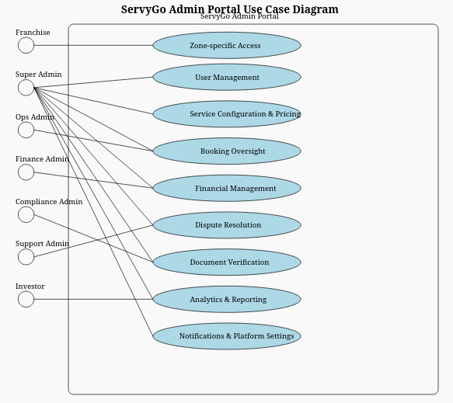
Figure 4.1: Use Case Diagram

4.2 Sequence Diagram
The sequence diagram below illustrates the lead dispute Resolution flow. This shows how the admin portal talks to the backend when admin reviews and resolves a customer dispute.
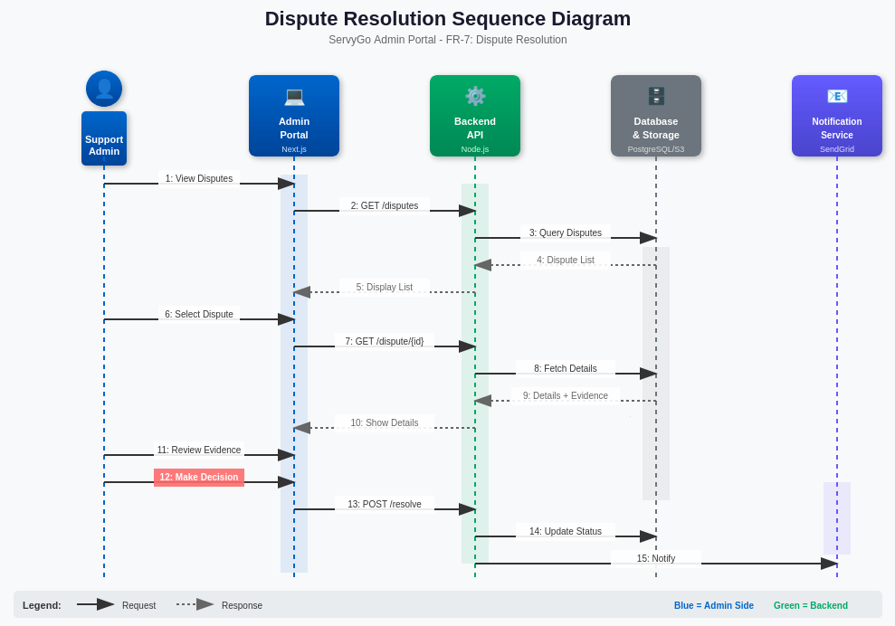
Figure 4.2.1: Sequence Diagram - Dispute Resolution
The sequence diagram below illustrates the booking management flow.
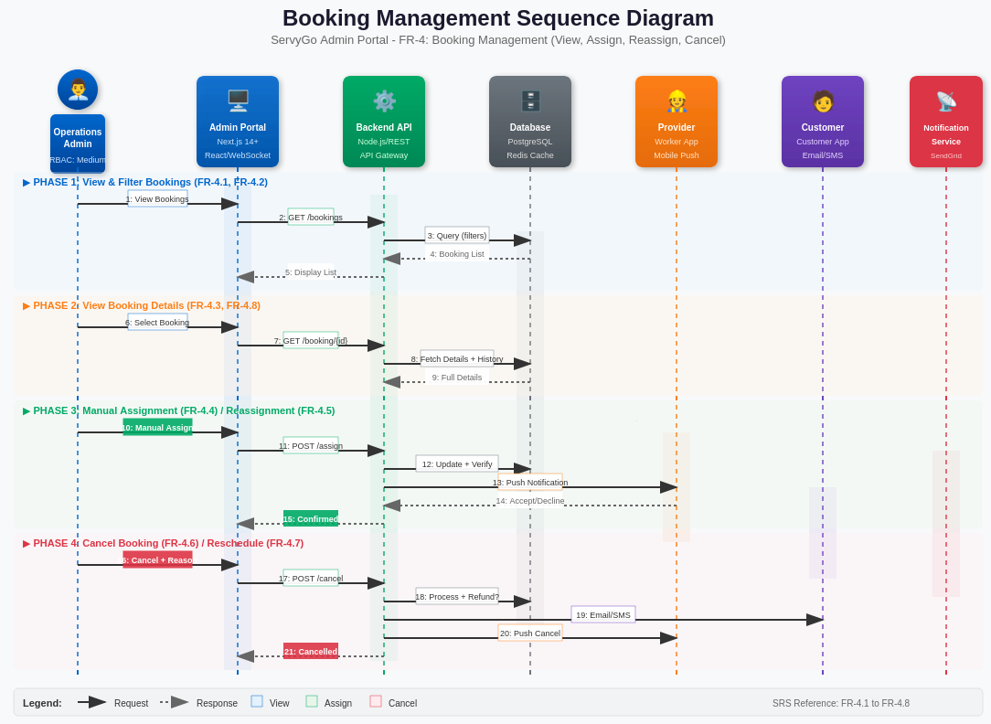
Figure 4.2.2: Sequence Diagram - Booking Management

4.3 Deployment Diagram
The deployment diagram shows the infrastructure architecture and component distribution.
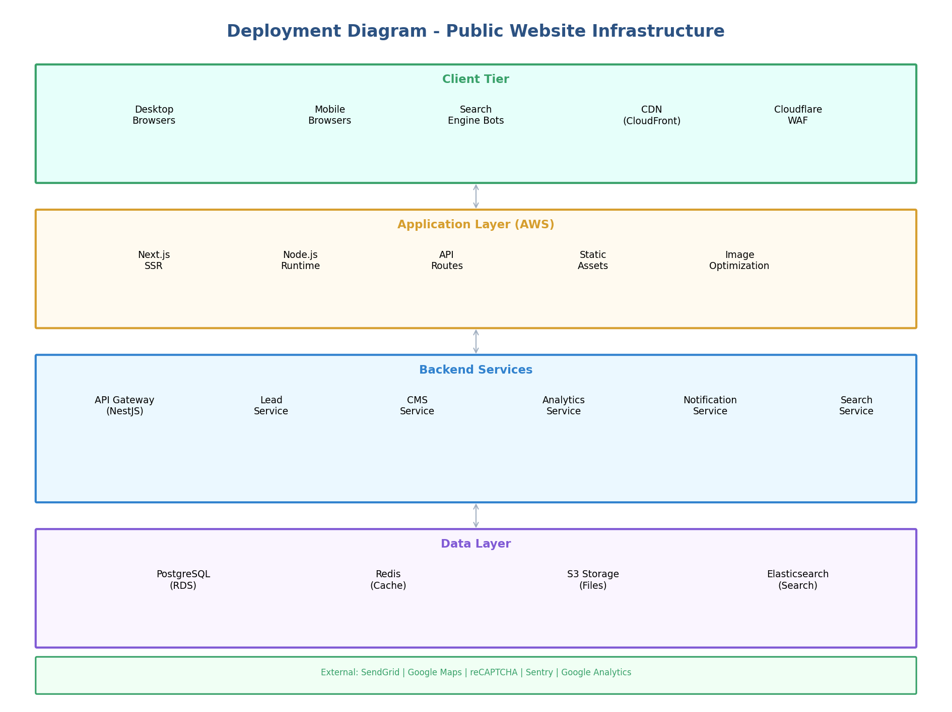
Figure 4.3: Deployment Diagram - Infrastructure

4.4 Entity Relationship Diagram
The ER diagram shows the database tables and their relationships for the Public Website.
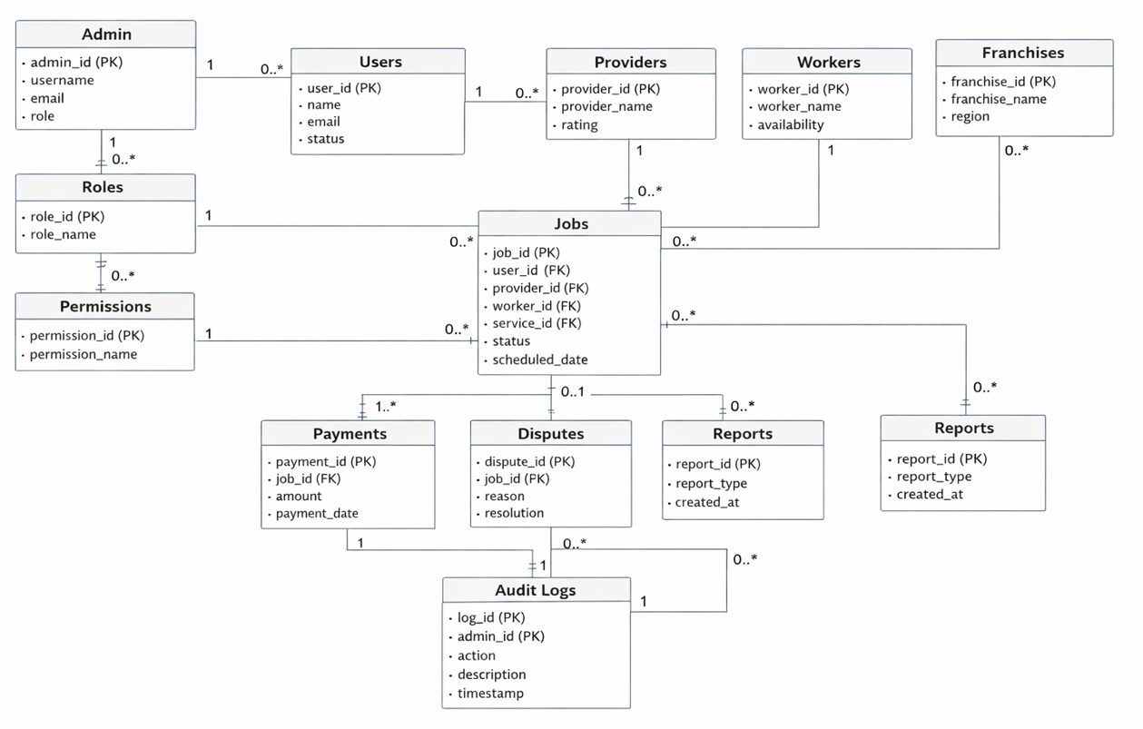
Figure 4.4: Entity Relationship Diagram - Database Schema

4.5 State Machine Diagram
The state machine diagram of lifecycle.
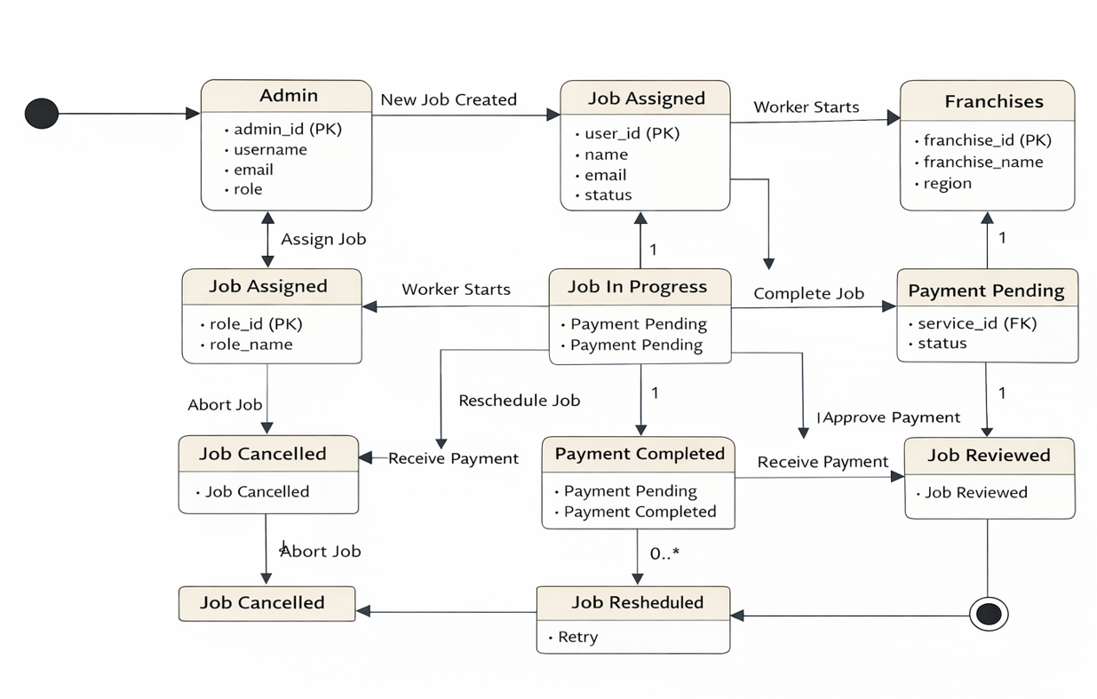
Figure 4.5: State Machine Diagram - Lifecycle

4.6 Flowcharts
The following flowcharts illustrate key business processes:

4.6.1 User Signup and Administrative Document Verification
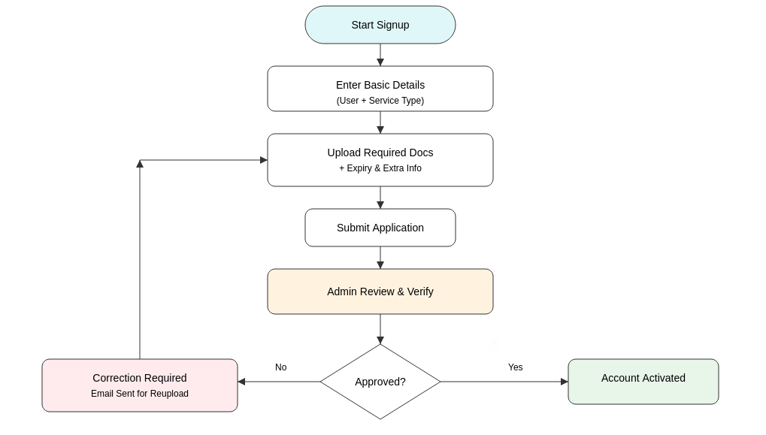
Figure 4.6.1: User Signup and Administrative Document Verification Workflow
This diagram illustrates the end-to-end user registration process, where applicants submit required documents along with relevant metadata (such as expiry details) for administrative review. The operational admin verifies the submission and either approves the account for activation or requests corrections. In case of rejection, the system notifies the user to reupload corrected documents, creating a controlled validation loop until approval is granted.

4.6.2 Administrative Dispute Resolution
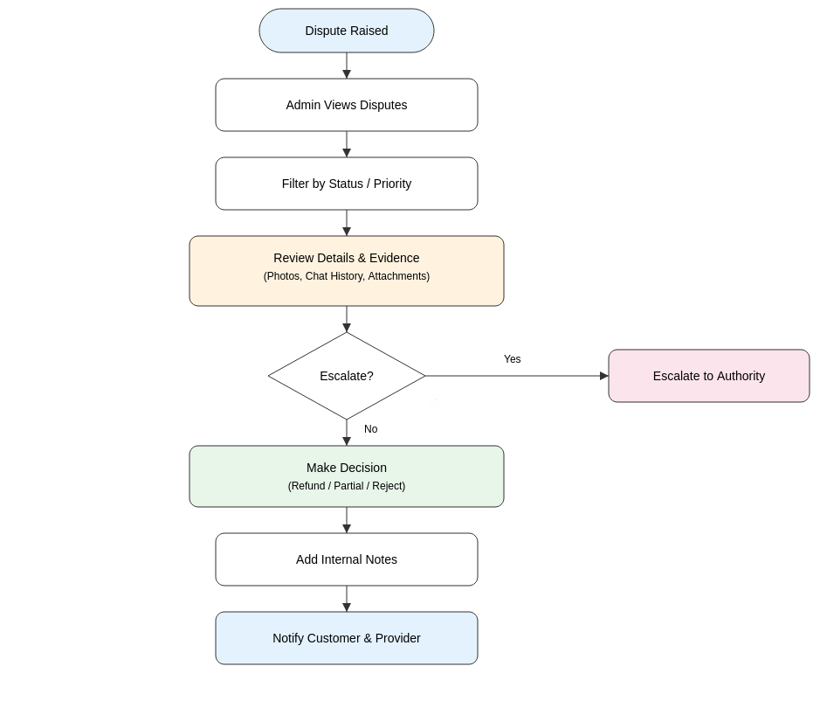
Figure 4.6.2: Administrative Dispute Resolution Workflow
This diagram illustrates the structured dispute handling process managed by the administrator. Upon a dispute being raised, the admin reviews the list of disputes and may filter them by status or priority. The admin then examines dispute details, including supporting evidence such as uploaded photos and chat history. Based on the assessment, the dispute may either be escalated to a higher authority or resolved directly. If resolved, the admin records a decision (refund, partial refund, or rejection), adds internal notes, and the system automatically notifies both the customer and the service provider of the final outcome.

4.6.3 Weekly Auto-Payout Cron with Order Loop
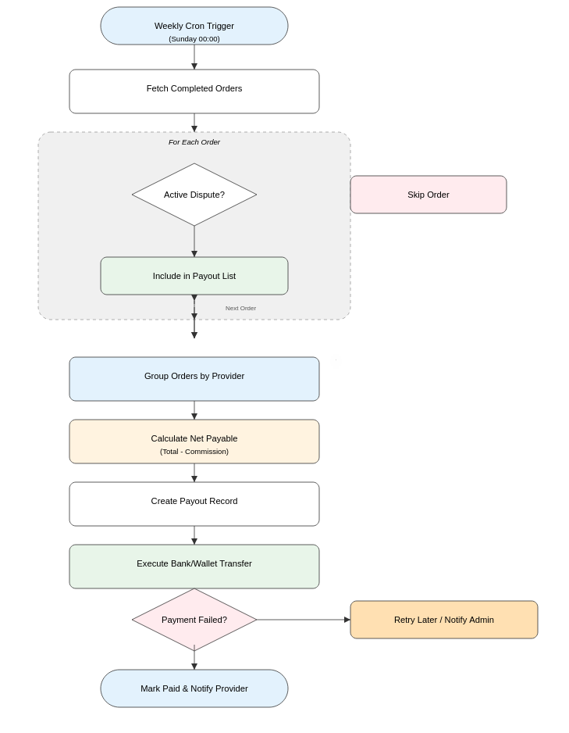
Figure 4.6.3: Weekly Auto-Payout Cron Flow with Order Loop
This diagram represents the weekly automated payout process executed by a scheduled cron job. After triggering, the system fetches all completed service orders. Each order is processed individually in a loop: orders with active disputes are skipped, while eligible orders are included in the payout batch. After iterating through all orders, the system groups the orders by provider, calculates the net payable amount (after deducting commissions), creates payout records, executes bank or wallet transfers, and finally marks the orders as paid while notifying the service providers. If payment fails, then notifies the admin.

4.6.4 Admin Job cancellations
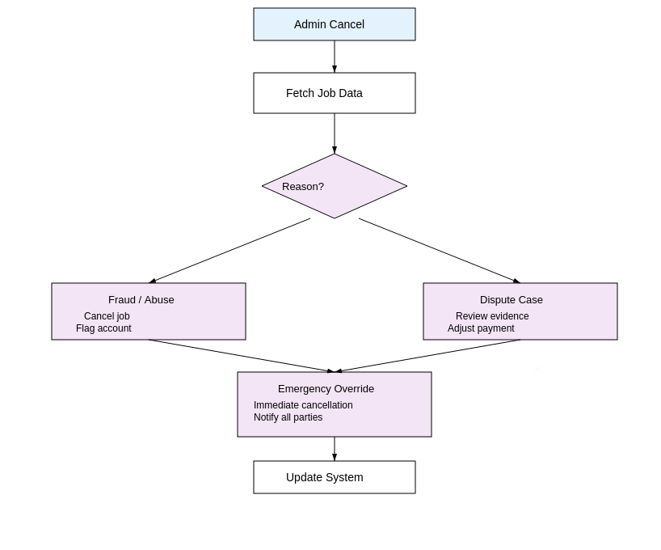
Figure 4.6.4: Admin Job cancel flow

4.6.5 Franchise Job cancellations
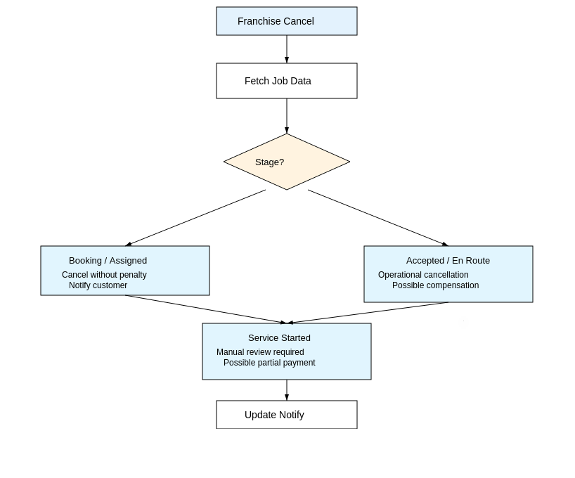
Figure 4.6.5: Franchise Job cancel flow

5. Appendices

5.1 Data Flow Diagrams

5.1.1 DFD Level 0 - Context Diagram
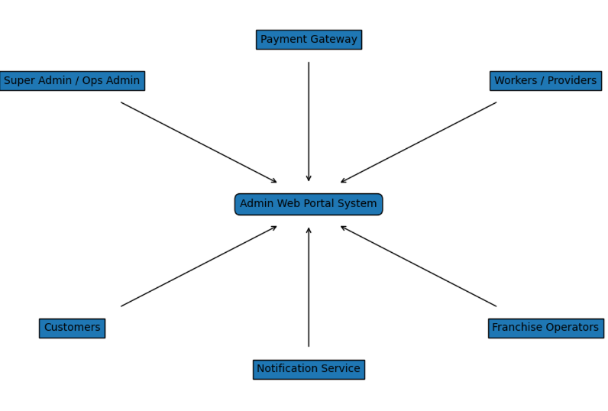
Figure 5.1: Data Flow Diagram Level 0

5.2 Security Threat Model (STRIDE)
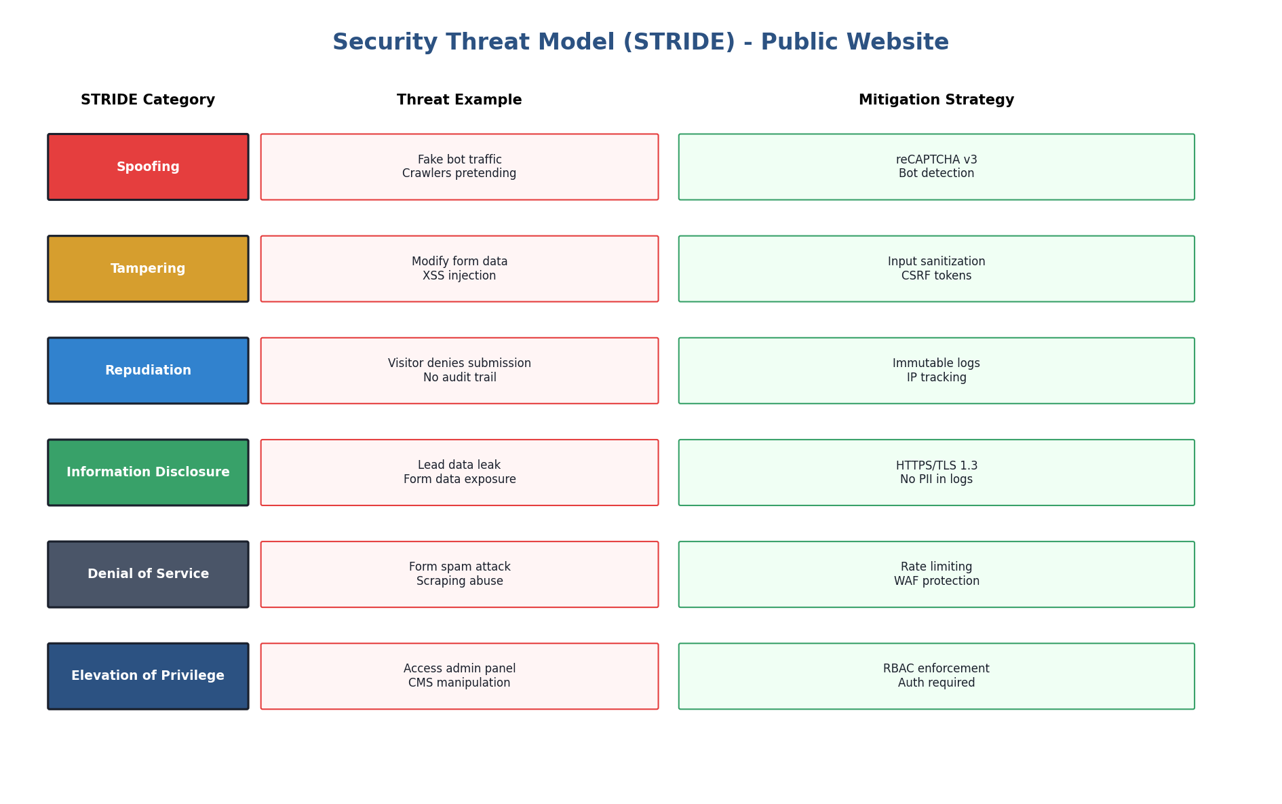
Figure 5.2: Security Threat Model - STRIDE Analysis

5.3 System Architecture
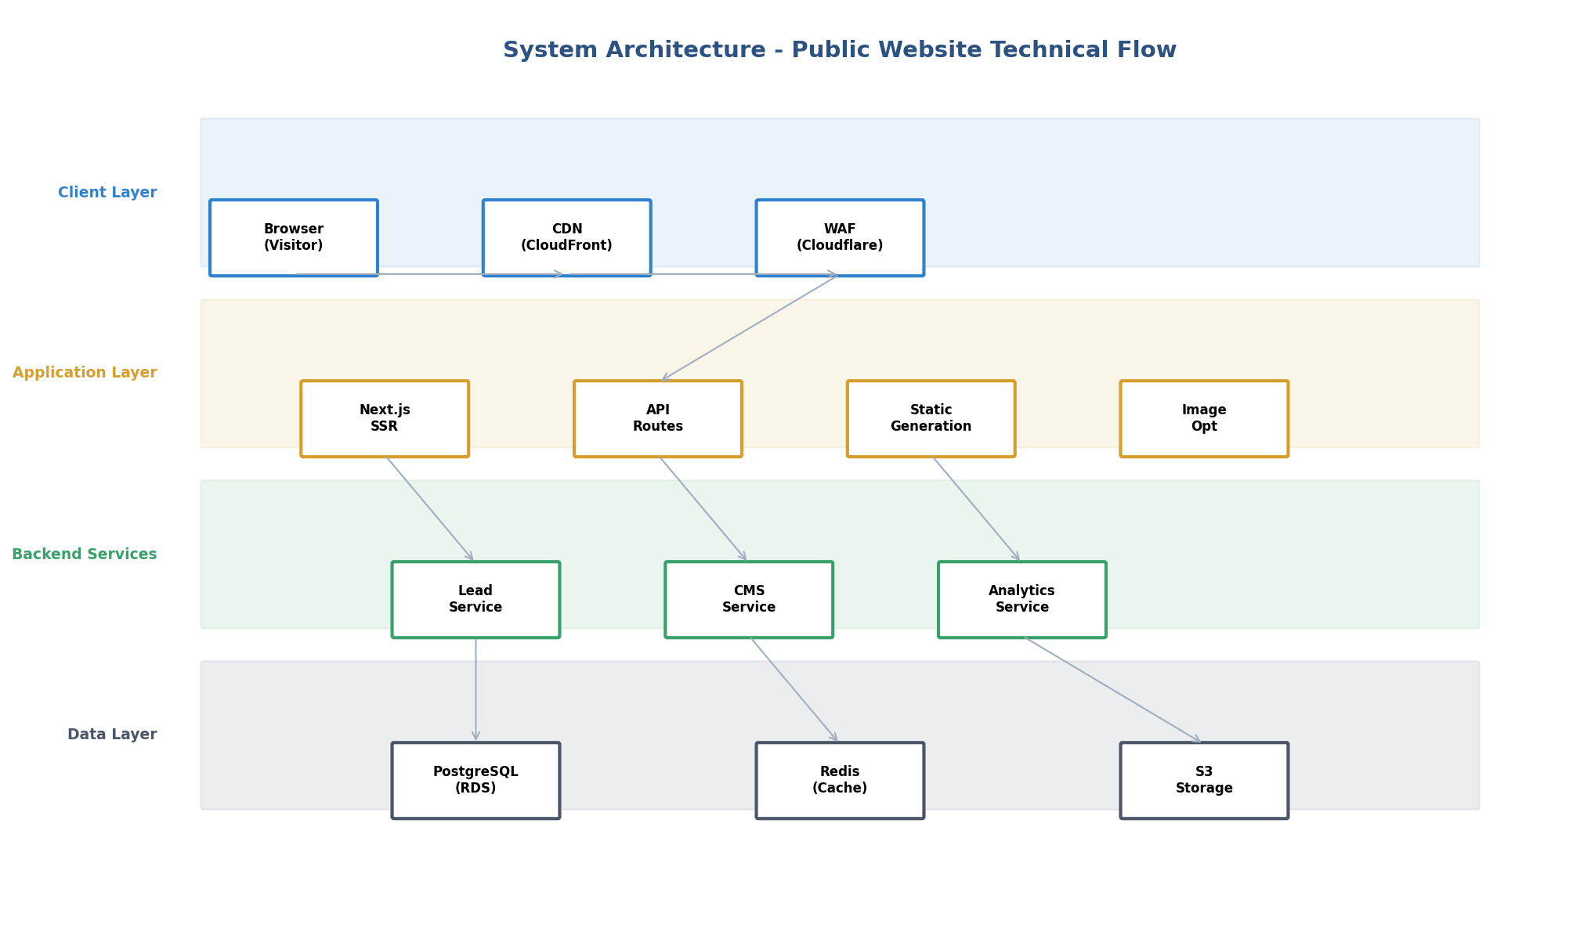
Figure 5.3: System Architecture - Technical Flow

5.4 Backup & Disaster Recovery
- Automated daily backups with 7-day retention are included in Phase 1 delivery.
- Vendor shall document a basic disaster recovery procedure covering restore-from-backup scenarios.
- Full business continuity planning, real-time replication, multi-region failover, and RTO/RPO guarantees are outside Phase 1 scope and available as a paid enhancement.

5.5 Explicitly Out of Scope / Limitations
The following are explicitly excluded from Phase 1 deliverables:
- 24/7 system monitoring or alerting
- Advanced security audits or penetration testing
- Legal compliance certification
- Multi-language support (French) - Phase 2
- Advanced analytics or AI features
- Real-time chat or support systems
- Automated backups are included. Vendor shall document backup process, retention policy, and restoration procedures.
- Basic disaster recovery procedures shall be documented and tested before handover.
- Load testing covering peak concurrent usage is included prior to production launch.
Important: Any items above requiring implementation shall be addressed via separate Change Request and additional pricing.

5.5 Shared Responsibilities Matrix
Responsibility | Client | Vendor | Notes
Privacy Policy content | Yes | No | Legal text provided by Client
Technical privacy features | No | Yes | Banner, forms, logging
Final compliance verification | Yes | No | Legal review by Client
API backend development | No | Yes | Or 3rd party provider
Frontend integration | No | Yes | Next.js implementation
UAT and acceptance | Yes | No | Client sign-off required
Production deployment | No | Yes | AWS deployment
Post-launch monitoring | Yes | No | Optional: Vendor support available
Security hardening | Shared | Shared | Per contract phase
Data retention decisions | Yes | No | Vendor implements policy
Third-party service accounts | Yes | No | AWS, Stripe, etc.
Domain & SSL certificates | Yes | No | Client-owned assets

5.6 Third-Party Services
The following third-party services shall be used to minimize vendor liability and leverage industry-standard solutions:

5.6.1 Infrastructure (AWS) – Mandatory Baseline
Service | Provider | Purpose | Cost Responsibility
AWS Lightsail Container Service | Amazon Web Services | Container hosting | Client
Amazon RDS (PostgreSQL) | Amazon Web Services | Database | Client
Amazon S3 | Amazon Web Services | File storage | Client
AWS CloudFront | Amazon Web Services | CDN (optional) | Client
AWS Route 53 | Amazon Web Services | DNS management | Client
AWS Certificate Manager | Amazon Web Services | SSL certificates | Client (free service)
AWS CloudWatch (Basic) | Amazon Web Services | Infrastructure metrics, logs, alerts | Client
Amazon ECR / Docker Hub | Amazon Web Services / Docker Hub | Container image registry
Terraform | Amazon Web Services | Infrastructure-as-Code provisioning | Client (free)

Note: AWS region for all PII-bearing resources shall be ca-central-1 (Montreal, Canada) to support PIPEDA data residency expectations.

5.6.2 Security & Protection – Flexible Options (Client Selection Required)
Service | Provider | Purpose | Cost Responsibility
Web Application Firewall (WAF) | AWS WAF or Cloudflare WAF | Block OWASP Top 10 threats (SQLi, XSS, etc.) | Client
DDoS Protection – Network Layer | AWS Shield Standard or Cloudflare Free | Mitigate volumetric DDoS attacks | Client (free tier)
DDoS Protection – Application Layer | AWS Shield Advanced or Cloudflare Business | Mitigate sophisticated layer-7 attacks | Client
Bot Management / Rate Limiting | Cloudflare Bot Fight / AWS WAF Rate-Based Rules | Block automated form spam, credential stuffing | Client
Form Protection | reCAPTCHA v3 (Google) | Bot detection for contact/lead forms | Client (free tier ≤1M calls/mo)
Cookie Consent Management | Osano or Cookiebot | Granular cookie consent banner + logging | Client
Security Event Logging | AWS CloudTrail + CloudWatch | Audit trail for admin actions, API calls | Client (Included in CloudWatch)

Selection Process: Client shall confirm preferred security stack (AWS-native vs. Cloudflare vs. hybrid) during infrastructure planning phase. Vendor will implement based on Client's written selection.

5.6.3 Communications – Email/SMS/Push
Service | Provider | Purpose | Cost Responsibility
Email Delivery | SendGrid or AWS SES | Transactional emails: lead confirmations, admin alerts | Client
SMS Gateway (Optional) | Twilio (Canada) or AWS SNS SMS | Critical alerts, OTP (if required) | Client
Push Notifications | Firebase Cloud Messaging (FCM) | Browser push notifications (if PWA enabled) | Client (free tier)

5.6.4 Analytics & Monitoring
Service | Provider | Purpose | Cost Responsibility
Web Analytics | Google Analytics | Visitor behavior, conversion tracking | Client (free tier)
Error Tracking | Sentry | JavaScript error capture, stack traces | Client (free tier 5k errors/mo)
Performance Monitoring | Lighthouse CI + WebPageTest | Page speed validation in CI pipeline | Client (free tier)
Uptime Monitoring | UptimeRobot or AWS CloudWatch Alarms | External health checks, alerting | Client

5.6.5 Integration Notes for Development Team
- Environment Variables: All third-party credentials shall be injected via AWS Secrets Manager or environment variables—never hardcoded.
- Feature Flags: Optional services (WAF, advanced bot mgmt) shall be controlled via feature flags to enable/disable without code changes.
- Fallback Behavior: If a third-party service fails (e.g., reCAPTCHA timeout), core functionality (form submission) shall degrade gracefully with logging.
- PIPEDA Alignment: Any service processing PII (e.g., GeoIP, analytics) shall be configured to minimize data collection and respect user consent preferences.
- Documentation: Vendor shall document all integration points, error handling, and retry logic in the Technical Requirements Document (TRD).

5.7 Risk Register
ID | Risk | Mitigation
R1 | Backend API downtime | fallback messaging
R2 | SEO indexing delay | Sitemap + Schema
R3 | Form spam attack | WAF + CAPTCHA
R4 | CDN outage | Regional fallback
R5 | Third party script slowdown | Async Loading

5.8 Glossary
Term | Definition
Aggregated Rating | Combined performance metrics from multiple providers
CDN | Content Delivery Network - distributes content globally
CMS | Content Management System - for dynamic content
DSAR | Data Subject Access Request - privacy request
GeoIP | Technology to detect user location from IP address
LCP | Largest Contentful Paint - performance metric
Lead | Contact form submission captured for follow-up
OWASP | Open Web Application Security Project - security guidelines
PIPEDA | Canadian privacy law
PWA | Progressive Web App - web app with native features
reCAPTCHA | Google service to detect bots
SEO | Search Engine Optimization - to rank higher in search results
SLA | Service Level Agreement - uptime guarantee
SSR | Server-Side Rendering - for SEO optimization
TLS | Transport Layer Security - encryption protocol
TRD | Technical Requirements Document
UAT | User Acceptance Testing
WAF | Web Application Firewall

