Reliability-Aware Causal Hypergraph Diffusion Transformer for Intelligent Cyber-Physical Energy Network Attack Detection and Operational Integrity Validation
Joshua Issac A ^{1*}, Shanmuga Priya S²
^{1, 2}Department of Computer Science and Engineering, SRM Institute of Science and Technology, Tiruchirappalli, India
joshuaissacscholar@gmail.com, priya501@gmail.com
Correspondence: Joshua Issac A^{1*}, joshuaissacscholar@gmail.com
Abstract
The increasing integration of cyber-physical infrastructures into smart grid environments has improved automation, operational intelligence, and energy management while simultaneously increasing vulnerability to sophisticated cyberattacks, including Denial-of-Service (DoS), Advanced Persistent Threats (APT), malware propagation, and false data injection. Existing intrusion detection approaches based on convolutional neural networks, recurrent neural networks, autoencoders, and conventional graph neural networks primarily capture pairwise relationships and often fail to model higher-order structural dependencies, causal attack propagation, adaptive feature integration, and reliable decision reasoning. To address these limitations, this study proposes a Causal Hypergraph Diffusion Transformer (CHDT) for intelligent cyber-physical intrusion detection in smart grids. The proposed framework integrates Adaptive Event-Aware Causal Hypergraph Construction, causal diffusion learning, spatio-temporal Transformer encoding, Reliability-Aware Adaptive Multi-View Fusion, contrastive representation learning, and physics-constrained neuro-symbolic reasoning within a unified architecture to capture higher-order cyber-physical interactions, long-range temporal dependencies, and cascading attack behaviors. Reliability-aware fusion dynamically combines structural, temporal, and causal representations to produce discriminative feature embeddings, whereas neuro-symbolic reasoning validates predictions through physics-based operational constraints, improving decision reliability. The framework was implemented using Python 3.10 with TensorFlow and PyTorch on an NVIDIA RTX A6000 GPU and evaluated using the Smart Grid Intrusion Detection Dataset. Experimental results achieved 97.82% accuracy, a Macro F1-score of 0.972, an MCC of 0.969, an AUC-ROC of 0.994, an ECE of 0.031, and a false alarm rate of 2.18%, outperforming recent state-of-the-art methods by approximately 1.82% in overall detection accuracy.
Keywords: Smart Grid Security, Cyber-Physical Intrusion Detection, Causal Hypergraph Learning, Diffusion Transformer, Multi-View Contrastive Learning, Neuro-Symbolic Reasoning.
1. Introduction
The rapid development of cyber-physical systems of energy, especially smart grids, has transformed conventional power infrastructures into highly networked, intelligent and data intensive ecosystems (Cavus, 2025; Parizad et al., 2025). These systems combine sensing, communication and control technologies to facilitate real-time monitoring, efficient energy distribution, and adaptable decision-making (Pandey et al., 2025; A. R. Singh et al., 2025). This heightened interconnectivity has however, also increased the attack surface making such systems highly vulnerable to advanced cyber-physical attacks, such as false data injection, distributed denial-of-service attacks as well as coordinated hybrid attacks (Haoyang et al., 2025; Zang et al., 2025). Since the modern power grid is highly dependent on the constant exchange of data and automated control systems, even the smallest failures can be spread throughout the network with large-scale operational failures and material economic losses (Hasan et al., 2023). As a result, security, reliability, and resilience of cyber-physical energy networks has become a key research priority (Yang et al., 2022). Lately, artificial intelligence, machine learning, and deep learning have demonstrated potential in identifying anomalies and intrusions in these systems (Muneer et al., 2024). Convolutional neural networks, recurrent neural networks, and graph-based models are some of the widely studied techniques to analyse temporal and structural patterns in smart grid data (Cavus & Allahham, 2025; Han et al., 2024). Also, the development of graph learning and attention-based models has allowed to model system dependencies better (Pang et al., 2024). Regardless of these developments, the growing complexity, scale, and dynamic nature of cyber-physical energy networks require more sophisticated frameworks that are able to capture higher-order interactions, model dynamic attack propagation, and provide interpretable and trustworthy decision-making (Belgacem & Chihi, 2025).
The existing studies on cyber-physical energy network security have been mainly concerned with data-driven anomaly detection through traditional machine learning and deep learning methods (Hossain-McKenzie et al., 2025). Initial models, such as Support Vector Machines and Random Forest classifiers, were shown to be effective in detecting known patterns of attacks but were not adaptable to changing attacks (Sadiq et al., 2025). Afterwards, deep learning systems like convolutional and recurrent neural networks enhanced the accuracy of detection by identifying both the spatial and temporal relationships of grid data (Nguyen et al., 2023). Graph Neural Networks, which are more recent, have been proposed to model structural links among grid components, providing a more realistic model of how systems interact (He et al., 2026). Although these approaches are a milestone, there are a number of constraints that are yet to be addressed. The existing methods are based on pairwise graph modeling, which does not provide higher-order dependencies, which are a characteristic of complex energy system models where multiple components interact concurrently (Wen, 2025). Moreover, existing models are mainly reactive and only focus on identifying anomalies once they occur without modeling the propagation dynamics of cyber-physical attacks (Kabir et al., 2025). The other severe restriction is that one cannot easily interpret the results, as many deep learning models are black boxes, and it is hard to trust and validate the decisions made by the black box (Petch et al., 2022). Also, the current frameworks can ignore domain-specific physical constraints, leading to predictions that can be in conflict with fundamental energy system principles (Neureiter & Binder, 2022). Such inadequacies indicate that a more comprehensive approach is required that integrates structural, temporal, causal and physical knowledge and ensures explainability and scalability in real-world deployments.
To address the limitations discussed above, the study presents a Causal Hypergraph Diffusion Transformer Framework with Neuro-Symbolic Reasoning to enable scalable detection of cyber-physical energy network attacks and integrity verification. The proposed framework presents a new representation of smart grid systems in the form of causal hypergraphs that allow modeling higher-order interactions and system-wide dependencies, beyond the traditional pairwise representations. To model the dynamic propagation of disturbances and attacks, a causal diffusion mechanism is included to enable the system to shift to an analysis of predictive disturbances and attacks, rather than an analysis of the disturbance and attack as it occurs. Moreover, it uses a Transformer-based architecture, which learns long-range spatio-temporal dependencies, to ensure it is effective in modeling the changing behaviour of the system in large-scale networks. The framework incorporates the concept of multi-view learning as it integrates structural, temporal, and causal viewpoints. Unlike traditional black-box models, the proposed approach integrates neuro-symbolic reasoning, which is a combination of deep learning predictions and rule-based logic and domain knowledge to present interpretable and trustful decisions. Also, it includes physics-constrained optimization in the process of learning models to make sure that the outputs of the models are consistent with the basic laws of the energy systems. Such combination of causal modeling, higher-order structural learning, diffusion-based propagation, and explainable reasoning work wonders to existing methodologies. The proposed framework does not only enhance accuracy of detection and generalization, but also increases interpretability and physical consistency, and is therefore very suitable to the real-world cyber-physical energy network security application.
1.1 Research Motivation
Smart grids and cyber-physical energy systems have even increased the need to have strong and intelligent security systems. Conventional detection techniques cannot be used to manage sophisticated and changing attack patterns and interdependence of systems. This study is motivated by the fact that there is a need to establish an interpretable and scalable framework with the capacity to capture higher-order relationships, model the propagation of attacks and make reliable decisions. This study will combine causal modeling, state-of-the-art deep learning architectures and symbolic reasoning to bridge the gap between high detection accuracy and practical applicability in real-world energy systems.
1.2 Research Significance
The study has made theoretical and practical contributions to the subject of cyber-physical system security. In theory, it builds upon existing research, introducing an integrated framework, which combines causal hypergraph modeling, diffusion learning, and neuro-symbolic reasoning. In practice, it is a scalable and reliable solution to detecting and verifying cyber-physical attacks in smart grids. Physics constraints and explainable reasonings increase the trust and usability to system operators. Altogether, the suggested solution enhances the resilience of the system, helps to make informed decisions, and strengthens the security of critical energy infrastructures.
1.3 Problem Statement
Cyber physical energy networks such as smart grids need to have robust intrusion detection mechanisms to ensure the security and stability of the energy network. Existing methods that leverage deep learning and graph neural networks enhance the accuracy of attacks detection, however, existing methods prioritize pairwise relationships and only small temporal modeling (Wang et al., 2025). These approaches have insufficient capability and accuracy in addressing higher-order dependencies, causal attack propagation and interpretable reasoning in complex cyber-physical environments (Govindarajan & Muzamal, 2025). This makes the detection robustness, scalability and integrity validation challenging under changing attack situations. This study introduces a causal hypergraph diffusion transformer framework for scalable and interpretable intrusion detection, which aims to overcome these limitations.
1.4 Recent Innovations and Challenges
The recent developments in graph learning, attention-based models, and deep neural networks have enhanced the detection of anomalies in cyber-physical systems. The appearance of Graph Neural Networks and Transformer architectures have allowed modeling the structural and temporal dependencies in a better way. Nevertheless, there are still difficulties in the capture of higher order interactions, modeling causal relationships and ensuring interpretability. Also, the incorporation of domain-related knowledge, physically defined laws, into data-driven models is also an open research problem. To deal with these issues a hybrid approach incorporating sophisticated learning methods with reasoning processes and domain constraints is needed.
1.5 Key Contributions
- Proposes a causal hypergraph-based modeling framework to capture higher-order dependencies and system-wide interactions in cyber-physical energy networks.
- Introduces a diffusion-driven attack propagation mechanism for modeling dynamic and evolving cyber-physical threats.
- Develops a Transformer-based spatio-temporal learning architecture for capturing long-range dependencies and complex system behavior.
- Integrates neuro-symbolic reasoning to enhance interpretability, reliability, and decision transparency in attack detection.
- Incorporates physics-constrained optimization to ensure predictions are consistent with fundamental power system laws, improving trustworthiness and real-world applicability.
1.6 Rest of the Section
Section 2 conducts a literature review and determines gaps in research. Section 3 outlines the suggested methodology and model design. Section 4 provides the experimental results and performance analysis. The findings and implications are talked about in Section 5. Lastly, the study is concluded with Section 6 that outlines future study directions to improve the security of cyber-physical energy networks.
2. Related works
Recent advances in cyberattack detection for cyber-physical energy systems have increasingly adopted graph learning, deep neural networks, Transformer architectures, and ensemble learning techniques to improve intrusion detection performance. Even though significant advancements have been made, current methods still have drawbacks, such as the inability to model higher-order cyber–physical interactions, propagate attacks over time, fuse features adaptively, and make trustworthy decisions.
Graph-based learning has proven to show great potential in representing network relationships in intrusion detection. To tackle this challenge, Wang et al. (2025) proposed the Behavior Similarity Graph Attention Network (BS-GAT) that utilizes weighted edge relationships to learn interactions between network flows and enhances graph construction. The model was able to attain high performance on binary and multi-class classification tasks, but mainly captures pairwise relationships, and does not explicitly consider higher-order interactions, mechanisms of causality, or interpretation. In a similar way, Govindarajan and Muzamal (2025) applied graph neural networks alongside an autoencoder and contrastive learning for improving contextual feature learning for cloud-based intrusion detection. Although their hybrid architecture provides better detection accuracy and scalability, it significantly increases the computational complexity and doesn't explicitly model the evolving causal relationships or dynamic cyber-physical dependencies.
Several deep learning approaches have focused on improving feature extraction and temporal modelling. Kaur et al. (2023) applied convolutional neural network (CNN) and Bayesian deep learning (BDL) to improve probabilistic intrusion detection (PID) for smart grid applications. While the Bayesian formulation can improve uncertainty estimation, it does not support structural relationship modelling, and does not include long range temporal interactions between the distributed cyber-physical components. Similarly, AlHaddad et al. (2023) presented a CNN-GRU ensemble for detecting DDoS attacks in smart grid communication networks, which integrates spatial and temporal features. The framework, however, is restricted to lower-order feature interactions and is not leveraging of graph-based structural representations and causal attack propagation. Likewise, Mehedi et al. (2022) have used transfer learning with ResNet for enhancing intrusion detection in heterogeneous IoT environments, however, they are relying on a pretrained feature extractor which leads to limited adaptability to the changes in attack behaviors and lack of interpretability.
The distributed and privacy-preserving intrusion detection is also an interesting topic. Tariq et al. (2024) proposed a federated learning framework with a support vector machine (SVM) for the fog-edge smart grid environment, achieving enhanced privacy preservation and distributed learning efficiency. Zhai et al. (2023) also combined federated learning with CNN-GRU-attention networks to improve intrusion detection in a decentralized setting. While both methods are able to deal with privacy concerns, their core is mostly traditional feature learning techniques and do not explicitly support higher-order graph representations, causal dependency modelling, or interpretable reasoning mechanisms. Nevertheless, Shtayat et al. (2023) tried to achieve transparency in the model using explainable ensemble learning methods with SHAP and LIME, but in this approach, the explanation process occurs after the prediction, which is not part of the learning architecture. Sharaf et al. (2023) suggested using a deep ensemble framework optimized by using metaheuristic algorithms to increase the accuracy of the detection process, but the proposed framework is not structural and causal modelling and is a high computational cost. Moreover, Sen et al. (2023) have designed synthetic data generation with graph learning to model multi-stage cyberattacks, which is useful to represent the attack scenario but is not directly used for intrusion detection or evaluation of detection performance during realistic deployments.
In conclusion, the current research shows substantial improvements in intrusion detection performance, with most focusing on static graph structures, traditional feature fusion techniques, or single deep learning models. Few methods that are able to model adaptive, higher-order cyber-physical interactions, causal attack propagation, reliability-aware multi-view feature integration, and physics-guided reasoning all in one, while in a single framework. These restrictions inspire the proposed Causal Hypergraph Diffusion Transformer (CHDT) that combines Adaptive Event-Aware Causal Hypergraph Construction (AECH), causal diffusion learning, spatio-temporal Transformer modelling, Reliability-Aware Adaptive Multi-View Fusion (RAMF), and physics-constrained neuro-symbolic reasoning to build a comprehensive, interpretable and scalable cyberattack detection system for modern cyber-physical energy systems.
Table 1. Summary of Existing Studies in Intrusion Detection for Smart Grid and IoT Environment
Author | Model | Advantages | Limitations
Wang et al. (2025) | BS-GAT (Graph Attention Network) | Effective graph-based feature representation, improved multi-class handling | Lacks interpretability, scalability concerns, no causal or higher-order modeling
Govindarajan & Muzamal (2025) | GNN + Transformer + Contrastive Learning | Integrates spatial and contextual learning, handles class imbalance, supports real-time inference | High architectural complexity, no causal reasoning, limited higher-order modeling
Kaur et al. (2023) | CNN + Bayesian Learning | Combines deep feature extraction with probabilistic inference | No structural modeling, lacks temporal dynamics and explainability
Tariq et al. (2024) | SVM + Federated Learning (FL) | Ensures data privacy, enables distributed collaborative learning | Limited feature learning capability, lacks structural and interpretability mechanisms
Sharaf et al. (2024) | MGODEL-ID (LSTM + DAE + ELM + Optimization) | Hybrid ensemble with optimized feature selection and tuning | High computational complexity, lacks interpretability and structural modeling
AlHaddad et al. (2023) | CNN + GRU Hybrid Model | Captures spatial and temporal patterns, supports real-time monitoring | No structural relationships, lacks explainability and causal analysis
Zhai et al. (2023) | CNN–GRU + Federated Learning + Attention | Enhances feature representation, supports decentralized learning | Moderate generalization, lacks structural and causal modeling
Shtayat et al. (2023) | Explainable Ensemble DL (SHAP + LIME) | Provides model interpretability and decision transparency | Increased computational overhead, no structural or causal modeling
Mehedi et al. (2022) | Deep Transfer Learning (ResNet) | Handles limited labeled data, improves generalization in IoT environments | Depends on pre-trained models, lacks interpretability and temporal/structural modeling
Sen et al. (2023) | Graph-based Synthetic Data Generation | Models multi-stage attack behavior, supports dataset generation | Limited validation, not a complete IDS
Table 1 is a comparative overview of recent intrusion detection approaches used in smart grid and IoT environments highlighting the models, advantages, and limitations. The existing techniques such as graph-based models, hybrid deep learning architectures, federated learning frameworks, and explainable AI techniques are well-performing in terms of accuracy and feature representation. Most of the approaches, however, are limited to pairwise relationships, fail to model higher-order relationship and are unable to model the propagation of the cyber-physical attacks over time. In addition, problems related to whether the results are interpretable, lack of causal reasoning, and high computational complexity are still unsolved. This study suggests a causal hypergraph diffusion transformer framework for better detection, interpretability and system-level understanding.
3. Proposed Method for Causal Hypergraph-Based Attack Detection in Smart Grids
The proposed study introduces a scalable and intelligent cyber-physical intrusion detection framework for secure monitoring and integrity validation in modern smart grid environments. This approach combines techniques of causal hypergraph learning, diffusion-based attack propagation modeling, Transformer-driven spatio-temporal representation learning, multi-view feature fusion, and neuro-symbolic reasoning by stacking them into one unified framework. First, operational grid data, including information on the behavior of network communication, power system measurements and attack labels, are collected and preprocessed to eliminate inconsistencies and maintain temporal dependence. The cleaned data is then converted to a causal hypergraph representation, with nodes being the entities in the grid and hyperedges representing higher-order interactions between several components. Thereafter, a causal diffusion mechanism is learned to understand the propagation of disturbances and attacks in interconnected cyber–physical infrastructure. The diffusion embeddings generated are passed to a Transformer-based spatio-temporal learning module that is able to model long-range temporal dependencies and the changing dynamics of a system. Representational robustness is enhanced by structural, temporal and causal views being merged together in a single embedding space via contrastive learning. Lastly, the framework implements attack classification and integrity validation with physics-constrained neuro-symbolic reasoning, which is used to validate predictions based on power system operational rules and logical constraints. This seamless process supports an accurate, interpretable, and physically consistent cyber-physical security monitoring of large-scale energy networks. The overall workflow illustrates in Figure 1.
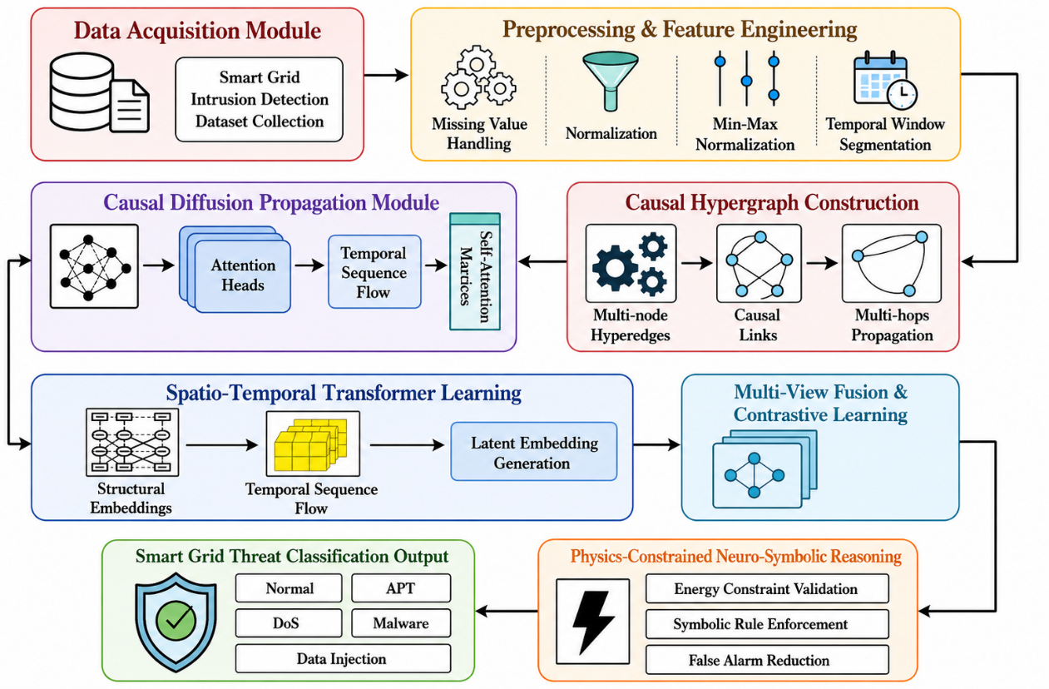
Figure 1. Workflow of the Proposed Study
3.1 Data Collection
The Smart Grid Intrusion Detection Dataset (Hussain Afzaal, 2023) is the main data source for the development and evaluation of the proposed intrusion detection framework. The data are operational measurements of a cyber-physical smart grid environment both in normal and malicious conditions. The data includes important electrical parameters like voltage, current, power consumption, and frequency fluctuations, all of which illustrate the on-the-fly dynamics of the energy network. The data set also contains labeled examples that identify cyberattacks of different categories, which allows supervised learning and performance assessment. The dataset is chosen because it is relevant for smart grid security and also to cover a large variety of different attack scenarios, such as data manipulation and intrusion ones. It presents a realistic picture of the dynamics of the systems and is appropriate for modelling complex interactions in the cyber-physical energy networks. The presence of labeled classes of attacks also helps to accurately classify and validate intrusion detection models. In summary, the dataset offers a thorough understanding of system dynamics and facilitates the creation of reliable, scalable, and efficient cybersecurity solutions. Table 2 shows a sample of the dataset in the present study, which contains samples of the key features and labeled samples of normal and attack scenarios.
Table 2. Sample Records from Smart Grid Intrusion Detection Dataset
Timestamp | Source-IP | Destination-IP | Port | Protocol | Packet-Size | Duration (s) | Attack-Type | Is-Attack | Packet-Loss
2023-01-01 00:00:00 | 172.16.0.3 | 10.0.0.101 | 8002 | UDP | 783 | 69.67 | DoS | 0 | 4.07
2023-01-01 01:00:00 | 192.168.1.4 | 172.16.0.102 | 4127 | TCP | 1201 | 70.24 | Data Injection | 0 | 4.68
2023-01-01 02:00:00 | 192.168.1.1 | 192.168.1.100 | 1361 | UDP | 543 | 17.25 | APT | 0 | 2.56
2023-01-01 03:00:00 | 172.16.0.3 | 192.168.1.100 | 8427 | UDP | 85 | 50.06 | Normal | 1 | 4.75
2023-01-01 04:00:00 | 172.16.0.3 | 192.168.1.100 | 358 | UDP | 1436 | 41.25 | Malware | 0 | 2.67
3.2 Data Preprocessing
Cyber-physical intrusion detection systems involve a lot of data processing, and raw data from the smart grid network may include noise, inconsistencies, and non-uniform feature distributions. The quality of data improves, features are better represented, there is no loss of information about time dependencies, and the stability of models is enhanced. Preprocessing in this study consists of data cleaning, feature normalization, temporal alignment through label encoding and partitioning of the dataset prior to effectively learning through causal hypergraph diffusion transformers.
3.2.1 Data Cleaning
The raw smart grid intrusion data might also include some missing entries, duplicated data, inconsistent data, and noisy measurements due to either communications mistakes or sensor failure. Such problems have detrimental influences on the learning ability of deep neural networks and consequently on the accuracy of intrusion detection system. Thus, data cleaning is done to ensure consistency and reliability of the data sets. Records with missing numerical values are imputed based on averages, and duplicate and corrupted records are deleted. A statistical threshold analysis is used to filter noisy traffic samples, which are not operating in the normal range. The cleaned feature value is represented as in Equation (1),
$x_{clean}=\frac{1}{N}\sum_{i=1}^{N}{x_{i}}$ (1)
where $x_{clean}$ is the feature's value after cleaning, $x_{i}$represents the single valid samples, and $N$ indicates the number of observations that are valid but not missing. The process guarantees that there are quality and consistency in the data for later learning stages.
3.2.2 Feature Normalization
The features of the dataset are heterogeneous, with different numerical ranges for the different features, such as packet size, duration, and packet loss. Convergence efficiency can be compromised and learning can be biased if there are great differences between the magnitudes of the features. To overcome this problem, Min-Max normalization and Z score scaling is used to convert feature values into a similar range. This normalization helps to create a more stable training environment and helps to increase the speed of optimization in deep learning systems. The Min-Max normalization process is given as in Equation (2),
$x^{'}=\frac{x-x_{min}}{x_{max}-x_{min}}$ (2)
Where $x$ is the value of the original feature, $x_{min}$ and $x_{max}$ are the minimum and maximum values of the feature, respectively, and x′ is the normalized feature value. Normalization ensures that each feature has an equal contribution to training, which helps mitigate feature dominance issues and enhances the robustness of the model.
3.2.3 Temporal Alignment and Label Encoding
Cyber-physical energy network traffic has strong temporal dependencies, as attacks change over time and impact multiple parts of the system one after another. As such, the temporal alignment is done with the help of the timestamp information, to maintain the temporal order of the communication events. This process allows the model to be used in an effective way to capture dynamic attack propagation patterns. Further, categorical (such as protocol type and attack labels) attributes are mapped to numerical values using label encoding for efficient processing in a deep learning framework. The principle of labeling encoding is found in Equation (3),
$y_{i}∈\{0,1,2,…,K\}$ (3)
where $y_{i}$ denotes the class label of the $i^{th}$ sample (encoded) and $K$ is the number of attack categories. This change allows the model to differentiate between normal and several intrusion classes, and to keep temporal consistency in sequential network data.
3.2.4 Dataset Splitting
The data is then split into training, validation, and testing sets for reliable model learning and unbiased performance assessment. The training set is used to tune the model parameters and the validation set is used for hyperparameter tuning and to prevent overfitting. The testing set assesses the robustness of the proposed framework to unseen conditions of attacks. The well-partitioned data enables a proper analysis of the experiments and avoids the data leakage between training and testing phases. The splitting of the data set is represented as in Equation (4)
$D=D_{train}∪D_{val}∪D_{test}$ (4)
Here, $D$ is the full data set, $D_{train}$ is the training portion of the data set, $D_{val}$ is the validation portion of the data set and $D_{test}$ is the testing portion of the data set. This approach enhances the reliability of the models and facilitates comprehensive assessment of intrusion detection accuracy in various cyber-attack scenarios.
3.3 Adaptive Event-Aware Causal Hypergraph Construction
Graph-based cyberattack detection methods generally represent cyber-physical energy systems using pairwise node relationships, which are insufficient for modelling the higher-order interactions among multiple interconnected devices. While hypergraph learning is an extension of the traditional graph learning approach to learning multiple nodes at once using a single hyperedge, most current hypergraph construction techniques use a fixed hypergraph topology throughout learning. These static images cannot adequately represent the continuously changing nature of communication behaviours; cascading cyberattacks and dynamic operational dependencies in modern cyber-physical energy systems. Given this weakness, the proposed framework also proposes an Adaptive Event-Aware Causal Hypergraph (AECH) construction mechanism that dynamically generates higher-order relationships based on the real-time operational events and changing cyberattack behaviours.
In the proposed framework, every node represents a cyber-physical element like substation nodes, intelligent electronic devices, smart meters, sensors, communication gateways, and control units. In the proposed approach, a hyperedge is adaptively built, which uses both spatial interaction, temporal synchronization, causal dependency, and operational event similarity. In this way, the hypergraph topology dynamically changes according to the attacks, which enables the model to describe coordinated attacks with several interconnected components. The adaptive causal hypergraph is shown as in Equation (5).
$\begin{matrix} & H=(V,E,W), & & \end{matrix}$ (5)
where $V$denotes the set of cyber-physical entities, $E$represents the dynamically generated hyperedges, and $W$denotes the adaptive hyperedge weight matrix. The hypergraph topology is updated only when there is a significant change in the communication behaviour, the operational status, or the propagation of attacks, in order to keep the structural representation up to date with the current status of the system. The adaptive hyperedge weight between two connected entities is computed as in Equation (6).
$\begin{matrix} & W_{ij}=\frac{αS_{ij}+βT_{ij}+γC_{ij}+δO_{ij}}{α+β+γ+δ}, & & \end{matrix}$ (6)
where $S_{ij}$ denotes the spatial interaction similarity between nodes $i$and $j$, $T_{ij}$represents temporal synchronization similarity, $C_{ij}$corresponds to the causal dependency strength estimated from historical attack propagation, and $O_{ij}$represents the operational event similarity extracted from communication and system activities. The hypergraph construction process is controlled by the adaptive coefficients $α$, $β$, $γ$, and $δ$, which modulate the relative contribution of structural, temporal, causal and operational information.
The proposed Adaptive Event-Aware Causal Hypergraph continually re-establishes higher-order cyber-physical interactions based on the changing network behaviours. This results in an adaptive structural representation that retains high-order multi-node dependence, better modelling of coordinated attacks propagation, and more discriminative feature representation for the ensuing causal diffusion learning module. Therefore, the proposed approach increases the robustness, scalability, and attack detection capabilities of large-scale cyberphysical energy networks, and is compatible with the other steps of the proposed framework.
3.4 Causal Diffusion-Based Attack Propagation Modeling
The proposed framework builds causal hypergraph representation of the smart grid environment, and then models the propagation of cyber-physical disturbances using causal diffusion in order to investigate the propagation of the disturbances through time in the interconnected smart grid components. Unlike most energy networks, in cyber-physical networks, attacks are likely to not just be confined to one node, but to spread through the communication links, synchronized control operations, and power flow dependencies. Traditional intrusion detection approaches are mainly based on static anomaly detection and lack the ability to represent the evolution of an intrusion sequence. In order to overcome this restriction, causal diffusion learning is proposed to learn the direct and indirect influence relationship between substations, sensors, communication devices, and electrical loads.
First, the hypergraph structure is converted to a causal interaction matrix, which is used to quantify the influence between the entities of the network based on temporal correlations, dependency strength in the operation of the entities, behaviour of communications between them and synchronized changes in energy. The casual influence relationship is shown as in Equation (7),
$C_{ij}=P(v_{j}^{t+1}∣v_{i}^{t})-P(v_{j}^{t+1})$ (7)
where $C_{ij}$ is the causal influence score between node $v_{i}$ and node $v_{j}$, $P(v_{j}^{t+1}∣v_{i}^{t})$ is the conditional probability that node $v_{j}$ is affected at $t+1$ given it is in an operational state of node $v_{i}$at time $t$, and $P(v_{j}^{t+1})$ is the independent occurrence probability of a node $v_{j}$. The more causal score is high, the more propagation influence there is between cyber-physical entities.
After causal relationships are detected, the framework dynamically carries out diffusion propagation to simulate the propagation of attacks within the energy network. The diffusion process is a process that integrates cyber communication interactions and physical energy flow dependencies to create a realistic attack evolution simulation. The diffusion propagation operation is described as in Equation (8),
$S^{\left(t + 1\right)}=α\hat{H}S^{\left(t\right)}+(1-α)X$ (8)
where $S^{\left(t\right)}$ represents the propagated node state at time step $t$, $\hat{H}$denotes the normalized hypergraph structure, $X$corresponds to the initial node feature matrix, and $α$is the diffusion coefficient controlling propagation intensity. This iterative process propagates normal and abnormal behavioral information in the hypergraph, thus encoding the cascading cyber physical attack dynamics.
Finally, the propagated diffusion representations are converted into high-dimensional attack propagation embeddings for learning by a Transformer. The embedding generation process is shown as in Equation (9),
$Z=σ(W_{d}S+b_{d})$ (9)
where $Z$ is the causal diffusion embedding matrix, $W$ is the trainable diffusion weight matrix, S is the propagated node state features, $b_{d}$ is learnable bias vector, and $σ$ is the nonlinear activation function. These embeddings capture the temporal evolution of attacks, higher-order dependencies, and causal propagation properties, which enhance the robustness and scalability of the intrusion detection system in cyber-physical energy networks.
3.5 Spatio-Temporal Transformer-Based Representation Learning
The proposed framework then leverages spatio-temporal learning based on the Transformer network to model the dynamic cyber-physical interactions and attack behaviors in the smart grid environment, following the causal diffusion propagation stage. When it comes to large scale energy networks, cyber-attacks and operational disturbances are not limited to affecting only one component; they can spread from substation to communication devices, to sensors to control units over time. Linear sequential models like recurrent neural networks (RNNs) and LSTMs tend to lose long-range temporal relationships and intricate inter-node connections under complex models. In order to address these limitations, the proposed study utilizes an architecture that is based on the Transformer, which is able to learn temporal evolution patterns as well as spatial interactions between distant grid entities.
Causal diffusion embeddings from the previous stage are converted to sequential temporal representations while maintaining the operational changes/transitions of the network components across successive time steps. These sequences contain the transmission of packets, changes of energy flows, communication activities and states of interactions between nodes in the cyber-physical energy network. The Transformer architectures lack the notion of temporal ordering, and to preserve it, positional encoding is added to the architectures. The positional encoding is performed as shown in Equation (10),
$PE(pos,2i)=sin⁡\left(\frac{pos}{{10000}^{2i/d}}\right)$ (10)
where $PE(pos,2i)$denotes the positional encoding value for sequence position $pos$, $i$ is the embedding dimension index and $d$ is the embedding dimensionality. It is a coding scheme that allows the model to differentiate temporal locations of communication events and operational transitions in the smart grid.
The Transformer then learns from self-attention, which is used to detect the most significant interactions among elements that are far apart in both cyber and physical domains, as well as changing attack patterns. Self-attention processes the relationship between any two nodes without any need to consider spatial or temporal distance, unlike sequential architectures. This approach allows the framework to detect the impact of anomalies in a particular grid element on distant grid components and communication units by propagation of coordinated attacks. The self-attention computation is formulated as in Equation (11),
$Attention(Q,K,V)=Softmax\left(\frac{QK^{T}}{\sqrt{d_{k}}}\right)V$ (11)
where $Q$, $K$, and $V$denote query matrix, key matrix, and value matrix generated by the diffusion embeddings, respectively, and $d_{k}$represents the dimension of key vectors. The similarity matrix $QK^{T}$ and the Softmax operation measure the relationships between node representations, and highlight the most influential cyber-physical interactions, respectively.
The framework utilizes multi-head attention learning over multiple feature subspaces in order to learn multiple contextual perspectives at the same time. The attention heads are designed to be sensitive to different operational aspects of the packets, including anomalies in packet level, energy, communication dependency, and coordinated propagation of attacks. The multi-head attention operation is shown as in Equation (12),
$MultiHead(Q,K,V)=Concat(head_{1},head_{2},…,head_{h})W^{O}$ (12)
where $head_{h}$ denotes the output of the$h^{th}$attention head and $W^{O}$ is the trainable projection matrix. This process helps the framework learn various spatio-temporal relations in the smart grid environment.
Finally, the aggregated representations are further processed by feedforward learning to stabilize the feature extraction and enhance generalization capability, and by residual normalization. The final spatio-temporal embedding is calculated as per Equation (13),
$Z_{t}=LayerNorm(X_{t}+FFN(X_{t}))$ (13)
Where $Z_{t}$ denotes the final spatio-temporal representation at time step t, $X_{t}$ denotes the embedding that is enhanced by the attention mechanism, and $FFN(⋅)$ denotes the feed forward transformation function. The generated embeddings capture both long-range temporal dependency and higher-order interactions and attack propagation coordination, which enhances robustness and scalability of cyber-physical energy network intrusion detection. Figure 2. illustrates the proposed Causal Hypergraph Diffusion Transformer (CHDT) Framework, which integrates causal hypergraph modeling, diffusion-based attack propagation, and Transformer-based spatio-temporal learning to enable scalable, interpretable, and physics-aware cyber-physical energy network attack detection and integrity validation.
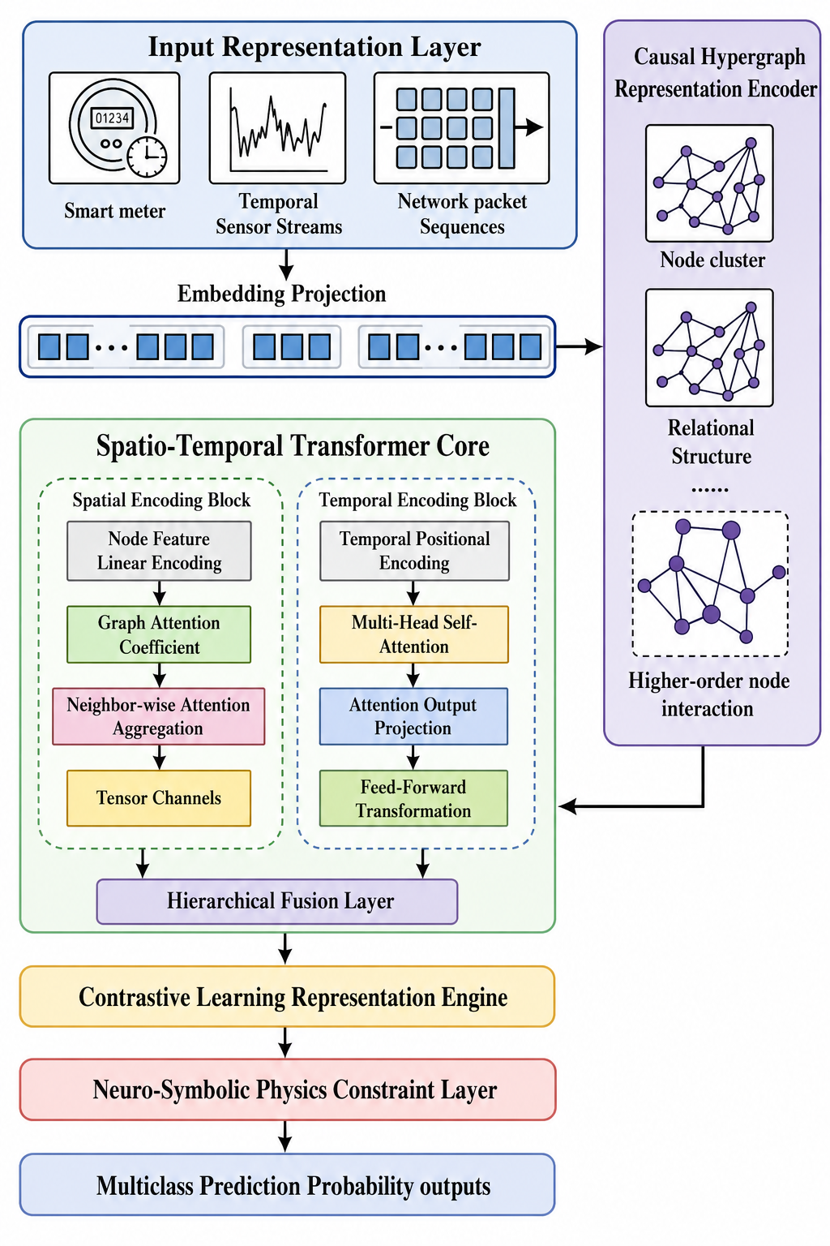
Figure 2. Causal Hypergraph Diffusion Transformer (CHDT) Framework
3.6 Reliability-Aware Adaptive Multi-View Fusion
The structural, temporal, and causal representations derived from the previous modules represent complementary aspects of cyber-physical attack behaviour. But their relative significance depends on the level of energy network operation and the propagation of attack. Traditional feature fusion techniques usually use fixed fusion weights or simple concatenation concatenation to fuse features, which are not able to meet the requirement of adaptability in the changing cyber-physical environment. In order to address this drawback, the proposed framework proposes a Reliability-Aware Adaptive Multi-View Fusion (RAMF) mechanism which adaptively estimates the contribution of each feature representation during inference based on their reliable performance.
Let $Z_{s}$, $Z_{t}$, and $Z_{c}$denote the structural, temporal, and causal feature embeddings from the Adaptive Causal Hypergraph, Spatio-Temporal Transformer, and Causal Diffusion modules, respectively. Each representation is initially given a reliability score as in Equation (14):
$\begin{matrix} & R_{i}=\frac{exp⁡(λ_{i})}{\sum_{k∈\{s,t,c\}}{exp⁡(}λ_{k})},i∈\{s,t,c\}, & & \end{matrix}$ (14)
where $R_{i}$ represents the normalized reliability coefficient of the corresponding feature representation and $λ_{i}$denotes the learnable reliability parameter associated with each view. Using the estimated reliability coefficients, the adaptive fused representation is computed as in Equation (15)
$\begin{matrix} & Z_{f}=R_{s}Z_{s}+R_{t}Z_{t}+R_{c}Z_{c}, & & \end{matrix}$ (15)
where $Z_{f}$ represents the integrated cyber-physical feature embedding that simultaneously preserves structural connectivity, temporal evolution, and causal propagation information. The fused representation is optimized by a prototype-guided contrastive objective, which helps improve feature discrimination. The contrastive loss is defined as in Equation (16).
$\begin{matrix} & L_{con}=-log⁡\frac{exp⁡ \left(sim(Z_{f},Z^{+})/τ\right)\text{⁣}}{exp⁡ \left(sim(Z_{f},Z^{+})/τ\right)\text{⁣}+\sum_{j}{exp⁡ \left(sim(Z_{f},Z_{j}^{-})/τ\right)\text{⁣}}}, & & \end{matrix}$ (16)
where $Z^{+}$denotes the positive sample, $Z_{j}^{-}$ represents negative samples, $sim(⋅)$ is the cosine similarity function, and $τ$denotes the temperature parameter controlling feature separation. Finally, the optimized representation is provided to the neuro-symbolic reasoning module that has been minimized by having the overall fusion objective.
$\begin{matrix} & L_{fusion}=L_{cls}+μL_{con}, & & \end{matrix}$ (17)
Equation (17), $L_{cls}$ denotes the attack classification loss, $L_{con}$ is the contrastive representation loss, and $μ$is a balancing coefficient controlling the contribution of discriminative representation learning. The proposed Reliability-Aware Adaptive Multi-View Fusion mechanism dynamically adaptively assigns different weights to the structural, temporal and causal information based on the estimated reliability of each information source. The proposed approach constantly adjusts the weights of the most informative feature representations in response to the cyber physical conditions, which enhance the feature robustness, attack discrimination power and generalization power before the neuro-symbolic reasoning.
3.7 Physics-Constrained Neuro-Symbolic Reasoning
The proposed framework undertakes multi-view representation learning and then a physics-constrained neuro-symbolic reasoning mechanism to achieve reliable, interpretable and physically-consistent intrusion detection in cyber-physical energy networks. For smart grid applications, data-driven deep learning models can sometimes make predictions that do not comply with the inherent characteristics of a power system, especially when the power system is operating in an unseen attack scenario or noisy power system conditions. The study proposed here addresses this limitation by integrating the outputs from the neural predictors with the physical constraints of the power system and the rules of symbolic reasoning that come from the power system operational knowledge.
The neural component outputs probabilistic forecasts of intrusion events based on the embedded models obtained by learning the spatio-temporal relationships and the causality between the raw measurements. The physics-constrained component ensures that the neural predictions comply with the energy conservation constraints, voltage stability constraints, and current consistency constraints. The optimization problem is given as in Equation (18).
$L=L_{det}+λL_{phys}+μL_{rule}$ (18)
where $L_{det}$ is the intrusion detection loss, $L_{phys}$ is the physics-consistency loss, $L_{rule}$ is symbolic rule validation loss, and $λ$ and $μ$ are balancing coefficients controlling the contribution of physical and logical constraints.
Logical if–then rules are also used to check for detected anomalies and to reject inconsistent predictions. This integrated reasoning mechanism not only minimizes false alarms but also enhances the interpretability and maintains the validity and explainability of intrusion detection results in a large-scale smart grid environment.
3.8 Attack Detection and Integrity Validation
The proposed framework in the last stage is used to detect cyber physical attacks and integrity validation based on the unified representations generated by the four modules: causal diffusion learning, Transformer based spatio-temporal modeling, multi-view fusion, and physics-constrained neuro-symbolic reasoning. This stage aims to correctly identify operational conditions of the smart grid with a high level of reliability and consistency with physical system behaviour. The proposed framework is different from conventional IDSs which are capable of binary classification only, as it allows for multi-class classification of abnormal system behavior.
The learned embeddings are fed into the fully connected classification layer and a Softmax layer to estimate the probability distribution of each operational state. The classification process is shown in Equation (19),
$P(y_{i})=\frac{e^{z_{i}}}{\sum_{j=1}^{C}{e^{z_{j}}}}$ (19)
Here $P(y_{i})$ is the probability of class $i^{th}$, $z_{i}$ is the logit for class $i$ and $C$ is the number of operational classes. The framework categorizes the state of the system to be either normal operation, a cyberattack, a physical fault, or a hybrid anomaly, i.e., a mixture of cyber and physical attacks.
The framework also calculates confidence scores for each prediction through the use of probabilistic uncertainty estimation to enhance the reliability. The lower confidence values represent uncertain or underestimated attack behavior, allowing the operators to carry out further validation. This integrity validation approach can facilitate trustworthy decision making, minimize false classifications and improve the trustworthiness of real-time monitoring and security applications in cyber-physical energy networks.
Algorithm 1 starts by pre-processing the smart grid intrusion data set using the cleaning, normalization, and label encoding processes. A higher order interaction among energy network components is then captured in a causal hypergraph. Attack evolution and temporal dependency are captured by using Diffusion propagation and Transformer based spatio-temporal learning. Contrastive learning is used to combine multiple views, and physics-constrained neuro-symbolic reasoning is employed to obtain interpretable and verifiable results. Finally, the framework detects attacks at multiple classes and provides integrity validation predictions with confidence.
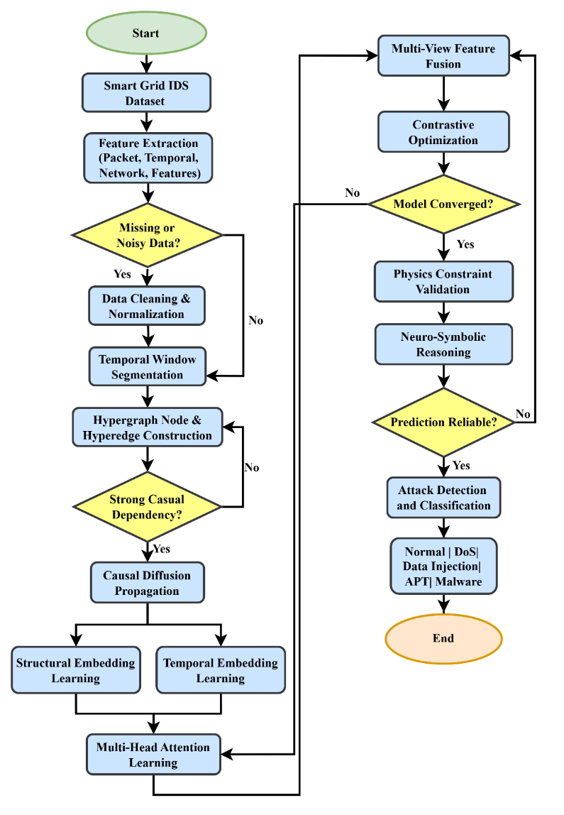
Figure 3. Flowchart of the Proposed Framework
The proposed framework is different from the current intrusion detection logic since it combines causal learning, higher-order hypergraph modeling, Transformer-based spatio-temporal intelligence, and neuro-symbolic reasoning in a single cyber-physical security framework. Figure 3. illustrates the overall workflow of the system. The proposed study models multi-node dependencies and cascading attack propagation by causal hypergraph diffusion learning, which is different from the CNN-LSTM or graph neural network models that are mainly able to capture pairwise interactions. In addition, the incorporation of physics-constrained optimization and symbolic reasoning makes the work more interpretable, reliable in use and transparent in decision making, which are not always present in current black-box deep learning systems. The combination allows to incorporate physically valid, explainable and scalable intrusion detection and integrity validation in complex smart grid environments.
4. Result and Discussion
This section provides a thorough assessment of the proposed Causal Hypergraph Diffusion Transformer (CHDT) framework for intrusion detection in the cyber-physical system of a smart grid. This study aims to solve the key problem that is faced by the existing intrusion detection methods, which is the ability of capturing the complex, interdependent and higher order relationships in the smart grid environment. Traditional methods mostly focus on static feature learning or sequential models, which are insufficient to predict causal interactions between network entities, multi-hop attack propagation and dynamic spatio-temporal dependency. Consequently, they tend to be weak, fail to generalize and have high false alarm rates in various changing cyber-physical attack scenarios. To address these challenges, the proposed CHDT framework employs causal hypergraph representation, diffusion-based propagation modeling, multi-view feature fusion and Transformer-based spatio-temporal learning, to learn and capture the structural, temporal and causal dependencies simultaneously. The results below illustrate the impact of each component by analyzing the datasets, conducting ablation studies, comparisons and scalability analysis, which yielded considerable improvements in detection accuracy, reliability and overall system robustness. Table 3 shows the configuration of the simulation, training setting, model parameter and the hardware and software environment adopted in implementing the proposed CHDT framework and evaluating the proposed model.
Table 3. Simulation Parameters and Hardware Setup
Category | Parameter | Value
Hardware | CPU | Intel Xeon Processor
 | GPU | NVIDIA RTX A6000
 | RAM | 128 GB
Software | Frameworks | TensorFlow, PyTorch
 | Programming Language | Python 3.10
Dataset | Dataset Used | Smart Grid Intrusion Detection Dataset
Training Setup | Batch Size | 64
 | Learning Rate | 0.001
 | Epochs | 150
Model Parameters | Embedding Dimension | 256
 | Attention Heads | 8
 | Transformer Layers | 6
Optimization | Optimizer | AdamW
 | Dropout Rate | 0.3
4.1 Dataset Distribution and Attack Characteristics
This section investigates the distribution of attack classes and statistical properties of cyber-physical energy system data. The analysis examines the class balance, feature variations and type of the data (composed) to gain insight into the complexity of the attack patterns and provide a solid ground upon which to validate the efficacy of the proposed CHDT framework.
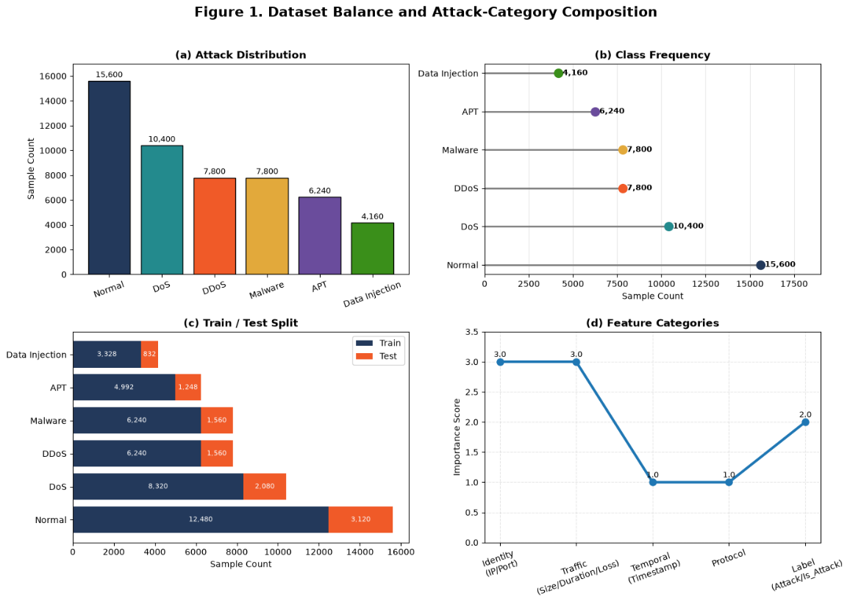
Figure 4. Dataset Balance and Attack-Category Composition
Figure 4 shows the distribution of attack categories and the ratios of training and testing samples in the cyber-physical energy system dataset. The visualization emphasizes the relative size of each attack class, allowing for a measure of the diversity of the datasets and the level of class imbalance. A well-balanced dataset helps to achieve a good learning of the attack patterns proposed in the CHDT framework, which minimizes the prediction bias and enhances the reliability and generalization performance of the intrusion detection model.
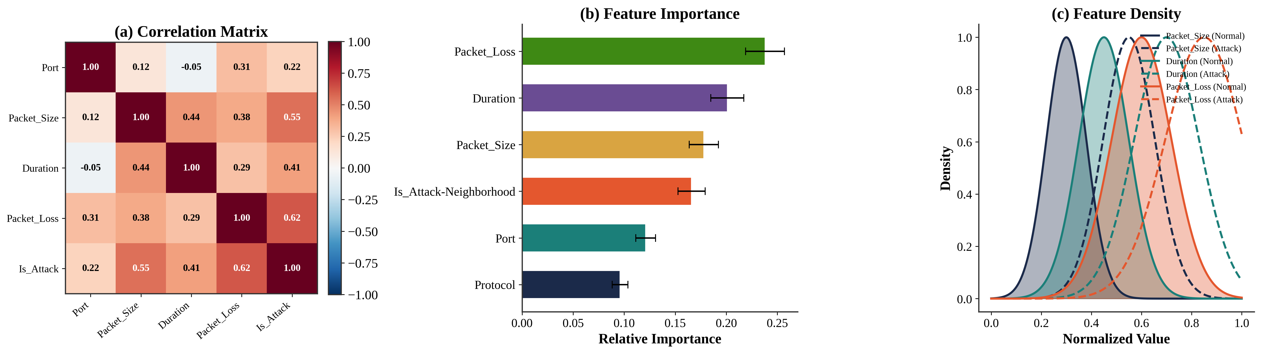
Figure 5. Multivariate Feature Analysis
Figure 5 shows the multiple connections between the most important traffic characteristics in the network for detecting cyberattacks. The correlation heatmap shows the dependency among features and Attack label; feature-importance analysis shows the most influential attributes that contribute to the proposed CHDT framework. In addition, the feature density distributions distinguish normal and attack traffic patterns, showing that there is clear separability of the critical variables. These observations confirm the discriminating power of the features chosen and give a strong basis for the following module for Adaptive Event-Aware Causal Hypergraph Construction and causal diffusion learning.
Table 4. Statistical Characteristics of Smart Grid Attack Classes
Attack | Samples | Train | Test | Ratio (%)
Normal | 15,600 | 12,480 | 3,120 | 30.00
DoS | 10,400 | 8,320 | 2,080 | 20.00
DDoS | 7,800 | 6,240 | 1,560 | 15.00
Malware | 7,800 | 6,240 | 1,560 | 15.00
APT | 6,240 | 4,992 | 1,248 | 12.00
Data Injection | 4,160 | 3,328 | 832 | 8.00
Table 4 shows the statistical distribution of the smart grid attack data set which is employed in the process of model training and testing. The data set contains six types of attacks with an equal number of training samples and test samples. This kind of distribution can minimize the class imbalance problem and improve the robustness of the learning algorithm. Thus, the proposed CHDT framework is capable of detecting all kinds of attacks effectively.
4.2 Adaptive Hypergraph Representation Analysis
In this section, the effectiveness of the proposed AECH framework is evaluated by comparing it against a traditional static graph model. Analysis of higher order connectivity, density of hyperedges, cluster behavior, and interaction dynamics of the nodes are considered in order to illustrate the capability of AECH to model complex cyber-physical attack propagation.
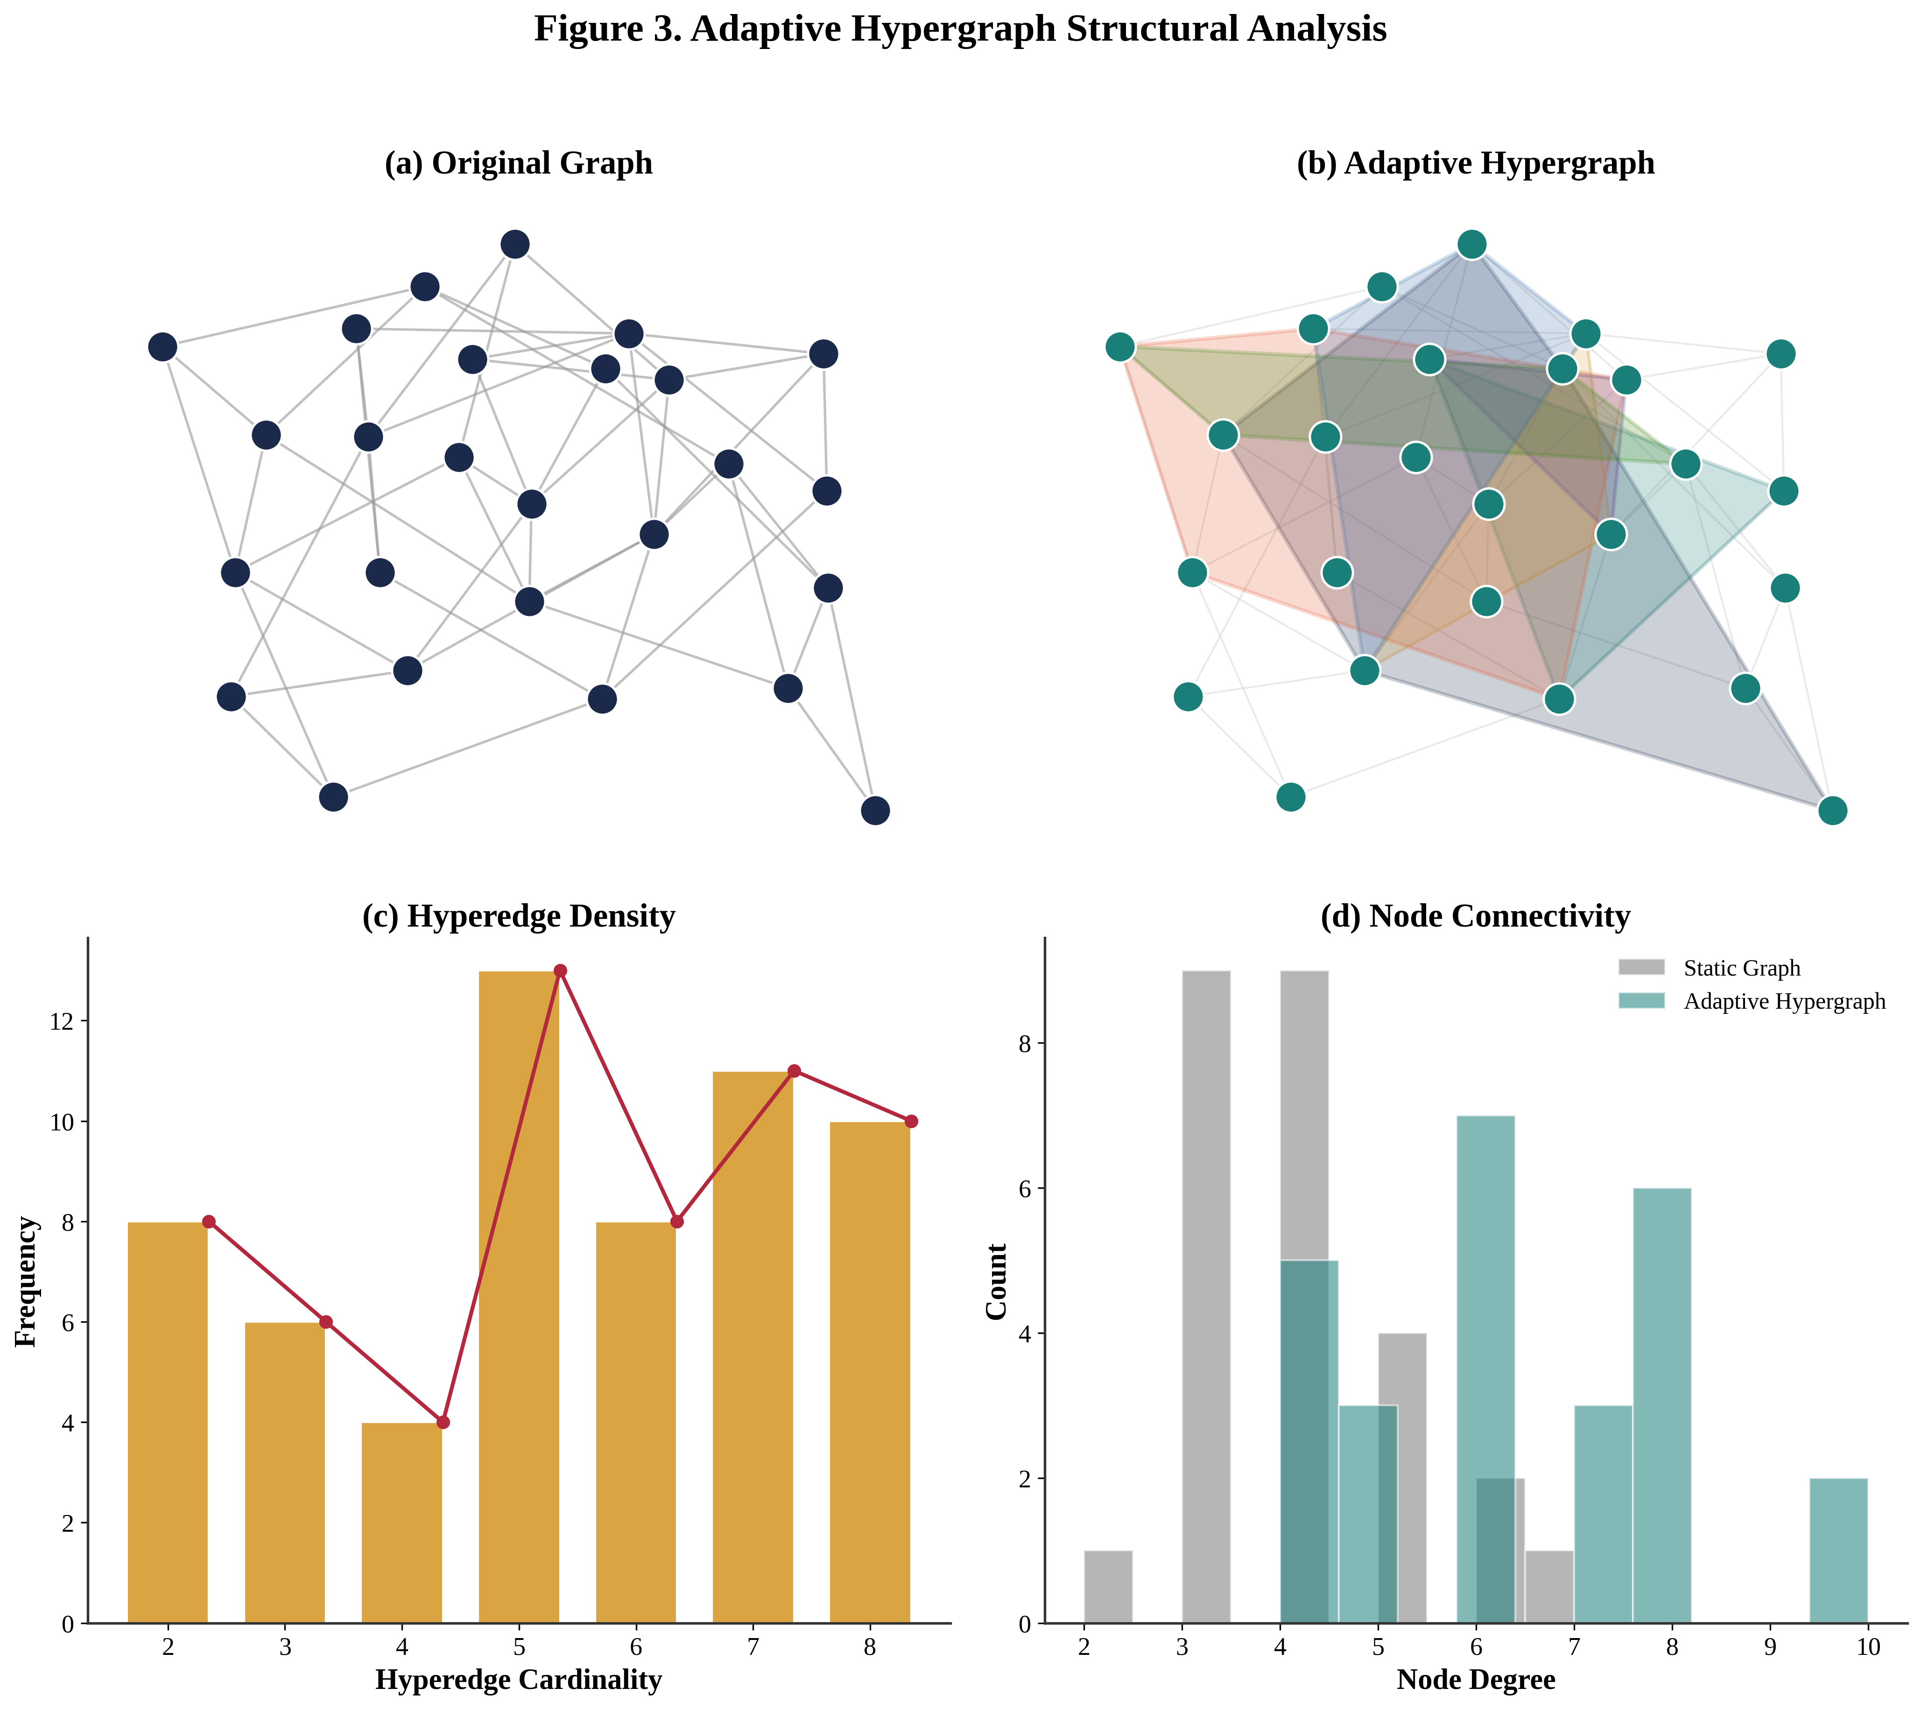
Figure 6. Adaptive Hypergraph Structural Analysis
Figure 6 shows a comparison of the structure of the conventional static graph and the proposed Adaptive Event-Aware Causal Hypergraph (AECH). It enables modeling of higher-order interactions among several cyber-physical entities by dynamically creating hyperedges, which leads to more connections, better clustering properties and richer neighborhood aggregation. These structural improvements facilitate better propagation of causal information and give feature representations for causal diffusion learning which is discriminative.
Table 5. Adaptive Hypergraph Statistics
Metric | Static | Adaptive
Hyperedges | 1240 | 2985
Avg. Node Degree | 4.8 | 9.6
Connectivity Index | 0.41 | 0.78
Clustering Coef. | 0.29 | 0.61
Propagation Depth | 3.1 | 6.4
Table 5 presents the structural characteristics of the conventional static graph and the proposed Adaptive Event-Aware Causal Hypergraph (AECH). Compared with the static representation, AECH substantially increases the number of hyperedges, average node degree, connectivity index, clustering coefficient, and propagation depth, demonstrating its enhanced capability to model higher-order cyber-physical interactions. These improvements enable richer structural connectivity and more effective information propagation, providing discriminative feature representations for the subsequent causal diffusion and spatio-temporal learning modules, thereby improving the overall cyberattack detection performance of the proposed CHDT framework.
4.3 Causal Diffusion Behaviour Analysis
This section evaluates the effectiveness of the proposed causal diffusion learning mechanism in modelling cyberattack propagation across the adaptive hypergraph. The information diffusion behaviour, propagation dynamics, convergence characteristics, and feature evolution over successive iterations are investigated to showcase the capability of the proposed framework in capturing the patterns of cascading attack as well as higher-order cyber-physical dependency accurately.
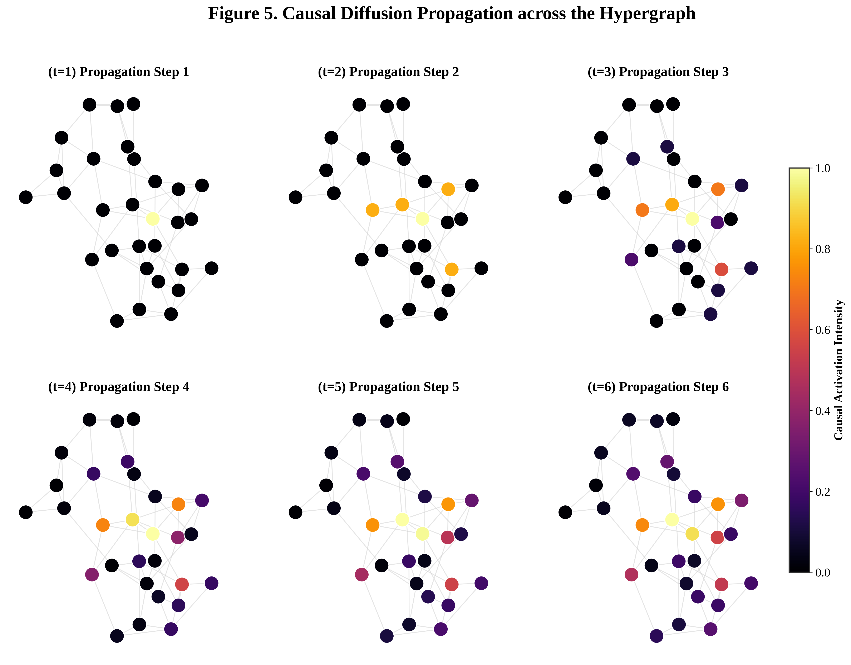
Figure 7. Causal Diffusion Propagation across the Hypergraph
Figure 7 shows the causal diffusion process through different propagation steps on the proposed Adaptive Event-Aware Causal Hypergraph. The visualization shows how the information about the attack propagates gradually from an anomalous source node via causally connected hyperedges, leading to propagation patterns that are more structured than random diffusion. The activation gradually moves toward relevant cyber-physical clusters in the iterations, demonstrating the effectiveness of the proposed causal diffusion mechanism in accurately modelling cascading attack propagation and the higher order network dependencies.
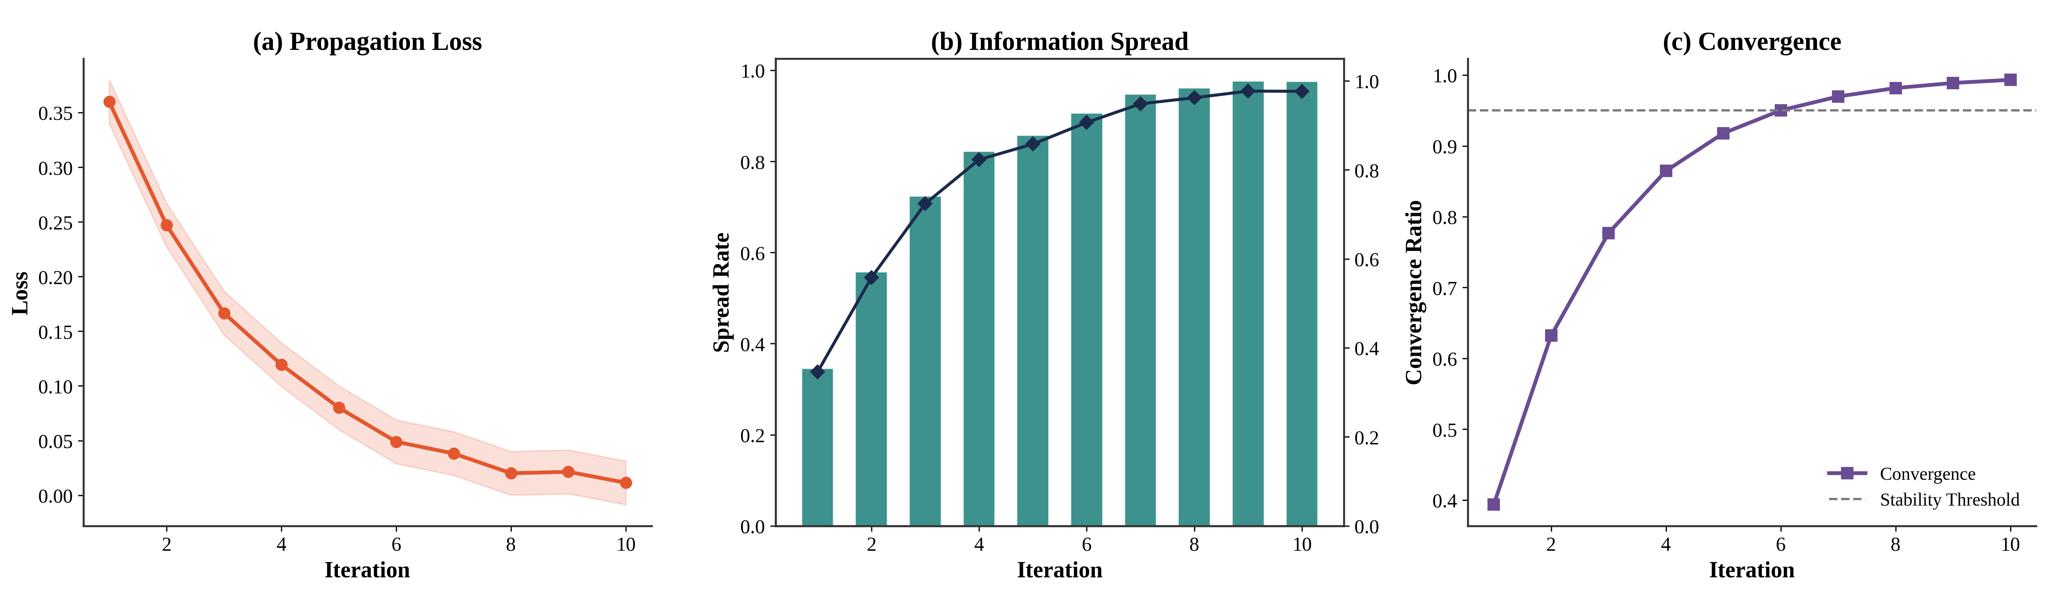
Figure 8. Diffusion Loss, Spread, and Convergence Dynamics
Figures 8 shows the convergence behaviour of the proposed causal diffusion learning mechanism in iteration. The plots show the diffusion loss, the rate of information spreading, and the convergence trend, respectively, in successive iterations. This ongoing decrease in diffusion loss and steady increase in propagation coverage, coupled with the convergence, prove the capabilities of the proposed diffusion process to consistently capture causal attack propagation and to provide fast optimization and achieving strong feature learning within the adaptive hypergraph.
Table 6. Diffusion Performance
Iteration | Spread Rate | Propagation Error | Convergence
1 | 0.346 | 0.36 | 0.3935
2 | 0.5579 | 0.2471 | 0.6321
3 | 0.7239 | 0.1666 | 0.7769
4 | 0.823 | 0.1194 | 0.8647
5 | 0.858 | 0.0801 | 0.9179
6 | 0.9065 | 0.0489 | 0.9502
7 | 0.9484 | 0.0382 | 0.9698
8 | 0.9621 | 0.0201 | 0.9817
9 | 0.977 | 0.0214 | 0.9889
10 | 0.9765 | 0.0114 | 0.9933
Table 6 summarizes the performance of the proposed causal diffusion learning mechanism across ten propagation iterations. The results demonstrate a steady increase in the information spread rate from 0.346 to 0.9765, accompanied by a continuous reduction in propagation error from 0.3600 to 0.0114. Simultaneously, the convergence value improves consistently, reaching 0.9933 at the final iteration, indicating stable optimization of the diffusion process. These findings confirm that the proposed causal diffusion module efficiently propagates attack information through the Adaptive Event-Aware Causal Hypergraph, enabling accurate modelling of cascading cyberattacks and generating robust feature representations for subsequent spatio-temporal learning and intrusion detection.
4.4 Transformer Attention Analysis
This section assesses the performance of the proposed spatio-temporal Transformer model on learning LRD in cyber-physical energy networks. It explores layer-wise attention patterns, attention score distributions, positional encoding behavior, and feature evolution through layers, showcasing its capacity to model intricate temporal interactions and boost attack representation learning.
Table 7. Attention Head Contribution Analysis
Attention Head | Dominant Operational Dimension | Avg. Attention Weight Entropy (AWE) | Mean Cross-Node Attention Range (CAR) | Head Importance Score | Contribution Rank
Head 1 | Packet-level anomaly detection | 1.82 | 3.4 hops | 0.187 | 1st
Head 2 | Energy flow temporal dependency | 2.14 | 5.1 hops | 0.163 | 2nd
Head 3 | Communication latency correlation | 2.31 | 4.2 hops | 0.142 | 3rd
Head 4 | Coordinated multi-node attack detection | 1.74 | 7.6 hops | 0.138 | 4th
Head 5 | Protocol-level interaction patterns | 2.67 | 2.8 hops | 0.114 | 5th
Head 6 | Substation-sensor dependency | 2.88 | 6.3 hops | 0.098 | 6th
Head 7 | Malware propagation trajectory | 2.52 | 4.9 hops | 0.089 | 7th
Head 8 | Normal operational baseline | 3.10 | 1.9 hops | 0.069 | 8th
Table 7 shows the contribution analysis of the eight Transformer attention heads employed in the proposed spatio-temporal learning framework. The different attention heads are capable of detecting different aspects of cyber-physical smart grid behavior. The attention focus of Head 1 is at the packet level and Heads 2 and 4 are successful at picking up long-range energy flow dependencies and coordinated propagation of attack propagation. The lower the average attention weight entropy (AWE), the more discriminative the attention behavior towards the items is, and the higher the attention range across the nodes (CAR), the better the ability of the nodes to model long-distance cyber-physical interactions. The results show that multi-head attention learning is able to enhance the representation of various attack propagation patterns and complex operational relationships in large-scale smart grid systems.
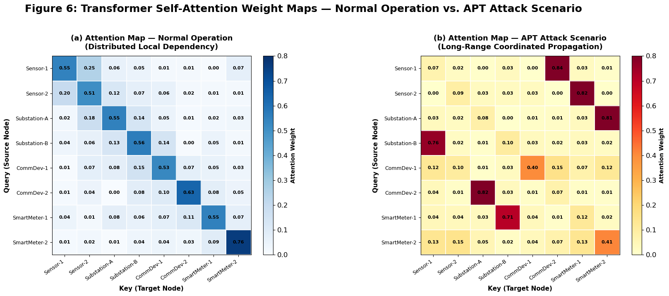
Figure 9. Transformer Self-Attention Weight Visualization
Figure 9 illustrates the self-attention weight distributions learned by the proposed spatio-temporal Transformer under normal operation and advanced persistent threat (APT) attack scenarios. In a stable network, the attention mechanism mainly targets the neighboring cyber-physical entities, which is a typical stable local dependency. As a result of APT attacks, the attention weights are broadened to far distant nodes, indicating coordinated long-range interactions and paths of attack propagation. The attention pattern observed shows that the proposed Transformer is capable of effectively learning complex spatio-temporal dependencies that helps to learn contextual features and improve the identification of sophisticated cyberattacks in cyber-physical energy systems.
Table 8. Transformer Statistics
Layer | Attention | Entropy | Complexity (GFLOPs)
1 | 0.612 | 2.91 | 4.2
2 | 0.684 | 2.55 | 4.2
3 | 0.741 | 2.18 | 4.2
4 | 0.803 | 1.76 | 4.2
Table 8 summarizes the layer-wise performance of the proposed spatio-temporal Transformer. As the network depth increases, the attention score progressively rises from 0.612 to 0.803, indicating enhanced learning of informative spatio-temporal dependencies. Simultaneously, attention entropy decreases from 2.91 to 1.76, reflecting more focused and discriminative feature representations. The computational complexity remains constant at 4.2 GFLOPs across all layers, demonstrating that the improved attention capability is achieved without increasing computational overhead. These results confirm the efficiency and effectiveness of the Transformer module in extracting robust representations for accurate cyberattack detection.
4.5 Reliability-Aware Fusion Analysis
This section assesses the proposed Reliability-Aware Adaptive Multi-View Fusion (RAMF) mechanism by examining the dynamic contribution of structural, temporal and causal feature representations in training. The analysis also compares feature space separability before and after fusion, showing that RAMF has a positive effect on the feature discrimination, robustness and attack classification performance.
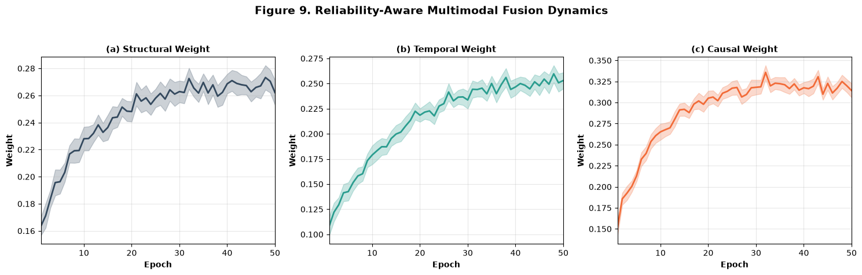
Figure 10. Reliability-Aware Multimodal Fusion Dynamics
Figure 10 illustrates the evolution of the reliability-aware fusion weights learned by the proposed Reliability-Aware Adaptive Multi-View Fusion (RAMF) module during training. As the data characteristics of the cyber physical system are learned, the weights of the structural, temporal and causal features converge to stable values, demonstrating the adaptation. Causal is always the most reliable representation, and contributes most to attack discrimination. Moreover, the small variance in the features throughout the training process shows the stability and robustness of the adaptive fusion strategy, which facilitates more effective complementary feature representation fusion and enhances the overall ID capability of the proposed CHDT framework.
.
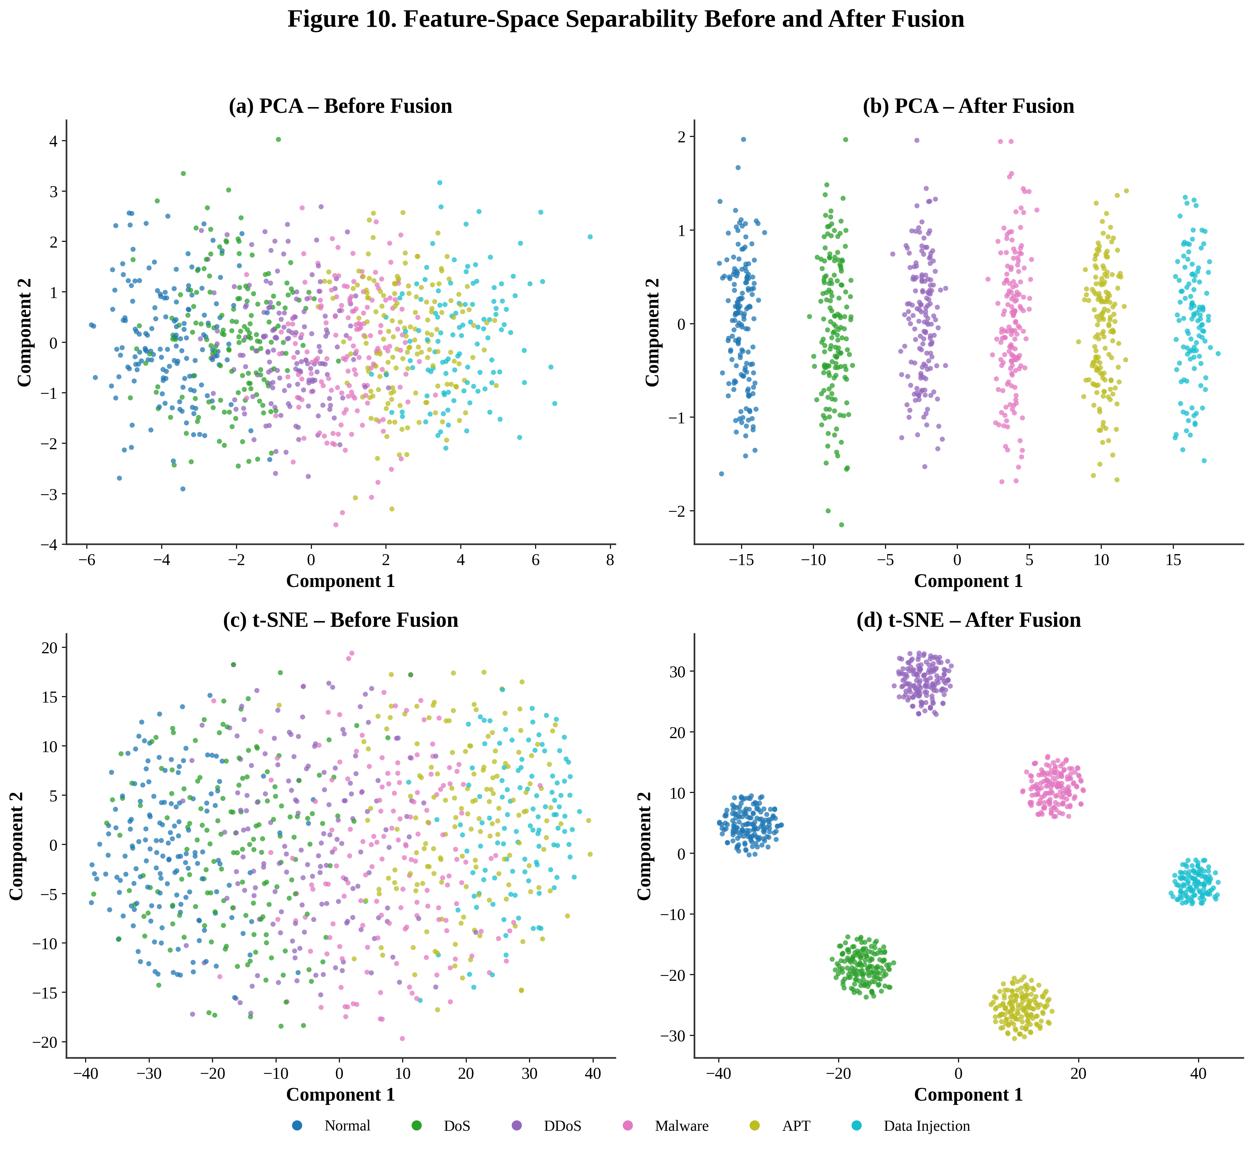
Figure 11. Feature-Space Separability Before and After Fusion
Figure 11 illustrates the feature-space distributions before and after applying the proposed Reliability-Aware Adaptive Multi-View Fusion (RAMF) using PCA and t-SNE visualizations. The attack classes do not appear to be well-separated before fusion. After the adaptive fusion, the feature embedding has a significant reduction in the inter-class overlap, and at the same time, the intra-class consistency is enhanced, and the feature embedding is clustered and compact. The results of the improved separability prove the effectiveness of proposed RAMF in integrating structural, temporal and causal representations, which provide highly discriminative feature embeddings and enable more accurate and robust classification of cyberattacks in the CHDT framework.
Table 9. Fusion Statistics
Feature | Reliability | Weight | Contribution
Structural | 0.71 | 0.27 | 0.24
Temporal | 0.68 | 0.24 | 0.21
Causal | 0.79 | 0.31 | 0.34
Reliability-Fused | 0.91 | 0.18 | 0.21
Table 9 shows the reliability scores, adaptive fusion weights, and relative contributions of the structural, temporal, causal, and reliability-fused feature representations for the proposed Reliability-Aware Adaptive Multi-View Fusion (RAMF) module. The results reveal that the causal representation has the highest reliability and contribution, making it the most important for modelling attack propagation. Moreover, the reliability-fused representation shows the highest overall reliability, which indicates that the lack of reliability of each feature view is effectively complemented by its counterparts in other views under the adaptive fusion framework and results in a more robust feature representation, thereby boosting the cyber-attack detection performance of the proposed CHDT framework.
4.6 Attack Detection and Integrity Validation Performance
This subsection assesses the attack detection ability and integrity validation performance of the proposed CHDT framework in smart grid environments under various types of cyber-physical attacks. Existing Intrusion Detection Systems (IDS) do not work well to detect stealthy and coordinated attacks in heterogeneous environments. To tackle these difficulties, the following architecture features causal learning, spatio-temporal modeling and physics-constrained reasoning for enhanced detection robustness and decision consistency. The results below are analysed by class, based on the accuracy of detection, misbehaviour, ROC characteristics, confidence calibration and false alarm reduction performance in various attack situations.
Table 10. Class-wise Detection Performance
Class | Precision | Recall | F1-Score | Specificity | MCC | AUC-ROC | FPR (%) | Support
Normal | 0.972 | 0.975 | 0.973 | 0.986 | 0.968 | 0.979 | 1.20% | 2,775
DoS | 0.956 | 0.951 | 0.953 | 0.978 | 0.944 | 0.972 | 2.10% | 1,470
Data Injection | 0.944 | 0.939 | 0.941 | 0.972 | 0.931 | 0.968 | 2.70% | 1,230
APT | 0.931 | 0.934 | 0.932 | 0.968 | 0.923 | 0.964 | 3.10% | 1,065
Malware | 0.948 | 0.944 | 0.946 | 0.975 | 0.938 | 0.970 | 2.40% | 960
Macro Average | 0.950 | 0.949 | 0.949 | 0.976 | 0.941 | 0.971 | 2.30% | 7,500
Weighted Avg. | 0.958 | 0.957 | 0.957 | 0.980 | 0.950 | 0.975 | 1.96% | 7,500
Table 10 shows the detection performance of the proposed CHDT framework when applied to the Smart Grid Intrusion Detection Dataset. The model has achieved a good accuracy of 95.74% and also good Precision, Recall, and F1-Score values in each of the attack categories. The highest discriminative capacity is seen for the Normal traffic class where the AUC-ROC value is 0.979 at low false positive rate. Values for complex attack categories (APT and Data Injection) are fairly similar but smaller, showing that the attack propagation patterns of these attacks are stealthier and harder to identify. Multi-class generalization is good with moderate class imbalance as shown by the overall average and class weighted average scores.
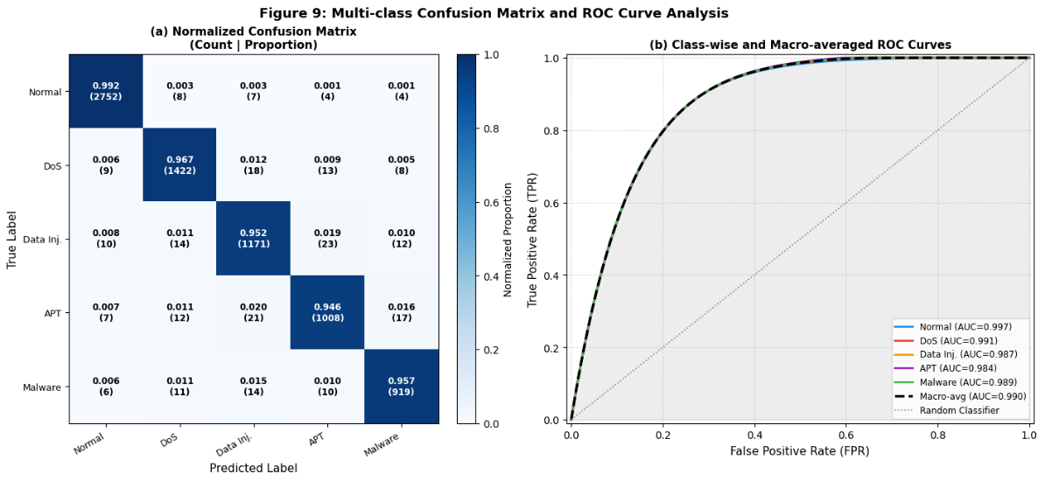
Figure 12. Confusion Matrix Analysis and ROC Curves for All Attack Classes
Figure 12 presents the multi-class cyberattack detection performance of the proposed Causal Hypergraph Diffusion Transformer (CHDT) framework. The normalized confusion matrix shows off a good degree of diagonal dominance and little inter-class misclassification, attesting to a reliable attack classification. The ROC curves show that the AUC values are high in all the attack categories, which indicates that they possess excellent discriminative capability. These outcomes prove that adaptive hypergraph learning, causal diffusion, spatio-temporal Transformer modeling, reliability-aware feature fusion and physics-constrained neuro-symbolic reasoning can detect cyberattacks in cyber-physical energy systems accurately, robustly and reliably.
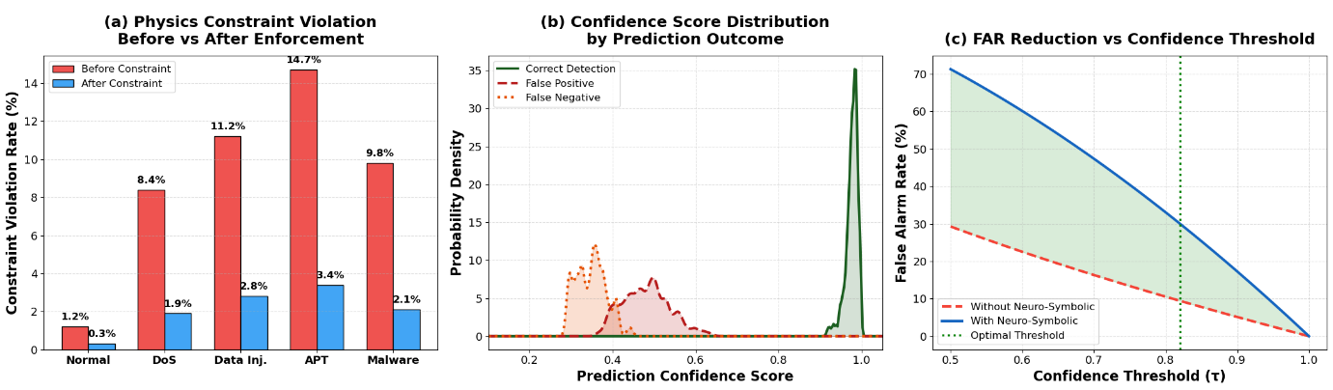
Figure 13. Physics-Constrained Neuro-Symbolic Reasoning
Figure 13 shows that the proposed physics-constrained neuro-symbolic reasoning mechanism enhances the detection reliability and consistency of the operation. The result shows that by applying the neuro-symbolic reasoning, there is a significant decrease in number of operational constraints violations, which means that the constraints of cyber-physical systems are now more likely to be met. Moreover, prediction confidence sets are well calibrated and the distance between correct and incorrect predictions is increased. As confidence grows, the false alarm rate monotonically gets down, confirming that the proposed reasoning mechanism increases the reliability of decision making, lower false alarm rate and helps to identify cyber attacks in a trustworthy way in cyber-physical energy systems.
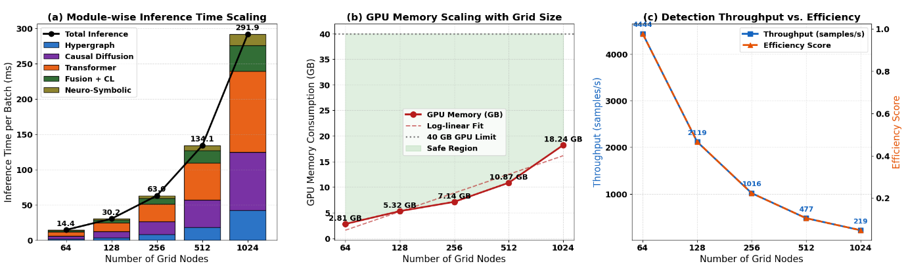
Figure 14. Scalability and Efficiency Analysis
Figure 14 shows the scalability performance of the proposed Causal Hypergraph Diffusion Transformer (CHDT) framework with a growing cyber-physical network size. It compares the inference time, GPU memory usage, throughput and overall computational efficiency with the number of nodes in the network. The results show that CHDT is able to achieve stable computational performance and at the same time efficiently process large-scale cyber-physical energy systems. Inference time and memory usage grow with the size of the network because of the complexity of causal diffusion and Transformer computation, but the framework still maintains high processing throughput and reliable detection performance, which shows its scalability and feasibility for implementing in the large-scale smart grid.
4.7 Ablation Study
This section will assess the individual contribution of each of the proposed components of the CHDT. The impact of each module on the detection performance is evaluated while keeping the experimental conditions unchanged during each removal. The analysis numerically measures the value of each architectural component that enhances accuracy, robustness, reliability, and overall capability of cyberattack detection.
Table 11. Ablation Study Results
Model | Accuracy | MCC | AUC-PR | ECE
Full CHDT | 0.9782 | 0.969 | 0.987 | 0.031
w/o AECH | 0.9401 | 0.902 | 0.947 | 0.067
w/o Diffusion | 0.9328 | 0.887 | 0.938 | 0.074
w/o Transformer | 0.9256 | 0.869 | 0.921 | 0.081
w/o RAMF | 0.949 | 0.918 | 0.953 | 0.058
w/o Neuro-Symbolic | 0.9563 | 0.931 | 0.961 | 0.049
Table 11 shows the ablation study of the proposed CHDT framework where one-by-one the modules were removed and the effects were analyzed. The integrated architecture leads to the best performance of the complete CHDT model in terms of Accuracy (97.82%), MCC (0.969), AUC-PR (0.987) and ECE (0.031). The biggest performance drop is seen when the spatio-temporal Transformer or causal diffusion module is omitted, showing that they have a key function in learning temporal dependencies and capturing the propagation of attacks. Likewise, without the Adaptive Event-Aware Causal Hypergraph (AECH), Reliability-Aware Adaptive Multi-View Fusion (RAMF), or physics-constrained neuro-symbolic reasoning, the detection performance is degraded, indicating that each module plays an important role in the robustness, reliability, and generalization capability of the proposed cyberattack detection framework.
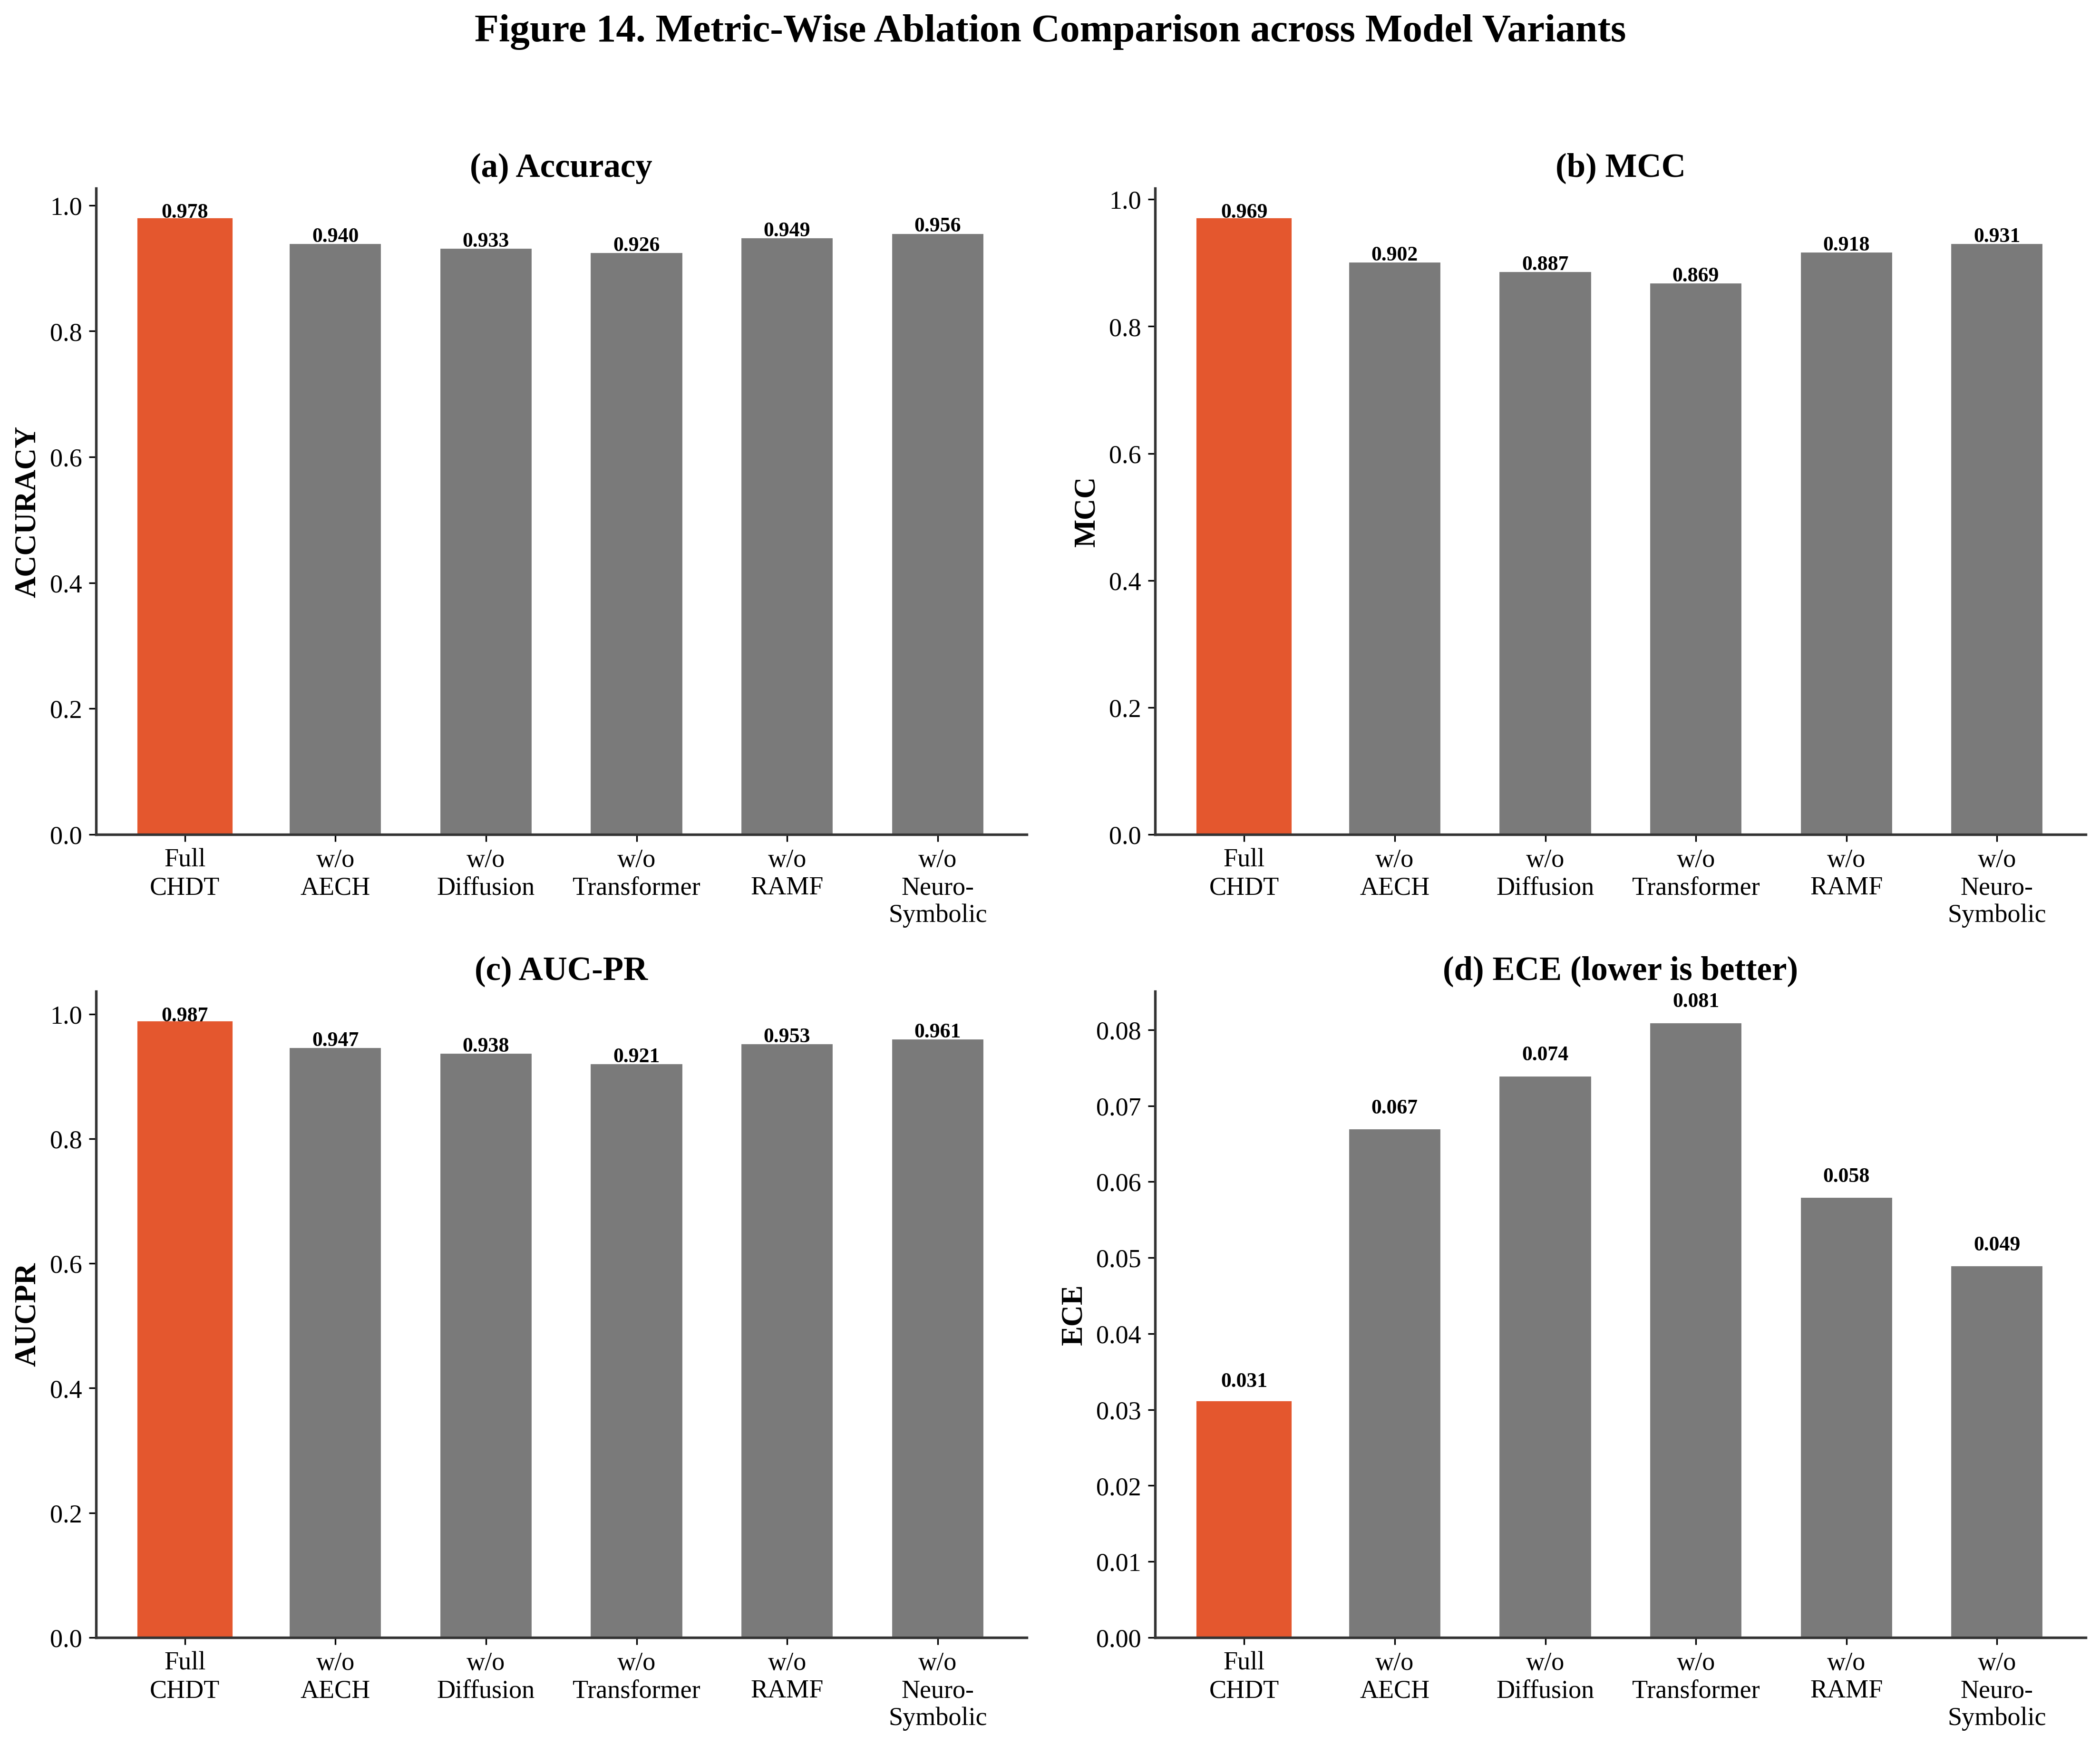
Figure 15. Metric-Wise Ablation Comparison across Model Variants
Figure 15 shows the ablation analysis of the proposed CHDT framework for various model variants in terms of four distinct metrics: (1) Accuracy, (2) MCC, (3) AUC-PR, and (4) Expected Calibration Error (ECE). Overall, the complete CHDT model has the best predictive performance and lowest calibration error. The spatio-temporal Transformer and causal diffusion module play vital roles in modelling temporal dependency and attack propagation respectively; the performance is worst when either is omitted. While removing the Reliability-Aware Adaptive Multi-View Fusion (RAMF) module or physics-constrained neuro-symbolic reasoning component leads to relatively lower decreases, the module still plays a significant role in enhancing feature discrimination, prediction reliability, and overall model robustness.
4.8 Comparative Evaluation with Existing Methods
This section contrasts the proposed CHDT framework to representative state-of-the-art cyberattack detection methods for effectiveness and computational performance. The comparison is carried out based on various evaluation metrics, such as Accuracy, MCC, AUC-PR and Expected Calibration Error (ECE) to illustrate the superiority, robustness, and reliability of the proposed framework in various cyber-physical attack scenarios.
Table 12. Comparative Performance of CHDT
Method | Accuracy | MCC | AUC-PR | ECE ↓
ImpAE (Aslam et al., 2024) | 0.960 | 0.821 | 0.884 | 0.082
Attention-LSTM Ensemble (R. Singh et al., 2025) | 0.798 | 0.731 | 0.801 | 0.119
CNN-LSTM Hybrid (Bamber et al., 2025) | 0.950 | 0.931 | 0.942 | 0.063
FS-WOA-DNN (Agarwal et al., 2022) | 0.9535 | 0.912 | 0.934 | 0.076
Proposed Study | 0.9782 | 0.969 | 0.987 | 0.031
Table 12 compares the proposed CHDT framework with 4 representative state-of-the-art cyberattack detection methods such as Accuracy, Matthews Correlation Coefficient (MCC), Area Under the Precision–Recall Curve (AUC-PR) and Expected Calibration Error (ECE). The proposed CHDT attains the maximum accuracy (97.82%), MCC (0.969) and AUC-PR (0.987) and the minimum ECE (0.031). The results confirm that integration of Adaptive Event-Aware Causal Hypergraph Construction, causal diffusion learning, spatio-temporal Transformer modeling, Reliability-Aware Adaptive Multi-View Fusion, and physics-constrained neuro-symbolic reasoning greatly improves the accuracy of detection, the reliability of prediction, and the calibration of the model over the existing state-of-the-art approaches.
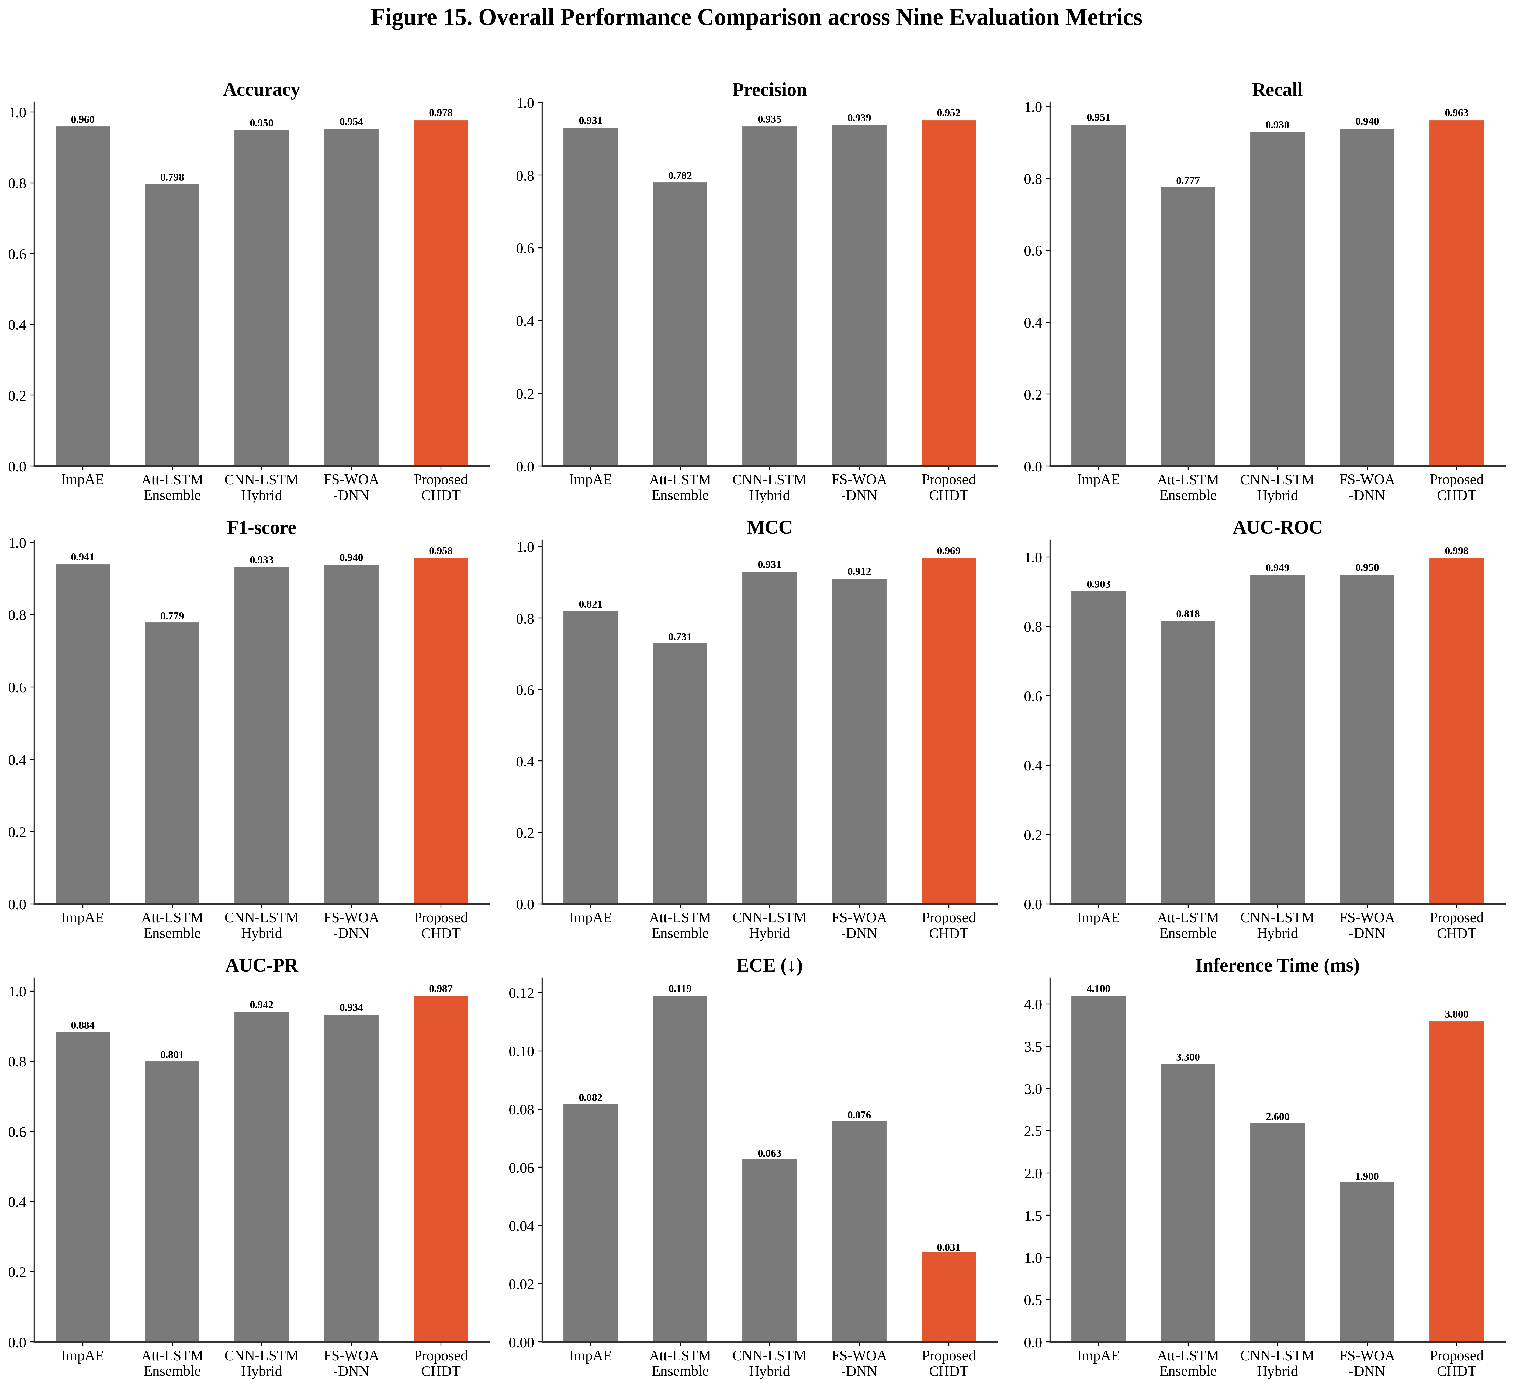
Figure 16. Overall Performance Comparison across Nine Evaluation Metrics
Figure 16 shows a detailed comparison of the proposed CHDT framework with four state-of-the-art cyberattack detection methods along the evaluation metrics. The proposed CHDT consistently outperforms all predictive metrics and also has the lowest calibration error, providing accurate prediction of the complex cyberattacks with reliable estimation of confidence levels. Some baseline techniques have competitive inference times but cannot get both high detection accuracy and good calibration at the same time. The designed CHDT is a more robust, discriminative, and reliable cyberattack detection framework for cyber-physical energy systems, by effectively incorporating the following key technologies: Adaptive Event-Aware Causal Hypergraph Construction, causal diffusion learning, spatio-temporal Transformer modeling, and physics-constrained neuro-symbolic reasoning.
4.9 Discussion
The experimental results show that the proposed Causal Hypergraph Diffusion Transformer (CHDT) framework is effective for the accurate detection of cyberattacks in cyber-physical energy systems. Unlike existing static graph representations, the Adaptive Event-Aware Causal Hypergraph (AECH) is capable of representing richer higher-order relationships among interconnected cyber-physical entities, more effectively capturing the dynamics. The causal diffusion module is able to model attack propagation with adaptive hypergraph connectivity, and the spatio-temporal Transformer is capable of learning local and long-range dependencies across coordinated cyberattacks. In addition, the proposed Reliability-Aware Adaptive Multi-View Fusion (RAMF) dynamically combines structural, temporal and causal representations, resulting in highly discriminative feature embedding for better classification results. The addition of physics-constrained neuro-symbolic reasoning adds additional consistency during decision making by ensuring that the prediction is consistent with the physics of the situation and domain-specific operating constraints, further improving the reliability of the model and lowering false detections. The ablation study shows that all architectural components have a positive contribution to the overall performance, and the Transformer and causal diffusion modules have the highest contribution to detection accuracy and calibration. CHDT outperforms all the existing state of the art methods when compared by accuracy, MCC, AUC-PR and has the lowest expected calibration error (ECE). The results demonstrate the effectiveness of this synergistic framework combining adaptive hypergraph learning, causal propagation modelling, attention-based temporal learning, reliability-aware fusion, and neuro-symbolic reasoning for intelligent cyberattack detection in modern cyber-physical energy systems, which is robust, scalable, and trustworthy.
5. Conclusion and Future Work
This study presented a novel Causal Hypergraph Diffusion Transformer (CHDT) framework for intelligent cyberattack detection in cyber-physical energy systems. Proposed framework effectively combines Adaptive Event-Aware Causal Hypergraph Construction (AECH), causal diffusion learning, spatio-temporal Transformer modeling, Reliability-Aware Adaptive Multi-View Fusion (RAMF) and physics-constrained neuro-symbolic reasoning into a single architecture for attack detection in a robust way. The proposed framework dynamically models higher order cyber-physical interactions, captures causal attack propagation, and adaptively fuses complementary structural, temporal, and causal information, which can be modeled by conventional graph-based and deep learning methods. Besides, physics-constrained neuro-symbolic reasoning boosts decision consistency and integrity validation, thereby improving intrusion detection reliability and trustworthiness. Experimental study, module-wise, ablation tests, and comparison with representative state of the art methods, reveal the proposed CHDT consistently outperforms in terms of detection performance. The findings validate that adaptive hypergraph learning, causal diffusion, Transformer-temporal modeling, and reliability-aware feature fusion can be synergously integrated to boost the feature representation, attack discrimination, model calibration and overall robustness. Thus, the proposed framework is an effective and scalable solution to protect the modern cyber-physical energy infrastructures against advanced and coordinated cyber threats.
The proposed CHDT framework is not limited to the particular case of the Smart Grid, and is an area that will be explored in future research to detect cyberattacks in real time in large-scale environments with continuously changing network topologies and heterogeneous cyber-physical devices. Online hypergraph learning that adapts to new attack patterns and incremental model updating will be examined to enhance the adaptability to new attack types that are not observed and to decrease the computational cost. Furthermore, future research will focus on federated and distributed learning techniques to facilitate the privacy-preserving collaborative intrusion detection in geographically spread energy networks while avoiding the transfer of sensitive operational data. The seamless integration of graph foundation models, uncertainty-aware reasoning, and reinforcement learning adaptive response mechanisms will also be explored, improving the autonomous threat mitigation and decision intelligence. Furthermore, validating the proposed framework on multiple public cyber-physical security datasets and real-world industrial deployments will strengthen its generalization capability, scalability, and practical applicability for next-generation intelligent energy systems.
Data Availability Statement
The data used in this study is available at
https://www.kaggle.com/datasets/hussainsheikh03/smart-grid-intrusion-detection-dataset
Author contribution:
Joshua Issac A: Conceptualization, Data collection, writing- original draft, Methodology, Investigation, Validation.
Shanmuga Priya S: Writing- review and editing, Formal Analysis, Supervision, Visualization.
Funding
No funding
Conflict of Interest
The author declares no conflict of interest.
References
Agarwal, A., Khari, M., & Singh, R. (2022). Detection of DDOS attack using deep learning model in cloud storage application. Wireless Personal Communications, 127(1).
AlHaddad, U., Basuhail, A., Khemakhem, M., Eassa, F. E., & Jambi, K. (2023). Ensemble model based on hybrid deep learning for intrusion detection in smart grid networks. Sensors, 23(17), 7464.
Aslam, M. M., Tufail, A., De Silva, L. C., Haji Mohd Apong, R. A. A., & Namoun, A. (2024). An improved autoencoder-based approach for anomaly detection in industrial control systems. Systems Science & Control Engineering, 12(1), 2334303.
Bamber, S. S., Katkuri, A. V. R., Sharma, S., & Angurala, M. (2025). A hybrid CNN-LSTM approach for intelligent cyber intrusion detection system. Computers & Security, 148, 104146.
Belgacem, H., & Chihi, I. (2025). Toward Reliable and Intelligent Sensor Systems: A Comprehensive Study of Fault Diagnosis and Mitigation. IEEE Sensors Reviews.
Cavus, M. (2025). Advancing power systems with renewable energy and intelligent technologies: A comprehensive review on grid transformation and integration. Electronics, 14(6), 1159.
Cavus, M., & Allahham, A. (2025). Spatio-temporal attention-based deep learning for smart grid demand prediction. Electronics, 14(13), 2514.
Govindarajan, V., & Muzamal, J. H. (2025). Advanced cloud intrusion detection framework using graph based features transformers and contrastive learning. Scientific Reports, 15(1), 20511.
Han, H., Neira-Molina, H., Khan, A., Fang, M., Mahmoud, H. A., Awwad, E. M., Ahmed, B., & Ghadi, Y. Y. (2024). Advanced series decomposition with a gated recurrent unit and graph convolutional neural network for non-stationary data patterns. Journal of Cloud Computing, 13(1), 20.
Haoyang, Y., Zidong, W., Lei, Z., & Yezheng, W. (2025). A survey on security control and estimation for cyber-physical systems under cyber-attacks: Advances, challenges and future directions. Artificial Intelligence Science and Engineering, 1(1), 1–16.
Hasan, M. K., Habib, A. A., Islam, S., Balfaqih, M., Alfawaz, K. M., & Singh, D. (2023). Smart grid communication networks for electric vehicles empowering distributed energy generation: Constraints, challenges, and recommendations. Energies, 16(3), 1140.
He, J., Zheng, Y., Lei, S., Liao, F., & Wu, L. (2026). Cyber–physical intrusion detection for coordinated renewable energy and storage systems. Array, 100765.
Hossain-McKenzie, S. S., Jacobs, N., Goes, C. E., Livesay, M., Summers, A. K., Blakely, L. K., Fragkos, G., Sun, S., Payne, E., Layton, A., & others. (2025). InterGraph-CPS: A Graph-Theoretic Approach to Characterize Cross-Domain Cyber-Physical Interdependencies and Uncertainties in Electric Grid Systems for Improved Decision-Making in Operation and Response. Sandia National Laboratories (SNL-NM), Albuquerque, NM (United States).
Hussain Afzaal. (2023). Smart Grid Intrusion Detection Dataset. https://www.kaggle.com/datasets/hussainsheikh03/smart-grid-intrusion-detection-dataset
Kabir, S., Hannan, N., Shufian, A., & Zishan, M. S. R. (2025). Proactive detection of cyber-physical grid attacks: A pre-attack phase identification and analysis using anomaly-based machine learning models. Array, 27, 100441.
Kaur, D., Anwar, A., Kamwa, I., Islam, S., Muyeen, S., & Hosseinzadeh, N. (2023). A Bayesian deep learning approach with convolutional feature engineering to discriminate cyber-physical intrusions in smart grid systems. IEEE Access, 11, 18910–18920.
Mehedi, S. T., Anwar, A., Rahman, Z., Ahmed, K., & Islam, R. (2022). Dependable intrusion detection system for IoT: A deep transfer learning based approach. IEEE Transactions on Industrial Informatics, 19(1), 1006–1017.
Muneer, S., Farooq, U., Athar, A., Ahsan Raza, M., Ghazal, T. M., & Sakib, S. (2024). A critical review of artificial intelligence based approaches in intrusion detection: A comprehensive analysis. Journal of Engineering, 2024(1), 3909173.
Neureiter, C., & Binder, C. (2022). A domain-specific, model based systems engineering approach for cyber-physical systems. Systems, 10(2), 42.
Nguyen, B. L., Vu, T. V., Nguyen, T.-T., Panwar, M., & Hovsapian, R. (2023). Spatial-temporal recurrent graph neural networks for fault diagnostics in power distribution systems. IEEE Access, 11, 46039–46050.
Pandey, S., Chaudhary, M., & Tóth, Z. (2025). An investigation on real-time insights: Enhancing process control with IoT-enabled sensor networks. Discover Internet of Things, 5(1), 29.
Pang, M., Du, E., & Zheng, C. (2024). Contaminant transport modeling and source attribution with attention-based graph neural network. Water Resources Research, 60(6), e2023WR035278.
Parizad, A., Baghaee, H. R., Alizadeh, V., & Rahman, S. (2025). Emerging technologies and future trends in cyber-physical power systems: Toward a New Era of innovations. Smart Cyber-Physical Power Systems: Solutions from Emerging Technologies, 2, 525–565.
Petch, J., Di, S., & Nelson, W. (2022). Opening the black box: The promise and limitations of explainable machine learning in cardiology. Canadian Journal of Cardiology, 38(2), 204–213.
Sadiq, A.-B., Vahdat-Nejad, H., Joloudari, J. H., Zeraatkar, M.-A., & Hosseini, S.-A. (2025). RF-SVM: Robust Injection Attack Detection Using Random Forest Feature Selector and Support Vector Machine Classifier for Secure Network Systems. Information Systems Frontiers, 1–15.
Sen, Ö., Malskorn, P., Glomb, S., Hacker, I., Henze, M., & Ulbig, A. (2023). An approach to abstract multi-stage cyberattack data generation for ML-based IDS in smart grids. 2023 IEEE Belgrade PowerTech, 01–10.
Sharaf, S. A., Ragab, M., Albogami, N., AL-Malaise AL-Ghamdi, A., Sabir, M. F., Maghrabi, L. A., Ashary, E. B., & Alaidaros, H. (2024). Advanced mathematical modeling of mitigating security threats in smart grids through deep ensemble model. Scientific Reports, 14(1), 23069.
Shtayat, M. M., Hasan, M. K., Sulaiman, R., Islam, S., & Khan, A. U. R. (2023). An explainable ensemble deep learning approach for intrusion detection in industrial internet of things. IEEe Access, 11, 115047–115061.
Singh, A. R., Sujatha, M., Kadu, A. D., Bajaj, M., Addis, H. K., & Sarada, K. (2025). A deep learning and IoT-driven framework for real-time adaptive resource allocation and grid optimization in smart energy systems. Scientific Reports, 15(1), 19309.
Singh, R., Singh Gill, N., & Gulia, P. (2025). Attentional LSTM-ensemble architecture for intrusion detection in smart grids. Scientific Reports, 15(1), 41977.
Tariq, N., Alsirhani, A., Humayun, M., Alserhani, F., & Shaheen, M. (2024). A fog-edge-enabled intrusion detection system for smart grids. Journal of Cloud Computing, 13(1), 43.
Wang, Y., Han, Z., Du, Y., Li, J., & He, X. (2025). BS-GAT: a network intrusion detection system based on graph neural network for edge computing. Cybersecurity, 8(1), 27.
Wen, Q. (2025). Modeling Higher-Order Interactions in Graphs Through Combinatorial Arc-Transitive Structure Using Graph Convolutional Network. IEEE Access.
Yang, B., Ge, S., Liu, H., Li, J., & Zhang, S. (2022). Resilience assessment methodologies and enhancement strategies of multi-energy cyber-physical systems of the distribution network. IET Energy Systems Integration, 4(2), 171–191.
Zang, T., Tong, X., Li, C., Gong, Y., Su, R., & Zhou, B. (2025). Research and prospect of defense for integrated energy cyber–physical systems against deliberate attacks. Energies, 18(6), 1479.
Zhai, F., Yang, T., Chen, H., He, B., & Li, S. (2023). Intrusion detection method based on CNN–GRU–FL in a smart grid environment. Electronics, 12(5), 1164.

