WEEK 2 INTERNSHIP TASK

Data Visualization and Reporting in Agribusiness
A step-by-step strategy for turning agricultural market data into clear, decision-ready visuals

Item | Details
Internship role | Junior Data Analyst – Agribusiness
Platform | Yuva Intern
Task | Week 2: Data Visualization and Reporting in Agribusiness
Working dataset | Task1_DataSet.csv — 11,215 rows and 10 columns
Prepared output | Visualization plan, conceptual samples, dashboard storyboard, tools, risks, and timeline

Data limitation: the supplied market-price file contains one arrival date only.

Executive Summary
This plan describes how to visualize agricultural market-price data so that readers can quickly understand the dataset, compare commodity prices, examine geographic coverage, and identify data-quality issues. The working file contains 11,215 records, with fields for state, district, market, commodity, variety, grade, arrival date, minimum price, maximum price, and modal price. The current file has one arrival date, so it supports cross-sectional comparisons but not historical price trends. The visualizations in this document are sample outputs generated from the supplied file to demonstrate the proposed style and approach. They are not evidence of price changes over time or of crop production, sales, demand, or profitability.

1. Objectives and Audience
The objective is to create a consistent, accessible visual report that transforms raw market-price records into useful descriptive information without overstating what the data can prove.
Audience | Information need | Design response
Agribusiness managers | Which commodities and markets are represented? | Summary indicators, ranked bars, concise notes.
Market analysts | How do modal prices differ across commodities? | Comparable bar charts with sample sizes and clear units.
Data-quality reviewers | Can the dataset be trusted for the intended analysis? | Coverage notes, validation checks, missingness and duplicate summaries.
General readers | What can and cannot be concluded? | Plain-language captions, definitions, and visible limitations.

2. Metrics to Visualize
Metric | Definition / calculation | Recommended display | Interpretation guardrail
Record count by commodity | Count of rows per commodity | Horizontal bar chart | Record count is not production or sales volume.
Mean modal price by commodity | Average Modal_Price within each commodity; use a minimum sample threshold such as n ≥ 10 | Ranked horizontal bar chart | State source-reported units; commodity types may not be directly comparable.
Modal-price distribution | Distribution of Modal_Price across records | Histogram and box plot | High values need review; do not automatically delete outliers.
Geographic coverage | Record counts by state/region, district, and market | Ranked bar chart and summary table | Uneven coverage means the dataset is not necessarily nationally representative.
Minimum, maximum, and modal price | Source-reported price fields for each record | Table; grouped comparison only where legible | Check units and definitions before cross-source comparisons.
Data-quality indicators | Missing cells, exact duplicate rows, invalid price ranges, date coverage | KPI cards and quality checklist | A basic check does not guarantee every value is correct.
Historical price change | Change in modal price over time for a consistent commodity-market pair | Line chart, only after multiple dates are collected | Not available from the current one-date file.

3. Visualization Techniques and Justification
Technique | Use in this project | Why it fits | Design rule
Horizontal bar chart | Rank commodities and regions by record count or average modal price | Easy to compare categories and read longer labels | Sort values; show units; use one measure per chart.
Histogram | Show the spread of modal prices | Reveals concentration, skew, and a long tail | Label binning/axis; note that unlike commodities may have different price levels.
Box plot | Summarize median, quartiles, and potential outliers | Compact distribution summary | Treat outliers as review flags, not automatic errors.
Line chart | Show price movement for a commodity-market pair across dates | Makes temporal direction and changes visible | Use only with multiple valid dates and a consistent series.
Scatter plot | Explore relationship between two numeric measures, if a compatible dataset is added | Can reveal association and clusters | Do not imply causation; current dataset may not contain a suitable second independent metric.
Summary table | Show exact state, market, commodity, date, min/max/modal price | Supports lookup and exact values | Keep columns limited; apply consistent number formatting.
KPI cards | Show record count, distinct markets, commodities, date coverage, and quality flags | Gives a quick overview before detail | Every card must state what it measures and the dataset scope.

4. Step-by-Step Design and Execution Process

Step 1 — Confirm the question and audience
Decide what each page should answer. Avoid charts that look attractive but do not answer a clear question.

Step 2 — Profile the dataset
Confirm row/column counts, field meanings, date range, units, categories, missingness, duplicates, and price-range logic.

Step 3 — Define each metric
Write down the calculation, grouping fields, exclusions, units, and any minimum sample-size rule before charting.

Step 4 — Match question to chart
Use bars for rankings, histograms/box plots for distributions, tables for exact lookup, and lines only for multi-date series.

Step 5 — Build an initial draft
Use a consistent page grid, short titles, readable labels, restrained colour, and enough whitespace.

Step 6 — Add interpretation
For each figure, write one sentence describing the observed pattern and one sentence stating its limitation.

Step 7 — Validate the visuals
Recalculate displayed values from the data; verify axis labels, units, sample sizes, sorting, and totals.

Step 8 — Test readability
Review at normal screen size and when printed; ensure text is readable and colours are not the only way to convey meaning.

Step 9 — Export and document
Export the report to DOCX/PDF as required, retain the data source and chart calculations, and record limitations.

5. Recommended Tools
Tool | Recommended role | Reason / practical use
Microsoft Excel | Quick filtering, pivot tables, basic charts, and quality summaries | Accessible for small exploratory tasks and review by non-technical readers.
Python — pandas | Read CSV, validate fields, group records, and calculate metrics | Repeatable calculations and clear data-quality checks.
Matplotlib / Seaborn | Create static charts for the report | Consistent chart styling and export to high-resolution images.
Jupyter Notebook / Google Colab | Keep code, outputs, and notes together | Supports reproducibility and review of calculation steps.
Microsoft Word | Assemble narrative, tables, figures, captions, and references | Matches the requested DOC/DOCX deliverable.
Power BI (optional) | Interactive filters and dashboard delivery if required | Useful for a later interactive version; not necessary for the basic Week 2 document.

6. Sample Charts (Demonstration from the Supplied Dataset)
These sample charts are generated from Task1_DataSet.csv and demonstrate the planned visual style. They summarize a single-date snapshot. They must not be described as historical trends.

Figure 1. Record frequency by commodity
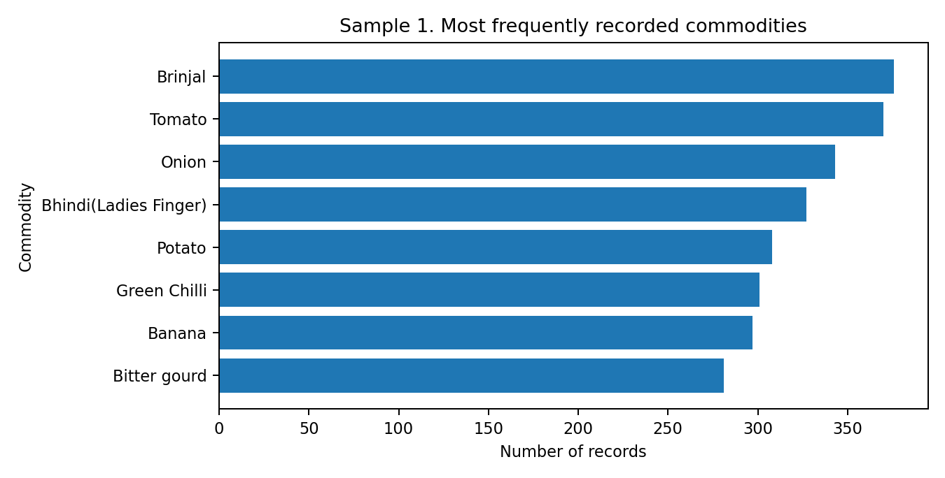
The chart ranks the most frequently recorded commodities. It shows how the file is composed; it does not measure production, demand, or sales.

Figure 2. Mean modal price by commodity
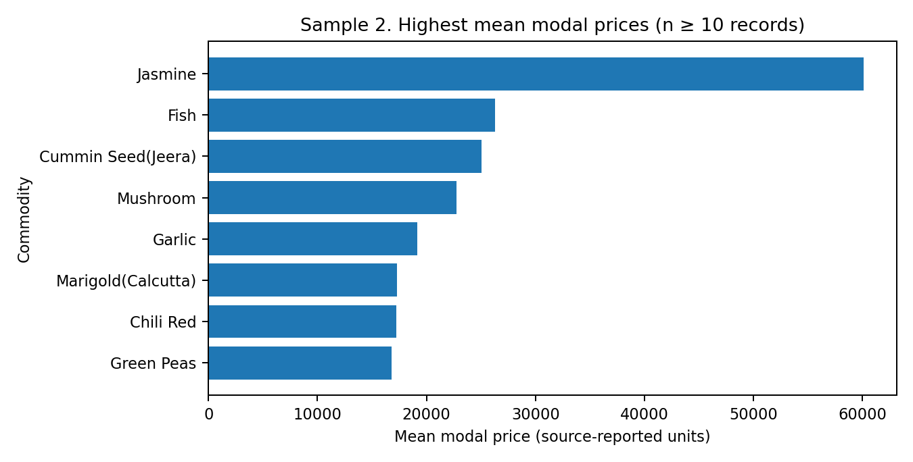
The sample includes commodities with at least 10 records to reduce emphasis on very small groups. Source-reported price units should be verified before comparison.

Figure 3. Distribution of modal prices
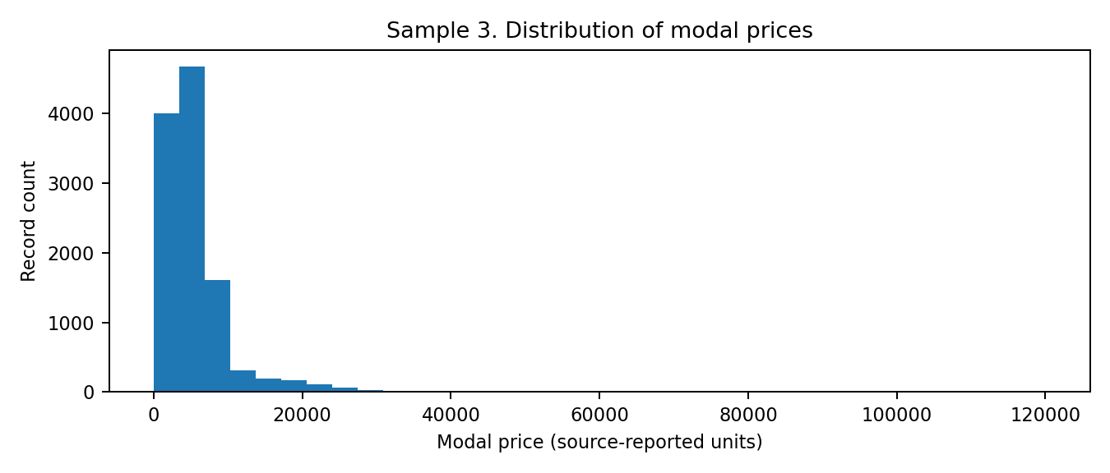
The distribution helps identify skew and values for review. Unusual values should be checked against commodity and market context, not automatically removed.

7. Storyboard / Report Layout Plan
The report should move from context to comparisons, then to data quality and limitations. The wireframe below is conceptual and shows the order and relative placement of components, not a finished interactive dashboard.
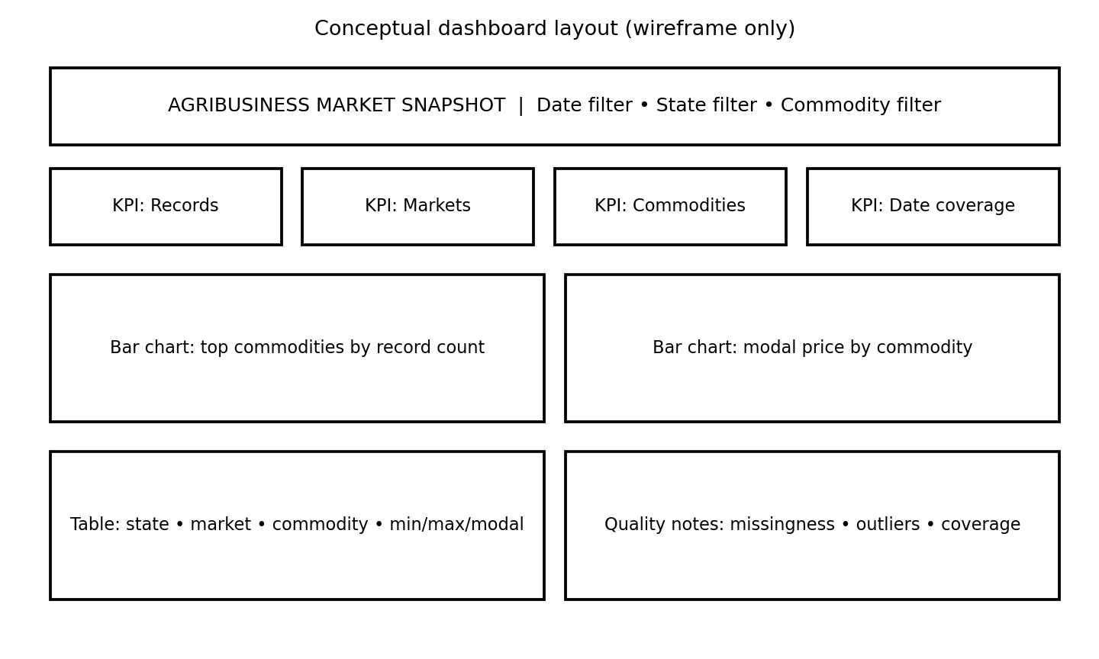
Panel / section | Contents | Reader question answered
Header and filters | Report title, arrival-date scope, state and commodity filters in a dashboard version | What data am I looking at?
KPI row | Record count, market count, commodity count, date coverage | How large and broad is the dataset?
Main left chart | Top commodities by record count | Which commodities have the most records?
Main right chart | Modal price comparison with sample sizes | How do recorded modal prices differ?
Bottom left | Detailed table with state, market, commodity, date, min/max/modal price | Where can I inspect exact values?
Bottom right | Quality indicators and limitations | What checks were done, and what remains uncertain?

8. Visual Design Standards
- Use a clear title that states the metric, grouping, and scope (for example, “Record count by commodity — downloaded file”).
- Label axes and state the source-reported price units; do not assume a unit if the source metadata has not confirmed it.
- Sort ranked bar charts by value and use horizontal bars for long category names.
- Use consistent number formats, decimal precision, font sizes, and spacing throughout the report.
- Use colour to support meaning, not decoration; maintain strong contrast and do not rely on colour alone.
- Include sample size (n) when comparing averages and state the selection rule.
- Place a short caption and interpretation under every chart, including the key limitation.
- Avoid 3D charts, crowded legends, unnecessary gridlines, and dual axes that can mislead.
- Keep raw values and calculations available so charts can be checked and reproduced.

9. Challenges and Mitigation Strategies
Challenge | Potential effect | Mitigation
Single-date coverage | No historical trend or seasonality analysis can be supported | Label the report as cross-sectional; obtain a compatible multi-date dataset for time-series work.
Uneven regional representation | Large contributors may dominate summaries | Show counts and percentages; disclose coverage; avoid claiming national representativeness.
Price outliers / different commodities | Averages may be dominated by high values or incomparable items | Use distribution plots, sample-size thresholds, and record-level verification.
Unconfirmed units or definitions | Cross-commodity or cross-source comparison may be invalid | Check metadata; state units; avoid merging incompatible measures.
Long labels and dense tables | Visuals become difficult to read | Use horizontal bars, concise labels, filters, and a separate detailed table.
Misleading chart choices | Readers may infer causation or trends that are not shown | Match chart to question and add plain-language limitations.
Accessibility and printing | Colours or small text may become unreadable | Use contrast, readable fonts, direct labels, and test a print/PDF version.
Reproducibility issues | Displayed figures may not match the source data | Save calculation code, record cleaning decisions, and re-check chart values before submission.

10. Proposed Timeline and Action Points
Work block | Activity | Estimated time | Output
1 | Confirm scope, audience, and key questions | 1 hour | Scope and metric list
2 | Profile data and verify source fields/units | 2 hours | Data profile and limitations
3 | Calculate summary metrics and quality checks | 3 hours | Validated summary table
4 | Create charts and storyboard | 3 hours | Draft figures and layout
5 | Review captions, design consistency, and readability | 2 hours | Revised visuals
6 | Assemble report, verify facts, and export | 2 hours | Final DOCX and optional PDF
Total |  | 13 hours | Completed visualization plan and sample outputs

11. Quality Checklist Before Delivery
- Every chart answers a defined question and uses an appropriate technique.
- All plotted values can be traced to the supplied dataset and calculation.
- Titles, axes, units, sample sizes, and captions are present.
- Chart labels and values have been checked against the source calculations.
- Single-date coverage is clearly stated; no time trend is claimed.
- Commodity record counts are not misrepresented as production or sales volume.
- Outliers are described as candidates for review rather than assumed errors.
- The report is readable in Word and after export; tables and figures are not clipped.
- Source details and any remaining limitations are included.

12. Conclusion
An effective agribusiness visualization report should be accurate, readable, reproducible, and honest about data limitations. Ranked bar charts are suitable for comparing category counts and average modal prices, distribution plots help reveal spread and unusual observations, and tables support detailed lookup. Line charts should be reserved for compatible observations across multiple dates. The proposed workflow combines data profiling, metric definition, chart selection, design review, validation, and documentation. The sample charts and storyboard demonstrate how the report can be organized while keeping conclusions within the evidence available in the current single-date dataset.

References and Data Note
Working dataset: Task1_DataSet.csv, supplied for the Week 1 agribusiness analysis. The report's sample charts were generated from this file. Before making external comparisons, confirm the exact resource metadata, publisher, units, date coverage, and reuse terms on the relevant official data portal.
Open Government Data Platform India — Agriculture sector: https://data.gov.in/sector/agriculture
Current Daily Price of Various Commodities from Various Markets (Mandi) catalogue: https://www.data.gov.in/catalog/current-daily-price-various-commodities-various-markets-mandi

13. Detailed Data Sources and Collection Plan
The supplied Task1_DataSet.csv remains the primary working file for this report. The additional sources below are proposed for validation, context, and future multi-date analysis; they are not silently merged into the supplied file. Before combining any source, confirm its date, geographic level, commodity/variety definition, unit, licensing terms, and update frequency.
Source | What it can provide | How it will be used | Important checks
Open Government Data (OGD) Platform India – Current Daily Price of Various Commodities from Various Markets (Mandi) | Daily wholesale minimum, maximum and modal prices from markets; the catalogue identifies AGMARKNET as the source. | Primary external reference for extending the one-date snapshot into a date-wise dataset and checking field definitions. | Confirm resource version, date coverage, units, field names, download/API limits and update date.
AGMARKNET – Agricultural Marketing Information System Network | Market-wise and commodity-wise daily market price and arrival information. | Collect repeated observations for the same commodity-market pair to build a valid time series. | Keep market names and commodity/variety labels consistent; distinguish price from arrival quantity.
e-NAM – National Agriculture Market | Market and commodity information, price-related views and trading context where available. | Optional contextual comparison for markets/commodities covered by the platform. | Do not assume e-NAM coverage equals all mandis; verify that the measure and date match.
India Meteorological Department (IMD) – weather observations / products | Rainfall and weather context at available station or regional levels. | Optional explanatory context in a separate analysis after aligning location and dates. | Weather association does not prove that weather caused a price movement; check spatial and temporal alignment.

Official source links:
- OGD mandi-price catalogue: https://data.gov.in/catalog/current-daily-price-various-commodities-various-markets-mandi
- OGD mandi-price resource: https://data.gov.in/resource/current-daily-price-various-commodities-various-markets-mandi
- AGMARKNET portal: https://agmarknet.gov.in/
- e-NAM portal: https://enam.gov.in/
- India Meteorological Department: https://mausam.imd.gov.in/

14. Data Dictionary and Metric Specifications
The following dictionary is based on the ten fields described for the supplied working dataset. Exact spelling and data types must be confirmed against the CSV header before running the workflow.
Field | Expected type | Meaning | Validation / treatment
State, District, Market | Text/category | Geographic identifiers for the reporting market. | Trim whitespace, standardise spelling/case for grouping; do not merge similar names without a documented mapping.
Commodity, Variety, Grade | Text/category | Product and quality descriptors. | Preserve source labels; use a reviewed mapping table if labels differ across sources.
Arrival_Date | Date | Date associated with the reported market observation. | Parse with an explicit day/month convention; report min and max dates and count distinct dates.
Min_Price, Max_Price, Modal_Price | Numeric | Source-reported wholesale price fields. | Convert to numeric; check non-negative values and Min ≤ Modal ≤ Max; confirm the unit from source metadata.

Metric | Exact calculation | Required breakdown | Interpretation
Total records | Number of rows after loading; also report rows after cleaning. | Overall and optionally by state. | Number of observations, not tonnes, transactions, or sales.
Distinct market count | Count of unique (State, District, Market) combinations. | Overall / state. | A market is counted once even if it reports several commodities.
Commodity coverage | Count of unique Commodity values. | Overall / state. | Shows category coverage, not production diversity.
Mean modal price | Arithmetic mean of Modal_Price among valid rows. | Commodity and, where meaningful, market. | Sensitive to extreme values; show median and n alongside it.
Median modal price | 50th percentile of Modal_Price among valid rows. | Commodity and market. | A robust centre measure; still not automatically comparable across different units/grades.
Price spread | Max_Price − Min_Price for each row; summarise median and IQR. | Commodity / market. | Describes within-record reported range, not volatility over time.
Missingness rate | Missing cells in a field ÷ total rows × 100. | Each field. | Report both count and percentage.
Duplicate rate | Duplicate rows under a documented business key ÷ total rows × 100. | Overall. | Review duplicates before dropping; repeated observations may be legitimate if dates/grades differ.

15. Reproducible Data Collection and Preparation Workflow
- Acquire: download the CSV from the approved portal or use the supplied internship file. Record the file name, source page, download date, and any filters used.
- Preserve: keep an untouched raw copy. Perform all transformations on a separate working copy so that every change can be audited.
- Inspect: read the header, row count, column count, data types, date format, unique category counts, and first/last records.
- Standardise: trim leading/trailing spaces in text fields; standardise date parsing; convert price columns to numeric without replacing unparseable values silently.
- Validate: test missing values, exact duplicates, impossible negative prices, and the logical range Min_Price ≤ Modal_Price ≤ Max_Price.
- Investigate: review flagged rows against the original source. Do not automatically delete a high price or unusual commodity value.
- Transform: create analysis tables using documented groupings and filters. Retain the sample size (n) for every mean or median.
- Visualise: create charts only after the calculations have been checked independently.
- Document: save the cleaning log, calculation output, chart files, code/notebook, and final report together.

16. Concrete Data-Cleaning Rules with Examples
Issue | Detection rule | Action | Illustrative example (not a value from the supplied CSV)
Missing price | Modal_Price is blank or cannot be parsed as a number. | Count and report it. Investigate source. Exclude only from the relevant price statistic, and disclose the excluded n; do not invent a price. | A record has no modal price: it remains in coverage counts but is excluded from mean/median modal-price calculations.
Negative price | Any price field < 0. | Flag as invalid and verify against source; correct only if source evidence confirms a transcription error. | Min_Price = -50 is flagged for review.
Inconsistent price range | Min_Price > Modal_Price or Modal_Price > Max_Price. | Flag the full record; verify units, parsing and source. Do not silently reorder the values. | Min=1,200; Modal=1,100; Max=1,500 violates the expected order.
Duplicate record | Same State + District + Market + Commodity + Variety + Grade + Arrival_Date. | Inspect all matching rows. Remove only confirmed duplicate copies and record the number removed. | Two identical rows for the same market/date/commodity are reviewed as a possible duplicate.
Inconsistent labels | Values differ only by spaces, case, or known spelling variants. | Trim whitespace and use a documented mapping table; preserve the raw label. | 'Tomato ' and 'Tomato' can be standardised after checking they refer to the same category.
Extreme price | Value outside a commodity-specific IQR fence: Q1 − 1.5×IQR or Q3 + 1.5×IQR. | Flag for investigation, compare with market/grade context, and retain unless confirmed erroneous. | A high-value observation is not deleted solely because it is statistically unusual.

Important: IQR flags are screening signals, not proof of error. Price levels can differ substantially by commodity, variety, grade, and market. Therefore, investigate outliers within sensible groups rather than applying one global threshold to every commodity.

17. Practical Python Implementation (pandas and Matplotlib)
The analysis code is provided in Section 26 and is tailored to the uploaded Task1_DataSet(1).csv file. It should be treated as the authoritative implementation.
The original generic code example has been superseded by the corrected, dataset-specific implementation in Section 26. Use Section 26 as the authoritative code listing because it normalises the actual CSV headers and reproduces the audit checks and summary outputs reported in Sections 24–25.
The actual dataset audit and findings generated from this workflow are summarised in Sections 24 and 25. Keep the source CSV and generated outputs with the report so the results can be reproduced.

18. Chart-by-Chart Interpretation and Reporting Template
Visual | Question answered | Required annotation | Example interpretation wording
Ranked bar: record count by commodity | Which commodities have the most observations in this file? | Count, data date/scope, top-N rule. | “Commodity A has the largest number of records in this extract. This indicates greater representation in the file, not higher production or demand.”
Ranked bar: mean modal price | How do average reported modal prices differ across commodities? | Mean, n, source unit, minimum n threshold, median in supporting table. | “The displayed mean is higher for Commodity B in this extract. Commodity prices may not be directly comparable unless units, grades and reporting conditions are consistent.”
Histogram: modal price distribution | Are observations concentrated, skewed, or spread across a wide range? | Bin width, observation count, x-axis unit. | “Most recorded values fall in the lower portion of the displayed range, with a long right tail. The high values require market- and commodity-level review.”
Box plot by commodity | Which groups have wider distributions or flagged extreme values? | Median, quartiles, whisker definition, n. | “The interquartile range is wider for this group, indicating greater spread among the recorded observations; it does not establish price volatility over time.”
Line chart (future multi-date data only) | How does one consistent commodity-market series change over time? | Daily/weekly frequency, missing dates, market, variety, grade and unit. | “The series rose between the selected dates. This is a descriptive movement and does not identify its cause.”

For each chart, use a two-part caption: (1) observation — what the chart visibly shows; (2) limitation — what the chart cannot establish. This directly prevents unsupported claims about production, demand, profitability, causation, or historical movement.

19. Dashboard Specification and User Interaction
Dashboard component | Fields / interaction | Design and behaviour | Acceptance test
Header and scope | Report title, source, extraction date, arrival-date range. | Show that the current file is a single-date snapshot; display source and last refresh. | A reader can identify the file and date scope without reading the full report.
Filter row | State, district, market, commodity, variety, grade. | Filters should update all relevant charts and tables together. | Selecting one state does not leave unrelated visuals unchanged.
KPI cards | Rows, unique markets, unique commodities, distinct arrival dates, missing modal-price count. | Show labels, units and scope; avoid decorative metrics. | KPI values reconcile to the filtered data.
Commodity charts | Record count and mean/median modal price. | Sort bars; show n; enforce a documented minimum sample size. | Displayed values match a separately exported summary table.
Quality panel | Missingness, duplicate candidates, invalid price order, negative prices. | Show counts and percentages; provide a note that flags require review. | Quality indicators recalculate when filters change.
Detail table | State, district, market, commodity, variety, grade, date, min/max/modal. | Enable search/sort; keep price unit visible; avoid excessive decimal places. | A user can trace a charted group to its underlying records.

20. Validation, Reproducibility and Sign-off
- Reconciliation: total rows in the loaded dataset must match the source file before cleaning; report any row exclusions and the reason.
- Calculation check: independently recalculate the top commodity counts and mean/median modal prices in Excel or a second pandas groupby and compare results.
- Chart check: confirm each chart uses the intended filtered population, axis labels, unit, sorting, sample size and title.
- Date check: count distinct arrival dates. If there is only one date, do not publish a line chart or claim a trend.
- Geography check: count unique State–District–Market combinations; do not interpret record counts as market share or national coverage.
- Quality check: verify missingness, duplicate candidates, negative values and price-order violations against source records.
- Reproducibility check: retain the raw CSV, cleaned file (if created), notebook/script, summary tables, chart images and this report.
- Peer review: ask a second reviewer to trace at least three chart values back to source rows and confirm the captions are not overstated.

21. Expanded Work Plan and Deliverables
Phase | Activity | Estimated effort | Evidence / deliverable
1. Scope and source verification | Confirm audience, questions, source, metadata, date range and units. | 2 hours | Source register and metric specification.
2. Data profiling | Inspect schema, types, categories, date coverage, missingness and duplicates. | 4 hours | Data profile and quality audit.
3. Cleaning and validation | Standardise fields, parse dates/prices, flag invalid ranges and investigate duplicates/outliers. | 5 hours | Cleaning log and validated analysis copy.
4. Metric calculations | Calculate counts, market coverage, mean/median prices, distributions and sample sizes. | 4 hours | Reconciled summary tables.
5. Visual design | Build ranked bars, histogram, box plot and dashboard storyboard. | 6 hours | Chart pack and dashboard wireframe.
6. Interpretation and review | Write evidence-based captions, limitations and management takeaways; peer-check values. | 4 hours | Reviewed narrative and QA checklist.
7. Final reporting | Format DOCX/PDF, verify references, save code and supporting outputs. | 3 hours | Final report and reproducibility bundle.
Total | Estimated working time; actual time should be logged. | 28 hours | Complete, reviewable visualization and reporting package.

22. Practical Findings, Recommendations and Limitations
The supplied report already contains three sample visualisations: commodity record frequency, mean modal price by commodity (with a minimum group-size rule), and the distribution of modal prices. These are useful descriptive views of the supplied extract. The first chart describes representation in the file; the second compares source-reported price summaries; and the histogram highlights skew and values that may deserve review.
Because the supplied extract is described as containing one arrival date, the report cannot establish price direction, seasonal patterns, price volatility, demand, production, sales volume, or causal relationships. A multi-date dataset with consistent commodity, variety, grade, market and unit definitions is required for time-series analysis.
Recommended next actions:
- Retain the three existing charts, but regenerate them from the supplied CSV after running the documented validation workflow.
- Add a data-quality summary table with actual missing, duplicate-candidate, negative-price and invalid-order counts.
- Add a median modal-price chart or a commodity-wise box plot so that readers are not dependent on means alone.
- If historical analysis is required, collect a consistent daily series for selected commodity-market pairs from AGMARKNET/OGD and document missing dates.
- Use a dashboard only after the metric definitions and validation checks are stable; Power BI is optional, not a substitute for data-quality work.

23. References and Source Notes
The following official portals were consulted as candidate public sources. The supplied Task1_DataSet.csv remains the basis for the existing sample charts. External sources are recommended for future extension and validation only; no external observations have been merged into the supplied data in this report.
- Open Government Data Platform India. Current Daily Price of Various Commodities from Various Markets (Mandi). https://data.gov.in/catalog/current-daily-price-various-commodities-various-markets-mandi — Catalogue describes daily wholesale minimum, maximum and modal prices and identifies AGMARKNET as the source.
- Open Government Data Platform India. Current Daily Price of Various Commodities from Various Markets (Mandi) – resource page. https://data.gov.in/resource/current-daily-price-various-commodities-various-markets-mandi — Resource-level page for download/preview and metadata.
- AGMARKNET. Agricultural Marketing Information System Network. https://agmarknet.gov.in/ — Government market information portal for daily market and commodity reporting.
- National Agriculture Market (e-NAM). https://enam.gov.in/ — Additional market-platform context; coverage and measures must be checked before comparison.
- India Meteorological Department. https://mausam.imd.gov.in/ — Potential source for weather context, subject to geographic/date alignment.
Source verification note: portal contents, downloadable resources, API availability, field definitions and update dates can change. Record the actual access date and resource version when collecting data for a final analysis.

Final Submission Note
The raw dataset was subsequently supplied and analysed. Verified dataset-derived statistics, four additional charts, and a corrected Python implementation have been added in Sections 24–26. Before submission, retain the original CSV and the code/output files as supporting evidence.

24. Actual Dataset Audit and Verified Results
This section is based on direct analysis of the uploaded Task1_DataSet(1).csv file. Unlike the proposed methodology sections above, the counts and descriptive statistics below are calculated from the supplied 11,215-row dataset. They describe this extract only and should not be interpreted as national production, sales, demand, or a time trend.
Audit item | Verified result | Interpretation
Rows and columns | 11,215 rows; 10 columns | The CSV contains 11,215 observations and 10 fields.
Arrival-date coverage | 1 distinct date: 26 Oct 2026 | Single-day cross-section; no historical trend can be calculated.
Geographic coverage | 26 states; 333 districts; 995 unique State–District–Market combinations | Coverage is broad in category count but unevenly distributed.
Commodity coverage | 197 commodities; 365 varieties; 13 grades | The file includes diverse commodity and quality categories.
Missing cells | 0 across all 10 columns | No missing cells were detected in the loaded CSV.
Exact duplicate rows | 0 | No exact duplicate rows were detected.
Duplicate business keys | 0 | No repeated State–District–Market–Commodity–Variety–Grade–Date key was detected.
Negative price records | 0 | No negative values were detected in the three price fields.
Invalid price-order records | 0 | No rows violated Min_Price ≤ Modal_Price ≤ Max_Price.
Unparsed arrival dates | 0 | All arrival-date values parsed successfully using day-first parsing.

Geographic concentration: Tamil Nadu contributes 6,740 records (60.1% of the dataset). This is a strong coverage imbalance. State-level record counts should therefore be shown with percentages and should not be treated as a measure of agricultural output or market size.
Modal-price summary: mean = 5,608.47; median = 4,200.00; first quartile = 2,800.00; third quartile = 6,500.00. The mean is above the median, consistent with a right-skewed distribution in which some high observations pull the arithmetic average upward. Price units must be confirmed from source metadata before external comparison.
Outlier screening: the global IQR rule flags 719 records (6.4%) above/below the global fences. This is a screening result only. Since different commodities have very different price scales, these flags must not be labelled errors or deleted automatically; commodity-specific and market-specific review is more appropriate.

25. Actual Findings from the Dataset
Finding | Evidence from this extract | Responsible interpretation
Most frequently recorded commodity | Brinjal: 376 records (3.4%). | It is the most represented commodity in this file, not necessarily the most produced or consumed.
Second and third most represented | Tomato: 370; Onion: 343. | These are record-frequency rankings only.
Largest state contribution | Tamil Nadu: 6,740 records (60.1%). | The dataset is heavily weighted toward this state; avoid claiming equal state coverage.
Modal-price centre | Median 4,200.00, compared with mean 5,608.47. | Median is less affected by extreme high values and should accompany the mean.
Date limitation | All observations are dated 26 October 2026. | No daily movement, seasonality, volatility, or before/after comparison can be inferred.

Figure 4. Actual top commodities by record frequency
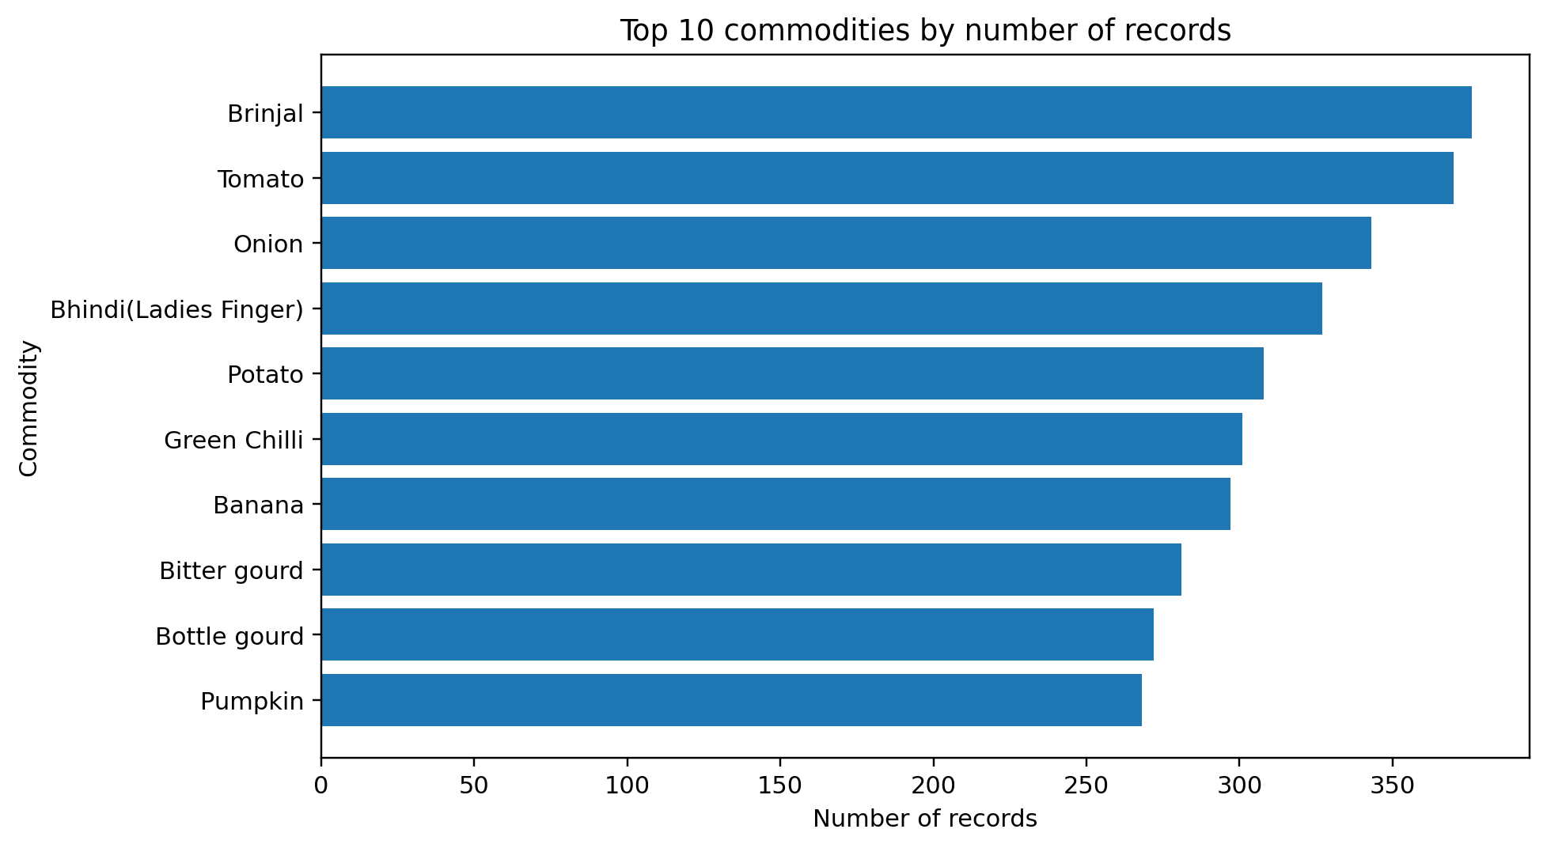
Interpretation: Brinjal is the most frequently represented commodity with 376 records, followed by Tomato and Onion. The differences describe file composition, not production volume or demand.

Figure 5. Actual state coverage by record frequency
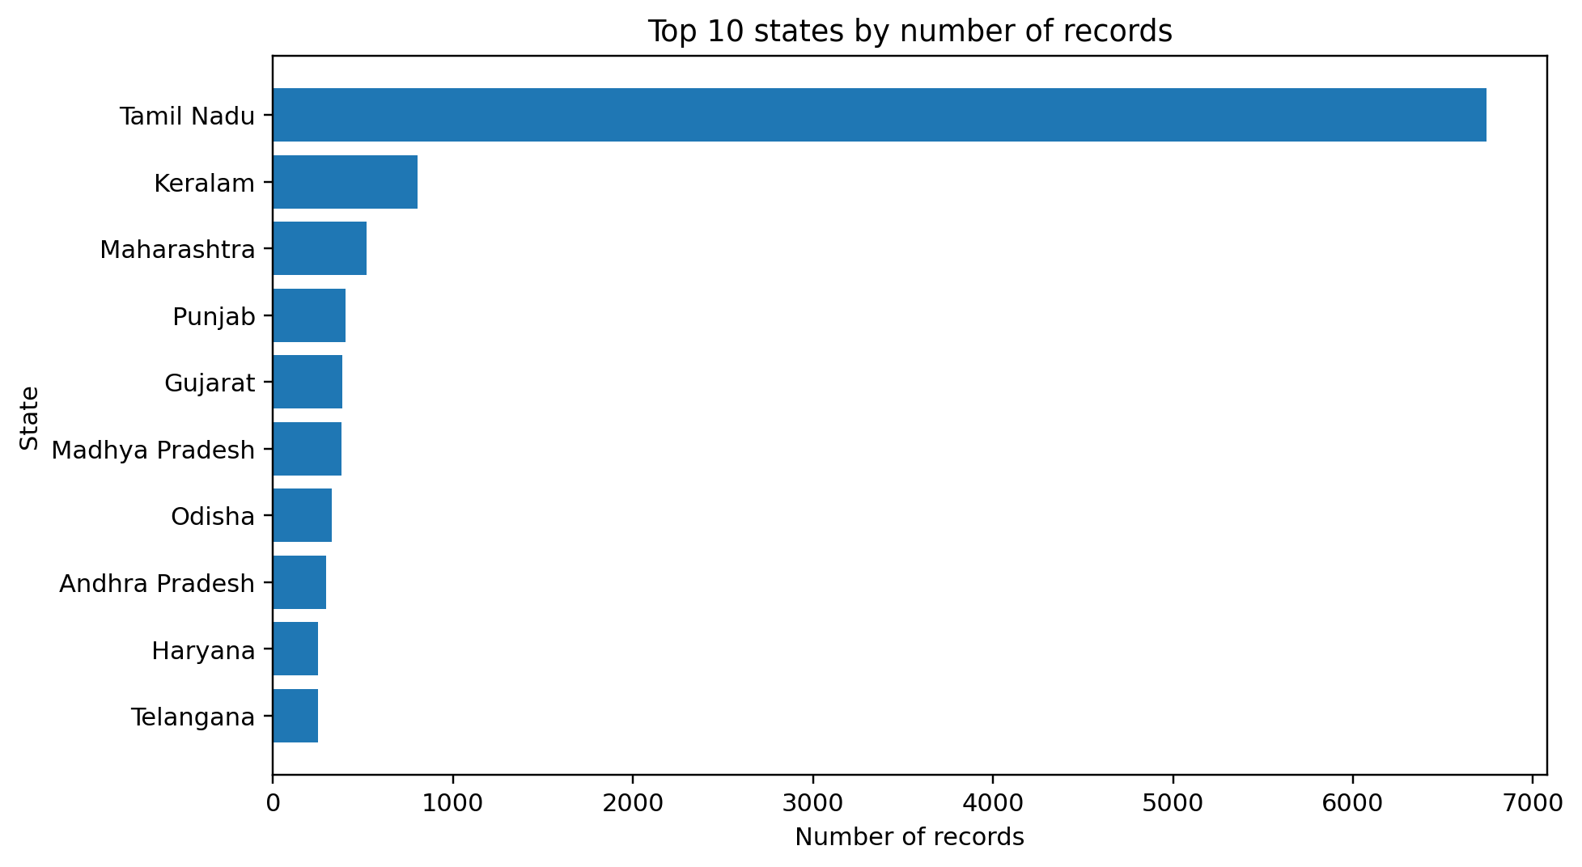
Interpretation: Tamil Nadu dominates the top-state ranking with 6,740 observations. Its 60.1% share means aggregate results can be strongly influenced by this state's records. A state filter and percentage-based coverage display are recommended.

Figure 6. Actual distribution of modal prices
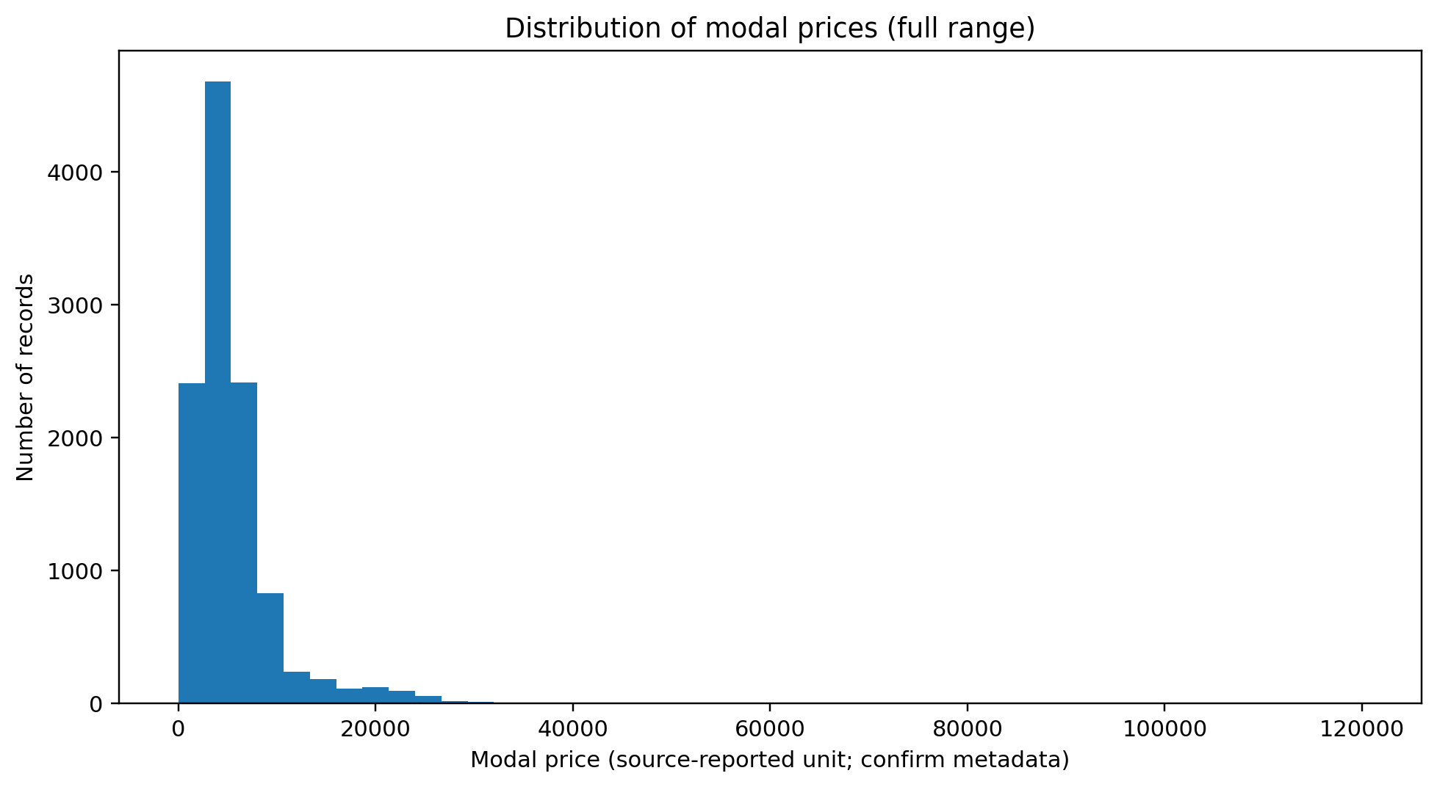
Interpretation: the histogram shows a long right tail. The high-value tail should be investigated by commodity, variety, grade and market. Do not remove these observations solely because they are visually distant from the main concentration.

Figure 7. Actual modal-price box plot
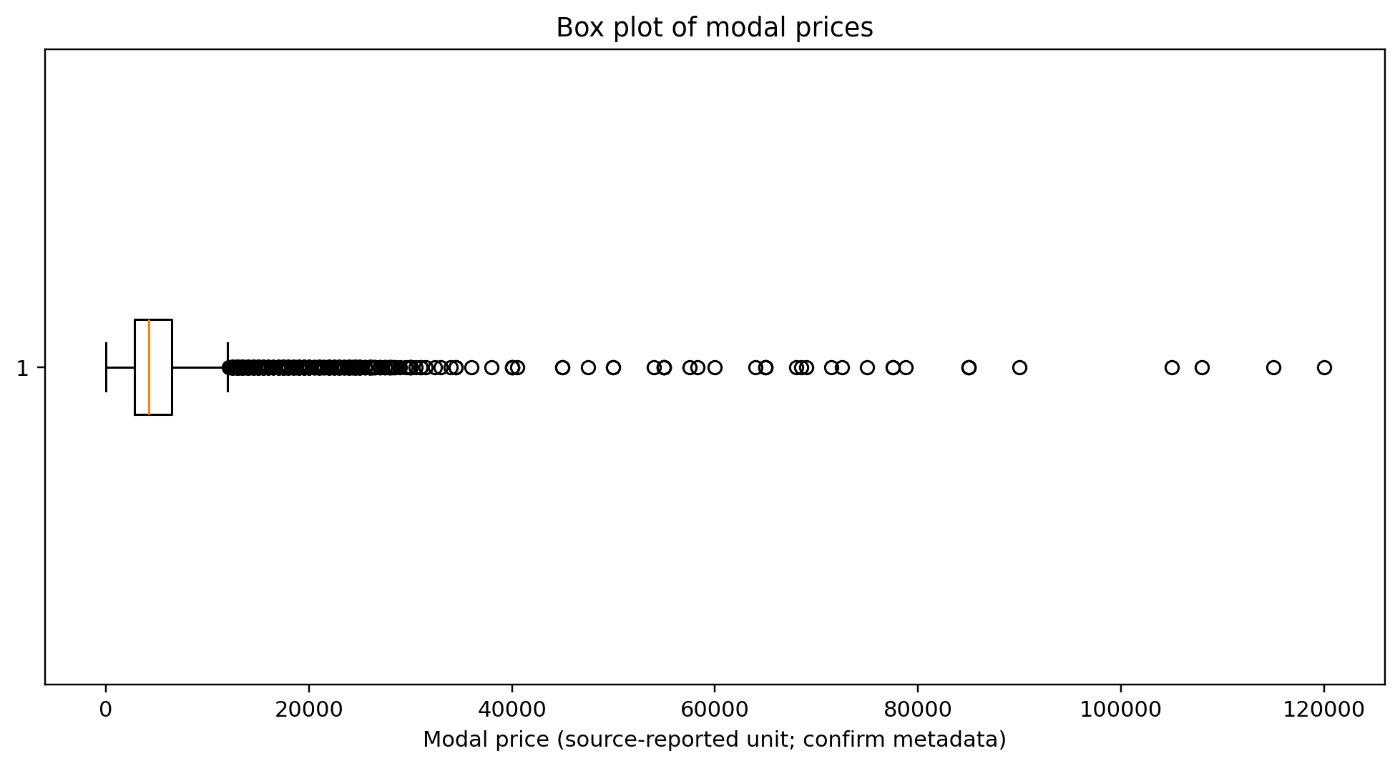
Interpretation: the box plot highlights the broad spread and high-end observations. A single global box plot mixes unlike commodities, so the next analytical step should be commodity-wise box plots for groups with sufficient observations.

26. Corrected Python Code for the Supplied CSV
The actual CSV uses the encoded headers Min_x0020_Price, Max_x0020_Price and Modal_x0020_Price. The following code normalises those exact headers before analysis. This corrects the earlier generic example's rename-map assumption and reproduces the main audit figures and tables.
import pandas as pd
import matplotlib.pyplot as plt
df = pd.read_csv("Task1_DataSet(1).csv")
df.columns = [c.replace("_x0020_", "_").replace(" ", "_")
for c in df.columns]
text_cols = ["State", "District", "Market", "Commodity",
"Variety", "Grade"]
for col in text_cols:
df[col] = df[col].astype("string").str.strip()
df["Arrival_Date"] = pd.to_datetime(
df["Arrival_Date"], dayfirst=True, errors="coerce"
)
price_cols = ["Min_Price", "Max_Price", "Modal_Price"]
for col in price_cols:
df[col] = pd.to_numeric(df[col], errors="coerce")
# Dataset profile
print("Shape:", df.shape)
print("Date coverage:", df["Arrival_Date"].min(),
df["Arrival_Date"].max(),
df["Arrival_Date"].nunique())
print("Unique states:", df["State"].nunique())
print("Unique districts:", df["District"].nunique())
print("Unique markets:", df[["State","District","Market"]]
.drop_duplicates().shape[0])
print("Unique commodities:", df["Commodity"].nunique())
# Quality checks
print("Missing cells:", int(df.isna().sum().sum()))
print("Exact duplicate rows:", int(df.duplicated().sum()))
key = ["State","District","Market","Commodity","Variety",
"Grade","Arrival_Date"]
print("Duplicate business keys:",
int(df.duplicated(subset=key).sum()))
print("Negative-price rows:",
int((df[price_cols] < 0).any(axis=1).sum()))
bad_order = ((df["Min_Price"] > df["Modal_Price"]) |
(df["Modal_Price"] > df["Max_Price"]))
print("Invalid price-order rows:", int(bad_order.sum()))
# Summaries
print(df["Modal_Price"].describe())
commodity_counts = df["Commodity"].value_counts()
print(commodity_counts.head(10))
state_counts = df["State"].value_counts()
print(state_counts.head(10))
# Mean and median by commodity; retain sample size
summary = (df.groupby("Commodity")["Modal_Price"]
.agg(n="count", mean="mean", median="median")
.query("n >= 10")
.sort_values("mean", ascending=False))
print(summary.head(10))
# Export evidence for the report
summary.to_csv("commodity_price_summary.csv")
df.isna().sum().to_csv("missing_value_audit.csv")

27. Submission Evidence Pack
To make the work independently reviewable, submit or retain the following supporting files alongside the Word report where the internship portal permits attachments:
- Original Task1_DataSet(1).csv (unchanged source file).
- Python notebook or .py script used to generate the audit and charts.
- commodity_price_summary.csv and missing_value_audit.csv.
- The four chart images included in this enhanced report.
- A short cleaning log stating that no rows were removed in the checks reported here, and recording any later manual corrections with evidence.
- A PDF export of the final DOCX after checking page breaks, figure captions, table clipping and readable chart labels.
Final analytical caution: these verified results are descriptive statistics from a single date. The report does not claim causal explanations, historical trends, production estimates, sales volumes, or profitability. Any future time-series or forecasting work must use a multi-date dataset with consistent definitions and documented units.

Final Pre-Submission Verification
- Confirm that the internship portal accepts this as the Week 2 task and that the task title matches the portal.
- Open the DOCX in Microsoft Word or LibreOffice and inspect all page breaks, tables, chart captions and page numbering.
- Keep Task1_DataSet(1).csv and the Python code/output files available in case the evaluator requests evidence.
- Verify that the source portal metadata and price unit are accurately described before making any external comparison.
- Do not add claims about price trends, production, sales, demand or profitability; the supplied file contains one arrival date.

