WEEK 1 INTERNSHIP TASK

Data Collection, Exploration
and Cleaning in Agribusiness
A practical plan for building a reliable agricultural dataset

Internship role | Junior Data Analyst – Agribusiness
Platform | Yuva Intern
Task | Week 1: Data Collection, Exploration and Cleaning
Estimated effort | 32 hours (within the required 30–35 hours)
Prepared as a replicable planning document

Abstract
This report documents the initial exploration and quality checks of an official agricultural market-price CSV containing 11,215 records and 10 fields. It summarises commodity and regional record counts, modal-price distributions, and data-quality checks. All records share one arrival date, so findings are limited to a cross-sectional snapshot; the report does not claim historical trends or crop-production/weather relationships.

Table of Contents
1. Introduction and Objectives
2. Scope and Research Questions
3. Public Data Source Identification
The following candidate sources were selected because they are published by government bodies or recognised international organisations and may provide relevant agricultural information. The exact dataset resource, metadata, date coverage, geographical coverage, units, access method, and reuse terms must be checked before the data are used. The descriptions below distinguish proposed uses from work already completed; no source is treated as downloaded or validated unless that action is documented.
4. Data Types and Planned Variables
5. Data Collection Strategy
6. Initial Data Exploration Plan
7. Data Cleaning Methodology
8. End-to-End Workflow Diagram
9. Challenges and Mitigation Strategies
10. Quality Assurance and Reproducibility
11. Work Plan and Timeline (32 Hours)
12. Expected Outputs and Completion Checklist
13. Dataset Analysis and Conclusion
References

1. Introduction and Objectives
Reliable agribusiness decisions depend on data that are sufficiently accurate, consistent, timely, and properly documented. Agricultural datasets can be issued by various departments, have varying units of measurement or geographical labels, or have missing values and revisions. Combining such datasets incorrectly can create erroneous conclusions. Hence, there is a need for data collection and cleaning prior to any statistical modelling or business interpretation.
The objectives of this Week 1 plan are to:
- Describe the process of initial data preparation to support the analysis of agribusiness.
- identify at least three publicly accessible, credible data sources related to agribusiness;
- define a manageable pilot dataset and fields of interest;
- describe the first checks to be made that will highlight key patterns, relationships, and problems;
- specify the rules for dealing with missing values, duplicates, inconsistencies, labels, units, dates, and suspicious values
- develop a workflow, risk control measures, and time budget that another analyst would understand.

2. Scope and Research Questions
This project focuses on the collection, exploration, and cleaning of agricultural data in India, with a particular emphasis on examining Karnataka as a regional case study where sufficient data are available. The study will use publicly accessible agricultural datasets to investigate crop production, market prices, and data quality.
The analysis will focus on two primary categories of agricultural information: crop production statistics and agricultural market prices. Crop production data can help identify differences in agricultural output across crops, districts, seasons, and years. Market-price data can help examine price variation across commodities, markets, and observation dates.
The project will follow a data-driven approach. Rather than assuming that particular trends or relationships exist, the analysis will calculate descriptive statistics, examine data distributions, identify potential data-quality problems, and interpret findings based on the records actually collected.
The final scope will depend on the verified availability, completeness, time coverage, geographical coverage, and compatibility of the selected datasets. If suitable historical observations are available, the project will investigate changes over time. If the available data do not support a particular analysis, that limitation will be explicitly documented rather than replaced with unsupported conclusions.
The project is designed to be completed within the required 30–35 hours, including data source identification, collection, initial exploration, cleaning, validation, visualization, documentation, and report preparation.

2.1 Exploratory Research Questions
The following questions will guide the analysis:
- Crop production: How does recorded agricultural production vary across selected crops, districts, seasons, and years?
- Market prices: How do minimum, maximum, and modal market prices differ across selected commodities and agricultural markets?
- Price variation: Where sufficient observations exist, how do market prices for selected commodities change across observation dates, and which markets show the greatest variation?
- Data quality: What proportion of the collected records contain missing values, duplicate entries, inconsistent labels, invalid dates, or suspicious numerical values?
- Data cleaning: How do documented cleaning rules affect the number of usable records, the consistency of variables, and the reliability of the resulting dataset?
- Dataset compatibility: Can crop production, market-price, and other agricultural datasets be combined reliably, given their geographical coverage, time periods, units, and definitions?
- Agribusiness relevance: What practical observations about agricultural production and market-price differences can be supported by the available data?
These questions will be answered using actual dataset records and calculated results. Any conclusions will be limited to what the collected data can reasonably support.

3. Public Data Source Identification

1. Open Government Data (OGD) Platform India – Agriculture / Crop Production
Official source: https://data.gov.in/sector/agriculture
Dataset selection and relevance
The Open Government Data (OGD) Platform India is an official Government of India portal that provides access to datasets published by government departments and public institutions. For this project, the portal will be used to identify a specific crop-production dataset containing agricultural statistics for India and, where available, Karnataka.
The preferred dataset should include variables such as crop name, state, district, agricultural season, year, cultivated or harvested area, and production quantity. The actual availability of these fields will be verified against the selected dataset's metadata and downloaded file before analysis.
Planned analytical use
After downloading the selected dataset, the analysis will examine the number of observations, geographical coverage, year range, crop categories, missing values, and duplicate records. Where compatible area and production measurements are available, agricultural yield may be calculated as:
Yield = Production Quantity ÷ Harvested Area
The units used for production and area will be checked before calculating yield. For example, production recorded in tonnes and area recorded in hectares would produce a yield expressed in tonnes per hectare.
The analysis will also compare production across selected crops, districts, or years, depending on the dataset's actual coverage. Any differences in units, reporting periods, or crop classifications will be documented before comparisons are made.
Data validation requirements
Before using this dataset, the following details will be recorded:
- Dataset title and publishing department.
- Dataset URL and date of retrieval.
- Available years and geographical coverage.
- Number of rows and columns in the downloaded file.
- Definitions and measurement units of the relevant variables.
- Missing-value counts, duplicate records, and potential inconsistencies.
- Applicable licence or terms of use.
These checks will establish whether the dataset is suitable for the research questions and provide a reproducible record of the data-selection process.

2. Open Government Data Platform India – Daily Agricultural Market Prices
Official source: https://www.data.gov.in/catalog/current-daily-price-various-commodities-various-markets-mandi

Dataset selection and relevance
The catalogue entry titled Current Daily Price of Various Commodities from Various Markets (Mandi) is a candidate source for examining wholesale agricultural prices. The available fields are expected to describe commodities, markets or mandis, arrival dates, and minimum, maximum, and modal prices; the exact names, units, coverage, and date range must be confirmed from the resource metadata and downloaded file.

Planned analytical use
The analysis will compare prices across commodities and markets where units and definitions are comparable. If the file contains multiple dates for the same commodity-market combination, price changes over time may also be examined. The validation checks will include: (1) testing whether minimum price ≤ modal price ≤ maximum price; (2) reviewing duplicate rows and possible duplicates under a commodity-market-date key; (3) checking invalid dates, negative or non-numeric prices, and inconsistent commodity or location labels; and (4) reviewing extreme values against the source before deciding whether they should be retained, corrected, or excluded. A flagged record is an investigation candidate, not proof of an error.

Interpretation limit
The dataset used for the figures contains 11,215 records from one arrival date. The charts describe record frequency, cross-sectional modal-price differences, price distribution, and geographic concentration; they cannot establish historical trends.

3. Food and Agriculture Organization of the United Nations – FAOSTAT
Official source: https://www.fao.org/faostat/

Dataset selection and relevance
FAOSTAT is an international statistical database maintained by the Food and Agriculture Organization of the United Nations. It is a candidate source for national-level agricultural and food statistics, depending on the selected domain and indicator. Before use, the relevant domain, indicator definitions, country coverage, years, units, and download format will be recorded. National aggregates will not be treated as equivalent to district-level observations.

Planned analytical use
If a suitable indicator and time range are available, FAOSTAT may be used for contextual comparisons with Indian agricultural statistics or for a separate national-level trend description. Any comparison with district or mandi data will first assess differences in geographical level, definitions, units, and reporting periods. The report will not merge records simply because their crop names appear similar.

4. India Meteorological Department – Weather Data
Official source: https://mausam.imd.gov.in/

Dataset selection and relevance
The India Meteorological Department (IMD) is a candidate source for weather observations and climate information. The exact product or dataset must be selected from the official portal, and its access conditions, station or spatial coverage, observation period, variables, and units must be verified. The portal itself is not treated as a single ready-to-use dataset.

Planned analytical use and limitation
Weather variables such as rainfall or temperature could provide context for a future crop-production study only when their spatial and temporal resolution is compatible with the agricultural data. For example, daily station rainfall cannot be directly compared with annual district crop production without a documented aggregation and geographic matching method. No rainfall-versus-yield relationship is claimed in the present report because compatible datasets have not yet been assembled.

Source-selection record
For each source actually used, record the exact dataset title and resource URL, publisher, retrieval date, file format, date and geographic coverage, row and column counts, variable definitions, measurement units, licence or terms of use, and any limitations stated by the publisher. These records will make the data-selection process traceable and reproducible.

4. Data Types and Planned Variables
The data can be presented in various forms such as table type, containing numerical values, dates, categorical values, and geographical information. Some sources can provide the data in CSV or Excel format while others might offer API or downloadable tables. The format will be identified once the sources are evaluated.
Data category | Example variables | Type / unit examples | Potential relevance
Crop production | Crop, season, year, area, production, yield | Categorical, integer/date, numeric; hectares, tonnes, kg/ha as published | Compare output and productivity across crops, places and years.
Market prices | Commodity, mandi, date, min/max/modal price | Categorical, date, numeric; verify price unit | Explore price variation and differences between markets.
Weather | Rainfall, maximum/minimum temperature, station/location, date | Numeric; mm, °C; daily/monthly as published | Provide environmental context for future analysis.
Geography | State, district, market, station code | Categorical/string or standard code | Enable grouping and carefully controlled data joins.
Metadata | Source URL, download date, unit, revision, licence | Text/date/category | Maintain traceability and reproducibility.

5. Data Collection Strategy

5.1 Define and record the scope
- Choose your initial list of crops/commodities and/or geographic scope based on data availability (don't expand the pilot before seeing results).
- Pick a time period common to the sources if possible and note rationale for the dates selected
- For each set, identify the unit of observation on which the data are standardized (e.g., one crop-location-season-year or one commodity-market-date).
- Document the inclusion and exclusion criteria before undertaking cleaning procedures to ensure that decisions are not made selectively to favor a specific finding.

5.2 Download and preserve raw data
- Open the page with the data set and check its metadata, the date of publication/update, its dictionary and license or terms.
- Download the original file or access it using documented API (if available). Do not use unofficial copies if there is an official copy available
- Save the untouched copy in read only folder. The file name could be like source_title_download-date_original.csv.
- Record the data set's title, publisher, the web address of the set, the date of retrieval, the type of file, the dates it covers, its geographic coverage, its license or terms, its units and any caveats if any in a source log
- Make a separate copy for exploring and cleaning data. Do not make any changes in the raw file.
- If there are more than one version of the same data set keep the older version or record the version/date so that it could be replicated.

5.3 Proposed folder structure
agribusiness_week1/
├── raw/ # untouched downloaded files
├── processed/ # cleaned and standardised files
├── documentation/ # source log, data dictionary, cleaning log
├── figures/ # exploratory charts
└── report/ # final report and submission copy

6. Initial Data Exploration Plan
Exploration will reveal what the data contain and whether they can be useful. The analyst will not take for granted that the data are clean or that some patterns exist in them before looking at the files.

File and schema inspection
Record file size, the number of rows and columns, the column names, data types, encoding, delimiter, date format, and any parsing warnings.

Data dictionary review
Compare fields seen with source documentation. Clarify units, definitions, aggregation levels, and special codes such as -1, 0, blank, or 'NA'.

Descriptive statistics
For numeric fields, calculate count, missing count, mean, median, standard deviation, minimum, maximum and selected percentiles. For categorical fields, calculate distinct values and frequency counts.

Missingness profile
Calculate missing-value counts and percentages per column and inspect whether missingness clusters by year, crop, market or location.

Duplicate assessment
Check exact duplicate rows and duplicates under the proposed business key, such as commodity + market + date for prices.

Range and plausibility checks
Flag negative production, impossible dates, negative prices, minimum prices greater than maximum prices, or yields that are extreme relative to comparable records. Treat flags as review items, not automatic proof of error.

Distribution and time checks
Use histograms or boxplots for numeric variables, line charts for time series, and bar charts for counts or averages by crop/market. Look for spikes, gaps and abrupt changes.

Cross-source compatibility
Compare location labels, date resolution, commodity names and units. Test whether a proposed join creates unexpected row multiplication or unmatched records.

6.1 Graphical Analysis:
Figure 1. Ten most frequently recorded commodities in Task1_DataSet.csv (n = 11,215).
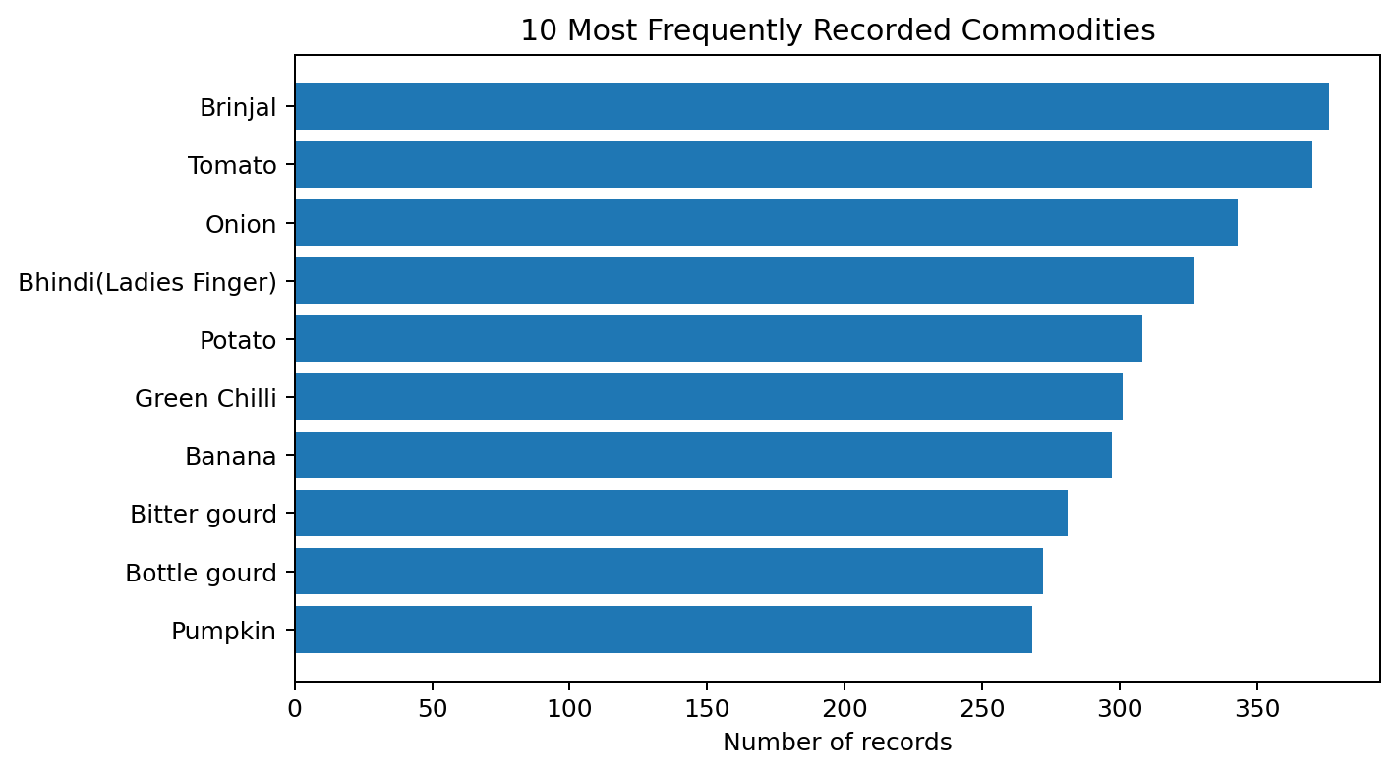

Figure 1 shows record frequency, not production volume or market importance. Brinjal has the most observations (376), followed by Tomato (370) and Onion (343). The counts describe the composition of this downloaded file only.

Figure 2. Ten highest mean modal prices among commodities with at least 10 records.
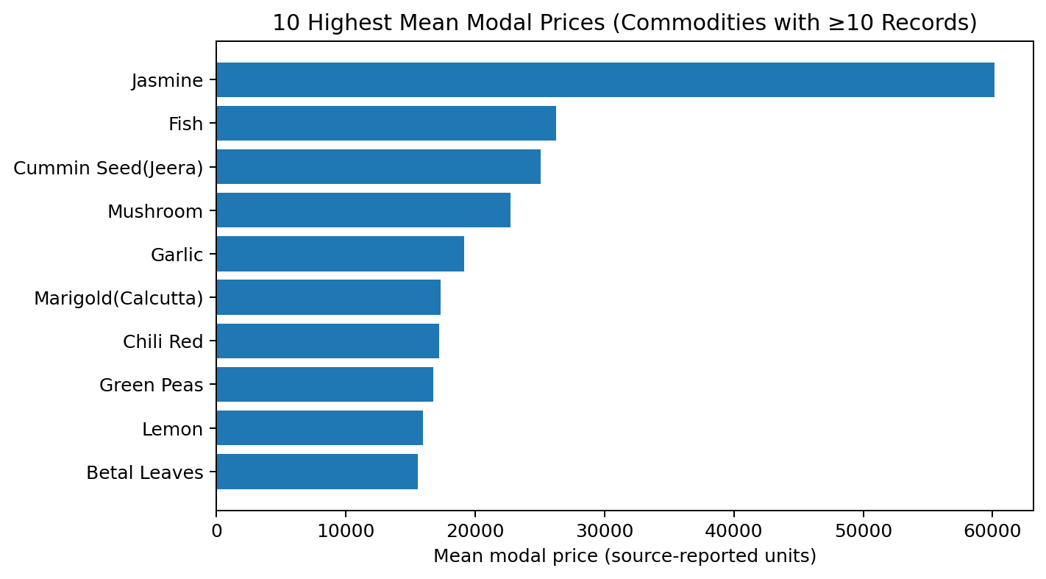
Figure 2 compares mean modal prices for commodities with at least 10 observations, reducing the influence of categories represented by only one or two records. The three highest means in the displayed group are Jasmine (60,133.33; n=15), Fish (26,275.00; n=20), and Cummin Seed(Jeera) (25,054.46; n=18). These are cross-sectional price comparisons for the recorded date, not price trends.

Figure 3. Distribution of modal prices across all 11,215 records.

Figure 3 summarises the modal-price distribution. The mean modal price is 5,608.47 and the median is 4,200.00; the difference indicates a right-skewed distribution in which high-price observations pull the mean upward. Outliers should be checked against commodity type and source records rather than removed automatically.

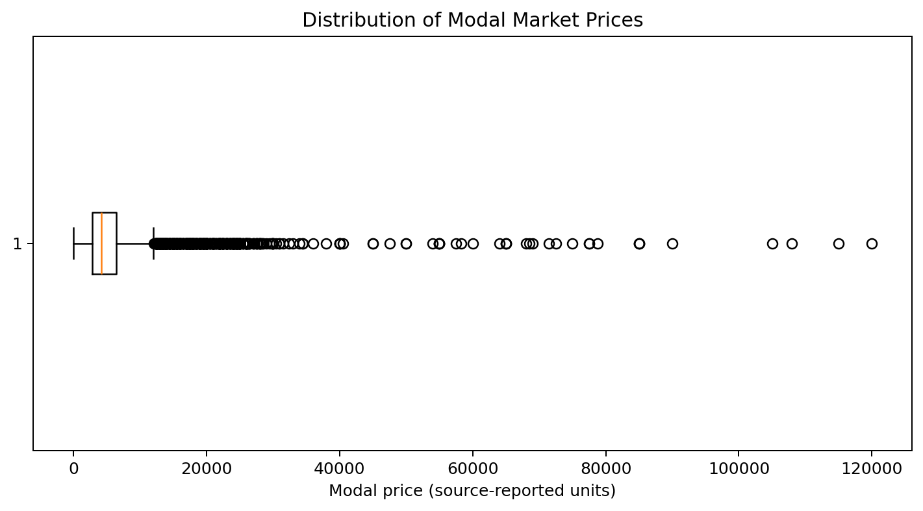
Figure 4. Ten states/regions with the highest record counts.
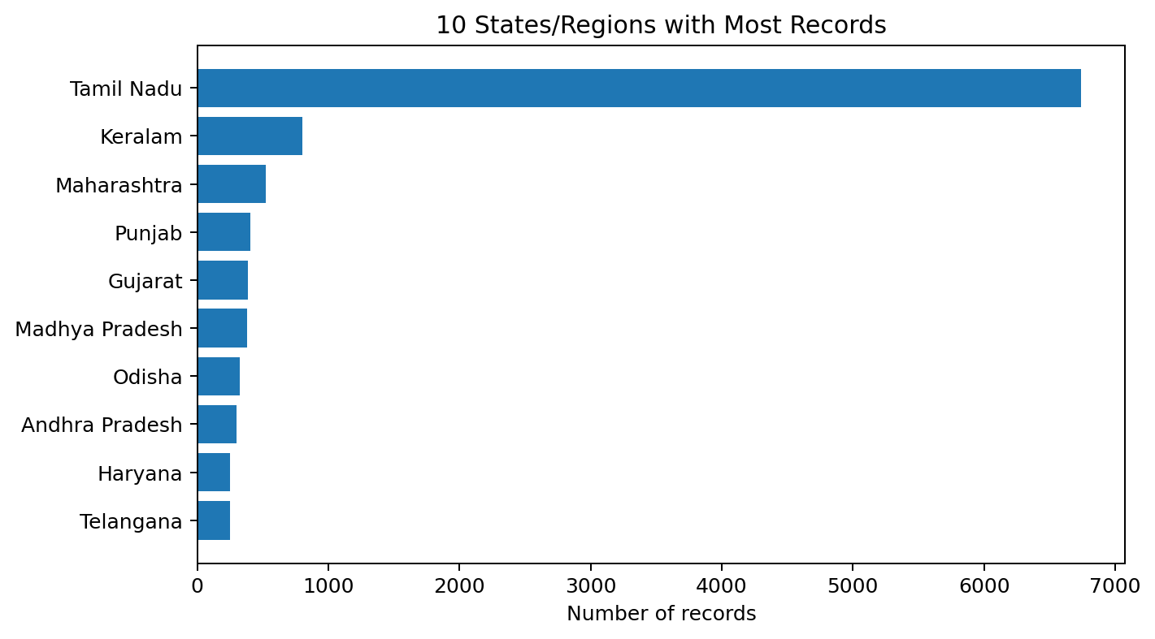
Figure 4 shows that records are concentrated in a small number of state/region labels. Tamil Nadu contributes 6,740 records (60.1% of the file). This concentration should be considered when interpreting national-looking summaries; the file is not evenly distributed across regions.

6.2 Interpretation of the Initial Exploration
The four charts profile commodity frequency, mean modal prices for sufficiently represented commodities, the overall modal-price distribution, and geographic concentration. Together they describe the downloaded file but do not establish causes, production levels, consumer prices, or historical changes.
The mean modal-price comparison is restricted to commodities with at least 10 records to avoid overemphasising single-record categories. The highest displayed means are Jasmine (60,133.33), Fish (26,275.00), Cummin Seed(Jeera) (25,054.46). Price differences may reflect commodity characteristics, units, grade, or market composition; they should not be interpreted as profitability or affordability without additional context.
The modal-price distribution has a mean of 5,608.47 and median of 4,200.00. High observations warrant record-level review, but may be genuine prices for different commodities. No observation is removed solely because it appears as a statistical outlier.
The dataset contains 11,215 rows and 10 columns. Standard missing-value checks found 0 missing cells; exact duplicate checking found 0 duplicate rows. These checks do not detect every possible semantic problem, so range and label validation are also required.

Concrete validation examples
For each market-price record, a validation routine can flag (a) a negative minimum, maximum, or modal price; (b) minimum price greater than maximum price; (c) a modal price outside the reported minimum-to-maximum range; (d) an unparseable arrival date; and (e) a repeated commodity-market-date combination. Each flagged row should be reviewed against the source metadata and original record. The number of flagged rows and the decision taken should be reported only after the checks are run; no count of such issues is assumed here.
All 11,215 records share the arrival date 26/10/2026. Therefore, the dataset supports a single-date cross-sectional analysis only; it cannot establish price trends, seasonality, or changes over time.

6.3 Evidence and reporting discipline
For every numerical finding in the final report, retain the calculation or code that produced it and state the relevant subset, units, and number of observations. Distinguish observed results from proposed checks and future work. Where the data do not support a question, report the limitation explicitly rather than infer a result.

7. Data Cleaning Methodology
Cleaning will be rule-based, documented and reversible. Each change should be recorded with the affected field, rule, number of rows affected, reason and action taken. Suspicious records should be flagged for review instead of being silently deleted.
Stage | Planned method | Evidence/output
1. Preserve and profile | Keep raw files unchanged; create a working copy; capture initial row/column counts and quality metrics. | Baseline profiling summary.
2. Standardise column names | Trim whitespace; use consistent lowercase snake_case names; retain a mapping from original to standard names. | Consistent schema and field map.
3. Parse types and dates | Convert dates using explicit formats; parse numeric fields carefully; retain unparseable values in a review log rather than coercing them invisibly. | Correct data types and parsing-error log.
4. Handle missing values | Quantify missingness first. Recover values from the original source if possible. Do not fill missing crop yields or prices with zero unless the source definition explicitly means zero. For essential fields, exclude rows only when justified and record the count. For optional fields, retain missing values or use a documented method suited to the analysis. | Missingness report and documented decisions.
5. Remove duplicates | Identify exact duplicates and business-key duplicates. Compare source timestamps or metadata before removing; retain the most authoritative record when a duplicate is a revision, and document the rule. | Duplicate report and de-duplicated working data.
6. Standardise categories | Trim spaces, standardise case and map known spelling variants for crop, market, state and district names using a controlled mapping table. Do not merge names unless equivalence is confirmed. | Canonical category values and mapping table.
7. Normalise units and scales | Convert units only with verified conversion factors; add a unit field or standard-unit field; document original and converted values. For modelling, standardisation such as z-scores or min–max scaling may be applied to selected numeric features after cleaning, but not to source values used for reporting. | Consistent units and documented transformation rules.
8. Validate ranges and logic | Flag negative values where not meaningful, min price > max price, impossible dates, and yield/production inconsistencies. Check formulas such as yield ≈ production / harvested area only when units and definitions align. | Validation exceptions list.
9. Investigate outliers | Use percentiles, IQR or domain comparisons to flag unusual values. Verify against the source and surrounding observations. Correct only when evidence supports a correction; otherwise retain with a flag or exclude for a clearly stated analytical reason. | Outlier review log.
10. Validate joins | Before merging, align location, date, commodity and unit definitions. Measure matched/unmatched rows and check for one-to-many or many-to-many join expansion. | Join audit and merged dataset, if justified.
11. Save and re-check | Save a clean file separately; rerun row counts, schema, missingness, uniqueness and range checks; compare before/after metrics. | Clean dataset and quality summary.

7.1 Normalisation: two different meanings
In this plan, normalisation has two distinct uses. First, unit harmonisation converts equivalent measurements to a common unit (for example, after verifying the source definition). Second, statistical scaling transforms numeric features to comparable scales for some analytical methods. These operations are not interchangeable. Source values and original units must be preserved so that the data remain interpretable.

7.2 Missing-value decision rules
- If the source provides a corrected or updated value, prefer verifying and retrieving it from the source.
- If missingness is small and confined to non-essential fields, retain the row and leave the value missing where appropriate.
- If an essential key field such as date, commodity or market is missing and cannot be recovered, exclude the row from analyses requiring that key and record the exclusion.
- Use median/mean imputation only when justified by the intended analysis, and keep an indicator or note that the value was imputed. Avoid blanket imputation for time-series or grouped data.
- Never treat a blank as zero unless the source documentation defines it that way.

8. End-to-End Workflow Diagram
The following diagram summarises the proposed process from defining the question through final quality checks.
1. Define scope & questions
Select crops, markets, geography and period
↓
2. Identify official sources
Review metadata, access, licence and units
↓
3. Download & log raw data
Preserve original files and retrieval details
↓
4. Inspect & explore
Schema, summaries, missingness, duplicates, ranges
↓
5. Clean & standardise
Types, categories, missing values, units and errors
↓
6. Validate & document
Quality checks, join audit and cleaning log
↓
7. Save clean outputs
Clean dataset, data dictionary and summary report
Decision gate: if a source lacks adequate metadata, has unclear reuse terms, or cannot be aligned reliably with the other data, document the limitation and either replace it with a suitable source or keep it separate. Do not force a merge simply to produce one combined table.

9. Challenges and Mitigation Strategies
Challenge | Why it matters | Mitigation strategy
Different units and definitions | Prices, area, production and yield may use different units or definitions. | Inspect metadata; preserve original units; create explicit conversion rules and a standard-unit field.
Missing or delayed observations | A market may not report every day, and some fields may be blank. | Quantify gaps; check source updates; distinguish no report from a true zero; document exclusions and avoid unsupported filling.
Inconsistent names and spelling | The same commodity or location may appear with spelling variants or changed administrative boundaries. | Use a controlled mapping table and official codes where available; manually review ambiguous matches.
Outliers and data-entry errors | Unusually high or low values can be valid events or errors. | Flag with statistical and domain checks; verify against source records; never delete solely because a value is extreme.
Different temporal/geographic resolutions | Annual crop statistics cannot automatically be joined to daily market prices or station-level weather. | Aggregate or align only with a justified method; document the analysis level; keep datasets separate when compatibility is inadequate.
Source revisions and API changes | A dataset may be updated, moved or change fields. | Record retrieval date and version; retain raw copies; validate schema after each download; document API parameters.
Licence and attribution requirements | Open data may still require attribution or have specific terms. | Read the source licence and terms; cite publisher and dataset; follow any reuse restrictions.
Limited time | Multiple sources and complex joins may exceed the available hours. | Prioritise a small, high-quality pilot; time-box exploration; postpone optional weather integration if core production and price cleaning are not complete.

10. Quality Assurance and Reproducibility
Before finishing the task, the analyst will have performed the following checks:
• Source traceability: every dataset has a source URL, publisher, retrieval date, coverage and license/terms
notes
• Raw-data integrity: raw downloads remain unchanged; all transformations occur on copies.
• Schema validity: expected columns exist and have appropriate types.
• Key uniqueness: duplicate counts are measured using both exact-row and business-key definitions.
• Missingness transparency: missing values are counted and treatment decisions are justified.
• Logical consistency: ranges and field relationships are checked using documented rules.
• Unit consistency: all conversions are traceable and original values are retained when practical.
• Merge integrity: joins are checked for unmatched keys and unexpected row multiplication.
• Before/after comparison: row counts, missingness and validation exceptions are compared after cleaning.
• Reproducibility: steps and assumptions are recorded so another analyst can repeat the process.
Suggested success criteria for the pilot are: all used fields are documented; all cleaning rules are logged; no unexplained duplicate business keys remain in the selected analytical table; critical fields have been checked for missingness; all unit conversions are traceable; and every flagged exception is either resolved or explicitly retained with a reason. These are process targets, not claims about results before data inspection.

11. Work Plan and Timeline (32 Hours)
Work block | Activity | Hours | Output
1 | Define analytical scope and research questions | 2 | Scope note; initial inclusion/exclusion rules
2 | Locate sources and review metadata/licensing | 4 | Source inventory; access and coverage notes
3 | Download data and create source log/folder structure | 4 | Untouched raw files; source log
4 | Inspect schemas and create a data dictionary | 3 | Field definitions, types and units
5 | Perform initial exploration and quality profiling | 5 | Descriptive statistics; missingness, duplicate and range checks
6 | Apply cleaning and standardisation rules | 6 | Clean working files; cleaning log
7 | Validate data and review potential joins | 3 | Before/after quality checks; join audit if applicable
8 | Prepare workflow diagram, findings and final document | 3 | Formatted report and final checklist
 | TOTAL | 32 | Within the required 30–35-hour estimate
The schedule is an estimate. In the case of a selected source with access problems or inadequately presented information, use the allocated contingency time within the corresponding block and reduce the pilot scope before sacrificing data-quality checks.

12. Expected Outputs and Completion Checklist
- Create a source inventory (with at least three public sources), containing links and relevance notes;
- Develop a clearly bounded pilot scope and list of variables, units and intended use;
- Provide untouched raw files and a source/retrieval log;
- Submit an initial exploration summary, which should include schema, descriptive statistics, missingness, duplicates, ranges and potential outliers;
- Prepare a cleaning methodology, with explicit rules for missing values, categories, units, error correction and outlier review;
- Construct a workflow diagram from collection to cleaning and validation;
- Prepare a risk/challenge table, with mitigation strategies;
- Create a 30–35-hour timeline; this plan budgets 32 hours;
- Provide a clean, properly formatted DOCX document, with references and working source links.

13. Dataset Analysis and Conclusion

Dataset Summary and Quality Checks
The supplied CSV, Task1_DataSet.csv, contains 11,215 rows and 10 columns: State, District, Market, Commodity, Variety, Grade, Arrival_Date, Min_Price, Max_Price, and Modal_Price. The source column names for the three price fields were normalised for readability in this report; the underlying values were not changed.
Coverage and concentration. The file contains 26 distinct state/region labels, 333 districts, 995 markets, and 197 commodities. Tamil Nadu contributes 6,740 records (60.1%). This reflects the downloaded file's composition and should not be read as proportional national coverage.
Most frequent commodities. Brinjal (376), Tomato (370), Onion (343), Bhindi(Ladies Finger) (327), Potato (308). These are record counts, not production quantities or sales volumes.
Date limitation. All 11,215 records have the same arrival date (26/10/2026). The dataset cannot support historical trend or seasonality analysis.
Price summary. Mean prices are minimum 5,204.57, maximum 5,990.97, and modal 5,608.47; medians are 4,000.00, 4,500.00, and 4,200.00, respectively. Values are in the source-reported price units; confirm the catalogue's unit definition before comparing with external datasets.
Data-quality checks. Standard missing-value checks found 0 missing cells; there were 0 exact duplicate rows, 0 rows where minimum price exceeded maximum price, and 0 rows where modal price fell outside the minimum–maximum interval. These checks are useful but do not prove all records are error-free.
Reporting correction. All four charts in this version have been regenerated from Task1_DataSet.csv. The report no longer uses the earlier 8,969-record charts. The analysis is cross-sectional because the file contains only one arrival date.
The analysis of Task1_DataSet.csv provides a first descriptive profile of agricultural market-price records and basic data-quality checks. The regenerated charts and calculated statistics describe only the downloaded file and its single arrival date. Crop-production and weather sources are listed as candidates for future work, not as datasets analysed in this report.

References
- Open Government Data Platform India – Agriculture sector. https://data.gov.in/sector/agriculture Government of India platform for agriculture-related datasets.
- Open Government Data Platform India – Crop Production Statistics. https://data.gov.in/dataset-group-name/crop-production-statistics Dataset group to explore for crop production indicators.
- Open Government Data Platform India – Current Daily Price of Various Commodities from Various Markets (Mandi). https://www.data.gov.in/catalog/current-daily-price-various-commodities-various-markets-mandi Catalogue description of daily minimum, maximum and modal wholesale prices.
- Food and Agriculture Organization of the United Nations – FAOSTAT. https://www.fao.org/faostat/ Public international food and agriculture statistics.
- India Meteorological Department – Mausam. https://mausam.imd.gov.in/ Official weather portal; consult individual product documentation for access and reuse terms.
- Government of India National Portal – Website of AGMARKNET. https://www.india.gov.in/category/agriculture-rural-environment/subcategory/agricultural-produce/details/website-of-agmarknet Government portal description of agricultural market information.
NOTE: The analyst should note dates of access to the source pages and specific dataset availability, as this can vary. An initial exploratory analysis was performed on the downloaded mandi-price dataset. The results are based exclusively on the downloaded data and the checks carried out. Historical price analysis, as well as rainfall-against-crop-yield analysis, were not completed as appropriate datasets could not be assembled. The availability, metadata, and reuse terms of the selected sources should be checked before further analysis. Check the actual metadata and reuse terms at the time of retrieval.

