PERFORMANCE EVALUATION
AND STRATEGIC
RECOMMENDATIONS REPORT
Agribusiness Performance Assessment and Operational Improvement Plan

Programme: Yuva Intern – Junior Data Analyst (Agribusiness)
Task: Week 4 – Performance Evaluation and Strategic Recommendations
Reporting Period: FY 2023–24 to FY 2025–26
Geographic Focus: Maharashtra, India
Prepared by: [Insert Your Full Name]
Submission Date: 10 November 2026

IMPORTANT DATA NOTE
The enterprise-level figures in this report are hypothetical and are used only to demonstrate a realistic KPI evaluation process. Publicly published sources are cited separately and are not presented as evidence that the fictional enterprise achieved these results.

EXECUTIVE SUMMARY
This report evaluates a hypothetical onion-producing and aggregation enterprise in Maharashtra that coordinates approximately 500 farmers across 1,000 cultivated hectares. The enterprise supports input planning, cultivation, harvesting, sorting, storage, transport and wholesale marketing. Performance is reviewed across FY 2023–24, FY 2024–25 and FY 2025–26 using seven operational and commercial KPIs.
The illustrative dataset indicates improving production and financial performance: harvested yield increased from 15.8 to 17.2 tonnes per hectare (+8.9%), operating margin increased from 18.3% to 28.5% (+10.2 percentage points), and cost per tonne declined from ₹14,700 to ₹14,300 (−2.7%). Water productivity improved from 5.2 to 6.1 kg/m³, but remained below the proposed internal target of 6.5 kg/m³. Physical post-harvest loss declined from 14.5% to 11.5%, while on-time delivery improved from 78% to 88%; both remain below internal targets.
The key conclusion is that productivity and profitability are strengthening, but value is still being lost through handling, quality rejection, water inefficiency and delivery delays. The report recommends a phased programme: establish verified baseline data; pilot improved grading, curing and storage; improve irrigation scheduling; strengthen market intelligence and dispatch planning; and operate a monthly KPI review with named owners and corrective-action thresholds.
Priority finding | FY 2025–26 illustrative result | Management implication
Production efficiency | 17.2 t/ha; internal comparator 15.5 t/ha | Maintain yield gains, but validate performance across farm and season segments.
Profitability | 28.5% operating margin; internal target 25% | Protect margin through cost controls and better price/grade realisation.
Water productivity | 6.1 kg/m³; internal target 6.5 | Improve irrigation scheduling and meter-based monitoring.
Post-harvest loss | 11.5%; internal target 9% | Prioritise handling, curing, grading and storage interventions.
Delivery reliability | 88%; internal target 95% | Improve order planning, vehicle allocation and dispatch tracking.
Marketable output | 88.5%; internal target 95% | Reduce quality rejection through field-level quality protocols.

Interpretation caution: targets other than the cited public yield and irrigation-study comparisons are proposed management targets for this fictional enterprise. They are not claimed to be universal Maharashtra industry averages.

CONTENTS
Executive Summary
1. Introduction
2. Methodology
3. Evaluation Results
4. Strategic Recommendations
5. Ongoing Evaluation and Adjustment Plan
6. Data Quality, Bias, Risk and Limitations
7. Conclusion
References
Page numbers can be refreshed in Microsoft Word by selecting the document contents and pressing F9 after opening the file.

1. INTRODUCTION

1.1 Background and business context
Onion agribusiness performance is influenced by biological production factors and commercial execution. Yield depends on variety, seed quality, soil, weather, irrigation, nutrient management and pest pressure. The value ultimately realised also depends on harvest maturity, curing, grading, storage, market timing, transport and price conditions. Therefore, a production increase alone does not prove that the enterprise is creating more value: the additional crop must be saleable, delivered on time and sold at a price that covers the full cost of operations.
Maharashtra is a major onion-producing state. Government statistics report state-level onion yield of approximately 14.88 tonnes per hectare for 2022–23 (second advance estimates), providing a broad contextual reference rather than a like-for-like benchmark for a particular season, district, variety or farm group [1].

1.2 Hypothetical enterprise profile
Profile element | Scenario assumption
Business model | Farmer-linked onion production, aggregation and wholesale marketing.
Farmer network | Approximately 500 participating farmers.
Cultivated area | 1,000 hectares in aggregate; average 2 hectares per farmer for scenario modelling.
Geography | Selected onion-producing areas of Maharashtra; not a real named enterprise.
Value chain | Input coordination → cultivation → harvest → curing/sorting/grading → storage → transport → wholesale sale.
Evaluation period | FY 2023–24 to FY 2025–26.
Data status | All enterprise operating, financial and KPI figures are hypothetical and illustrative.

1.3 Purpose, objectives and evaluation questions
The purpose is to determine whether the enterprise is improving operational efficiency, financial performance and resource use, identify gaps against appropriate comparators, and recommend feasible actions.
- Measure production efficiency, profitability, water productivity, physical post-harvest loss, delivery reliability, unit cost and marketable output.
- Compare three-year trends with clearly labelled external evidence or internal management targets.
- Identify where operational losses occur and estimate their potential financial significance without confusing gross sales value with profit.
- Recommend interventions with owners, timelines, resource requirements, risks and measurable outcomes.
- Establish a repeatable monitoring and adjustment process.
Evaluation questions include: Are higher yields translating into stronger margins? Which stages contribute most to loss and rejection? Is water productivity improving at a comparable rate to yield? What explains delivery delays? Which actions should be funded first?

2. METHODOLOGY

2.1 KPI selection and operational definitions
Seven KPIs were selected to cover the production-to-market chain. Each KPI has a defined numerator, denominator, unit, direction of improvement, proposed target and data owner. The definitions are important because inconsistent denominators can create misleading comparisons.
KPI | Operational definition / formula | Direction | FY26 target
1. Harvested yield | Total gross harvested onion weight (tonnes) ÷ harvested area (ha). Unit: t/ha. | Higher | 15.5 t/ha planning comparator; external context discussed separately.
2. Operating profit margin | (Operating revenue − operating cost) ÷ operating revenue × 100. Excludes financing and tax unless included consistently in cost policy. | Higher | 25% internal target.
3. Water productivity | Gross harvested output (kg) ÷ irrigation water applied (m³). Water applied must be meter- or volume-estimated consistently. | Higher | 6.5 kg/m³ internal target.
4. Physical post-harvest loss | Weight physically lost through damage, decay, spillage or shrinkage after harvest ÷ gross harvested weight × 100. Quality downgrades without weight loss are not counted here. | Lower | 9% internal target.
5. On-time delivery | Customer orders delivered within agreed delivery window ÷ total eligible orders × 100. | Higher | 95% internal target.
6. Cost per tonne | Total defined operating production and aggregation cost (₹) ÷ gross harvested tonnes. Cost scope must be consistent each year. | Lower | ₹13,500/t internal target.
7. Marketable production rate | Weight meeting the enterprise's minimum saleable grade specification at dispatch ÷ gross harvested weight × 100. Rejected/downgraded quality is captured here; physical loss is tracked separately. | Higher | 95% internal target.

Important distinction: physical post-harvest loss measures missing or physically unusable weight. Marketable production rate measures the share meeting the agreed saleable grade at dispatch. A bulb can remain physically present but be downgraded for size, shape, disease or appearance; therefore the two KPIs are not mathematical complements. The scenario uses separate illustrative series for them.

2.2 Data collection plan and publicly available information
Data domain | Potential source / record | Use in evaluation | Collection frequency
State and national production | Ministry of Agriculture & Farmers Welfare; Directorate of Economics & Statistics; Agricultural Statistics at a Glance [1] | State/country area, production and yield context; check year and estimate status. | Annual / release-based
Market prices and arrivals | AGMARKNET / e-NAM market records; relevant APMC market bulletins | Compare modal/minimum/maximum prices and arrivals by market, date and commodity grade. | Daily or weekly
Agronomy and technology | ICAR–Directorate of Onion and Garlic Research; peer-reviewed studies [2][3] | Assess irrigation, production practices, marketable quality and technology options. | Study / season-based
International context | FAOSTAT and World Bank datasets | Broader context and cross-country indicators where definitions are comparable. | Annual
Enterprise production | Farm registers, harvest slips, weighbridge records, farmer plot register | Calculate area, harvested tonnes, yield and farm-level dispersion. | Per plot / harvest
Water use | Calibrated flow meters, pump-hour logs and irrigation schedules | Calculate water applied and productivity; identify high-use plots. | Per irrigation / weekly
Post-harvest and quality | Intake, grading, rejection, stock and dispatch records | Separate physical loss from quality downgrade and reconcile mass balance. | Per lot / daily
Financial and logistics | Purchase invoices, payroll, fuel, storage, freight, sales invoices, order and proof-of-delivery records | Calculate costs, realised prices, margin and delivery reliability. | Transaction-level / monthly

For public data, the analyst should record the exact dataset/table, publication year, geography, unit, estimate status, access date and any revisions. Market prices should be compared only after matching commodity, grade, market, date and transaction basis. Public information provides context; it cannot replace enterprise-level operational records.

2.3 Step-by-step analytical workflow
- Define the reporting boundary: participating farmers, plots, crop season, hectares, storage facilities, markets and costs included.
- Create a unique farmer ID, plot ID, harvest-lot ID, storage-lot ID and sales-order ID so records can be traced across stages.
- Collect raw records from farm, water, weighbridge, grading, inventory, transport and finance sources; retain original files unchanged.
- Standardise units (kg, tonnes, hectares, m³, rupees), dates, crop seasons and market/grade codes. Do not mix gross and net weights.
- Run quality checks: missing fields, duplicate IDs, impossible values, inconsistent units, negative quantities, date sequence and mass-balance reconciliation.
- Calculate plot-level KPIs first, then aggregate using appropriate weighted denominators. Do not take a simple average of farm percentages when farm sizes differ.
- Compare trends year-on-year and against relevant external context or explicitly labelled internal targets.
- Segment results by district, season, variety, irrigation method, farm size, storage duration and market channel to reveal variation hidden by the overall average.
- Investigate material variances with field interviews, document review and root-cause analysis; distinguish correlation from causation.
- Present findings with limitations, confidence level, recommended action, accountable owner and a follow-up measurement date.

2.4 Analytical techniques and validation
Technique | How it is applied | Illustrative example
Trend and year-on-year analysis | Track direction and percentage change across three years. | Yield rose from 15.8 to 17.2 t/ha; change = (17.2−15.8)/15.8 ×100 = 8.9%.
Variance analysis | Compare actual value with target; interpret favourable direction according to KPI type. | Loss of 11.5% versus 9% target is 2.5 percentage points adverse.
Weighted aggregation | Sum numerators and denominators before calculating network-level ratios. | Network yield = total harvested tonnes ÷ total harvested hectares, not average of farm yields.
Segment analysis | Compare groups by irrigation, district, season, variety, grade and storage duration. | Compare drip and flood plots while controlling, where possible, for season and soil differences.
Root-cause analysis | Use 5 Whys / fishbone and process mapping to investigate a variance. | Late delivery: late harvest notice → incomplete order forecast → vehicle not allocated → missed dispatch window.
Scenario and sensitivity analysis | Change price, yield, loss and input cost assumptions to test financial exposure. | Test a 5% price decline or 2 percentage-point loss reduction; report assumptions explicitly.
Reconciliation / validation | Recompute samples, match weighbridge to intake/dispatch, reconcile sales to invoices and verify meter readings. | Monthly mass balance variance should be investigated if it exceeds the proposed 1% control threshold.

Validation controls proposed for the pilot: (i) 100% automated duplicate-ID check; (ii) missing mandatory fields below 2% before KPI publication; (iii) monthly mass-balance variance no greater than 1% or documented exception; (iv) random physical verification of at least 10% of participating plots per season; (v) calibration/verification of weighing scales and water meters at the start of the season and at scheduled intervals; and (vi) independent recomputation of a sample of at least 10% of KPI records. These are proposed internal controls, not external standards.

2.5 Benchmarking framework
The report uses a three-level comparison hierarchy: (1) official state/national statistics for broad context; (2) peer-reviewed studies for technology- or location-specific evidence; and (3) internal management targets for operational KPIs where a sufficiently comparable public benchmark is not available. These categories must not be blended.
Benchmark category | Comparison method | Interpretation rule
Official statistical context | Compare enterprise yield with state-level yield for the same or nearest available year, while noting estimate status and geographic scale. | Context only; state average is not a direct farm-level target.
Peer-reviewed practice evidence | Compare similar production settings, season, irrigation system and sample design. | Evidence of potential under study conditions, not guaranteed causal gain for this enterprise.
Internal management target | Set after baseline review, feasibility, cost and risk assessment. | A planning threshold for management, not a published industry average.

A comparator is rated Above / At / Below only when the definition, unit, geography, season and data quality are sufficiently aligned. If comparability is weak, the report labels the comparison as contextual and avoids a definitive performance rating.

3. EVALUATION RESULTS

3.1 Consolidated KPI scorecard
KPI | FY23–24 | FY24–25 | FY25–26 | FY26 target | FY26 assessment
Harvested yield (t/ha) | 15.8 | 16.5 | 17.2 | 15.5* | Above planning comparator
Operating margin (%) | 18.3 | 23.7 | 28.5 | 25 | Above internal target
Water productivity (kg/m³) | 5.2 | 5.6 | 6.1 | 6.5 | Below internal target
Physical post-harvest loss (%) | 14.5 | 12.8 | 11.5 | 9 | Below internal target
On-time delivery (%) | 78 | 84 | 88 | 95 | Below internal target
Cost per tonne (₹) | 14,700 | 14,500 | 14,300 | 13,500 | Above cost target (cost remains high)
Marketable production (%) | 82.0 | 85.0 | 88.5 | 95 | Below internal target

*The 15.5 t/ha figure is a scenario planning comparator. The external state-level reference for Maharashtra was approximately 14.88 t/ha in 2022–23; see Section 2.5 and Reference [1].

3.2 Production efficiency
Harvested yield increased from 15.8 to 17.2 t/ha over the three-year period. The absolute gain was 1.4 t/ha and the relative gain was 8.9%. At 1,000 hectares, the FY 2025–26 scenario implies 17,200 tonnes of gross harvested output. The trend is positive, but the report cannot attribute the increase to a particular intervention because plot-level weather, variety, soil, irrigation and input data have not been supplied.
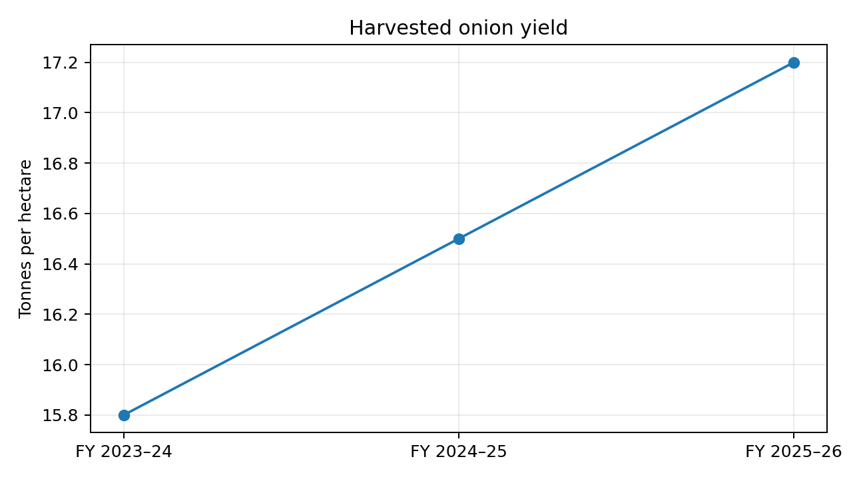
External context: the Government of India's Agricultural Statistics at a Glance reports Maharashtra onion yield of about 14.88 t/ha for 2022–23 [1]. The fictional enterprise's 17.2 t/ha is 15.6% higher than that state-level reference (17.2−14.88)/14.88 ×100. This is only an indicative comparison because the enterprise value is hypothetical, the years differ, and state-level averages combine diverse production systems.
A 2024 study of onion growers in Maharashtra reported mean yields of 36.23 t/ha among sampled drip adopters and 30.13 t/ha among non-adopters [2]. Those sample means are materially higher than the scenario yield, but they should not be used as a universal target: study farms, production seasons, management intensity and sampling conditions may differ. The finding is useful as a reason to test technology and management practices locally, not as proof that drip alone will generate the same result.

3.3 Market profitability and worked financial calculation
Operating margin improved from 18.3% to 28.5%, a gain of 10.2 percentage points. In the hypothetical model, FY 2025–26 yield is 17.2 t/ha, average realised selling price is ₹20,000/tonne and operating cost is ₹245,960/ha. The calculation below demonstrates how the reported margin is derived.
FY 2025–26 calculation | Formula | Illustrative result
Gross harvested output | 17.2 t/ha × 1,000 ha | 17,200 tonnes
Operating revenue | 17,200 t × ₹20,000/t | ₹34.40 crore
Operating cost | ₹245,960/ha × 1,000 ha | ₹24.596 crore
Operating profit | ₹34.40 crore − ₹24.596 crore | ₹9.804 crore
Operating profit margin | ₹9.804 crore ÷ ₹34.40 crore ×100 | 28.5%
Cost per tonne | ₹24.596 crore ÷ 17,200 t | ₹14,300/t

The calculation is internally consistent under the stated assumptions. However, the result is not a verified business account: central overheads, financing, tax, depreciation, inventory changes and differences between harvested and sold quantities may affect actual profitability. The enterprise must publish a cost policy and use it consistently each year.
Price sensitivity: at 17,200 tonnes, a 5% reduction in average price from ₹20,000 to ₹19,000 per tonne would reduce gross revenue by ₹1.72 crore if volume and costs remain unchanged. This demonstrates why market intelligence and grade-wise price realisation matter. It is a static sensitivity calculation, not a price forecast.

3.4 Operational sustainability and water productivity
Water productivity rose from 5.2 to 6.1 kg/m³, an improvement of 17.3%. It remains 0.4 kg/m³ below the internal target of 6.5. The indicator must be interpreted carefully: the denominator should represent measured irrigation water applied, not rainfall or an estimated pump-hour proxy unless the method is disclosed. Meter calibration, irrigation scheduling and plot-level records are therefore essential.
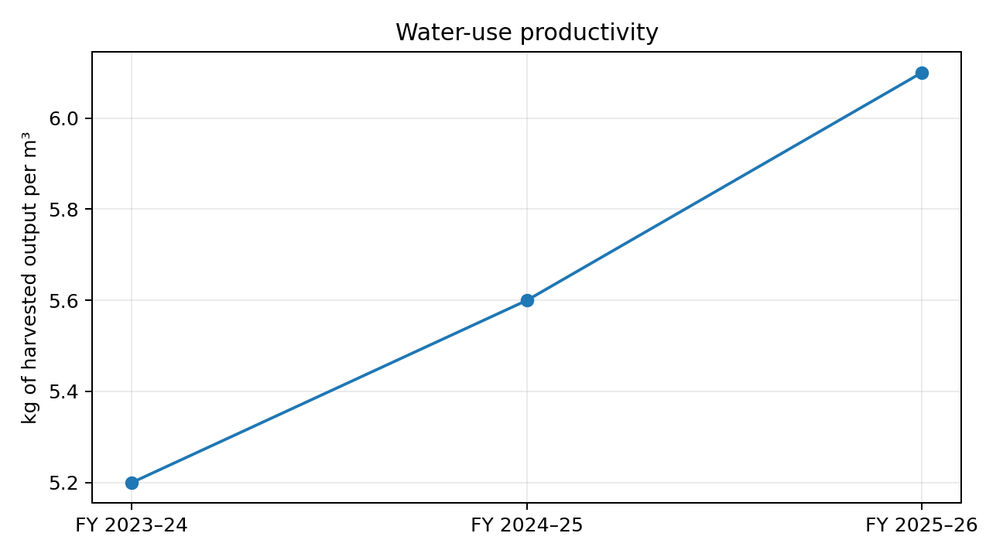
A 2025 study in Maharashtra's Ghod River basin compared raised-bed drip irrigation with flat-bed flood irrigation across 480 farmers. It reported water savings of approximately 24.52% in late monsoon and 28.79% in post-monsoon, and higher yield and marketable bulb proportions for the raised-bed drip group [3]. These findings support piloting water-efficient practices, but adoption costs, maintenance capacity and local conditions must be assessed before scaling.

3.5 Post-harvest and marketable output
Physical post-harvest loss declined from 14.5% to 11.5%, an improvement of 3.0 percentage points, but remains 2.5 percentage points above the 9% target. At FY 2025–26 gross harvest of 17,200 tonnes, the scenario's physical loss is 1,978 tonnes (17,200 × 11.5%). At a 9% loss rate, loss would be 1,548 tonnes. The difference is 430 tonnes of potentially recoverable physical volume.
At the illustrative price of ₹20,000 per tonne, 430 tonnes represents ₹86 lakh of gross sales value if all recovered produce is saleable and sold at that price. This is not profit or guaranteed cash benefit. Incremental sorting, storage, packaging, financing, handling and selling costs, as well as quality and price discounts, must be deducted before estimating net benefit.
Marketable production rate increased from 82.0% to 88.5%, a gain of 6.5 percentage points, but is 6.5 points below the 95% internal target. This measure captures quality acceptance at dispatch; physical loss is tracked separately. The 2025 Maharashtra study reported marketable onion proportions of about 92.2% to 94.02% for raised-bed drip adopters in the studied seasons, compared with approximately 87.97% to 88.96% for the conventional comparison group [3]. This supports investigating agronomic and grading practices, while recognising the study-specific setting.

3.6 Supply-chain reliability and unit cost
On-time delivery improved from 78% to 88%, but remains seven percentage points below the 95% internal target. A 12% late-delivery share can lead to customer dissatisfaction, additional transport or handling cost, quality deterioration and reduced bargaining power. The enterprise should classify delays by cause: late harvest readiness, grading queue, vehicle shortage, route disruption, documentation, loading time or customer-side receiving constraints.
Cost per tonne decreased from ₹14,700 to ₹14,300 (2.7% lower), which is favourable. Nevertheless, it remains ₹800 per tonne above the ₹13,500 target. At 17,200 tonnes, the gap corresponds to ₹1.376 crore relative to the target cost if volume and cost scope are comparable. This is a gap analysis, not automatically an achievable saving; management should identify controllable cost drivers and avoid reducing spending that protects quality or yield.
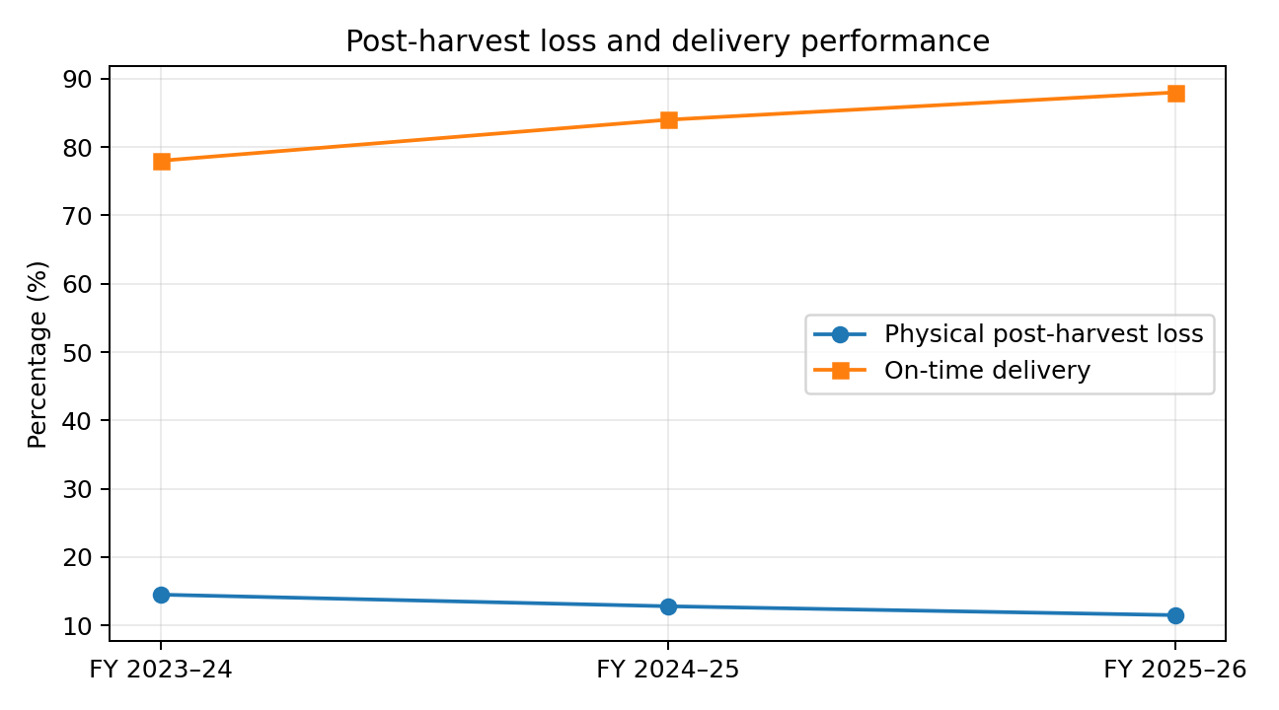

3.7 Overall strengths, gaps and root-cause hypotheses
Performance area | Evidence from scenario | Likely operational questions to test
Strength: yield | 15.8 → 17.2 t/ha | Which plots, varieties, seasons and practices explain the gain? Is the result consistent or driven by a few high-performing farms?
Strength: margin | 18.3% → 28.5% | How much comes from price, yield, grade mix or cost control? Are all overheads included?
Gap: water | 6.1 vs 6.5 kg/m³ target | Are irrigation schedules based on crop stage and soil moisture? Are leaks, pressure variation or over-irrigation present?
Gap: physical loss | 11.5% vs 9% target | At which stage do losses occur: harvest, curing, loading, storage or transport?
Gap: delivery | 88% vs 95% target | Are order forecasts, vehicle allocation, route plans and dispatch cut-offs coordinated?
Gap: marketable rate | 88.5% vs 95% target | Are field disease, harvest maturity, bulb size, curing and grading specifications understood?

These are root-cause hypotheses, not confirmed findings. Confirmation requires lot-level records, field observation, interviews and segmented analysis.

4. STRATEGIC RECOMMENDATIONS
Recommendations are ranked by likely value, feasibility, urgency and ability to verify results. Each action is designed as a pilot before network-wide expansion.

4.1 Recommendation 1 – Reduce post-harvest loss through process control
Problem and justification: physical loss is 11.5%, above the 9% target. The scenario estimates 430 tonnes of potentially recoverable volume if the target is achieved. This is a meaningful opportunity, but the financial case must use net benefit after intervention costs.
- Map the flow from harvest to dispatch at two representative aggregation centres. Weigh a sample lot at intake, after curing, after grading, after storage and at dispatch.
- Introduce maturity-based harvest instructions, shaded collection points, ventilated crates, careful loading and standard curing/curing-duration logs.
- Grade using written size, defect and disease criteria; record physical loss separately from quality downgrades.
- Pilot improved ventilation and storage monitoring at one centre; log temperature, humidity, storage duration, stock movement and rejection reasons.
- Compare pilot lots with matched control lots by season, variety and storage duration.
Success measures: reduce physical loss from 11.5% to ≤10.5% in the first pilot season and toward 9% by month 12; reduce unexplained mass-balance variance to ≤1%; improve marketable rate from 88.5% to at least 91% in pilot lots. Owner: Post-Harvest Operations Manager. Risks: capital cost, insufficient ventilation, inconsistent staff practice; mitigation: small pilot, operator training and preventive maintenance.

4.2 Recommendation 2 – Improve irrigation scheduling and water productivity
Problem and justification: water productivity is 6.1 kg/m³ versus the 6.5 internal target. The Maharashtra field study on raised-bed drip systems provides evidence that water savings and quality gains may be achievable in suitable settings [3].
- Select 30–50 representative plots for a season-long pilot, stratified by soil type, farm size and irrigation method.
- Install or verify flow meters; record water volume by plot and irrigation event, not only pump running hours.
- Train farmers on irrigation scheduling by crop stage, soil moisture and local weather; include filter cleaning, leak checks and pressure checks.
- Compare pilot and comparison plots on yield, water applied, marketable rate, energy cost and maintenance time.
- Calculate payback using actual equipment cost, subsidy eligibility if applicable, energy savings and yield/quality benefits; do not assume every farm is suitable.
Success measures: improve pilot water productivity by at least 5% relative to matched comparison plots in the first season, with no deterioration in yield or bulb quality; reduce avoidable water use; achieve ≥95% completeness in water logs. Owner: Agronomy / Irrigation Lead. Risks: equipment cost, clogging, poor maintenance and unequal water access; mitigation: demonstration plots, spare-part plan, farmer co-design and maintenance training.

4.3 Recommendation 3 – Raise marketable output through quality management
Problem and justification: marketable production is 88.5%, below the 95% internal target. The 2025 Maharashtra study observed marketable proportions above 92% for its raised-bed drip adopter group in the studied seasons [3], demonstrating that higher quality shares can occur under specific management conditions.
- Publish a one-page grade specification with photographs and clear defect thresholds for each buyer channel.
- Train field coordinators and farmers on disease monitoring, harvest maturity, bulb handling and curing.
- Record grade-wise intake and dispatch weights for every lot, including reason codes for rejection or downgrade.
- Share weekly quality feedback with farmer groups and identify repeat patterns by plot, variety and season.
- Link a portion of farmer incentives to verified quality and traceable lot records, while avoiding penalties for factors outside farmer control.
Success measures: increase marketable rate to 91% in the first 6–9 months and 93% by month 18; reduce repeat rejection causes by 25% from the baseline. Owner: Quality Assurance Lead. Risks: inconsistent grading and disputes; mitigation: calibrated grading protocol, sample rechecks and transparent appeal process.

4.4 Recommendation 4 – Improve order planning and on-time delivery
- Create a rolling 7-day harvest and dispatch forecast using buyer orders, expected plot readiness, grading capacity, storage stock and vehicle availability.
- Set daily dispatch cut-off times and assign one dispatch coordinator per aggregation centre.
- Capture planned and actual milestones: harvest ready, lot received, grading complete, vehicle assigned, gate-out and proof of delivery.
- Use delay reason codes and review the top three causes weekly; negotiate delivery windows with buyers where constraints are recurring.
- Pilot route consolidation and vehicle scheduling for the highest-volume routes before purchasing additional vehicles.
Success measures: improve on-time delivery from 88% to 92% within six months and 95% within 12–18 months; reduce average dispatch waiting time by 20% from baseline. Owner: Logistics Manager. Risks: vehicle breakdown, traffic, weather and buyer-side delays; mitigation: backup transporter panel, buffer capacity and escalation protocol.

4.5 Recommendation 5 – Establish market intelligence and margin protection
- Track daily market arrivals and modal prices in the enterprise's actual target APMC markets using AGMARKNET/e-NAM where available.
- Compare prices by grade, variety, market and date; do not use a single market price as a universal selling price.
- Build a weekly dashboard showing realised price, reference market price, grade mix, transport cost and net realisation per tonne.
- Use buyer commitments and staggered dispatch to reduce distress selling; avoid speculative storage without price-risk and quality-loss analysis.
- Run monthly price sensitivity scenarios (e.g., −5%, base, +5%) and review working-capital exposure.
Success measures: 100% of major sales lots have grade, market, date and realised-price records; explain monthly price-realisation variance; maintain or improve margin without increasing unsold inventory. Owner: Commercial Manager / Finance Lead. Risks: price volatility and delayed data; mitigation: multiple market references, conservative scenarios and buyer diversification.

4.6 Recommendation 6 – Control cost per tonne with activity-based review
- Break cost into seed/planting material, fertiliser, crop protection, labour, irrigation energy, packaging, grading, storage, freight and administration.
- Calculate cost per tonne by farm group and by value-chain stage; identify cost drivers rather than applying across-the-board cuts.
- Review freight cost per tonne-kilometre, storage cost per tonne-day and labour cost per tonne handled.
- Consolidate procurement only where quality, timing and supplier reliability remain acceptable.
- Approve cost-saving projects only after a documented benefit-cost estimate and a post-implementation review.
Success measures: reduce cost per tonne from ₹14,300 to ≤₹14,000 within 12 months, then assess feasibility of ₹13,500; do not allow yield, marketable rate or delivery performance to deteriorate. Owner: Finance Controller / Operations Manager. Risks: underinvestment in quality or farm inputs; mitigation: KPI guardrails and approval based on total value, not unit cost alone.

4.7 Recommendation 7 – Introduce a single KPI dashboard and review cadence
A shared dashboard should display the seven KPIs, current result, target, trend, variance, source timestamp, data completeness and accountable owner. It should allow drill-down by season, district, farmer group, variety, irrigation method, lot and market. Red/amber/green status should be determined by approved thresholds, not visual judgement.
Status | Suggested trigger | Required response
Green | At or better than target, with data-quality checks passed. | Maintain controls; document successful practice.
Amber | Within 5% relative of target or adverse movement for one period. | Owner submits cause analysis and preventive action within 7 working days.
Red | More than 5% relative away from target, two consecutive adverse periods, or material data-quality failure. | Escalate to programme lead; corrective-action plan within 3 working days; review weekly until closed.

4.8 Prioritisation
Priority | Action | Reason | Start
1 – Immediate | KPI definitions, source register, data validation and dashboard baseline | Without trusted data, other interventions cannot be evaluated. | Month 1
2 – High | Post-harvest process pilot and grading standards | Directly addresses loss and marketable-output gaps. | Months 2–4
3 – High | Irrigation pilot | Addresses water productivity; test economics before scaling. | Months 2–6
4 – High | Dispatch planning and delay coding | Targets the 7-point delivery gap. | Months 2–5
5 – Medium | Market intelligence and cost-driver review | Protects realised margin and identifies controllable cost. | Months 1–4
6 – Scale decision | Expand only interventions with verified net benefit | Avoids premature capital commitment. | Months 7–18

5. ONGOING EVALUATION AND ADJUSTMENT PLAN

5.1 Monitoring calendar and accountability
Frequency | Monitoring activity | Responsible role | Output / decision
Daily | Market price/arrival capture; order and dispatch milestones; stock and lot movement. | Market Analyst; Dispatch Coordinator | Daily exception log and delivery status.
Weekly | Harvest forecast, quality rejection, loss reason, water-log completeness and delay causes. | Field Coordinators; QA; Logistics | Weekly operations huddle and assigned actions.
Monthly | Seven-KPI dashboard; cost and margin bridge; data-quality checks; target variance review. | Data Analyst; Finance Controller; KPI owners | Signed monthly scorecard and corrective-action register.
Each crop season | Farm/plot sampling, meter and scale checks, farmer interviews, intervention comparison. | Agronomy Lead; QA; Data Analyst | Season evaluation and pilot continuation decision.
Quarterly | Management review of investment, risks, benchmark relevance and benefit realisation. | Programme Lead / Management | Resource reallocation and approved changes.
Annually | Rebaseline targets and review KPI definitions, cost policy and source register. | Management + Data Analyst | Annual performance evaluation report.

5.2 Detailed 18-month implementation roadmap
Timeline | Key actions | Accountable owner | Deliverables and acceptance criteria
Month 1 | Confirm scope, KPI dictionary, IDs, data owners, source register and cost policy; train record keepers. | Programme Lead + Data Analyst | Signed KPI dictionary; source register; 90% of active plots mapped; baseline data-gap log.
Months 2–3 | Clean historical data; verify scales/meters; map post-harvest flow; start delivery delay coding; select pilot plots/centres. | Data Analyst + QA + Agronomy + Logistics | Data quality report; process map; pilot selection register; meter/scale verification log.
Months 4–6 | Run post-harvest, grading and irrigation pilots; operate 7-day dispatch forecast; conduct farmer training. | Operations + Agronomy + QA | Pilot dataset with control/comparison lots; ≥95% mandatory-field completeness; first benefit estimate.
Months 7–9 | Analyse pilot results by season/segment; validate costs and net benefits; correct unsuccessful practices. | Data Analyst + Finance + Programme Lead | Pilot evaluation memo; scale / modify / stop decisions with evidence.
Months 10–12 | Scale proven low-risk practices to additional farmer groups; refine buyer and route planning. | Operations + Commercial + Logistics | At least 50% of eligible groups covered by approved practices; loss trending toward ≤9–10%.
Months 13–15 | Audit sustained performance; review cost per tonne, margin bridge and water productivity; retrain weak-performing groups. | Internal Review Team | Quarterly audit; corrective-action closure ≥90%; revised training plan.
Months 16–18 | Complete impact review; update targets; prepare next-year investment and operating plan. | Programme Lead + Finance + Data Analyst | Final evaluation report; verified benefit-cost analysis; next-cycle plan.

5.3 Evaluation design for intervention pilots
Where feasible, use a matched comparison design rather than attributing every improvement to the intervention. Select pilot and comparison plots with similar district, soil, variety, season, farm size and baseline performance. Record pre-intervention and post-intervention values. Report the absolute and percentage difference, sample size, missing data and contextual differences. If random assignment is not feasible, state that selection bias may remain.
Example: for the irrigation pilot, compare water productivity and yield for participating plots against matched plots in the same season. Report mean and median, range, number of plots and confidence intervals where sample size permits. A simple before/after increase alone is insufficient because rainfall, variety, planting date and market conditions may also have changed.

6. DATA QUALITY, BIAS, RISK AND LIMITATIONS

6.1 Potential sources of bias and error
Source | How it could distort results | Control / mitigation
Selection bias | Pilot farmers may be more motivated or better resourced than non-participants, overstating intervention impact. | Use matched comparison plots; document selection criteria; report baseline differences.
Coverage bias | Records may omit small farms, informal sales, rejected lots or produce sold outside the network. | Reconcile farmer register with sales/dispatch records; disclose coverage rate.
Measurement error | Uncalibrated scales, estimated water volumes or inconsistent moisture/weight basis can distort yield and loss. | Calibrate equipment; standardise gross/net weight; verify sample records.
Reporting and recall bias | Farmers may under-report input use or recall irrigation and loss inaccurately. | Prefer contemporaneous logs, invoices, meter readings and spot checks.
Seasonality and weather confounding | Rainfall, temperature, disease pressure and planting dates may explain KPI movement. | Compare like seasons; include weather and crop-calendar variables where available.
Price and grade-mix effects | Margin can improve due to market price or grade mix rather than operational efficiency. | Decompose margin into volume, price, grade mix and cost effects.
Denominator mismatch | Mixing harvested area with planted area, gross with net weight, or order count with shipment count creates false ratios. | Maintain KPI dictionary and automated denominator checks.
Aggregation bias | Network averages can hide poor-performing groups or be skewed by large farms. | Use weighted network KPIs plus median, quartiles and segment breakdowns.
Survivorship / missing records | Failed plots or farmers who leave the programme may disappear from the dataset. | Maintain a complete cohort register and record exits with reasons.
Double counting | The same loss may be recorded at both storage and dispatch, inflating total loss. | Use unique lot IDs and stage-specific mass balance.

6.2 Risk register and mitigation
Risk | Likelihood / impact | Early warning trigger | Mitigation and contingency | Owner
Extreme rainfall / drought | High / High | Weather alerts; irrigation shortfall; yield variance >10%. | Diversify planting windows where agronomically suitable; contingency water plan; revise forecast and procurement. | Agronomy Lead
Storage deterioration | Medium / High | Temperature/humidity excursion; rising rejection or stock ageing. | Routine inspection, ventilation and stock rotation; isolate affected lots; divert to suitable channel promptly. | QA / Warehouse
Drip system failure or clogging | Medium / Medium | Pressure drop; non-uniform flow; repeated repair. | Filter maintenance, spare parts, farmer training; temporary alternative irrigation schedule. | Irrigation Lead
Market price volatility | High / High | Weekly price falls >5% or arrivals spike. | Multiple buyers/markets, staggered dispatch, scenario analysis; avoid speculative storage without approval. | Commercial Manager
Transport disruption | Medium / High | Vehicle non-availability; repeated late dispatch. | Backup transporter, route alternatives, dispatch buffers and buyer communication. | Logistics Manager
Poor data quality / manipulation | Medium / High | Missing fields >2%; mass-balance variance >1%; duplicate lots. | Freeze KPI publication, investigate, retrain and require independent sign-off. | Data Analyst
Farmer non-adoption | Medium / Medium | Training attendance low; practice compliance below 70%. | Demonstration plots, local champions, feedback, staged incentives and simplified procedures. | Field Coordinator
Cost overrun | Medium / High | Pilot spend exceeds budget by 10%. | Stage-gate approvals, monthly budget tracking; pause expansion pending revised business case. | Finance Controller

6.3 Limitations and responsible interpretation
- The enterprise is hypothetical; no actual company, farmer, plot, financial statement or operational system has been audited.
- Three annual observations are adequate for a demonstration of trend analysis but insufficient for robust causal inference or seasonal forecasting.
- Internal targets are proposed planning values and require validation against the enterprise's baseline, buyer requirements, local agronomy and cost-benefit feasibility.
- External studies are context-specific. Their results should not be transferred directly to all districts, seasons, varieties or farmer groups.
- Gross sales value from avoided loss is not the same as net profit. Additional costs and saleability must be verified.
- Public datasets may be revised and may use different definitions or estimate stages. The report therefore records the source year and comparison caveats.

7. CONCLUSION
The hypothetical evaluation shows a positive three-year direction in yield, operating margin, water productivity, physical loss, delivery reliability, marketable production and unit cost. The strongest improvements are in operating margin and yield. However, water productivity, post-harvest loss, on-time delivery, cost per tonne and marketable production remain short of the proposed internal targets. The evidence suggests that the next phase should focus not only on growing more onions, but on preserving quality, reducing physical losses, using water more productively and delivering reliably.
The recommended approach is to establish trusted KPI definitions and validated records first, pilot interventions in representative locations, measure outcomes against matched comparisons, and scale only when net benefits are demonstrated. A monthly scorecard, a detailed 18-month roadmap, explicit risk ownership and transparent treatment of data limitations will make performance evaluation an ongoing management process rather than a one-time report.
The report meets the task's evaluation purpose by defining seven KPIs, explaining public and enterprise data collection, applying a benchmark hierarchy, presenting quantitative and qualitative analysis, providing worked calculations, and setting out practical recommendations and an ongoing review plan. All enterprise figures remain illustrative and must not be represented as actual business results.

REFERENCES
[1] Government of India, Ministry of Agriculture & Farmers Welfare, Directorate of Economics and Statistics. Agricultural Statistics at a Glance 2023, Table 2.50(b): Onion area, production and yield in major producing states (2022–23, second advance estimates). https://www.desagri.gov.in/wp-content/uploads/2024/09/Agricultural-Statistics-at-a-Glance-2023.pdf
[2] Kale, R. et al. (2024). “Efficiency dynamics among onion growers in Maharashtra: a comparative analysis of drip irrigation adopters and non-adopters.” BMC Plant Biology, 24, 237. https://doi.org/10.1186/s12870-024-04875-2
[3] Gaikwad, S. Y. et al. (2025). “Potential of improved irrigation technologies for onion farming in Maharashtra, India: a study of productivity and adoption drivers.” Frontiers in Agronomy. https://doi.org/10.3389/fagro.2025.1634867
[4] Government of India, Ministry of Agriculture & Farmers Welfare. AGMARKNET / Agricultural Marketing Information Network. Market arrivals and price data. https://agmarknet.gov.in/
[5] Food and Agriculture Organization of the United Nations. FAOSTAT: Crops and livestock products database. https://www.fao.org/faostat/
[6] ICAR–Directorate of Onion and Garlic Research. Research, production technologies and extension resources. https://dogr.icar.gov.in/
[7] Government of Maharashtra. Economic Survey of Maharashtra 2023–24, horticulture area and production tables. https://mahades.maharashtra.gov.in/ESM1920/chapter/English/esm2324_e.pdf

APPENDIX A – KPI FORMULA AND DATA CHECKLIST
KPI | Required fields | Minimum validation check
Harvested yield | Plot ID, harvested area, gross weight, harvest date, season. | Area and weight units standardised; weighbridge slip sample checked.
Operating margin | Sales invoice, grade, quantity sold, realised price, cost ledger, cost policy. | Sales reconciled to invoices; cost scope consistent year-on-year.
Water productivity | Plot ID, gross harvested kg, irrigation volume m³, meter ID. | Meter verified; missing water volumes flagged; denominator method recorded.
Physical post-harvest loss | Lot ID, gross intake weight, stage weights, loss reason and date. | Stage mass balance; no double counting; physical loss separated from downgrade.
On-time delivery | Order ID, promised window, dispatch time, proof-of-delivery time. | Eligible order definition fixed; cancelled orders handled consistently.
Cost per tonne | Cost category, amount, period, harvested tonnes. | Cost categories reconciled to ledger; tonnes denominator matches reporting scope.
Marketable production | Lot ID, gross harvest weight, grade weights, rejection reason, dispatch weight. | Grade totals reconcile to gross weight; grading standard version recorded.

APPENDIX B – ILLUSTRATIVE DATASET
KPI | FY 2023–24 | FY 2024–25 | FY 2025–26
Harvested yield (t/ha) | 15.8 | 16.5 | 17.2
Operating margin (%) | 18.3 | 23.7 | 28.5
Water productivity (kg/m³) | 5.2 | 5.6 | 6.1
Physical post-harvest loss (%) | 14.5 | 12.8 | 11.5
On-time delivery (%) | 78 | 84 | 88
Cost per tonne (₹) | 14,700 | 14,500 | 14,300
Marketable production (%) | 82.0 | 85.0 | 88.5

All values in Appendix B are hypothetical scenario data created for analytical demonstration. They are not sourced from a real enterprise.

