Name: Farhan Ali

Roll no: 20sw072

Topic: Power BI

**TASK 01:**

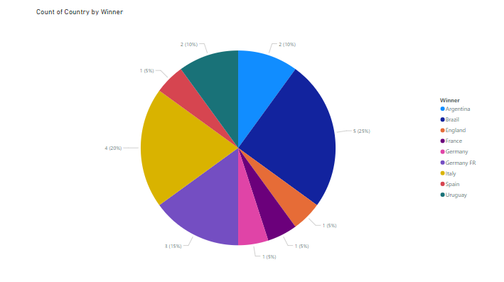

**TASK 02:**

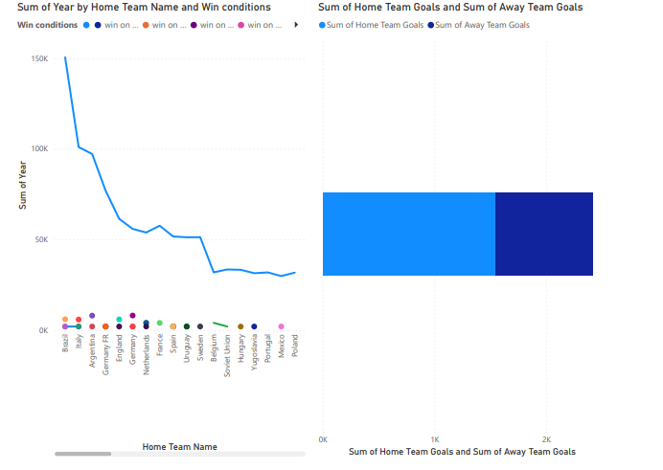

**TASK 03:**

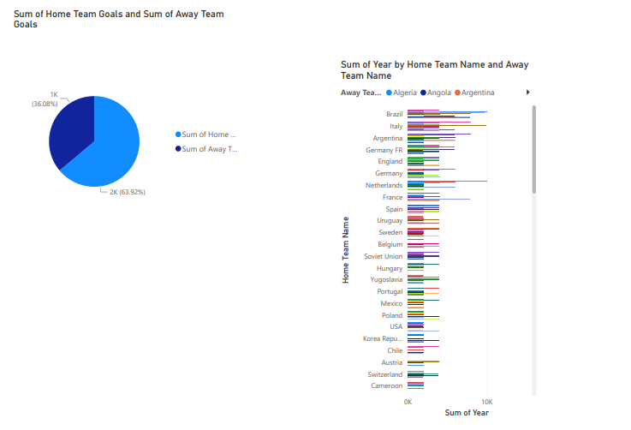

**TASK 04:**

