<https://studio.code.org/projects/gamelab/OlNxyHLQmlLydbsf1Sf2qsDG8isX2YsxQY64xxXIhfA>

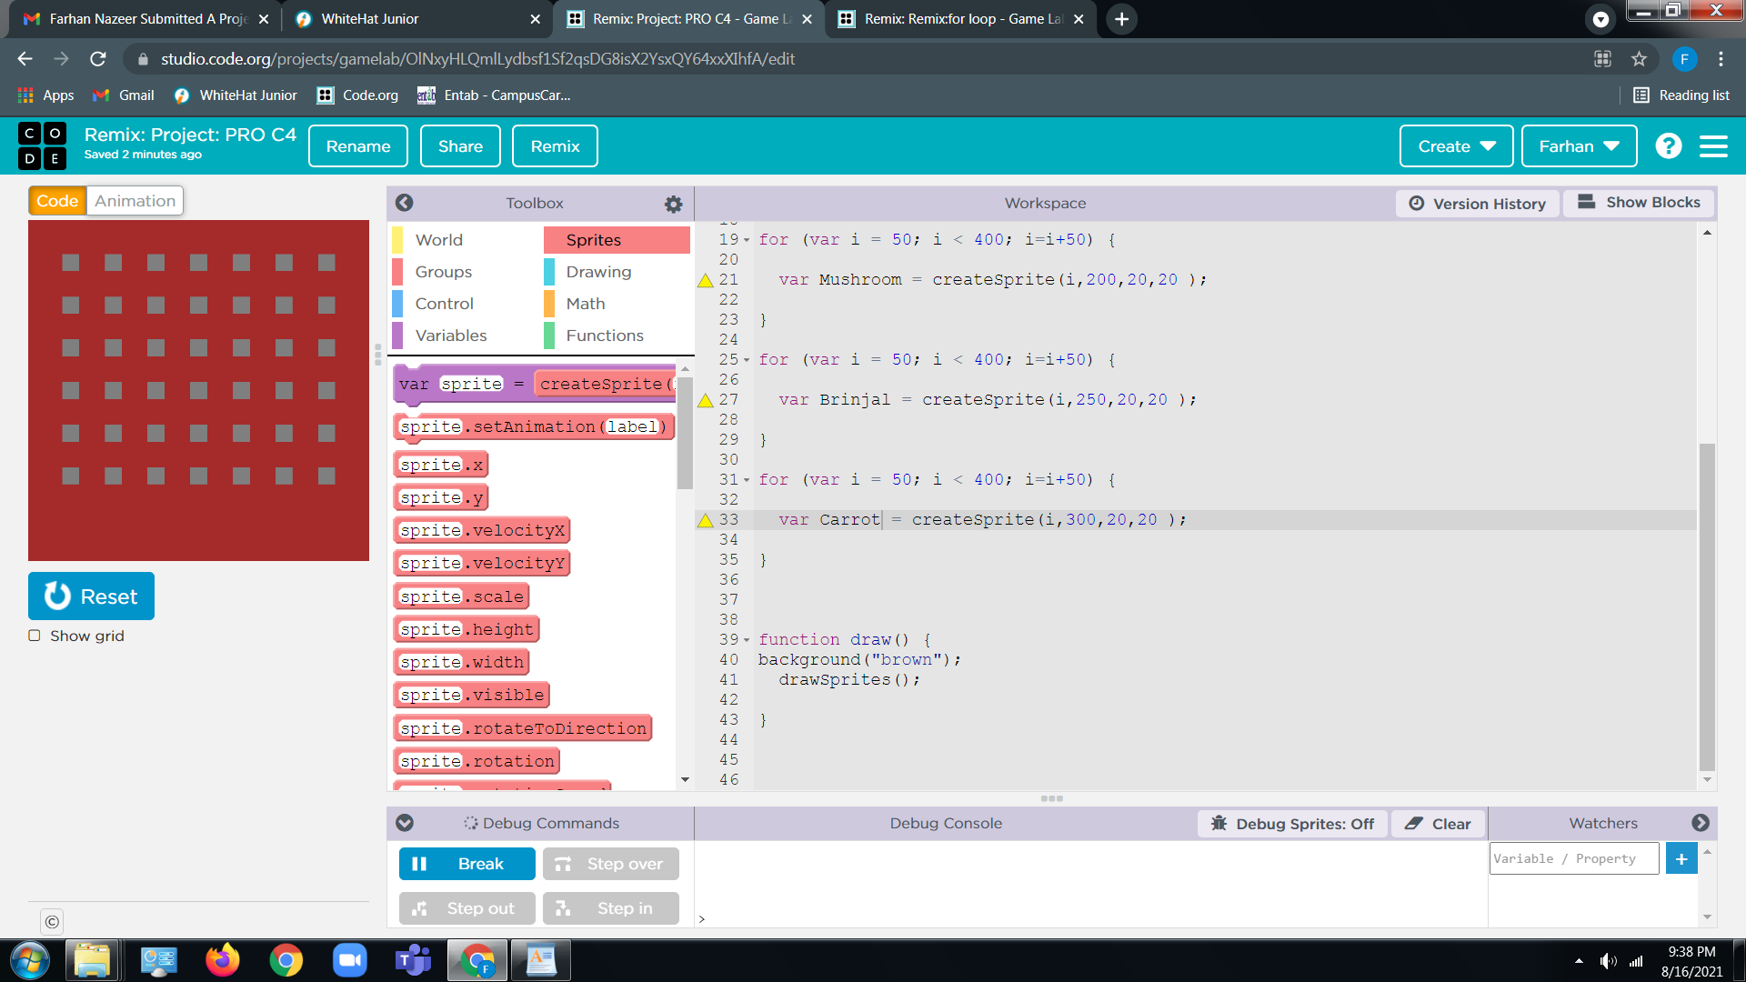

<Https://studio.code.org/projects/gamelab/dqhKqHQWl2xwwOP3UtZGeRFGrucqmhhkcQMvHsbMuBM>

<https://studio.code.org/projects/gamelab/EB7jvkXcNyeu7VyiqGZDBElL7mhUbDThaU4bbjm9vqM>

complete game with all instructions.

<https://studio.code.org/projects/gamelab/uUdvmorihl_3b_63UuCIGUKVwLBzIKkYgSGCBiLgTb0>