- How Simpsonville, KY Homeowners Can Prepare Their Trees for the First Snow

Wet first snow piles onto oak and ash limbs across Simpsonville, KY. Weak branches often crack before anyone notices the strain.
Our crew prepares your trees by removing weak wood before the first storm arrives. We focus on these tasks before snow season:
✓ Remove dead branches
✓ Thin heavy canopies
✓ Raise limbs over roofs
✓ Check ash for borers
📞 Call Tino's Tree Service for winter prep from a fully insured crew with years of local storm experience.

- Why Dormant Season Pruning Reduces Tree Stress

Pruning during summer growth leaves fresh wounds open to insects and disease. Stressed trees then lose strength before the next storm season.
Dormant pruning lowers stress because disease-spreading beetles stay inactive and wounds close fast in spring. Our arborists cut back to strong branch collars on oaks and basswoods in Simpsonville, KY, in late winter.
🗓️ Schedule dormant pruning with Tino's Tree Service for clear updates, careful cuts, and a clean yard when we leave.

- https://maps.app.goo.gl/PanhRhWW3LoSfzVx7
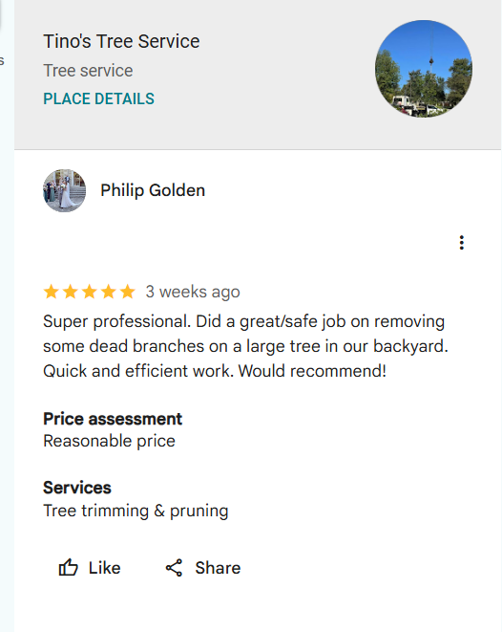

Tino's Tree Service removed dead branches from a large backyard tree for Philip Golden.
He called the work professional, safe, and quick, with a price that felt reasonable.
📅 Schedule your tree trimming and pruning with our local crew today.

- Emergency Tree Removal After November Wind Storms in Simpsonville, KY

November wind storms snap weakened limbs and drop whole trees across driveways and roofs. Tino's Tree Service clears that damage around the clock.
Our crew rigs each fallen oak or ash with ropes and lowers it in sections, away from your house. We haul the debris away so your property in Simpsonville, KY, is usable again.
📞 Call our 24-hour emergency line for fast, reliable help whenever storms hit your yard.

- Trimming Trees So Snow Plows Can Reach Driveway

Low limbs over long driveways catch snow and block plow trucks after winter storms. Your driveway then stays buried for days.
Clearance trimming fixes this by lifting branches high enough for plows and delivery trucks. Our crew raises oak and boxelder limbs along driveways in Simpsonville, KY, before the first big snow.
📲 Get in touch with Tino's Tree Service for quick scheduling, clear pricing, and tidy cleanup after every trim.

- How Whiteshop Estates, Culpeper, VA Homeowners Can Prepare Their Trees for the First Snow

Heavy wet snow bends tulip poplar and pine limbs over homes in Whiteshop Estates in Culpeper, VA. Cracked branches then fall without warning.
Good prep means trimming weak wood before the first storm. Our crew covers these steps on every winter visit:
✓ Remove cracked limbs
✓ Shorten long branches
✓ Clear roof overhangs
✓ Inspect leaning pines
📞 Call David Kennedy Tree & Landscaping for safe winter prep from a fully licensed and insured crew.

- Why Dormant Season Pruning Reduces Tree Stress

Summer pruning cuts open fresh wounds just as insects and fungi are most active. That added stress weakens trees heading into storm season.
Dormant pruning lowers that stress because cuts close fast once spring growth starts. Our crew prunes white oaks across Whiteshop Estates in Culpeper, VA, in late winter while beetles stay inactive.
🗓️ Schedule with David Kennedy Tree & Landscaping for honest advice, careful cuts, and a yard left clean when the job ends.

- Night and Weekend Emergency Tree Service in Whiteshop Estates, Culpeper, VA

Storms ignore business hours, and fallen trees block driveways at night or on Sundays. David Kennedy Tree & Landscaping answers those emergency calls.
Our crew arrives with chainsaws, ropes, and lights to cut fallen tulip poplars into safe sections. We clear your driveway in Whiteshop Estates in Culpeper, VA, so you can leave home again.
📞 Call any night or weekend for fast, reliable storm help from a crew close to home.

- Emergency Tree Removal After November Wind Storms in Whiteshop Estates, Culpeper, VA

November gusts strip weakened limbs from oaks and push shallow-rooted pines toward houses. Leaving that damage overnight risks a second break.
Emergency removal stops that risk before the next gust arrives. Our crew ropes each broken section to the ground in Whiteshop Estates in Culpeper, VA, then hauls every limb away.
📲 Get in touch with David Kennedy Tree & Landscaping for clear updates from the first call to a safe, tidy finish.

- Trimming Trees So Snow Plows Can Reach Driveway

Low branches over long driveways stop snow plows from reaching your house. David Kennedy Tree & Landscaping trims those limbs back before winter.
Our crew raises the canopy with pole saws and climbing gear for plow clearance. We trim white oaks and pines along drives in Whiteshop Estates in Culpeper, VA, and keep each tree's natural shape.
📅 Book driveway clearance now for quick, convenient service before the first plow comes through.

- How Islip, NY Homeowners Can Prepare Their Trees for the First Snow

Nor'easters off Great South Bay dump heavy snow on oak and maple limbs across Islip, NY. Overloaded branches split before anyone sees the damage.
Our crew prepares your trees by cutting out weak wood before winter. Every snow-prep visit includes these steps:
✓ Remove dead limbs
✓ Lighten heavy crowns
✓ Trim roof overhangs
✓ Check storm cracks
📞 Call Garcia Tree Removal Service for safe winter prep from a fully licensed and insured team.

- Why Dormant Season Pruning Reduces Tree Stress

Pruning in warm months leaves open cuts while insects and fungi spread fast. Those wounds drain energy a tree needs for winter.
Dormant pruning reduces stress because the tree rests and cuts seal fast in spring. Our crew prunes red maples and oaks across Islip, NY, in the coldest weeks of winter.
🗓️ Schedule with Garcia Tree Removal Service for straight answers, clean cuts, and a yard left neat after every visit.

- https://maps.app.goo.gl/3XPQ7NBCabKAr4YT6
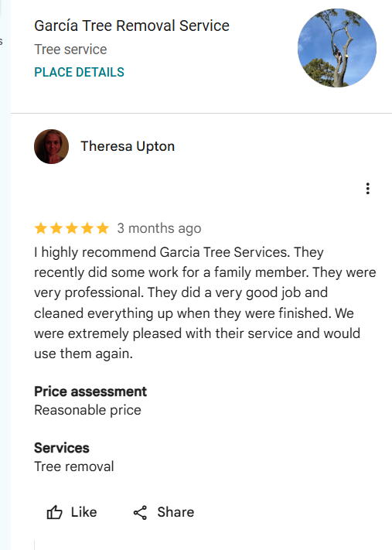

Theresa Upton hired our crew for tree removal at a family member's home.
She praised the professional work and full cleanup.
Garcia Tree Removal Service is glad to earn her repeat business.
📞 Call us to plan your tree removal.

- Emergency Tree Removal After November Wind Storms in Islip, NY

November winds off the bay snap weak limbs and tip trees onto roofs and fences. Garcia Tree Removal Service answers these storm calls 24/7.
Our crew cuts fallen pines and oaks into small sections and lowers them with ropes. We clear and haul the debris from your property in Islip, NY, on the same visit.
📞 Call our emergency line any hour for fast, reliable local help after the storm passes.

- Trimming Trees So Snow Plows Can Reach Driveway

Overhanging limbs catch wet snow and sag low over driveways after a heavy storm. Plow drivers then pass your driveway by.
Clearance trimming solves this by raising limbs well above plow height. Our crew lifts maple and oak branches with pole saws along driveways in Islip, NY, before winter storms arrive.
📲 Get in touch with Garcia Tree Removal Service for quick scheduling and a clean, clear driveway when our crew finishes.

GBP posts planned this month
- How Normandy, Jacksonville, FL Homeowners Can Prepare Their Trees for the First Snow

Snow rarely reaches Normandy, Jacksonville, FL, but a hard freeze can still crack laurel oak limbs. Brittle branches then drop in the next wind.
Preparing for a rare snow or freeze means removing weak wood early. Our crew handles these winter tasks:
✓ Remove dead limbs
✓ Thin dense crowns
✓ Clear roof overhangs
✓ Trim weak branches
📞 Call Show Me Tree Service for safe winter prep from an experienced, fully insured local crew.

- Why Dormant Season Pruning Reduces Tree Stress

Heavy pruning in hot summer months stresses trees already fighting heat and insects. Fresh cuts also attract pests during the growing season.
Winter pruning works better because growth slows and wounds close with less strain. Our crew trims live oaks and pines across Normandy, Jacksonville, FL, through the cool, dormant winter months.
🗓️ Schedule with Show Me Tree Service for clear communication, careful cuts, and a tidy yard when the work ends.

- https://share.google/p4r1nXfnnQssGAG0K
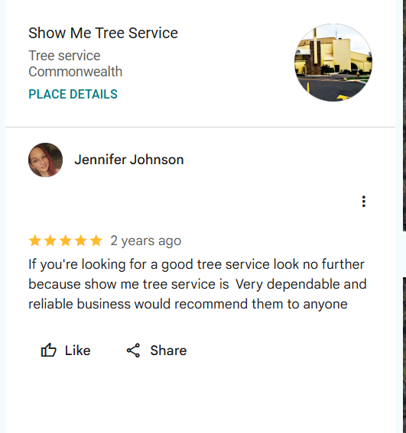

“Very dependable and reliable” is how Jennifer Johnson describes Show Me Tree Service.
She recommends our crew to anyone who needs a tree service they can count on.
📅 Schedule your visit with our team today.

- Emergency Tree Removal After November Wind Storms in Normandy, Jacksonville, FL

Late-season tropical storms and November nor'easters drop heavy limbs and knock trees onto roofs. Show Me Tree Service clears that storm damage and restores safe access.
Our crew ropes each broken laurel oak or pine and lowers it in sections, away from your house. We haul every limb from your yard in Normandy, Jacksonville, FL, before leaving.
📞 Call any time for fast, reliable storm cleanup from a licensed crew close to home.

- Trimming Trees So Snow Plows Can Reach Driveway

[Not written: snow plows don't apply in Normandy, Jacksonville, FL. Please send a replacement topic for this post.]

GBP posts planned this month
- How Lower Burrell, PA Homeowners Can Prepare Their Trees for the First Snow

Snow on the hills above the Allegheny River bends oak and maple limbs in Lower Burrell, PA. Cracked branches then hang over roofs.
Good prep starts with removing weak wood before snow arrives. Our team checks these points on every winter visit:
✓ Cut dead limbs
✓ Thin crowded crowns
✓ Shorten roof-side branches
✓ Inspect leaning trunks
📞 Call Solid Oak Tree Service for safe snow prep from a team with more than 25 years of experience.

- Why Dormant Season Pruning Reduces Tree Stress

Pruning while leaves are out exposes fresh cuts to insects and fungus. That extra stress leaves trees weaker before winter storms hit.
Dormant pruning eases that stress because bare branches show every defect and weak joint. Our crew prunes oaks and maples across Lower Burrell, PA, from late fall through early spring.
🗓️ Schedule with Solid Oak Tree Service for honest advice, steady updates, and a clean yard when the crew leaves.

- https://maps.app.goo.gl/HJQRLCbEqQh8nSwR8
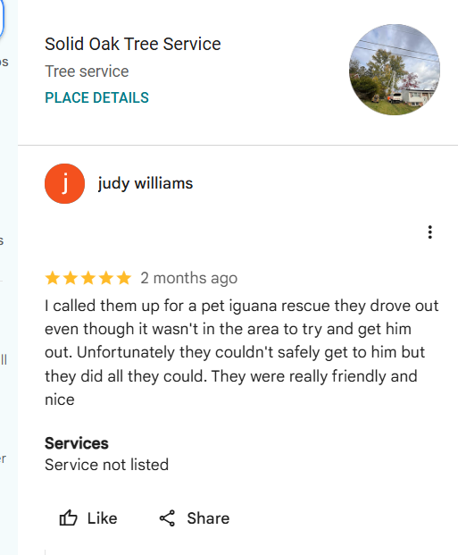

Solid Oak Tree Service drove outside our usual area to help rescue Judy Williams's pet iguana.
We could not reach him safely, but she called our team friendly and nice.
📞 Call us for friendly, careful tree help.

- Emergency Tree Removal After November Wind Storms in Lower Burrell, PA

November winds funneling up the river valley snap limbs and drop trees on houses and cars. Solid Oak Tree Service removes storm-damaged trees before they cause more harm.
Our crew uses ropes and rigging to lower each broken oak in controlled sections. We clear your driveway and yard in Lower Burrell, PA, so life gets back to normal.
📞 Call now for fast, reliable emergency removal from an experienced local crew near you.

- Trimming Trees So Snow Plows Can Reach Driveway

Branches that droop over steep driveways trap snow and block plows after storms. Your car may then stay stuck for days.
Clearance trimming lifts those limbs high enough for plows and trucks to pass. Our crew uses pole saws on maple and oak branches along driveways in Lower Burrell, PA, every fall.
📲 Get in touch with Solid Oak Tree Service for quick scheduling and a clear, safe driveway all winter long.

GBP posts planned this month
- How Penacook Concord, NH Homeowners Can Prepare Their Trees for the First Snow

Heavy first snow loads white pine branches across Penacook in Concord, NH, and soft pine limbs snap under the weight.
Preparing your trees for winter means removing weak wood early. Our crew covers these snow-prep tasks on every visit:
✓ Prune weak pine limbs
✓ Thin dense hemlocks
✓ Clear roof overhangs
✓ Remove dead branches
📞 Call Tree Fellas for safe snow prep with honest prices and quality work from an experienced local crew.

- Why Dormant Season Pruning Reduces Tree Stress

Pruning in spring and summer opens wounds when insects and spongy moths are active. Stressed trees then struggle through the next winter.
Dormant pruning lowers stress because the tree rests and cuts seal once spring growth begins. Our crew prunes red maples and hemlocks across Penacook in Concord, NH, in late winter.
🗓️ Schedule with Tree Fellas for honest prices, clear updates, and a yard left clean when the work ends.

- https://maps.app.goo.gl/iE52kSf8DLUAKRFE9
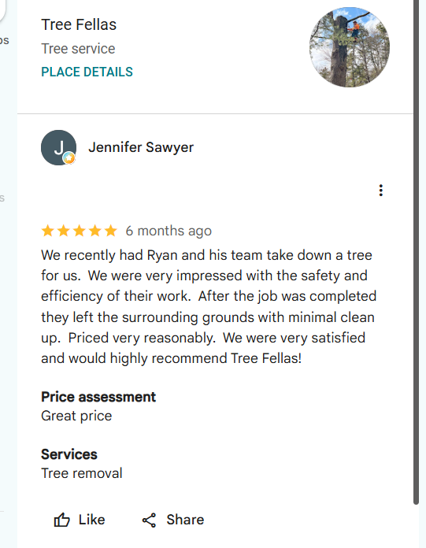

Jennifer Sawyer hired our crew to take down a tree at her home.
The safe, efficient work and reasonable price impressed her.
She would highly recommend Tree Fellas.
📅 Schedule your tree removal with our local crew today.

- Emergency Tree Removal After November Wind Storms in Penacook Concord, NH

November wind storms push tall white pines over and drop limbs on roofs and wires. Tree Fellas clears that storm damage for you.
Our crew rigs each broken trunk with ropes and lowers it piece by piece, away from your house. We haul the wood from your property in Penacook in Concord, NH, before we leave.
📞 Call our emergency line for fast, reliable storm help from an experienced local crew.

- Trimming Trees So Snow Plows Can Reach Driveway

Snow-heavy branches sag low over driveways and stop plows from clearing your way out. You lose time waiting while the storm passes.
Clearance pruning fixes this by raising the canopy well above plow height. Our crew trims red maple and pine limbs along driveways in Penacook in Concord, NH, before snow season.
📲 Get in touch with Tree Fellas for quick scheduling, honest prices, and a clear driveway all winter long.

GBP posts planned this month
- How Parchment, MI Homeowners Can Prepare Their Trees for the First Snow

Early snow and ice coat red maple limbs across Parchment, MI, and brittle branches crack under the load. Fallen limbs then block driveways and damage roofs.
Snow prep starts with removing weak wood before winter. Our crew handles these tasks on every visit:
✓ Cut dead branches
✓ Thin box elder crowns
✓ Raise low limbs
✓ Clear roof overhangs
📞 Call Perkins Lawn Care for safe snow prep from an experienced local tree crew that respects your property.

- Why Dormant Season Pruning Reduces Tree Stress

Summer pruning leaves fresh cuts open while beetles and fungi are busy. Those open wounds add stress before a long, cold winter.
Dormant pruning reduces stress because oak wilt beetles stay inactive and cuts seal in spring. Our crew prunes white oaks and sugar maples across Parchment, MI, from November through March.
🗓️ Schedule with Perkins Lawn Care for clear answers, careful cuts, and a clean yard when our crew finishes.

- https://maps.app.goo.gl/VrVTQYNPTNBXNQKLA
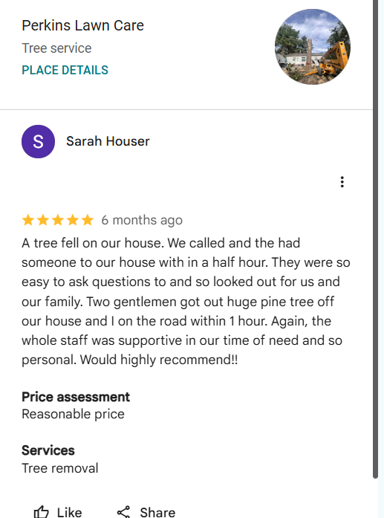

Within half an hour, our crew reached Sarah Houser after a pine fell on her house.
Perkins Lawn Care had it off the roof within an hour.
She called the whole staff supportive and personal.
📞 Call us after storm damage.

- Emergency Tree Removal After November Wind Storms in Parchment, MI

November wind storms snap box elder limbs and drop weakened trees onto roofs and cars. Perkins Lawn Care removes that storm damage fast.
Our crew uses ropes and rigging to lower each broken section away from your house. We haul every limb and log from your property in Parchment, MI, before we leave.
📞 Call now for fast, reliable storm help from a local crew that treats your home with respect.

- Trimming Trees So Snow Plows Can Reach Driveway

Ice-heavy branches droop over driveways and keep plow trucks from reaching your garage door. Your winter morning then starts with a shovel.
Clearance trimming fixes this by lifting limbs well above plow height. Our crew uses pole saws on red maple and white oak branches along driveways in Parchment, MI, each fall.
📲 Get in touch with Perkins Lawn Care for quick scheduling and a clear, safe driveway all winter long.

- How Morrisville Morristown, VT Homeowners Can Prepare Their Trees for the First Snow

Heavy wet snow bends birch and sugar maple limbs across Morrisville in Morristown, VT, long before winter settles in. Cracked limbs then fall without warning.
Good snow prep removes weak wood before the first storm. Our crew covers these tasks on every winter visit:
✓ Prune bent birch stems
✓ Thin heavy spruce limbs
✓ Remove dead branches
✓ Check ash for borers
📞 Call Iconic Tree Care for safe snow prep from a fully insured, family-owned local crew.

- Why Dormant Season Pruning Reduces Tree Stress

Summer pruning leaves fresh cuts open when insects and fungi are most active. That stress follows the tree into a long winter.
Dormant pruning avoids that stress because the tree rests and cuts seal once spring growth starts. Our crew prunes birches and spruces across Morrisville in Morristown, VT, from late fall into winter.
🗓️ Schedule with Iconic Tree Care for a free written estimate, careful cuts, and complete cleanup after every job.

- https://maps.app.goo.gl/hZhs3FT9r8XnCVAi7


Iconic Tree Care balanced looks and safety for Lillian Dominguez-Konicki while clearing tree hazards.
Our crew answered her many questions and kept softwood and hardwood chips separate for her garden paths.
✉️ Contact us to plan your project.

- Emergency Tree Removal After November Wind Storms in Morrisville Morristown, VT

November winds rolling down the Lamoille River valley snap limbs and drop trees on homes. Iconic Tree Care clears that storm damage for you.
Our crew ropes each broken spruce or maple and lowers it in sections, away from your roof. We clean up every limb at your home in Morrisville in Morristown, VT, before we leave.
📞 Call now for fast, reliable storm cleanup from a fully insured local crew.

- Trimming Trees So Snow Plows Can Reach Driveway

Snow-loaded branches hang low over long country driveways and stop plows in their tracks. You may wait hours for a clear path out.
Clearance trimming fixes this by raising limbs above plow height before snow falls. Our crew trims hemlock and maple branches with pole saws along driveways in Morrisville in Morristown, VT.
📲 Get in touch with Iconic Tree Care for quick scheduling, clear updates, and a driveway plows can reach.

GBP posts planned this month
- Weekend and Holiday Septic Emergency Service in Beaver Falls, PA

Septic backups do not wait for Monday, and a holiday weekend can bring overflowing drains. Bonzo Septic Repair and Installation answers those calls 24/7.
Our technicians use a sewer camera to find the clog or break fast. We repair lines and tanks at your home in Beaver Falls, PA, and stop the backup at its source.
📞 Call any day or holiday for fast, reliable septic repair from a local crew.

- Getting Your Septic System Ready for Freezing Weather in Beaver Falls, PA

Freezing nights can stop the flow in shallow septic lines and frozen drain fields. A frozen system can push sewage back into your home.
Winter prep keeps the system flowing before the ground freezes hard. Our crew checks lines for leaks and slow spots at homes in Beaver Falls, PA, with a sewer camera.
📲 Get in touch with Bonzo Septic Repair and Installation for friendly service and clear, upfront pricing on every visit.

- Why You Should Never Open a Septic Tank Lid Yourself

Septic tanks hold toxic gases that can knock a person unconscious within seconds. Bonzo Septic Repair and Installation takes on that risk for you.
Our licensed technicians use protective gear and ventilate the opening before any inspection. We secure the lid again at your home in Beaver Falls, PA, so children and pets stay safe.
📅 Book a septic system check for safe, convenient service from a licensed and insured local crew.

- Signs Your Septic Tank Is Getting Full

A full septic tank in Beaver Falls, PA, can send sewage back into your home with little warning.
Your tank gives clear warnings before it overflows. Watch for these signs around the house and yard:
✓ Slow sinks and tubs
✓ Gurgling drain pipes
✓ Sewage odors outside
✓ Soggy grass above tank
✓ Toilets backing up
📞 Call Bonzo Septic Repair and Installation for an experienced, licensed crew that fixes septic problems the right way.

- Book Your Septic Pumping Before the Year Ends

Holiday guests add heavy use to septic systems, and a full tank fails fast under that load. A year-end backup can ruin the holidays.
Pumping before the year ends clears solids and resets your tank for winter. Our crew pumps and inspects tanks in Beaver Falls, PA, then checks the lines with a camera.
🗓️ Schedule with Bonzo Septic Repair and Installation for on-time arrival, friendly service, and fair, upfront pricing.

- A Thanksgiving Thank You to Every Local Septic Service Customer

This Thanksgiving, we thank every family who trusted us with their septic system. Bonzo Septic Repair and Installation is grateful for your support.
Your calls kept our crew busy with repairs, drain field fixes, and camera inspections across Beaver Falls, PA. We look forward to keeping your system running through winter and the new year.
📞 Call us any time this holiday season for friendly, reliable septic help from your local crew.

