White Oak Tree Expert
- Tree Removal Permits in Severna Park: Know the Rules Near the Water
Lots near the Severn and Magothy Rivers often sit in the Chesapeake Bay Critical Area. White Oak Tree Expert helps you plan a legal removal there.
Anne Arundel County often requires approval for removals within 1,000 feet of tidal water in Severna Park, MD. Our arborist checks your buffer and replanting rules first. The crew then lowers the tree section by section with ropes and rigging. We can also plant any replacement trees the county asks for.
📅 Book a free estimate and get clear answers before any tree work starts near the water.
- https://maps.app.goo.gl/zAFoWz3hTEHMwW3QA
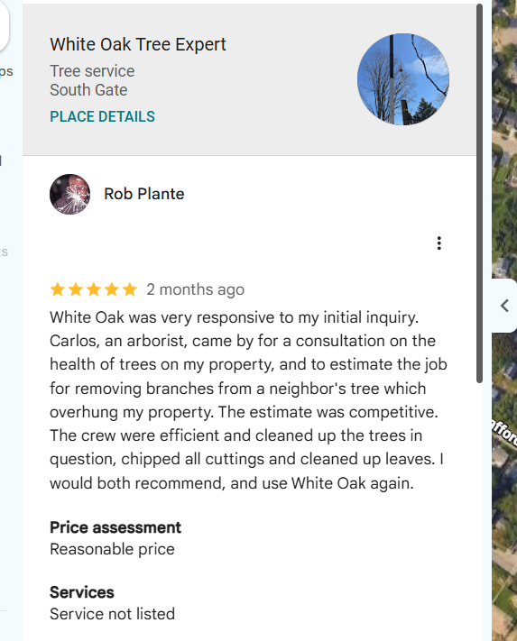
Rob Plante gave White Oak Tree Expert a 5-star rating after we removed a neighbor's overhanging branches.
He noted our quick reply, fair estimate, and full cleanup with every cutting chipped.
🗓️ Schedule your free estimate today.
- Licensed, Insured and Bonded Tree Care for Brooklyn, MD Winter Storms
Ice and wet snow off the Patapsco River can snap weak limbs onto roofs, cars, and fences. An uninsured crew adds risk when storm work goes wrong.
A licensed and insured team protects you from that liability in Brooklyn, MD. We trim weak limbs before winter and clear storm damage after it hits. Our crew uses ropes, rigging, and crane service for big trees near homes.
📞 Call White Oak Tree Expert for clear communication, a free estimate, and a careful crew that cleans up before leaving.
- https://maps.app.goo.gl/XDfbiBcNYrQkW3TX6
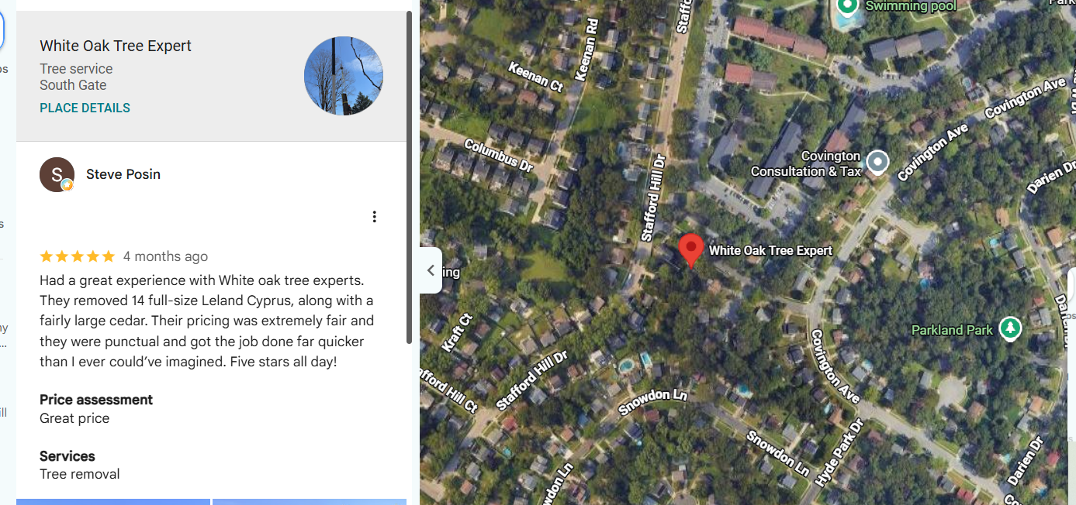
Fourteen full-size Leyland cypress and a large cedar, finished faster than expected.
That job earned White Oak Tree Expert a 5-star review from Steve Posin.
He also praised our fair pricing and on-time crew.
📞 Call us for your next removal.
- Storm Damage Tree Services for Riviera Beach: Bay Winds and Nor’easters
Nor'easter winds sweep across Stoney Creek and the Patapsco River and can split trunks or drop limbs on homes. White Oak Tree Expert offers emergency storm cleanup for these moments.
Our crew checks for wires and stress points before any cut in Riviera Beach, MD. We lower hanging limbs with ropes and rigging. For a tree resting on your roof, our crane lifts the sections away without more damage.
🗓️ Schedule storm help with a licensed, insured crew that responds fast and cleans up fully.
- Offer: Get a Free Hazardous tree removal Service Quote
A dead oak or a leaning tulip poplar can fall without warning. Many homeowners never learn the removal cost until a crew shows up, so they wait and the risk grows.
White Oak Tree Expert now offers free quotes on hazardous tree removal in Glen Burnie, MD. Our arborist inspects the tree, checks nearby roofs and lines, and explains the plan. You get a clear price for section-by-section removal and cleanup with no pressure to book.
📞 Call our team today to claim your free hazardous tree quote and get the danger out of your yard.

Cliburn Woodwork
- Warning Signs Your Tree Needs Professional Inspection in Vaughan, MS
Hollow water oaks and leaning loblolly pines often look fine from the road in Vaughan, MS. Hidden decay can drop a limb or trunk during the next storm.
A professional inspection catches these problems before they fail. Watch for these signs around your yard:
✓ Mushrooms at the base
✓ Cracks in the trunk
✓ Dead upper branches
✓ New lean after rain
✓ Bark falling off
📞 Call Cliburn Woodwork for an inspection from a crew with 15 years of experience and safe, careful tree work.
- What to Expect During Stump Grinding on Your Wanilla, MS Property
A leftover pine stump keeps sprouting, draws termites, and blocks your mower. Cliburn Woodwork grinds it out in a single visit.
On your Wanilla, MS, property, our crew marks utility lines and clears rocks around the stump first. A stump grinder then chews the wood below the soil line. We rake the chips into the hole or haul them away with our own trucks.
📅 Book stump grinding for an on-time crew, honest pricing, and a clean yard when we leave.
- https://maps.app.goo.gl/sExuust5ENWArHeb6
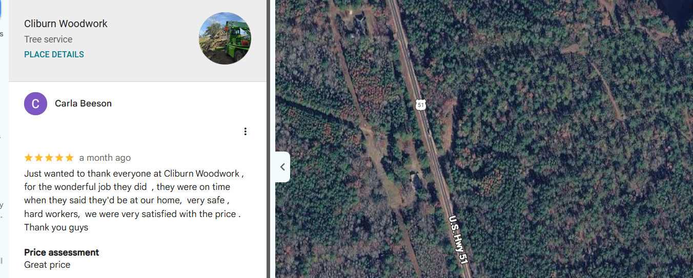
Cliburn Woodwork showed up right on time and worked safely from start to finish.
Carla Beeson gave our crew a 5-star rating for the hard work and fair price.
📞 Call us for a free estimate.
- Licensed and Bonded Tree Care Professionals Serving Union Church, MS
Rural lots often have tall pines and oaks close to homes, barns, and fence lines. Hiring an unlicensed crew leaves you exposed if a tree lands wrong.
A licensed, bonded, and insured crew carries the coverage that protects your property in Union Church, MS. Our arborists and tree surgeons lower big trees in sections with ropes. CDL drivers then haul the logs and debris away in our own trucks.
🤝 Get in touch with Cliburn Woodwork for a free estimate, clear answers, and a crew that leaves no mess behind.
- https://maps.app.goo.gl/gsjoyiGyaqh1yYuT7
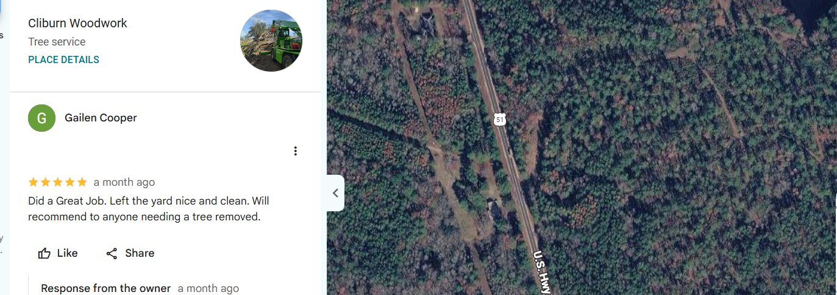
A great job and a yard left nice and clean.
Gailen Cooper said it in a 5-star review for Cliburn Woodwork.
The review recommends us to anyone who needs a tree removed.
🗓️ Schedule with our crew.
- Offer: Get a Free Hazardous tree removal Service Quote
A storm-weakened pine or a dead water oak can fall across a roof without warning. Many homeowners delay removal because they fear the cost, and the danger grows each week.
Cliburn Woodwork offers free quotes on hazardous tree removal in Brookhaven, MS. Our arborists inspect the tree and plan a safe section-by-section removal. Your quote covers the cutting, debris hauling, and full cleanup, so you see the real cost before any work begins.
📞 Call today to claim your free quote from a licensed, bonded, and insured local crew.

Robison Tree Service
- Storm Damage Tree Services for Winchester, KY Residents Before Wednesday’s Rain
Rain soaks the clay soil and loosens roots, so weakened trees can tip or drop limbs. Robison Tree Service can trim risky limbs before the rain arrives.
Our crew checks your yard in Winchester, KY, for cracked limbs, leaning trunks, and loose roots. We trim weak branches with pole saws and ropes. After a storm, our team cuts fallen trees into sections and chips the brush on site.
🗓️ Schedule a visit today for fast storm help and a crew that clears the debris before leaving.
- Warning Signs Your Tree Needs a Professional Inspection in Stanton, KY
Trees near the Red River Gorge deal with wet springs and steep slopes in Stanton, KY. Homeowners often notice trouble only after a limb falls.
An inspection finds weak spots before they fail. Look for these warning signs on your trees:
✓ Cankers on the bark
✓ Brown leaf spots
✓ Dead branch tips
✓ Cracks near the base
✓ Roots lifting soil
📞 Call Robison Tree Service for an honest assessment from an insured crew that puts your safety first.
- Offer: Get a Free Tree Cutting Service Quote
An unwanted tree in an open yard or field still needs a clear plan. Without a quote, you cannot tell if one clean fell or a slower job fits your budget.
Robison Tree Service offers free quotes on tree cutting across Lexington, KY. Our crew checks the open drop zone first. We then fell the tree in one piece with a planned notch and back cut. The quote also covers bucking the trunk and chipping the brush.
📞 Call today to claim your free tree cutting quote and get a clear price before work starts.
- What to Expect During Stump Grinding on Your Mt. Sterling Property
An old stump attracts insects and sends up new sprouts each spring. It also hides in tall grass and catches mower blades.
Most stumps grind away in a single visit on a Mt. Sterling, KY, property. The crew clears rocks first, then a stump grinder chips the wood several inches below grade. Leftover chips can fill the hole or leave with the debris.
📞 Call Robison Tree Service for clear communication, safe work, and a clean yard when the job wraps up.
- https://maps.app.goo.gl/GVBR4g7X5JeJGAiE9
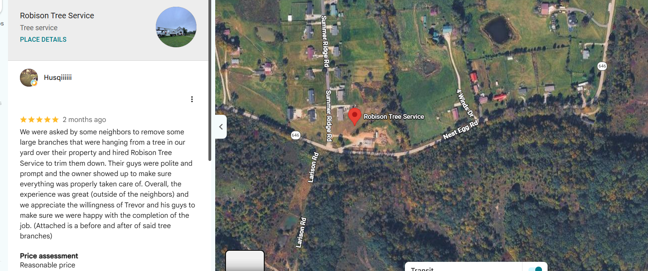
Polite guys, quick work, and an owner who checked the job in person.
Husqiiiii gave Robison Tree Service a 5-star review after we trimmed large branches hanging over a neighbor's yard.
📅 Book your trim with our crew.
Oathkeepers tree care
- Storm Damage Tree Services for Dover, PA Residents – Rain Returns Thursday
Heavy rain softens the ground and loosens roots, so tall pines and oaks can lean or drop limbs. Oathkeepers tree care handles that storm damage fast.
Our climbing arborist uses rope and rigging to lower broken limbs over roofs and fences in Dover, PA. For bigger jobs, we bring an aerial bucket lift or crane. Each piece comes down under control, away from your home.
📞 Call before Thursday's rain for fast storm help and a crew that keeps your yard safe.
- Warning Signs Your Tree Needs Professional Inspection in Shiloh, PA – Check Before Winter
Ice and wind arrive soon in Shiloh, PA, and weak trees often fail first. Most problems show up as small changes homeowners overlook.
A winter check now prevents surprise damage later. Watch for these signs before the first freeze:
✓ Dead limbs overhead
✓ Splits in the trunk
✓ Fungus at the base
✓ A sudden new lean
✓ Thin, sparse canopy
📞 Call Oathkeepers tree care for an inspection from a second-generation climbing arborist who works safely on every job.
- Licensed & Bonded Tree Care Professionals Serving Rheems, PA
Big trees near homes and power lines carry real risk during removal. An uninsured crew can leave you paying for a damaged roof or fence.
A licensed and bonded team gives you protection if a job goes wrong in Rheems, PA. Our crew climbs with rope and rigging to lower limbs piece by piece. We also clear brush and haul the debris when the work ends.
🗓️ Schedule with Oathkeepers tree care for clear communication, careful climbing work, and a clean yard at the end.
- https://maps.app.goo.gl/743FgrYTE9Ax8ek16
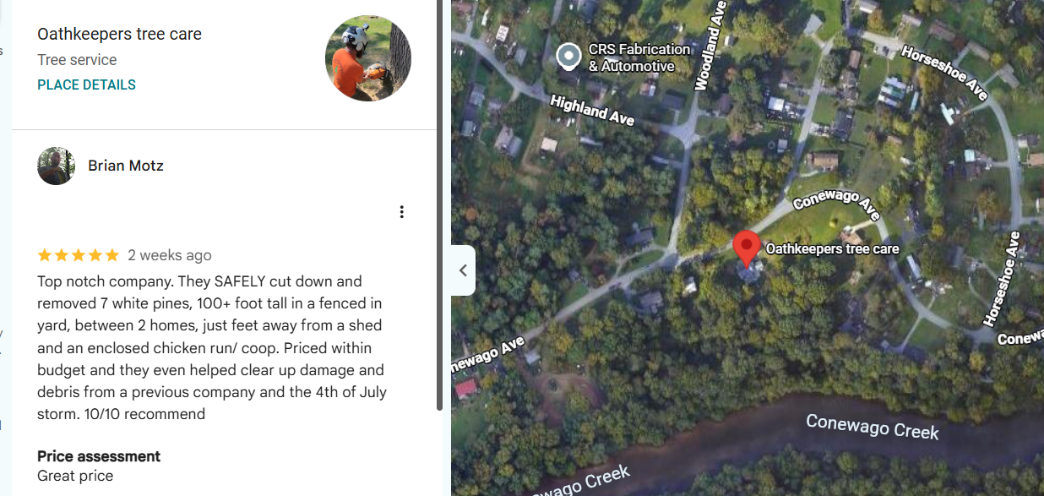
Brian Motz gave Oathkeepers tree care a 5-star review after we removed seven 100-foot white pines.
The trees stood between two homes, a shed, and a chicken coop.
Everything stayed safe and within budget.
📞 Call us for tight-space removals.

- Offer: Get a Free Hazardous tree removal Service Quote
A dead ash or a storm-cracked oak can drop without warning. Many homeowners put off removal because they fear the price, and the risk keeps growing each season.
Oathkeepers tree care offers free quotes on hazardous tree removal in York, PA. Our climbing arborist inspects the tree and plans each rigging point. Your quote covers section-by-section removal, crane or bucket lift work when needed, and full cleanup.
📞 Call today to claim your free quote and get that hazard off your property safely.

Timber Pros Tree Service
- Santa Ana Winds & Storm Damage Tree Services for San Bernardino Residents
Santa Ana winds rush down the Cajon Pass and snap brittle eucalyptus and pine limbs. Timber Pros Tree Service clears that damage and trims weak trees before the next wind event.
In San Bernardino, CA, our crew thins dense crowns with crown reduction so wind passes through. We remove dead fronds with palm skinning before they fly loose. After a storm, we cut fallen trees into sections and haul them off.
📞 Call for fast storm help and clear pricing from a crew that cleans up before leaving.
- Warning Signs Your Tree Needs Professional Inspection Before Winter Rains in Rialto
Dry summers leave roots stressed, and the first winter rains can tip weak trees in Rialto, CA. Problems often stay hidden until a limb falls.
An inspection now spots the risk before the storms. Watch for these warning signs in your yard:
✓ Dead, brittle branches
✓ Cracks in the trunk
✓ Mushrooms near roots
✓ Leaning after wind
✓ Dry fronds hanging down
📞 Call Timber Pros Tree Service for a careful inspection and safe, professional work from an experienced local crew.
- Offer: Get a Free Hazardous tree removal Service Quote
A dead eucalyptus or a leaning palm can fall during the next windstorm. Without a quote, many homeowners keep waiting, and the hazard over the house grows each season.
Timber Pros Tree Service offers free quotes on hazardous tree removal in Fontana, CA. Our crew inspects the tree, checks nearby roofs and lines, and plans a section-by-section removal. The quote includes stump grinding options and full cleanup, so you know the whole cost upfront.
📞 Call today to claim your free quote and remove the danger before the next windstorm.
- What to Expect During Stump Grinding on Your Colton Property
An old stump attracts termites and takes up useful yard space. It also trips guests and blocks new planting.
Most stumps grind away in one visit on a Colton, CA, property. Our crew checks for sprinkler lines, then a stump grinder cuts the wood below the soil. We fill the hole with chips or haul them away for you.
🤝 Get in touch with Timber Pros Tree Service for clear pricing, safe work, and a level yard afterward.
- https://maps.app.goo.gl/HTx8PaDZPAxPgA7i7

Timber Pros Tree Service earned a 5-star rating from D JG for tree removal and stump grinding.
The review praised our friendly customer service, professional crew, and quality work at a reasonable price.
🗓️ Schedule your free quote today.
Advanced Hood Cleaning Solutions
- Keep Your Fairport Restaurant Ready for Service with Expert Hood Cleaning
Grease builds up inside hoods, filters, and ducts with every shift. Advanced Hood Cleaning Solutions removes it before it turns into a fire hazard or a failed inspection.
For kitchens in Fairport, NY, our team scrapes and degreases hoods, filters, ducts, and fans to NFPA 96 standards. We clean before or after your hours. Before-and-after photos show you every section we cleaned.
📅 Book your hood cleaning on a schedule that keeps your doors open and your kitchen ready for inspection.
- Refresh Your Property with Professional Pressure Washing in Greece, NY
Grease, grime, and road salt build up on dumpster pads, sidewalks, and storefronts. Dirty exteriors turn customers away and create slip hazards.
Pressure washing clears that buildup fast for businesses in Greece, NY. Our crew uses hot water and degreasers on kitchen exhaust areas, rooftops, and walkways. We work around your hours and leave every surface clean.
🗓️ Schedule with Advanced Hood Cleaning Solutions for clear communication, flexible timing, and a property that looks cared for.
- Improve Your Indoor Airflow with Air Duct Repair in Irondequoit, NY
Leaky or damaged ducts waste heat and push dust through your building. Advanced Hood Cleaning Solutions repairs them so air moves where it should.
In Irondequoit, NY, our team inspects ductwork for loose joints, gaps, and crushed sections. We seal seams with metal tape and mastic and replace damaged runs. You get steadier airflow and less wasted heat this winter.
📞 Call for a duct inspection and repairs that fit your schedule and keep your business running.
- Keep Your Business Spotless with Commercial Cleaning in Pittsford, NY
Busy offices, kitchens, and storefronts collect dirt faster than staff can handle. A messy space hurts first impressions and health inspections.
Regular commercial cleaning keeps floors, restrooms, and kitchens in shape for businesses in Pittsford, NY. Our crew degreases kitchen surfaces, scrubs floors, and sanitizes high-touch areas. We work after hours so your team stays productive.
🤝 Get in touch with Advanced Hood Cleaning Solutions for reliable service, clear quotes, and a crew that respects your space.
- Hood Cleaning Service Near Ontario Beach Park, Rochester
https://advancedhoodsolutions.com/near/ontario-beach-park-in-rochester/
Ontario Beach Park occupies the northwest quadrant of Rochester on the shores of Lake Ontario. This 39-acre park features one of the best natural sand beaches in the Great Lakes region. Visitors flock here to ride the 1905 Dentzel Menagerie Carousel or walk the picturesque pier.
Advanced Hood Cleaning Solutions offers kitchen exhaust cleaning for restaurants and food stands around Ontario Beach Park in Rochester.
Summer crowds near the Dentzel Carousel and the pier keep fryers and grills busy along Lake Avenue in Charlotte. Our team degreases hoods, filters, ducts, and rooftop fans to NFPA 96 standards. We also pressure wash exhaust areas and send photo reports after each visit.
📞 Call to book hood cleaning before your busy season and get clear reports your inspector can trust.

- Professional Restaurant Hood Cleaning in Pittsford, NY for a Cleaner Kitchen
Grease inside a restaurant hood raises fire risk and draws inspector attention. Advanced Hood Cleaning Solutions cleans the full system, not just the filters you can see.
In Pittsford, NY, our team covers the hood, plenum, ductwork, and rooftop fan with scrapers and hot-water degreasers. We work closely with ANSUL system inspectors. A photo report lists anything that needs repair.
🗓️ Schedule cleaning after hours so your kitchen stays clean, compliant, and ready for the next service.
- https://maps.app.goo.gl/G3xAiaogBsMWnWWD6
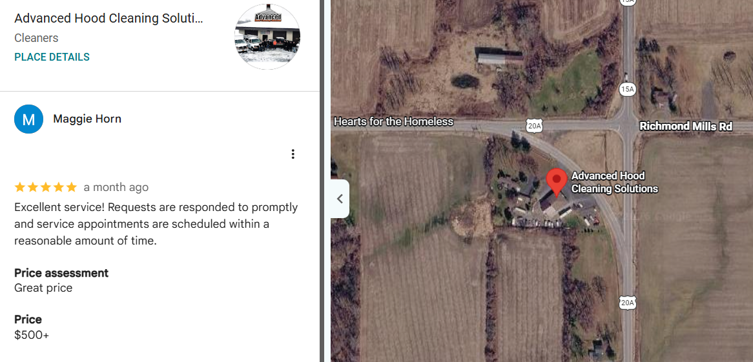
Maggie Horn gave Advanced Hood Cleaning Solutions a 5-star rating for excellent service.
The review noted how fast we answer each request and how soon we book service visits.
📞 Call to set up your next cleaning.

Rugged Tree Service
- Stump Grinding in Willmar, MN: Clear Leftover Stumps Before Winter
Frozen ground and snow cover make stumps hard to spot and harder to grind. Rugged Tree Service removes them now while the soil stays workable.
Our crew grinds stumps below grade around Willmar, MN, with a stump grinder sized for your yard. We clear rocks first and protect the nearby lawn. Then we fill the hole with chips or haul them away.
📅 Book stump grinding before the first hard freeze for fast scheduling and a clean, level yard.
- https://maps.app.goo.gl/izgxq8NY68CNrRDEA
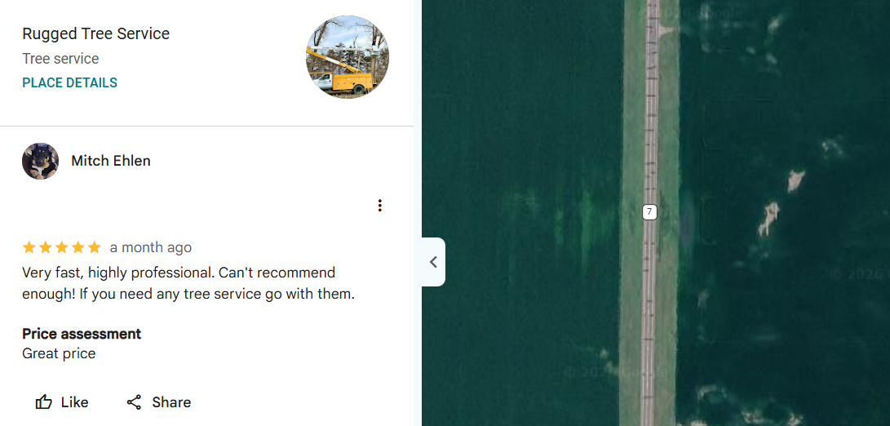
Fast, highly professional, and easy to recommend.
Those words come from Mitch Ehlen, who gave Rugged Tree Service a 5-star rating.
Mitch recommends us to anyone who needs tree work.
🗓️ Schedule your service with our family-owned crew.
- Warning Signs Your Tree Needs Professional Inspection in Granite Falls, MN This Fall
Cottonwoods and ash trees along the Minnesota River grow fast and weaken with age in Granite Falls, MN. Fall is the time to catch problems.
An inspection now prevents damage from winter wind and snow. Look for these warning signs in your yard:
✓ D-shaped holes in ash
✓ Bark splitting open
✓ Dead upper limbs
✓ Fungus on the trunk
✓ Lean toward your house
📞 Call Rugged Tree Service for an inspection from experienced arborists who explain each step and work safely.
- Storm Damage Tree Services in Redwood Falls, MN After Strong Winds and Rain
Strong prairie winds and soaked soil can snap limbs and uproot trees overnight. Damaged trees left standing can fall on homes and sheds.
Our storm crew clears broken limbs and fallen trees across Redwood Falls, MN, with chainsaws and a bucket truck. We remove hanging limbs first, then cut trunks into sections. Brush and logs leave with us, and your yard stays clean.
📞 Call Rugged Tree Service for fast storm cleanup, clear communication, and fair pricing from a family-owned team.

3in1 Tree Service
- Dead Limbs Showing Now That Leaves Are Down? Get Your Winder Tree Inspected
Bare branches make dead limbs easy to spot in November. 3in1 Tree Service can inspect them before winter wind brings them down on your roof.
Our team checks oaks, pines, and sweetgums around Winder, GA, for dry, barkless limbs and cracks. We remove dead wood with pole saws and climbing gear. Large limbs come down on ropes to protect your roof and lawn.
🗓️ Schedule a free estimate for direct communication and reliable service from a local crew.
- Fall Stump Grinding in Russell, GA: What to Expect on Your Property
Fall leaves hide old stumps and turn them into a tripping hazard. Stumps left in Georgia red clay also invite termites.
A stump grinder removes most stumps in a single visit in Russell, GA. Our crew checks for buried lines and rocks first. We grind below grade, then fill the hole with chips or rake the area level.
🤝 Get in touch with 3in1 Tree Service for a free estimate, clear pricing, and a tidy yard afterward.
- https://maps.app.goo.gl/vVbMXubbrouFjn358
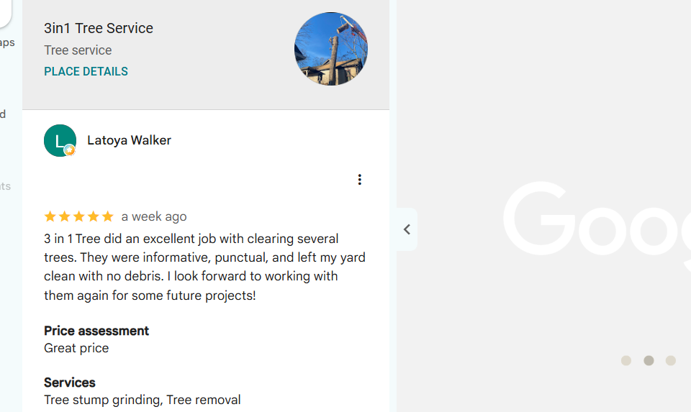
3in1 Tree Service cleared several trees for Latoya Walker and left the yard free of debris.
The 5-star review praised our punctual, informative crew.
Latoya plans to call us again for more projects.
📞 Call for a free estimate.
- Insured Tree Care for Mulberry, GA Homes
A tree job without insurance can leave you paying for a cracked roof or crushed fence. 3in1 Tree Service works with insurance coverage on every job.
Our crew trims trees, removes them, and grinds stumps for homes across Mulberry, GA. We lower large limbs with ropes and rigging to protect gutters and lawns. A free estimate explains the work before we start.
📞 Call for safe tree care, direct communication, and nearly two decades of local experience.
Buffalo Tree Service
- Lake-Effect Snow and Wind: Check Your Trees in Niagara Falls
Heavy lake-effect snow and gusty winds put extra weight on weak limbs. Buffalo Tree Service checks your trees before the winter storms hit.
Our arborists look for cracked limbs, dead wood, and weak branch unions around Niagara Falls, NY. We trim risky branches with pole saws and rope rigging. Crown reduction then lowers the wind load on tall maples and oaks.
📅 Book an inspection today for 24-hour emergency support and reliable service from a local crew.
- https://maps.app.goo.gl/4rXDAQ6u4J6gETc97
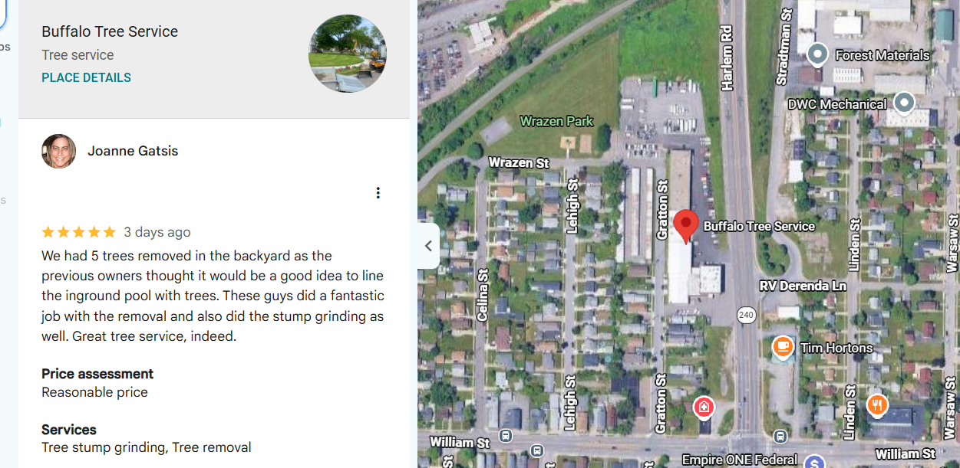
Joanne Gatsis gave Buffalo Tree Service a 5-star review after we removed five trees lining an inground pool.
Our crew also ground every stump, and the backyard opened up.
Joanne called it a fantastic job.
🗓️ Schedule your removal today.
- Warning Signs Your Tree Needs Professional Inspection in Niagara Falls
Road salt and freeze-thaw cycles weaken street-side trees in Niagara Falls, NY. Many problems stay hidden until a limb drops on a car or walkway.
A trained arborist can spot these issues early. Watch for these warning signs:
✓ Dead, leafless branches
✓ Deep trunk cracks
✓ Fungus near roots
✓ Sudden new lean
✓ Peeling, loose bark
📞 Call Buffalo Tree Service for an inspection from trained arborists who work safely and explain every step.
- What to Expect During Stump Grinding on Your Marilla Property
An old stump attracts carpenter ants and keeps sending up sprouts. It also makes mowing and new planting harder.
Most stump grinding takes one visit on a Marilla, NY, property. Our crew marks lines and clears stones first. The grinder then cuts the stump below the soil, and we rake the chips into the hole.
🤝 Get in touch with Buffalo Tree Service for competitive prices, safe work, and a level yard when we finish.
Allegiant Tree Care
- Warning Signs Your Tree Needs Professional Inspection in Lampeter, PA
Tulip poplars and red maples around Lampeter, PA, can hide decay behind healthy leaves. Homeowners often miss the signs until a limb breaks.
An inspection catches trouble early. Watch for these warning signs before winter:
✓ Cankers on the bark
✓ Dead branch tips
✓ Mushrooms at the base
✓ Cracked or split trunk
✓ Leaves wilting early
📞 Call Allegiant Tree Care for an inspection from an insured, bonded team with over 25 years of experience.
- Storm Damage Tree Services for Strasburg, PA Residents
Summer storms and winter ice can split trunks and drop limbs on homes and barns. Allegiant Tree Care clears that damage and makes your property safe again.
Our crew handles storm cleanup across Strasburg, PA, with chainsaws, ropes, and rigging. We lower hanging limbs first, then cut fallen trees into sections. Debris leaves with our crew, so your yard stays clean.
📞 Call for fast storm help from a family-owned crew with free quotes and full debris cleanup.
- https://maps.app.goo.gl/vrUCuyx6TAicg8kNA

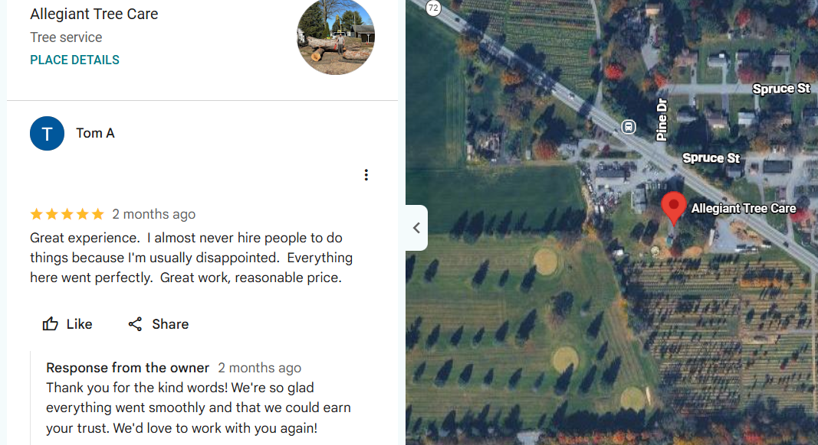
Everything went perfectly, from great work to a reasonable price.
Tom A rarely hires outside help, yet gave Allegiant Tree Care a 5-star review after the job.
📅 Book your free quote with our family-owned crew today.
- What to Expect During Stump Grinding on Your Marietta, PA Property
An old stump keeps rotting in place and draws termites and carpenter ants. It also blocks mowing and new plantings.
Stump grinding usually takes one visit on a Marietta, PA, property. Our crew checks for utility lines, then a grinder cuts the stump several inches below grade. We fill the hole with chips or haul them off.
🗓️ Schedule with Allegiant Tree Care for a free quote, careful work, and a clean yard when we finish.

Gomez Tree Service
- Warning Signs Your Trees Need Inspection Before Winter in Pegram, TN
Oaks and tulip poplars along the Harpeth River in Pegram, TN, face ice and wind each winter. Weak trees often fail during the first storm.
A pre-winter inspection finds these risks early. Watch for these warning signs:
✓ Dead upper branches
✓ Bagworms on evergreens
✓ Mushrooms near roots
✓ Cracks in the trunk
✓ Leaning toward structures
📞 Call Gomez Tree Service for an inspection from a locally owned team that works safely and quotes for free.
- What to Expect During Stump Grinding in Fairview, TN
A leftover stump attracts termites and keeps sprouting each spring. Gomez Tree Service grinds it out and gives you back usable yard space.
In Fairview, TN, our crew checks for utility lines and rocks before grinding. A stump grinder cuts the wood below ground level. We then fill the hole with chips or haul them away from your property.
📅 Book a free stump grinding quote for fast scheduling and a clean finish.
- https://maps.app.goo.gl/J9zhmnb9A2dJq9Ju9
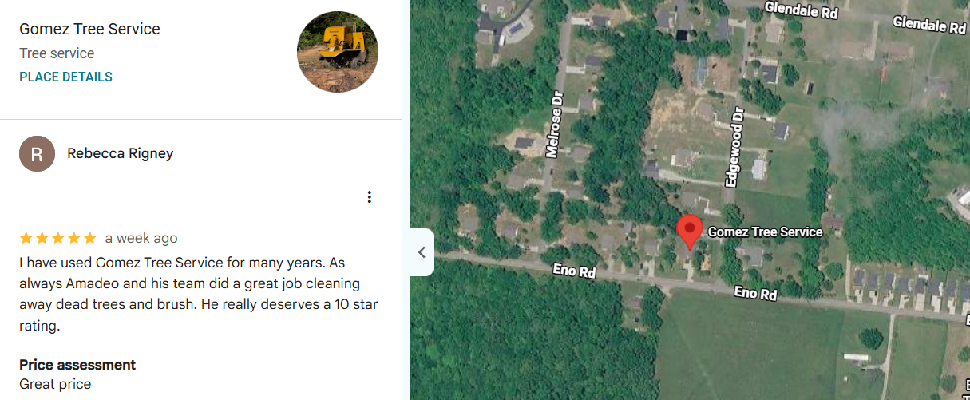
Gomez Tree Service has worked with Rebecca Rigney for many years.
Our latest visit cleared away dead trees and brush.
Rebecca left a 5-star review and said our team earned a 10-star rating.
🗓️ Schedule your cleanup with us.
- Storm-Damaged Trees in Ashland City, TN? Put Safety First
Storm-damaged trees often hold hidden stress, broken hanging limbs, and tangled power lines. Cutting them without training puts you at real risk.
Safety comes first after every storm in Ashland City, TN. Our crew checks for wires, then removes hanging limbs before cutting the trunk. We cut fallen trees in sections and clear the debris.
📞 Call Gomez Tree Service for fast emergency help, clear communication, and a crew that leaves your yard safe.
Top Chop Tree Service & Land Management
- Storm Damage Tree Services in Sheboygan, WI: Protect Your Property During Fall Winds
Fall winds off Lake Michigan snap weak limbs and topple shallow-rooted trees. Top Chop Tree Service & Land Management handles both the cleanup and the prevention.
Our crew trims weak branches around Sheboygan, WI, before the storms hit. After high winds, we cut downed trees into sections with chainsaws and haul away the debris. Your yard is clear and safe again.
📞 Call for fast storm help from an insured and bonded crew that puts safety first.
- Warning Signs Your Tree Needs Professional Inspection in West Bend, WI This Fall
Oak wilt and Dutch elm disease weaken trees across West Bend, WI. Fall is a good time to check them before snow arrives.
An inspection spots weak trees before winter. Look for these warning signs:
✓ Early browning leaves
✓ Dead upper limbs
✓ Cracks in the bark
✓ Fungus at the base
✓ Roots lifting soil
📞 Call Top Chop Tree Service & Land Management for a safe inspection and honest advice from a local crew.
- https://maps.app.goo.gl/KTiS6jPLRCphjfAy5
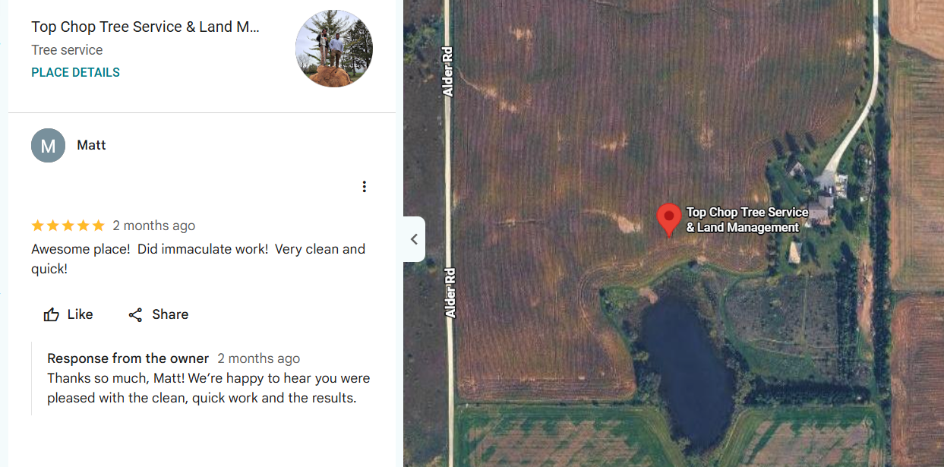
Immaculate work, a clean site, and a quick finish.
Matt shared that praise in a 5-star review for Top Chop Tree Service & Land Management.
Our crew keeps every job site tidy to the end.
📲 Contact us for your next project.

- What to Expect During Stump Grinding on Your Port Washington, WI Property Before Winter
Stumps left through winter hide under snow and damage plows and mowers. They also attract insects and fungus.
Grinding before the ground freezes works well on a Port Washington, WI, property. Our crew clears debris, then a stump grinder cuts below grade. We fill the hole with chips or haul them off.
🗓️ Schedule with Top Chop Tree Service & Land Management for a free quote, clear updates, and a clean yard.
United Tree Pro Service
- Warning Signs Your Trees Need a Fall Inspection in Powder Springs, GA
Loblolly pines and water oaks in Powder Springs, GA, often show stress after a dry summer. Weak trees can fail during winter storms.
A fall inspection catches problems before they turn dangerous. Watch for these warning signs:
✓ Pitch tubes on pines
✓ Dead branch tips
✓ Hollow or cracked trunk
✓ Mushrooms near roots
✓ New lean after rain
📞 Call United Tree Pro Service for an inspection from an insured, bonded team with fair, transparent pricing.
- Storm Damage Tree Services After Strong Fall Winds in Smyrna, GA
Strong fall winds can split tall pines and drop oak limbs on roofs and cars. United Tree Pro Service clears that damage fast.
Our crew removes broken limbs and fallen trees across Smyrna, GA, with chainsaws, ropes, and rigging. We lower each section away from your home. Cabling and bracing can then support weak trees that stay.
🗓️ Schedule storm cleanup today for a fast response and fair pricing with no hidden fees.
- https://maps.app.goo.gl/cpPDjvwF29arUzaR7

Chauntrell Brewer gave United Tree Pro Service a 5-star review for professional, fast work and great pricing.
Our team managed the tree removal and cabling from quote to cleanup.
📞 Call us for your next tree project.
- Stump Grinding Before Winter: What to Expect in Mableton, GA
Old stumps attract termites and sprout new growth through Georgia's mild winters. They also make yard work harder.
Grinding in fall or early winter gives you a clean yard by spring in Mableton, GA. Our crew checks for lines, then grinds the stump below grade. We fill the hole with chips or haul them away.
🤝 Get in touch with United Tree Pro Service for a free estimate, clear pricing, and a tidy finish.
Andrew’s All Around Tree & shrub
- Rain-Soaked Ground and a Weekend Cold Snap? Storm Damage Tree Services in Ellwood City, PA
Soaked soil loosens roots, and a hard freeze can crack weak limbs. Andrew’s All Around Tree & shrub clears storm damage before it gets worse.
Our crew handles fallen trees and hanging limbs across Ellwood City, PA, with chainsaws, ropes, and rigging. We lower each piece away from your home. Then we clean up every branch and haul the debris away.
📞 Call for 24-hour emergency storm relief from an insured crew with over a decade of experience.
- 5 Warning Signs Your Tree Needs a Professional Inspection in Poland, OH
Oaks and maples around Poland, OH, can look healthy while decay spreads inside. Homeowners often notice only after a limb falls.
An inspection finds these problems before they cause damage. Here are five signs to watch:
✓ Dead limbs overhead
✓ Cracks in the trunk
✓ Fungus at the base
✓ Sudden new lean
✓ Bark falling away
📞 Call Andrew’s All Around Tree & shrub for an inspection from a fully insured team that works safely.
- https://maps.app.goo.gl/tnveD5y1pkPGDZ1m9

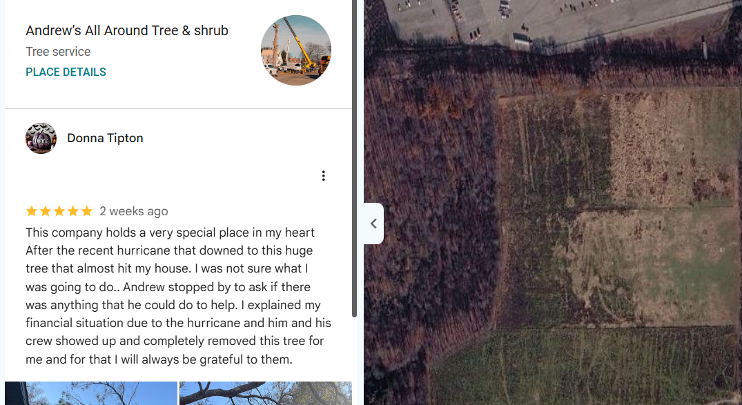
A huge tree almost hit Donna Tipton's house after a recent hurricane.
Andrew’s All Around Tree & shrub removed it and worked with Donna's budget.
Donna left a 5-star review full of gratitude.
🗓️ Schedule your storm cleanup today.
- What to Expect During Stump Grinding on Your Boardman, OH Property
Old stumps attract carpenter ants and send up new shoots. They also get in the way of mowing and planting.
Most grinding takes one visit on a Boardman, OH, property. Our crew clears rocks and checks for lines first. The grinder cuts the stump below grade, and we rake chips into the hole or haul them off.
🗓️ Schedule with Andrew’s All Around Tree & shrub for fair pricing, careful work, and a clean yard.

