Assignment 3: Problems 1 and 2
Name: Farhan Quadir

Problem 1:
Accuracy = 98.4%
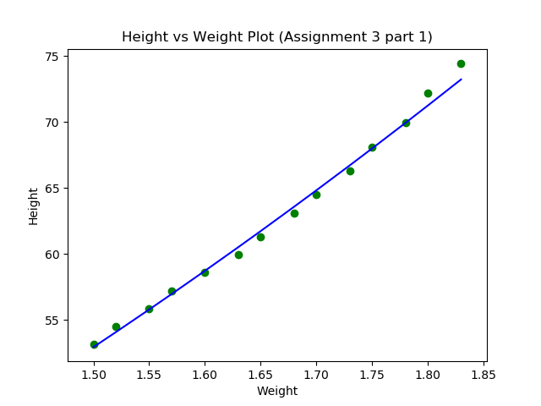

Problem 2:
Accuracy = 100%
Loss Curve:
