AI-Based Climate Risk Analytics for Food Security: Predicting Rice Productivity and Supporting Climate Adaptation Decisions

Abstract
This project presents an AI-based climate risk analytics platform developed to predict rice productivity and provide explainable climate adaptation insights. The framework integrates climate, agricultural, economic, and disaster-related indicators with machine learning, Explainable AI, and policy decision support. A time-based validation approach was applied to evaluate the model under realistic forecasting conditions.

1. Project Overview
Climate variability creates challenges for agricultural productivity and food security. This project develops an interactive AI-powered system that estimates rice productivity, explains model predictions, and provides climate adaptation insights through a dashboard interface.

2. Objectives
The objectives of this project are to analyze climate-related factors affecting rice productivity, develop a machine learning prediction model, explain prediction outcomes using SHAP, and provide decision-support information for climate adaptation planning.

3. Dataset Description
The final dataset contains country-year observations from 2000 to 2022. The dataset includes rice yield as the target variable along with temperature, rainfall, fertilizer use, GDP per capita, disaster events, flood events, and drought events.

4. Methodology
The project workflow consists of data preparation, exploratory analysis, machine learning development, Explainable AI analysis, policy interpretation, and dashboard implementation. A time-based validation strategy was used, where observations from 2000–2019 were used for training and 2020–2022 observations were reserved for testing.

5. Machine Learning Results
The final prediction model uses Random Forest Regression. The model was evaluated using MAE, RMSE, and R² metrics on unseen future-year observations.

Final Model Performance
Algorithm: Random Forest Regression
Validation Strategy: Time-based split
Training Period: 2000–2019
Testing Period: 2020–2022
MAE: 0.521
RMSE: 0.870
R²: 0.816

6. Explainable AI Analysis
SHAP-based Explainable AI was integrated to identify how individual climate and socioeconomic variables influence model predictions. This improves transparency by showing why a particular prediction was generated.

7. Dashboard Implementation
The interactive Streamlit dashboard provides five main modules: Global Overview, Country Explorer, AI Prediction, Explainable AI, and Policy Support. The dashboard transforms analytical outputs into an accessible decision-support platform.

8. Policy Decision Support
The system connects identified climate risks with possible adaptation areas. Temperature stress, rainfall variability, flood exposure, and drought conditions are linked with relevant climate adaptation considerations.

9. Practical Relevance
The project demonstrates how AI-based analytics can support climate adaptation planning, food security analysis, and evidence-based decision-making by combining prediction, explanation, and visualization in a single platform.

10. Limitations and Future Work
Future improvements may include integration of satellite-based indicators, additional agricultural variables, real-time climate monitoring, and broader geographical analysis.

11. Conclusion
The developed platform demonstrates the potential of combining machine learning, Explainable AI, and dashboard-based analytics to support climate-related food security decisions.

Dashboard Screenshots
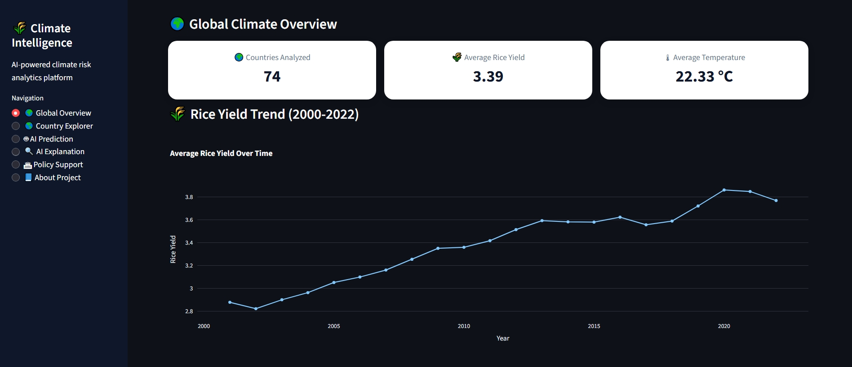
Figure 1: Global Climate Overview Dashboard
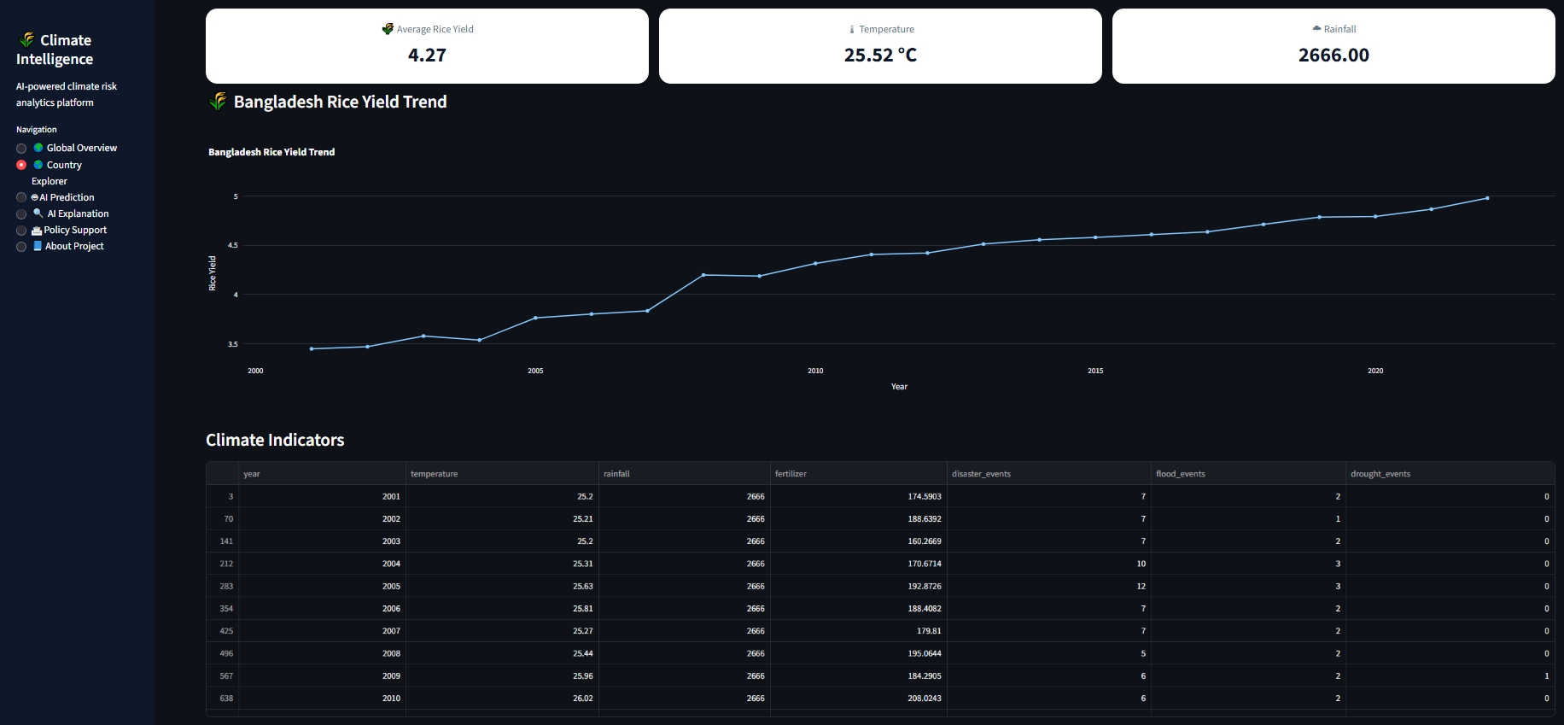
Figure 2: Country Explorer Module
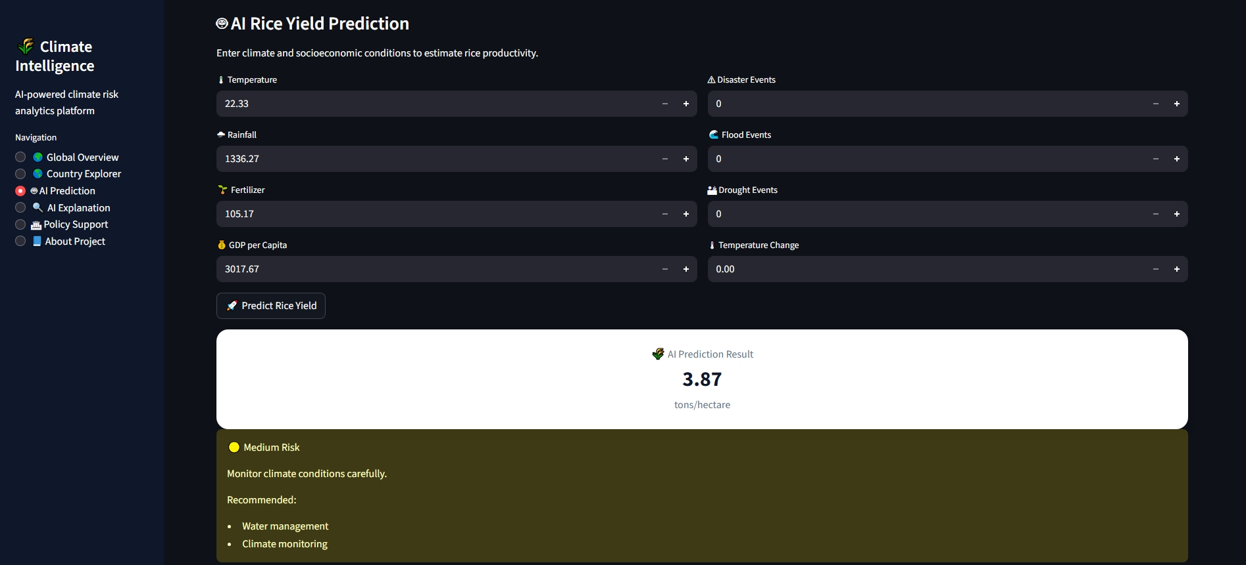
Figure 3: AI Rice Yield Prediction Module
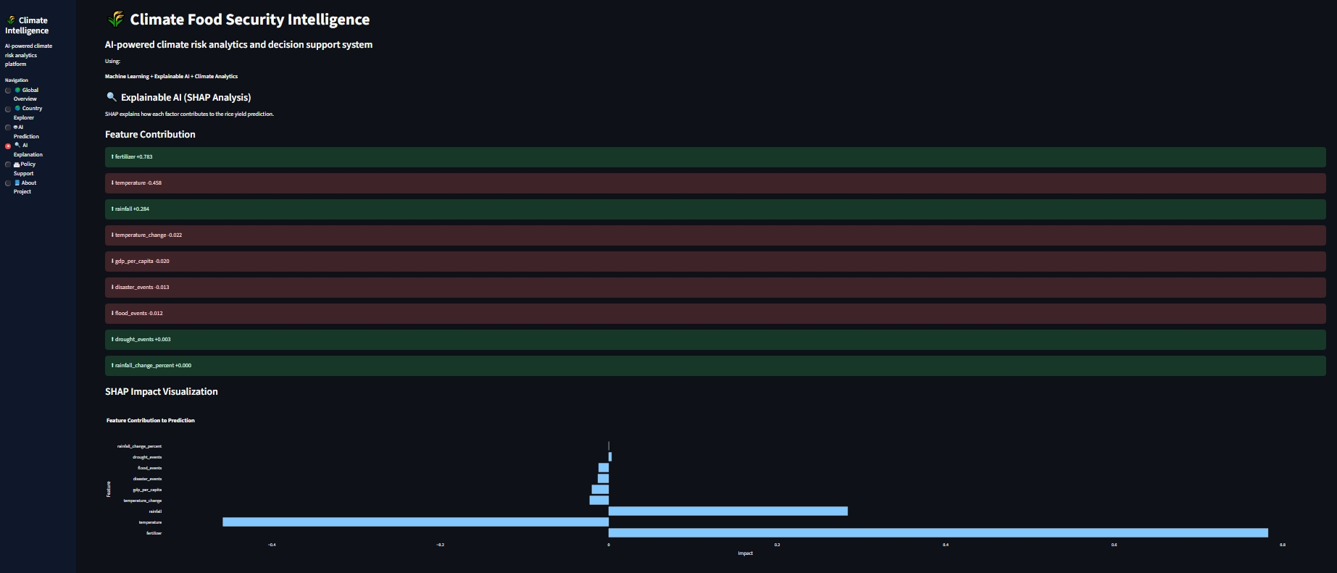
Figure 4: SHAP Explainable AI Module
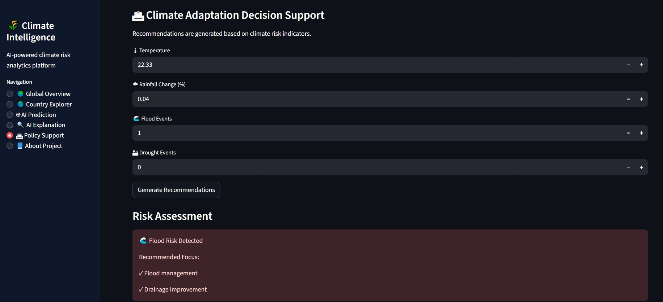
Figure 5: Policy Decision Support Module

References
FAO. FAOSTAT: Food and Agriculture Data.
World Bank. World Development Indicators.
EM-DAT. The International Disaster Database.
Breiman, L. (2001). Random Forests. Machine Learning, 45, 5–32.
Lundberg, S. M., & Lee, S. I. (2017). A Unified Approach to Interpreting Model Predictions.
Chen, T., & Guestrin, C. (2016). XGBoost: A Scalable Tree Boosting System.

