

**Documentation &**

**Project Diary**

Innovation Lab

1/2/3

Year

2021

Project:

**Git-Game**

Team:

**Group 01**

# General Information

**Project name:** Git-Game

**Supervisor:** Prof. Lukas Aichbauer

Innovation Lab < *1/2/3, summer term/winter term 2021/23 >*

**Projectteam:**

Tomanovic Pavle, if20b162@technikum-wien.at

Awan Malik, if20b501@technikum-wien.at

Saifee Farhan, if20b505@technikum-wien.at

**Management Summary of the Project**

This project will help users to learn more about git functions in an interactive and interesting way. The Github web game is built from low to high level difficulties. Users with zero knowledge of Github functionalities will be able to master them through our web game.

**Framework Conditions and Project Environment**

* **PHP**: Data Handling und Validation
* **JavaScript**/**Typescript**: Interactive Frontend Features
* **HTML**/**CSS**: Base layout of the Frontend and responsiveness
* **SQL**: Database and DB-queries

**Semester-Roadmap**

In the first semester we will start with the backend. We will create a database with all the tables. We will specify all the tables and the ERM diagram in Sprint 2. After that, we will start with registration and login as the first pages to be done. And after that we will plan and develop the game logic (with 1 Challenge ready).

Focus in the second and third semester will be on design and developing sharing functions, so that more people can hear about our game. But this will be discussed in the beginning of the second semester. The Challenges will be more advanced and the whole product will be expanded more and more suitable for the users’ needs.

**Collaboration & Tooling**

Google Sheets (Time Management): [https://docs.google.com/spreadsheets/d/1OMArljF2LpWNn-FKRMXUrwybi12l5OPowxQbWUMZ8U/edit#gid=0](https://docs.google.com/spreadsheets/d/1OMArljF2LpWNn-FKRMXUrwybi12l5OPowxQbWUM-Z8U/edit#gid=0)

Github (Project): <https://github.com/farhansaifee/Git-Game>

Trello (Kanban-Board): <https://trello.com/b/gF0VGzul/git-kanban>

**Remarks**

No other remarks.

# Brief Description of the Project

This project will help users to learn more about git functions in an interactive and interesting way. The Github web game is built from low to high level difficulties. Users with zero knowledge of Github functionalities will be able to master them through our web game.

Our main priority will be to create a game logic using all functions, so users can experience all of them through the game.

The challenges for the whole team could be the bulid-process/implementation of the game logic, as well as connecting frontend with backend. Responsive designs could take a few weeks to build.

Our first main task on this project will be database creation and project creation. We will create the pages in our application. After that we will start planning and developing the game logic.

Our idea is to create Web-Application where the user should register himself. This will be created as a normal registration form. We will also require the password with one big letter and one number.

When the user logs in, he will be able to start the new game or to continue where he left last time.

We will create levels in the game and every new level will be harder than the previous one. Our idea is to have and to develop new levels all the time, so that particularly game never ends. If somebody is really motivated to play and learn and he finish all the levels, he will get the popup message that we are working on the new levels and that he will get the email when we finish them. In meantime, he will be able to start the new game.

Our goal is not to create multiple choice or fill in the blank questions, on which user should answer. Because we want to create more interactive and interesting way of learning more about git.

# Specification of the Solution

First, we created an idea of how we would like to go on with this project. We created requirements, roles for each team member and first prototypes of how the design should look. After we had the foundation we needed, we implemented the features (requirements).

The solution was created as we planned on the beginning.

We completed the registration and login functions. User is now able to register himself, and everything will be stored in database. After registration, user can log himself and enjoy our new gaming platform. After logging in in profile section, user can change some information about his profile. For example, to change his password, username, or email address. Also is possible to change an avatar image.

In our new gaming platform, for now, user can play Challenge 1 and complete tasks to learn how to use git. Challenge should be completed in our designed terminal, which will check all commands user entered. After entered command, user would get the message if he entered the command is right or not. If user is not sure how to complete the task it is possible to enter “1” for the hint.

Also, in the challenge section will be presented how much tasks user have done and how much is left to be done. Also, if user is not sure about his knowledge and want to complete the challenge one more time, there is a button for that.

Our first goal in the next semester is to implement the highscore page, so the users can compete against each other.

Second goal is to design and create some new challenges.

Third goal is to enable the git users to register themselves using their git account.

## 3.1 Prototypes/Mock-Ups

There is a prototype and mock-up for every task of the first challenge:

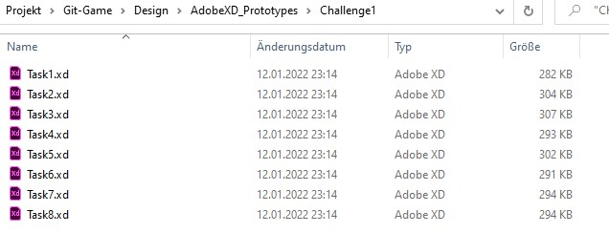

All prototypes and mock-ups look like each other, with just a difference of their font. That is why I am not going to put every file in here.

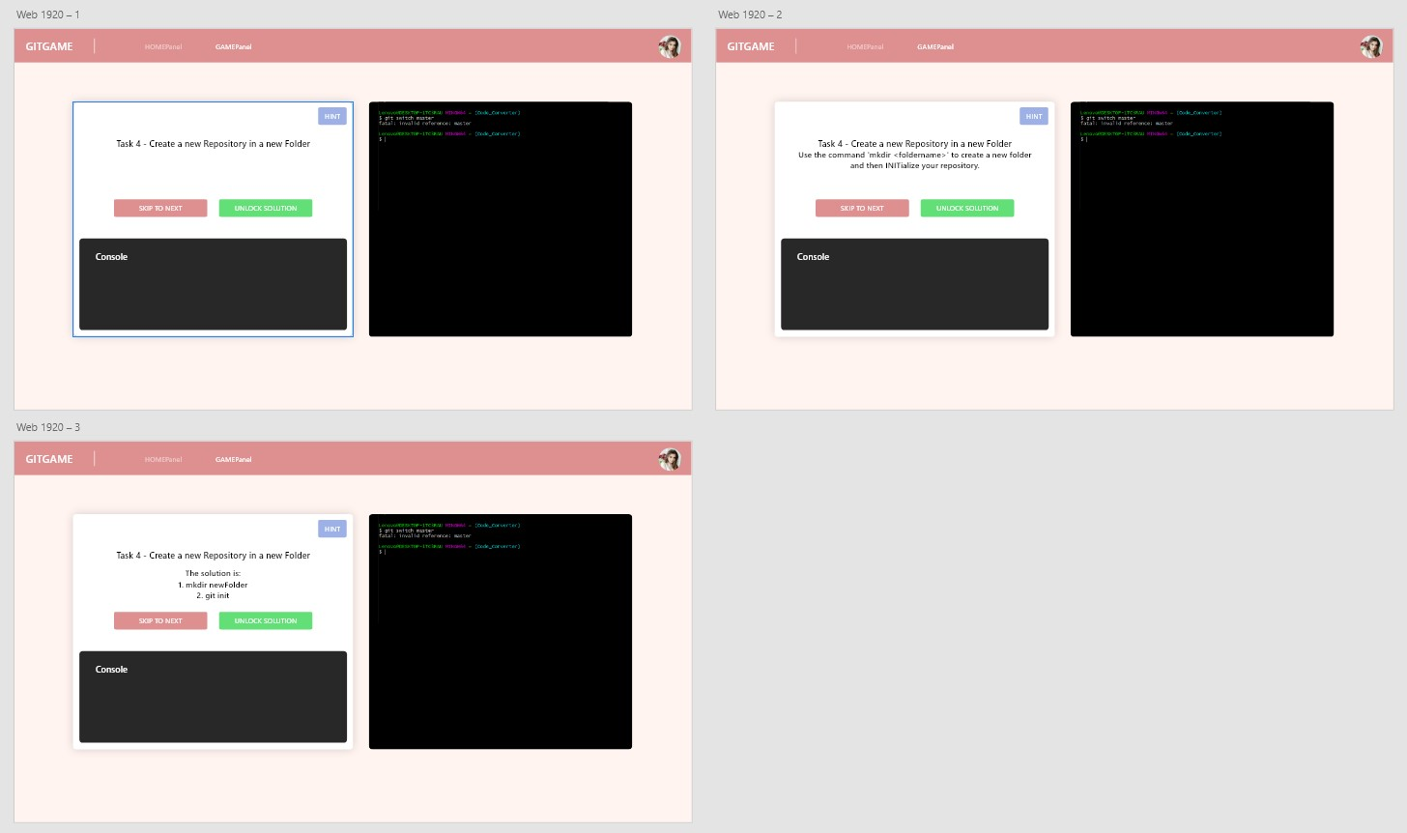

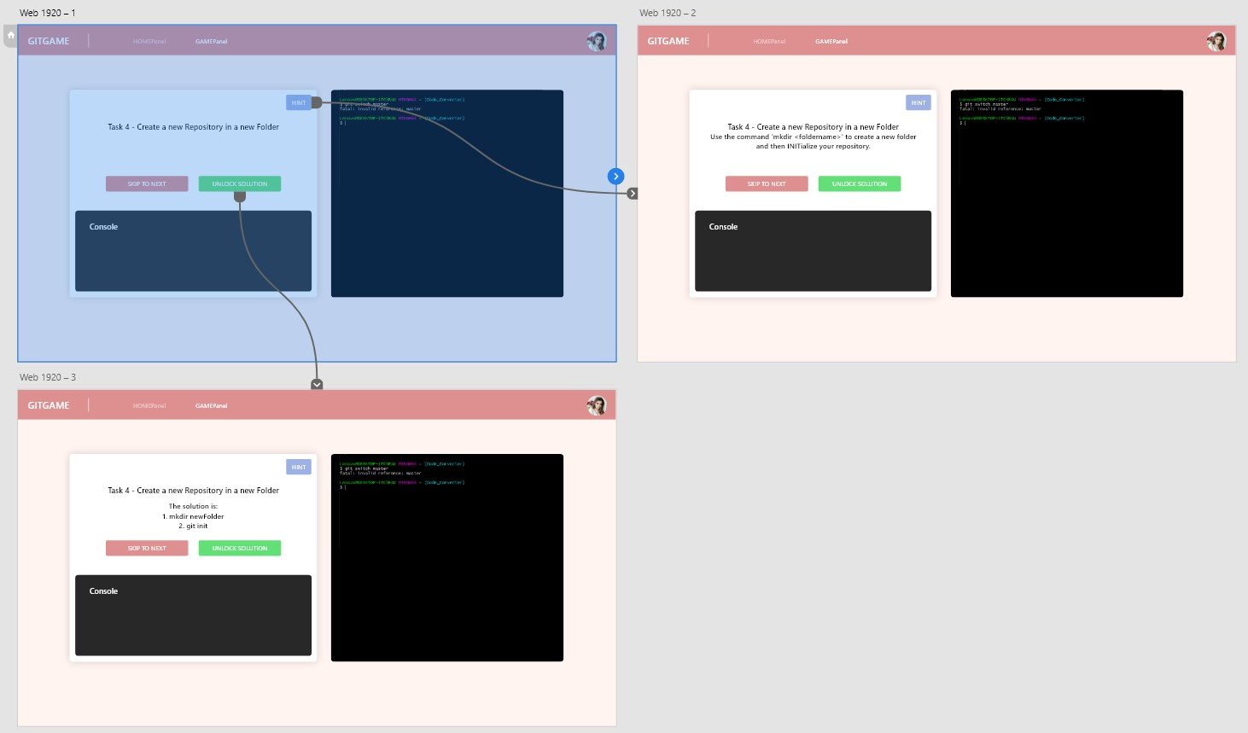

## Requirements

We have set 5 must-haves (requirements/functionalities) for this semester:

* User should be able to create an account (Register)
* User should be able to login (if the account is already created)
* User can do tasks in the section “Challenge 01”
* User can edit his user data (for example change the avatar, username, etc.)
* User can reset his or her password

In the 2nd semester our main focus will be the design. Currently our design looks basic and there is definitely need for improvement. Furthermore, we will try to add more tasks in a challenge and a wiki-like website, where users can learn in advance about git or if they forgot some commands, they can look them up afterwards.

This is what our website looks like today:

Ein Bild, das Text enthält.

A nice-to-have function we are currently planning is to add a certificate function, where users get a certificate after completing this “course” about git.

# Delivery

So, what do you need to run our project on your laptop or computer?

## 4.1 Localhost

Our customers and other developers, first, need to download SQL_File.zip and Git-Game.zip from our repository on github ([https://github.com/farhansaifee/Git-Game)](https://github.com/farhansaifee/Git-Game).

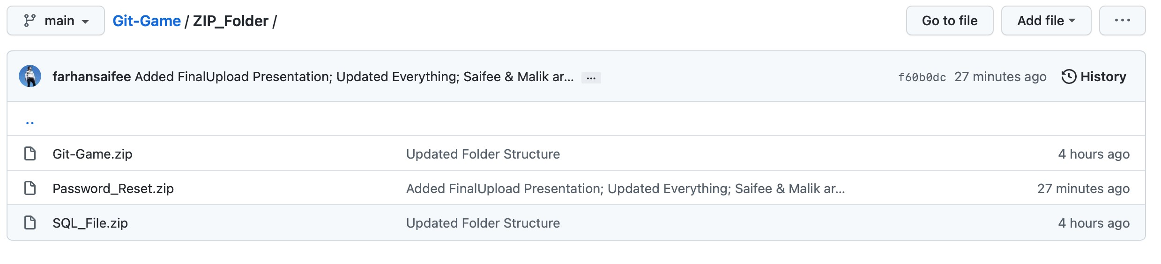

After that, they need to import our database (SQL_File.zip) in their phpMyAdmin. There is import option in the menu on the right.

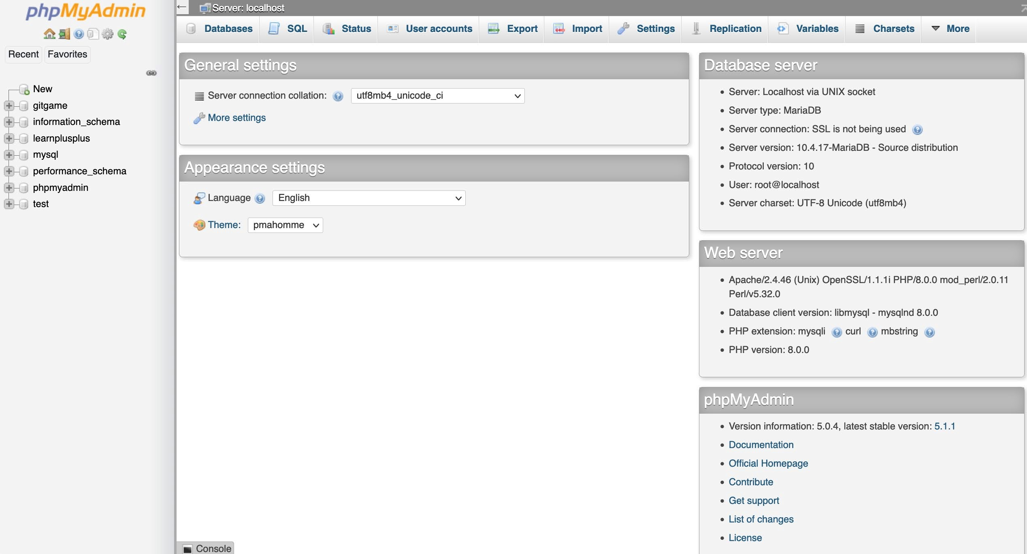

Next step is to start the xampp application after that extract the Git-Game.zip and copy the folder in xampp/htdocs folder.

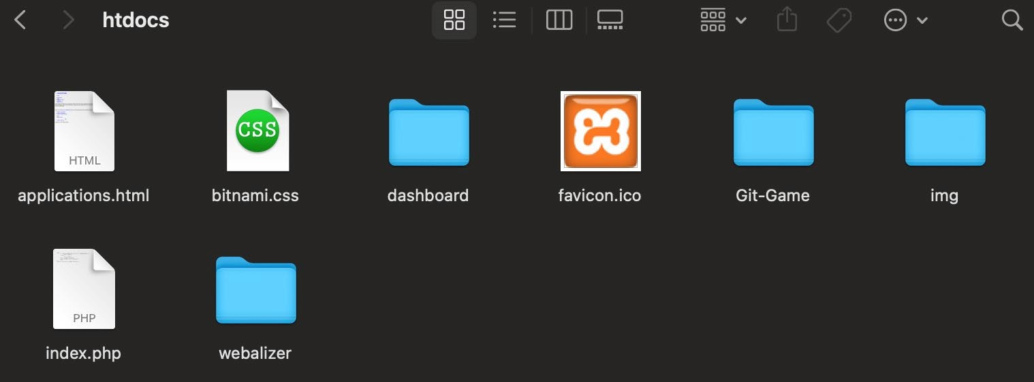

Final step is to start our application in browser using *localhost:8080/Git-Game.*

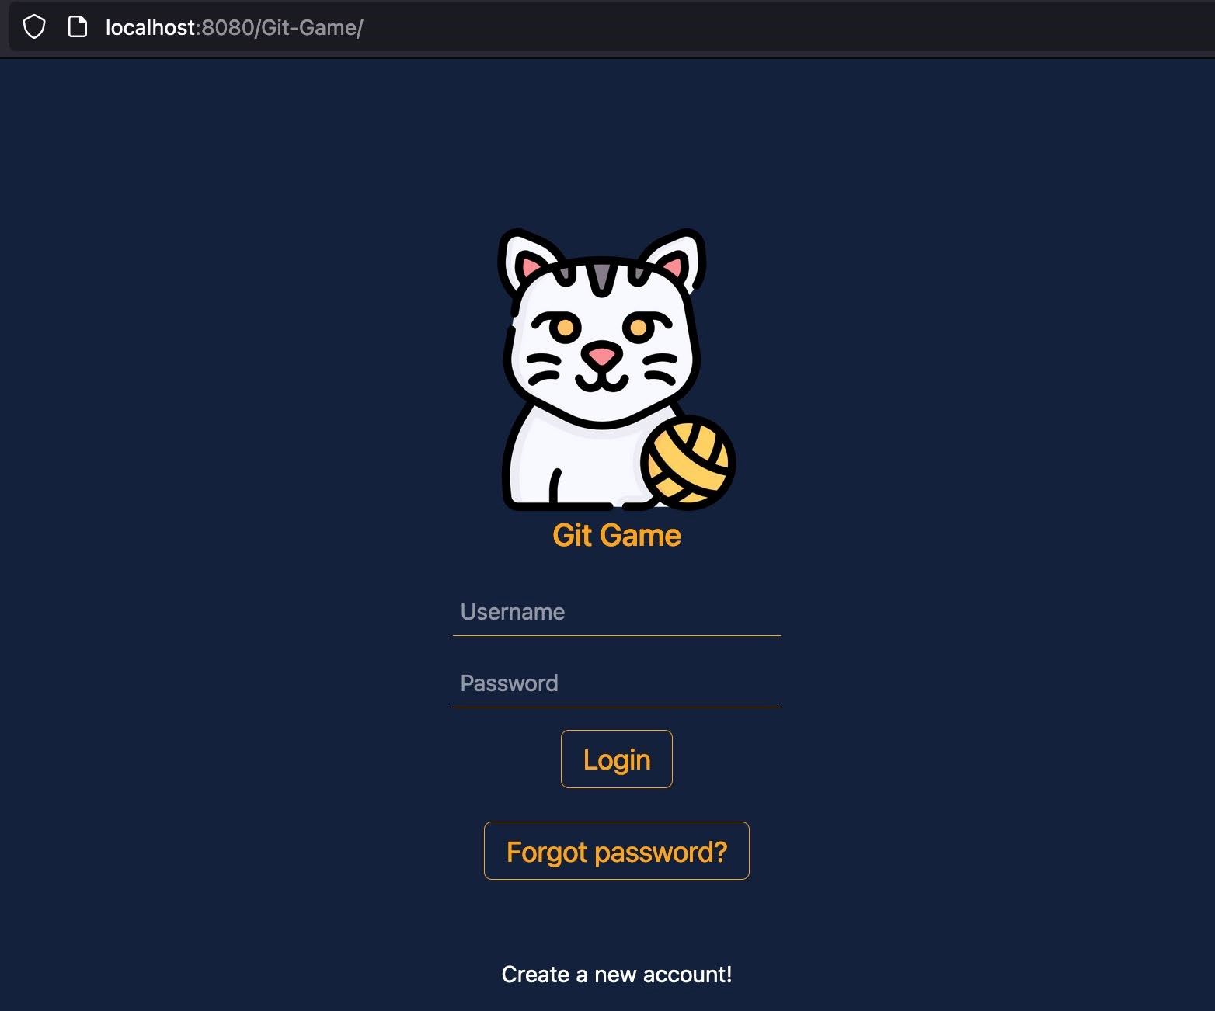

## Webhost

**General:**

For web hosting we use the free web host 000webhost.com, this offers us the different possibilities to test different processes that we can't test locally.

*Fantastic features of 000webhost:*

* 3 GB bandwidth!
* Simple and costless homepage builder
* Almost endless 300MB disk space
* WordPress Auto Installer
* No advertising
* Full PHP and MySQL database support - Free Cpanel web hosting admin panel - Instant account activation, no fees!

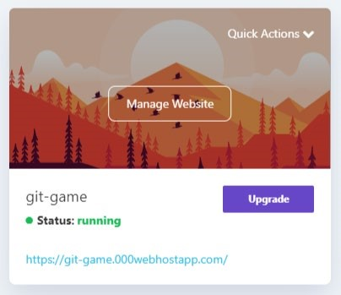

Website-Link: [https://git-game.000webhostapp.com](https://git-game.000webhostapp.com/)

**File upload:**

There are two ways to upload files to the web hosting service:

The first option - using the browser-based file manager. This tool allows you to navigate, upload and delete files on your web server. You can access this feature from your Control Panel.

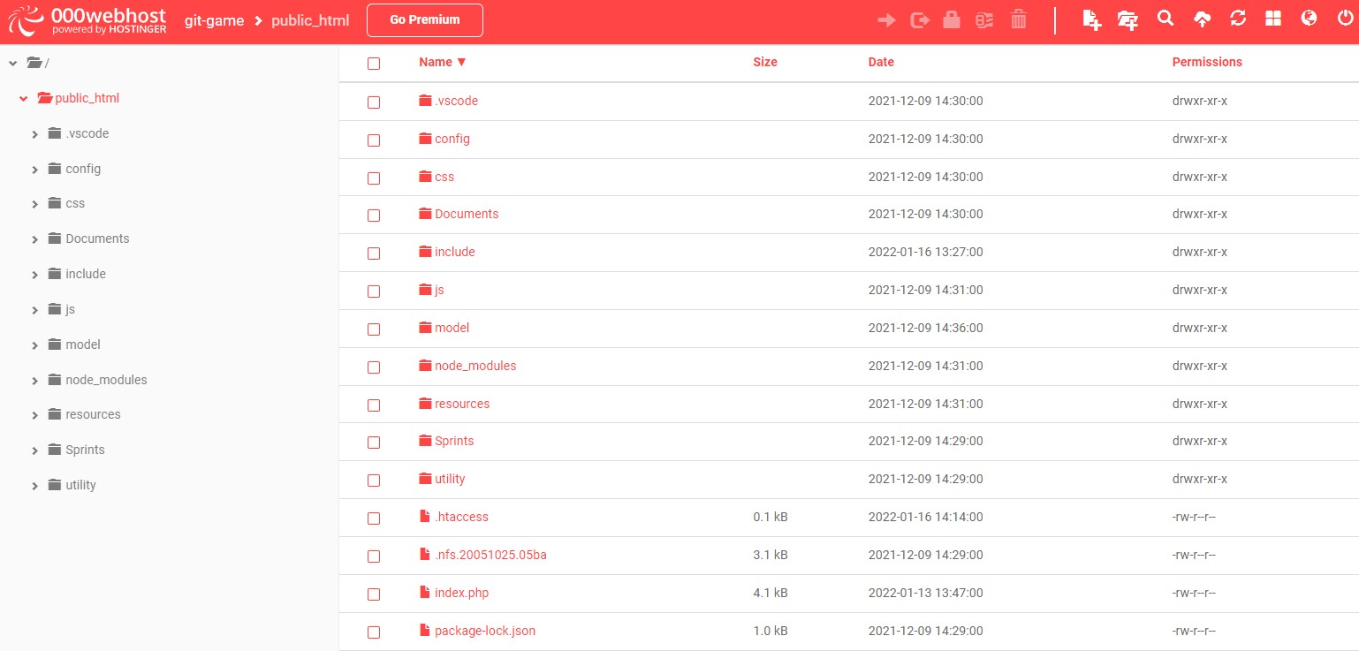

The second option is to use FTP. FTP stands for File Transfer Protocol. With it you can conveniently manage your files similar to a file manager.

Used software for file transfer: FileZilla. FileZilla is a free FTP client for all major platforms (Windows, Mac OS X, BSD and Linux). The tool has an intuitive visual user interface and many handy features

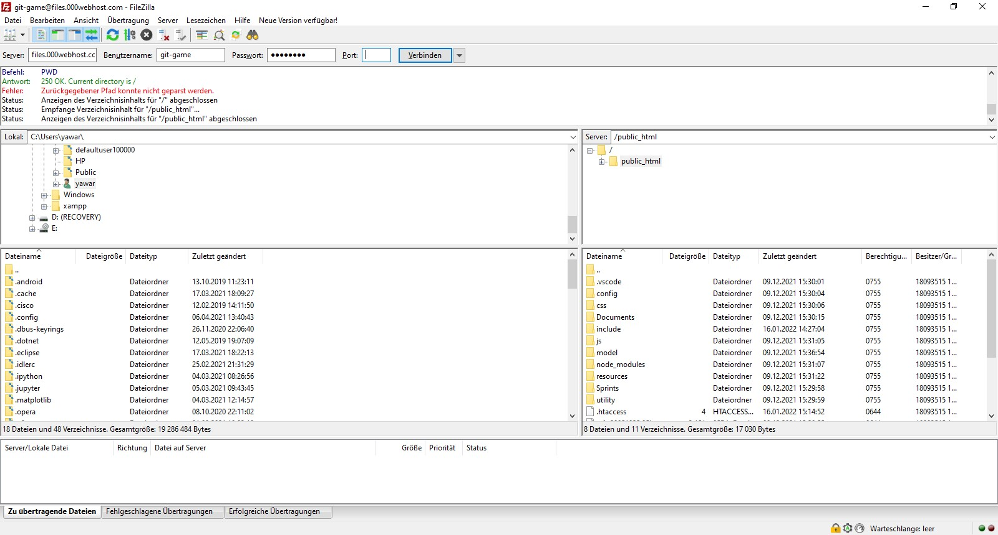

**Database:**

You can create up to two databases with the free version.

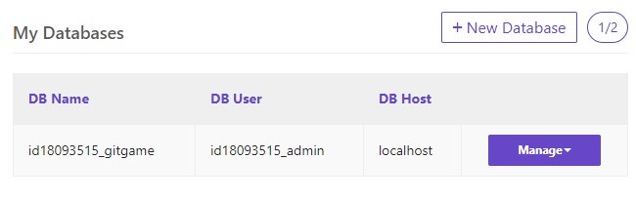

*Specifications oft he Datebase:*

* Database Space Limit: 1GB
* Database Table Limit: 100 Tables
* Manage your database at databases.000webhost.com
* Use localhost as a connection hostname.

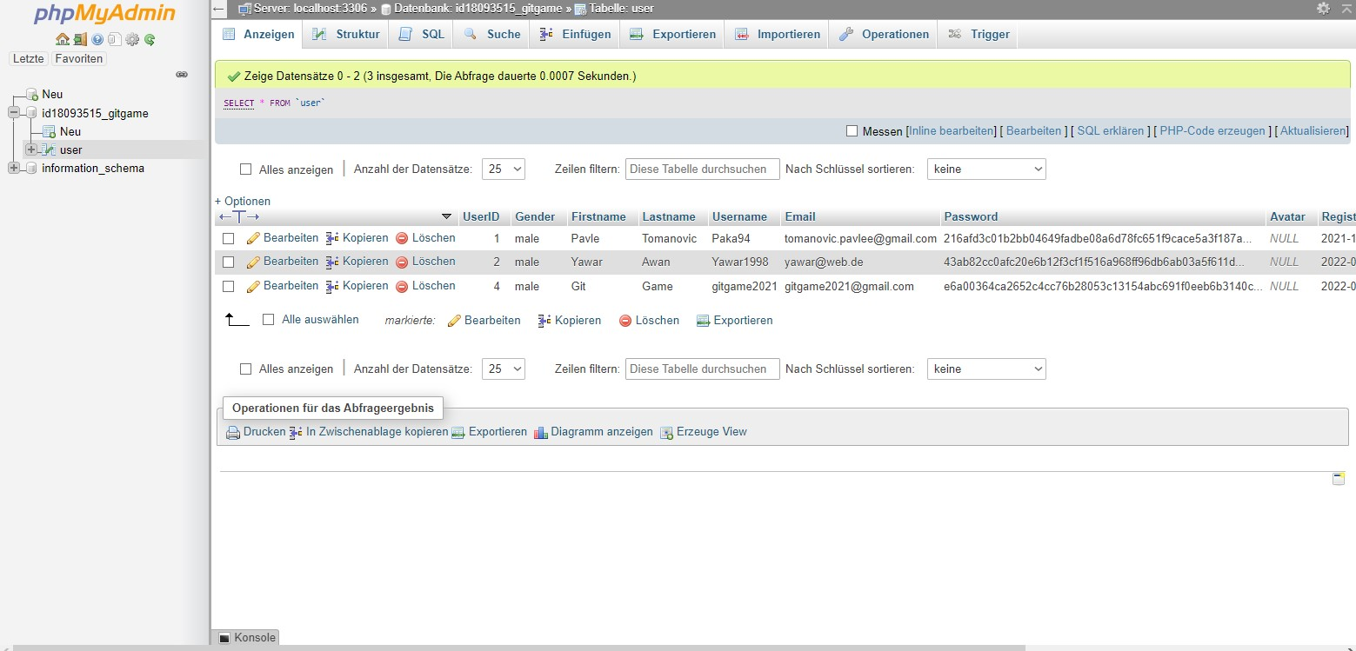

The table from the database can be easily imported to phpMyAdmin.

# Our Project Diary

**Malik Awan**:

We signed up for the Git-Game project because the short description of the project sounded very interesting. We started everything with research, team meetings, prototyping. The initial phase of the project started quite well, we got to know the other team members and created a Discord server and a WhatsApp group for communication.

With the time two members left us because they quit the university and now there were three of us in the team and we had to work even harder to finish the project on time. When the two team members left, we would have to redistribute the tasks and step on the gas again, that we would be finished on time with the whole project.

We had some problems as mentioned above, the biggest problem I had was with GitHub authentication, because we wanted to provide login/registration via GitHub on the website. I spent most of my time researching and trying out a lot of things, then after many hours of research I found out that you can program this via Auth0 and that you can read a lot of "values" from GitHub with the Git API and then output these "values" back to our website. In the end, we didn't get the login/registration via GitHub completely right, because you had to program it with React and we all didn't know React that well and didn't have the necessary time to teach ourselves. But this feature is planned for the next semester.

Another very big problem was that I couldn't manage to create an email server with Localhost via XAMPP for testing purposes. Then I decided to spare myself this and get the email server function from a web hoster as already described in paragraph 4. delivery. Then I used the php mailer function at the beginning there were also a lot of problems, because the email was not sent correctly, but that was also fixed with time. The very cool feature we have I think is the email function and for the next semester planned GitHub authentication function.

Overall, I am very happy with my performance in the project, and I am also happy with the performance of my colleagues. It wasn't always easy, but we all worked very well together and acted as a team.

**Mohammad Farhan Saifee**:

The topic of this project was very interesting and for me it was very exciting to develop an educational website for people who want to learn GIT in a fun way.

Throughout the project we as a team faced some challenges, but personally for me the biggest challenge was to create the Design at the beginning and during the implementation the

Terminal we had to create. It took a lot of time to implement the terminal and all things around it.

There were also some problems during our project because 2 of our members left the university and automatically left the team. This made it harder for all 3 of us because we had to change the roles in our team and had to work more than planned.

I learned quite a few things during the last few months. To implement a terminal wasn’t only a big challenge, it was also a major thing I learned from this project. Besides that, I learned how to manage my time better now than I did in last semester and I feel like I am getting better and better with it.

Because of the COVID 19 situation and lockdowns going on in Austria we couldn’t meet each other in person, but nevertheless we managed everything online through Zoom, or Discord perfectly. Besides that, we exchanged each other’s numbers so we can contact each other if there is any emergency concerning the project.

But all in all we as a team managed to finish our goals for this semester and we can’t wait to get going with this project.

## 5.1 Problems

* Zeiteinteilung
* Communication
* Why Delays

## 5.2 Experiences/Learned Lessons

* Learned something new
* First time building a new terminal
* New knowledge of some git commands