

**Documentation &**

**Project Diary**

Innovation Lab

1/2/3

Year

2022/23

Project:

**Git-Game**

Team:

**Group 01**

# General Information

**Project name:** Git-Game

**Supervisor:** Prof. Lukas Aichbauer

Innovation Lab 123

**Projectteam:**

Tomanovic Pavle, if20b162@technikum-wien.at

Arber Bajraktari, if19b022@technikum-wien.at

Saifee Farhan Mohammad, if20b505@technikum-wien.at

Grassl Lukas, if19b020@technikum-wien.at

Koller Lukas, if20b043@technikum-wien.at

**Management Summary of the Project**

This project will help users to learn more about git functions in an interactive and interesting way. The Github web game is built from low to high level difficulties. Users with zero knowledge of Github functionalities will be able to master them through our web game.

**Framework Conditions and Project Environment**

* **PHP**: Data Handling und Validation
* **JavaScript**/**Typescript**: Interactive Frontend Features
* **HTML**/**CSS**: Base layout of the Frontend and responsiveness
* **SQL**: Database and DB-queries

**Semester-Roadmap**

In the first semester we will start with the backend. We will create a database with all the tables. We will specify all the tables and the ERM diagram in Sprint 2. After that, we will start with registration and login as the first pages to be done. And after that we will plan and develop the game logic (with 1 Challenge ready).

Focus in the second and third semester will be on design and developing sharing functions, so that more people can hear about our game. But this will be discussed in the beginning of the second semester. The Challenges will be more advanced and the whole product will be expanded more and more suitable for the users’ needs.

**Collaboration & Tooling**

Google Sheets (Time Management): [https://docs.google.com/spreadsheets/d/1OMArljF2LpWNn-FKRMXUrwybi12l5OPowxQbWUMZ8U/edit#gid=0](https://docs.google.com/spreadsheets/d/1OMArljF2LpWNn-FKRMXUrwybi12l5OPowxQbWUM-Z8U/edit#gid=0)

Github (Project): <https://github.com/farhansaifee/Git-Game>

Trello (Kanban-Board): <https://trello.com/b/gF0VGzul/git-kanban>

**Remarks:** No other remarks.

# Brief Description of the Project

This project will help users to learn more about git functions in an interactive and interesting way. The Github web game is built from low to high level difficulties. Users with zero knowledge of Github functionalities will be able to master them through our web game.

Our main priority will be to create a game logic using all functions, so users can experience all of them through the game.

The challenges for the whole team could be the bulid-process/implementation of the game logic, as well as connecting frontend with backend. Responsive designs could take a few weeks to build.

Our first main task on this project will be database creation and project creation. We will create the pages in our application. After that we will start planning and developing the game logic.

Our idea is to create Web-Application where the user should register himself. This will be created as a normal registration form. We will also require the password with one big letter and one number.

When the user logs in, he will be able to start the new game or to continue where he left last time.

We will create levels in the game and every new level will be harder than the previous one. Our idea is to have and to develop new levels all the time, so that particularly game never ends. If somebody is really motivated to play and learn and he finish all the levels, he will get the popup message that we are working on the new levels and that he will get the email when we finish them. In meantime, he will be able to start the new game.

Our goal is not to create multiple choice or fill in the blank questions, on which user should answer. Because we want to create more interactive and interesting way of learning more about git.

# Specification of the Solution

First, we created an idea of how we would like to go on with this project. We created requirements, roles for each team member and first prototypes of how the design should look. After we had the foundation we needed, we implemented the features (requirements).

The solution was created as we planned on the beginning.

We completed the registration and login functions. User is now able to register himself, and everything will be stored in database. After registration, user can log himself and enjoy our new gaming platform. After logging in in profile section, user can change some information about his profile. For example, to change his password, username, or email address. Also is possible to change an avatar image.

In our new gaming platform, for now, user can play Challenge 1 and complete tasks to learn how to use git. Challenge should be completed in our designed terminal, which will check all commands user entered. After entered command, user would get the message if he entered the command is right or not. If user is not sure how to complete the task it is possible to enter “1” for the hint.

Also, in the challenge section will be presented how much tasks user have done and how much is left to be done. Also, if user is not sure about his knowledge and want to complete the challenge one more time, there is a button for that.

Our first goal in the next semester is to implement the highscore page, so the users can compete against each other.

Second goal is to design and create some new challenges.

Third goal is to enable the git users to register themselves using their git account.

## 3.1 Prototypes/Mock-Ups

There is a prototype and mock-up for every task of the first challenge:

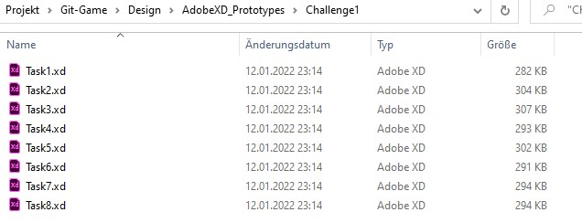

All prototypes and mock-ups look like each other, with just a difference of their font. That is why I am not going to put every file in here.

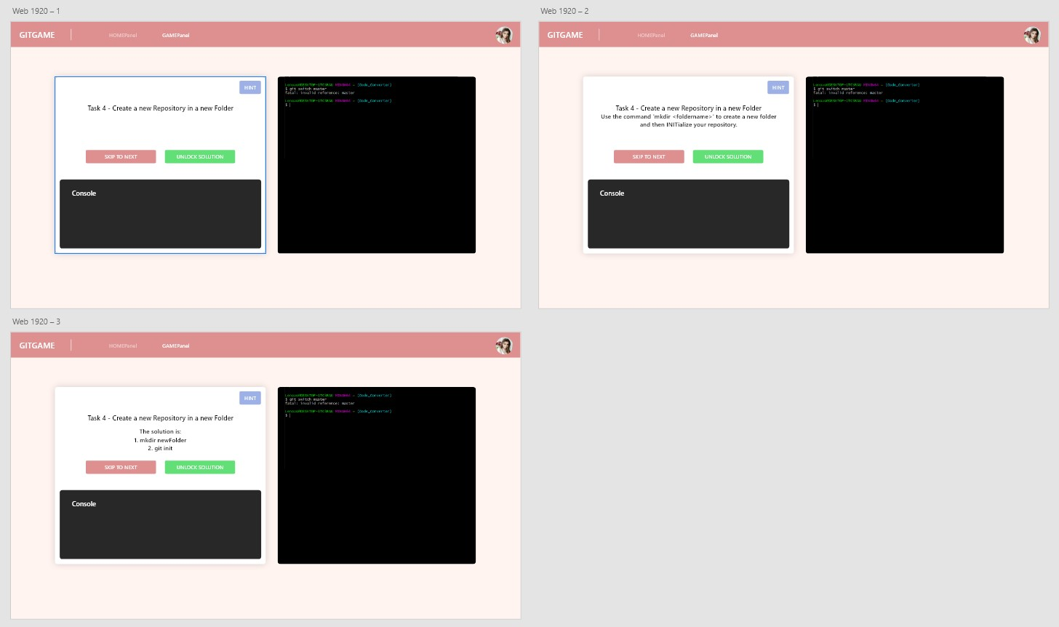

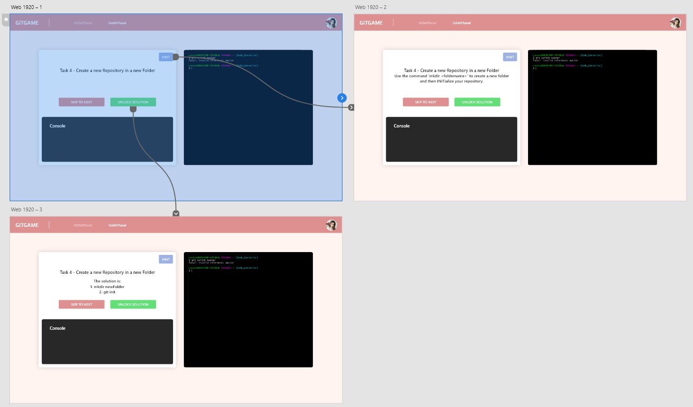

## Requirements

We have set 5 must-haves (requirements/functionalities) for this semester:

* User should be able to create an account (Register)
* User should be able to login (if the account is already created)
* User can do tasks in the section “Challenge 01”
* User can edit his user data (for example change the avatar, username, etc.)
* User can reset his or her password

In the 2nd semester our main focus will be the design. Currently our design looks basic and there is definitely need for improvement. Furthermore, we will try to add more tasks in a challenge and a wiki-like website, where users can learn in advance about git or if they forgot some commands, they can look them up afterwards.

This is what our website looks like today:

Ein Bild, das Text enthält.

A nice-to-have function we are currently planning is to add a certificate function, where users get a certificate after completing this “course” about git.

## Challenges

The core functionality of this Project would be the challenges. After the user logs in, he should be able to perform the Challenges in his disposal and navigate between them.

Ein Bild, das Text enthält.

As seen in the picture above, the user has in his disposal all the Challenges that this course offers, but he can only access the one that he is currently at (Challenge 1 for this instance), or repeat the ones that he has already finished. That is why, the Challenges that come after the one he currently is at, are all grayed out and not clickable.

When you click on the current Challenge (Challenge 1), the terminal will open. Here the user will be able to answer the questions prepared from our Team (as seen in the picture below). He can also click on 1, but this would cause him to lose points from this Challenge. The hint though, would help him in answering the question if he was not too sure.

Something else you can notice here is the progress bar, which shows you how far with the Challenge you are. This will be explained more vividly in another section of the document.

Ein Bild, das Text enthält.

For every answer of the Challenge you get right, you get points for it and you are told how many tasks you did. But this is only for the current Challenge the user is on. If the user goes back to one of the Challenges he already finished, the progress bar will not be showing. This is because all the Tasks for this Challenge have already been finished.

However, if the user is not satisfied with himself for a Challenge, he can click on “Start Over“ button before going to the next Challenge, and he will start over this Challenge from the beginning.

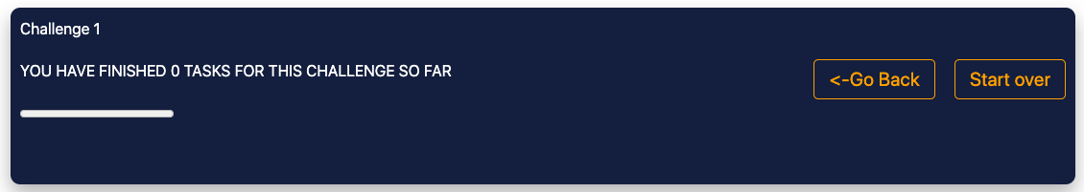

## Reset Password & Wiki-Page

My goal this semester was to finish the Forgot password function, which we started to implement in the last semester. I created a Forgot password button on the login page and when user clicks on it, the new page is loaded on which user needs to insert his email address used when creating account.

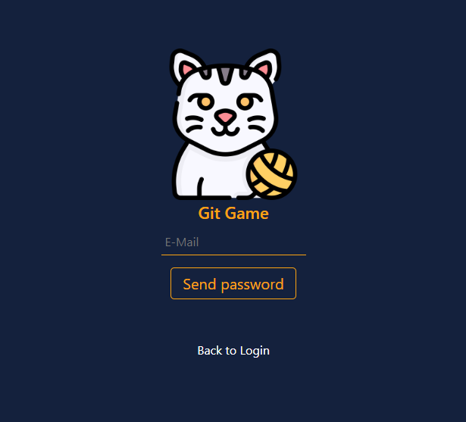

After inserting his email address, user will get an email from git-game mail address and he will get the token in mail body. Using this token, user will generate new password, which will be hashed and saved in the database. After data, user will be automatically loged in, and next time, when he wants to log himself, he will use the new password.

Second goal for this semester was to implement the wiki page. That will provide more information about the git functions and it will help user to solve the tasks.

The idea was that the wiki page should be always easily accessible. That is why I implemented it as a search bar on the top of every page in the app.

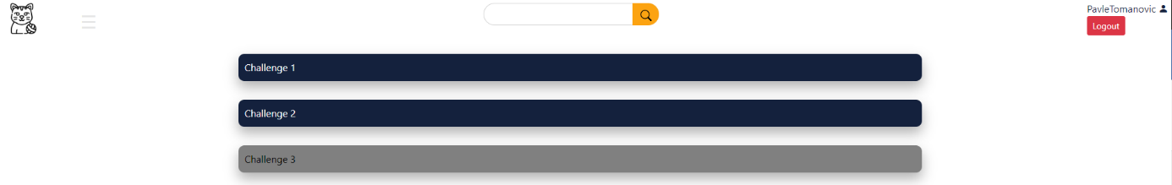

The search bar has a functionality as a full text search bar. So, if user is not completely sure, how the function is called, he can probably type just few letters and he will get all the results associated to these letters. Finally, if user wants to see all the information on the wiki page he can just click the search button without any text inserted.

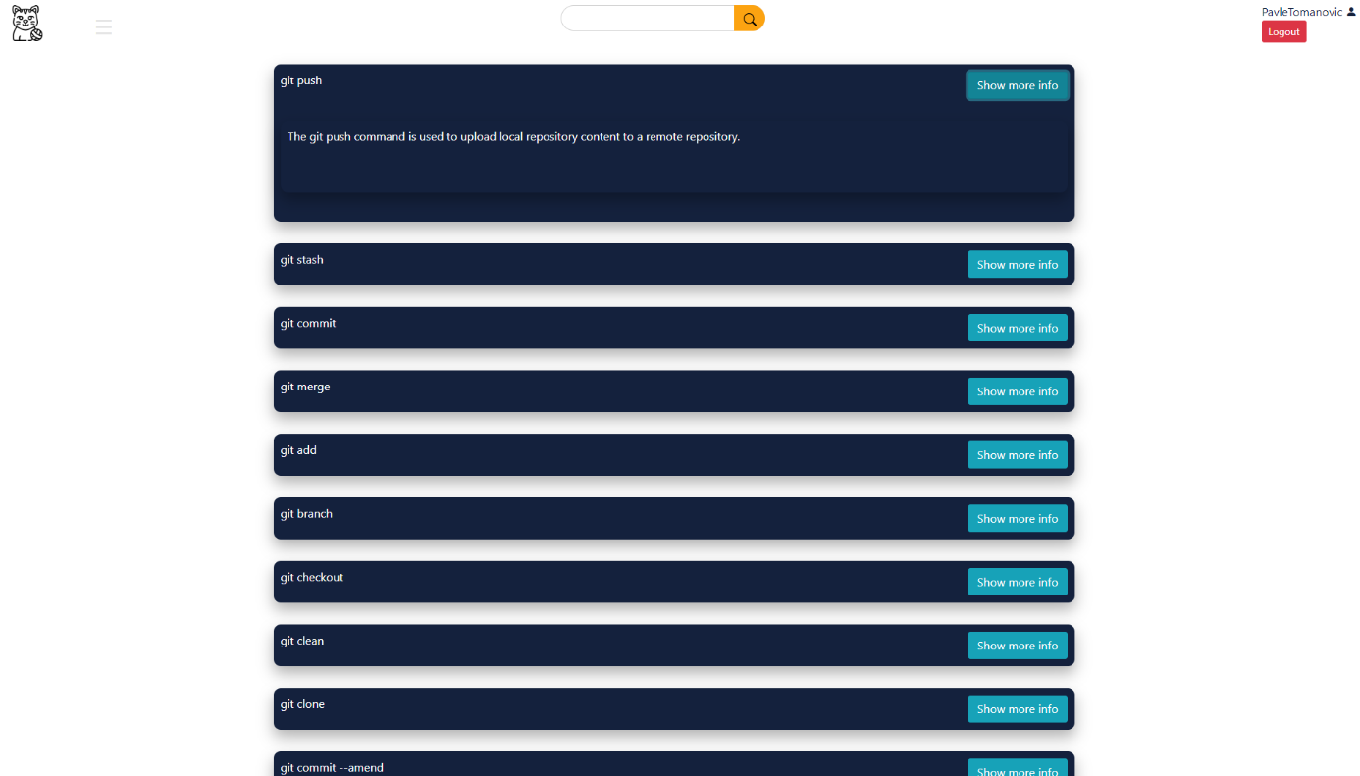

All the functions are inserted in the boxes as on the main page with the show more info button on the right side. If the button is clicked, the box will be expended and the additional info will be shown.

For now, the wiki page is working as two-dimensional array with hardcoded text inside of those. Maybe, the goal for the next semester will be to optimize it and save all the functions and descriptions in the database, so it will be easier to expand the list.

## Progress & Highscore

Another task for this semester was to implement a scoring system. The idea was to implement a maximum score for each task, each time you need a hint some points get removed and after you put in the correct answer the points get sent to the database and added to the old ones. After the first coding attempt, we realised that we couldn’t test for some reason and needed help. This took a bit longer to resolve since the overlapping free time between the team members was little. But after a bit of time, we fixed the problem, and we could test and debug the code.

For my second task, we had to implement a progress bar one of our team members decided to do create a progress bar which shows how many tasks a user for a given challenge have been completed. We put the progress bar under the text which shows at which task you are because it felt like those to things showed progress in one way or another.

Ein Bild, das Text enthält.

# Delivery

So, what do you need to run our project on your laptop or computer?

## 4.1 Localhost

Our customers and other developers, first, need to download SQL_File.zip and Git-Game.zip from our repository on github ([https://github.com/farhansaifee/Git-Game)](https://github.com/farhansaifee/Git-Game).

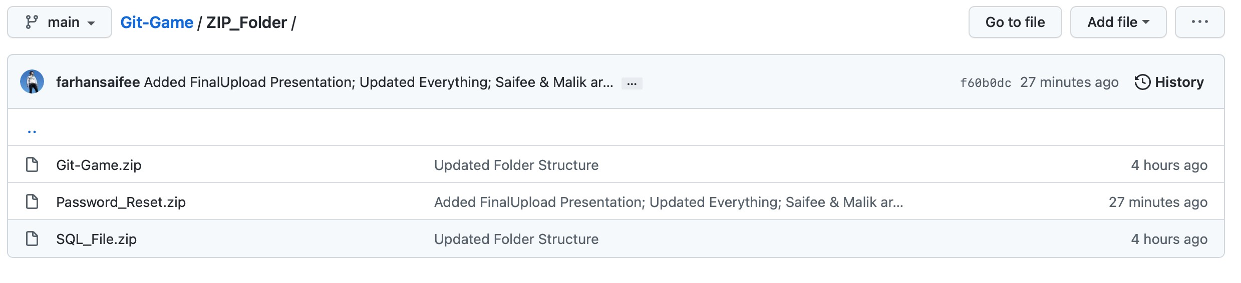

After that, they need to import our database (SQL_File.zip) in their phpMyAdmin. There is import option in the menu on the right.

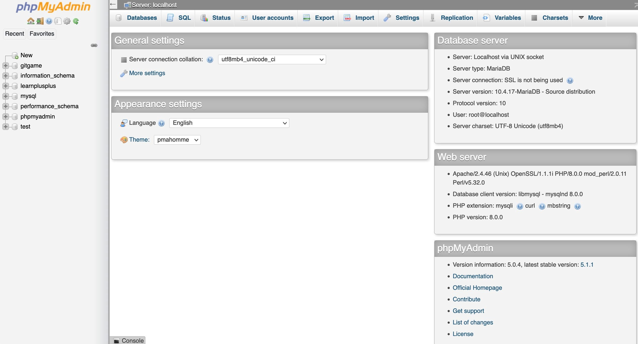

Next step is to start the xampp application after that extract the Git-Game.zip and copy the folder in xampp/htdocs folder.

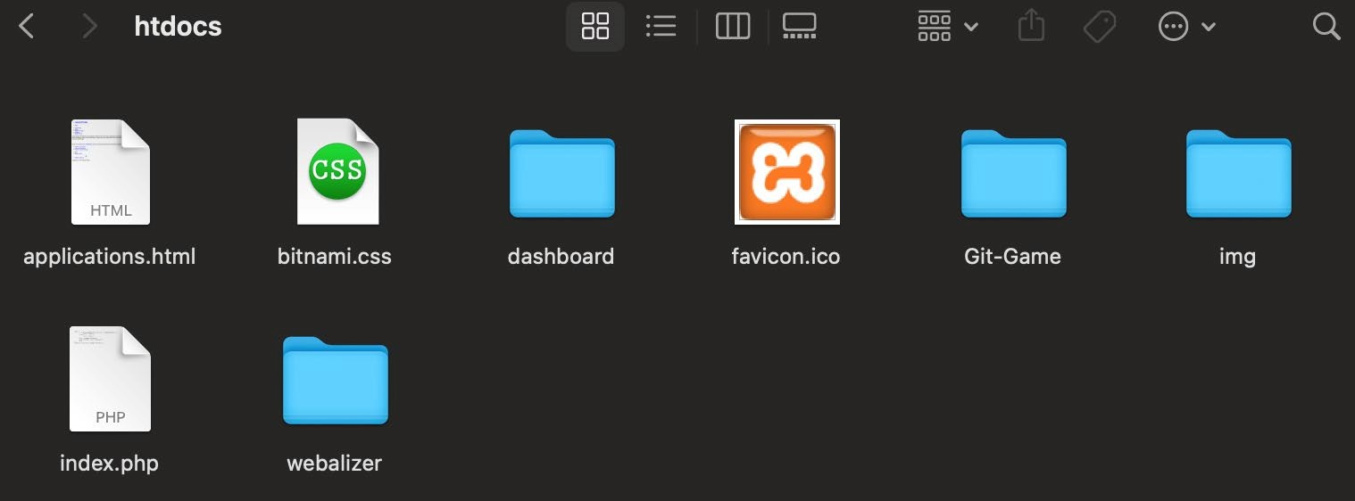

Final step is to start our application in browser using *localhost:8080/Git-Game.*

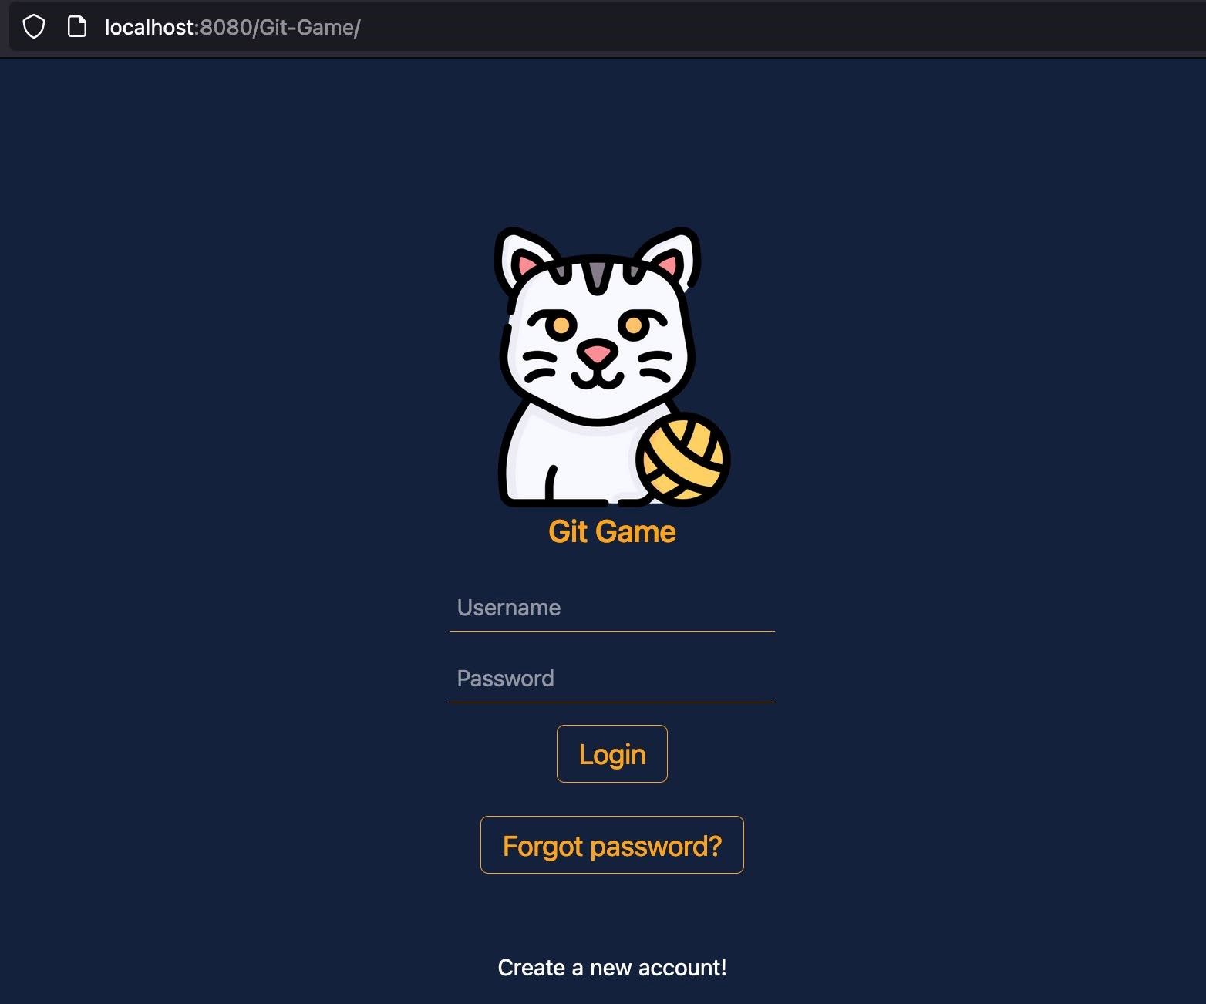

# Effort Estimation

This is how our current effort estimation looks like:

Ein Bild, das Tisch enthält.

We created this effort estimation during the 2nd semester, and it has really everything one needs to know. Hence why we will keep on using this format in this semester.

# Our Project Diary

**Lukas Koller**:

After changing from dual to vollzeit I had to pick an Innovation Lab Team to join and I thought that a Git based Game sounds like fun and that I could learn something about Git along the way too. Since Innovation Lab was never in presence we mostly communicated via our discord or if we need something from Mr Aichbauer via mail. At the start of the semester, I had to get familiar with the already existing code. I also had to reintroduce myself to PHP and JavaScript again (which took longer than expected). After that I started my first and only task and had Problems testing. This took a bit longer to resolve since the overlapping free time between the team members was little. But after a bit of time we fixed the problem and I could test and debug my code. Through that I learned that you sometimes have to take extra time to look out if others need help, so they can finish their part of the work.

**Arber Bajraktari**:

This task changed with time, so I will walk through it. First of all, this is the first Semester I was part of this project, so it took me some time to understand how this project was created and worked.

Then the first task was assigned. It was to add a challenge to the game. My colleague Lukas, had the same task as I did because he also joined the project this semester. We decided to do this together since these Challenges will be used together and we needed to be coordinated.

After the creation of the Challenges it was time to implement them into the code. This is where the tricky part was. The JS file was created and worked fine for 1 Challenge. It took the data from the DB and it validated them with what the user entered. But, when I tried to insert the second Challenge, I noticed that this script was prepared for 1 Challenge only. It was good, not completely hard-coded but also not automated.

That’s why I took the task of automating this script so that we wouldn’t need to add each Challenge manually. After the automation of the script, all you need to do in order to add a Challenge, is to simply add it on the DB, and then it will be created and also validated on the Website without any extra effort.

It was fun reading the code of another colleague and then trying to understand it and amend it. It was different than changing your code, and I think it is a necessary experience to have, especially in IT.

**Lukas Grassl**:

I only joined the project group this semester, so I needed the first part of the semester to get comfortable with the website and how everything worked together. There were some problems on my end with the set up of the database, which took me some time to fix. Only after I got everything running on my machine I could start doing new features for the website.

One of the tasks I was responsible for was to create new challenges. The group had already created one set of tasks in the last semester, covering the absolute basics of Git. I tried to expand these by adding tasks about branching and some other features. The focus was on making them solvable, but not too easy as well.

Eventually, the website is supposed to be hosted on the FHTW web servers, so we had to ask the IT support for web space with PHP and a MySQL database on it. Once I received an answer, I tried to transfer the whole project to run there. After that, one could view the login page of our website, but the connection to the database could not be established. I tried to update our code to be adapted to the new hosting platform but I could not get it to work just now.

It was good to get my PHP and JavaScript skills refreshed because since it was covered at the FH, I did not really use it a lot.

## 5.1 Problems

* Zeiteinteilung
* Communication
* Why Delays

## 5.2 Experiences/Learned Lessons

* Learned something new
* First time building a new terminal
* New knowledge of some git commands