

**Documentation &**

**Project Diary**

Innovation Lab

1/2/3

Year

2022/23

Project:

**Git-Game**

Team:

**Group 01**

# General Information

**Project name:** Git-Game

**Supervisor:** Prof. Lukas Aichbauer

Innovation Lab 123

**Projectteam:**

Tomanovic Pavle, if20b162@technikum-wien.at

Arber Bajraktari, if19b022@technikum-wien.at

Saifee Farhan Mohammad, if20b505@technikum-wien.at

Grassl Lukas, if19b020@technikum-wien.at

**Management Summary of the Project**

This project will help users to learn more about git functions in an interactive and interesting way. The Github web game is built from low to high level difficulties. Users with zero knowledge of Github functionalities will be able to master them through our web game.

**Framework Conditions and Project Environment**

* **PHP**: Data Handling und Validation
* **JavaScript**/**Typescript**: Interactive Frontend Features
* **HTML**/**CSS**: Base layout of the Frontend and responsiveness
* **SQL**: Database and DB-queries

**Semester-Roadmap**

In the first semester we will start with the backend. We will create a database with all the tables. We will specify all the tables and the ERM diagram in Sprint 2. After that, we will start with registration and login as the first pages to be done. And after that we will plan and develop the game logic (with 1 Challenge ready).

Focus in the second and third semester will be on design and developing sharing functions, so that more people can hear about our game. But this will be discussed in the beginning of the second semester. The Challenges will be more advanced and the whole product will be expanded more and more suitable for the users’ needs.In the 3rd semester of this project the focus will be on bringing the project on a webspace and LDAP.

**Collaboration & Tooling**

Google Sheets (Time Management): [https://docs.google.com/spreadsheets/d/1OMArljF2LpWNn-FKRMXUrwybi12l5OPowxQbWUMZ8U/edit#gid=0](https://docs.google.com/spreadsheets/d/1OMArljF2LpWNn-FKRMXUrwybi12l5OPowxQbWUM-Z8U/edit#gid=0)

Github (Project): <https://github.com/farhansaifee/Git-Game>

Trello (Kanban-Board): <https://trello.com/b/gF0VGzul/git-kanban>

# Brief Description of the Project

This project will help users to learn more about git functions in an interactive and interesting way. The Github web game is built from low to high level difficulties. Users with zero knowledge of Github functionalities will be able to master them through our web game.

Our main priority will be to create a game logic using all functions, so users can experience all of them through the game.

The challenges for the whole team could be the bulid-process/implementation of the game logic, as well as connecting frontend with backend. Responsive designs could take a few weeks to build.

Our first main task on this project will be database creation and project creation. We will create the pages in our application. After that we will start planning and developing the game logic.

Our idea is to create Web-Application where the user should register himself. This will be created as a normal registration form. We will also require the password with one big letter and one number.

When the user logs in, he will be able to start the new game or to continue where he left last time.

We will create levels in the game and every new level will be harder than the previous one. Our idea is to have and to develop new levels all the time, so that particularly game never ends. If somebody is really motivated to play and learn and he finish all the levels, he will get the popup message that we are working on the new levels and that he will get the email when we finish them. In meantime, he will be able to start the new game.

Our goal is not to create multiple choice or fill in the blank questions, on which user should answer. Because we want to create more interactive and interesting way of learning more about git.

# Specification of the Solution

First, we created an idea of how we would like to go on with this project. We created requirements, roles for each team member and first prototypes of how the design should look. After we had the foundation we needed, we implemented the features (requirements).

The solution was created as we planned on the beginning.

We completed the registration and login functions. User is now able to register himself, and everything will be stored in database. After registration, user can log himself and enjoy our new gaming platform. After logging in in profile section, user can change some information about his profile. For example, to change his password, username, or email address. Also is possible to change an avatar image.

In our new gaming platform, for now, user can play Challenge 1 and complete tasks to learn how to use git. Challenge should be completed in our designed terminal, which will check all commands user entered. After entered command, user would get the message if he entered the command is right or not. If user is not sure how to complete the task it is possible to enter “1” for the hint.

Also, in the challenge section will be presented how much tasks user have done and how much is left to be done. Also, if user is not sure about his knowledge and want to complete the challenge one more time, there is a button for that.

In the past semester we implemented the highscore page, improved the design and

Our goals for this semester is to

## 3.1 Prototypes/Mock-Ups

There is a prototype and mock-up for every task of the first challenge:

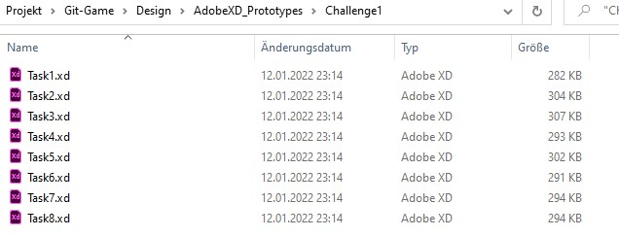

All prototypes and mock-ups look like each other, with just a difference of their font. That is why I am not going to put every file in here.

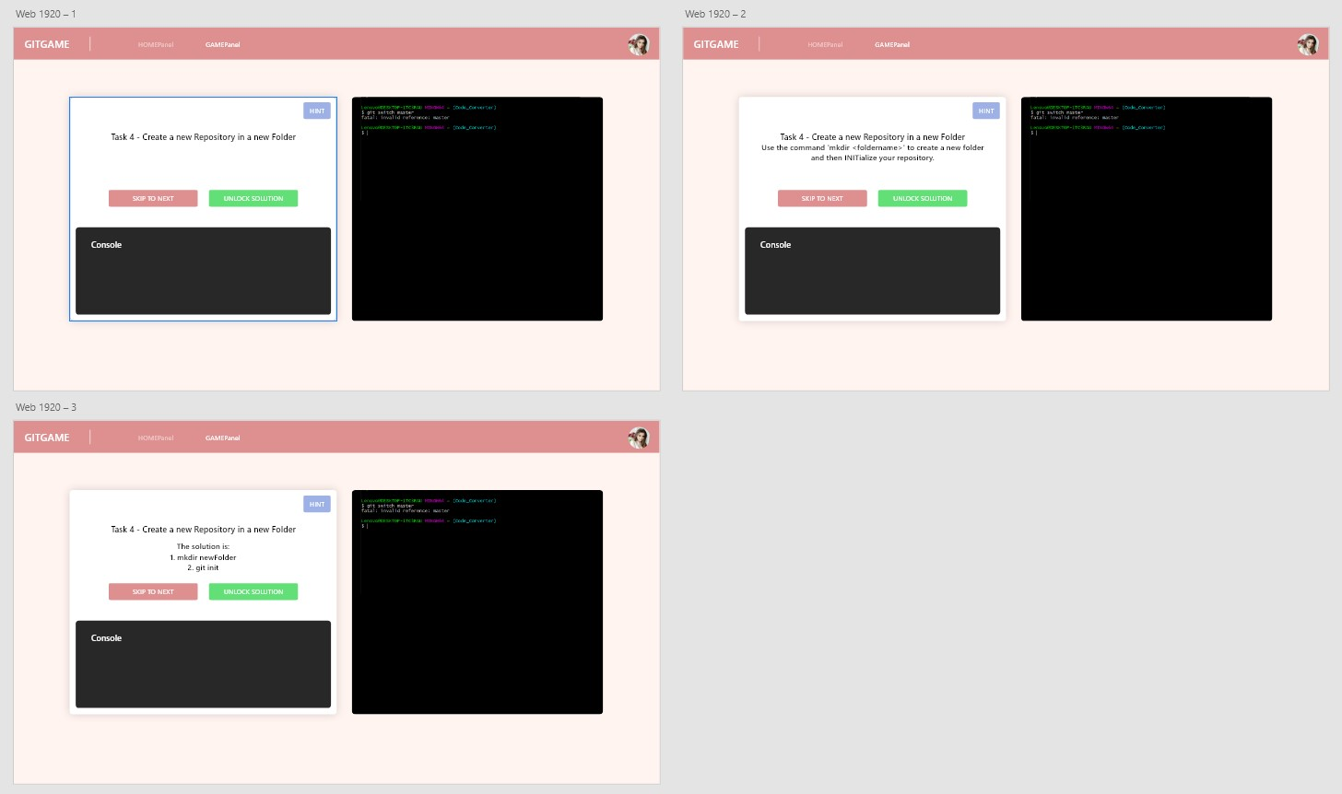

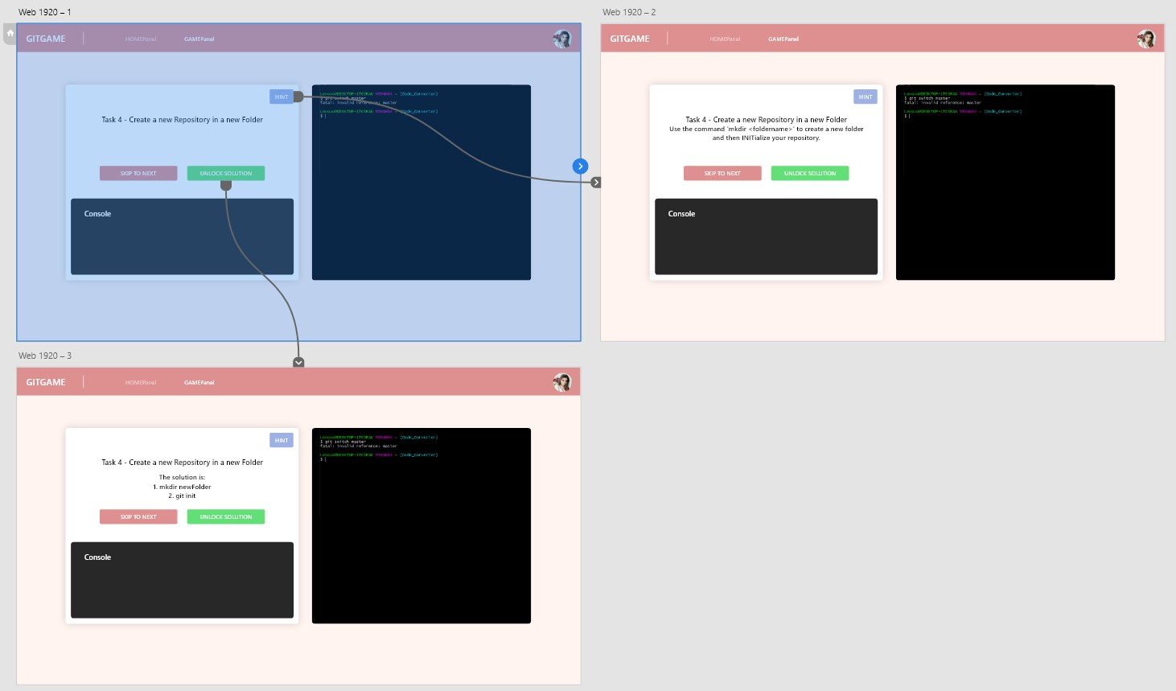

## Requirements

We have set 3 must-haves (requirements/functionalities) for this semester:

* User should be able to create an account (Register)
* The project should run on a webspace
* One more challenge should be added to the game

In this semester we will try to implement these features. Currently our design looks basic and there is definitely need for improvement. Furthermore, we will try to add more tasks in a challenge and a wiki-like website, where users can learn in advance about git or if they forgot some commands, they can look them up afterwards.

This is what our website looks like today:

Ein Bild, das Text enthält.

## **Challenges**

The core functionality of this Project would be the challenges. After the user logs in, he should be able to perform the Challenges in his disposal and navigate between them.

Ein Bild, das Text enthält.

As seen in the picture above, the user has in his disposal all the Challenges that this course offers, but he can only access the one that he is currently at (Challenge 1 for this instance), or repeat the ones that he has already finished. That is why, the Challenges that come after the one he currently is at, are all grayed out and not clickable.

When you click on the current Challenge (Challenge 1), the terminal will open. Here the user will be able to answer the questions prepared from our Team (as seen in the picture below). He can also click on 1, but this would cause him to lose points from this Challenge. The hint though, would help him in answering the question if he was not too sure.

Something else you can notice here is the progress bar, which shows you how far with the Challenge you are. This will be explained more vividly in another section of the document.

Ein Bild, das Text enthält.

For every answer of the Challenge you get right, you get points for it and you are told how many tasks you did. But this is only for the current Challenge the user is on. If the user goes back to one of the Challenges he already finished, the progress bar will not be showing. This is because all the Tasks for this Challenge have already been finished.

However, if the user is not satisfied with himself for a Challenge, he can click on “Start Over“ button before going to the next Challenge, and he will start over this Challenge from the beginning.

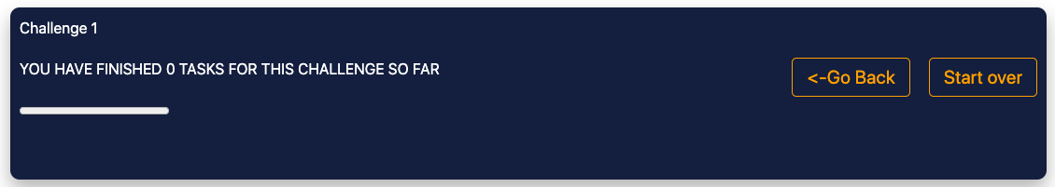

## Reset Password & Wiki-Page

My goal this semester was to finish the Forgot password function, which we started to implement in the last semester. I created a Forgot password button on the login page and when user clicks on it, the new page is loaded on which user needs to insert his email address used when creating account.

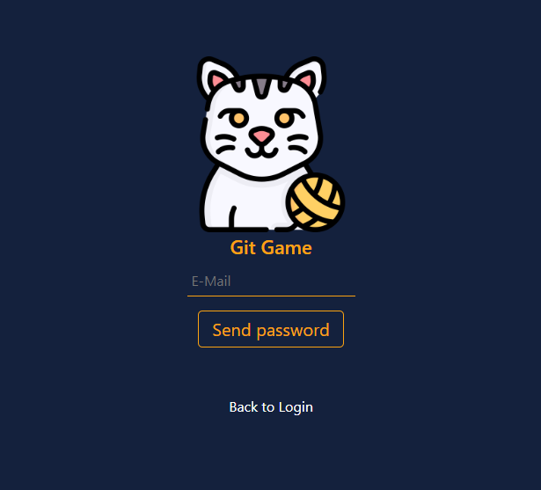

After inserting his email address, user will get an email from git-game mail address and he will get the token in mail body. Using this token, user will generate new password, which will be hashed and saved in the database. After data, user will be automatically loged in, and next time, when he wants to log himself, he will use the new password.

Second goal for this semester was to implement the wiki page. That will provide more information about the git functions and it will help user to solve the tasks.

The idea was that the wiki page should be always easily accessible. That is why I implemented it as a search bar on the top of every page in the app.

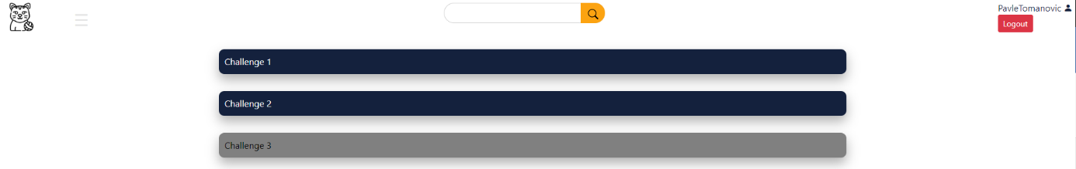

The search bar has a functionality as a full text search bar. So, if user is not completely sure, how the function is called, he can probably type just few letters and he will get all the results associated to these letters. Finally, if user wants to see all the information on the wiki page, he can just click the search button without any text inserted.

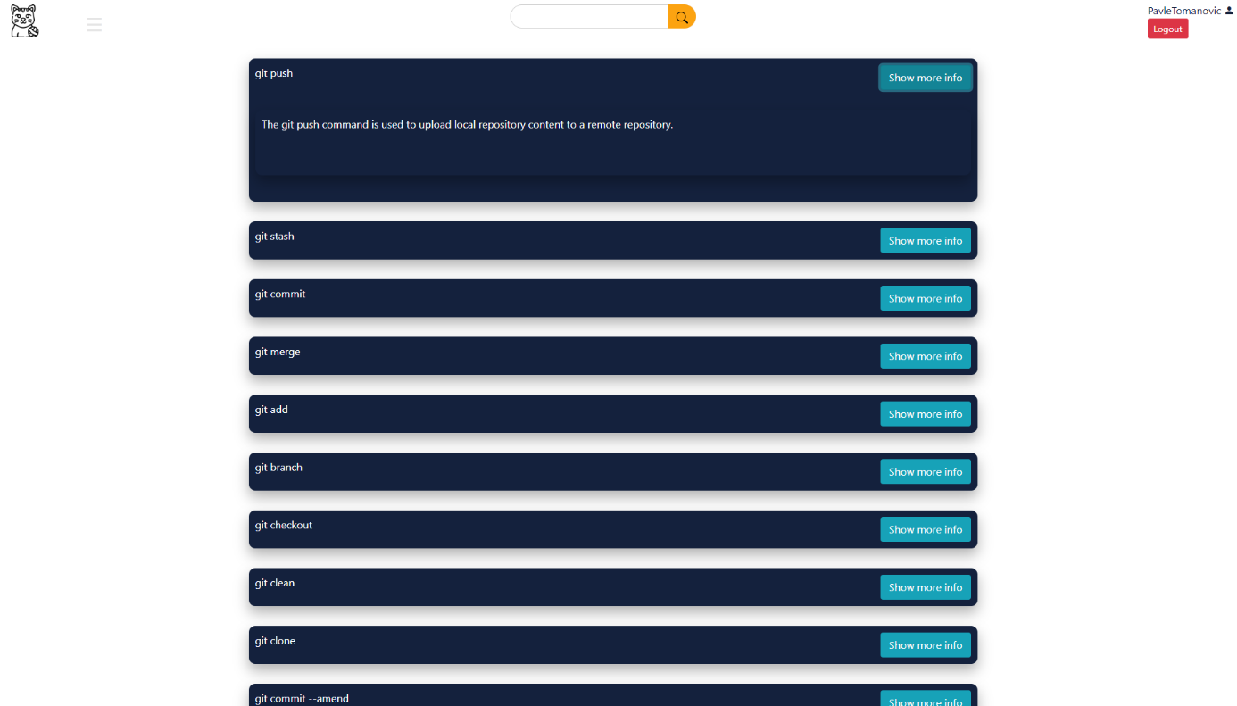

All the functions are inserted in the boxes as on the main page with the show more info button on the right side. If the button is clicked, the box will be expended and the additional info will be shown.

For now, the wiki page is working as two-dimensional array with hardcoded text inside of those. Maybe, the goal for the next semester will be to optimize it and save all the functions and descriptions in the database, so it will be easier to expand the list.

## Progress

Another task for this semester was to implement a scoring system. The idea was to implement a maximum score for each task, each time you need a hint some points get removed and after you put in the correct answer the points get sent to the database and added to the old ones. After the first coding attempt, we realised that we couldn’t test for some reason and needed help.

This took a bit longer to resolve since the overlapping free time between the team members was little. But after a bit of time, we fixed the problem, and we could test and debug the code.

For my second task, we had to implement a progress bar one of our team members decided to do create a progress bar which shows how many tasks a user for a given challenge have been completed. We put the progress bar under the text which shows at which task you are because it felt like those to things showed progress in one way or another.

Ein Bild, das Text enthält.

## High score & Personal score

For the High score page was one new function implemented. This function reads from the new database column the score for every user in the database. This score of all users is presented on the High score page sorted from the highest to the lowest score. For each user, a username and score (points) are shown.

Ein Bild, das Text enthält.

For the Personal Score page, we created one new function which will read the user score from the database and show the user score (number of points) with all other user information on the Profile page.

Ein Bild, das Text enthält.

## LDAP & Webspace

LDAP (Lightweight Directory Access Protocol) is a protocol for accessing and maintaining distributed directory information services over an Internet Protocol (IP) network. It is used to store and manage data, such as user authentication and authorization information, in a centralized directory server.

These are the steps we followed to implement the LDAP protocol:

1. Install and configure an LDAP server (such as OpenLDAP or Microsoft Active Directory).
2. Create a directory structure to store user information in the LDAP server.
3. Connect the website to the LDAP server using an LDAP client library (such as PHP-LDAP for PHP-based websites).
4. Implement user authentication by searching for user credentials in the LDAP directory and verifying them against the provided password.
5. Implement user authorization by retrieving user roles or permissions from the LDAP directory and using them to determine what actions the user is allowed to perform on the website.
6. Test and refine the LDAP implementation, paying attention to security, performance, and scalability considerations.

Web space is a storage area on a web server that is used to host a website. It is the physical location where all the files and data associated with a website are stored and served to the users who access the website.

These are the steps we followed to implement the webspace:

1. Choose a web hosting provider: Select a web hosting provider that offers the necessary resources and features to host your website.
2. Purchase web space: Buy the required amount of web space from your chosen hosting provider.
3. Set up a domain name: Register a domain name for your website and configure it to point to your web space.
4. Upload website files: Upload the HTML, CSS, JavaScript, and other files that make up your website to your web space.
5. Install a web server software: If your web hosting provider does not provide a web server software, install one, such as Apache or Nginx, on your web space.
6. Configure the web server software: Set up the web server software to serve your website files, configure security, and define URL redirects.
7. Test the website: Access your website using the domain name and ensure that it is properly functioning.
8. Maintain the website: Keep the web space, web server software, and website files updated and secure.

# Delivery

So, what do you need to run our project on your laptop or computer?

## 4.1 Localhost

Our customers and other developers, first, need to download SQL_File.zip and Git-Game.zip from our repository on github ([https://github.com/farhansaifee/Git-Game)](https://github.com/farhansaifee/Git-Game).

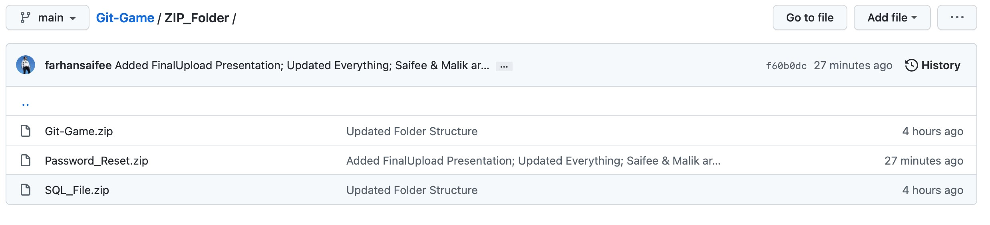

After that, they need to import our database (SQL_File.zip) in their phpMyAdmin. There is import option in the menu on the right.

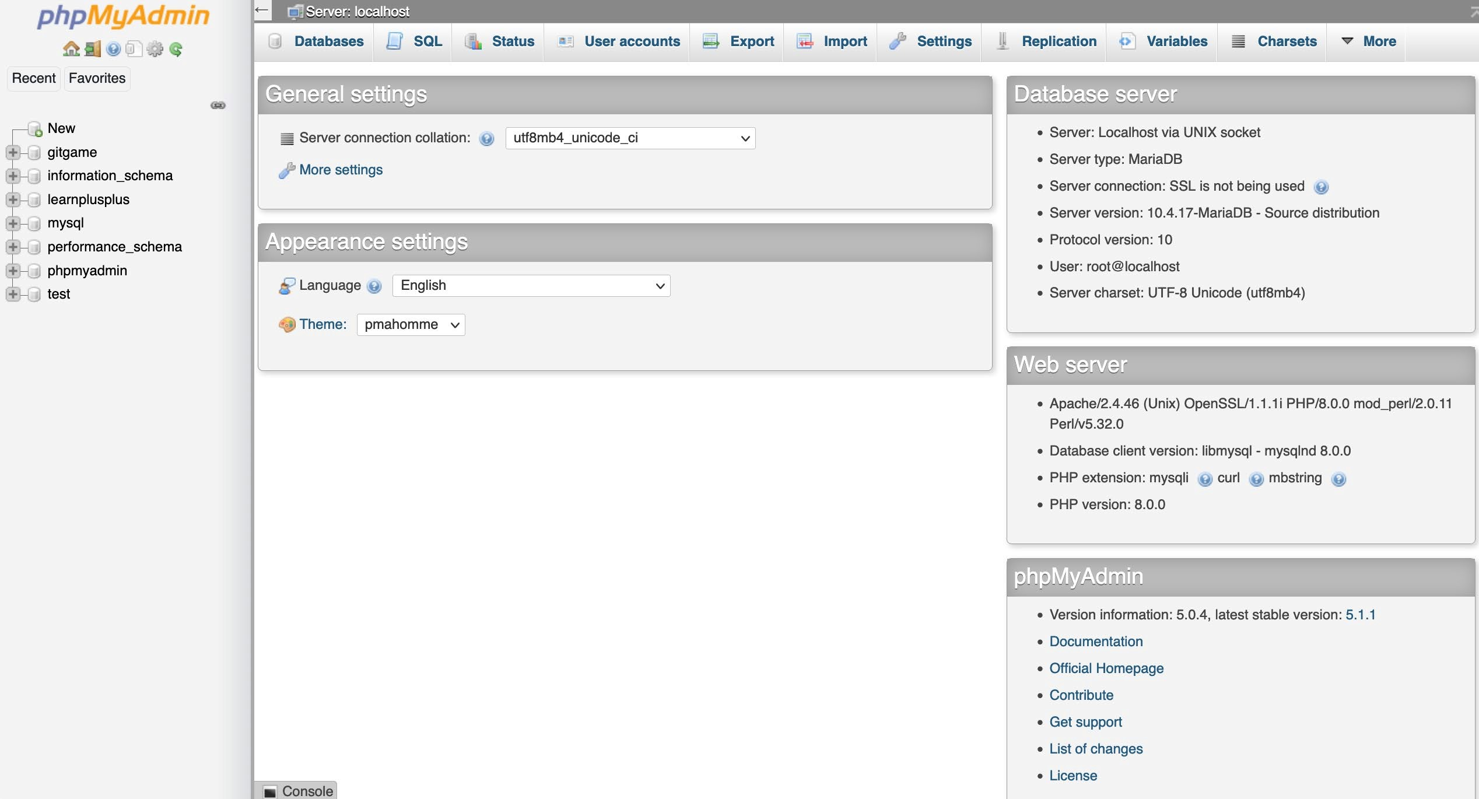

Next step is to start the xampp application after that extract the Git-Game.zip and copy the folder in xampp/htdocs folder.

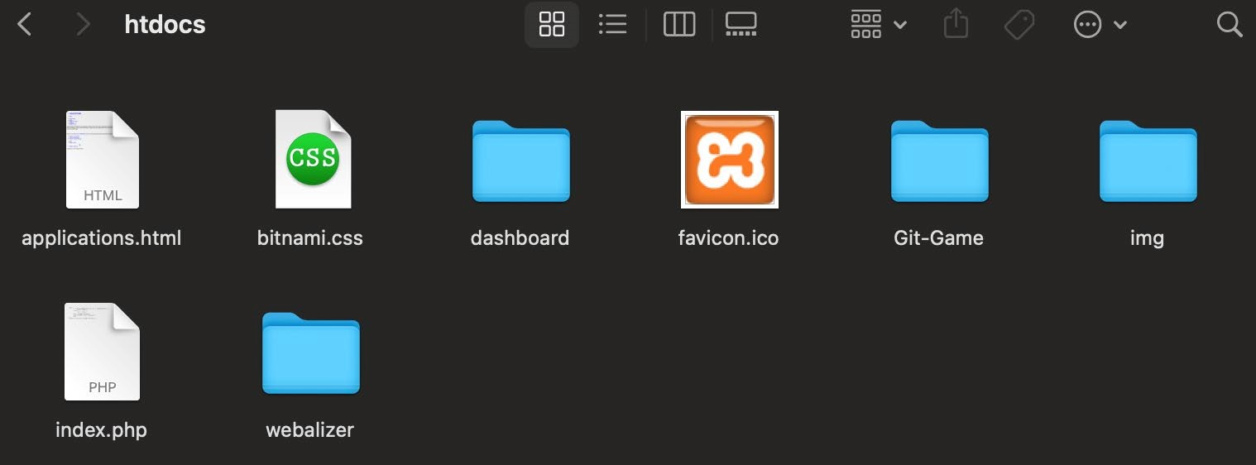

Final step is to start our application in browser using *localhost:8080/Git-Game.*

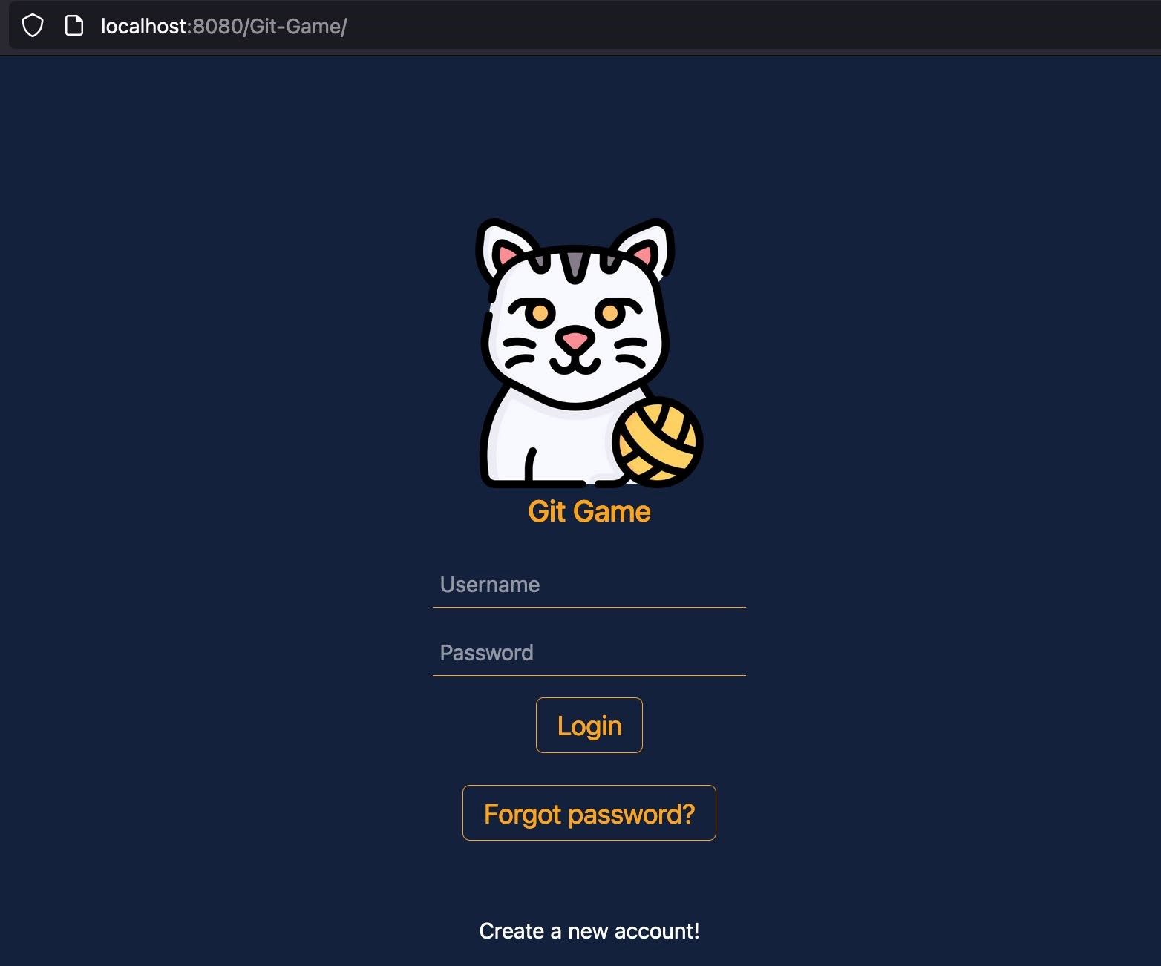

# Effort Estimation

This is how our current effort estimation looks like:

Ein Bild, das Tisch enthält.

We created this effort estimation during the 2nd semester, and it has really everything one needs to know. Hence why we will keep on using this format in this semester.

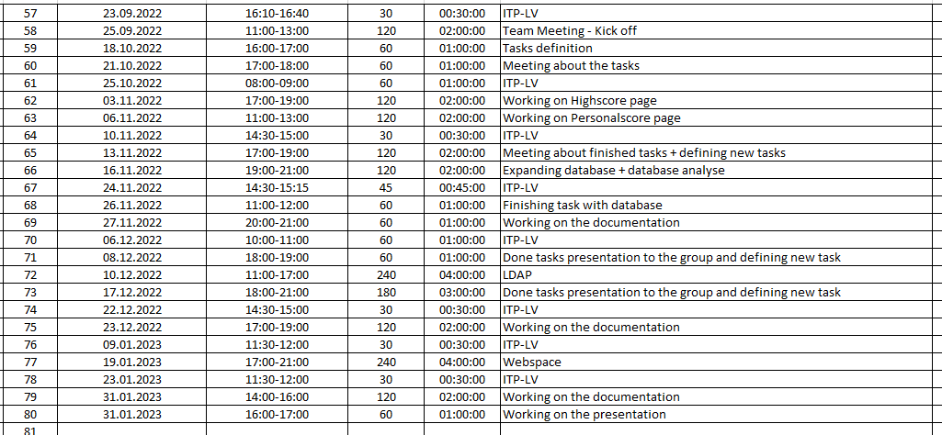

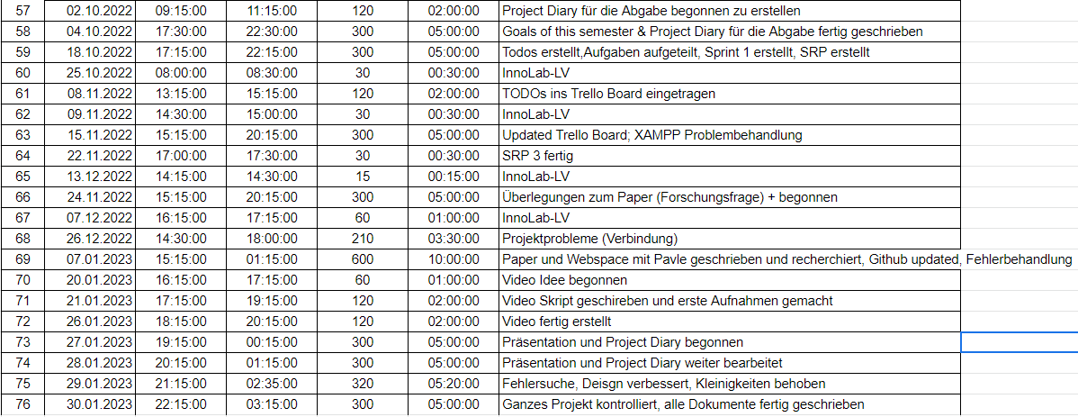

The second and third picture is the effort estimation of Tomanovic and Saifee, which is used to show the structure of how we carried on the time estimation. We created these at the beginning of the 1st semester of this project and kept it also during the 2rd and 3th semester.