Final Year Project Proposal

E-Construction

Farhan Ahmed Sheikh(11378)
Muhammad Yaseen Nayyer(12183)
Anas Shahid(11414)
Mirza Jahangir Baig (14788)

Superviser
Dr.Noman Islam

List of Abbreviations and Acronyms

PHP: Hypertext Preprocessor

SQL: Structured Query Language

XAMPP: Cross-Platform (X), Apache (A), MySql (M), PHP (P) and Perl (P)

AJAX: Asynchronous JavaScript and XML
Table of Contents

Description Page #

Section – 1 1
1.1 Project Identification 1
Section – 2 5
2.1 Background 5
2.2 Outcomes and Benefits 6
2.3 Objectives 6
2.4 Research Approach 7
2.5 Risk Analysis 8
Section – 3 9
3.1 Resources & Other Requirements 9
Annexure–A: Project Schedule / Milestone Chart 11
Annexure–B: Proposed Budget 12
Annexure–C: Business Canvas Model 13
Bibliography 14

Final Year Project Proposal

Section – 1

1.1 Project Identification
Project Title:
E-Construction

Group Leader (GL):
1. | Name: | Farhan Ahmed Sheikh
 | Reg #: | 11378
 | CGPA: | 2.75
 | Mobile # : | 03472840156 | Email: |  | scheikhfarhan@gmail.com
 | Signature:
Group Members (GM’s):
2. | Name: | Muhammad Yaseen Nayyer
 | Reg #: | 12183
 | CGPA: | 2.56
 | Mobile # : | 03232624343 |  | Email: |  | Yaseen.nayyer@hotmail.com
 | Signature:
3. | Name: | Anas Shahid
 | Reg #: | 11414
 | CGPA: | 2.63
 | Mobile # : | 03343348028 |  | Email: |  | anasshahidsiddiqui@gmail.com
 | Signature:

4. | Name: | Mirza Jahangir Baig
 | Reg #: | 14788
 | CGPA: | 2.7
 | Mobile # : | 03168656703 | Email: | khanjahangir532@gmail.com
 | Signature:

What technology is core to your product?
[ ] 3D/4D Printing |  | [ ] Augmented Reality / Virtual Reality
[ ] Big Data, Artificial Intelligence |  | [ ] Blockchain
[ ] Cloud |  | [ ] Neurotech
[ ] Robotics |  | [ ] Shared economy
[ ] The Internet of Things |  | [ ] Wearables, Implantables
[☑] Others (specify): | Web application

What is the target market(s) for the products?
[ ] Automotive, aviation, marine |  | [ ] Business, marketing, finance
[ ] Defence, security, safety |  | [ ] Education and training
[ ] Environment, water management |  | [ ] Entertainment, tourism, sport/recreation
[ ] Food, livestock, agribusiness |  | [ ] Healthcare
[☑] Infrastructure, housing & transport |  | [ ] Mining equipment technology & services
[ ] Oil, gas, energy |  | [ ] Textiles, clothing, footwear
[ ] Others (specify):

Other Organizations Involved in the Project:
Academic Organizations:
# | Organization Name |  |  | Role / Contribution
 | Iqra University
Industrial Organizations:
# | Organization Name |  | Role / Contribution
 | Al-Musab |  | Real estate solutions
Funding Organizations:
# | Organization Name |  |  | Role / Contribution
Key Words:
E Construction
Real State
E-Commerce
Material Estimation
Research and Development Theme:
Generally, we don’t have online website for house construction that provides complete house solution, so we have decided to design an e-construction platform which enables a user to get complete solution to his house related (construction) or real estate problem
Project Status:
[☑] New [ ] Modification to previous Project
[ ] Extension of existing project

Project Duration: |  | 8 Months
Proposed Budget: |  | 148000 PKR
The Problem:
21st century have provided humans a lot of ease for their work by means of technology. A lot of human problem which needed human effort to be done have been adopted by devices making their tasks easy and more feasible to solve within their time.
- Still humans have a lot of difficulties in construction of their residence as they had to put a lot of effort in finding land then finding an architect for their structure then estimating material required and choosing right material for their houses then finding the labor for construction and other services is another part which requires human effort.
- Moreover, the Gas, Electric, Water connection services are another issues which are needed by people when the house is fully constructed.
Following are some of the well-known (identify the best known if possible) existing solutions to this problem. Their known strengths and weaknesses are also provided.

Banwao ghar and Ghar banwao are website which resembles with our project but both of these websites are not providing complete solution like they are not providing material estimation and services and an e commerce platform for construction material

Our solution will address the following weaknesses of above mentioned solutions.

Our website will provide complete house solution to user for constructing their houses
- Construction
- Real Estate platform
- Material Estimation
- Labor Services

We will use the following techniques to achieve improvements mentioned above.

Our website will have the following modules
- Plots
- House
- Architectural solution
- Services
- Materials

User
- The user will be able to search items
- View items
- To view details of items he must login and if a new user then he must signup
- User can buy architectural design and add to cart the construction materials and services
- Can manage his password
- Make Payments
- Sale land or house
- If the user is interested to purchase/rent a house or land he will have to pay advance payment up to 50000 to book the house online, upon his payment an email would send to the user from admin for the meeting to complete other formalities and payment method.

Admin
- Admin can manage properties, architectural design, services and materials
- Can send email to users.

Synopsis:
E-construction is a website where people can solve their house construction problem which include rent/purchase of houses, selling/buying of land which is verified as per area map and owner authentication by government authorities so our users have no risk of illegal or fake property. We also provide architectural services to build their house according to their choice. Currently many people are having problem to find constructors and materials which is also provided on our website, our website provides complete real estate and house construction solution online

Section – 2

2.1 Background
Scope of the Project:
The objective of the project is to create a website which provides users with services and material required to construct a building,
The idea is to reduce human effort for construction and provide approximate estimation of materials required for the construction of the building before user starts construction on his selected architectural design
The website will also provide user with verified lands and trustworthy labors who will not delay the work which usually happens
The project will provide users which an e-commerce platform where all the needed materials required to built a house will be provided with delivery

Literature Review:
A lot of work is done in the proposed area. There are many websites that are providing material estimation some are mentioned below

- homes4india
http://www.homes4india.com/MaterialEstimator.aspx
Material estimation

- materialtree
https://www.materialtree.com/
material estimation calculators and ecommerce

- onlinemetals
https://www.onlinemetals.com/en/weight-calculator
1) PAINT & WALLPAPER CALCULATORS
2) CONCRETE PROJECTS CALCULATORS

Current State of the Art:
A lot of companies have been establish that aims to provide construction solution through web platform, most of the web solution have targeted their area of work using different techniques to reduce the effort of construction like some are providing Bathroom construction, Some of them provides labor services and some of them provides material and material estimation services
Challenges:
Currently no website provides complete house solution from buying land to construct it and services. No website provides a platform where it provides complete construction solution which includes providing labor services, architectural design and material estimation

Motivation and Need:
To make a web-application that provide complete house construction is the motivation for the project that helps their user to sit at home and construct their houses without any hurdle for finding labors etc.

2.2 Outcomes and Benefits
Expected Outcomes:
The basic outcome of the website is to provide human with ease in the field of construction.
The outcome of our project will be a website which provides land, architectural design and approximated material estimation required to build that design. material, labor services.

Key Benefits and Beneficiaries:
The benefit of website is to provide user with verified legal land.
The benefit of website is to provide user with architectural design.
The benefit of website is to provide user with material estimation.
The benefit of website is to provide user with labor services
The benefit of website is to provide user with material required
The benefit of website is to provide user with after services i.e. gas, electric and water connection

Technology Transfer/Diffusion Approach:
The web will be live on the domain for the customers to use it

2.3 Objectives
Research Objectives:
- Material Estimation

Commercial Objectives:
- To launch the idea of e-construction in the future

Other Objectives:
- Human effort reduction
- Provide construction materials online

2.4 Research Approach
Development / Research Methodology:
We’ll be using the iterative waterfall method in our project as this model falls into our project and explains our project requirements completely.

Structure of waterfall:
- Requirement Engineering: Requirements for the project data etc. are gathered.
- System Design: System will be designed and elaborated through different diagrams.
- Coding: The implementation of the design will be done with respect to coding.
- Integration and verification: The systems and database that all which will be integrated in our project will be than verified and validated to check its running and processing.
- Maintenance and Operation: After completing all the requirements of the project it will be checked if there are any bugs in the web app or any problems are occurring if a bug occurs it will be removed and maintained and made operable for the use.

Key Milestones and Deliverables:
S. No. | Elapsed time since start of the project | Milestone | Deliverable
1. | Week 01 – 04 | Idea Discussion | Idea Finalized
2. | Week 05 – 08 | Documentation | Finalized Documentation
3. | Week 09 – 12 | Database design | Data base complete
4. | Week 13 – 16 | Ui Design
5. | Week 17 – 20 | Ui Design | UI Completed
6. | Week 25 – 24 | BackEnd Development
7. | Week 25 – 28 | BackEnd Development
8. | Week 29 – 32 | BackEnd Development | Back End Complete
9. | Week 37 – 36 | Testing | Testing Complete
10. | Week 37 – 40 | Deployment | Deployment Complete
(Please add more rows if required.)

2.5 Risk Analysis
Risk | Likelihood  (Low, Med, High) | Impact | Mitigation
Server Issue | Medium | The website will not be online | Use a better server.
No. Users | Medium | The website will not bear load of excessive users | Use a better server.
Security Issue | Medium | Data will be hacked | Use bindparam to reduce risk of sql injection.

Section – 3

3.1 Resources & Other Requirements
Project Team:
Title / Position | Number
Team Leads | Farhan Ahmed Sheikh
Researchers / Developers | Yaseen Nayyer and Mirza Jahangir Baig
Researcher / Development Assistants | Anas Shahid
Support Staff
Contract Staff (please specify)
Others (please specify)
Add more rows if required
Team Structure:
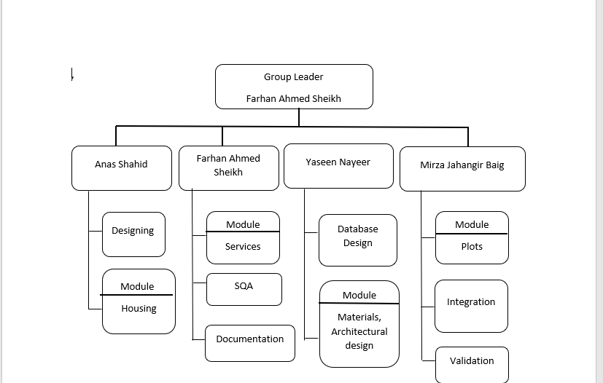

Title/Position  (of each member) | Role/Key Responsibilities | Minimum Qualification Required | Expertise / Background Required | Minimum Experience Required (years)
Anas Shahid | Designing, Module Housing |  | HTML, CSS, bootstrap, JavaScript, jQuery | 1 year
Farhan Ahmed Sheikh | Module Services, SQA, Documentation |  | HTML, CSS, JavaScript | 1 year
Yaseen Nayeer | Database Design, Module Materials and Architectural Solution |  | MYSQL, PHP, AJAX, | 1 year
Mirza Jahangir Baig | Module Plots, Integration, Validation |  | PHP, AJAX | 1 year

Remarks:

1. Name & Signature of Supervisor:

2. Name & Signature of Co-Supervisor:

3. Name & Signatures of FYP Coordinator:

Annexure–A: Project Schedule / Milestone Chart

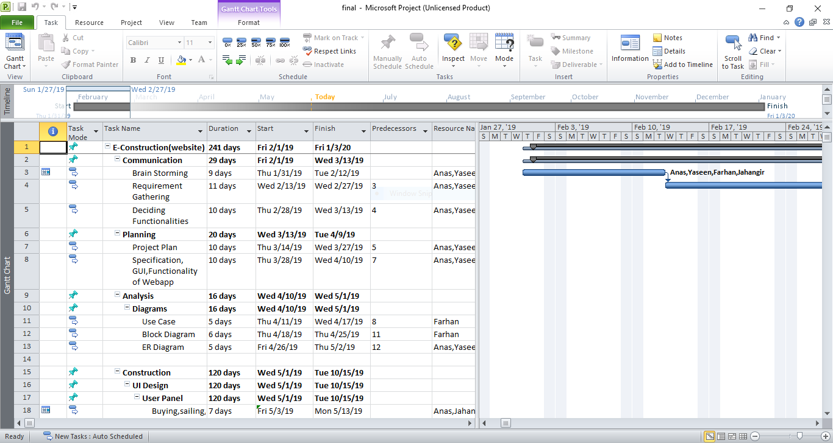

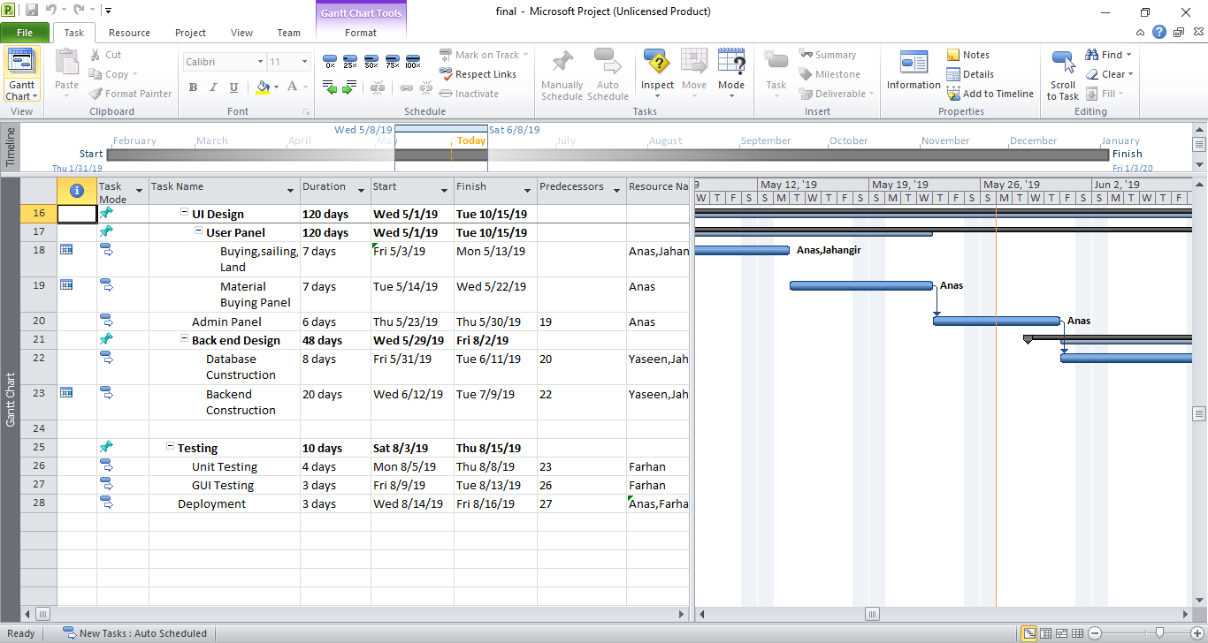

Annexure–B: Proposed Budget

SNo | Description | Amount
1 | Domain Purchase | 8000
2 | Printing and others | 10000
3 | Salaries | 128000
4 | Total | 148000

ERD
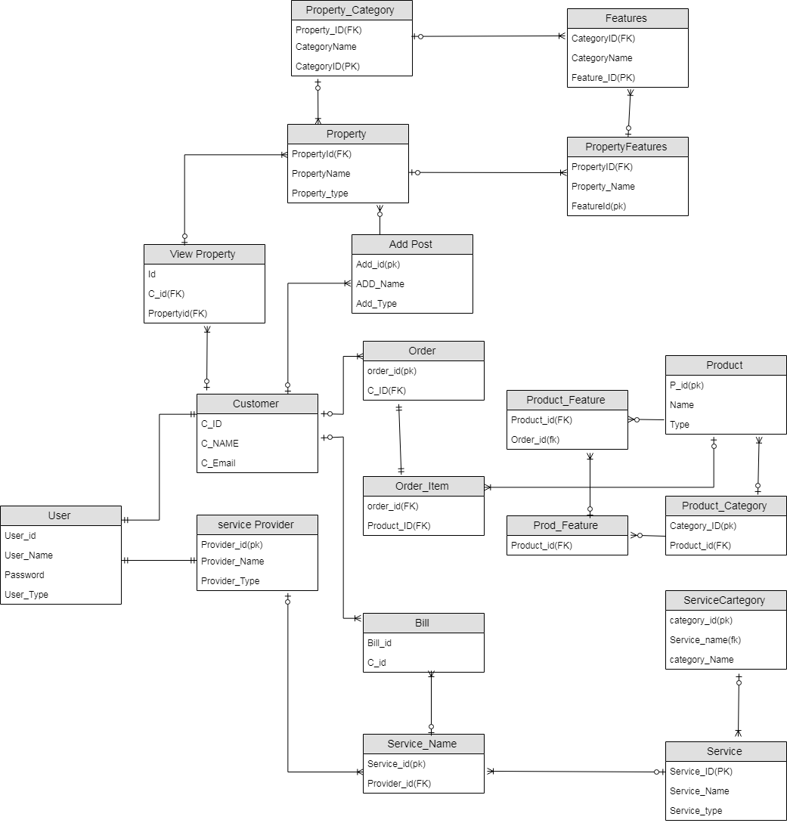

STATE DIGRAM

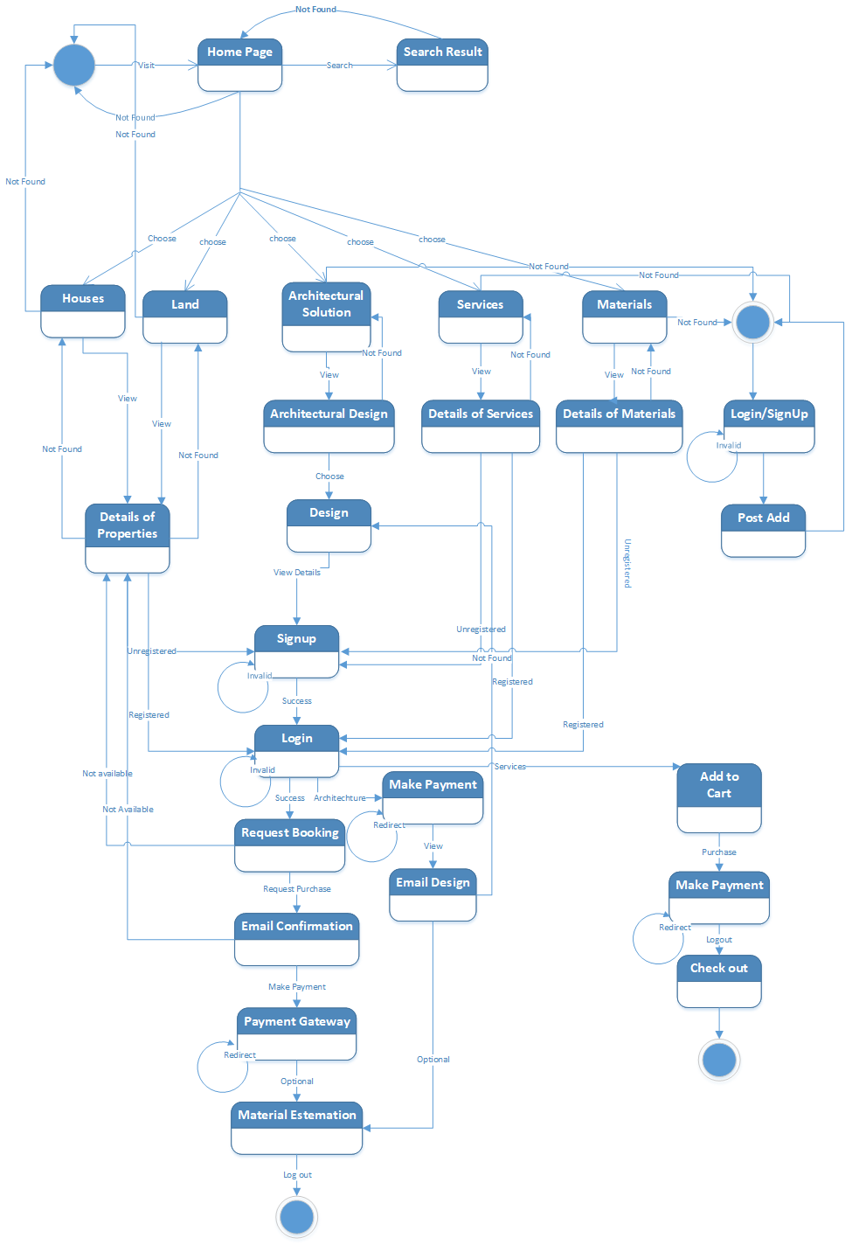

USE CASE
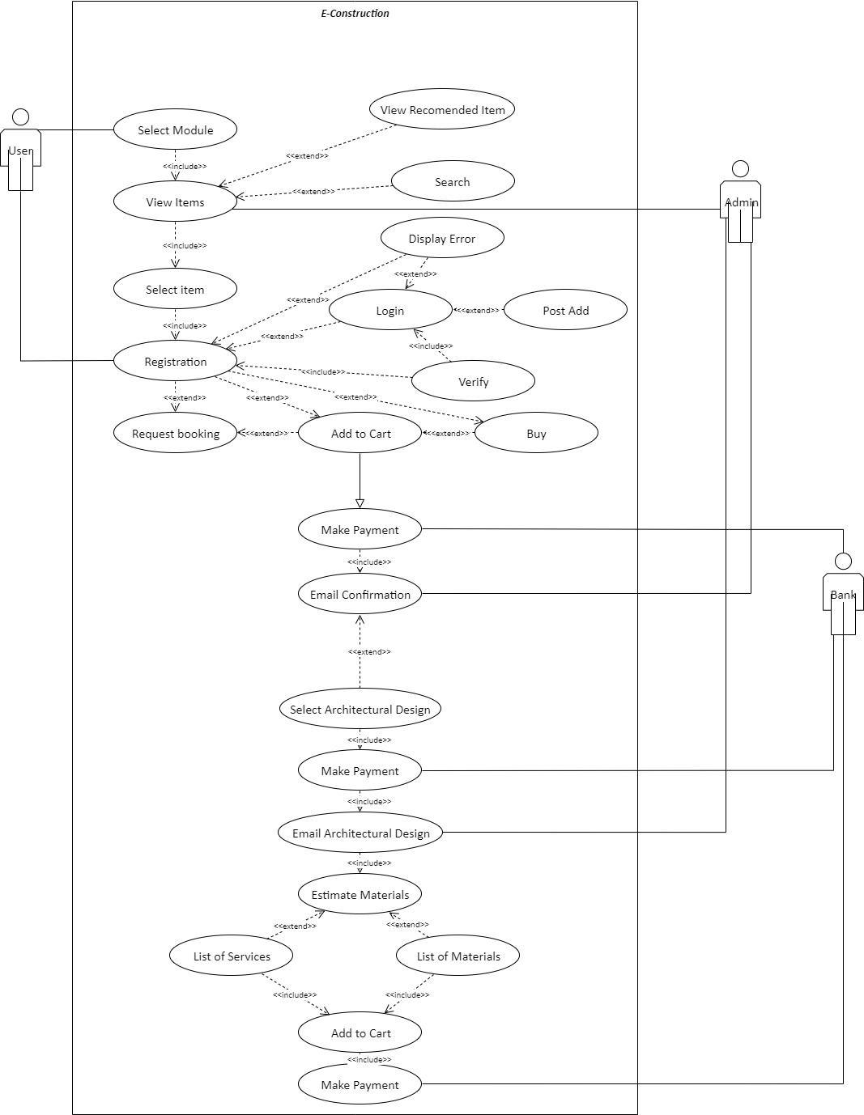

Use Case Name | Select Module, View Items, Select items
Actors | User
Pre-conditions | User visits our website.
Post-condition | Items view to the user.
Description | - User will select module as per his requirement.  - User can search items.  - User can view items.  - User can select the items.

Use case Name | Login/Registration
Actors | User, Admin
Pre-conditions | User view items
Post-condition | User can request booking and add to cart.
Description | - User will have to register/login to make purchase, to book a house or plot or to add to cart Services and Materials.  - If user enter invalid login or password system will display error and redirect to login page.  - System will verify entered details from database, if not verified user will be redirected to registration page.

Use case Name | Request Booking/Add to cart/Buy
Actors | User
Pre-condition | Registration/login
Post-condition | Payment
Description | After login/ registration user can request booking of house and add to cart services, material and architectural solution.

Use case Name | Payment
Actors | Bank, User
Pre-condition | Add to cart, Buy
Post-condition | Email confirmation
Description | - User will make payment online.  - Admin will send user an email confirming his booking or purchase.

Use case Name | Select Architecture Design, Material Estimation
Actors | Users, Bank, Admin
Pre-condition | Email confirmation,
Post-condition | Problem of users should be solved regarding Property, Construction and Services.
Description | - User can estimate materials required after purchasing architectural design  - Bank will Receive all transaction and update it to admin.  - Admin will verify the ads and then after approved ads will appear  to the website.  - User can submit request to post add after registration/login.  - User must make full payment to view details of architectural design, after receiving confirmation of transaction from bank admin will send details of design in an email

