Practice_Task1:

Result:

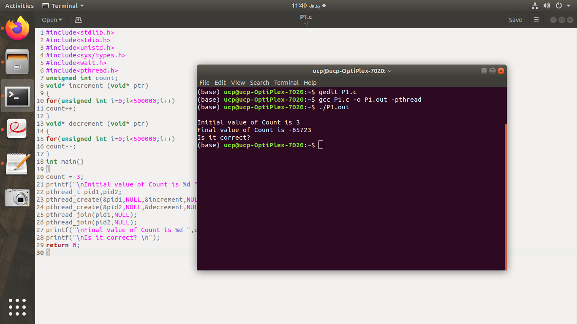

Reason:

This is not correct answer Due to the wrong value of Final value of Count.
In this problem the value of count increase one time and decreasing multi time because there is no synchronization due to this race condition occurs.

Practice_Task2:

Result:

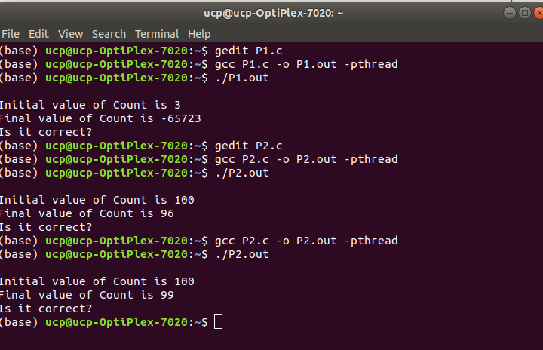

Reason:

Increment and decrement Count variable vary, sometimes out is equal number of times simultaneously and sometimes not equal.
When two process enter in critical section at the same time then this problem occurs.
To counter this problem we put a lock which allow one process to enter critical section at a time.

Practice_Task2:

Result:

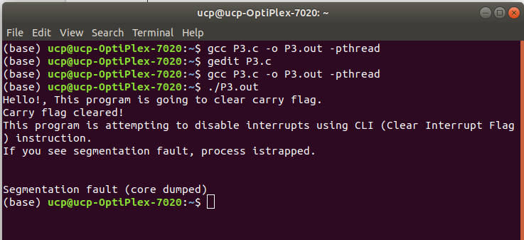

Reason:

This is Not work, because the instruction for clearing the interrupt flag is a privileged instruction and is trapped if executed in user-mode. However, the instruction to clear the carry flag is not privileged.

Practice_Task4:

Result:

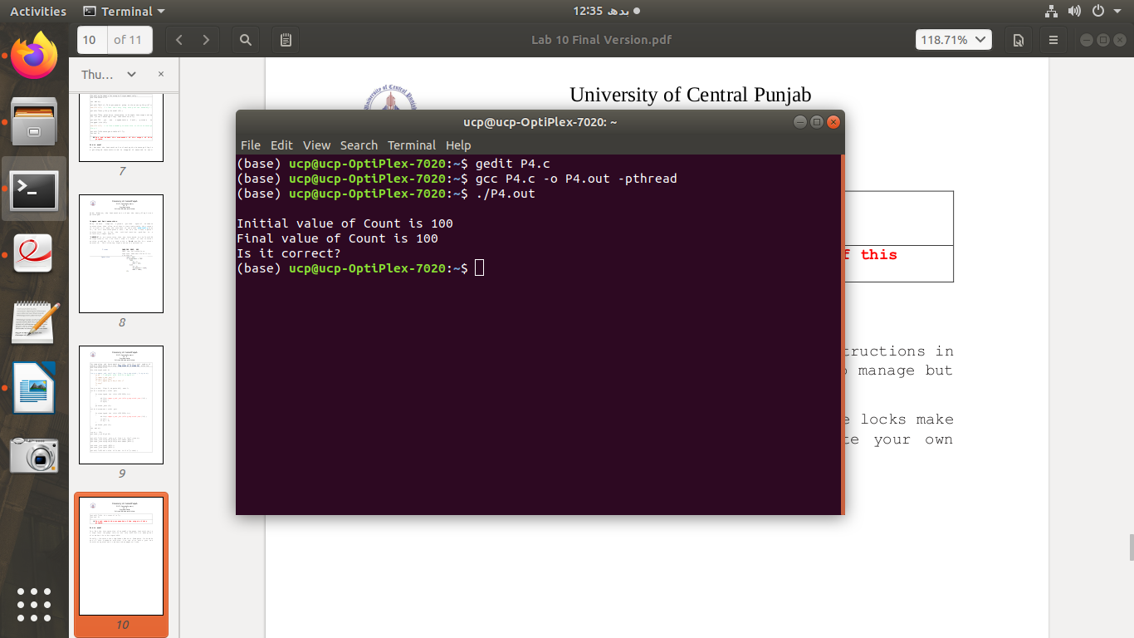
Reason:

Increment and decrement Count variable is equal number of times simultaneously.
When two process enter in critical section at the same time then this solution allow one process to enter critical section at a time because we put a lock.

