1. For installing laravel first we need to install composer
2. Need a code editor like vs code
3. composer create-project laravel/laravel app_name
4. 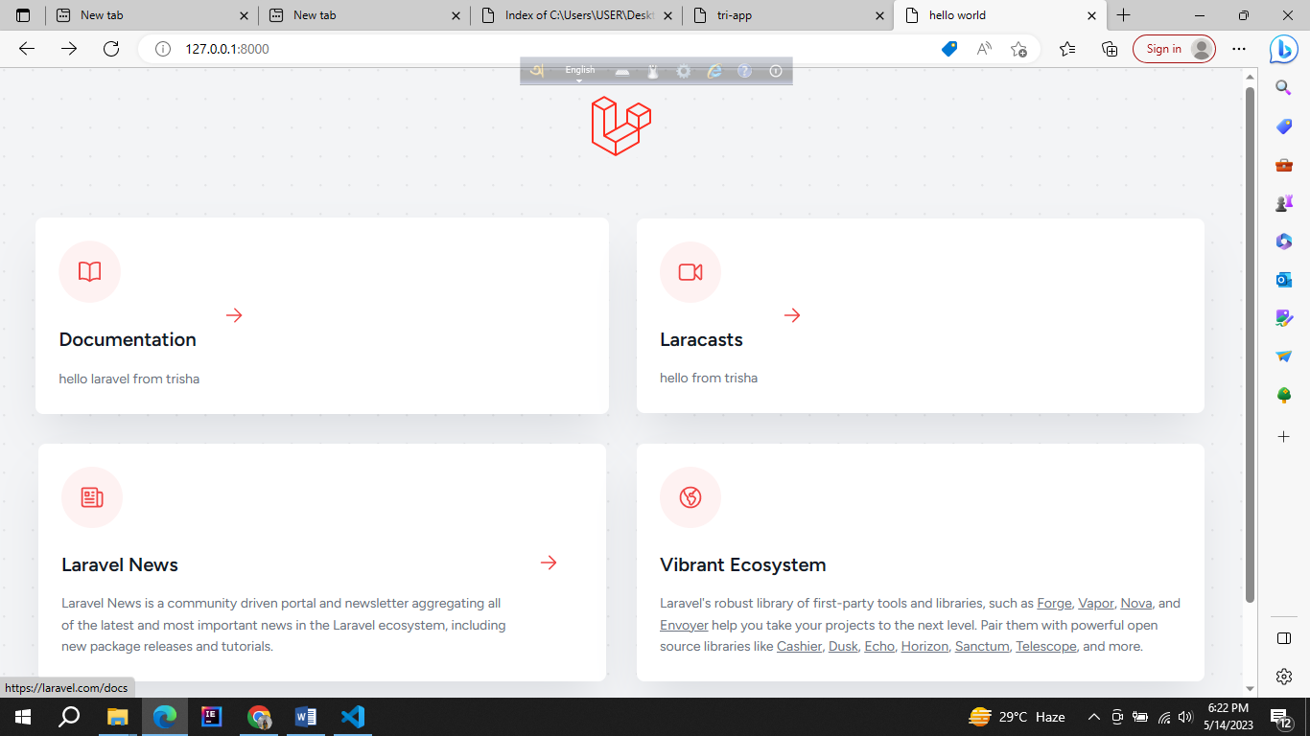Here my project running successfully. In the documentation and laracast section I wrote hello from trisha. And it is showing so