**PROJECT 2 REPORT**

**COVID 19 CASES ON REGIONS AND COUNTRIES**

MOTIVATION OF STUDY

Motivation of this study/project is to investigate how different regions and countries are dealing with cases of COVID 19. we will study positive cases based on regions and COVID related deaths per million in each region. We will choose 10 countries in which we will study COVID 19 related deaths from July 2021 to December 2021 and conclude if the country is handling the COVID 19 cases or its on the rise.

DATA SOURCES

My data set has 154 rows(154 countries) and 9 columns. This data is created from four sources, three scraped HTML tables and one API. The first HTML table scraped is from Wikipedia (<https://en.wikipedia.org/wiki/COVID19_pandemic_by_country_and_territory>).

The table scraped provides data on COVID related deaths monthly from July to December. The second table scraped is also from Wikipedia (<https://en.wikipedia.org/wiki/List_of_countries_and_dependencies_by_population>). This table gives data on population of each country. The third Table scraped is from Word Population View (<https://worldpopulationreview.com/country-rankings/country-codes>), this table provide codes representing each country for API calls.

For the API I used an API from Rapid (<https://covid-193.p.rapidapi.com/statistics>) this provides the following end points:

* GET countries : Get all available countries
* GET statistics : Get all current statistics for all countries (country codes passed as a parameter to get data/statistics on the country)
* GET historical : Get historical statistics for a country

DATAFRAME STATISTICS

Dataframe head: 10 values

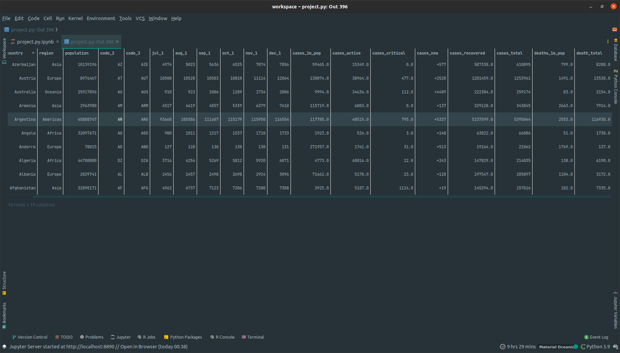

Columns descriptions

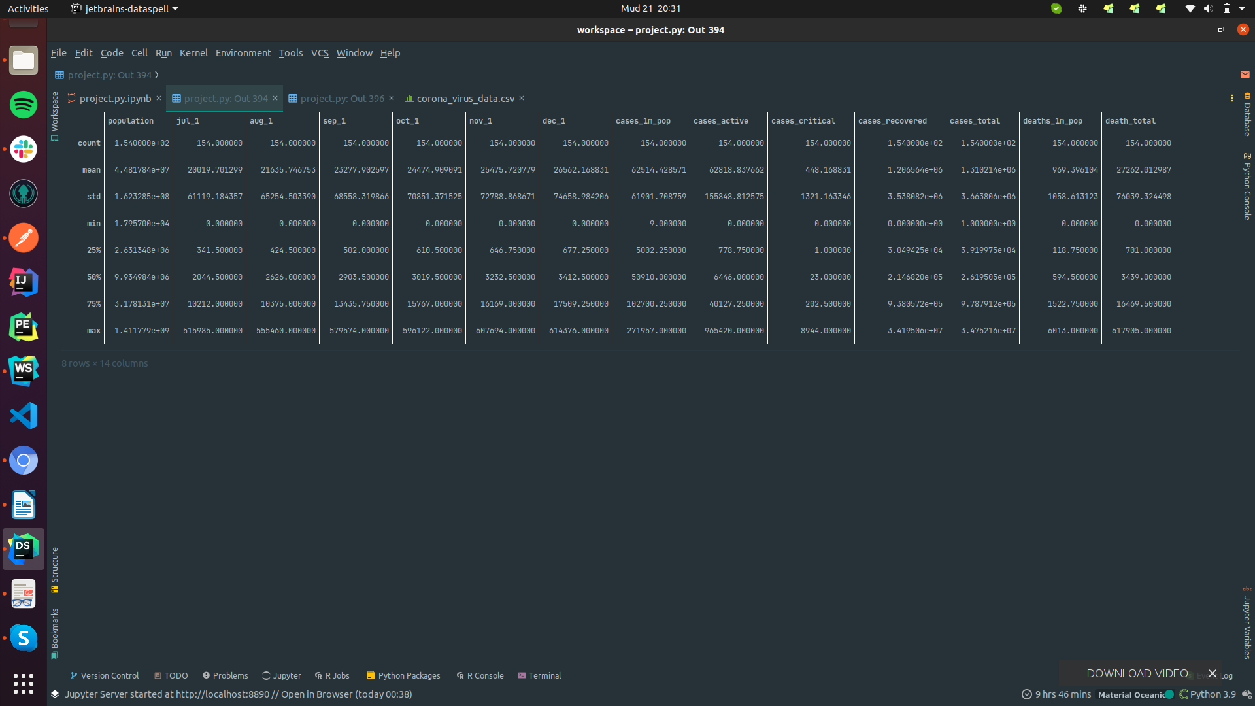

DISCUSSIONS:

Looking at regions we can clearly see that Europe is the most affected region having the highest infections per million and deaths per million. Americas region, Asia, Africa, Oceania follow in the given order. Looking at the countries with the highest population in the dataset, Brazil has the highest deaths and is on upward trend. All the countries have an increase in deaths every month.

This data can be helpful in various:

* Help the W.H.O identify countries strangling to contain the virus
* Help in distribution of vaccines
* Help other countries monitor and control travel to “at risk” countries

DATA VISUALIZATION

Cases per million graph

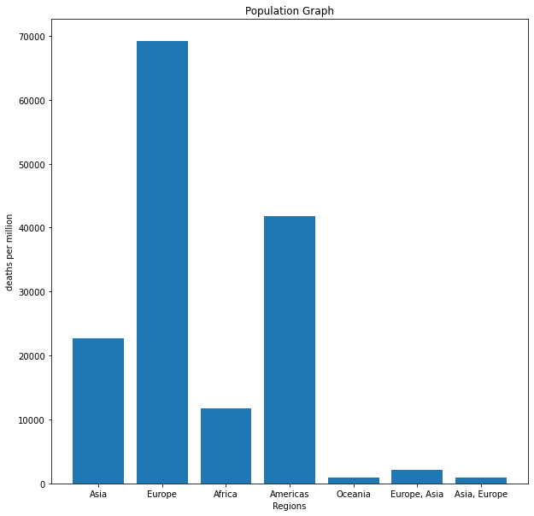

Death per million graph

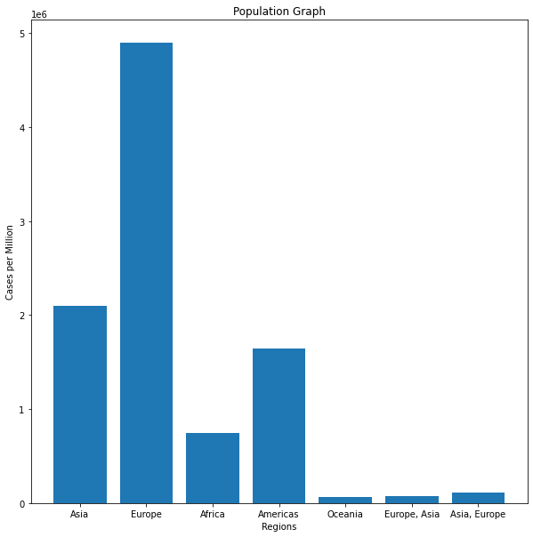

deaths between July and December

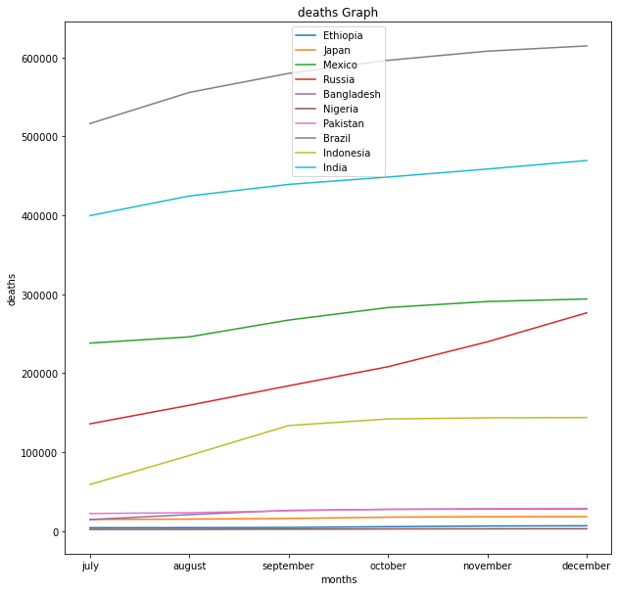

CONCLUSION

COVID 19 is still a problem as cases and deaths have increased in the recent months. People still need to get vaccinated and protect themselves.