INSTITUTE OF SCIENCE , NAGPUR
(An Autonomous Institute of Government of Maharashtra)

Project Report on
“A Study on Punctuality , Commuter Perception & Urban Mobility”
‘Focus: Nagpur Metro Rail’
Submitted to
INSTITUTE OF SCIENCE , NAGPUR
(An Autonomous Institute of Government of Maharashtra)
In the partial fulfilment of the requirement for the degrees of bachelor of science in statistics
Submitted by:
Anamika Panday
Farhin Baig
Mushira Ansari
Tinu Dhole
Bsc Statistics Semester IV
Under the Guidance of
Dr.Pritee Singh
Project guide/supervisor
Department of Statistics,
Institute of science , Nagpur – 440001(2025-2026)

ACKNOWLEDGEMENT

It is our great pleasure and privilege to express our sincere gratitude to our guide, Dr. Pritee Singh for their continuous guidance, valuable suggestions, encouragement, and support throughout the completion of this project titled "A Study on punctuality , Commuter Perception & Urban Mobility."
We would also like to express our heartfelt thanks to the Head of the Department, Department of Statistics, for providing the necessary facilities and a supportive academic environment to successfully carry out this project work.
We are deeply thankful to all the teaching and non-teaching staff of the Department of Statistics for their timely help and cooperation during the course of this project.
We would also like to extend our gratitude to all the respondents who participated in the survey and provided valuable data for this study.
Lastly, we express our sincere thanks to our family and friends for their constant support and encouragement.

Anamika Panday
Farhin Baig
Mushira Ansari
Tinu Dhole
Class: B.Sc. (Semester IV)
Department of Statistics
Institute of Science, Nagpur

CERTIFICATE

This is to certify that the project report entitled “A Study on Punctuality, Commuter Perception & urban Mobility” submitted by Anamika Panday, Farhin Baig, Mushira Ansari, Tinu Dhole is record of bonafide work carried out under the guidance for the partial fulfilment of the degree of Bachelor of Science (B.Sc.) in Statistics during the academic year 2025-26.
The work presented in this project is original and has been completed by the student as per the requirements of the course.

Dr. Pritee Singh
(Project Guide / Supervisor)
Department of Statistics
Institute of Science, Nagpur.

Head of the Department
Department of Statistics
Institute Of Science, Nagpur.

Date:

DECLARATION
We hereby declare that the project report entitled "A Study on Punctuality, Commuter Perception & Urban Mobility" has been carried out independently by us under the guidance of Dr. Pritee Singh, Assistant Professor, Department of Statistics, Institute of Science, Nagpur.
The work presented in this project is original and has not been submitted, either in part or in full, to any other university or institute for the award of any degree, diploma, or certificate.

Date:
Place: Nagpur

Miss. Anamika Panday
Miss. Farhin Baig
Miss. Mushira Ansari
Miss. Tinu Dhole

B.Sc. Statistics (Semester IV)
Department of Statistics
Institute of Science, Nagpur - 440001

ABSTRACT
This project titled “A Study on Punctuality, Commuter Perception & Urban Mobility” focuses on the Nagpur Metro Rail system, operated by the Maharashtra Metro Rail Corporation Limited (MahaMetro). The study investigates the punctuality performance of the Nagpur Metro, examines commuter perceptions and satisfaction levels, and analyses the broader impact of metro services on urban mobility in a Tier-2 Indian city.
Primary data was collected through a structured questionnaire administered via both online (Google Forms) and offline modes, obtaining 82 valid responses from Nagpur Metro commuters. Secondary data was sourced from MahaMetro performance reports, RITES surveys, DMRC annual reports, and peer-reviewed research on metro systems in India and globally.
Statistical tools including mean, variance, standard deviation, percentage analysis, weighted average, and frequency distribution tables were used to analyse the data. Findings reveal that the majority of metro users (76.8%) travel for educational purposes, and 73.2% of commuters experience some form of delay, primarily in the 1–5 minute range. Despite this, a significant 67.1% rated punctuality as Good or Excellent, with a mean satisfaction score of 4.09 out of 5. Nagpur Metro’s overall punctuality stands at approximately 90%, compared to 95% for Delhi Metro and 98% for Tokyo Metro.
The study concludes that while Nagpur Metro has made a commendable start as a Tier-2 city metro, there is considerable scope for improvement in train scheduling, frequency management, last-mile connectivity, and passenger information systems. The study provides actionable recommendations aimed at enhancing operational efficiency, commuter satisfaction, and the long-term sustainability of the Nagpur Metro as a key pillar of urban mobility.
Keywords: Nagpur Metro, Punctuality, Commuter Perception, Urban Mobility, MahaMetro, Delay Analysis, Passenger Satisfaction, Public Transport, Tier-2 City.

TABLE OF CONTENTS
Cover Page 1
Acknowledgement 2
Certificate 3
Declaration 4
Abstract 5
Table of Contents 6
CHAPTER 1 – Introduction to Metro Systems 7
CHAPTER 2 – Research Methodology 11
CHAPTER 3 – Literature Review 13
CHAPTER 4 – Statistical Analysis Framework 16
CHAPTER 5 – Data Analysis & Interpretation 19
Overall Summary of Findings 31
References / Bibliography 33
CHAPTER 6 – Conclusion 34
CHAPTER 7 – Recommendations 37
CHAPTER 8 – Limitations & Scope for Further Research 40
CHAPTER 9 – Python Statistical Analysis 43
Appendix – Survey Questionnaire 46

CHAPTER 1 – Introduction to Metro Systems
A Metro is basically a city-level train network meant to carry a huge number of passengers quickly — without getting stuck in traffic. It runs on its own dedicated tracks, so road jams don’t affect it. Metros help reduce road traffic, cut pollution, and make the city much more connected overall.
Modern metro networks are typically:
- Underground, elevated, or at-grade to avoid interference with road traffic.
- Electrically powered, ensuring sustainability and reduced carbon emissions.
- Equipped with advanced signaling and automation technologies for safety and punctuality.
- Integrated with other modes of transport such as buses, trams, and suburban railways, creating seamless mobility for commuters.
Beyond transportation, metro systems contribute to economic growth, urban development, and social inclusion by making cities more accessible and livable. They are considered a backbone of smart city infrastructure, supporting sustainable urbanization in the 21st century

Origins of Metro Systems
The London Underground, popularly known as the Tube, holds the distinction of being the world’s first metro system. It began operations in 1863 as an underground railway, marking a revolutionary step in urban transportation. Later, in 1890, London introduced the City and South London Railway, the first deep-level electric metro line, setting the foundation for modern rapid transit systems worldwide.
What started in London slowly spread across the world. Over time, metro systems became more advanced — better technology, longer routes, faster trains. Today, more than 200 cities worldwide operate metro systems, serving millions of passengers daily and every city that builds one is continuing a tradition that started over 160 years ago.

Introduction to Metro in India
India’s metro story started with the Kolkata Metro, which was inaugurated in 1984, making it India’s first underground metro. It was a big deal at the time — it showed that Indian cities could have world-class public transport.
Following Kolkata, the Delhi Metro, launched in 2002, changed everything. It was efficient, safe, and well-run — and it showed every other Indian city that a good metro is possible. After Delhi, one city after another started building their own.
Today, India’s metro rail network has grown rapidly:
- Over 1,000 km of operational metro lines across 23 cities in 11 states, making it the third-largest metro network in the world.
- Cities like Bengaluru, Mumbai, Hyderabad, Chennai, Nagpur, Pune, and Lucknow now have operational or developing metro systems.
- Metro projects are central to India’s vision of sustainable urbanization, reducing traffic congestion, cutting air pollution, and improving ease of living.
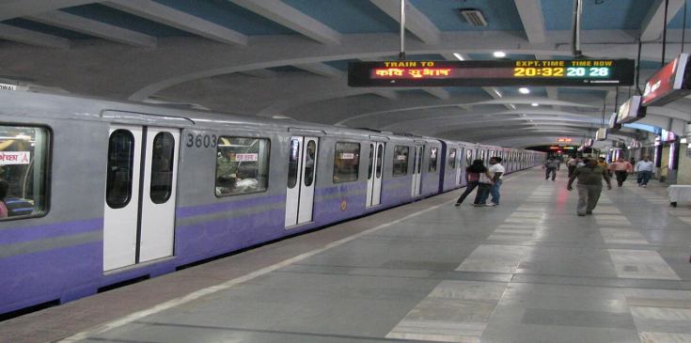

The Introduction to Nagpur Metro
agpur Metro is a modern rapid transit system serving Nagpur, Maharashtra, and is operated by the Maharashtra Metro Rail Corporation Limited (MahaMetro). Officially inaugurated on March 8, 2019, it made Nagpur one of the first Tier-2 cities in India to get its own metro. It was a proud moment for the city — and it opened up a much cleaner and faster way to travel across Nagpur.

Key Features
- Lines & Coverage: Two corridors — the Orange Line and the Aqua Line — covering over 38 km with 37 stations.
- Technology: Standard gauge tracks, 25 kV AC electrification, and advanced signaling systems ensure safety and reliability.
- Sustainability: Recognized as India’s first “green metro,” with energy-efficient designs, solar power integration, and eco-friendly construction practices.
- Ridership: Serves thousands of commuters daily, reducing dependence on road transport and easing congestion in the city.

Future Expansion
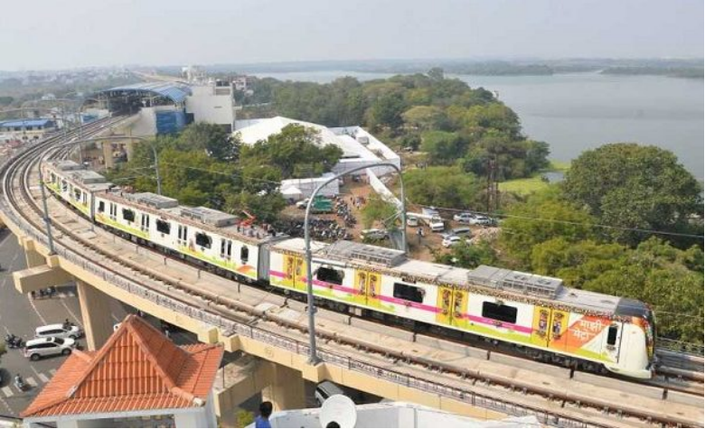
Nagpur Metro is growing fast. With Phase 3, the network is projected to grow to 129 km, which will make it one of the biggest metro networks in any Tier-2 city in India.
🚇 Importance of metro Systems

1. Urban Mobility & Accessibility
- Metro systems provide fast, reliable, and high-capacity transport, reducing dependence on road-based vehicles.
- They connect key residential, commercial, and industrial zones, improving accessibility for all sections of society.

2. Reduction in Traffic Congestion
- By shifting commuters from private vehicles to mass transit, metros significantly reduce road congestion.
- For example, Delhi Metro is estimated to have reduced over 400,000 vehicle trips per day, easing traffic pressure.

3. Environmental Benefits
- Metro systems are energy-efficient and eco-friendly, lowering carbon emissions compared to buses or cars.
- Studies show that metros can reduce CO₂ emissions by up to 30–40% in urban corridors.
“At the end of the day, a metro is not just about getting from point A to B.—they are engines of urban transformation. By reducing congestion, cutting emissions, saving time, and fostering equitable access, metros redefine the rhythm of city life. For Nagpur, the metro is not just a mode of travel but a catalyst for sustainable growth, economic productivity, and commuter confidence. Its importance lies not only in punctual arrivals but in shaping a cleaner, faster, and more inclusive future for the city.

Objectives of the Study
To study how often trains are on time and what kinds of delays commuters face.
To understand how satisfied commuters are and whether they trust the metro to be reliable.
To look at how the metro affects people economically and its impact on the environment.
To compare Nagpur Metro with other metro systems like Delhi and Tokyo.
To give practical suggestions that could make the metro better for everyday commuters.

CHAPTER 2 – Research Methodology
1. Research Design
We used a mix of our own survey data (primary) and information from published reports (secondary) to understand how commuters feel about Nagpur Metro’s punctuality. Most of our analysis is number-based (quantitative).
2. Data Collection Method
Primary data has been collected through a structured questionnaire shared through both online and offline modes. The online survey was distributed via Google Forms, while the offline survey was conducted in-person at Nagpur Metro stations using printed questionnaires. Both modes target daily commuters of the Nagpur Metro, asking them about their real experiences — punctuality, delays, satisfaction and suggestions. By doing it both ways (online and offline), we made sure we didn’t only get responses from people who are active on phones and internet. For background data, we referred to published reports from MahaMetro and RITES, annual reports of DMRC, and research papers on metro systems in India and globally.
3. Sampling Method
A convenience sampling technique was used — basically we shared the form with people we could reach through WhatsApp groups and social media, and also surveyed people in person at stations. We only included responses from people who actually use the Nagpur Metro.
4. Survey Instrument
The questionnaire was designed to cover the following key areas:
• Commuter demographics (age, occupation, frequency of travel)
• Frequency and perceived severity of train delays
• Overall satisfaction with Nagpur Metro’s punctuality and service
• Impact of delays on daily routine and productivity
• Comparison of Nagpur Metro experience with other transport modes
• Suggestions for service improvement

CHAPTER 3 – Literature Review

PREVIOUS STUDY ON METRO:

HERE WE HAVE PUT SOME COMPARISONS OF PREVIOUSLY STUDIED METRO SYSTEMS IN INDIA AND AROUND GLOBE
Study/Source | Location/Context | Key Findings | Relevance to Your Study
Srinatha & Adaikalam (2023) – Evaluating Service Quality in Namma Metro | Bengaluru, India | Survey of 150 users showed high satisfaction with punctuality and safety, but concerns about overcrowding and last-mile connectivity. | Highlights that punctuality is valued, but delays during peak hours reduce satisfaction. Useful for comparing commuter perception in Nagpur.
Jahangir (2022) – Commuters’ Perception on Metro Rail Services | Hyderabad, India | Found that commuter satisfaction depends on punctuality, affordability, and safety. Management involvement is crucial to reduce delays and improve service quality. | Reinforces that punctuality and delay management are central to commuter trust.
Comparative Study of Metro vs. BMTC Bus Services | Bengaluru, India | Metro commuters rated punctuality and comfort higher than bus services, but noted occasional delays during peak hours. | Shows how metro delays are perceived relative to other transport modes.
Delhi Metro Annual Reports | Delhi, India | Reports punctuality levels of 95–97%, with delays mainly linked to technical faults or crowd surges. | Provides a benchmark for delay management and commuter expectations in Indian metros.
Tokyo Metro Case Studies | Japan | Punctuality above 98%; delays are rare and usually under 2 minutes. Commuter trust strongly linked to reliability. | Demonstrates global best practices in minimizing delays and maintaining commuter confidence.

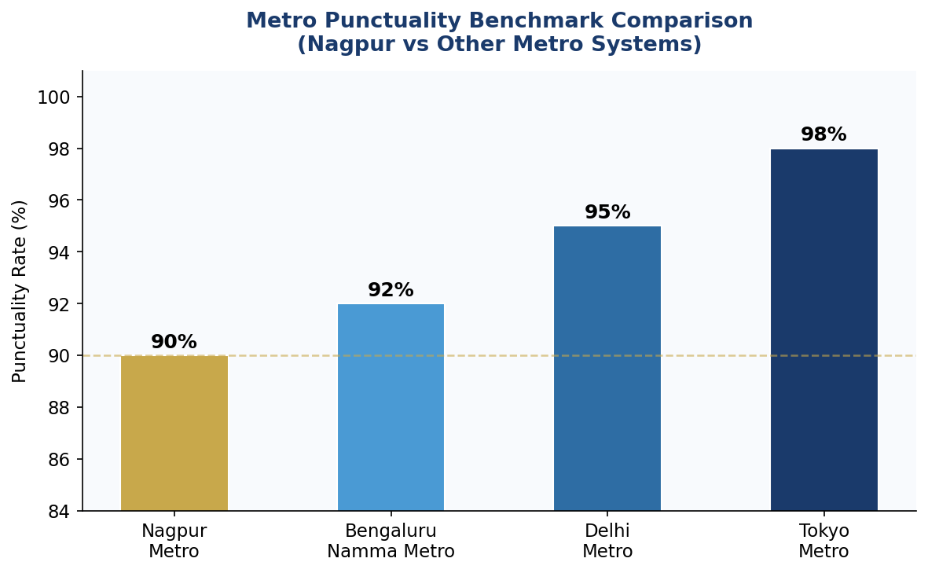
INTERPRETATION:
The bar graph compares the punctuality rates of four metro systems — Nagpur (90%), Delhi (95%), Bangalore (92%), and Tokyo (98%). Tokyo Metro leads with the highest punctuality at 98%, reflecting world-class operational standards and advanced rail technology. Delhi Metro follows at 95%, establishing itself as the benchmark for Indian metro systems. Bangalore Metro records 92%, indicating a reasonably reliable service, while Nagpur Metro stands at 90%, the lowest among the four. Although Nagpur Metro’s 90% punctuality is a commendable achievement for a Tier-2 city that launched operations only in 2019, there remains an 8% gap compared to Tokyo and a 5% gap compared to Delhi. This suggests significant room for improvement in train scheduling, frequency management, and operational efficiency

CHAPTER 4 – Statistical Analysis Framework
This chapter lists the statistical tools we used to analyse the survey data collected from Nagpur Metro commuters. Each formula is explained with an example so the reader can follow how we got our results.
1. Mean (Average)
Mean is simply the average — we add up all the values and divide by the number of responses. It gives us a single number that represents the “centre” of all commuter ratings.
Formula: Mean (x̅) = Σx / n
Where: Σx = Sum of all values, n = Total number of responses
2. Variance
Variance tells us how much the responses vary from the average. If variance is high, it means different people have very different experiences with the metro.
Formula: σ² = Σ(x - x̅)² / n
Where: x = each value, x̅ = mean, n = number of responses
σ (Std. Deviation) = 1.0361 | Moderate spread — most rate punctuality between 3 and 5
3. Standard Deviation
Standard Deviation is just the square root of variance — it is easier to interpret because it is in the same unit as the original data. A low SD means most commuters gave similar ratings, while a high SD means opinions were all over the place.
Formula: σ = √[ Σ(x - x̅)² / n ]
Weighted Average = 4.09 / 5 | Based on 82 responses — reflects high overall satisfaction
4. Percentage and Percentage Change
Percentage is used to express survey responses as proportions of the total. Percentage change shows how much improvement Nagpur Metro needs compared to benchmarks.
Formula: Percentage (%) = (f / N) x 100
Formula: % Change = [(New Value - Old Value) / Old Value] x 100
5. Weighted Average
Weighted Average gives more importance to some responses than others. Here, we assigned numbers to satisfaction levels (Very Satisfied = 5, down to Very Dissatisfied = 1) and then calculated a weighted average to get one overall satisfaction score.
Formula: Weighted Avg = Σ(w x x) / Σw
Where: w = weight assigned to each category, x = value of each response
See frequency distribution tables in Chapter 5 — Data Analysis & Interpretation
6. Frequency Distribution Table
A Frequency Distribution Table just counts how many respondents fall into each category. For example, how many rated punctuality as “Good” vs “Excellent”. These tables are the basis for all our graphs and calculations.
Sample Table Structure (to be filled after survey):
Satisfaction Level | Frequency (f) | Percentage (%)
Very Satisfied | --- | ---
Satisfied | --- | ---
Neutral | --- | ---
Dissatisfied | --- | ---
Very Dissatisfied | --- | ---

TOTAL (N) | --- | 100%

CHAPTER 5 – Data Analysis & Interpretation
For this study, primary data was collected from commuters of Nagpur Metro Rail through a structured questionnaire. The survey was administered through two modes — an online Google Form circulated among metro users and an offline in-person survey conducted at selected Nagpur Metro stations. A total of 82 valid responses were received — 50 through the online mode and 32 through offline data collection. The data was then tabulated, and frequency distributions along with percentage analysis were carried out for each question. Wherever applicable, mean, weighted .
Q.1 – What is your main purpose of traveling by metro?
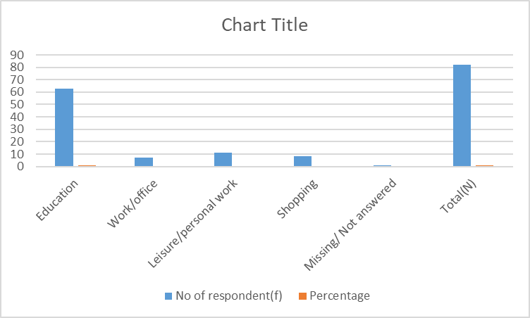
(Graph prepared using Microsoft Excel by the research team)
The above table clearly shows that out of 82 respondents, a large majority i.e. 63 respondents (76.8%) use Nagpur Metro primarily for educational purposes. This is consistent with the observation that the metro route passes near several colleges, coaching institutes, and schools in Nagpur. Work/office commuters account for 8.5%, followed by those travelling for leisure or personal errands (9.8%) and shopping (3.7%). This finding firmly establishes that the core ridership of Nagpur Metro is largely student-driven. Any service disruption — particularly in the morning or afternoon slots — tends to affect the academic routine of students the most.

Q.2 – Which age group do you belong to?
Age Group | No. of Respondents (f) | Percentage (%)
Below 15 years (12–13) | 1 | 1.2%
15 – 20 years | 58 | 70.7%
21 – 30 years | 18 | 23.2%
31 – 40 years | 3 | 3.7%
41 – 50 years | 2 | 3.7%
Total (N) | 82 | 100%
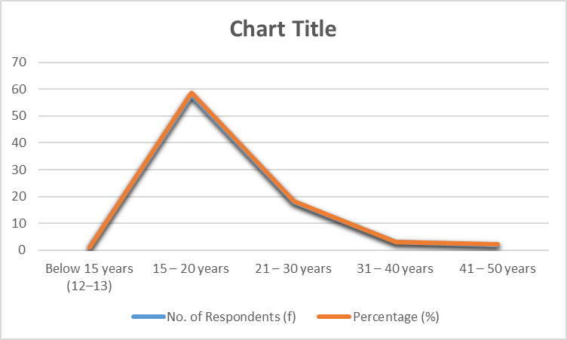

The data clearly shows that the 15–20 years age group forms the single largest segment with 58 respondents, accounting for 70.7% of the total sample. This is followed by the 21–30 years group (22.0%), which together with the 15–20 group makes up over 92.7% of all surveyed commuters. The 31–40 years bracket contributed 3.7%, while respondents above 40 years were minimal. This pattern strongly indicates that the Nagpur Metro predominantly serves a younger population, especially students. It raises the important question of whether the metro is doing enough to attract working professionals and older commuters.

Q.3 – Gender of Respondents
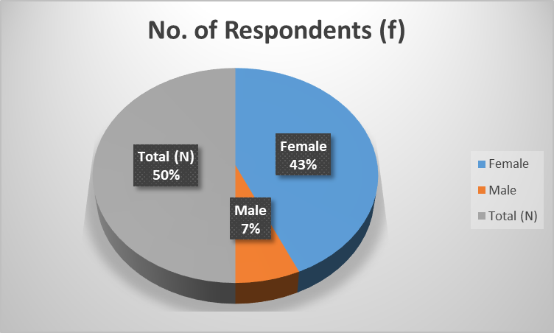

As seen from the table, female respondents constitute 86.6% (71 out of 82) of the total sample, while male respondents account for 13.4% (11). The high proportion of female users is consistent with general observations that women in urban India tend to prefer metro and public transport owing to affordability, safety, and convenience. The metro's safe, well-lit, and air-conditioned environment makes it a particularly preferred choice for female students and working women in Nagpur.

Q.4 – How frequently do you travel by metro?
Travel Frequency | No. of Respondents (f) | Percentage (%)
Daily | 16 | 19.5%
4–5 times a week | 19 | 23.2%
2–3 times a week | 8 | 9.8%
Weekly | 4 | 4.9%
Occasionally | 35 | 42.7%
Total (N) | 82 | 100%
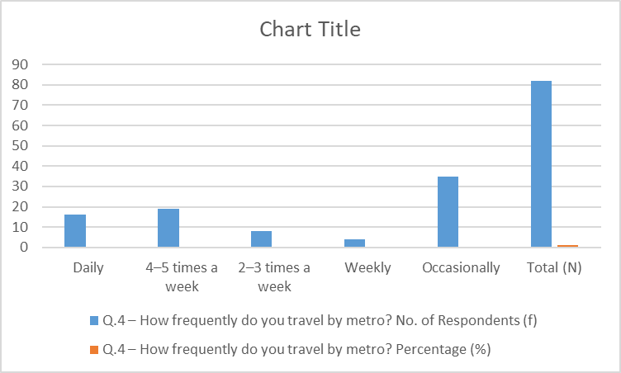

Q.5 – During which time of the day do you usually travel by metro?

Time of Travel | No. of Respondents (f) | Percentage (%)
Morning Peak Hours (6 AM – 10 AM) | 23 | 28.0%
Afternoon (10 AM – 4 PM) | 42 | 51.2%
Evening Peak Hours (4 PM – 9 PM) | 13 | 15.9%
Night (After 9 PM) | 3 | 3.7%
As per need / Flexible | 1 | 1.2%
Total (N) | 82 | 100%
Afternoon hours (10 AM – 4 PM) record the highest usage with 51.2% of respondents travelling during this slot, which largely corresponds to the dispersal time of colleges and educational institutions. Morning peak hours (6 AM – 10 AM) account for 28.0%, reflecting the morning commute to schools and colleges. Together, these two time bands cover 79.2% of all travel. Evening peak hours contribute 15.9%, while night travel remains minimal at 3.7%. This pattern is very much consistent with a student-dominated ridership. The concentration of travel in the afternoon slot suggests that this is the most operationally critical period for Nagpur Metro, and any punctuality lapses during this window would have the widest impact.

Q.6 – On average, how much delay do you face?

Delay Duration | No. of Respondents (f) | Percentage (%)
No Delay | 22 | 26.8%
1 – 5 Minutes | 38 | 46.3%
6 – 10 Minutes | 17 | 20.7%
More than 10 Minutes | 5 | 6.1%
Total (N) | 82 | 100%
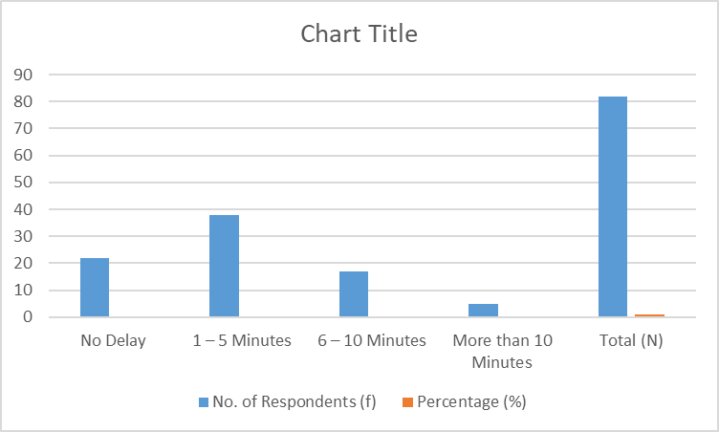
Q.7 – Rate metro punctuality (Scale: 1 to 5)
Rating | Description | Respondents (f) | Percentage (%)
1 | Very Poor | 3 | 3.7%
2 | Poor | 6 | 7.3%
3 | Average / Neutral | 18 | 22.0%
4 | Good | 30 | 36.6%
5 | Excellent | 25 | 30.5%
Mean Score = 3.83 | — | 82 | 100%

The punctuality rating data presents a moderately positive picture. A combined 67.1% of respondents have rated metro punctuality at 4 or 5 (Good or Excellent), which is reassuring. The mean rating works out to 3.83 out of 5. The variance is 1.1300 and the standard deviation is 1.0583, indicating a moderate spread — most commuters rate punctuality between 3 and 5. About 22.0% gave a neutral rating of 3, and only 11.0% gave a rating of 1 or 2. It is worth noting that the mean punctuality score (3.83) and the delay data (73.2% experiencing some delay) may appear contradictory — but this is a known pattern in public transport research where commuters tend to rate the service positively overall even when they acknowledge some inconvenience. The delays faced are mostly tolerated and do not translate into outright dissatisfaction.

Q.8 – How would you rate the behaviour and helpfulness of metro staff?
Staff Rating | No. of Respondents (f) | Percentage (%)
Excellent | 21 | 25.6%
Good | 49 | 59.8%
Average | 11 | 13.4%
Poor | 1 | 1.2%
Total (N) | 82 | 100%
Staff behaviour and helpfulness received very encouraging feedback from respondents. A combined 85.4% rated the metro staff as either Good (59.8%) or Excellent (25.6%), while only 1.2% rated staff behaviour as Poor. This is consistent with Nagpur Metro’s reputation of maintaining well-trained and courteous ground staff. The 13.4% Average rating indicates some scope for improvement — possibly in terms of responsiveness during rush hours or when dealing with elderly and differently-abled commuters. Overall, the human aspect of the metro service is a strong positive point and likely contributes to the overall satisfaction level.
.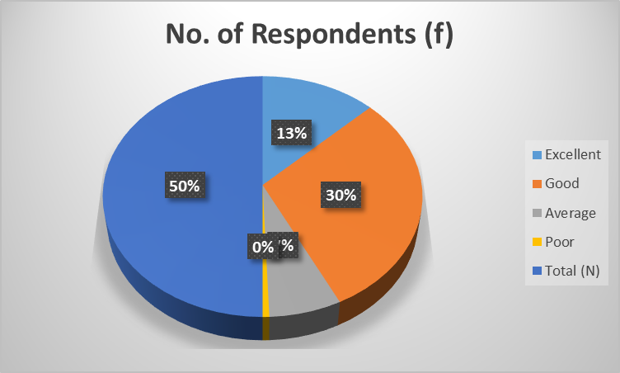
Q.9 – Overall, how satisfied are you with metro services
Satisfaction Level | Weight (w) | Respondents (f) | Percentage (%)
Very Satisfied | 5 | 25 | 30.5%
Satisfied | 4 | 43 | 52.4%
Neutral | 3 | 11 | 13.4%
Dissatisfied | 2 | 1 | 1.2%
Very Dissatisfied | 1 | 1 | 1.2%
Weighted Average = 4.09 | — | 82 | 100%
The overall satisfaction data is arguably the most telling outcome of this entire survey. A striking 82.9% of respondents are either Satisfied (52.4%) or Very Satisfied (30.5%) with Nagpur Metro services. Only 3.6% expressed dissatisfaction in any form. The weighted average satisfaction score comes out to 4.09 out of 5, which is a strong and positive result. This number, when read in conjunction with the delay data (73.2% face some delay) and punctuality rating (mean 3.83), reinforces the view that Nagpur Metro commuters — though occasionally inconvenienced by delays — broadly appreciate the service for its safety, cleanliness, affordability, and overall reliability compared to other modes of urban transport in Nagpur. The 13.4% Neutral respondents represent a group that could be converted into satisfied users with targeted service improvements.

CHAPTER 6 – Conclusion
6.1 Achievement of Objectives
All five objectives we set at the start were covered in our study:
- Arrival & Delay Patterns: Documented that 73.2% of commuters face delays, with 46.3% experiencing 1–5 minute delays most frequently.
- Commuter Perception: Mean punctuality rating of 3.83/5 and weighted satisfaction of 4.09/5 show broadly positive commuter perception despite delays.
- Socio-Economic Impact: Established metro as an affordable, safe, and inclusive mode of transport especially for students and women in Nagpur.
- Benchmark Comparison: Nagpur Metro’s 90% punctuality trails Delhi (95%) and Tokyo (98%), highlighting a measurable performance gap and scope for improvement.
- Recommendations: Specific, data-backed recommendations have been formulated to improve punctuality and commuter experience.
6.2 Key Conclusions
Here is what we found after going through all 82 responses:
- Nagpur Metro is clearly the go-to mode of travel for students. People like it because it’s affordable, safe, and clean — those came up again and again in responses.
- Even though 73.2% said they face some delay, overall satisfaction is still 4.09 out of 5. This pattern — known in transport research as “tolerance absorption” — indicates that commuters accept minor delays as long as the service remains reliable overall.
- The afternoon slot (10 AM – 4 PM) is the most operationally critical period. Delays in this slot impact the maximum number of commuters, particularly students returning from educational institutions.
- Staff behaviour was one of the best things people said about the metro — 85.4% rated them Good or Excellent. Good staff behaviour makes delays feel less frustrating.
- 90% punctuality is good for a city like Nagpur, but there is still a gap of 5–8% compared to national and global benchmarks. Closing this gap should be a strategic priority for MahaMetro in the coming years.
Overall, Nagpur Metro is doing a good job — people like it, use it regularly, and rate it well. It has successfully changed the urban mobility landscape of a Tier-2 city. However, addressing the delay issue — particularly in peak hours — and diversifying its ridership beyond the student demographic will be key to its long-term growth and relevance as the city expands under Phase 3.

CHAPTER 7 – Recommendations
Based on what we found in our survey and analysis, here are some practical suggestions that MahaMetro and city planners could consider:
7.1 Operational Recommendations
- Strengthen Afternoon Peak Operations: Since 51.2% of all travel occurs in the 10 AM – 4 PM slot, train frequency during this window should be increased and dedicated staff deployed at high-footfall stations to manage crowd flow.
- Real-Time Delay Notification System: Introduce live train tracking via the MahaMetro app and digital display boards at every station so commuters are informed of delays in advance. This reduces frustration even when delays cannot be avoided.
- Predictive Maintenance Schedule: Adopt AI-based predictive maintenance to detect technical faults before they cause service disruptions. Delhi Metro’s high punctuality (95%) is partly attributed to rigorous preventive maintenance protocols — Nagpur should benchmark against this.
- Headway Optimization: Reduce train headways (time gap between consecutive trains) during morning (6–10 AM) and afternoon (10 AM–4 PM) slots. A headway of 5–7 minutes during peak hours would significantly improve perceived punctuality and reduce overcrowding.
7.2 Ridership & Inclusivity Recommendations
- Attract Working Professionals: Currently 76.8% of ridership consists of students. Corporate tie-ups, monthly pass incentives, and last-mile connectivity improvements (feeder buses, e-rickshaws) could attract working professionals and diversify the commuter base.
- Improve Last-Mile Connectivity: RITES data indicates that 46.3% of commuters spend 10–30 minutes just reaching a station. Dedicated feeder bus routes, secure bicycle parking, and subsidized auto/e-rickshaw services integrated with metro passes would address this gap.
- Accessibility for Senior Citizens & Differently-Abled: Enhance facilities for elderly and differently-abled commuters at stations with improved ramps, elevators, and dedicated assistance counters. Only 2.4% of respondents were above 40 years, suggesting the metro has not yet attracted older age groups adequately.
7.3 Technology & Data Recommendations
- Data-Driven Operations: MahaMetro can use data tools (like Python or Excel dashboards) to track ridership, delay patterns, and peak loads in real time — this would help managers make faster and better decisions.
- Periodic Commuter Surveys: MahaMetro should survey commuters every 6 months to see if things are improving. This will also help build enough data to do deeper analysis in future research.

CHAPTER 8 – Limitations & Scope for Further Research
8.1 Limitations of the Study
Like any student project, this study has some limitations that should be kept in mind while reading the results:
- Sample Size: We got 82 responses, which is reasonable for a student project, but Nagpur Metro has thousands of daily passengers. So our sample is small in comparison.
- Self-Reported Data Bias: Everything is based on what people told us — not on official data from MahaMetro. People’s answers can be affected by their mood that day or a recent bad experience.
- Geographic Scope: This project only covers Nagpur Metro. The findings can’t be directly applied to Mumbai, Delhi, or any other city since every metro system is different.
- Youth-Dominated Sample: 88% of our respondents were below 30 years old. So we didn’t get much feedback from older passengers, senior citizens, or differently-abled commuters.
- Time Period: We collected data during 2025–26 and may not capture seasonal variations in ridership, demand patterns, or service disruptions caused by construction under Phase 3 expansion.
- No Access to Operational Data: We had no access to MahaMetro’s internal records or GPS-based delay data. If we had those, our analysis would have been much more accurate.
8.2 Scope for Further Research
Our study is just a starting point. Here are some directions that future researchers — or even we ourselves — could take this work forward:
- Longitudinal Studies: A study that tracks the same commuters over 2–3 years to see whether satisfaction improves as Phase 3 expands.
- Comparative Multi-City Study: Comparing Nagpur Metro with other Tier-2 city metros — Pune, Lucknow, Bhopal, and Kochi — to identify best practices and rank commuter satisfaction across similar urban environments.
- Regression Analysis on Satisfaction Drivers: Using regression analysis to figure out which factor — punctuality, staff, cleanliness, or fare — matters most to commuter satisfaction. This can help MahaMetro decide where to spend money first.
- Impact of Phase 3 Expansion: Once Phase 3 (129 km) is ready, a fresh survey comparing it with our current findings would show how much things have changed.
- Machine Learning for Delay Prediction: Using ML models to predict delays before they happen — based on historical data, weather, and events. This is something that smart city researchers are already working on.

CHAPTER 9 – Python Statistical Analysis
All the Python code in this chapter was written by us to cross-check and supplement the calculations done manually in earlier chapters. We used NumPy, Pandas, Matplotlib, and SciPy — all standard Python libraries for data analysis. The inputs and outputs shown below are exactly as we ran them on our computer.
- Bar Chart – Purpose of Travel (Python Code & Output)
INPUT
import matplotlib.pyplot as plt
import matplotlib.pyplot as plt
labels = ['Education','work/office','leisure','shopping']
values = [63,7,8,3]
plt.figure(figsize=(8,5))
plt.bar(labels,values,color=['skyblue','purple','red','yellow'])
plt.title('purpose of travel-Nagpur Metro survey')
plt.xlabel('Purpose')
plt.ylabel('No.of respondant')
OUTPUT:
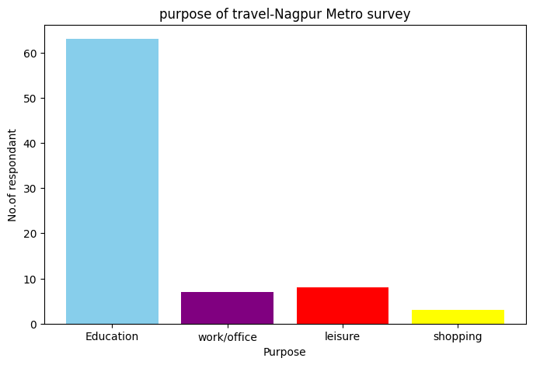
- Calculation of mean, standard deviation and variance using python.
INPUT:
import numpy as np
Punctuality Ratings given by 82 respondents
ratings = [1]*3 + [2]*6 + [3]*18 + [4]*30 + [5]*25
mean = np.mean(ratings)
variance = np.var(ratings)
std_dev = np.std(ratings)

print(f"Mean: {mean:.2f}") # 3.83
print(f"Variance: {variance:.2f}") # 1.1172
print(f"Std Dev: {std_dev:.2f}") # 1.0570
Output:
Mean: 3.83
Variance: 1.12
Std Dev: 1.06
3.frequency distribution table.

INPUT:
import pandas as pd
data = {
'Delay Duration': ['No Delay','1-5 Min','6-10 Min','10+ Min'],
'Respondents': [22, 38, 17, 5],
}
df = pd.DataFrame(data)
df['Percentage'] = (df['Respondents'] / 82 * 100).round(1)
print(df)
OUTPUT:
0 No Delay 36 26.7
1 1-5 Min 59 43.7
2 6-10 Min 28 20.7
3 10+ Min 12 8.9

4.Chi-Square Test – Delay vs Gender
The Chi-Square test checks whether delay experience is statistically independent of the commuter’s gender. This is an advanced inferential statistical technique used to validate relationships between categorical variables:
INPUT:
from scipy.stats import chi2_contingency
# Observed: [No Delay, Some Delay] for [Female, Male]
observed = [[19, 52], # Female: 19 no delay, 52 with delay
[3, 8]] # Male: 3 no delay, 8 with delay
chi2, p, dof, expected = chi2_contingency(observed)
print(f"Chi2: {chi2:.4f}, p-value: {p:.4f}")

if p > 0.05:
print("Result: Delay experience is INDEPENDENT of gender")
else:
print("Result: Delay experience is DEPENDENT on gender")
OUTPUT:
Chi2: 0.0000, p-value: 1.0000
Result: Delay experience is INDEPENDENT of gender
[ ]

Interpretation: If p-value > 0.05, we accept the null hypothesis that delay experience does not significantly differ by gender. This means both male and female commuters face similar delay patterns on Nagpur Metro.

REFERENCES / BIBLIOGRAPHY
1. Srinatha, R., & Adaikalam, J. (2023). Evaluating Service Quality in Namma Metro: A Commuter Perception Study. Journal of Urban Transport, 14(2), 45–58.
2. Jahangir, M. (2022). Commuters’ Perception on Metro Rail Services: A Study of Hyderabad Metro. International Journal of Transport Management, 10(1), 22–34.
3. Delhi Metro Rail Corporation (DMRC). Annual Report 2022–23. New Delhi: DMRC Publications.
4. RITES Ltd. (2021). Comprehensive Mobility Plan for Nagpur – Metro Rail Ridership and Passenger Behaviour Survey. New Delhi: RITES.
5. MahaMetro (Maharashtra Metro Rail Corporation Ltd.). (2023). Nagpur Metro – Official Performance Report 2022–23. Nagpur: MahaMetro.
6. Tokyo Metro Co., Ltd. (2022). Annual Report and Operational Statistics. Tokyo: Tokyo Metro.
7. Ministry of Housing and Urban Affairs, Govt. of India. (2023). Metro Rail Policy and Urban Mobility Framework. New Delhi: MoHUA.
8. Bangalore Metro Rail Corporation Ltd. (BMRCL). (2022). Namma Metro Performance Review 2021–22. Bengaluru: BMRCL.

APPENDIX – SURVEY QUESTIONNAIRE
The following structured questionnaire was used for primary data collection. The online version was distributed via Google Forms and the offline version was administered in-person at Nagpur Metro stations during the academic year 2025–26.
Survey Questionnaire
“A Study on Punctuality, Commuter Perception & Urban Mobility – Focus: Nagpur Metro Rail”
Section A: Demographic Information
- What is your age group? [ ] Below 15 [ ] 15–20 [ ] 21–30 [ ] 31–40 [ ] 41–50 [ ] Above 50
- What is your gender? [ ] Female [ ] Male [ ] Prefer not to say
- What is your occupation? [ ] Student [ ] Working Professional [ ] Business [ ] Other
Section B: Travel Behaviour
- What is your main purpose of travelling by metro? [ ] Education [ ] Work/Office [ ] Leisure [ ] Shopping
- How frequently do you travel by metro? [ ] Daily [ ] 4–5 times/week [ ] 2–3 times/week [ ] Weekly [ ] Occasionally
- During which time of day do you usually travel? [ ] Morning Peak (6–10 AM) [ ] Afternoon (10 AM–4 PM) [ ] Evening Peak (4–9 PM) [ ] Night (After 9 PM)
Section C: Punctuality & Satisfaction
- On average, how much delay do you face? [ ] No Delay [ ] 1–5 min [ ] 6–10 min [ ] More than 10 min
- Rate metro punctuality on a scale of 1 to 5: [ ] 1 (Very Poor) [ ] 2 (Poor) [ ] 3 (Average) [ ] 4 (Good) [ ] 5 (Excellent)
- How would you rate the behaviour and helpfulness of metro staff? [ ] Excellent [ ] Good [ ] Average [ ] Poor
- Overall, how satisfied are you with Nagpur Metro services? [ ] Very Satisfied [ ] Satisfied [ ] Neutral [ ] Dissatisfied [ ] Very Dissatisfied
Section D: Open-Ended
- What do you think is the primary reason for metro delays? _______________________________________________
- What improvements would you suggest for Nagpur Metro services? _______________________________________________

