XMRemoteRobot

Change Log

|  |  |
| --- | --- |
| 20170819 Sat | Document current status codes  Update message examples and field descriptions to reflect most recent dev |
| 20170814 Sun | Rename category field descriptions - (1) "CommandSend", (2) "CommandReceive"  Rename db fields "Command", "Response" |
| 20170717 Mon | Tables "Message" and "MessageLog"  - change field name "Request" to "Command"  - change datatype of "IsLog" from int to bit  - change field name "XTimeRequest" to "XTimeCommand" |
|  |  |

SQL Server efficiency - use varchar  
<http://www.sql-server-performance.com/2007/datatypes/>

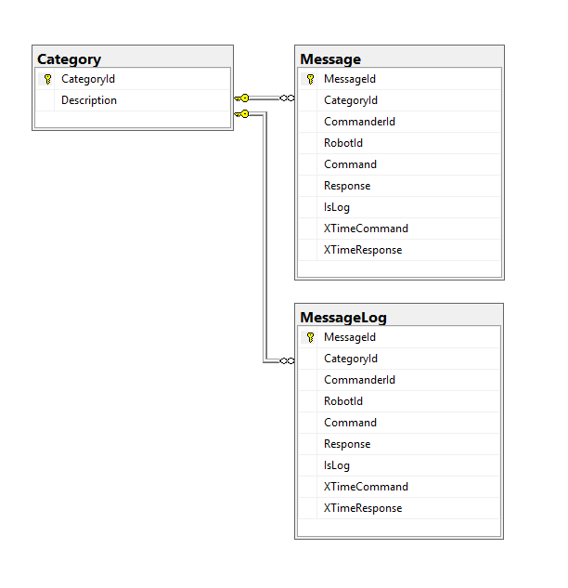

Protocol

Message from device - commander or robot - to server is a form submission   
with a detailed message in json format in field XData. The server response is a json string.

Example Message info from commanding laptop

|  |  |
| --- | --- |
| MessageId | -1 (new – will use identity on database) |
| CategoryId | 1 (CommandSend) |
| CommanderId | 1001 |
| RobotId | 1002 |
| XData | {"vx1x1": 80, "vx1x2": 100} |
| IsLog | 1 |
| XTimeCommand | 2017-08-04 14:33:21.89665 |
| XTimeCollect | (null) |

Response examples - responses always have keywords in lower case

{ "messageid":33071,"categoryid":1,"commanderid":1001,"robotid":1002,"command":{"color": "cyan"},"response":{"status":-1, "time": "12:59:46.51"}  
}

{   
"response":{"status":5, "message": "long polling slow-down while waiting for new command", "time": "13:05:25.08"}  
}

{  
"messageid":33108,"categoryid":1,"commanderid":1001,"robotid":1002,"command":{ "sx1x1":92, "sx1x2":83, "sx2x1":0, "sx2x2":0},"response":{"status":-1, "time": "13:11:31.15"}  
}

Message pickup from robot  
CategoryId = 2 (CommandReceive)  
Same as above except MessageId will be set by DB Identity (auto-increment) – eg 403

Table "Message" record gets cleaned up by the Robot conversation step which deletes old records.  
Because of the server workload, this happens only on every 30th remote method call.  
If IsLog == 1 then old records get backed up into table MessageHistory before doing DELETE

Start with robot polling loop at maximum speed but uses delays on the server to slow down if there are no new messages for the robot to collect. “Long Polling”.

Case: no new command messages after 4 sec – Robot exits with a message saying this has happened.  
"long polling slow-down while waiting for new command"

CategoryId

|  |  |  |
| --- | --- | --- |
| Code | Notes |  |
| 1 | Command Send |  |
| 2 | Collect (Command Receive) |  |
| (3) | (Planned, not yet implemented) Device Telemetry | Possibly implement as a special case of 2? |

Status Codes

|  |  |  |
| --- | --- | --- |
| Code | Specific Message | Other Messages/Data/Notes |
| -1 |  | SUCCESS complete command send/receive \"time\": \"" + HHmmss + "\" |
| 2 | \"messageid\": " + messageId + ", \"cutoffId\": " + cutoffId + ", \"rowsaffected\": " + rowsAffected; | Report to commander on cleanup of old messages. |
| 5 | \"message\", \"long polling slow-down while waiting for new command\" | \"time\": \"" + HHmmss + "\" |
| 20 | \"errormessage\": \"process incomplete\" | Generic error - default message |
| 21 | "errormessage\": \"access not available - contact app owner to check your registration and user status\" |  |
| 22 | \"errormessage\": \"protocol syntax or format error\" |  |
| 23 | \"errormessage\": \"this message has an unrecognised categoryid - we currently only support values of 1 for command-send - 2 for command-collect - and we are working on 3 for telemetry \" |  |
| 24 | \"errormessage\": \"cannot find any commands for this robot - check with the human operator that s/he is active - check config and connections of command device and software\" |  |
|  |  |  |