**OBE Summary**

* **Dashboard**
* **Organizational Setup**

1. Department
2. Degree
3. Program
4. Duration
5. Admission Batch
6. Curriculum Creation
7. Add Teacher
8. Add Appointment

* VC
* Pro- VC
* Treasurer
* Dean
* Head
* Exam Controller
* Faculty Members

1. Add Students

* **Academic Setup**

1. Academic Session
2. Add Courses
3. Course Curriculum Mapping
4. Course Offered
5. Course Teacher Allotment
6. Course Registration
7. Assessments & Exam
8. Semester Promotion

* **OBE Process**

1. Vision
2. Mission
3. PEO
4. PEO Mission Mapping
5. Program Outcomes (PO)
6. PO PEO Mapping
7. Course Outcomes (CO)
8. CO PO Mapping
9. Assessment Components
10. Question Paper Creation
11. Marks Entry
12. CO Attainment
13. PO Attainment
14. PEO Attainment
15. Mission Attainment

* **OBE and System Setup**
* **Indirect Attainment**
* Feedback Question Entry
* Feedback PO Mapping
* Feedback Entry
* Send Feedback Mail
* Feedback Attainment
* **Reports**
* **Additional Utilities**
* **Query Manage**

**OBE Details:**

* **Dashboard**
* **Organizational Setup**

**Faculty:**

* Faculty Name
* Faculty Short Name
* Status

1. **Department**

* Search Option
* Department Name
* Short Name
* Status
* Add Department
* List Table
* Department Name
* Department Short Name
* Category
* Faculty ID
* Status
* Action
* Download List

1. **Degree**

* Search Option
* Degree Type
* Degree Name
* Degree Short Name
* Department ID
* Status
* Add Degree (show form)
* List Table
* Degree Type
* Degree Name
* Degree Short Name
* Status
* Action

1. **Program**

* Search Option
* Program Name
* Program Short Name
* Degree Short Name
* Status
* Add Program (show form)
* List Table
* Program Name
* Program Short Name
* Degree Short Name
* Status
* Action

1. **Degree Program Mapping**

* Search Option
* Degree Department Name
* Program Name
* Degree Program Name
* Program Duration (in years)
* Add Degree Program (show form)
* List Table
* Department Name
* Program Name
* Degree Program Name
* Program Duration
* Status
* Action

1. **Admission Batch**

* Search Option
* Admission Batch
* Status
* Add Admission Batch (show form)
* List Table
* Admission Batch
* Status
* Action

1. **Curriculum Creation**

* Search Option
* Department
* Program
* With Effect From-Admission Batch
* Pattern
* Curriculum Name
* Status
* Add Curriculum Name (show form)
* List Table
* Curriculum Name
* Pattern
* Status
* Action

1. **Add Teacher**

* Search Option
* User Type
* Department
* User Name
* Login ID
* Password
* Mobile Number
* Email ID
* Status
* Add Staff (show form)
* List Table
* User Type
* Department
* User Name
* Login ID
* Mobile Number
* Email ID
* Status
* Action

1. **Add Students**

* Search Option
* Student Name
* Email ID
* Mobile Number
* Student ID
* Degree
* Program
* Level / Term
* Section
* Curriculum Name
* Admission Batch
* Department
* Submit
* Add Students (Show form)
* List Table
* Student Name
* Email ID
* Mobile Number
* Student ID
* Degree
* Program
* Level / Term
* Section
* Curriculum Name
* Admission Batch
* Department
* Status
* Action
* **Academic Setup**

1. Academic Session

* Search Option
* Academic Year Name
* Level / Term
* Semester Name
* Start Date
* End Date
* Status
* Submit
* Add Academic Session (show form)
* List Table
* Academic Year Name
* Start Date
* End Date
* Level / Term
* Semester Name
* Status
* Action

1. Add Courses

* Search Option
* Course Code
* Course Name
* Course Short Name
* Course Credit
* Course Category
* Course Type
* Department
* Status
* Submit
* Add Courses (show form)
* List Table
* Course Code
* Course Name
* Course Short Name
* Course Credit
* Course Category
* Curriculum **(New)**
* Department (list table a thakbe na but add course thakbe)
* Status
* Action

**10.1: Course Summery View (New)**

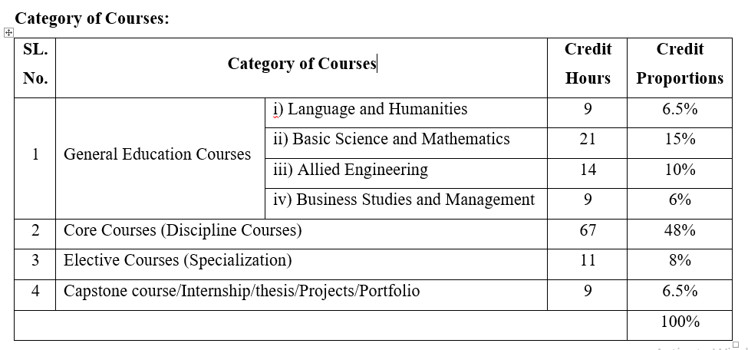

1. Course Curriculum Mapping

* Search Option
* Program
* Curriculum
* Course Type
* Course
* Curriculum Mapping Type
* Status
* Submit
* Add Course Curriculum Mapping (show form)
* List Table
* Curriculum Mapping
* Curriculum
* Course Name
* Course Type
* Status
* Action

1. Course Offered

* Search Option
* Academic Session
* Programme
* Curriculum
* Submit
* Add Course Offered (show form)
* List Table
* Course Code
* Course Name
* Credits
* Offered
* Level/Term

1. Course Teacher Allotment

* Search Option
* Academic Session
* Department
* Program
* Level/Term
* Course Mapping Name
* Section
* Teacher
* Primary Teacher
* Co Teacher
* Status
* Add Teacher Allotment (show form)
* List Table
* Curriculum Mapping Name
* Level/Term
* Section
* Batch
* Teacher
* Type
* Status
* Action

1. Course Registration

* Search Option
* Session
* Department
* Program
* Curriculum
* Section
* Level/Term
* Offered Courses
* Total Students
* Enrolled Students
* Submit
* List Table
* Student Select Option
* Student ID
* Student Name
* Level/Term
* Section

1. Assessments & Exam

* Search Option
* Examination Type
* Examination Name
* Is End Semester
* Submit
* List Table
* Add Examination (show Form)
* Examination Name
* Examination Type
* Is End Semester
* Status
* Action

1. Semester Promotion

* Search Option
* Program
* Curriculum Name
* Level/Term
* Admission Batch
* Section
* Total Selected Student
* Submit
* List Table
* Student Select Option
* Student ID
* Student Name
* Level/Term
* Section
* **OBE Process**

1. Vision
2. Mission
3. PEO
4. PEO Mission Mapping
5. Program Outcomes (PO)
6. PO PEO Mapping
7. Course Outcomes (CO)
8. CO PO Mapping
9. Assessment Components
10. Question Paper Creation
11. Marks Entry
12. CO Attainment
13. PO Attainment
14. PEO Attainment
15. Mission Attainment

* **OBE and System Setup**
* **Indirect Attainment**
* Feedback Question Entry
* Feedback PO Mapping
* Feedback Entry
* Send Feedback Mail
* Feedback Attainment
* **NBA Details**
* **Reports**
* **Additional Utilities**
* **Query Manager**