Lab 5: Adversarial Search
Minimax & Alpha-Beta Pruning
CAI601400 - Artificial Intelligence | CLO2 (C3: Apply)
Faria Moazzam 131 AI-3B

Task 1: Hand Trace of the Supplied Tree (Minimax)
Supplied tree (Section 5.1, padded): leaves [3, 5, 2, 9, 0, 7, 0, 0]. Values are computed bottom-up.
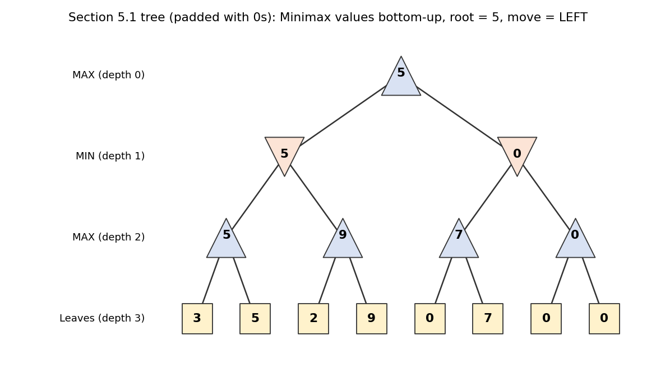
Minimax values for the padded Section 5.1 tree
Depth | Player | Node values (left to right) | How computed
3 | Leaves | 3, 5, 2, 9, 0, 7, 0, 0 | Given terminal utilities
2 | MAX | 5, 9, 7, 0 | max(3,5)=5; max(2,9)=9; max(0,7)=7; max(0,0)=0
1 | MIN | 5, 0 | min(5,9)=5; min(7,0)=0
0 | MAX (root) | 5 | max(5,0)=5
Result: root value = 5. The best move is the LEFT branch (value 5 beats 0). MIN is assumed to choose the outcome worst for MAX, so MAX evaluates each move by what an optimal opponent would leave it. The program output matches this paper trace, and the manual's driver prints the same optimal value 5. Minimax evaluated all 8 leaves.
For reference, the Section 5.2 tree [3, 5, 2, 9, 3, 5, 2, 9] gives MAX values 5, 9, 5, 9, MIN values 5, 5, and root value 5 (LEFT).

Task 2: Leaf Counters and Alpha-Beta Pruning

Alpha-beta trace on the Section 5.2 tree
Step | Event | alpha, beta at node | Decision
1 | Leaf (3,0) = 3 under MAX (2,0) | -inf, inf | value 3, alpha = 3
2 | Leaf (3,1) = 5 | 3, inf | value 5; (2,0) returns 5
3 | MIN (1,0) receives 5 | -inf, inf | beta = 5
4 | Enter MAX (2,1); leaf 2 | -inf, 5 | value 2, alpha = 2
5 | Leaf 9 | 2, 5 | value 9; alpha 9 >= beta 5, but no leaf left to skip. (1,0) = min(5,9) = 5; root alpha = 5
6 | Enter MIN (1,1) then MAX (2,2); leaf 3 | 5, inf | value 3 (alpha stays 5)
7 | Leaf 5; (2,2) returns 5 | 5, inf | value 5
8 | MIN (1,1) gets 5 | alpha 5, beta 5 | alpha >= beta: PRUNE MAX (2,3) and its leaves 2 and 9
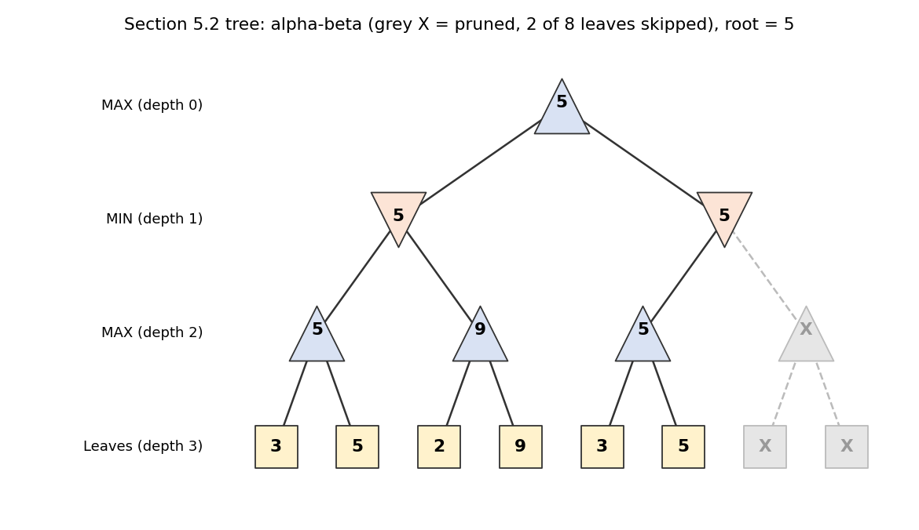
Figure 2: Alpha-beta on the Section 5.2 tree. Grey X nodes were never evaluated.
Why pruning is safe: after the left subtree, MAX is already guaranteed 5. The right MIN node can already be held to at most 5 (its first child is 5), so no value in its remaining child can make it better than 5 for MAX. Skipping it cannot change the root value.

Counter results
Tree | Root value | Minimax leaves | Alpha-beta leaves | Leaves saved
Section 5.2 [3,5,2,9,3,5,2,9] | 5 | 8 | 6 | 2
Section 5.1 padded [3,5,2,9,0,7,0,0] | 5 | 8 | 8 | 0

Both algorithms return the same value and the same move, and alpha-beta never evaluates more leaves than Minimax. In the padded 5.1 tree, alpha-beta saved nothing for this ordering: after the left subtree the right MIN node had alpha = 5, its first child returned 7 (so beta = 7), which does not cross alpha, so its second child (0, 0) still had to be checked. The amount of pruning depends on the tree and the ordering.

Task 3: Reordering Branches
Sibling subtrees were swapped to change the order in which branches are examined. The utilities are unchanged, so the game and its Minimax value are unchanged. Position labels refer to the root's left/right slot: after a swap the same underlying branch can sit in the other slot, so RIGHT in a reordered tree can be the same branch that was LEFT originally.

Named orderings
Ordering | Leaf order | Value | Alpha-beta leaves (of 8) | Position chosen
5.2 original | 3,5,2,9,3,5,2,9 | 5 | 6 | LEFT
5.2 mirror (all swapped) | 9,2,5,3,9,2,5,3 | 5 | 8 | LEFT
5.2 best-first | 5,3,9,2,5,3,9,2 | 5 | 5 | LEFT
5.2 worst-first | 2,9,3,5,2,9,3,5 | 5 | 8 | LEFT
5.1 original | 3,5,2,9,0,7,0,0 | 5 | 8 | LEFT
5.1 mirror | 0,0,7,0,9,2,5,3 | 5 | 7 | RIGHT (same branch)
5.1 swap root only | 0,7,0,0,3,5,2,9 | 5 | 8 | RIGHT (same branch)
5.1 best-first | 5,3,9,2,0,0,7,0 | 5 | 5 | LEFT
5.1 worst-first | 0,7,0,0,2,9,3,5 | 5 | 8 | RIGHT (same branch)
Best-first means a MAX node examines its largest child first and a MIN node its smallest child first. Worst-first is the opposite. For 5.2, swapping only the root gives the same array because its two halves are identical.

All 128 sibling orderings
Tree | Root values seen | Min / max leaves | Mean | Distribution (leaves: orderings)
Section 5.2 | 5 only | 5 / 8 | 6.75 | 5: 16, 6: 48, 7: 16, 8: 48
Section 5.1 padded | 5 only | 5 / 8 | 7.00 | 5: 8, 6: 32, 7: 40, 8: 48
Across all 128 orderings of each tree, Minimax and alpha-beta always agreed on the value (5), and alpha-beta evaluated between 5 and 8 leaves while Minimax always evaluated 8. The best case of 5 leaves matches the known best-case count for branching factor 2 and depth 3 of b^ceil(d/2) + b^floor(d/2) - 1 = 4 + 2 - 1 = 5. Good move ordering matters because pruning needs a strong bound to be found early; bad ordering finds it late and prunes nothing.

4.3 Randomised equivalence check
On 2000 random depth-4 trees (16 leaves, values -10 to 10, seed 42), alpha-beta matched Minimax's root value and root move every time and never evaluated more leaves. On average Minimax evaluated 16.00 leaves and alpha-beta 11.74, and 1955 of the 2000 trees had at least some pruning.

5. Comparison
Aspect | Minimax | Alpha-beta
Leaves evaluated | Always every leaf (8 of 8) | Between 5 and 8 of 8, depending on order
Root value and move | Optimal | Identical to Minimax (verified on all tests)
Ordering sensitivity | None | Large: best-first order gives the most pruning
Worst case | All leaves | Also all leaves (no saving), but never more than Minimax

6. Edge Cases and Failure Analysis
Test | Input | Result
Equal leaves (ties) | [4]*8 | Value 4; Minimax 8 leaves, alpha-beta 5; same move
Negative utilities | [-3,-5,-2,-9,-3,-5,-2,-9] | Value -3; 8 vs 5 leaves
Minimal tree | [6, 2] (depth 1) | Value 6 for both; 2 leaves each (nothing to prune)
Padding sensitivity | [3,5,2,9,0,7] + 0,0 vs + 8,8 | Root value 5 with zero padding, 7 with 8 padding

Failure case analysed: padding the six-leaf Section 5.1 tree.
Input: [3, 5, 2, 9, 0, 7] padded to 8 leaves with 0, 0 (as the manual's driver does) versus 8, 8.
Observed behaviour: the root value is 5 with zero padding but 7 with padding of 8; both algorithms agree with each other in each case.
Likely cause: the manual's code only works on complete binary trees, so the two extra leaves are invented terminal utilities that the algorithm treats as real outcomes. The result depends on that invented data, not only on the original six scores.
Proposed improvement: state the padding assumption explicitly (as done here), or use a tree representation (nested lists or node objects) that allows uneven branching so no artificial leaves are needed.
Second observation: pruning is not guaranteed. The padded 5.1 tree with its original ordering saved no leaves, while a better ordering of the same tree saved three.

Limitations
- The trees are tiny and hand-made, so leaf counts show the effect but do not measure real running time or memory.
- Utilities are given terminal values. Real games need a depth cut-off and a heuristic evaluation function, which are not covered here.
- The tests only use binary trees of fixed depth and assume perfect, alternating, zero-sum play.
- Alpha-beta saves work only when the ordering allows it. Its worst case equals Minimax.

Reflection
What did I learn today? Alpha-beta gives exactly the Minimax decision with the same or less work, and how much it saves depends on move ordering.
How will I apply this in a real AI system? Order moves so promising ones are searched first, document assumptions such as padding or evaluation functions, and always test the faster algorithm against the plain one.
What failed or surprised me? The supplied tree showed no pruning with its original order, and the padded zeros changed the answer when I changed them.
What would I do differently next time? Hand-trace the alpha and beta values before running, and test several orderings from the start.

