TASK-4
.model small
.stack 100h
.data
msg db 'Enter a character: $'
char db ?
.code
main proc
mov ax, @data
mov ds, ax
lea dx, msg
mov ah, 9
int 21h
mov ah, 1
int 21h
mov char, al ; Store the character
mov ah, 2
mov dl, 13
int 21h
mov dl, 10
int 21h
mov cx, 50
print_loop:
mov ah, 2
mov dl, char
int 21h
loop print_loop
Exit:
mov ah, 4ch
int 21h
main endp
end main

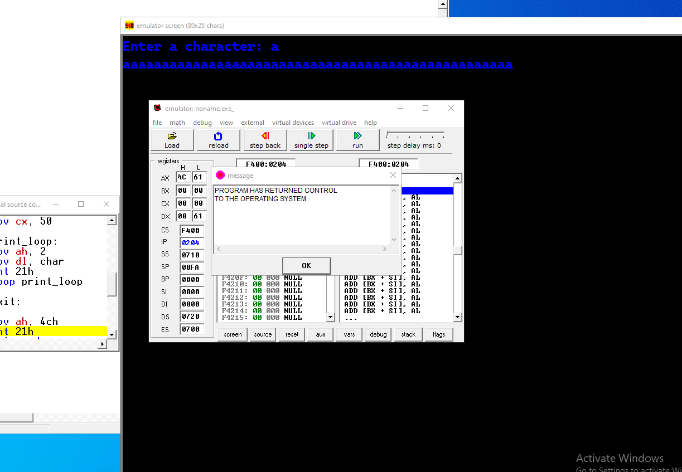

TASK-5
.model small
.stack 100h
.data
msg1 db 'Enter character: $'
msg2 db 'Thank you $'
char1 db ?
char2 db ?
.code
main proc
mov ax, @data
mov ds, ax
lea dx, msg1
mov ah, 9
int 21h
; Read first character
mov ah, 1
int 21h
mov char1, al
; Read second character
mov ah, 1
int 21h
mov char2, al
mov ah, 2
mov dl, 13
int 21h
mov dl, 10
int 21h
; Compare the two characters
mov al, char1
cmp al, char2
jg swap_letters
display_letters:
; Display the characters in order
mov ah, 2
mov dl, char1
int 21h
mov dl, char2
int 21h
mov ah, 2
mov dl, 13
int 21h
mov dl, 10
int 21h
lea dx, msg2
mov ah, 9
int 21h
; Exit
mov ah, 4ch
int 21h
swap_letters:
; Swap char1 and char2
mov al, char1
xchg al, char2
mov char1, al
jmp display_letters
main endp
end main

