Task-1
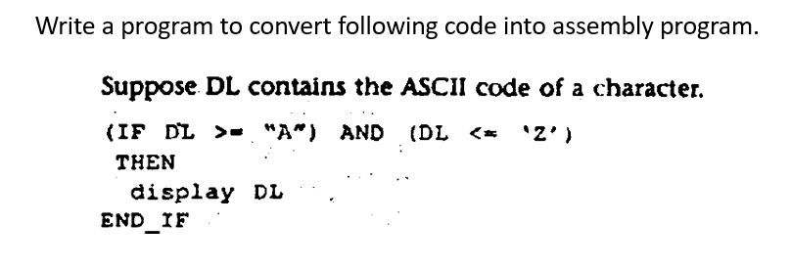
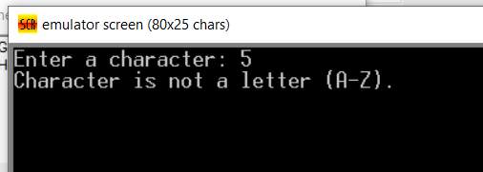

Task-2
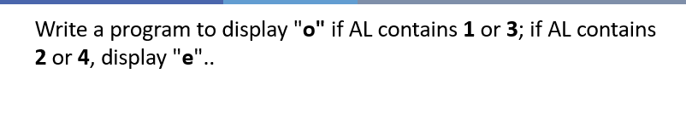
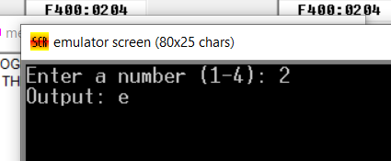
Task-3
Write a program to display a t 0 x 10 solid box of asterisks. Hint: declare a string in the data segment that specifies the box, and display it with INT 2lh, function 9h.
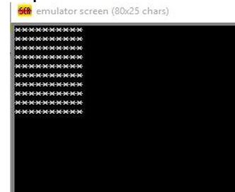

TASK-1
.MODEL SMALL
.STACK 100H
.DATA
MSG1 DB "ENTER A CHARACTER: $"
MSG2 DB "CHARACTER IS A LETTER (A-Z) $"
MSG3 DB "CHARACTER IS NOT A LETTER (A-Z) $"
.CODE
MAIN PROC
MOV AX, @DATA
MOV DS, AX
MOV AH, 09H
LEA DX, MSG1
INT 21H
MOV AH, 01H
INT 21H
MOV BL, AL
MOV AH, 02H
MOV DL, 0DH
INT 21H
MOV DL, 0AH
INT 21H
CMP BL, 'A'
JL NOTLETTER
CMP BL, 'Z'
JG NOTLETTER
MOV AH, 09H
LEA DX, MSG2
INT 21H
JMP ENDPROGRAM
NOTLETTER:
MOV AH, 09H
LEA DX, MSG3
INT 21H
ENDPROGRAM:
MOV AH, 4CH
INT 21H
MAIN ENDP
END MAIN
OUTPUT:
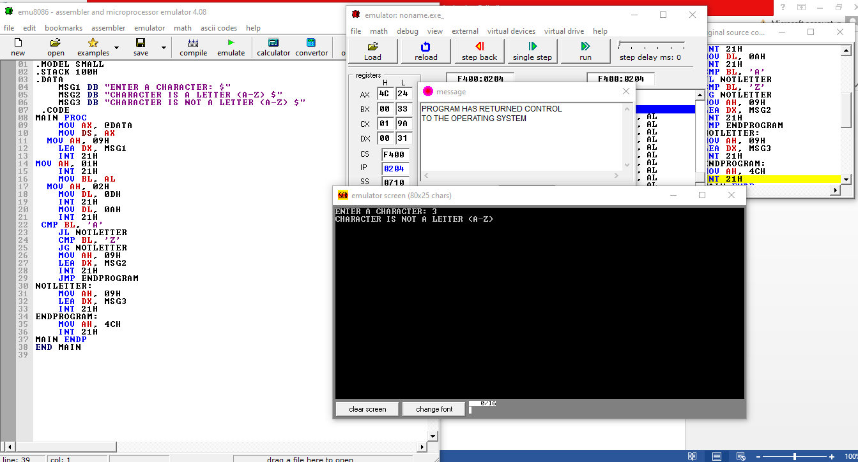
Task 2:
.MODEL SMALL
.STACK 100H
.DATA
MSG1 DB "ENTER A NUMBER (1-4): $"
MSG2 DB "OUTPUT: O $"
MSG3 DB "OUTPUT: E $"
.CODE
MAIN PROC
MOV AX, @DATA
MOV DS, AX
MOV AH, 09H
LEA DX, MSG1
INT 21H
MOV AH, 01H
INT 21H
SUB AL, 30H
MOV BL, AL
MOV AH, 02H
MOV DL, 0DH
INT 21H
MOV DL, 0AH
INT 21H
CMP BL, 1
JE PRINT_O
CMP BL, 3
JE PRINT_O
CMP BL, 2
JE PRINT_E
CMP BL, 4
JE PRINT_E
JMP ENDPROGRAM
PRINT_O:
MOV AH, 09H
LEA DX, MSG2
INT 21H
JMP ENDPROGRAM
PRINT_E:
MOV AH, 09H
LEA DX, MSG3
INT 21H
JMP ENDPROGRAM
ENDPROGRAM:
MOV AH, 4CH
INT 21H
MAIN ENDP
END MAIN
OUTPUT:
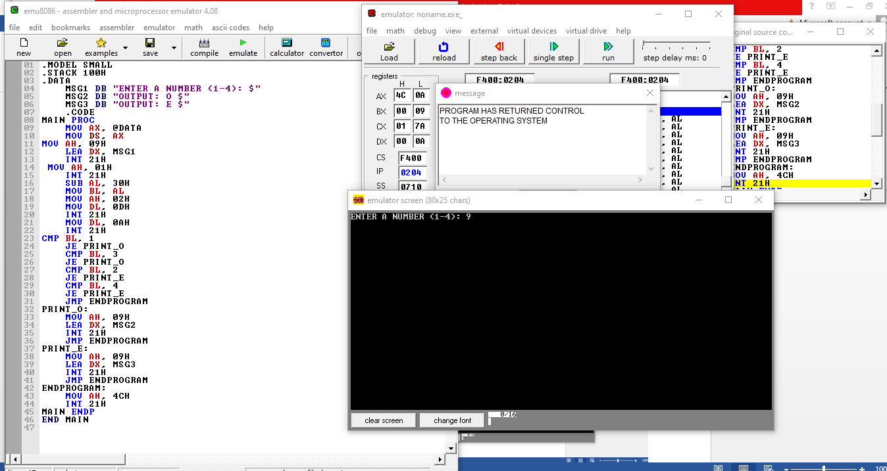

Task 3:
.MODEL SMALL
.STACK 100H
.DATA
MSG1 DB "ENTER A NUMBER:$"
MSG2 DB "THE NUMBER IS GREATER THAN 5.$"
MSG3 DB "THE NUMBER IS LESS THAN 5.$"
MSG4 DB "THE NUMBER IS EQUAL TO 5.$"
.CODE
MAIN PROC
MOV AX, @DATA
MOV DS, AX
MOV AH, 09H
LEA DX, MSG1
INT 21H
MOV AH, 01H
INT 21H
SUB AL, 30H
MOV BL, AL
MOV CL, 5
CMP BL, CL
JG GREATER
JL LESS
JE EQUAL
GREATER:
MOV AH, 09H
LEA DX, MSG2
INT 21H
JMP END_PROGRAM
LESS:
MOV AH, 09H
LEA DX, MSG3
INT 21H
JMP END_PROGRAM
EQUAL:
MOV AH, 09H
LEA DX, MSG4
INT 21H
END_PROGRAM:
MOV AH, 4CH
INT 21H
MAIN ENDP
END MAIN

OUTPUT:
