w00 | w01 | w02 | w03
w10 | w11 | w12 | w13
w20 | w21 | w22 | w23

w00 | w01 | w02 | w03
w10 | w11 | w12 | w13
w20 | w21 | w22 | w23

w00 | w01 | w02
w10 | w11 | w12

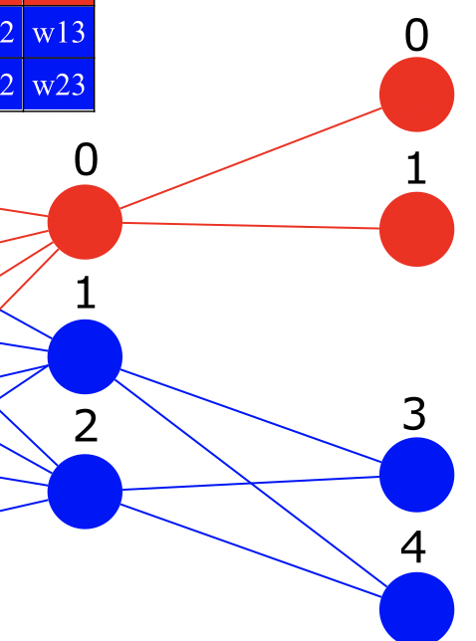
w00 | w01 | w02 | w03
w10 | w11 | w12 | w13
w20 | w21 | w22 | w23

w00 | w21 | w22
w10 | w31 | w32

w00 | w21+w22
w10 | w31+w32

