CSEE5590-0005

IoT/ Robot Programming

(2018 Fall)

*Lab Assignment 3*

**Visualization of the IoT Smart Home**

Submitted On:

11 November, 2018

Submitted By:

Name: Farid Uddin Ahmed

Class ID: 01

Name: Mihir Manoj Pitale

Class ID: 09

Name: Zarin Tasnim Sandhie

Class ID: 10

Name: Kenton William Hanifl

Class ID: 12



LIST OF THE DOCUMENTATIONS

1. AUTHORS
2. OBJECTIVE
3. INTRODUCTION
4. MATERIALS REQUIRED
5. PLATFORM USED
6. CIRCUIT CONNECTION
7. NODE RED FLOW
8. MIT APP DESIGN
9. METHODOLOGY
10. ANDROID APP VISUALIZATION
11. CONCLUSION
12. LINKS

AUTHORS

This is the report containing the documentations of the Assignment #2. The contributors of the assinments are: Farid Uddin Ahmed (Class ID: 01), Mihir Manoj Pitale (Class ID: 09), Zarin Tasnim Sandhie (Class ID: 10) and Kenton William Hanifl (Class ID: 12)

OBJECTIVE

The objective of the project can be listed as follows:

1. Create Arduino/ raspberry pie-based project which will be developed in MIT app inventor.
2. The app should have the ability to turn on the data transmission.
3. Connect any type of sensor with it and dynamically visualize the data in android.
4. For example, we connect light sensor with Arduino and develop app in MIT app inventor. The app should have the capability to turn on the sensor and turn off the sensor. If the sensor is turned on. The sensor should first send a notification “Data Transmission Started”. The app should show the data dynamically in form of graph for the slot of 2 hours. When turn off from app is invoked the data transmission should stop and notification will be received as “Sensor Data stopped”.
5. Finally, the Arduino should be connected via Wifi sensor rather than over the Bluetooth that was exercised in class.
6. Use appropriate use of LED’s, buzzer’s and alerting system as previously exercised. Connect any of the sensor (Light, pressure, temperature etc.) with node red and visualize the data on the dashboard. And post to social net apps.

INTRODUCTION

In the past three weeks of IoT/Robot Programming class, we learned how to communicate between Arduino and Raspberry Pi. We also used fingerprint sensor and firefighting robot with both of the platform. We learned how to view real time data through android app. The assignment #3 is a combination of all the previous three ICPs. The assignment can be subdivide into the following sections:

* Integrate a Light sensor and WIFI module with an Arduino Board.
* Transmit the data from the light sensor using WIFI module to thingspeak.
* From thingspeak, data is fetched to firebase platform via node-red.
* Show the real-time data of the sensors from the firebase into the android app developed in MIT app inventor.
* And observe the sensor data in chart form through developed app.
* Integrate a buzzer, alerting system and a turning on and off procedure with the design.

MATERIALS REQUIRED

* Light Sensor
* Arduino Uno
* ESP8266
* Connectors
* Buzzer
* Bluetooth Module

PLATFORM USED

* Node-red
* Arduino
* MIT app inventor (Android)

CIRCUIT CONNECTON

The circuit is connected as per figure:

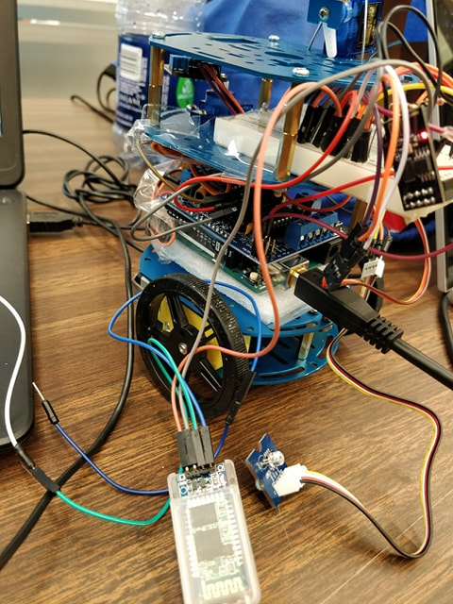

NODE-RED FLOW

The flow is made in node-red. The flow consists of two separate branches, one for dashboard visualization and another is for twitter visualization:

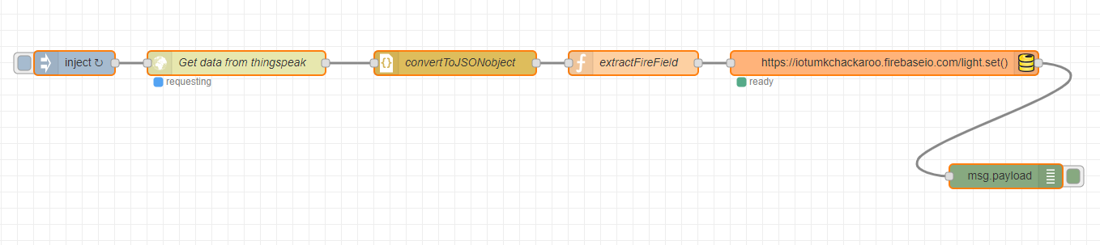

MIT APP DESIGN

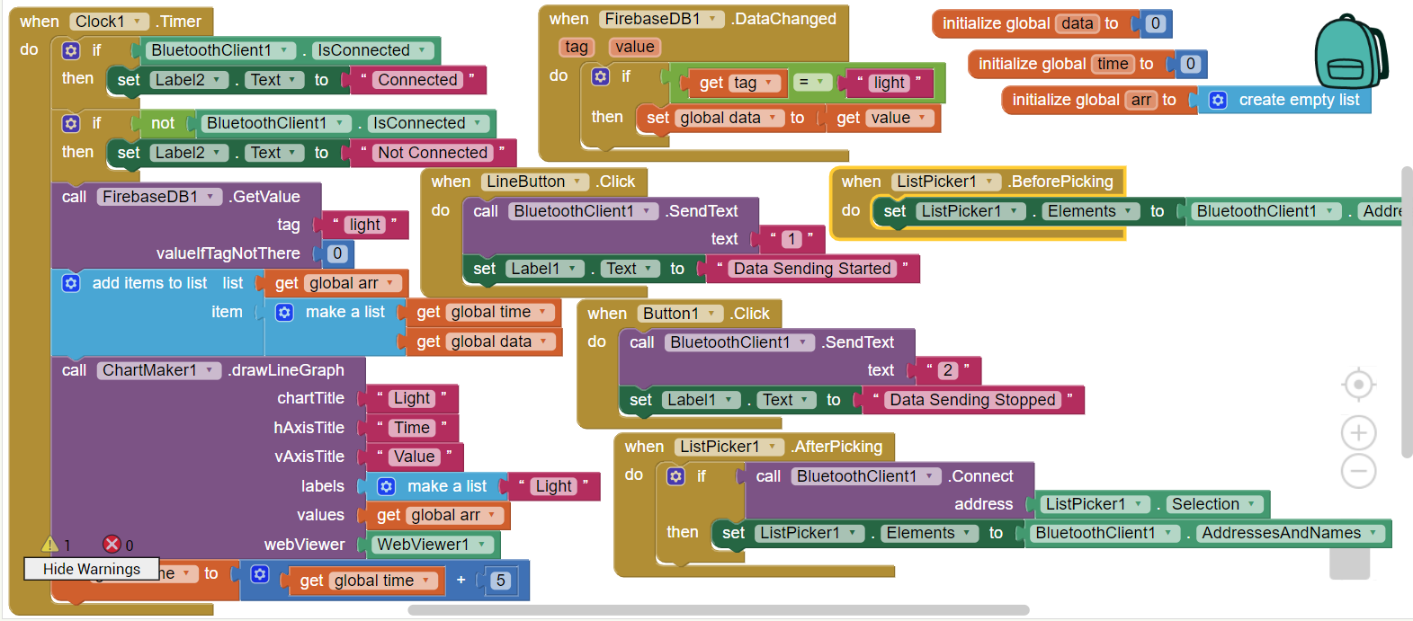

METHODOLOGY

* At first, ESP8266 (WIFI module), light sensor and Bluetooth module is connected to Arduino as per circuit connection.
* Using Arduino code, the data is fetched from sensor and via WIFI module, it is sent to thingspeak.
* Node-red is then used to collect the data from thingspeak and send it to firebase database.
* The data is then extracted from firebase by using MIT app inventor.
* The result is visualized in chart form in MIT app companion from android device.
* A turning on and off system is integrated with the whole design which can turn on and off the sending of the data from the sensor. This procedure is controlled with android app via Bluetooth module.
* A buzzer is also integrated with the system which will make a high pitched sound when the light intensity is too low (<200) and a notification is also sent to mobile.

ANDROID APP VISUALIZATION

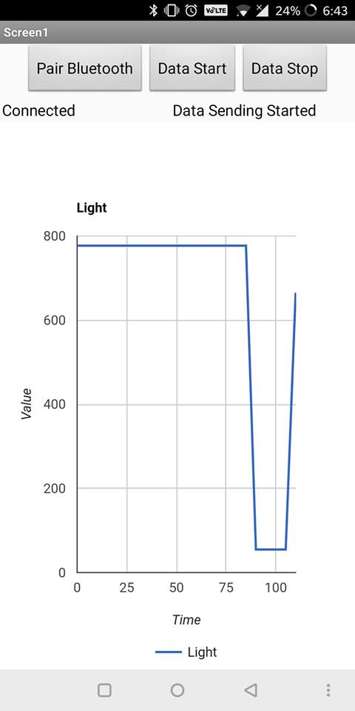

CONCLUSION

This assignment is a combination of all the ICPs done during the previous three weeks. During this assignment, we were able to create a visualization system of an IoT smart home, where we were able to see the sensor data and also control the sensor from a remote place. A turning on-off mechanism, buzzer and notification system were also integrated.

LINKS

GitHub Link:

https://github.com/farid7666/CS5690-IoT-Robot/tree/master/Assignment_3

GitHub Wiki Link:

<https://github.com/farid7666/CS5690-IoT-Robot/wiki/Lab-%233>

Video link:

https://www.youtube.com/watch?v=YGa_81UVn70&fbclid=IwAR1twwCk74GYmtI_ccECp0TOpFD2MwKFsLsqg2iIRXs2qdyGYwXStb1HofA

Source Code Link:

<https://github.com/farid7666/CS5690-IoT-Robot/tree/master/Assignment_3/Source%20code>

Android App Link:

<https://github.com/farid7666/CS5690-IoT-Robot/tree/master/Assignment_3/apk>