
MUHAMMAD FARID AIMAN BIN AZMI
Developer
NRIC No: 000212-10-1111
Nationality: Malaysian

PAST AND PRESENT WORK PORTFOLIO

Design and develop scalable web applications, working across both front-end and back-end to deliver efficient and user-friendly systems. Build and maintain secure APIs, ensuring reliable data handling and system performance. Enhance application responsiveness and usability, particularly for mobile platforms, while collaborating with cross-functional teams to improve overall system stability and user experience.

Projects Involved

- 2025 – National Integrated Immigration System (NIISe)
- 2024 – KPD Access System (Royal Malaysia Police Cooperative)
- 2024 – Retirement Fund System (KWAP)
- 2023 – TourList (Ministry of Tourism, Arts and Culture Malaysia)

QT260000000001793
EDUCATION QUALIFICATIONS

Year Discipline/University
2025 Bachelor of Information System Engineering, University Technology Mara

TECHNICAL EXPERIENCE

Demonstrated experience in full-stack web development using Java, JavaScript, ASP.NET Core, Angular, Blazor, HTML, and CSS to build and maintain scalable web applications. Skilled in working with databases such as MySQL, Oracle, and PostgreSQL, including relational design, query optimization, and data integrity. Experienced in developing secure APIs for high-reliability systems, as well as using Git and Visual Studio Code to support collaborative development, debugging, and structured workflows.

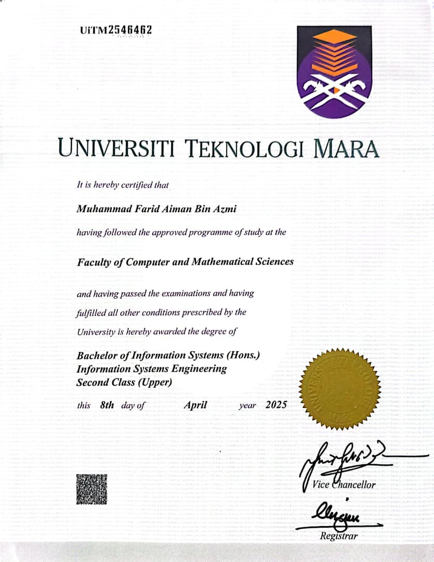
QT260000000001793
24/0054

