Database Design Document

# Curency Exchange Application

This Database Design provides the basis for the Curency Exchange App database design. It defines the database that will support the Curency Exchange App Data Model. It describes logical definition database.

## Entities and Attributes

The following table lists entities and attributes that are not implemented as tables and columns.

Table.ExchangeRate

|  |  |  |  |
| --- | --- | --- | --- |
| No | Entity | type | Description |
| 1. | Id_Rate | INTEGER | Primary Key |
| 2. | Cur_From | TEXT | Curency Name |
| 3. | Cur_To | TEXT | Curency Name |
| 4. | Cur_Rate | FLOAT | Curency Rate |
| 5. | Cur_Date | DATETIME | Store Date for the daily RATE |
| 6. | Cur_avg_Rate | FLOAT | Average rates from last 7 Days |

Table.MasukanRate

|  |  |  |  |
| --- | --- | --- | --- |
| No | Entity | type | Description |
| 1. | Id | INTEGER | Primary Key |
| 2. | Cur_From | TEXT | Curency Name |
| 3. | Cur_To | TEXT | Curency Name |
| 4. | Cur_Rate | FLOAT | Curency Rate |
| 5. | Cur_Date | DATETIME | Store Date for the daily RATE |
| 6. | Id_Rate | INTEGER | Foreign Key from Exchange Rate PK |

## Relational

## 

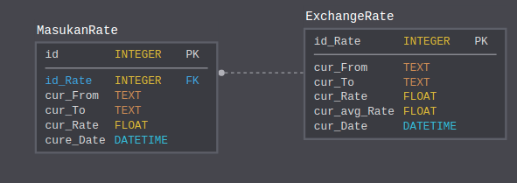

* When the user add a new exchange rate to the list, it will insert to the ExchangeRate Table
* MasukanRate table will Store the daily data Rate that input by user
* When user requested to track the exchange rate by date, App will be fetch daily data from Masukan Rate table and measure the average and update the ExchangeRate Record
* If user want to delete an Exchange Rate from the list. It will delete all record both in MasukanRate Table and ExchangeRate Table