CONTEXT DICTIONARY
The main function of the context dictionary in Django is to pass data from the view to the template so that it can be dynamically rendered in the browser.

Key Roles of the Context Dictionary:
- Connect View Logic to Templates:
  - It bridges the gap between the backend (view) and frontend (template).
  - For example:
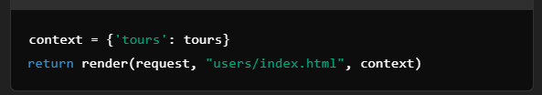
The template index.html can now access the tours data using the key 'tours'.
- Facilitate Dynamic Content:
- Data in the context dictionary allows templates to display dynamic content instead of static hardcoded values.
- Example in a template:
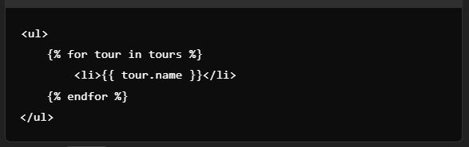
Here, the tours data from the context is dynamically iterated over.
- Organize and Manage Data:
- It groups multiple variables or objects into a single, well-structured dictionary that the template can access.
- Example:
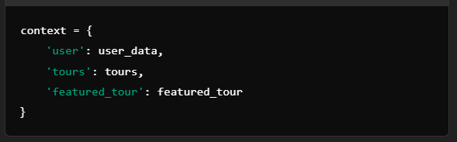

- Enhance Template Functionality:
  - The context allows you to inject not just raw data but also additional computed or filtered data needed for the template.

Why Use a Dictionary?
- Key-Value Structure: Makes it easy to map data in the backend (key) to the template (value).
- Flexibility: You can pass any type of data—strings, integers, lists, querysets, or even custom objects.
In summary, the context dictionary is a crucial tool in Django's Model-View-Template (MVT) architecture for sharing data between the view and template, enabling dynamic and interactive web pages.

