DJANGO ASSETS
In Django, assets refer to static files that are used by your web application. These files include CSS, JavaScript, images, fonts, and other resources necessary for rendering the user interface. Django provides a structured way to manage these static files through its static files framework.

Key Concepts of Django Assets
- Static Files:
Static files are non-dynamic resources like CSS, JavaScript, and images. These files do not change with user interactions or server processing.
- Static Root and URL:
Django uses a STATIC_URL setting to define the base URL where static files will be served from (e.g., /static/).
The STATIC_ROOT setting specifies the directory where static files are collected for deployment.
- Static File Storage:
During development, static files are usually served by Django's development server.
In production, they are typically collected and served from a centralized location, such as a CDN or a dedicated file server.
- Staticfiles App:
The django.contrib.staticfiles app provides utilities for managing static files. It includes:
  - collectstatic command: Collects all static files into a single directory specified by STATIC_ROOT.
  - findstatic command: Helps debug static file paths.
- Static Files Location:
You can store static files in several places:
  - App-level directories: Each app can have its own static directory.
  - Global directories: Common static files can be stored in global static directories listed in the STATICFILES_DIRS setting.
- Template Usage:
Static files can be included in templates using the {% static %} template tag:

- Media Files:
Media files are user-uploaded content, such as images or documents. They are separate from static files and managed using the MEDIA_URL and MEDIA_ROOT settings.

Best Practices for Managing Assets
- Use a Frontend Build Tool:
Integrate tools like Webpack, Gulp, or Django Webpack Loader to compile and bundle assets.
- Version Control:
Include only source files in version control. Compiled or minified files can be generated during deployment.
- Minification and Optimization:
Optimize CSS and JS files for faster loading in production.
- CDN for Deployment:
Serve static files through a Content Delivery Network (CDN) for better performance.
- Organize Files:
Structure your static files logically to avoid conflicts. For example:
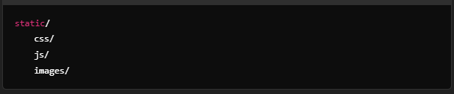
- Django Compressor:
Use tools like django-compressor to compress and combine CSS/JS files dynamically.
- Environment-specific Configuration:
Set up different configurations for development and production. For instance, use Django's development server for static files in development and a dedicated server (e.g., Nginx) in production.

1. App-Level Directories
Each Django app can include its own static directory to store static files specific to that app.

Key Points:
- The static directory is located inside the app directory.
- Files in this directory are automatically included when you use Django's static files framework.
- This approach is useful for keeping the static files closely tied to the functionality of the app.

Example:
Assume you have a blog app in your Django project. The structure might look like this:
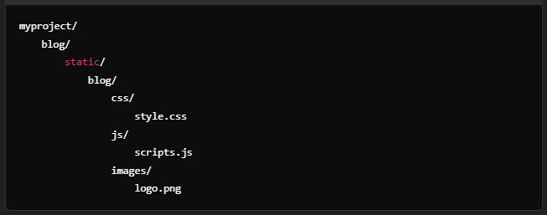
- Access in Templates:
You can access these files in your templates using the {% static %} template tag:
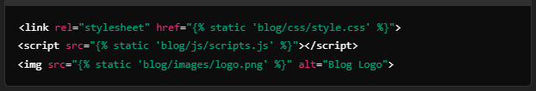

- Namespace Recommendation:
It's a good practice to namespace your static files (e.g., blog/css/style.css instead of css/style.css) to avoid naming conflicts across apps.

2. Global Directories
In addition to app-level directories, you can store static files in one or more global directories. These are defined in the STATICFILES_DIRS setting.

Key Points:
- Global directories are not tied to a specific app.
- They are useful for shared or commonly used static files (e.g., libraries, frameworks, or assets used across multiple apps).
- These directories need to be explicitly listed in the STATICFILES_DIRS setting in your Django settings file.

Configuration in settings.py:
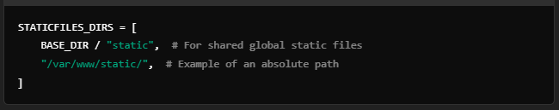

Example:
Assume you want to store shared files like Bootstrap CSS and global JavaScript files in a global static directory. The structure might look like this:
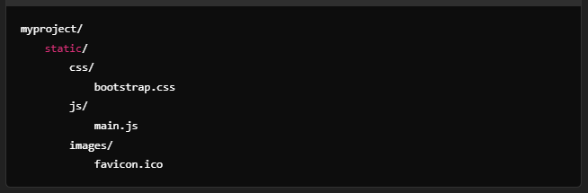
- Access in Templates:
You can access these files the same way:
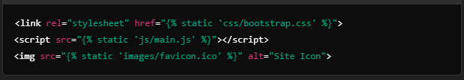

Differences Between App-Level and Global Directories
Feature | App-Level Directories | Global Directories
Location | Inside individual app directories | Separate directory (e.g., static/)
Purpose | App-specific static files | Shared/static files for the whole project
Automatic Inclusion | Automatically discovered by Django | Must be listed in STATICFILES_DIRS
Namespace Management | Namespacing recommended per app | Typically used for shared libraries or assets

Combining Static Files from Multiple Locations
When running the collectstatic command, Django collects all static files from:
- App-level static directories.
- Global directories listed in STATICFILES_DIRS.
These files are then placed in the directory specified by the STATIC_ROOT setting for deployment. This ensures all static files are centralized and can be served efficiently in production.

Example Deployment Structure:
After running collectstatic, your STATIC_ROOT directory might look like this:
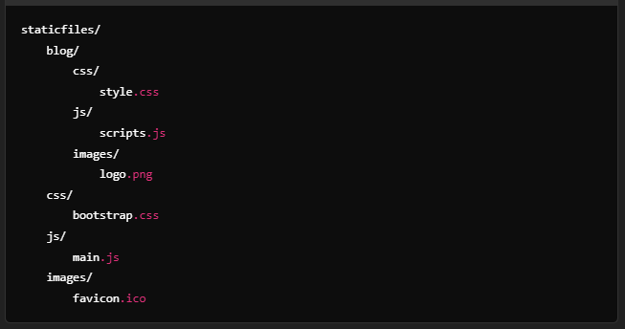

When to Use Which Location
- App-Level Directories:
Use when static files are specific to a single app (e.g., custom app styles, app-specific JavaScript).
- Global Directories:
Use for shared resources (e.g., Bootstrap, jQuery, or global branding assets like logos and icons).

CONFIGURATION IN SETTINGS.PY
Many older Django tutorials use os.path.join() to define paths for settings like STATICFILES_DIRS, MEDIA_ROOT, or TEMPLATES directories. This approach is still valid but has been somewhat replaced in modern Django projects by the pathlib library, which provides a more intuitive and object-oriented way to handle file paths.
Here’s an explanation of the os.path.join() approach and its usage:

Using os.path.join()

Why Use It?
Django projects often need to construct paths dynamically, particularly for directories like STATICFILES_DIRS, TEMPLATES, and MEDIA_ROOT. Since file paths vary by operating system, os.path.join() ensures compatibility by joining path components correctly for the operating system.

Example Configuration
Here's an example of using os.path.join() in settings.py:
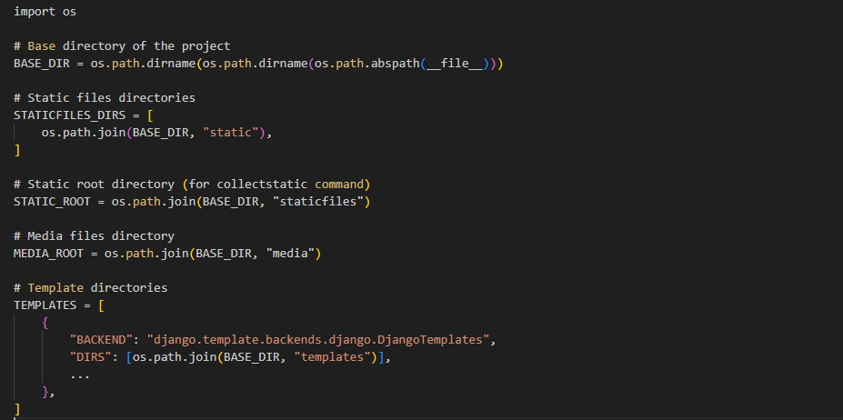

How os.path.join() Works
os.path.join() dynamically constructs file paths by combining directory names with the correct separator (/ on Unix-based systems or \ on Windows).

Example:
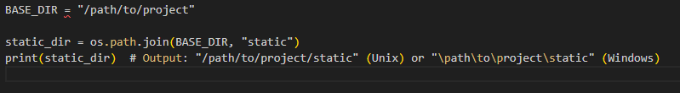
This ensures your project works seamlessly across different operating systems.

Why Some Tutorials Use pathlib Instead
The pathlib library introduced in Python 3.4 (and commonly used in Django projects starting with version 3.1) provides a more modern and intuitive way to handle paths. Instead of os.path.join(), you work with Path objects.

Example Using pathlib
Here’s the same configuration using pathlib:
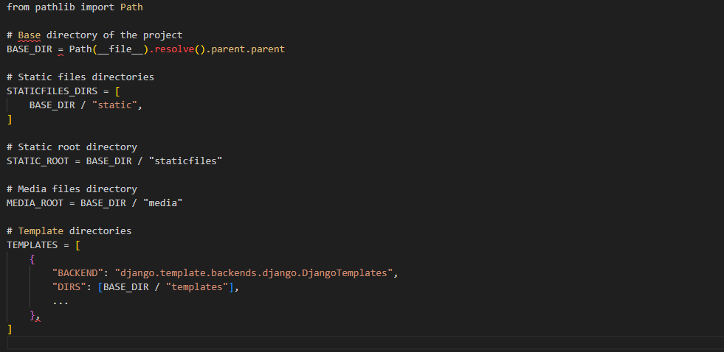

Feature | os.path.join() | pathlib
Syntax | Functional, uses function calls | Object-oriented, uses / operator
Readability | Less intuitive (nested function calls) | More intuitive and clean
OS Compatibility | Fully compatible | Fully compatible
Introduced in Python | Available in Python 2 and later | Introduced in Python 3.4 and later

Best Practice
- For new Django projects, use pathlib, as it is the modern standard and more readable.
- For existing projects or when following older tutorials, using os.path.join() is perfectly fine.
Both methods are valid and achieve the same result, so the choice depends on your project and Python version.

