DJANGO URLS
In Django, the two urls.py files serve distinct purposes and are part of a modular and scalable design for managing URLs in a project:

1. Project-level urls.py (Root URL Configuration)
- Located in the project's main directory (e.g., next to settings.py).
- Acts as the central dispatcher for the entire Django application.
- Maps root-level URL patterns to the URL configurations of individual apps via include().
- Example:
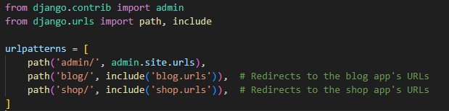
- It provides a global view of how URLs are distributed across the project.

2. App-level urls.py
- Located in the specific app directory (e.g., blog/urls.py or shop/urls.py).
- Handles URL patterns specific to that app.
- Keeps the URL routing logic for the app self-contained and modular.
- Example for blog/urls.py:
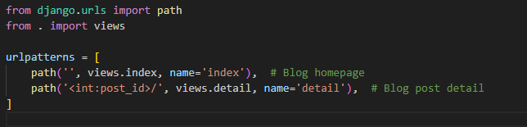
- This modularity makes it easier to manage URLs when the application grows or if the app is reused in other projects.

Benefits of this Design:
- Modularity: Each app can manage its own URLs independently, making the project easier to maintain.
- Reusability: Apps can be easily reused in other projects without conflicts, as their URL logic is self-contained.
- Scalability: Allows you to keep the project-level urls.py clean and focused on routing to apps.
By separating the project-level and app-level URLs, Django achieves a clean and organized structure for routing requests.

THE RULES USED TO DEFINE URLS IN DJANGO
Defining URLs in Django requires following specific rules and conventions to ensure the framework correctly routes incoming requests to the appropriate views. Below are the key rules and best practices:

1. Import Necessary Modules
- Use path (or re_path for regex-based patterns) from django.urls for URL patterns.
- Import include to link app-level URL configurations.
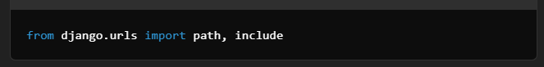

2. URL Patterns Must Be a List
- The urlpatterns variable in urls.py must be a Python list of URL patterns.
- Example:
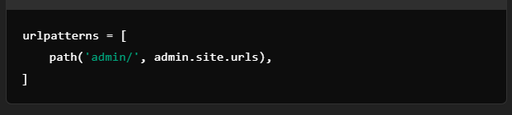

3. Path Format
- Use the path() function for defining simple, human-readable URL patterns.
- Syntax:
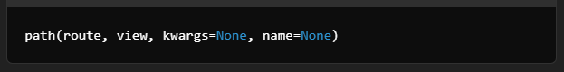
  - route: The URL string (e.g., 'blog/').
  - view: The view function or class that handles the request.
  - kwargs: Optional dictionary of additional arguments to pass to the view.
  - name: Optional name for the URL, used for reverse lookups.
Example:
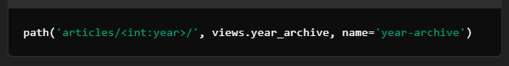

4. Dynamic Segments
- Use <converter:name> to capture dynamic parts of the URL.
- Available converters:
  - str: Matches any non-empty string (default).
  - int: Matches integers.
  - slug: Matches a slug string (letters, numbers, underscores, hyphens).
  - uuid: Matches a UUID string.
  - path: Matches any string, including slashes.
Example:
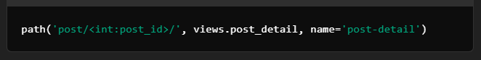

5. Use re_path for Regex-based Patterns
- For advanced URL matching, use re_path().
- Example:
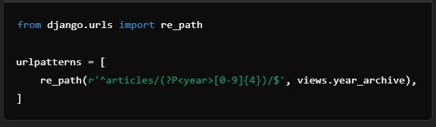

6. Include App-level URLs
- Use include() to connect project-level and app-level urls.py.
- Example:
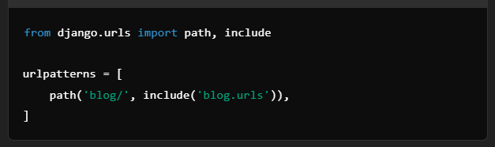

7. URL Names
- Assign a unique name to each URL for easy reference in templates and views.
- Example:
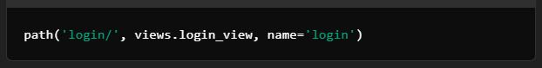

8. Default Admin URL
- Always include the Django admin route.
- Example:
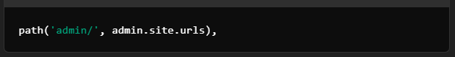

9. Namespace URLs
- Use namespaces for apps to avoid URL name conflicts when using include().
- Example in project-level urls.py:
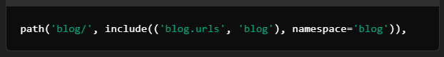

Reference a URL in templates/views:
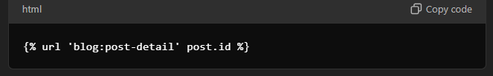

10. Trailing Slashes
- By default, Django expects trailing slashes in URLs (e.g., path('about/', views.about)).
- URLs without trailing slashes will redirect to their trailing slash versions unless APPEND_SLASH = False is set in settings.py.

11. Static and Media Files
- Use django.conf.urls.static.static to serve static and media files during development.
- Example:
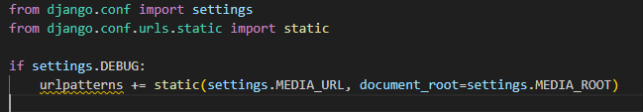

12. 404 Handling
- Ensure undefined URLs are handled gracefully using Django's default 404 page or custom error views.
- Example:
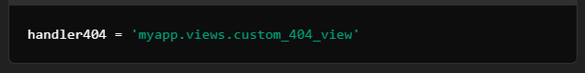

Following these rules ensures a clean, maintainable URL structure in Django projects.

