Django Forms: A Deep Dive
Django forms are a powerful feature of the Django framework that provides tools for handling user input, validation, and form rendering. Forms are used to collect and process data from users and ensure that the data submitted meets certain requirements.

1. Understanding Django Forms
A Django form is essentially a Python class that inherits from django.forms.Form or django.forms.ModelForm. It defines the fields of the form, their types, and any associated validation logic.

Key Benefits:
- Automatic Validation: Fields have built-in validators based on their types (e.g., EmailField checks for valid email addresses).
- Reusable: Forms can be used across views or templates.
- Clean Separation: Keeps the form logic separate from the HTML and business logic.

2. Creating a Django Form

Basic Example:
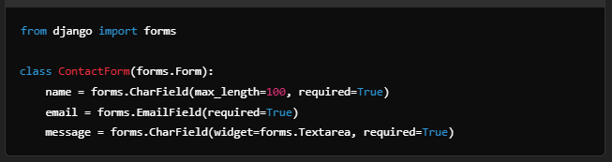

- Fields: Define the type of input (CharField, EmailField, etc.).
- Attributes:
  - max_length: Limits the length of input.
  - required: Specifies whether the field is mandatory.
  - widget: Customizes the HTML representation (e.g., Textarea for multi-line text).

3. Using Forms in Views

Rendering in a View:

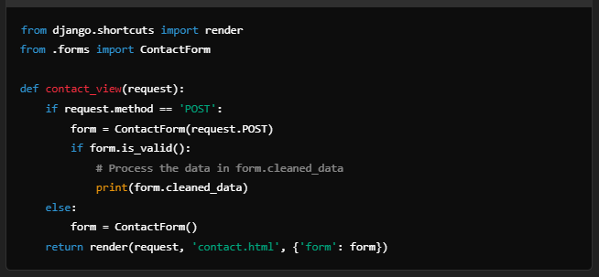
- Initialization:
  - ContactForm(): Renders an empty form.
  - ContactForm(request.POST): Populates the form with user-submitted data for validation.
- Validation:
  - form.is_valid(): Checks if the form data meets validation rules.
  - form.cleaned_data: Returns the validated data.

4. Rendering Forms in Templates
Use Django’s template system to render forms dynamically.

Example:

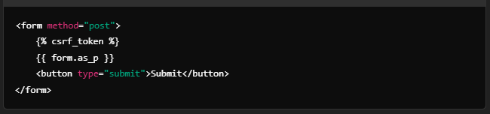
- Rendering Methods:
  - form.as_p: Renders fields wrapped in <p> tags.
  - form.as_table: Renders fields in a table.
  - form.as_ul: Renders fields as a list.

Custom Rendering:
For more control, render each field manually:
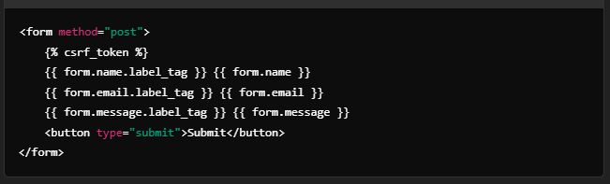

5. ModelForms
ModelForms simplify the process of creating forms for database models. They automatically generate form fields based on model fields.

Example:
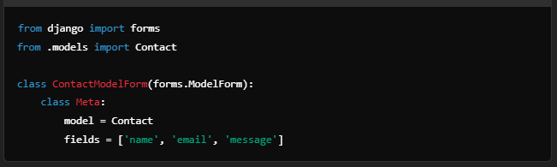
- Advantages:
  - Automatically linked to a model.
  - Reduces boilerplate code.
- Customizing: You can customize fields or widgets in the Meta class or override the __init__ method.

6. Form Validation
Django provides built-in and custom validation for form fields.

Built-in Validation:
Each field type has default validation. For example:
- EmailField: Ensures the input is a valid email.
- IntegerField: Ensures the input is a number.

Custom Field Validation:
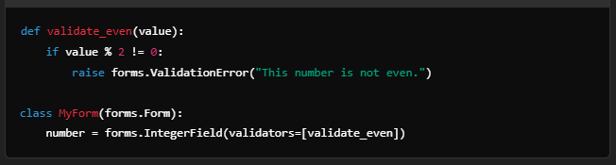

Custom Form Validation:
Override the clean method:
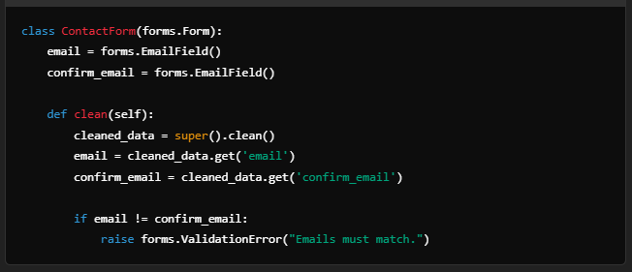

7. Widgets
Widgets control the HTML rendering of form fields. Django provides many built-in widgets like TextInput, Textarea, Select, etc.

Example:

8. Advanced Features

Handling File Uploads:
Use FileField or ImageField for handling file uploads.
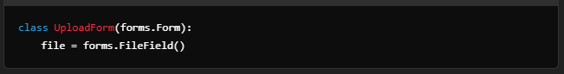
In the view:
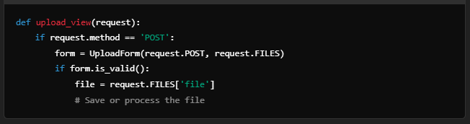

Formsets:
Formsets allow managing multiple forms on a single page.
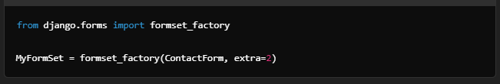

Crispy Forms:
The django-crispy-forms library helps style forms dynamically with frameworks like Bootstrap.
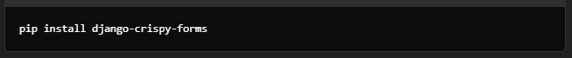

9. Best Practices
- Separation of Concerns: Keep form logic in forms.py and avoid mixing it with views.
- Custom Validation: Use the clean_<fieldname> method for field-specific validation.
- DRY Principle: Use ModelForms for forms linked to models to reduce duplication.
- Styling: Leverage widgets or libraries like django-crispy-forms for better UI.

ATTRS
The attrs parameter in Django forms is used to pass HTML attributes to form widgets. These attributes can define the appearance, behavior, or additional metadata for the rendered HTML elements.
For example, you can use attrs to set classes, placeholders, IDs, styles, and other properties of the HTML form elements.

Common Uses of attrs
- Styling Form Fields: Add CSS classes to style the form fields.
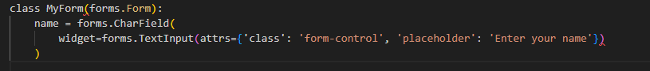
Generated HTML:
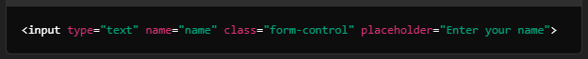
- Adding Placeholders: Provide placeholder text to guide users.
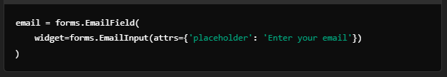
- Custom IDs: Assign unique IDs for JavaScript or CSS targeting.
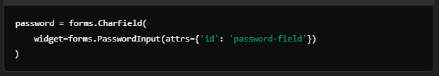
- Setting Read-only Fields: Make fields read-only.
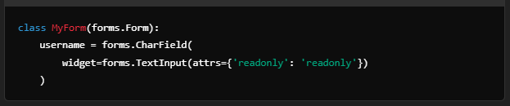
- Adding Inline Styles: Set inline styles directly.
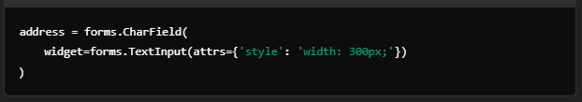
- Using JavaScript Events: Attach JavaScript event listeners.
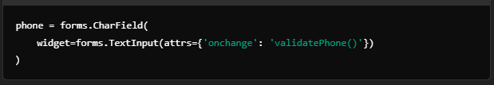

Example: Applying attrs to Multiple Fields
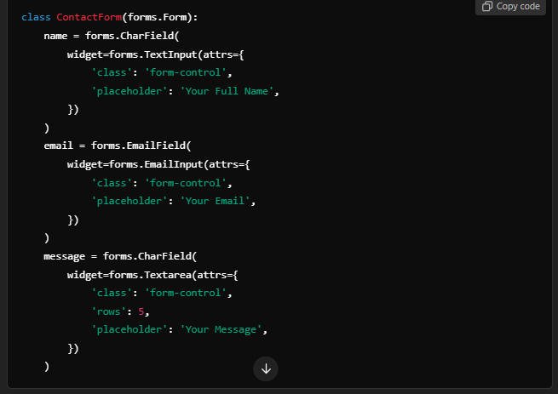
Generated HTML:
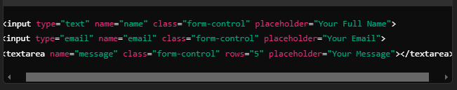

Why Use attrs?
- Customization: Makes it easy to tailor form fields for specific UI frameworks (e.g., Bootstrap).
- Accessibility: Add attributes like aria-label or aria-describedby for better accessibility.
- Behavior Control: Attach attributes like readonly, disabled, or event listeners for dynamic interactions.

Note:
The attrs parameter is passed to the widget associated with a form field. Each field type has a corresponding default widget, but you can also customize the widget or use a different one. For example:
By using attrs, you have fine-grained control over the rendered HTML elements for Django forms, making it easier to integrate with modern UI designs and libraries.
NOTE:
In the context of the forms.Textarea widget in Django, the rows and cols attributes are HTML attributes that define the dimensions of the <textarea> element. Here's what they mean:

rows
- Specifies the number of visible text lines in the <textarea>.
- Determines the vertical size of the <textarea> (height in terms of text lines).
- Example:
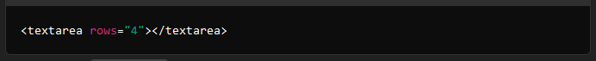
- This creates a <textarea> with 4 visible text lines.

cols
- Specifies the width of the <textarea> in terms of the number of characters it can display in a single line.
- Determines the horizontal size of the <textarea>.
- Example:
This creates a <textarea> with enough width to display approximately 50 characters on one line.

Full Example
Using both rows and cols together, as in your Django code:
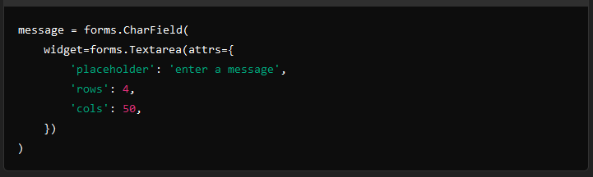
Would render HTML like this:
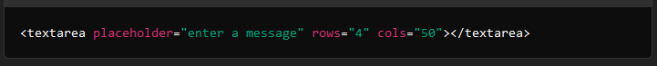

Effect
- This creates a <textarea> box with 4 lines of height and a width to fit about 50 characters per line.
- Users can still resize the <textarea> manually in modern browsers, unless CSS styles (like resize: none;) prevent it.

Modern Alternatives
If you want a more flexible layout, instead of hardcoding rows and cols, you can use CSS for better control:
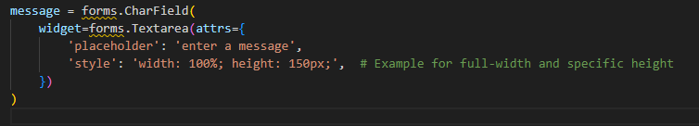
This would result in:

Summary
- rows: Controls vertical size (height in text lines).
- cols: Controls horizontal size (width in characters).
- Use them for simple sizing, or replace with CSS for more precise control and responsiveness.
WIDGET
In Django forms, a widget is a class that determines how a form field is rendered as HTML and how it interacts with user input. Widgets define the input type (e.g., text, password, checkbox) and provide the ability to customize the HTML structure of form fields.

Why Use Widgets?
- Control the HTML Representation: Choose the appropriate input type for your field (e.g., TextInput, Textarea, Select).
- Customize the Form: Add attributes like class, id, placeholder, etc., to tailor the appearance and behavior of the form fields.
- Handle User Input: Ensure the correct type of data is collected and processed.

Built-in Widgets
Django provides several built-in widgets for different input types:
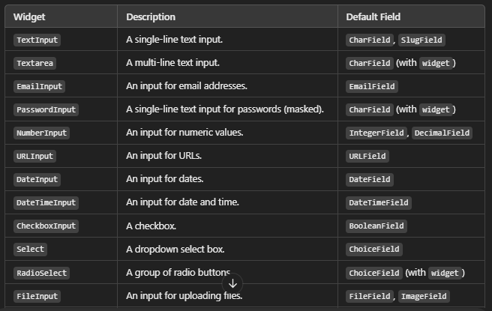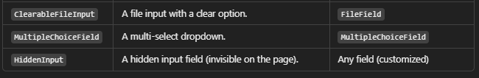

Customizing Widgets

Setting Widgets in a Form Field:
Widgets can be set when defining fields in a form.
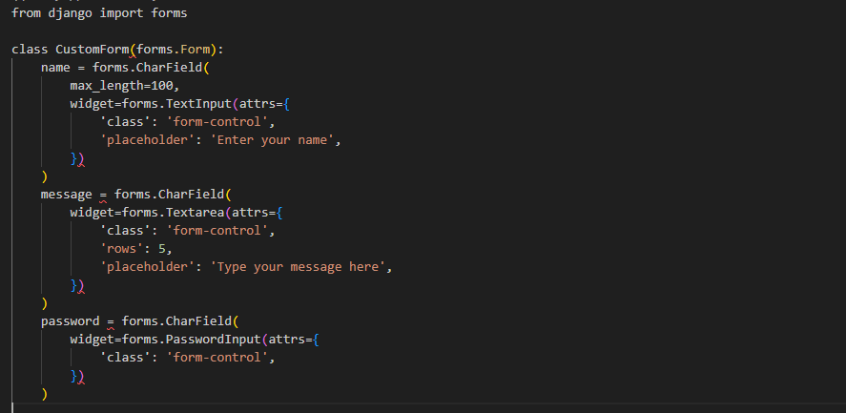
Generated HTML:
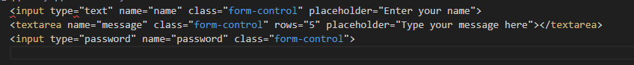

Using Widgets in ModelForms
Widgets can also be customized in ModelForm using the Meta class.
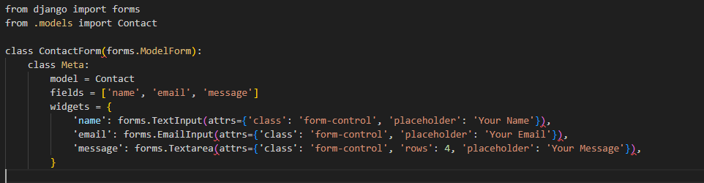

Custom Widgets
You can create your own widget by inheriting from Django's base widget classes.

Example:
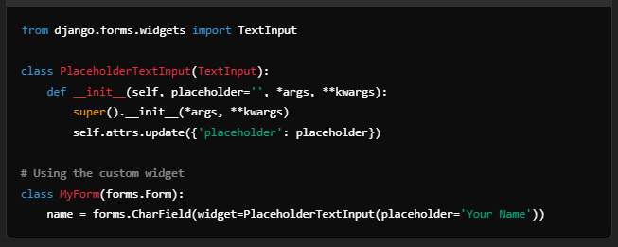

Advanced Widget Features
- Hidden Fields: Use HiddenInput for storing hidden data in the form.
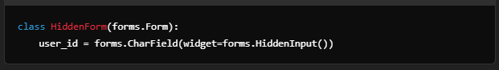
- File Uploads: Use FileInput or ClearableFileInput for handling file uploads.
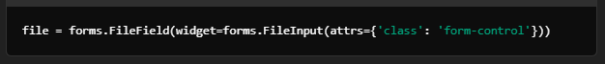
- JavaScript Integration: Add custom attributes for JS libraries (e.g., datepickers, sliders).
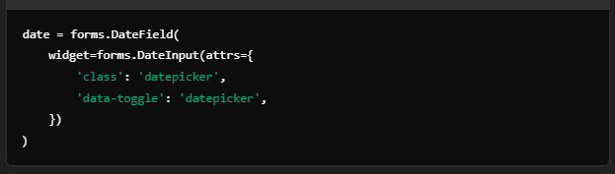
- Dynamic Widgets: Customize the widget at runtime by overriding the form’s __init__ method.
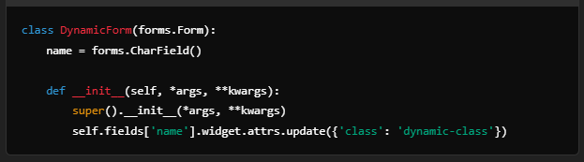

Summary
Widgets are a crucial part of Django forms, enabling developers to control how form fields are rendered in HTML. By using built-in widgets or creating custom ones, you can tailor your forms to fit specific UI requirements while ensuring user-friendly interaction.
NOTE:
If you are not explicitly using widgets in your Django forms, Django will still use its default widgets for rendering the form fields in HTML. Widgets are the way Django determines how a form field should be displayed in the browser. Without explicitly specifying a widget, Django assigns default widgets based on the type of the form field.
For example:
- A CharField will use a <input type="text">.
- An EmailField will use a <input type="email">.
- A ChoiceField will use a <select> element.
- A BooleanField will use a <input type="checkbox">.

What Happens Without Explicit Widgets?
If you don't use widgets explicitly:
- Django Auto-Assigns Default Widgets: Django uses default widgets for each field type. For example:
- forms.CharField() → <input type="text">
- forms.DateField() → <input type="text"> (or <input type="date"> if you use modern browsers)
- No Customization: Without widgets, you cannot customize attributes like placeholder text, CSS classes, or specific behaviors of the input fields.
- HTML Rendering: The rendered HTML will be simple and rely entirely on the defaults.
Example:
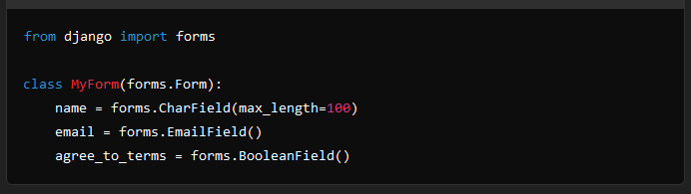
The resulting HTML will look like this:
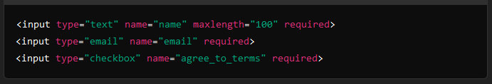

Why Use Widgets?
Using widgets allows you to customize how the form fields appear. For example:
- Add custom CSS classes for styling.
- Add placeholders, default values, and data attributes.
- Use advanced widgets like date pickers, rich text editors, or custom JavaScript components.
Here’s an example of customizing a field with a widget:
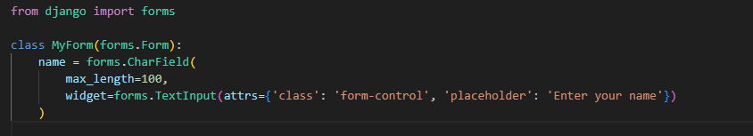
The resulting HTML:

When Not to Use Widgets Explicitly?
You might not need widgets in:
- Quick Prototyping: When you are building a form quickly for testing purposes.
- Simple Forms: If default HTML elements are sufficient.
- Backend-Only Forms: If the forms are used primarily for backend validation without concern for frontend display.
In summary, while widgets are not mandatory, they are highly recommended if you need to tailor the appearance or behavior of your form fields in the browser. Without them, Django will simply use its default rendering for each field.

