STATIC ASSETS
In Django, static assets refer to files such as CSS, JavaScript, images, fonts, and other resources that are not dynamically generated by the application but are required to enhance the user interface or functionality of a web application. Here's a detailed breakdown of static assets in Django:

1. What Are Static Files?
- Static Files are assets used to style, structure, and add interactivity to a web application.
  - Examples:
    - CSS: Styling of the web application.
    - JavaScript: Adds dynamic behaviors.
    - Images: Logos, backgrounds, icons, etc.
    - Fonts: Custom typography.

2. The Role of Static Files in Django
Django provides a robust framework to manage static files during:
- Development: For easy testing and debugging.
- Production: To serve them efficiently using a dedicated server or content delivery network (CDN).

3. Configuring Static Files in Django
To work with static files in a Django project, you need to configure several settings in the settings.py file:

Key Settings:
- STATIC_URL
- Defines the URL prefix for accessing static files.
- Example:


Static files will be accessible at URLs like http://example.com/static/css/style.css.
- STATICFILES_DIRS
- Specifies additional directories where Django will search for static files apart from the app-specific static folders.
- Example:
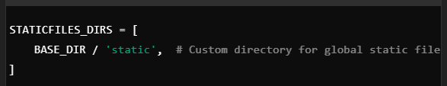
- STATIC_ROOT
- Specifies the directory where static files are collected when using the collectstatic command for deployment.
- Example:


4. Managing Static Files in Development
- Django serves static files automatically in development mode using the django.contrib.staticfiles app.
- Place static files in a folder named static within each app directory or a global static folder specified in STATICFILES_DIRS.

Example Directory Structure:

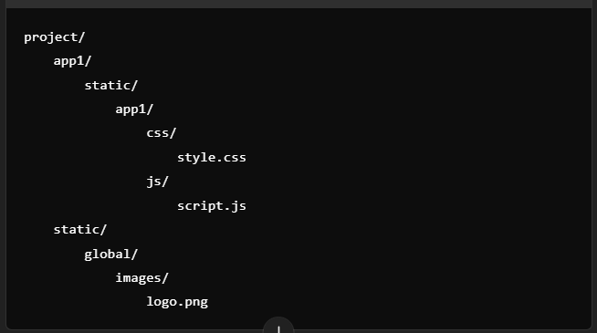

Accessing Static Files in Templates:
Use the {% static %} template tag to reference static files:

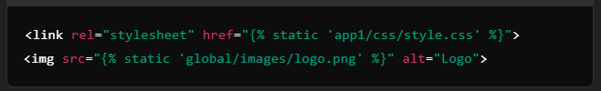

5. Collecting Static Files for Production
- In production, you usually serve static files using a web server like Nginx or Apache, or a CDN.
- Use the collectstatic command to gather all static files into the directory specified by STATIC_ROOT:

This combines all static files from app directories and STATICFILES_DIRS into the STATIC_ROOT folder.

6. Customizing Static Files Handling
Django allows customization and extension of static file handling through:
- Storage Backends: Serve static files from cloud storage like Amazon S3 or Google Cloud Storage using third-party libraries.
- Custom Finders: Locate static files using custom logic by subclassing django.contrib.staticfiles.finders.BaseFinder.

7. Best Practices for Static Files
- Organize Files Hierarchically: Keep CSS, JavaScript, images, and fonts in separate directories for better maintainability.
- Minify and Compress Files: Reduce file sizes to improve load times.
- Use a CDN in Production: A CDN improves performance by serving static files from servers closer to users.
- Version Control for Static Files: Use unique versioning in file names (e.g., style.v1.css) to prevent caching issues.
- Django WhiteNoise:
For small projects, the WhiteNoise package can serve static files directly without a separate web server.

8. Debugging Static Files Issues
- Check that django.contrib.staticfiles is listed in INSTALLED_APPS.
- Verify the STATICFILES_DIRS and STATIC_ROOT paths.
- Ensure static files are being collected and served correctly during production.

By properly configuring and managing static files, you can ensure your Django application runs smoothly with a professional user experience.

LET’S CONSIDER THE FOLLOWING IN “settings.py”
The provided Django settings relate to managing static files and media files in a Django project. Here's an explanation of each:

1. STATIC_URL = 'static/'
- Purpose:
- Defines the URL prefix for accessing static files in your project.
- Static files include assets like CSS, JavaScript, and images used in the frontend.
- Details:
- When a browser requests a static file, Django appends the STATIC_URL prefix to the file's relative path.
- For example:
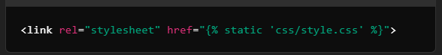

This translates to a URL like:
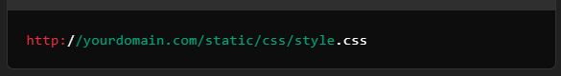
- Usage in Templates: Use the {% static %} template tag to reference static files in your HTML:



2. MEDIA_URL = 'images/'
- Purpose:
- Defines the URL prefix for accessing media files uploaded by users.
- Media files typically include user-uploaded content like profile pictures, documents, and videos.
- Details:
- When a user uploads a file, Django stores it in the directory specified by MEDIA_ROOT, and the file is accessed using the MEDIA_URL prefix.
- Example: If a user uploads a file named profile.jpg and it's stored in the MEDIA_ROOT, the file's URL would be:

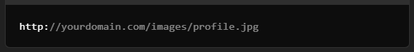

- Usage in Templates: Use the {{ object.field.url }} attribute (or similar) to access media file URLs:

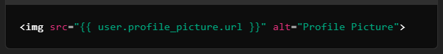

3. STATICFILES_DIRS = (os.path.join(BASE_DIR, 'static'),)
- Purpose:
- Specifies additional directories where Django will look for static files outside of app-specific static folders.
- Details:
- The os.path.join(BASE_DIR, 'static') dynamically creates the path to a static folder located in your project's base directory.
- This is useful for storing global static files (e.g., shared CSS or JavaScript) that aren't tied to a specific app.
- How It Works:
- When you define STATICFILES_DIRS, Django will include this directory during the collectstatic command and make its contents available under the STATIC_URL path.
- Example Directory Structure:
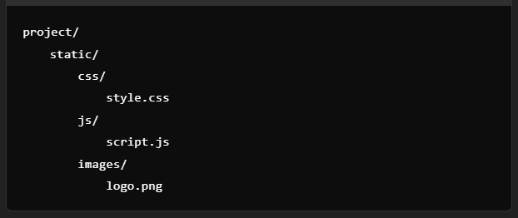
Files can be accessed as:
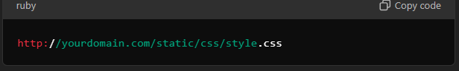

How These Settings Work Together
- Static Files (STATIC_URL and STATICFILES_DIRS):
  - STATIC_URL determines the URL prefix for serving static files.
  - STATICFILES_DIRS specifies the location of static files outside app directories.
- Media Files (MEDIA_URL):
  - MEDIA_URL determines the URL prefix for serving uploaded media files.
- Combined Example Configuration in settings.py:
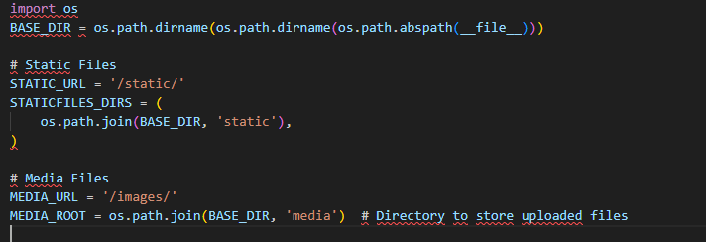
- Deployment Consideration:
  - In development, Django serves these files automatically.
  - In production, static files should be collected using collectstatic and served by a web server (e.g., Nginx or Apache), while media files are typically served from MEDIA_ROOT.

By configuring these settings correctly, you can manage static and media files efficiently in your Django project.

QUESTION:
In STATICFILES_DIRS, How Django understand the path to join for the BASE_DIR and static?
ANS: Since the ‘static/’ directory has been declared at
STATIC_URL = 'static/'
Then, click BASE_DIR to see where is declared
BASE_DIR = Path(__file__).resolve().parent.parent
The line
BASE_DIR = Path(__file__).resolve().parent.parent
is a common configuration in Django projects, used to define the base directory of the project. Let’s break it down step by step to understand what it does:

1. Understanding Each Component

Path
- Path is a class from Python's built-in pathlib module, which provides an object-oriented approach to handling filesystem paths.
- It replaces older modules like os.path with a more modern and flexible API.

__file__
- __file__ is a special variable in Python that contains the full path of the current file being executed.
  - In this case, it refers to the file where this code exists, typically settings.py in a Django project.

.resolve()
- .resolve() converts the relative path (__file__) to an absolute path, ensuring that the full path to the settings.py file is used, even if the script is executed from a different directory.

.parent
- .parent retrieves the parent directory of the current file or directory.
- Applying .parent twice:
  - The first .parent moves from settings.py to the directory containing it (typically the app or config directory).
  - The second .parent moves up one more level to the root of the Django project.

2. The Role of BASE_DIR
- BASE_DIR is used to define the root directory of your Django project.
- It allows you to easily construct paths to other directories and files within the project, ensuring portability and maintainability.
- Example project structure:
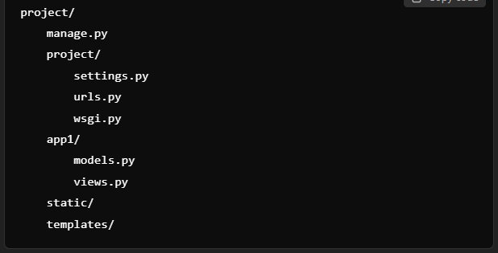
- If settings.py is located in project/project/, then:
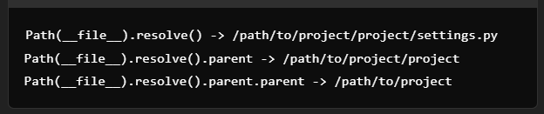

3. Example Usage of BASE_DIR

Static and Media Files
- BASE_DIR is commonly used to define paths for static and media files:
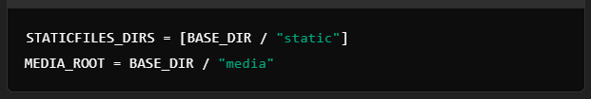

Templates Directory
- Referencing the templates folder in the project:
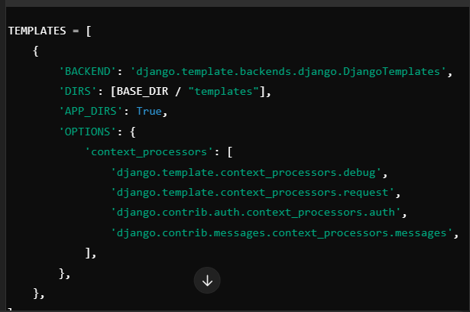

Databases
- Defining the SQLite database file path:
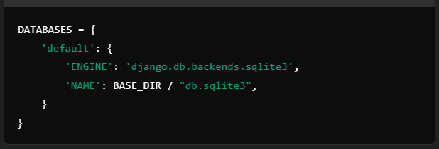

4. Benefits of Using BASE_DIR
- Portability:
  - Ensures the project works on different systems without modifying absolute paths.
- Maintainability:
  - Centralizes path management, making the project easier to configure and update.
- Avoid Hardcoding Paths:
  - Dynamically constructs paths based on the project structure, reducing errors and improving flexibility.
- Compatibility with pathlib:
  - Using Path provides a modern and readable syntax compared to os.path.

5. Potential Variations
In some cases, you might need to go further up or access specific directories:
- Moving up three levels:

- Combining paths dynamically:
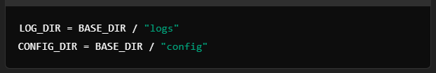

By using BASE_DIR, Django projects achieve better structure and flexibility, making it easier to locate and manage files.

{% load static %}
The {% load static %} template tag in Django is used to enable access to the static files in your templates. This is a crucial feature for managing assets like CSS files, JavaScript, and images in Django projects.

Purpose
- The {% load static %} tag imports the static template tag library, making the {% static %} tag available within the template.
- With {% static %}, you can generate URLs for static files defined in your Django project's settings (using STATIC_URL).

When to Use
You need to include {% load static %} at the top of your template whenever you want to:
- Reference a static file (e.g., CSS, JS, images).
- Use the {% static %} template tag.

Syntax
Place the {% load static %} tag at the beginning of your template:
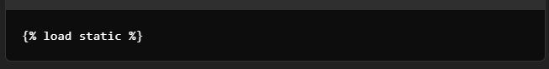

Usage Example

1. Loading a CSS File
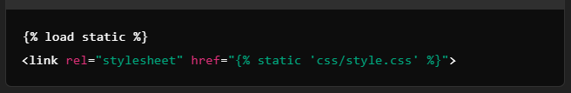
This will generate a URL like:
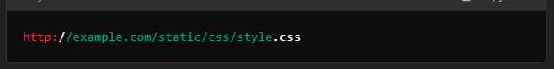
- Displaying an Image
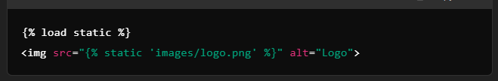
This will generate a URL like:
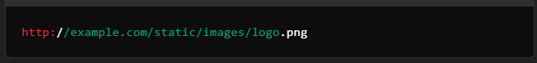
- Adding a JavaScript File
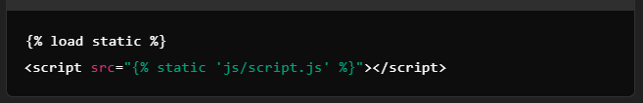

How It Works
- The {% load static %} tag loads the staticfiles library, enabling the use of the {% static %} tag.
- The {% static %} tag then appends the path provided (e.g., css/style.css) to the value of STATIC_URL defined in your settings.py.

Configuration Dependencies
For {% load static %} to work, ensure you have correctly configured static files in your Django project:

In settings.py
- Define the STATIC_URL:

- Define the STATICFILES_DIRS (optional):
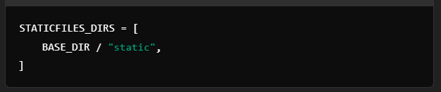
- (Optional) Use the collectstatic command in production to gather static files in a single location.

Key Points
- You only need to use {% load static %} once per template.
- The static tag will resolve URLs dynamically based on your STATIC_URL configuration.
- It simplifies the process of linking static files and ensures compatibility across development and production environments.
By using {% load static %}, you ensure your Django templates can correctly reference and serve static files with ease.

