VIRTUAL ENVIRONMENT
A virtual environment in Django (and Python in general) is an isolated environment where you can install and manage Python libraries and dependencies for a specific project without affecting other projects or the global Python installation on your system.

Why Use a Virtual Environment in Django?
- Dependency Management
  - Different Django projects may require different versions of Django or other libraries. A virtual environment allows you to manage these dependencies separately for each project.
- Avoid System-Level Conflicts
  - Installing Python packages globally can lead to version conflicts and potentially break other applications. Virtual environments isolate these installations.
- Portability
  - Virtual environments make it easy to reproduce the same environment on another machine using tools like pip freeze and requirements.txt.
- Clean Setup
  - Keeps your system Python installation clean and unaffected by project-specific libraries.

How to Create and Use a Virtual Environment for a Django Project

1. Create a Virtual Environment
- Use venv (comes built-in with Python 3.3+):
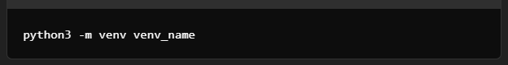

- Replace venv_name with your desired name (e.g., myenv).
- Activate the virtual environment:
- On Windows:
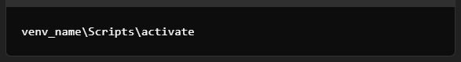
- On macOS/Linux:

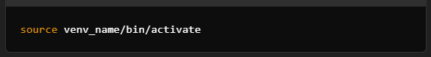

Once activated, you'll see the environment name in your terminal prompt, indicating you're in the virtual environment.

2. Install Django and Other Dependencies
- After activating the virtual environment, install Django and any other libraries required for your project:
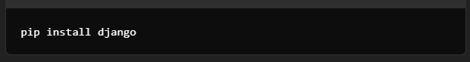

3. Freeze Dependencies
- To track installed packages, generate a requirements.txt file:
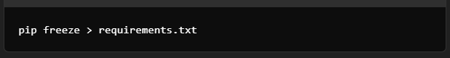

4. Deactivate the Virtual Environment
- When you're done working on the project, deactivate the virtual environment:
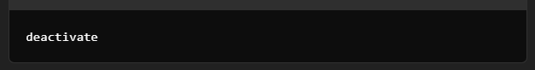

Using Virtual Environments in Existing Projects
- Create and activate a virtual environment as described above.
- Install dependencies from the requirements.txt file:
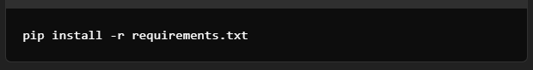

Best Practices
- Keep Dependencies Isolated
Always create a virtual environment for new Django projects.
- Use requirements.txt
Keep your requirements.txt file updated for easier collaboration and deployment.
- Avoid Global Installations
Never install project-specific libraries globally.

By using virtual environments, you ensure your Django projects remain clean, organized, and free of dependency conflicts.

VIRTUAL ENVIRONMENT IN DJANGO AND LARAVEL
Virtual environments in Django are conceptually similar to Laravel's dependency management with Composer, but they work differently in practice due to differences in the underlying languages (Python vs. PHP). Here's a comparison:

1. Purpose and Functionality

Django (Python): Virtual Environments
- A virtual environment isolates the entire Python environment, including Python itself and installed libraries.
- It ensures that dependencies and Python versions are specific to the project.
- Tools like venv or virtualenv create this isolated environment.

Laravel (PHP): Composer
- Laravel doesn't require isolating the PHP runtime since PHP is system-wide.
- Composer is used for dependency management, ensuring that specific PHP packages (e.g., Laravel, PHPUnit) are version-controlled for the project.
- It installs project dependencies in the vendor/ directory, which is isolated from the global environment.

2. Installation Scope

Django Virtual Environments
- Entirely separate Python environment for the project.
- Libraries like Django are installed inside this environment, and the global Python installation is untouched.
- You activate the environment explicitly for each project.

Laravel with Composer
- Composer installs PHP libraries only for the project directory (local scope).
- It does not isolate the PHP runtime but handles package installations in the project’s vendor/ folder.

3. Managing Dependencies

Django
- Use pip within the virtual environment to install Python packages (like Django).
- Use pip freeze > requirements.txt to track dependencies.
- Reproduce the environment using pip install -r requirements.txt.

Laravel
- Use Composer to manage dependencies listed in the composer.json file.
- Run composer install or composer update to install or update packages.
- Dependencies are tracked in composer.json and locked in composer.lock.

4. Portability
Both virtual environments in Django and Composer in Laravel make projects portable:
- Django: Reproduce the environment using requirements.txt and a virtual environment (venv).
- Laravel: Reproduce the project by running composer install on the composer.json file.
KEY DIFFERENCES
Feature | Django Virtual Environment | Laravel with Composer
Isolation | Full Python runtime isolation (per project). | Package isolation only (PHP is system-wide).
Tool Used | venv or virtualenv, along with pip. | Composer.
Dependencies Location | Installed within the virtual environment directory. | Installed in the vendor/ folder.
Purpose | Isolates Python runtime and dependencies. | Manages project-specific PHP dependencies.
Language Dependency | Python ecosystem. | PHP ecosystem.

Conclusion
While both Django (virtual environments) and Laravel (Composer) aim to handle project-specific dependencies, Django virtual environments go further by isolating the entire runtime, whereas Laravel relies on PHP being globally installed and manages only the project-specific packages.
If you’ve used Laravel's Composer, think of Django’s virtual environment as a broader version of Composer that isolates the Python environment itself!

