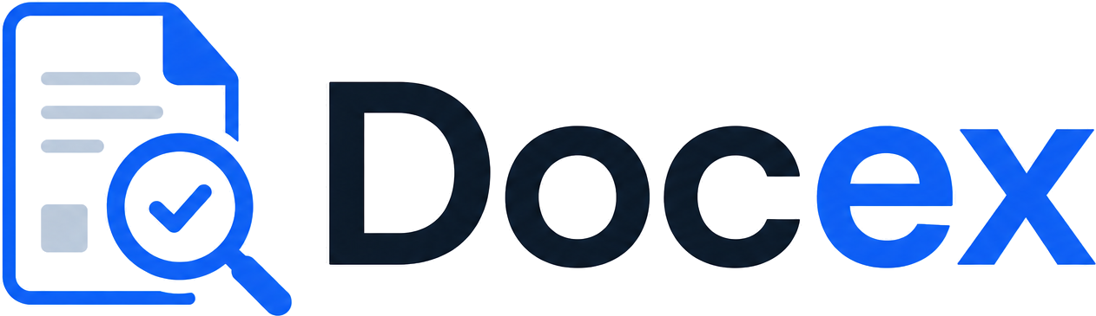
PILOT ONBOARDING GUIDE
Your first week with DOCex
A short, practical guide to going from a folder of documents to cited, audit-ready answers — without training, and without changing how your team already works.
Prepared for [CLIENT ORGANISATION]
Your contact Farid · founder@docex.app

Welcome
DOCex reads the documents your team already works with and answers the questions you ask of them — every answer backed by the source file, the exact quote, the page, and a confidence level. This guide walks you through your first week: what to gather, how each capability solves a specific problem, and how to get reliable results from day one.
The one idea to hold onto
DOCex is not a chatbot you have to coax. You define your questions or your policy once, and it applies them the same way to every document — one applicant or two hundred — leaving a trail you can defend later.

Before you start
Gather these and your first run will go smoothly:
- Your documents. One real set to work with — registration certificates, financials, audit reports, proposals, invoices, or policies. Real and messy beats clean and fake.
- Your questions. The things you need to know from every document — in plain language, exactly as you'd ask a colleague.
- Your policy (if checking compliance). The procurement, travel, or grant policy you want payments checked against.
- One or two people. The team members who will actually run the cycle and judge the results.

Your first week, at a glance
Day | Goal | What you'll do
Day 1 | Set up your questions | Write your standard questions as a reusable template — or upload a policy and let DOCex turn it into a rulebook.
Day 2 | Run one applicant | Upload one applicant's full set of documents and read the answers, sources and quotes end-to-end.
Day 3 | Run a batch | Add several applicants and export the results table to Excel — one row each, one column per question.
Day 4 | Check a payment | Run an invoice or voucher against a rulebook and review the per-rule verdicts and citations.
Day 5 | Review & decide | Look at the time saved and the consistency gained, and decide what to roll out next.

The capabilities, and the problem each one solves
You won't need all six in week one. Start with the one that matches your most painful workflow; the others use the same logic.

1 · Document extraction — “read all of this and tell me X”
Solves: reading every document by hand to answer the same questions. Upload one applicant's documents, ask your questions, and get an answer for each — with the source document, exact quote, page and confidence.
- Open the app and pick (or create) your question template.
- Upload all of one applicant's documents together.
- Run it, then read each answer with its source, quote and confidence — confidence is found, inferred, or not found.

2 · Reusable templates — ask the same things every time
Solves: re-typing your questions for every cycle and getting slightly different reviews each time. Save your question set once and run it identically on every future batch.
- Build your list of standard questions once.
- Save it as a template with a clear name (e.g. “Partner application — standard 15”).
- Select that template on every new batch — no retyping, no drift.

3 · Batch mode — a whole cycle at once
Solves: processing applicants one by one. Add each applicant with their own documents; DOCex answers your questions for all of them and gives you one table.
- Add each applicant and attach their document set.
- Run the batch and watch each applicant complete.
- Export to Excel — one row per applicant, one column per question — ready to sort, filter and share with your team.

4 · Compliance & approvals — check a payment against policy
Solves: manually checking whether a payment follows the rules, and proving it later. DOCex turns your policy into a rulebook and checks each payment rule by rule.
- Upload your policy; DOCex extracts every testable rule into a rulebook you can review and edit.
- Drop in an invoice or voucher and run the check.
- Read the verdict for each rule — pass, flag, or block — each cited from both the policy and the payment.
- Escalate a query by email if needed; the question, the answer and the trail stay in one place.

5 · Attendance & payment, and bank verification
Solves: reconciling who attended against who gets paid, and catching wrong account details before money moves. Match an attendance log to a payment list, apply per-diem rates, and verify each account holder against the bank of record.
- Upload the attendance log and the payment schedule.
- Let DOCex match them, apply the per-diem rate, and flag mismatches.
- Verify bank accounts before the schedule reaches finance.

6 · Knowledge Q&A — ask your library
Solves: hunting through old reports and decks for one fact. Ask a question of your whole library and get an answer with citations to the exact slide or page.
- Add your reports and decks to the knowledge library.
- Ask a plain-language question.
- Open the citation to jump straight to the source slide or page.

Getting reliable results
Five habits that make answers trustworthy
Ask one thing per question. “Is the org CAC-registered?” beats “Tell me about their registration and finances.”
Upload the whole set. DOCex reads across all of an applicant's documents together, so don't leave files out.
Trust the confidence flag. “Inferred” means reasonable but not stated — worth a human glance. “Not found” is an honest answer, not a failure.
Review the rulebook before checking payments. Correct any misread rule once, and every later check inherits the fix.
Keep the quote. When you share a result, the cited quote is what makes it defensible — keep it attached.

When something looks off
If an answer seems wrong, open the quote and source first — most surprises are the document itself, not the read. If a rule was misinterpreted, edit it in the rulebook and re-run. If you're still stuck, email founder@docex.app with the document and the question, and we'll take a look the same day during your pilot.

Where to get help
You want to… | Do this
Add or change your questions | Edit your template, or create a new one for a different review type.
Get a shareable result | Export the batch table to Excel — your team lives there, and so does DOCex's output.
Reach a person | Email founder@docex.app. During the pilot you have direct access — no ticket queue.
Welcome aboard. The goal for week one is simple: one real cycle, done in an afternoon, with every answer you can stand behind.

