SUMMARY OF MAXIMUM RECORDED TEMPERATURES:
UA CONTROL PANELS
Sr. # | Loc. | Max Temp | Thermal File | Thermal Image | Digital File | Digital Image
1 | Server Cabinet  Front |  | IR_52567 | 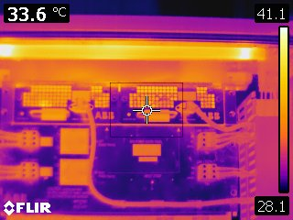 | IR_52568 | 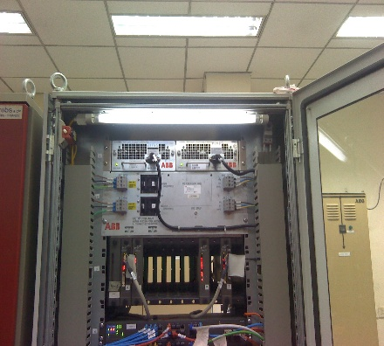
2 | Server Cabinet  Front |  | IR_52569 | 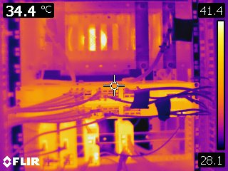 | IR_52570 | 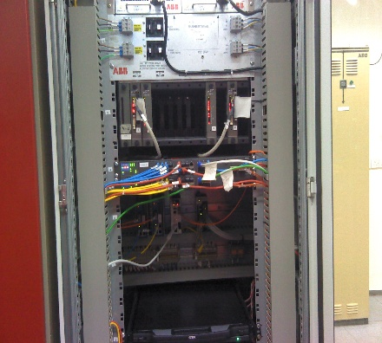
3 | Server Cabinet  Front |  | IR_52571 | 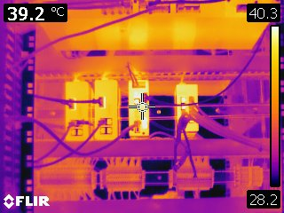 | IR_52572 | 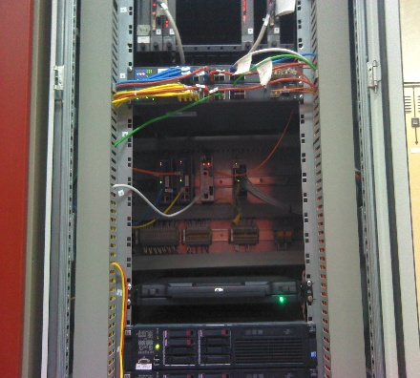
4 | Server Cabinet  Front |  | IR_52573 | 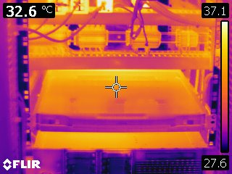 | IR_52574 | 