Photogrammetric Computer Vision

Assignment-3

Group-K

## 1.a)

The Calibration object we have chosen as a corner of a room. Setting up a XYZ axis to the right, up and left angle of the corner.

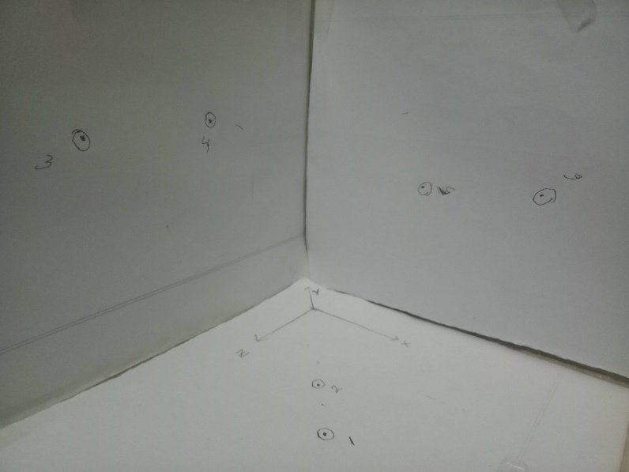

## 1.b)

The camera used was a mobile camera of autofocus 13-megapixel resolution with (f/1.7) aperture.

## 2.a)

We chose the right angular side of the corner as X axis. The upper angular side as Y axis and left angular side as Z axis.

## 2.b)

The well-distributed 6 points we chose were along all the axis of the calibration object. We took points 1 and 2 on the floor, points 3 and 4 on the left wall and points 5 and 6 on the right wall of the calibration object as a precision of all of them having 3D object coordinates (x, y, z).

## 3.

We implemented a function in Octave for spatial resection using the direct linear estimation method of the projection matrix with help of the singular value decomposition.

## 4.a)

We got the following findings in the end.

### Projection Matrix

P=

6.5689e+00 7.3651e+00 3.1799e+00 -1.3009e+03

3.4212e+00 7.2907e+00 7.4905e-01 -9.5899e+02

1.1131e-02 9.9443e-03 3.6683e-03 -1.8951e+00

### Exterior Orientation

* Projection Center

C =

73.1856

92.7712

43.0361

1.0000

* Rotation Matrix:

R =

0.377581 -0.082427 -0.922301

0.577035 -0.758042 0.303979

-0.724199 -0.646976 -0.238659

* Rotation Angles

omega = 69.752

phi = 46.402

kappa = 56.801

### Interior Orientation

* Calibration Matrix

K =

68.9412 53.7362 668.8888

0 216.3101 479.7076

0 0 1.0000

* Principle Distance

ax = 68.941

* Skew parameter

s = 53.736

* Principal Point

x0 = 668.89

y0 = 479.71

* Aspect Ratio

aspect_ratio = 3.1376

## 4.b)

We interpreted the values generating a projection matrix first using the calibration object we created. Then we interpretated values from the Projection Matrix producing Calibration Matrix, K and Rotation Matrix, R by doing a RQ-Decomposition. We got the principal distance ax/c, principial point X0Y0, skew parameter s and aspect ratio ay/ax from the Calibration Matrix and the Rotation angles (omega, phi, kappa) from the Rotation Matrix. Projection Center C we got by doing a singular value decomposition using the projection matrix.

From the findings, about the exterior parameters, we can say that the Projection Center C is parallel to the image plane. We see, C (Xc, Yc, Zc) is small here, (73,93,42). So, the camera used is a wide-angle camera.

From the Rotation Matrix and the Rotation angles we can say that, Rotation of the camera angles is defined by the Rotation Matrix. These image axis rotation angles (omega, phi, kappa) differed perhaps because, there were rotations, like movements with the camera while taking image.

From the interior parameters we can say that, the principal distance c, which is the distance perpendicular from the camera to the image point (x0, y0) is 68.941 pixel. We see ax (68.941) and ay 216.3101) differ quite maybe because the matrix values of the pixel points are not square.

The skew parameter is 53.74, which is larger than 0. So, the image coordinate system axis was a little greater than being orthogonal. Maybe because, the geometric sensor was not perfectly aligned with the camera body due to inaccuracies in placement of the camera and also because maybe of slight movements since there were no stands to hold the camera steady.

x0 = 668.89, y0 = 479.71 is the principal image point situated at the middle of the image plane where the image ray from camera intersects perpendicularly.

The aspect ratio (3.1) here differs from 1. So, the pixel values belong to a rectangular field.