Photogrammetry Computer Vision

Final Project Report

Students:

Name: Fariha Al Ferdous (124138)

M.Sc. in Digital Engineering

Name: Rahul Keerthi Parameswara (123981)

M.Sc. in Digital Engineering

Name: Farooq Syed (124445)

M.Sc. in Digital Engineering

In this project we used Least Squares Matching for finding geometric alignment between a deformed and input image pair. We have created a function named least_square_correlation and ran on Octave to perform the Least Square Matching between the reference image and the search image in order to find out the deformation and translation parameters that were used in deforming the input image. Since Octave does not support sum(variable,’all’) function we had to sum up the variables individually when we calculated the design matrix for solving the linearized inhomogeneous equation system to output the deformation and translation parameters. Following we shall discuss what we got from doing the experiments.

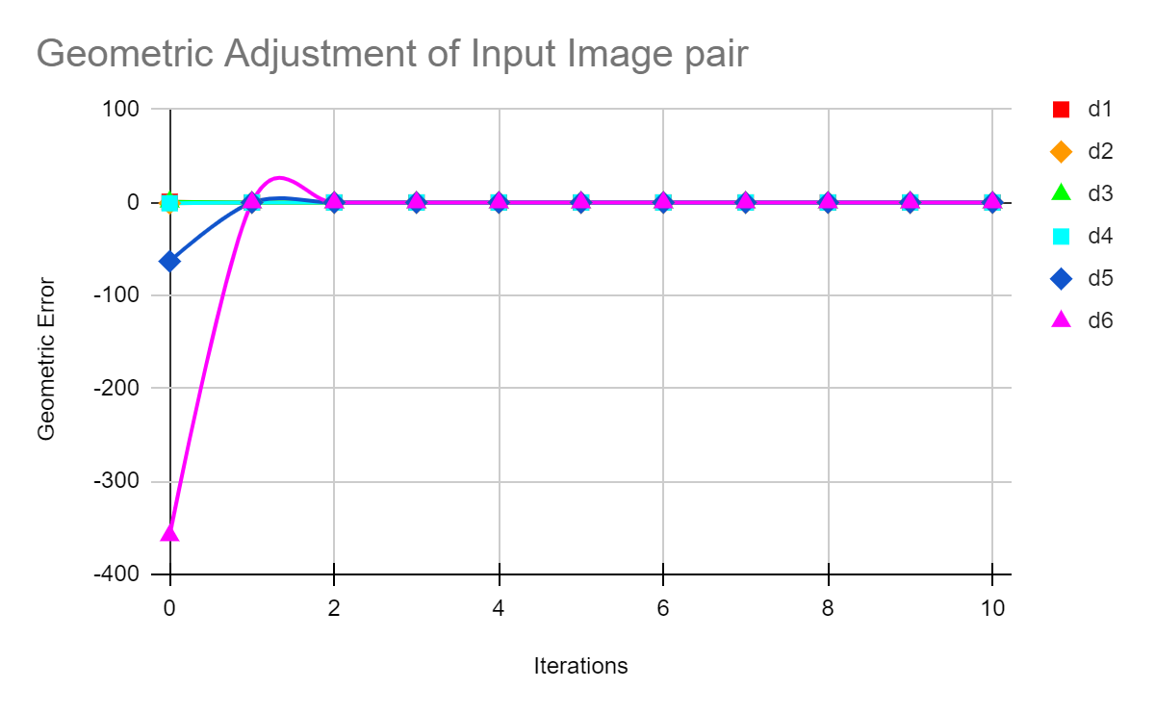

When we used an input image and distorted it with an arbitrarily selected affirmation matrix, we found the above criteria per iteration. From the plot above we can see that the convergence of the deformation and translation parameters happened after iteration 2. So, we can say that after iteration 2, the search image and the reference image pairs become most similar.

The following are the outputs of iterations at 1, and 2 of the source image on the left.

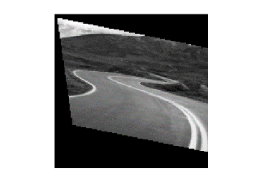

 = > =>

Figure 1 Input Image

Figure 3 Destination Image at Iteration 2

Figure 2 Iteration 1

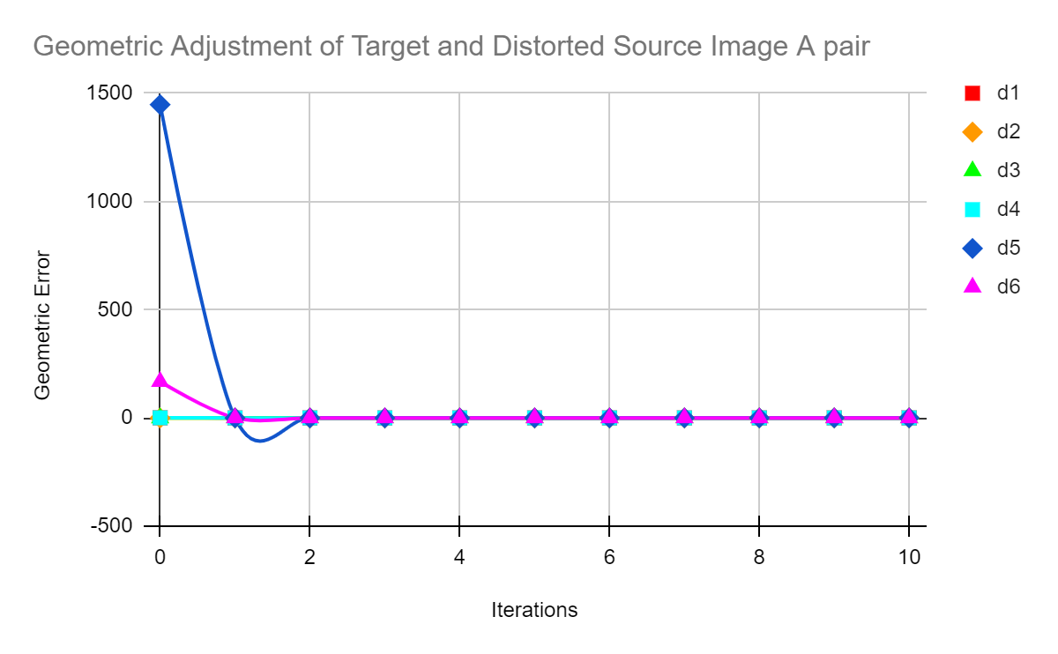

Then we evaluated the geometric adjustment of the target image and the distorted image A pair and found the above convergence. We can see that after iteration 2, the plot converges. Which means, after iteration 2, the image pair would be the most similar. Below we shall see the images we got after iteration 1 and 2. And we will also see that we found our destination image after iteration 2.



Figure 1 Source Image

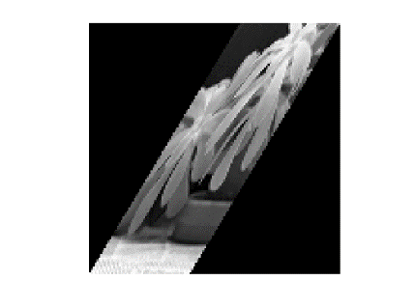

Figure 2 Image after Iteration 1

Figure Destination Image after Iteration 2

= >

= >

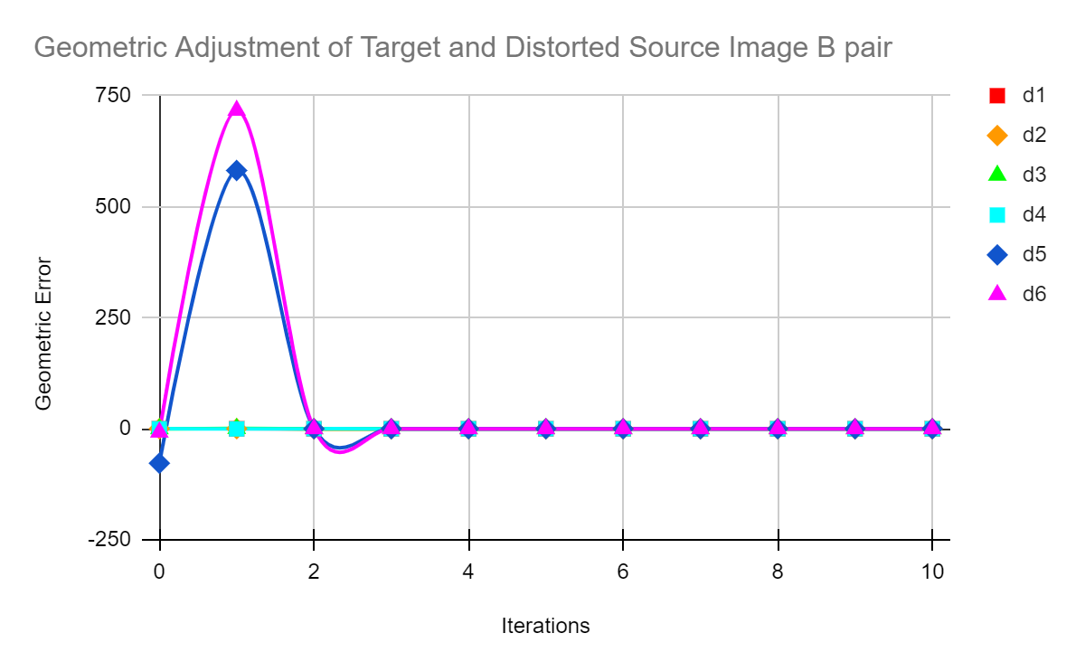

We evaluated distorted image B to find out the deformation and translation parameters to figure out the geometric adjustment. From the experiment we got the parameters such that, from the plot above we see this converges after iteration 3. So, we can say that, after iteration 3, the reference and the search images come out the most similar ones.

We also view below the images we got after iteration 1 and 3. We see that we get the most similar destination image after iteration 3.

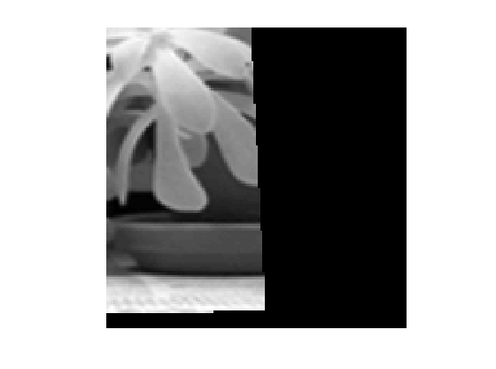

= >

= >

Figure Image after iteration 2

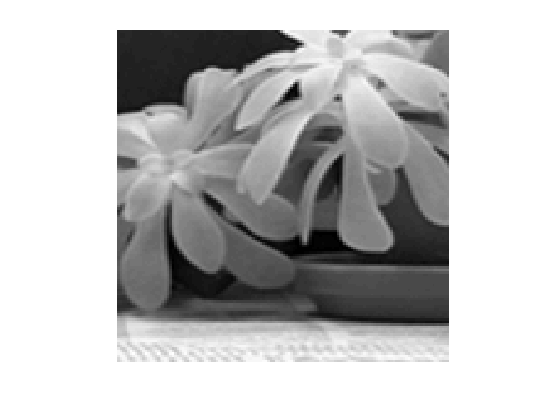

Figure 2 Image after iteration 1

Figure 1 Target Image

Figure Destination Image after iteration 3

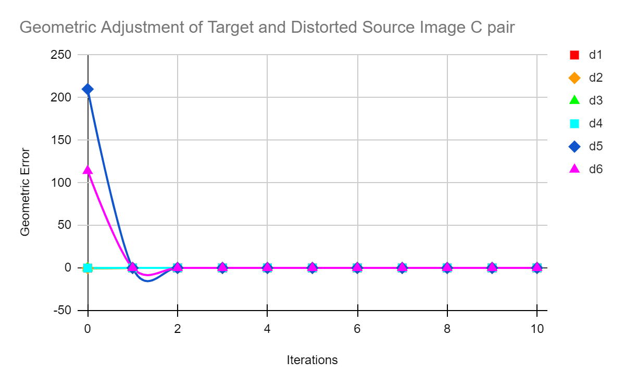

We evaluated Distorted image C and Target image pair and we see that after iteration 2 the deformation and translation parameters converge and thus, we can say that, the reference and search image get most similar after iteration 2.

If we view the results, we see that after iteration 2 we get the most similar images, and so, after iteration 2 we get the destination image.

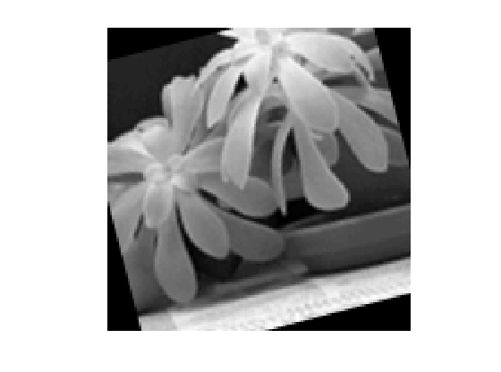

Figure 3 Destination Image after iteration 2

Figure 2 Image after iteration 1

Figure 1 Target Image

= > = >

We randomly made small variation in the size of the central image area (increased it) for the distorted image B. And we see for iteration number 2 we get the required output instead of 3.

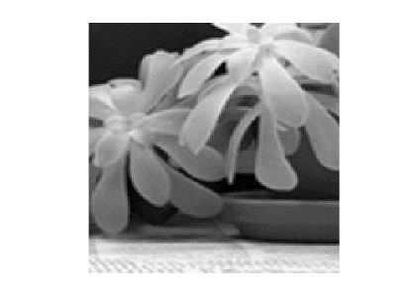

Figure 1 Target Image

= > = >

Figure 3 Destination Image after iteration 2

Figure 2 Image after Iteration 1

Likewise, we used different number of iterations but the output was the same. We managed to find out the six deformation and translation parameters for each of the image pairs, which have been shown here in the drawn plots above.

Least Squares Matching is used to evaluate corresponding image pairs. Image windows of a size are used named as reference and search image windows to find out the correspondences between both image pairs. Evaluating the distorted images and then getting it back to its initial state gives 6 deformed and translation parameters which then give the affirmation matrix used to transform the target image initially. In a word, Least Squares Matching enable us to find correspondences between two image pairs so that we can evaluate the differences of the image pairs in close range. These 6 transformation parameters are possible to be determined from the solution of the linearized inhomogeneous equation system. The 6-column solution vector we get by this contain the 6 transformation parameters.

**References:**

* Our project implementation took inspiration from the reference of <https://github.com/zxyctn/Least-Squares-Correlation>
* Input image taken from https://github.com/zxyctn/Least-Squares-Correlation/tree/main/img