**CSE421**

**COMPUTER NETWORKS**

**Lab Project**

**Topic 5**

**Shakib Al Hasan**

**Group 5 | Section: 01**

| Hamed Efaz Md. Elahi Dad | 19101304 |
| --- | --- |
| Fariha Rahman | 19101038 |

**SCREENSHOTS**

**Full View**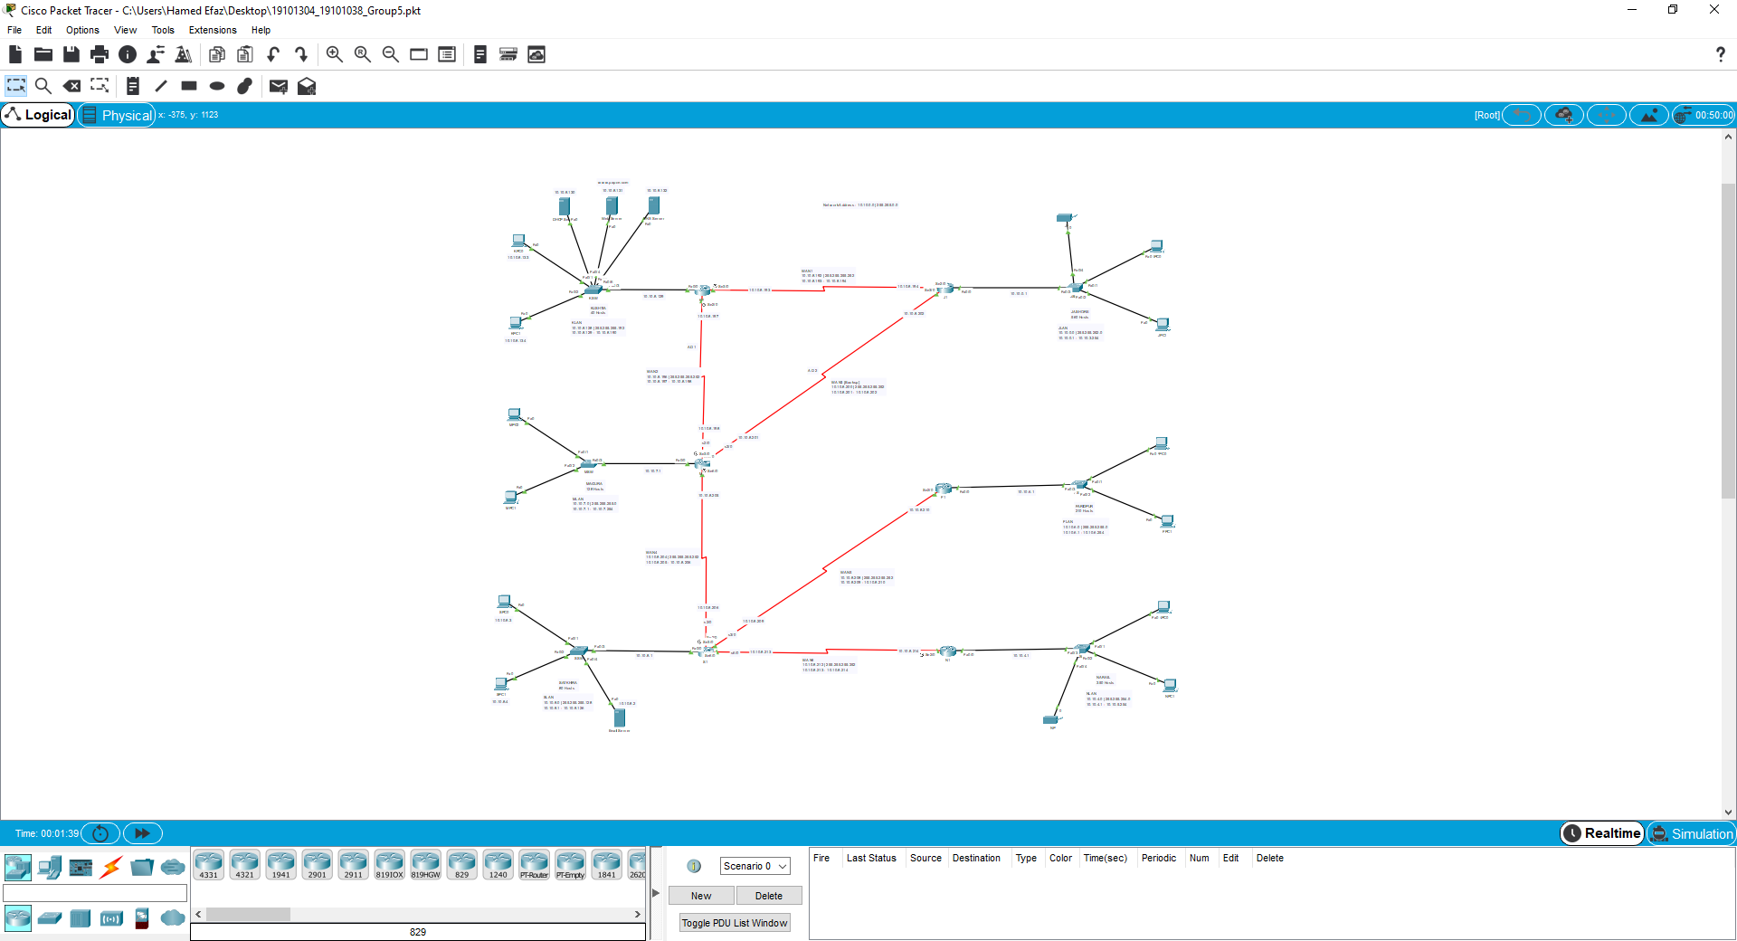

**Zoomed view [Full view divided into 3 parts]**

**1**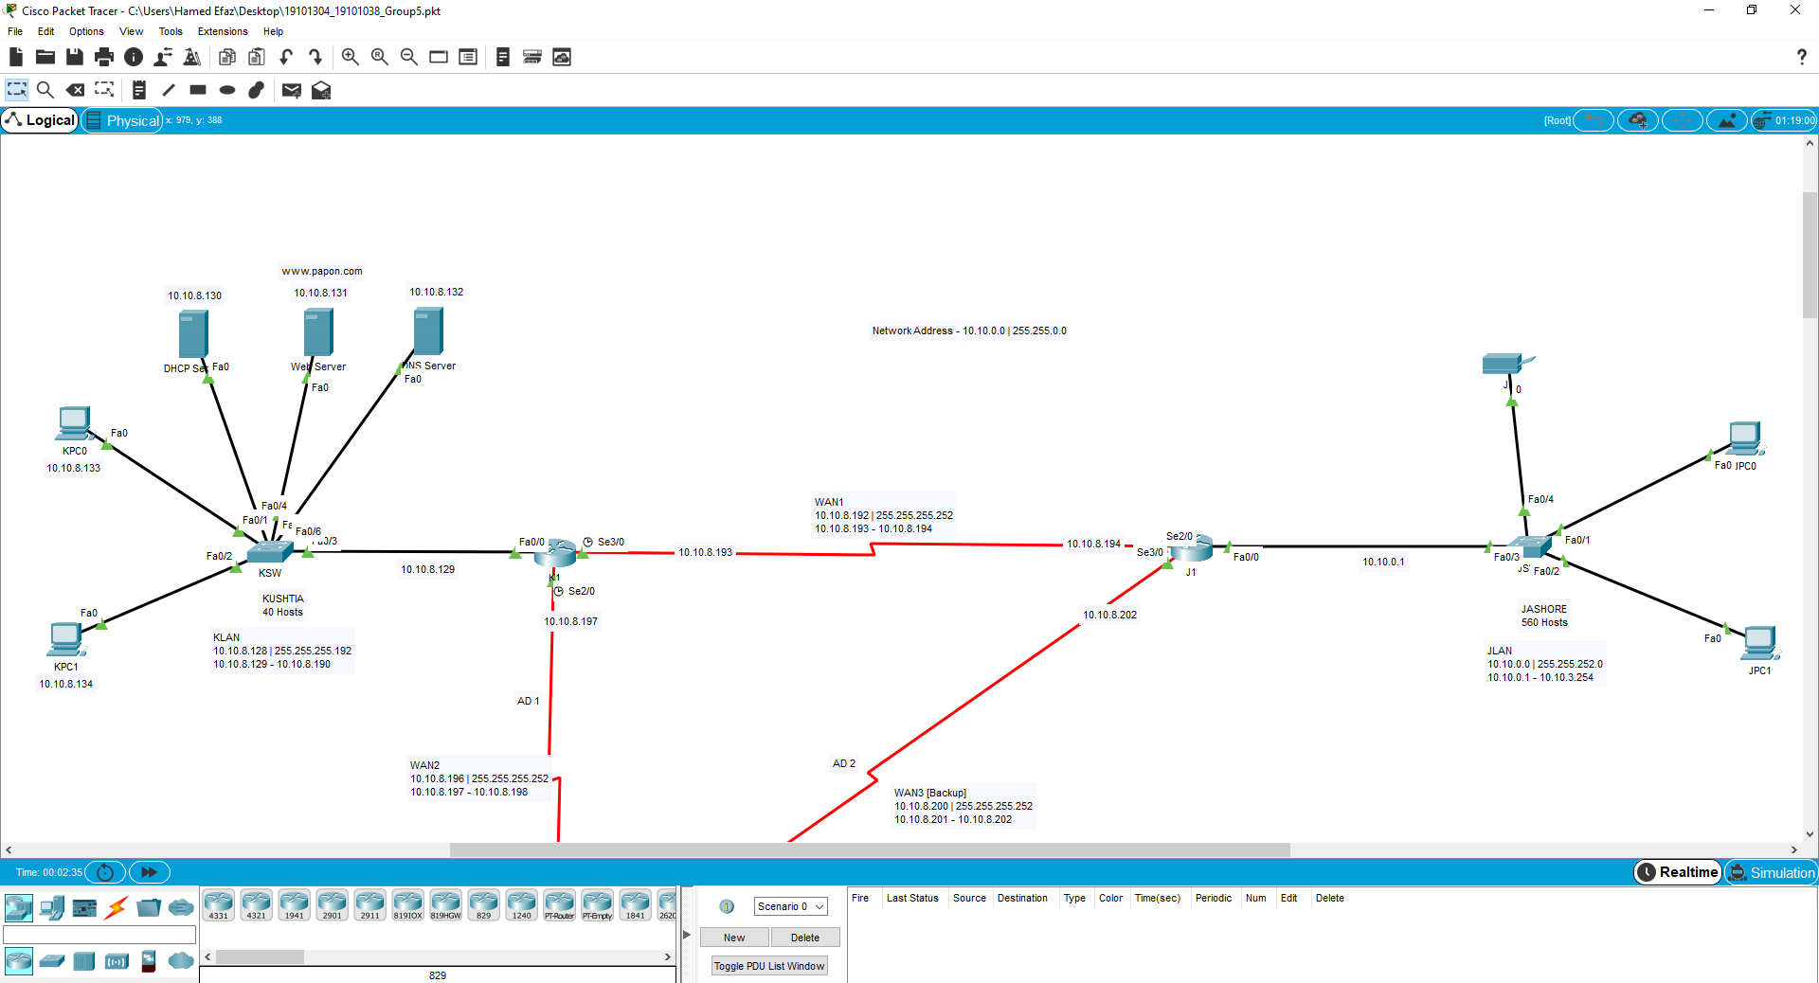

**2**

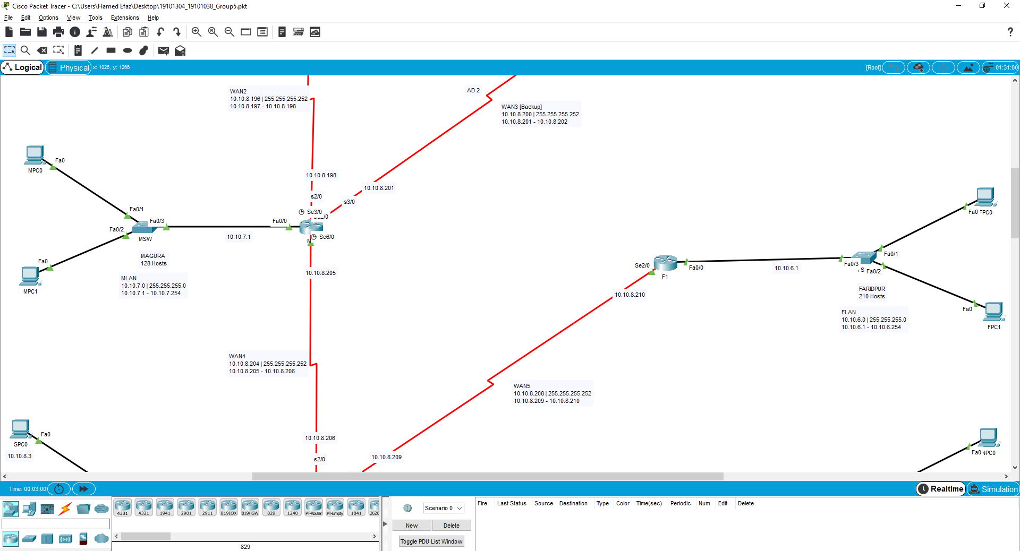

**3**

