CRUD
// create database using phpMyAdmin / MySQL
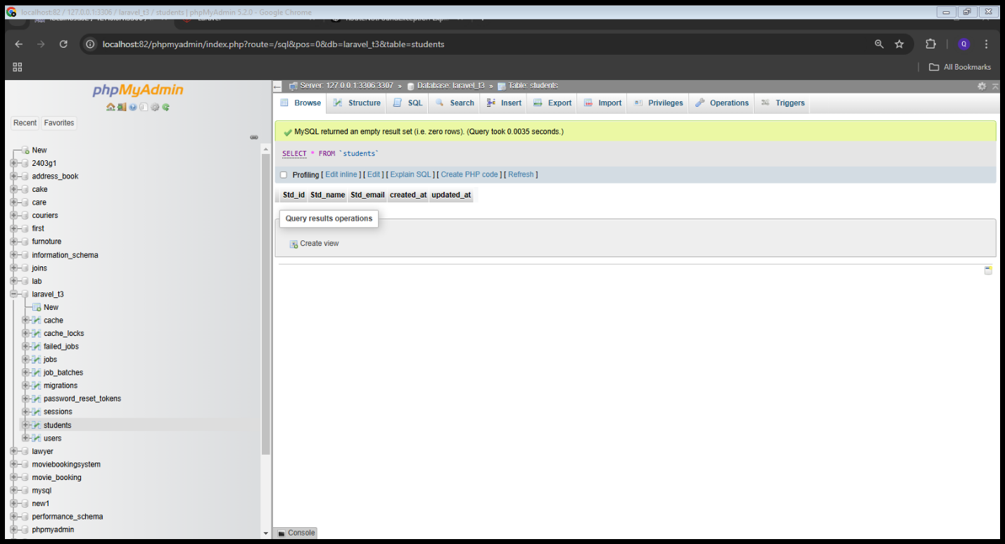
RENAME THE DATABASE INSIDE THE. ENV FILE
.ENV stands for (environment specific variables for the app)
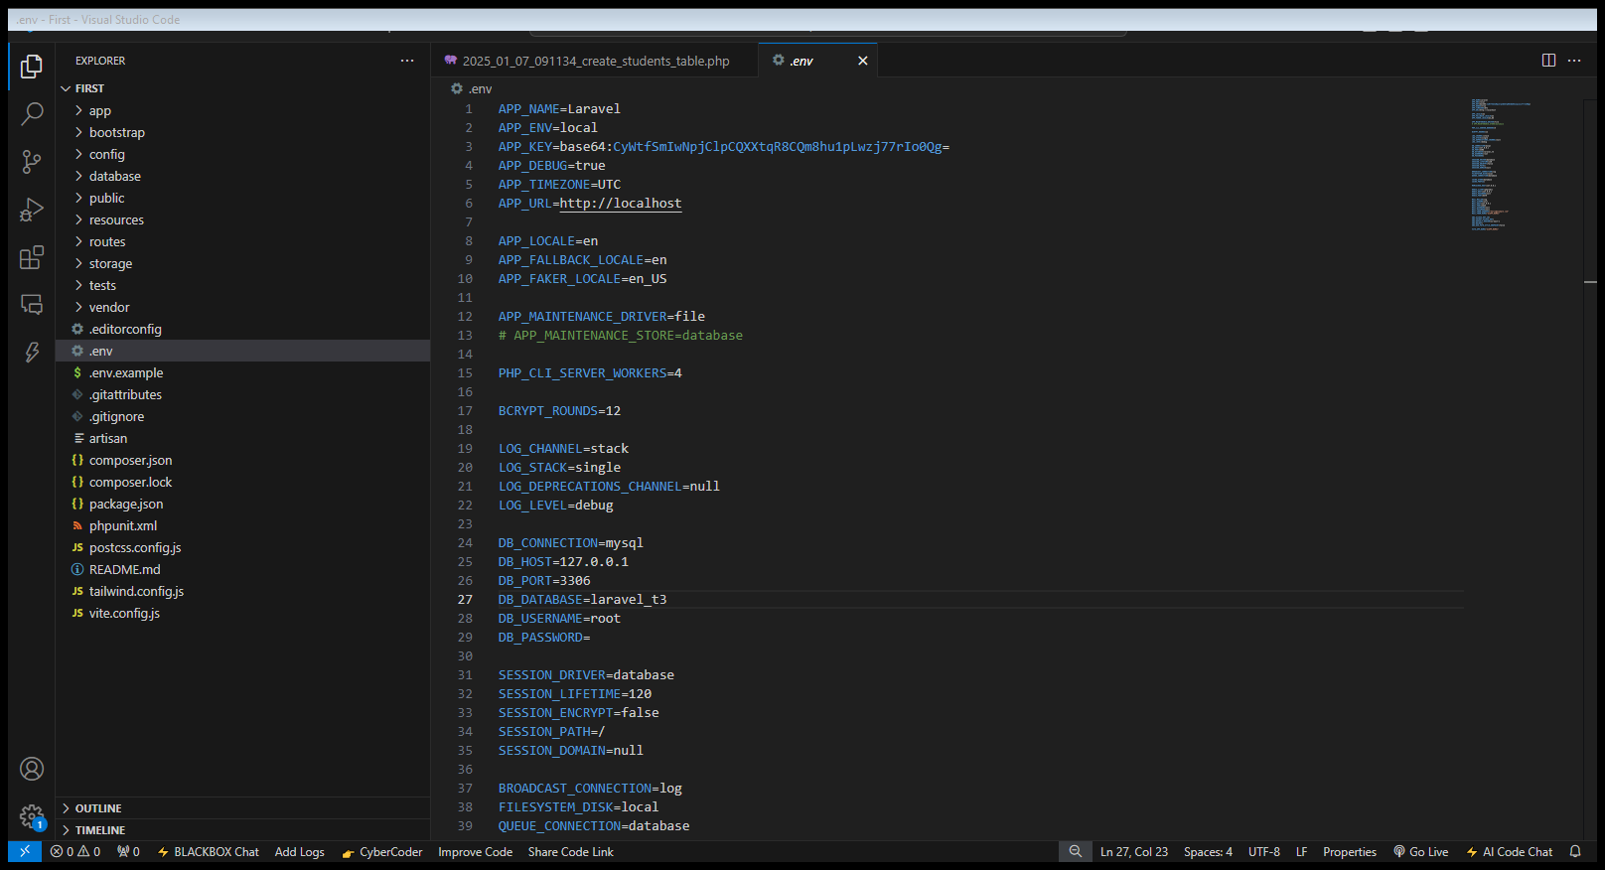

1. Create the Migration
First, make sure you have the migration for the products table.
Run the following command to create a migration:
php artisan make:migration create_students_table
After code in migration file

Run
php artisan migrate

2. Create the Student Model
Make sure you have a model for the Product table. You can create it using:
php artisan make:model Students
then code in model file

3. Create the Controller
Now, create the controller that will handle saving the data to the database.
Run the following command:
php artisan make:controller StudentsController

4. Define the Route
In the routes/web.php file, define the POST route that will trigger the save method in the controller.
Web page
<?php

use Illuminate\Support\Facades\Route;
use App\Http\Controllers\StudentsController;

Route::get('/', function () {
return view('form');
});

Route::post('/save',[StudentsController::class,'insert']);
Route::get('/display',[StudentsController::class,'getdata']);
Route::get('edit/Std_id={Std_id}',[StudentsController::class,'fetch_id']);
Route::post('/update',[StudentsController::class,'update_students']);
Route::get('delete/Std_id={Std_id}',[StudentsController::class,'del']);

You have these files
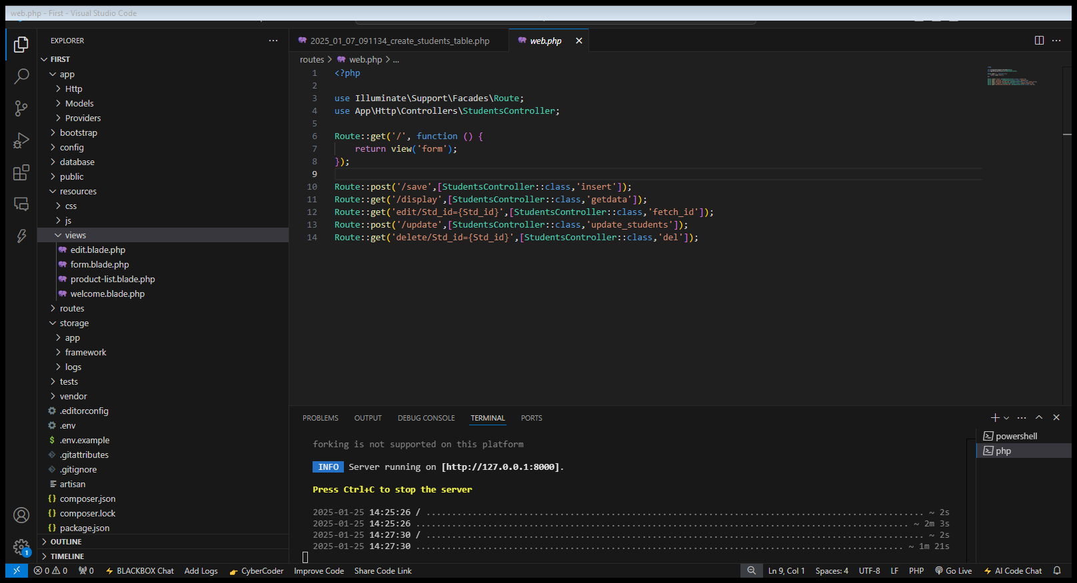

Students Controller
<?php

namespace App\Http\Controllers;

use Illuminate\Http\Request;
use App\Models\Students;

class StudentsController extends Controller
{
//insert data
public function insert(Request $req){
$stdname = $req->input('s_name');
$stdemail = $req->input('s_email');
Students::create(['Std_name'=>$stdname, 'Std_email'=>$stdemail]);
return redirect()->action([StudentsController::class,'getdata']);
}

//fetching data
public function getdata(){
$students = Students::all();
return view('display',compact('students'));
}

//method for fetching id
public function fetch_id($Std_id){
$editdata = Students::where('Std_id',$Std_id)->get();
return view('edit',compact('editdata'));
}
//update record
public function update_students(Request $req){
$id = $req->input('id');
$name = $req->input('name');
$email = $req->input('email');

Students::where('Std_id',$id)->update(['Std_name'=>$name, 'Std_email'=>$email]);
return redirect()->action([StudentsController::class,'getdata']);

}

//delete record
public function del($Std_id){
Students::where('Std_id',$Std_id)->delete();
return redirect()->action([StudentsController::class,'getdata']);

}
}

Students model
<?php

namespace App\Models;

use Illuminate\Database\Eloquent\Model;
use Illuminate\Database\Eloquent\Factories\HasFactory;

class Students extends Model
{
use HasFactory;
protected $fillable = [
'Std_name',
'Std_email'
];
}

Migration file
<?php

use Illuminate\Database\Migrations\Migration;
use Illuminate\Database\Schema\Blueprint;
use Illuminate\Support\Facades\Schema;

return new class extends Migration
{
/**
* Run the migrations.
*/
public function up(): void
{
Schema::create('students', function (Blueprint $table) {
$table->id('Std_id');
$table->string('Std_name');
$table->string('Std_email');
$table->timestamps();
});
}

/**
* Reverse the migrations.
*/
public function down(): void
{
Schema::dropIfExists('students');
}
};

Edit file
<!DOCTYPE html>
<html lang="en">
<head>
<meta charset="UTF-8">
<meta name="viewport" content="width=device-width, initial-scale=1.0">
<meta http-equiv="X-UA-Compatible" content="ie=edge">
<title>Document</title>
</head>
<body>
<h1>Update Data</h1>
@foreach ($editdata as $data)
<form action="/update" method="post">
@csrf
<input type="hidden" name="id" value="{{$data->Std_id}}"><br><br>
<input type="text" name="name" id="" value="{{$data->Std_name}}"><br><br>
<input type="email" name="email" id="" value="{{$data->Std_email}}"><br><br>
<input type="submit" value="Update Data">
</form>
@endforeach

</body>
</html>

Form file
<!DOCTYPE html>
<html lang="en">
<head>
<meta charset="UTF-8">
<meta name="viewport" content="width=device-width, initial-scale=1.0">
<meta http-equiv="X-UA-Compatible" content="ie=edge">
<title>Document</title>
</head>
<body>
<h1>Add Student Record</h1>
<form action="/save" method="post">
@csrf
<input type="text" name="s_name" id="" placeholder="Enter your name"><br><br>
<input type="email" name="s_email" id="" placeholder="Enter your Email"><br><br>
<input type="submit" value="Add New Student">
</form>
</body>
</html>

Table
<!DOCTYPE html>
<html lang="en">
<head>
<meta charset="UTF-8">
<meta name="viewport" content="width=device-width, initial-scale=1.0">
<meta http-equiv="X-UA-Compatible" content="ie=edge">
<title>Document</title>
</head>
<body>
<h1>Display Student Records</h1>
<table border="0" cellspacing="0" cellpadding="10">
<thead>
<tr>
<th>Student Name</th>
<th>Student Email</th>
<th>Actions</th>
</tr>
</thead>
<tbody>
@foreach ($students as $item)
<tr>
<td>{{$item->Std_name}}</td>
<td>{{$item->Std_email}}</td>
<td>
<a href="edit/Std_id={{$item->Std_id}}">Edit</a>
<a href="delete/Std_id={{$item->Std_id}}">Delete</a>
</td>
</tr>
@endforeach

</tbody>
</table>
</body>
</html>

